Table 1 (Title): Challenges with Lecture- and PBL-based approaches.
Lecture-based approaches | PBL-based approaches
- Substantial volume of material  - Information transmission-oriented  - Synchronous in-person or recorded  - Faculty-centric  - Passive  - Memorization heavy  - Limited peer teaching, peer interactions, peer co-creation of knowledge | - Self-directed learning permits students to gloss over difficulty topics  - Limited feedback from faculty facilitators  - Insufficient familiarity with subject matter to self-identify knowledge gaps  - Limited faculty guidance to foster cognitive bootstrapping, scaffolding, and flexibility  - Absence of a conceptual framework for approaching the discipline
Table 1 (Legend): Challenges in current formats used in pharmacology education.

Table 2 (Title): Education theories informed educational methods.
 | Constructivism | Communities of  Practice | Networked  Learning
Key Features | - Learning is an active, contextualized process of constructing knowledge through experience.  - Active creators of own knowledge.  - Ask questions, explore, assess what we know.  - Experience and reflection. | - Learning is a social, collaborative process.  - People who have common interests collaborate over an extended period of time.  - Contribute ideas and strategies, determine solutions.  - Embrace share responsibility. | - Learning is perceiving connections between fields, ideas, and concepts.  - Use of internet technologies to learn and share information.  - Asynchronous, online, peer networks.  - Faculty guide discovery and answer key questions as needed.  - Learners encouraged to seek and share information on their own.
Educational Methods | - Individual learners answer 1 of 5 case-based, wiki assignment questions across Bloom’s taxonomy.  - Reflection upon other learners’ posts.  - Individual learners post 1 peer-teaching, follow-up comment. | - Small group wiki communities of n = 5 learners.  - Collaboration extended over M1 academic year.  - Social learning; Shared responsibility. | - Blackboard® Wiki Tool.  - 15 formative small group wiki assignments; 1 summative individual wiki assignment.  - Learners contribute ideas, strategies, solutions, comments, and ask additional questions of one another.
Table 2 (Legend): Elements of constructivism, communities of practice theory, and networked learning theory used in the design of the social pedagogy model for pharmacology learning.

Table 3 (Title): Learner evaluation of pharmacology module/wiki learning.
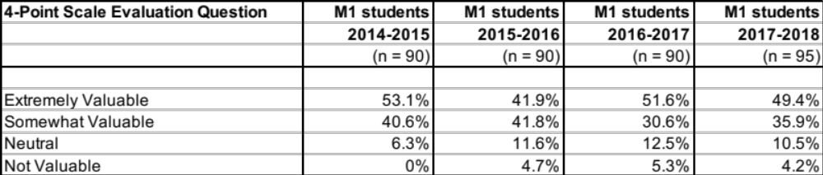
Table 3 (Legend): Percentage response on a 4-point scale to the evaluation question, “Please rate the value of the pharmacology module/wiki learning activity and resources in helping you achieve the learning objectives” for M1 students 2014-2018.

Table 4 (Title): Coding of a representative example of a summative final wiki assessment.

Bloom’s Cognitive Taxonomy | Conceptual Framework Elements | Pharmacodynamics Excerpts from a representative Summative Wiki
Remember  - identify, explain, define, recall, recognize, describe  Comprehend  - relate, categorize, explain  Evaluate  - searching, supporting, convincing  Synthesize  - composing, wiki-building | Distribution  Drug-Receptor Interactions | “GABA (ɣ-aminobutyric acid) is a neurotransmitter widely distributed within the central nervous system, and represents the major element in neuronal inhibition (Julio-Pieper et al. 2013)...”
Remember  - identify, explain, define, recall, recognize, describe  Evaluate  - assess, consider  Synthesize  - composing, wiki-building | Drug-Receptor Interactions  Drug-Response Relations | “…There are two main GABA receptors within the brain: GABA_{A} and GABA_{B}. GABA_{A} is the most well-studied of the two. It is a ligand-gated chloride ion channel expressed on the post-synaptic side of the cleft, with orthosteric and allosteric binding sites. With GABA release from the pre-synaptic terminal, and binding to GABA_{A}, the Cl⁻ channel is activated and Cl⁻ enters the neuron, effectively hyperpolarizing the membrane and increasing the threshold for action potential generation…”
Comprehend  - relate, associate, contrast  Evaluate  - searching, supporting, convincing  Synthesize  - composing, wiki-building | Drug-Receptor Interactions  Drug-Response Relations | “…Unlike GABA_{A}, GABA_{B} is a G-protein-coupled receptor. GABA signaling here decreases calcium conductance, inhibits cAMP production, increases K⁺ efflux – the net effect of which will hyperpolarize and reduce the frequency of post-synaptic action potentials (Kumar et al. 2015. Neuropharmacology. 97:414-425)…”
Analyze  - appraising  Evaluate  - hypothesizing  Synthesize  - composing, wiki-building | Drug-Response Relations | “…by triggering the inhibitory effects of GABAergic neurons in the central nervous system, the GABA added to Dream Water could potentially exert anxiolytic and myorelaxant effects (Richard and Foster 2003; Chou et al. 2008; Mazzoli et al. 2010)…”

Bloom’s Cognitive Taxonomy | Conceptual Framework Elements | Pharmacokinetics Excerpts from a representative Summative Wiki
Remember  - explain, recall, describe  Comprehend  - relate, associate, contrast  Evaluate  - searching, supporting, convincing  Synthesize  - composing, wiki-building | Elimination – Metabolism & Excretion | “…After exerting its function within the synaptic cleft, GABA experiences reuptake, whereby the presynaptic terminal and surrounding supporting glia cells reabsorb it in an exchange with sodium. The GABA which is reabsorbed by the neuron can be reused, while the GABA reabsorbed by the glia is metabolized to succinic semialdehyde and must be regenerated by GAD. (Cherlyn et al. 2010; Femenía et al. 2012)…”
Comprehend  - relate, associate, contrast  Apply  - applying, judging  Evaluate  - searching, supporting, convincing  Synthesize  - composing, wiki-building | Absorption  Bioavailability  Distribution  Elimination – Metabolism & Excretion  Elimination – Clearance & Half-life | “…Exogenously administered GABA, as in the case of Dream Water, would be subject to the challenges of absorption, distribution, metabolism, and excretion, as any exogenous substance is. GABA’s capacity to traverse the blood-brain barrier (BBB) is controversial (Boonstra et al. 2015). The bulk of evidence supports the impermeability of BBB to GABA, although Boonstra et al. (2015) report that “BBB permeability to GABA could diminish with increasing age.” In addition, mouse model studies have demonstrated evidence of GABA-facilitated transport across the BBB; however, measurements of GABA efflux were 17x greater than GABA-facilitated influx (Kakee et al. 2001). The presence of equivalent GABA transporters in the human blood-brain barrier has yet to be established. Moreover, Knych et al. (2015) demonstrated in a horse animal model that exogenous oral GABA – with a half-life of 25 minutes, bioavailability of 9.8%, and urine concentration peaking at 3 hours – had no discernable behavior effect. This means that half of the given GABA had been metabolized within 25 minutes, and that of all of the GABA administered, only 9.8% was available as active within the body. Given that no behavioral changes where seen with exogenous oral GABA, but was with IV, it appears that it did not appreciably enter the cerebrospinal fluid to exert its effects…”
Apply  - judging, determining  Evaluate  - assessing, concluding  Synthesize  - composing, wiki-building | Drugs and the Blood-Brain Barrier  Peripheral Restriction of Drugs | “…Therefore, the ultimate benefit of the GABA added to Dream Water may be in question. A Phase I clinical trial to study exogenous GABA in humans is currently recruiting participants (https://clinicaltrials.gov/ct2/show/  NCT01917760)…”

Table 4 (Legend): Coding of a single, representative example of a summative final wiki assessment with respect to Bloom’s cognitive taxonomy and pharmacological conceptual framework elements.

Table 5 (Title): Percentage prevalence of learner responses that aligned with thematic behaviors.
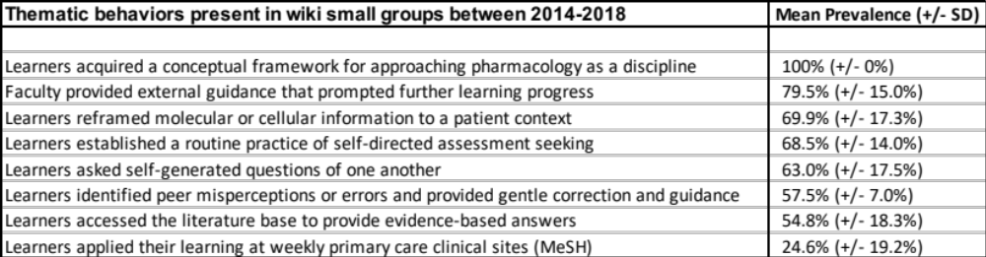
Table 5 (Legend): Mean percentage prevalence (+/- standard deviation) of learner responses, that aligned with the thematic behaviors discerned during qualitative analysis, in the 73 wiki small groups that interacted with formative wiki assignments 1-15 and the final, summative wiki assignment between 2014-2018.

