Host–Guest Recognition in the Crystalline State: Selective Inclusion of 1,4-Dibromobutane by Bromoethoxy-Functionalized Pillar[5]arenes

Mickey Vinodh, Fatemeh H. Alipour and Talal F. Al-Azemi*
Chemistry Department, Kuwait University, P.O. Box 5969, Safat 13060, Kuwait
e-mail: t.alazemi@ku.edu.kw

Supporting information

Table of Contents Page No
Table S1. Summary on the nature and various crystallographic parameters of PBr1.ButBr₂ and PBr2.ButBr₂ | 2
Table S2. Summary on the nature and various crystallographic parameters of PBr4.ButBr₂ and PBr6.ButBr₂ | 3
Fig. S1. Crystal structure of PBr1.ButBr₂ with displacement ellipsoids | 4
Fig. S2. Symmetry expanded structure of PBr2.ButBr₂ with displacement ellipsoids | 5
Fig. S3. Crystal structure of PBr4.ButBr₂ with displacement ellipsoids | 6
Fig. S4. Crystal structure of PBr6.ButBr₂ with displacement ellipsoids | 7
Table S3: Non-bonding interactions between pillar[5]arene host and dibromobutane guest in the PBr1.ButBr₂ crystals | 8
Table S4: Non-bonding interactions between pillar[5]arene host and dibromobutane guest in the PBr2.ButBr₂ crystals | 8
Table S5: Non-bonding interactions between pillar[5]arene host and dibromobutane guest in the PBr4.ButBr₂ crystals | 8
Table S6: Non-bonding interactions between pillar[5]arene host and dibromobutane guest in the PBr6.ButBr₂ crystals | 9
Fig. S5. Packing pattern of PBr1.ButBr₂ crystals | 10
Fig. S6. Packing pattern of PBr2.ButBr₂ crystals | 11
Fig. S7. Packing pattern of PBr4.ButBr₂ crystals | 12
Fig. S8. Packing pattern of PBr6.ButBr₂ crystals | 13
CheckCIF_ PBr1.ButBr₂ | 14
CheckCIF_ PBr2.ButBr₂ | 17
CheckCIF_ PBr4.ButBr₂ | 20
CheckCIF_ PBr6.ButBr₂ | 23

Table S1. Summary on the nature and various crystallographic parameters of PBr1.ButBr₂ and PBr2.ButBr₂
Crystal sample | PBr1.ButBr₂ | PBr2.ButBr₂
Chemical formula | C₅₁H₆₁Br₄O₁₀ | C₅₁H₆₀Br₄O₁₀
M_{r} | 1153.63 | 1152.63
Crystal system, space group | Triclinic, P-1 | Monoclinic, C2/c
Temperature (K) | 293 | 293
a, b, c (Å) | 11.9504 (6), 12.3790 (5), 19.820 (1) | 11.147 (6), 21.854 (14), 21.609 (13)
α, β, γ (°) | 87.229 (6), 85.730 (6), 61.925 (4) | 104.819 (9)
V (Å³) | 2579.6 (2) | 5089 (5)
Z | 2 | 4
Radiation type | Mo Kα | Mo Kα
µ (mm⁻¹) | 3.18 | 3.22
Crystal size (mm) | 0.15 × 0.12 × 0.08 | 0.20 × 0.20 × 0.11
Diffractometer | Rigaku R-AXIS RAPID | Rigaku R-AXIS RAPID
Absorption correction | Multi-scan  ABSCOR (Rigaku, 1995) | Multi-scan  ABSCOR (Rigaku, 1995)
T_{min}, T_{max} | 0.464, 0.789 | 0.444, 0.749
No. of measured, independent & observed [I > 2σ(I)] reflections | 30699, 9065, 4185 | 14748, 4465, 1888
R_{int} | 0.068 | 0.096
(sin θ/λ)_{max} (Å⁻¹) | 0.595 | 0.595
R[F² > 2σ(F²)], wR(F²), S | 0.096, 0.333, 1.02 | 0.077, 0.303, 0.93
No. of reflections | 9065 | 4465
No. of parameters | 649 | 372
No. of restraints | 174 | 205
H-atom treatment | Constrained | Constrained
Δρ_{max}, Δρ_{min} (e Å⁻³) | 1.15, −0.96 | 0.50, −0.63

Table S2. Summary on the nature and various crystallographic parameters of PBr4.ButBr₂ and PBr6.ButBr₂
Crystal sample | PBr4.ButBr₂ | PBr6.ButBr₂
Chemical formula | C₅₆H₆₈Br₇O₁₀ | C₅₅H₆₄Br₈O₁₀
M_{r} | 1460.47 | 1524.34
Crystal system, space group | Triclinic, P-1 | Orthorhombic, Aba2
Temperature (K) | 296 | 296
a, b, c (Å) | 12.491 (2), 12.859 (3), 19.944 (4) | 41.472 (5), 17.4570 (17), 16.6459 (17)
α, β, γ (°) | 94.148 (10), 93.140 (9), 111.521 (8)
V (Å³) | 2961.0 (10) | 12051 (2)
Z | 2 | 8
Radiation type | Cu Kα | Cu Kα
µ (mm⁻¹) | 6.13 | 6.80
Crystal size (mm) | 0.21 × 0.19 × 0.17 | 0.21 × 0.17 × 0.11
Diffractometer | Bruker APEX-II CCD | Bruker APEX-II CCD
Absorption correction | Multi-scan  SADABS2016/2 - Bruker AXS area detector scaling and absorption correction | Multi-scan  SADABS2016/2 - Bruker AXS area detector scaling and absorption correction
T_{min}, T_{max} | 0.31, 0.62 | 0.33, 0.64
No. of measured, independent & observed [I > 2σ(I)] reflections | 43527, 10517, 7640 | 17083, 9315, 8406
R_{int} | 0.054 | 0.041
(sin θ/λ)_{max} (Å⁻¹) | 0.599 | 0.596
R[F² > 2σ(F²)], wR(F²), S | 0.091, 0.293, 1.04 | 0.075, 0.225, 1.04
No. of reflections | 10517 | 9315
No. of parameters | 706 | 659
No. of restraints | 197 | 49
H-atom treatment | Constrained | Constrained
Δρ_{max}, Δρ_{min} (e Å⁻³) | 1.46, −1.21 | 1.32, −0.64

Fig. S1. Crystal structure of PBr1.ButBr₂ with displacement ellipsoids (30% probability). Hydrogen atoms are omitted for clarity.

Fig. S2. Symmetry expanded crystal structure of PBr2.ButBr₂ with displacement ellipsoids (30% probability; labeled only the symmetry independent atoms). Hydrogen atoms are omitted for clarity.

Fig. S3. Crystal structure of PBr4.ButBr₂ with displacement ellipsoids (30% probability). Hydrogen atoms are omitted for clarity.

Fig. S4. Crystal structure of PBr6.ButBr₂ with displacement ellipsoids (30% probability). Hydrogen atoms are omitted for clarity.

Table 3: Non-bonding interactions between pillar[5]arene host and dibromobutane guest in the PBr1_ButBr₂ crystals ( Å, º).
A-B...C |  | A-B |  | B...C |  | B....C |  | A-B...C
C39-H39C…Br2A | 0.96 |  | 3.133 |  | 4.01(1) |  | 152.1
C47A-H47A… O5 | 0.97 |  | 3.011 |  | 3.95(3) |  | 162
C47A-H47B… O3 | 0.97 |  | 2.946 |  | 3.66(5) |  | 131
C48A-H48A…O7 | 0.97 |  | 3.208 |  | 4.12(3) |  | 159
C48A-H48B…O9 | 0.97 |  | 3.325 |  | 4.16(3) |  | 145
C49A-H49A…π3 | 0.97 |  | 2.879 |  | 3.840 |  | 170.09
C49A-H49B…π2 | 0.97 |  | 3.013 |  | 3.723 |  | 130.88
C50A-H50A…π4 | 0.97 |  | 2.890 |  | 3.840 |  | 167.03
C50A-H50B…π5 | 0.97 |  | 2.850 |  | 3.673 |  | 143.10
C42-H42B…Br3A | 0.96 |  | 3.227 |  | 4.08(1) |  | 148.4
π2 - π5 are the centroid of the pillar[5]arene phenyl rings constitute C8-13,C15-C20, C22-C27 & C29-C34 respectively.

Table 4: Non-bonding interactions between pillar[5]arene host and dibromobutane guest in the PBr2_ButBr₂ crystals ( Å, º).
A-B...C |  | A-B |  | B...C |  | B....C |  | A-B...C
C23-H23B…Br2A | 0.959 |  | 3.12 |  | 3.97(1) |  | 147.3
C25A-H25A… O5 | 0.97 |  | 2.847 |  | 3.68(2) |  | 145
C25A-H25B… O3 | 0.97 |  | 2.964 |  | 3.86(2) |  | 155
C26A-H26A…π2 | 0.97 |  | 3.152 |  | 3.841 |  | 129.44
C26A-H26B…π3 | 0.97 |  | 2.944 |  | 3.875 |  | 161.05
π2 and π3 are the centroid of the pillar[5]arene phenyl rings constitute C5-10 & C12-C17 respectively.

Table 5: Non-bonding interactions between pillar[5]arene host and dibromobutane guest in the PBr4_ButBr₂ crystals ( Å, º).
A-B...C |  | A-B |  | B...C |  | B....C |  | A-B...C
C44-H44C…Br5 | 0.96 |  | 3.048 |  | 3.99(1) |  | 166.4
C50-H50A … O9 | 0.97 |  | 3.159 |  | 4.00(2) |  | 146
C50-H50B …π2 | 0.97 |  | 3.313 |  | 4.026 |  | 148.84
C51-H51A …π4 | 0.97 |  | 3.125 |  | 3.826 |  | 130.46
C51-H51B…π3 | 0.97 |  | 3.009 |  | 3.942 |  | 161.89
C52-H52A…π5 | 0.97 |  | 3.209 |  | 3.954 |  | 134.92
C52-H52B…π2 | 0.97 |  | 3.098 |  | 4.000 |  | 155.47
C53-H53A…π4 | 0.97 |  | 2.927 |  | 3.633 |  | 130.66
C53-H53B…π3 | 0.97 |  | 3.101 |  | 4.040 |  | 162.26
C42-H42A…Br6 | 0.97 |  | 3.218 |  | 4.138(8) |  | 158.9
π2 - π5 are the centroid of the pillar[5]arene phenyl rings constitute C8-13,C15-C20, C22-C27 & C29-C34 respectively.

Table 6: Non-bonding interactions between pillar[5]arene host and dibromobutane guest in the PBr6_ButBr₂ crystals ( Å, º).
A-B...C |  | A-B |  | B...C |  | B....C |  | A-B...C
C36-H36A…Br7 | 0.97 |  | 3.285 |  | 3.98(1) |  | 129.9
C52-H52A… O5 | 0.96 |  | 2.727 |  | 3.64(3) |  | 149
C52-H52B …O3 | 0.97 |  | 3.225 |  | 4.03(3) |  | 141
C53-H53A…π4 | 0.97 |  | 3.265 |  | 3.924 |  | 126.94
C53-H53B…π5 | 0.97 |  | 3.072 |  | 3.796 |  | 132.40
C54-H54A…π4 | 0.97 |  | 2.854 |  | 3.714 |  | 148.19
C54-H54B…π3 | 0.97 |  | 2.772 |  | 3.503 |  | 132.77
C55-H55A…O10 | 0.97 |  | 3.205 |  | 4.08(3) |  | 151
C55-H55B…π1 | 0.97 |  | 3.232 |  | 3.842 |  | 122.54
C49-H49C…Br8 | 0.96 |  | 3.208 |  | 4.12(1) |  | 158.5
π1 - π5 are the centroid of the pillar[5]arene phenyl rings constitute C1-6,C15-C20,C22-C27 & C29-C34 respectively.

Fig. S5. Packing pattern of PBr1.ButBr₂ crystals viewed from two different orientations.
Fig. S6. Packing pattern of PBr2.ButBr₂ crystals viewed from two different orientations.

Fig. S7. Packing pattern of PBr4.ButBr₂ crystals viewed from two different orientations.

Fig. S8. Packing pattern of PBr6.ButBr₂ crystals viewed from two different orientations.

CheckCIF_ PBr1.ButBr₂

checkCIF (basic structural check) running

Checking for embedded fcf data in CIF ...
Found embedded fcf data in CIF. Extracting fcf data from uploaded CIF, please wait . . . .

checkCIF/PLATON (basic structural check)

Structure factors have been supplied for datablock(s) PBr1_ButBr2
THIS REPORT IS FOR GUIDANCE ONLY. IF USED AS PART OF A REVIEW PROCEDURE FOR PUBLICATION, IT SHOULD NOT REPLACE THE EXPERTISE OF AN EXPERIENCED CRYSTALLOGRAPHIC REFEREE.
No syntax errors found. CIF dictionary
Please wait while processing .... Interpreting this report
Structure factor report
Datablock: PBr1_ButBr2

Bond precision: | C-C = 0.0115 A | Wavelength=0.71075

Cell: | a=11.9504(6) | b=12.3790(5) | c=19.820(1)
 | alpha=87.229(6) | beta=85.730(6) | gamma=61.925(4)
Temperature: | 293 K

 | Calculated | Reported
Volume | 2579.6(2) | 2579.6(2)
Space group | P -1 | P -1
Hall group | -P 1 | -P 1
Moiety formula | C46 H51 Br O10, C4 H8 Br2, 0.5(C2 H4 Br2) | ?
Sum formula | C51 H61 Br4 O10 | C51 H61 Br4 O10
Mr | 1153.60 | 1153.63
Dx,g cm-3 | 1.485 | 1.485
Z | 2 | 2
Mu (mm-1) | 3.175 | 3.175
F000 | 1174.0 | 1174.0
F000' | 1172.24
h,k,lmax | 14,14,23 | 14,14,23
Nref | 9119 | 9065
Tmin,Tmax | 0.639,0.776 | 0.464,0.789
Tmin' | 0.615

Correction method= # Reported T Limits: Tmin=0.464 Tmax=0.789 AbsCorr = MULTI-SCAN

Data completeness= 0.994 | Theta(max)= 25.026

R(reflections)= 0.0961( 4185) | wR2(reflections)= 0.3330( 9065)
S = 1.016 | Npar= 649

The following ALERTS were generated. Each ALERT has the format
test-name_ALERT_alert-type_alert-level.
Click on the hyperlinks for more details of the test.

Alert level B
PLAT910_ALERT_3_B Missing # of FCF Reflection(s) Below Theta(Min). 17 Note
1 0 0, 0 1 0, 1 1 0, -1 -1 1, 0 -1 1, -1 0 1,
0 0 1, 1 0 1, 0 1 1, 1 1 1, -1 -1 2, 0 -1 2,
-1 0 2, 0 0 2, 1 0 2, 0 1 2, 1 1 2,
RESPONSE: The unit cell is reasonable large and these low angle reflections are probably missing due to the beamstop. This occurs rather frequently with our goniometer's geometry, especially for larger unit cells.

Alert level C
PLAT026_ALERT_3_C Ratio Observed / Unique Reflections (too) Low .. 46% Check
PLAT084_ALERT_3_C High wR2 Value (i.e. > 0.25) ................... 0.33 Report
PLAT234_ALERT_4_C Large Hirshfeld Difference O5 --C41 . 0.19 Ang.
And 4 other PLAT234 Alerts
More ...
PLAT260_ALERT_2_C Large Average Ueq of Residue Including Br2A 0.175 Check
And 2 other PLAT260 Alerts
More ...
PLAT341_ALERT_3_C Low Bond Precision on C-C Bonds ............... 0.01145 Ang.
PLAT906_ALERT_3_C Large K Value in the Analysis of Variance ...... 17.262 Check
And 2 other PLAT906 Alerts
More ...
PLAT911_ALERT_3_C Missing FCF Refl Between Thmin & STh/L= 0.595 37 Report
-1 3 0, 3 4 0, 4 5 0, -10-14 1, -3 -2 2, -4-14 3,
-2 -5 3, 6 5 3, 14 9 3, -9-14 4, -6-14 4, -5-14 4,
-4-14 4, -11-13 4, 0 0 4, 10 14 4, -7-14 5, -6-14 5,
-5-14 5, -4-14 5, -7-14 6, -6-14 6, -7-13 7, -8-13 8,
-7-13 8, -1 0 8, -8-13 9, -7-13 9, -6-13 10, -5-13 10,
4 -9 11, 8 12 14, 9 -2 15, -4 -7 20, 1 -4 22, -2 0 23,
4 3 23,

Alert level G
PLAT002_ALERT_2_G Number of Distance or Angle Restraints on AtSite 12 Note
PLAT003_ALERT_2_G Number of Uiso or U(i,j) Restrained non-H-Atoms 12 Report
PLAT172_ALERT_4_G The CIF-Embedded .res File Contains DFIX Records 3 Report
PLAT173_ALERT_4_G The CIF-Embedded .res File Contains DANG Records 2 Report
PLAT177_ALERT_4_G The CIF-Embedded .res File Contains DELU Records 1 Report
PLAT178_ALERT_4_G The CIF-Embedded .res File Contains SIMU Records 1 Report
PLAT199_ALERT_1_G Reported _cell_measurement_temperature ..... (K) 293 Check
PLAT200_ALERT_1_G Reported _diffrn_ambient_temperature ..... (K) 293 Check
PLAT302_ALERT_4_G Anion/Solvent/Minor-Residue Disorder (Resd 2) 100% Note
PLAT302_ALERT_4_G Anion/Solvent/Minor-Residue Disorder (Resd 3) 100% Note
PLAT304_ALERT_4_G Non-Integer Number of Atoms in ..... (Resd 2) 7.50 Check
PLAT304_ALERT_4_G Non-Integer Number of Atoms in ..... (Resd 3) 6.50 Check
PLAT434_ALERT_2_G Short Inter HL..HL Contact Br4 ..Br3B . 3.40 Ang.
-1+x,y,z = 1_455 Check
PLAT860_ALERT_3_G Number of Least-Squares Restraints ............. 174 Note
PLAT883_ALERT_1_G Absent Datum for _atom_sites_solution_primary .. Please Do !
PLAT933_ALERT_2_G Number of HKL-OMIT Records in Embedded .res File 6 Note
0 0 4, -2 -5 3, -1 3 0, -3 -2 2, 6 5 3, -1 0 8,
PLAT941_ALERT_3_G Average HKL Measurement Multiplicity ........... 3.4 Low
PLAT969_ALERT_5_G The 'Henn et al.' R-Factor-gap value ........... 7.475 Note
Predicted wR2: Based on SigI**2 4.46 or SHELX Weight 32.78
PLAT978_ALERT_2_G Number C-C Bonds with Positive Residual Density. 6 Info

0 ALERT level A = Most likely a serious problem - resolve or explain
1 ALERT level B = A potentially serious problem, consider carefully
15 ALERT level C = Check. Ensure it is not caused by an omission or oversight
19 ALERT level G = General information/check it is not something unexpected

3 ALERT type 1 CIF construction/syntax error, inconsistent or missing data
8 ALERT type 2 Indicator that the structure model may be wrong or deficient
10 ALERT type 3 Indicator that the structure quality may be low
13 ALERT type 4 Improvement, methodology, query or suggestion
1 ALERT type 5 Informative message, check

PLATON version of 02/02/2025; check.def file version of 02/02/2025
Datablock PBr1_ButBr2 - ellipsoid plot
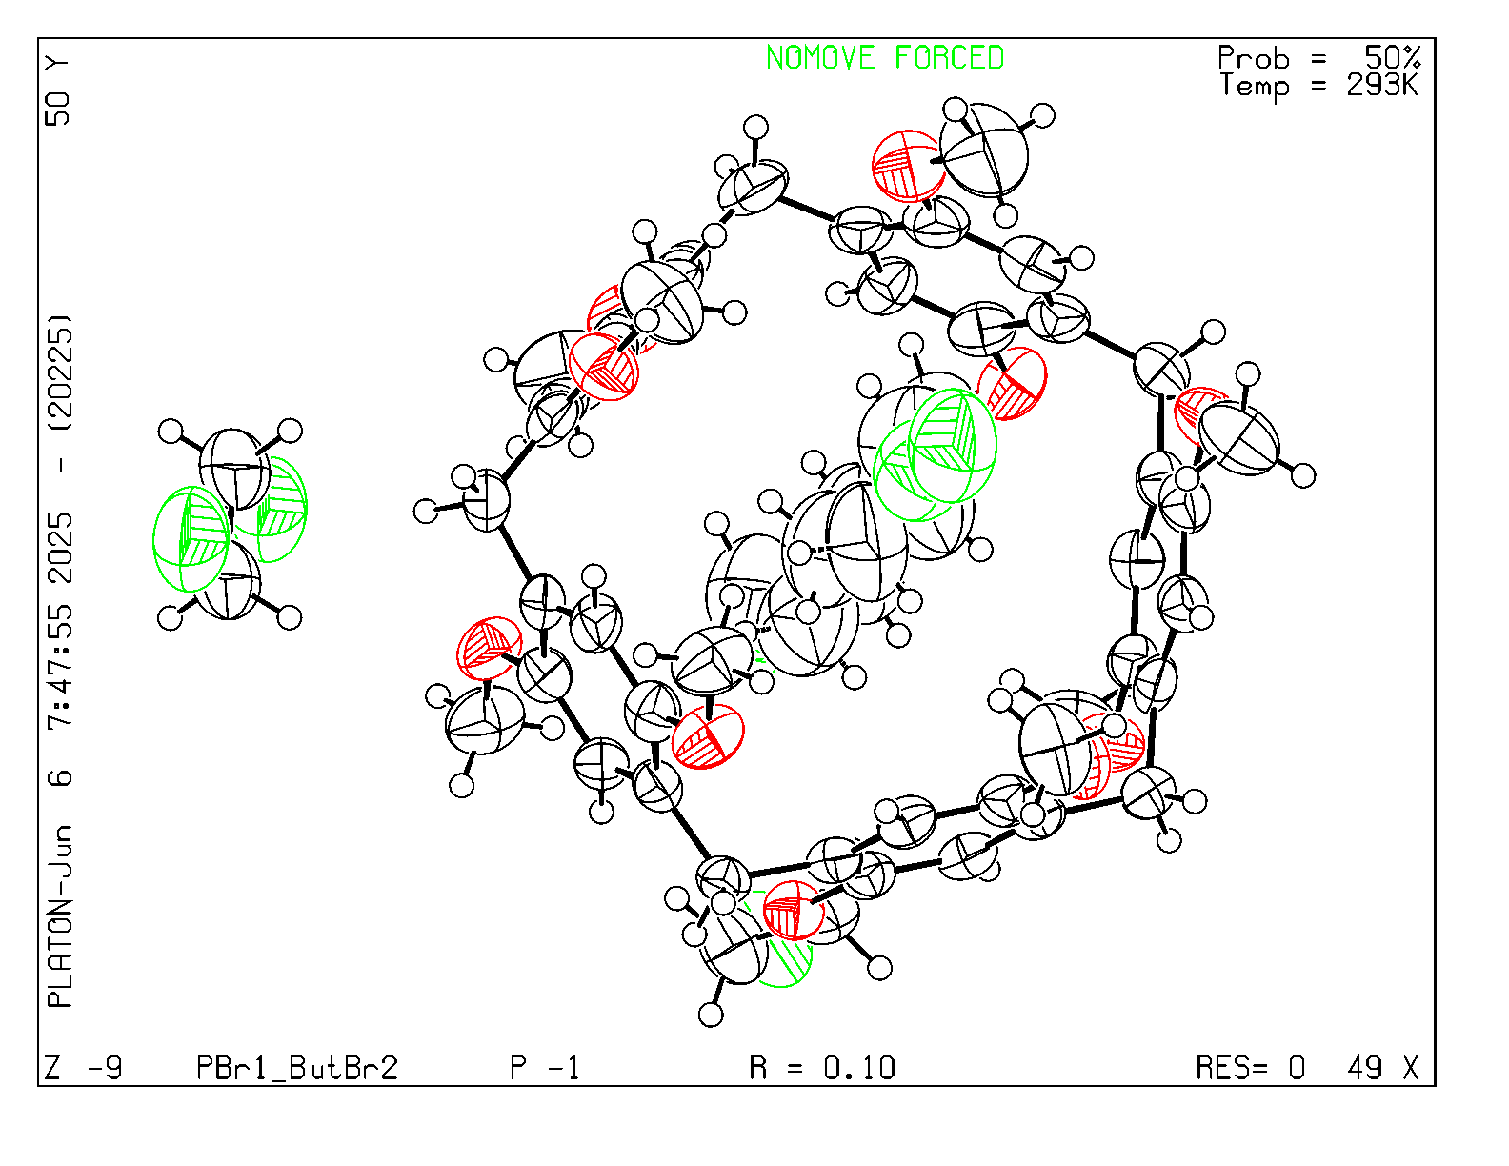

CheckCIF_ PBr2.ButBr₂

checkCIF (basic structural check) running

Checking for embedded fcf data in CIF ...
Found embedded fcf data in CIF. Extracting fcf data from uploaded CIF, please wait . . .

checkCIF/PLATON (basic structural check)

Structure factors have been supplied for datablock(s) PBr2_ButBr2
THIS REPORT IS FOR GUIDANCE ONLY. IF USED AS PART OF A REVIEW PROCEDURE FOR PUBLICATION, IT SHOULD NOT REPLACE THE EXPERTISE OF AN EXPERIENCED CRYSTALLOGRAPHIC REFEREE.
No syntax errors found. CIF dictionary
Please wait while processing .... Interpreting this report
Structure factor report
Datablock: PBr2_ButBr2

Bond precision: | C-C = 0.0091 A | Wavelength=0.71075

Cell: | a=11.147(6) | b=21.854(14) | c=21.609(13)
 | alpha=90 | beta=104.819(9) | gamma=90
Temperature: | 293 K

 | Calculated | Reported
Volume | 5089(5) | 5089(5)
Space group | C 2/c | C 2/c
Hall group | -C 2yc | -C 2yc
Moiety formula | C47 H52 Br2 O10, C4 H8 Br2 | ?
Sum formula | C51 H60 Br4 O10 | C51 H60 Br4 O10
Mr | 1152.59 | 1152.63
Dx,g cm-3 | 1.504 | 1.504
Z | 4 | 4
Mu (mm-1) | 3.219 | 3.219
F000 | 2344.0 | 2344.0
F000' | 2340.49
h,k,lmax | 13,26,25 | 13,26,25
Nref | 4500 | 4465
Tmin,Tmax | 0.531,0.702 | 0.444,0.749
Tmin' | 0.520

Correction method= # Reported T Limits: Tmin=0.444 Tmax=0.749 AbsCorr = MULTI-SCAN

Data completeness= 0.992 | Theta(max)= 25.028

R(reflections)= 0.0772( 1888) | wR2(reflections)= 0.3031( 4465)
S = 0.927 | Npar= 372

The following ALERTS were generated. Each ALERT has the format
test-name_ALERT_alert-type_alert-level.
Click on the hyperlinks for more details of the test.

Alert level C
PLAT026_ALERT_3_C Ratio Observed / Unique Reflections (too) Low .. 42% Check
PLAT084_ALERT_3_C High wR2 Value (i.e. > 0.25) ................... 0.30 Report
PLAT242_ALERT_2_C Low 'MainMol' Ueq as Compared to Neighbors of O5 Check
PLAT260_ALERT_2_C Large Average Ueq of Residue Including Br2A 0.182 Check
PLAT260_ALERT_2_C Large Average Ueq of Residue Including Br2B 0.181 Check
PLAT334_ALERT_2_C Small <C-C> Benzene Dist. C1 -C3_a . 1.37 Ang.
PLAT341_ALERT_3_C Low Bond Precision on C-C Bonds ............... 0.0091 Ang.
PLAT906_ALERT_3_C Large K Value in the Analysis of Variance ...... 10.974 Check
PLAT906_ALERT_3_C Large K Value in the Analysis of Variance ...... 2.615 Check
PLAT910_ALERT_3_C Missing # of FCF Reflection(s) Below Theta(Min). 8 Note
1 1 0, 0 2 0, -1 1 1, 1 1 1, 0 2 1, 0 0 2,
-1 1 2, 0 2 2,
PLAT911_ALERT_3_C Missing FCF Refl Between Thmin & STh/L= 0.595 27 Report
12 0 2, 12 2 3, 12 0 4, 12 2 4, 11 1 5, -12 0 6,
11 1 6, 11 3 6, 11 1 7, 11 3 7, 8 6 7, 10 0 8,
11 1 8, 11 3 8, 10 2 9, 10 0 10, 10 2 10, 7 3 10,
10 4 10, 9 1 11, 10 2 11, 9 5 11, 9 1 12, 9 1 13,
9 3 13, 8 0 14, 8 2 15,
PLAT918_ALERT_3_C Reflection(s) with I(obs) much Smaller I(calc) . 1 Check

Alert level G
PLAT002_ALERT_2_G Number of Distance or Angle Restraints on AtSite 17 Note
PLAT003_ALERT_2_G Number of Uiso or U(i,j) Restrained non-H-Atoms 17 Report
PLAT172_ALERT_4_G The CIF-Embedded .res File Contains DFIX Records 2 Report
PLAT173_ALERT_4_G The CIF-Embedded .res File Contains DANG Records 1 Report
PLAT175_ALERT_4_G The CIF-Embedded .res File Contains SAME Records 2 Report
PLAT176_ALERT_4_G The CIF-Embedded .res File Contains SADI Records 6 Report
PLAT177_ALERT_4_G The CIF-Embedded .res File Contains DELU Records 3 Report
PLAT178_ALERT_4_G The CIF-Embedded .res File Contains SIMU Records 3 Report
PLAT188_ALERT_3_G A Non-default SIMU Restraint Value has been used 0.0200 Report
PLAT199_ALERT_1_G Reported _cell_measurement_temperature ..... (K) 293 Check
PLAT200_ALERT_1_G Reported _diffrn_ambient_temperature ..... (K) 293 Check
PLAT299_ALERT_4_G Atom Site Occupancy Constrained at ............. 0.5 Check
H18A H18B
PLAT301_ALERT_3_G Main Residue Disorder ..............(Resd 1) 17% Note
PLAT302_ALERT_4_G Anion/Solvent/Minor-Residue Disorder (Resd 2) 100% Note
PLAT302_ALERT_4_G Anion/Solvent/Minor-Residue Disorder (Resd 3) 100% Note
PLAT304_ALERT_4_G Non-Integer Number of Atoms in ..... (Resd 2) 7.56 Check
PLAT304_ALERT_4_G Non-Integer Number of Atoms in ..... (Resd 3) 6.44 Check
PLAT367_ALERT_2_G Long? C(sp?)-C(sp?) Bond C15 - C18 . 1.51 Ang.
PLAT410_ALERT_2_G Short Intra H...H Contact H3 ..H19D . 1.78 Ang.
1-x,y,3/2-z = 2_656 Check
PLAT721_ALERT_1_G Bond Calc 0.97000, Rep 0.96000 Dev... 0.01 Ang.
C24A -H24C 1_555 1_555 ........ # 38 Check
PLAT860_ALERT_3_G Number of Least-Squares Restraints ............. 205 Note
PLAT883_ALERT_1_G Absent Datum for _atom_sites_solution_primary .. Please Do !
PLAT941_ALERT_3_G Average HKL Measurement Multiplicity ........... 3.3 Low
PLAT969_ALERT_5_G The 'Henn et al.' R-Factor-gap value ........... 3.188 Note
Predicted wR2: Based on SigI**2 9.51 or SHELX Weight 32.69
PLAT978_ALERT_2_G Number C-C Bonds with Positive Residual Density. 2 Info

0 ALERT level A = Most likely a serious problem - resolve or explain
0 ALERT level B = A potentially serious problem, consider carefully
12 ALERT level C = Check. Ensure it is not caused by an omission or oversight
25 ALERT level G = General information/check it is not something unexpected

4 ALERT type 1 CIF construction/syntax error, inconsistent or missing data
9 ALERT type 2 Indicator that the structure model may be wrong or deficient
12 ALERT type 3 Indicator that the structure quality may be low
11 ALERT type 4 Improvement, methodology, query or suggestion
1 ALERT type 5 Informative message, check

PLATON version of 02/02/2025; check.def file version of 02/02/2025
Datablock PBr2_ButBr2 - ellipsoid plot
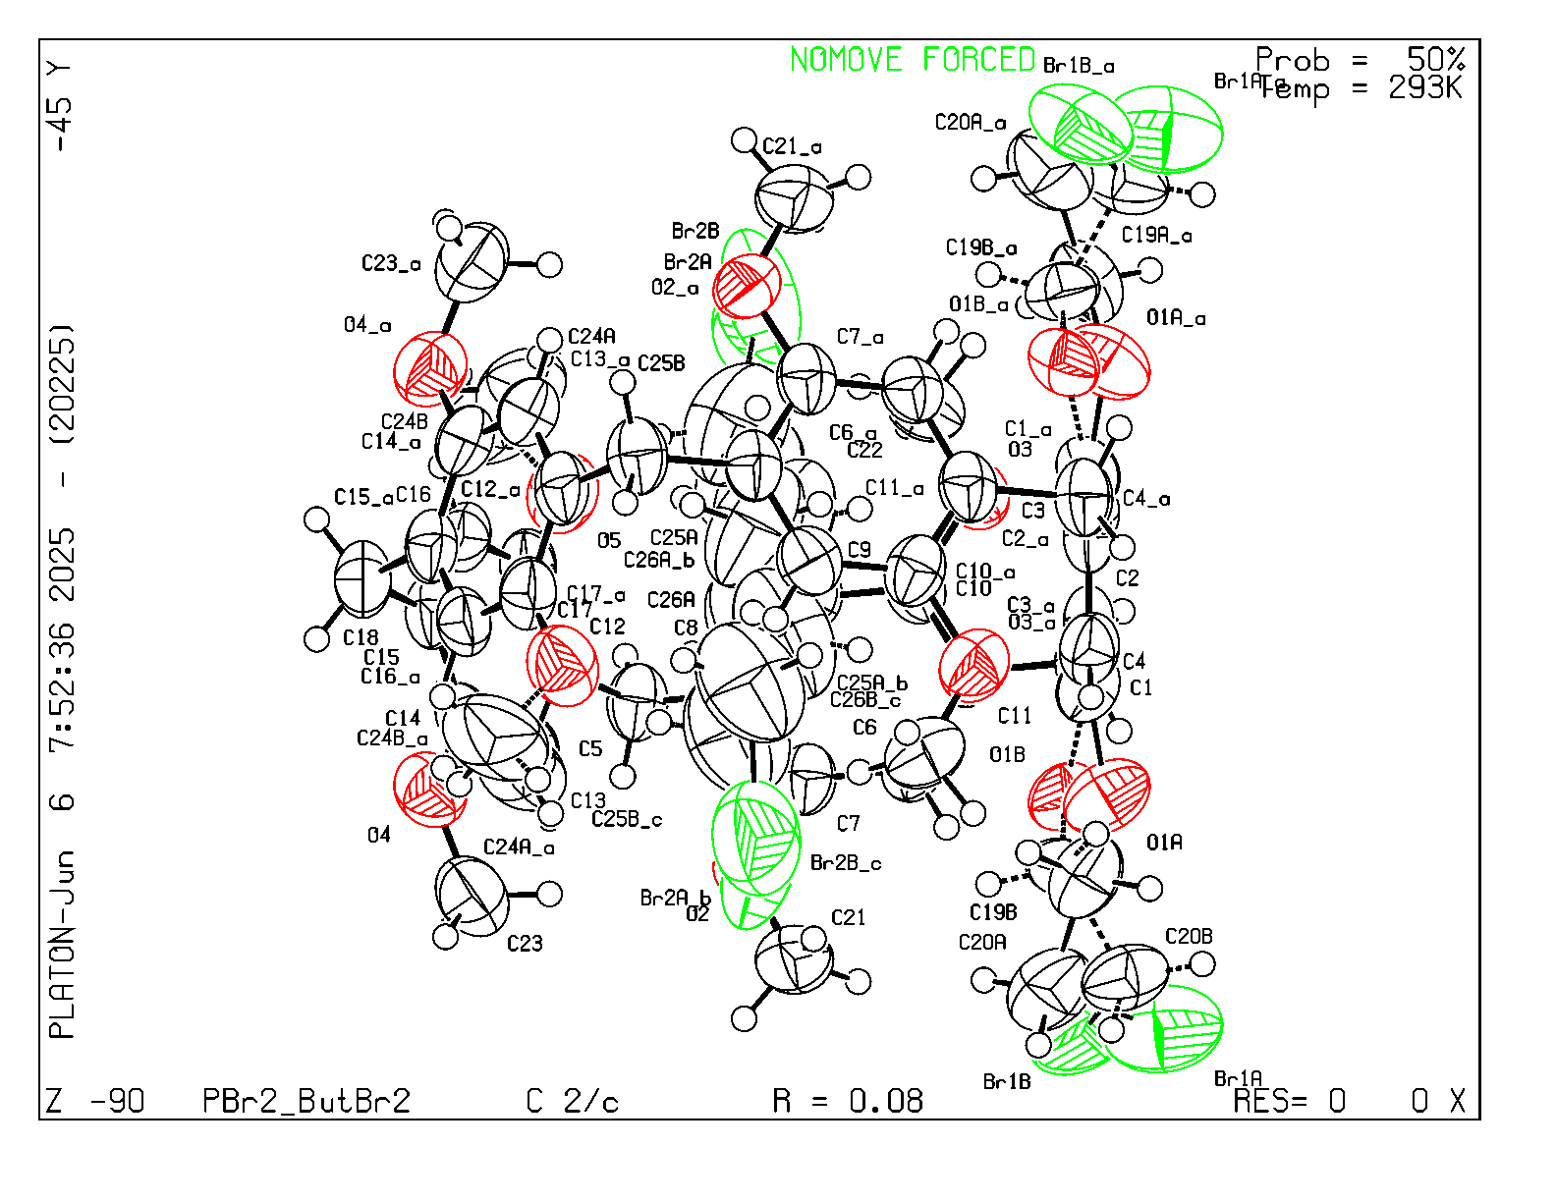

CheckCIF_ PBr4.ButBr₂

checkCIF (basic structural check) running

Checking for embedded fcf data in CIF ...
Found embedded fcf data in CIF. Extracting fcf data from uploaded CIF, please wait . . . .checkCIF/PLATON (basic structural check)Structure factors have been supplied for datablock(s) PBr4_ButBr2
THIS REPORT IS FOR GUIDANCE ONLY. IF USED AS PART OF A REVIEW PROCEDURE FOR PUBLICATION, IT SHOULD NOT REPLACE THE EXPERTISE OF AN EXPERIENCED CRYSTALLOGRAPHIC REFEREE.
No syntax errors found. CIF dictionary
Please wait while processing .... Interpreting this report
Structure factor report
Datablock: PBr4_ButBr2

Bond precision: | C-C = 0.0101 A | Wavelength=1.54178

Cell: | a=12.491(2) | b=12.859(3) | c=19.944(4)
 | alpha=94.148(10) | beta=93.140(9) | gamma=111.521(8)
Temperature: | 296 K

 | Calculated | Reported
Volume | 2960.9(10) | 2961.0(10)
Space group | P -1 | P -1
Hall group | -P 1 | -P 1
Moiety formula | C49 H54 Br4 O10, 0.5(C6 H12 Br2), C4 H8 Br2 | ?
Sum formula | C56 H68 Br7 O10 | C56 H68 Br7 O10
Mr | 1460.41 | 1460.47
Dx,g cm-3 | 1.638 | 1.638
Z | 2 | 2
Mu (mm-1) | 6.128 | 6.128
F000 | 1458.0 | 1458.0
F000' | 1451.47
h,k,lmax | 14,15,23 | 14,15,23
Nref | 10645 | 10517
Tmin,Tmax | 0.318,0.353 | 0.310,0.620
Tmin' | 0.240

Correction method= # Reported T Limits: Tmin=0.310 Tmax=0.620 AbsCorr = MULTI-SCAN

Data completeness= 0.988 | Theta(max)= 67.387

R(reflections)= 0.0914( 7640) | wR2(reflections)= 0.2927( 10517)
S = 1.043 | Npar= 706

The following ALERTS were generated. Each ALERT has the format
test-name_ALERT_alert-type_alert-level.
Click on the hyperlinks for more details of the test.

Alert level C
PLAT084_ALERT_3_C High wR2 Value (i.e. > 0.25) ................... 0.29 Report
PLAT220_ALERT_2_C NonSolvent Resd 1 C Ueq(max)/Ueq(min) Range 3.8 Ratio
PLAT222_ALERT_3_C NonSolvent Resd 1 H Uiso(max)/Uiso(min) Range 4.6 Ratio
PLAT234_ALERT_4_C Large Hirshfeld Difference Br4B --C43 . 0.20 Ang.
PLAT242_ALERT_2_C Low 'MainMol' Ueq as Compared to Neighbors of O6 Check
And 2 other PLAT242 Alerts
More ...
PLAT243_ALERT_4_C High 'Solvent' Ueq as Compared to Neighbors of C50 Check
PLAT243_ALERT_4_C High 'Solvent' Ueq as Compared to Neighbors of C53 Check
PLAT244_ALERT_4_C Low 'Solvent' Ueq as Compared to Neighbors of C51 Check
PLAT244_ALERT_4_C Low 'Solvent' Ueq as Compared to Neighbors of C52 Check
PLAT260_ALERT_2_C Large Average Ueq of Residue Including Br7A 0.233 Check
PLAT260_ALERT_2_C Large Average Ueq of Residue Including Br5 0.207 Check
PLAT341_ALERT_3_C Low Bond Precision on C-C Bonds ............... 0.01015 Ang.
PLAT906_ALERT_3_C Large K Value in the Analysis of Variance ...... 2.909 Check
PLAT911_ALERT_3_C Missing FCF Refl Between Thmin & STh/L= 0.599 130 Report
13 2 0, -12 13 0, 12-13 1, -12 13 1, -8 15 1, 12-13 2,
-7-10 2, 14-10 2, -12 -4 2, 14 -1 2, 4 12 2, -7-10 3,
-12 -4 3, 4 -4 3, -14 10 3, -7 15 3, 8-15 4, -9 -8 4,
-13 -2 4, 7 0 4, -12 11 4, -10 14 4, 10-14 5, -8 -9 5,
14 -9 5, 5 -4 5, -11 13 5, 14 -8 6, -14 1 6, 0 3 6,
-14 9 6, -13 11 6, -11 13 6, -9 14 6, 5-15 7, 9-14 7,
11-13 7, 12-12 7, 14 -6 7, 14 -5 7, 4 -3 7, 12 2 7,
9-14 8, 13 -1 8, -14 2 8, -4 14 8, 10-13 9, 11-12 9,
12-11 9, 13 -9 9, -12 -3 9, 13 -2 9, -14 3 9, -11 12 9,
13 -5 10, 13 -4 10, 12 0 10, -13 9 10, 3-14 11, 6-14 11,
9-13 11, 11-11 11, -11 -4 11, -12 -2 11, -13 8 11, -12 10 11,
-4 13 11, 0-13 12, -4-11 12, 12 -2 12, -13 7 12, 3 10 12,
1-13 13, 7-13 13, 9-12 13, 10-11 13, -5-10 13, 12 -6 13,
12 -5 13, 12 -4 13, -11 -3 13, 3-13 14, 5-13 14, 8-12 14,
10 1 14, 7-12 15, 11 -6 15, -9 -5 15, 11 -5 15, 11 -4 15,
10 0 15, -12 2 15, 9 2 15, 2-12 16, 5-12 16, 10 -8 16,
PLAT975_ALERT_2_C Check Calcd Resid. Dens. 0.65Ang From C56 . 0.69 eA-3
PLAT977_ALERT_2_C Check Negative Difference Density on H50B . -0.34 eA-3
And 4 other PLAT977 Alerts
More ...

Alert level G
PLAT002_ALERT_2_G Number of Distance or Angle Restraints on AtSite 21 Note
PLAT003_ALERT_2_G Number of Uiso or U(i,j) Restrained non-H-Atoms 21 Report
PLAT083_ALERT_2_G SHELXL Second Parameter in WGHT Unusually Large 9.38 Why ?
PLAT172_ALERT_4_G The CIF-Embedded .res File Contains DFIX Records 6 Report
PLAT173_ALERT_4_G The CIF-Embedded .res File Contains DANG Records 4 Report
PLAT175_ALERT_4_G The CIF-Embedded .res File Contains SAME Records 2 Report
PLAT177_ALERT_4_G The CIF-Embedded .res File Contains DELU Records 4 Report
PLAT178_ALERT_4_G The CIF-Embedded .res File Contains SIMU Records 4 Report
PLAT301_ALERT_3_G Main Residue Disorder ..............(Resd 1) 3% Note
PLAT302_ALERT_4_G Anion/Solvent/Minor-Residue Disorder (Resd 2) 75% Note
PLAT411_ALERT_2_G Short Inter H...H Contact H28B ..H54D . 1.76 Ang.
-x,1-y,1-z = 2_566 Check
PLAT413_ALERT_2_G Short Inter XH3 .. XHn H49A ..H54C . 2.06 Ang.
-x,1-y,1-z = 2_566 Check
PLAT432_ALERT_2_G Short Inter X...Y Contact O10 ..C54B . 2.58 Ang.
-x,1-y,1-z = 2_566 Check
PLAT432_ALERT_2_G Short Inter X...Y Contact C49 ..C54B . 3.04 Ang.
-x,1-y,1-z = 2_566 Check
PLAT434_ALERT_2_G Short Inter HL..HL Contact Br6 ..Br7B . 3.41 Ang.
x,y,z = 1_555 Check
PLAT860_ALERT_3_G Number of Least-Squares Restraints ............. 197 Note
PLAT883_ALERT_1_G Absent Datum for _atom_sites_solution_primary .. Please Do !
PLAT909_ALERT_3_G Percentage of I>2sig(I) Data at Theta(Max) Still 40% Note
PLAT941_ALERT_3_G Average HKL Measurement Multiplicity ........... 4.1 Low
PLAT965_ALERT_2_G The SHELXL WEIGHT Optimisation has not Converged Please Check
PLAT969_ALERT_5_G The 'Henn et al.' R-Factor-gap value ........... 4.922 Note
Predicted wR2: Based on SigI**2 5.95 or SHELX Weight 28.05
PLAT978_ALERT_2_G Number C-C Bonds with Positive Residual Density. 2 Info
PLAT992_ALERT_5_G Repd & Actual _reflns_number_gt Values Differ by 2 Check

0 ALERT level A = Most likely a serious problem - resolve or explain
0 ALERT level B = A potentially serious problem, consider carefully
22 ALERT level C = Check. Ensure it is not caused by an omission or oversight
23 ALERT level G = General information/check it is not something unexpected

1 ALERT type 1 CIF construction/syntax error, inconsistent or missing data
22 ALERT type 2 Indicator that the structure model may be wrong or deficient
9 ALERT type 3 Indicator that the structure quality may be low
11 ALERT type 4 Improvement, methodology, query or suggestion
2 ALERT type 5 Informative message, check

PLATON version of 02/02/2025; check.def file version of 02/02/2025
Datablock PBr4_ButBr2 - ellipsoid plot
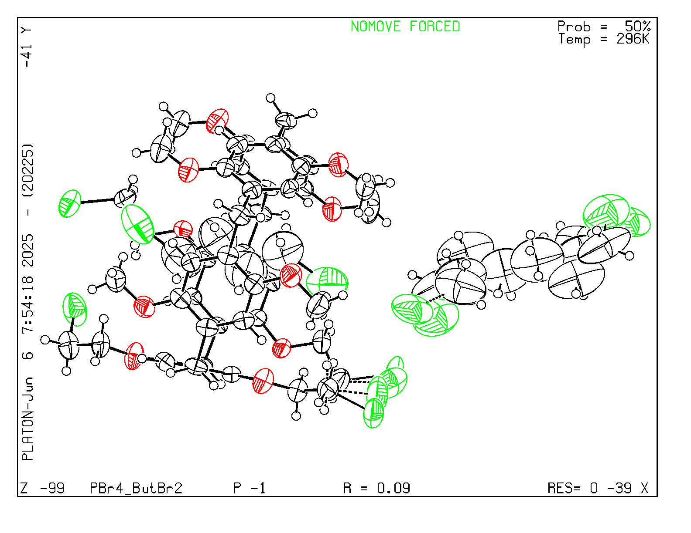

CheckCIF_ PBr6.ButBr₂

checkCIF (basic structural check) running

Checking for embedded fcf data in CIF ...
Found embedded fcf data in CIF. Extracting fcf data from uploaded CIF, please wait . . . . . .

checkCIF/PLATON (basic structural check)

Structure factors have been supplied for datablock(s) PBr6_ButBr2
THIS REPORT IS FOR GUIDANCE ONLY. IF USED AS PART OF A REVIEW PROCEDURE FOR PUBLICATION, IT SHOULD NOT REPLACE THE EXPERTISE OF AN EXPERIENCED CRYSTALLOGRAPHIC REFEREE.
No syntax errors found. CIF dictionary
Please wait while processing .... Interpreting this report
Structure factor report
Datablock: PBr6_ButBr2

Bond precision: | C-C = 0.0148 A | Wavelength=1.54178

Cell: | a=41.472(5) | b=17.4570(17) | c=16.6459(17)
 | alpha=90 | beta=90 | gamma=90
Temperature: | 296 K

 | Calculated | Reported
Volume | 12051(2) | 12051(2)
Space group | A b a 2 | A b a 2
Hall group | A 2 -2ac | A 2 -2ac
Moiety formula | C51 H56 Br6 O10, C4 H8 Br2 | ?
Sum formula | C55 H64 Br8 O10 | C55 H64 Br8 O10
Mr | 1524.27 | 1524.34
Dx,g cm-3 | 1.680 | 1.680
Z | 8 | 8
Mu (mm-1) | 6.800 | 6.799
F000 | 6032.0 | 6032.0
F000' | 6000.41
h,k,lmax | 49,20,19 | 49,20,19
Nref | 10714[ 5562] | 9315
Tmin,Tmax | 0.287,0.473 | 0.330,0.640
Tmin' | 0.209

Correction method= # Reported T Limits: Tmin=0.330 Tmax=0.640 AbsCorr = MULTI-SCAN

Data completeness= 1.67/0.87 | Theta(max)= 66.794

R(reflections)= 0.0750( 8406) | wR2(reflections)= 0.2245( 9315)
S = 1.038 | Npar= 659

The following ALERTS were generated. Each ALERT has the format
test-name_ALERT_alert-type_alert-level.
Click on the hyperlinks for more details of the test.

Alert level B
PLAT910_ALERT_3_B Missing # of FCF Reflection(s) Below Theta(Min). 45 Note
0 2 0, 0 4 0, 1 2 0, 1 4 0, 2 0 0, 2 2 0,
3 2 0, 4 0 0, 4 2 0, 5 2 0, 6 0 0, 6 2 0,
7 2 0, 8 0 0, 8 2 0, 1 1 1, 1 3 1, 2 1 1,
2 3 1, 3 1 1, 3 3 1, 4 1 1, 4 3 1, 5 1 1,
RESPONSE: The unit cell is reasonable large and these low angle reflections are probably missing due to the beamstop. This occurs rather frequently with our goniometer's geometry, especially for larger unit cells.

Alert level C
PLAT094_ALERT_2_C Ratio of Maximum / Minimum Residual Density .... 2.06 Report
PLAT234_ALERT_4_C Large Hirshfeld Difference C44 --C45 . 0.18 Ang.
PLAT242_ALERT_2_C Low 'MainMol' Ueq as Compared to Neighbors of C37 Check
And 3 other PLAT242 Alerts
More ...
PLAT243_ALERT_4_C High 'Solvent' Ueq as Compared to Neighbors of C55 Check
PLAT260_ALERT_2_C Large Average Ueq of Residue Including Br7 0.186 Check
PLAT341_ALERT_3_C Low Bond Precision on C-C Bonds ............... 0.01476 Ang.
PLAT601_ALERT_2_C Unit Cell Contains Solvent Accessible VOIDS <= 54 Ang**3
PLAT911_ALERT_3_C Missing FCF Refl Between Thmin & STh/L= 0.596 63 Report
0 6 0, 0 8 0, 0 10 0, 1 6 0, 1 8 0, 2 4 0,
2 6 0, 17 12 0, 22 18 0, 23 18 0, 24 18 0, 25 8 0,
26 8 0, 27 8 0, 39 12 0, 40 10 0, 40 12 0, 41 10 0,
42 10 0, 43 10 0, 1 5 1, 1 7 1, 2 5 1, 20 19 1,
41 11 1, 0 4 2, 0 6 2, 0 8 2, 1 4 2, 1 6 2,
23 18 2, 24 18 2, 6 1 3, 0 0 4, 0 2 4, 1 2 4,
2 0 4, 2 2 4, 4 0 4, 30 16 4, 1 1 5, 2 1 5,
3 1 5, 0 0 6, 2 0 6, 10 19 7, 10 16 12, 21 14 12,
11 15 13, 21 13 13, 11 14 14, 22 0 14, 32 6 14, 19 11 15,
0 0 16, 6 12 16, 17 10 16, 22 8 16, 0 0 18, 8 8 18,
15 6 18, 12 3 19, 14 1 19,

Alert level G
PLAT002_ALERT_2_G Number of Distance or Angle Restraints on AtSite 6 Note
PLAT003_ALERT_2_G Number of Uiso or U(i,j) Restrained non-H-Atoms 6 Report
PLAT083_ALERT_2_G SHELXL Second Parameter in WGHT Unusually Large 13.76 Why ?
PLAT172_ALERT_4_G The CIF-Embedded .res File Contains DFIX Records 2 Report
PLAT173_ALERT_4_G The CIF-Embedded .res File Contains DANG Records 2 Report
PLAT177_ALERT_4_G The CIF-Embedded .res File Contains DELU Records 1 Report
PLAT178_ALERT_4_G The CIF-Embedded .res File Contains SIMU Records 1 Report
PLAT188_ALERT_3_G A Non-default SIMU Restraint Value has been used 0.0100 Report
PLAT434_ALERT_2_G Short Inter HL..HL Contact Br2 ..Br3 . 3.43 Ang.
x,-1/2+y,-1/2+z = 5_544 Check
PLAT860_ALERT_3_G Number of Least-Squares Restraints ............. 49 Note
PLAT883_ALERT_1_G Absent Datum for _atom_sites_solution_primary .. Please Do !
PLAT909_ALERT_3_G Percentage of I>2sig(I) Data at Theta(Max) Still 73% Note
PLAT915_ALERT_3_G No Flack x Check Done: Low Friedel Pair Coverage 75 %
PLAT941_ALERT_3_G Average HKL Measurement Multiplicity ........... 3.1 Low
PLAT965_ALERT_2_G The SHELXL WEIGHT Optimisation has not Converged Please Check
PLAT969_ALERT_5_G The 'Henn et al.' R-Factor-gap value ........... 2.716 Note
Predicted wR2: Based on SigI**2 8.27 or SHELX Weight 21.63
PLAT978_ALERT_2_G Number C-C Bonds with Positive Residual Density. 0 Info
PLAT992_ALERT_5_G Repd & Actual _reflns_number_gt Values Differ by 5 Check

0 ALERT level A = Most likely a serious problem - resolve or explain
1 ALERT level B = A potentially serious problem, consider carefully
11 ALERT level C = Check. Ensure it is not caused by an omission or oversight
18 ALERT level G = General information/check it is not something unexpected

1 ALERT type 1 CIF construction/syntax error, inconsistent or missing data
13 ALERT type 2 Indicator that the structure model may be wrong or deficient
8 ALERT type 3 Indicator that the structure quality may be low
6 ALERT type 4 Improvement, methodology, query or suggestion
2 ALERT type 5 Informative message, check

PLATON version of 02/02/2025; check.def file version of 02/02/2025
Datablock PBr6_ButBr2 - ellipsoid plot
