Supplementary Information
Automation and machine learning drive rapid optimization of isoprenol production in Pseudomonas putida

David N. Carruthers^{†,1,2}, Patrick C. Kinnunen^{†,1,2}, Yuerong Li^{2,3}, Yan Chen^{1,2}, Jennifer W. Gin^{1,2}, Ian S. Yunus^{1,2}, William R. Galliard^{2,4}, Stephen Tan^{1,2}, Paul D. Adams^{2,5,6}, Anup K. Singh^{2,3}, Jess Sustarich^{2,4}, Christopher J. Petzold^{1,2}, Aindrila Mukhopadhyay^{1,2}, Hector Garcia Martin^{1,2,5}*, Taek Soon Lee^{1,2,}*

¹Biological Systems & Engineering Division, Lawrence Berkeley National Laboratory, Berkeley, CA, USA
²Joint BioEnergy Institute, 5885 Hollis Street, Emeryville, CA, USA
³Lawrence Livermore National Laboratory, Livermore, CA, USA
⁴Sandia National Laboratories, Livermore, CA, USA
⁵Molecular Biophysics and Integrated Bioimaging Division, Lawrence Berkeley National Laboratory, Berkeley, CA, USA
⁶Department of Bioengineering, University of California Berkeley, CA, USA

†Equal Contribution
*Corresponding Authors, Joint BioEnergy Institute, 5885 Hollis Street, Emeryville, CA 94608, USA.
E-mail addresses: tslee@lbl.gov (T. S. Lee). Tel: +1-510-495-2470. Fax: +1-510-495-2629; hgmartin@lbl.gov (H. G. Martin). Tel: +1-510-495-2505. Fax: +1-510-486-4252.
Github Repository: https://github.com/JBEI/Isoprenol_CRISPRi

Table of Contents:
Table S1: List of gene targets from this study by locus name, protein name, source (FluxRETAP vs. heuristics), presence in RbTnSeq library, isoprenol titer, relative dCas9 and POI expression, and usage in DBTL cycles.

Fig. S1: A thorough breakdown of DBTL cycles with a DBT timeline
Fig. S2: Liquid handling movements performed by automated laboratory equipment and number of sgRNA units per cycle.
Fig. S3: Dispensing of plasmid and competent cells into the electroporation plate
Fig. S4: QTrays of triplicate transformation using the HTME
Fig. S5: Modes of CRISPRi failure across DBTL cycles
Fig. S6: Parity plot of the full and cross-validated ART models throughout the pipeline for predicted and observed isoprenol titers (mg/L)
Fig. S7: Heatmaps of relevant pathways among best performing sgRNAs compared to the non-target control strain
Fig. S8: Heatmap of significantly changed proteins present in all 25 best performing CRISPRi strain
Fig. S9: Comparison of CRISPRi strains with their KO counterparts expressing non-target or KO sgRNAs
Fig. S10: Proteomics and production analysis of potential PP_0815 off-targets
Fig. S11: Investigation of potential PP_0815 sgRNA off-targets and the impact of their downregulation on isoprenol titer

Fig. S12: Overexpression of genes (PP_2971-74 and PP_2208-09) that are highly expressed in high titer isoprenol strains
Fig. S13: Spearman rank correlation coefficients of the 50 most abundant proteins and isoprenol titer in DBTL0
Table S2: sgRNA targets selected to investigate PP_0815 off-target effects
Table S3: List of oligonucleotides used in this study
Table S4: List of plasmids used in this study outside of DBTL1-6
Table S5: List of CRISPRi arrays built during cycles DBTL1-6
Table S6: List of Pseudomonas putida strains constructed in this study
Table S7: ModelParamsTable; all parameters shown are ART defaults and any other parameters are sklearn/TPOT defaults.
Table S8: Specific settings for selecting sgRNA combinations in each cycle
Table S9: Cpf1-mediated ssDNA recombineering for gene knockouts in P. putida

Table S1: List of gene targets from this study by locus name, protein name, source, presence in RbTnSeq library, isoprenol titer, relative dCas9 and POI expression, and usage in DBTL cycles.

Locus number | Protein name | Source (Flux-  RETAP or Heuristic) ¹ | RbTn-  Seq Data? | Mean isoprenol titer (mg/L) | dCas9/  control | POI/  control | Passed DBTL0 filter? | Used after DBTL2/3?
PP_0001 | Probable chromosome-partitioning protein ParB | FR | N | 58.03 | 1.04 | 0.08 | FALSE | FALSE
PP_0103 | Cytochrome c oxidase subunit 2 (EC 7.1.1.9) | FR | N | 183.52 | 0.2 |  | FALSE | FALSE
PP_0104 | Cytochrome c oxidase subunit 1 (EC 7.1.1.9) | FR | N | 130.41 | 1.11 |  | FALSE | FALSE
PP_0105 | Cytochrome c oxidase assembly protein CtaG | FR | N | 144.84 | 0.96 |  | FALSE | FALSE
PP_0106 | cytochrome-c oxidase (EC 7.1.1.9) (Cytochrome aa3 subunit 3) (Cytochrome c oxidase polypeptide III) | FR | N | 125.03 | 1.09 |  | FALSE | FALSE
PP_0168 | Surface adhesion protein | H | N | 196.29 | 1.13 | 0.03 | TRUE | FALSE
PP_0225 | Sulfur compound ABC transporter-ATP-binding subunit | FR | N | 119.72 | 1.79 |  | FALSE | FALSE
PP_0226 | Sulfur compound ABC transporter-permease subunit | FR | N | 139.64 | 1.13 | 0.06 | TRUE | FALSE
PP_0277 | Lipoprotein | H | Y | 126.66 | 0.92 |  | FALSE | FALSE
PP_0338 | Acetyltransferase component of pyruvate dehydrogenase complex (EC 2.3.1.12) | H | Y | 211.49 | 0.02 | 0.82 | FALSE | FALSE
PP_0362 | Biotin synthase (EC 2.8.1.6) | H | N | 215.79 | 0.03 |  | FALSE | FALSE
PP_0368 | Acyl-CoA dehydrogenase | H | N | 236.68 | 0.94 | 0.03 | TRUE | TRUE
PP_0437 | Bifunctional ligase/repressor BirA (Biotin operon repressor) (Biotin--[acetyl-CoA-carboxylase] ligase) (EC 6.3.4.15) (Biotin--protein ligase) (Biotin-[acetyl-CoA carboxylase] synthetase) | H | Y | 225.59 | 0.85 | 0.04 | TRUE | TRUE
PP_0528 | Farnesyl diphosphate synthase (EC 2.5.1.1, EC 2.5.1.10) | H | Y | 393.7 | 0.89 | 0.14 | TRUE | TRUE
PP_0548 | Flavin prenyltransferase UbiX (EC 2.5.1.129) | H | Y | 304.89 | 0.95 |  | FALSE | FALSE
PP_0582 | Thiolase family protein | H | N | 165.48 | 0.68 | 0.62 | FALSE | FALSE
PP_0597 | Methylmalonate-semialdehyde dehydrogenase (EC 1.2.1.27) | H | N | 163.8 | 1.11 | 0.02 | TRUE | FALSE
PP_0654 | Probable malate dehydrogenase (EC 1.1.1.37) | H | N | 112.83 | 0.83 | 0.2 | TRUE | FALSE
PP_0658 | Homocysteine S-methyltransferase family protein | FR | N | 130.08 | 0.97 | 0.01 | TRUE | FALSE
PP_0691 | Glutamate 5-kinase (EC 2.7.2.11) (Gamma-glutamyl kinase) (GK) | FR | N | 155.04 | 0.06 | 0.96 | FALSE | FALSE
PP_0751 | Probable malate:quinone oxidoreductase 1 (EC 1.1.5.4) (MQO 1) (Malate dehydrogenase [quinone] 1) | H | Y | 211.03 | 1.13 | 0.04 | TRUE | TRUE
PP_0774 | Phosphate acetyltransferase (EC 2.3.1.8) (Phosphotransacetylase) | H | N | 142.33 | 0.49 | 0.08 | TRUE | FALSE
PP_0806 | Surface adhesion protein | H | N | 212.08 | 1 |  | FALSE | FALSE
PP_0812 | Ubiquinol oxidase subunit 2 | FR | Y | 244.11 | 0.68 | 0.24 | TRUE | TRUE
PP_0813 | Cytochrome bo(3) ubiquinol oxidase subunit 1 (EC 7.1.1.3) (Cytochrome o ubiquinol oxidase subunit 1) (Oxidase bo(3) subunit 1) (Ubiquinol oxidase polypeptide I) (Ubiquinol oxidase subunit 1) | FR | Y | 267.8 | 0.91 | 0.17 | TRUE | TRUE
PP_0814 | Cytochrome bo(3) ubiquinol oxidase subunit 3 (Cytochrome o ubiquinol oxidase subunit 3) (Oxidase bo(3) subunit 3) (Ubiquinol oxidase polypeptide III) (Ubiquinol oxidase subunit 3) | FR | Y | 312.4 | 0.03 |  | TRUE | TRUE
PP_0815 | Cytochrome bo(3) ubiquinol oxidase subunit 4 (Cytochrome o ubiquinol oxidase subunit 4) (Oxidase bo(3) subunit 4) (Ubiquinol oxidase polypeptide IV) (Ubiquinol oxidase subunit 4) | FR | Y | 258.98 | 0.36 |  | TRUE | TRUE
PP_0897 | Fumarate hydratase class I (EC 4.2.1.2) | H | Y | 95.12 | 0.25 | 0.63 | TRUE | FALSE
PP_0944 | Fumarate hydratase class II (Fumarase C) (EC 4.2.1.2) (Aerobic fumarase) (Iron-independent fumarase) | H | N | 97.99 | 0.74 | 0.69 | TRUE | FALSE
PP_0999 | Carbamate kinase | FR | N | 148.3 | 0.58 | 0.07 | TRUE | FALSE
PP_1023 | 6-phosphogluconolactonase (6PGL) (EC 3.1.1.31) | FR | Y | 132.64 | 0.07 | 0.9 | FALSE | FALSE
PP_1031 | Inosine-5'-monophosphate dehydrogenase (IMP dehydrogenase) (IMPD) (IMPDH) (EC 1.1.1.205) | FR | Y | 119.89 | 0.79 | 0.89 | FALSE | FALSE
PP_1157 | Acetolactate synthase | H | Y | 167.83 | 0.94 |  | FALSE | FALSE
PP_1240 | Phosphoribosylaminoimidazole-succinocarboxamide synthase (EC 6.3.2.6) (SAICAR synthetase) | FR | Y | 281.78 | 0.06 | 0.86 | FALSE | FALSE
PP_1251 | Probable malate:quinone oxidoreductase 2 (EC 1.1.5.4) (MQO 2) (Malate dehydrogenase [quinone] 2) | H | N | 44.94 | 0.74 | 0.04 | FALSE | FALSE
PP_1317 | Ubiquinol-cytochrome c reductase iron-sulfur subunit (EC 7.1.1.8) | FR | N | 152.13 | 1.24 | 0.02 | TRUE | TRUE
PP_1318 | Cytochrome b | FR | N | 156.36 | 0.89 | 0.05 | TRUE | FALSE
PP_1319 | Ubiquinol--cytochrome c reductase, cytochrome c1 | FR | N | 152.73 | 1.32 | 0.06 | TRUE | FALSE
PP_1394 | Acetolactate synthase, large subunit | H | N | 170.67 | 1.14 |  | FALSE | FALSE
PP_1444 | Quinoprotein glucose dehydrogenase (EC 1.1.5.2) | H | N | 162.2 | 0.57 | 0.2 | TRUE | FALSE
PP_1457 | Formate-dependent phosphoribosylglycinamide formyltransferase (EC 6.3.1.21) (5'-phosphoribosylglycinamide transformylase 2) (Formate-dependent GAR transformylase) (GAR transformylase 2) (GART 2) (Non-folate glycinamide ribonucleotide transformylase) (Phosphoribosylglycinamide formyltransferase 2) | FR | N | 177.56 | 0.05 | 0.59 | TRUE | FALSE
PP_1506 | Adenylate kinase (AK) (EC 2.7.4.3) (ATP-AMP transphosphorylase) (ATP:AMP phosphotransferase) (Adenylate monophosphate kinase) | FR | Y | 233.58 | 0.06 | 0.63 | TRUE | TRUE
PP_1607 | Acetyl-coenzyme A carboxylase carboxyl transferase subunit alpha (ACCase subunit alpha) (Acetyl-CoA carboxylase carboxyltransferase subunit alpha) (EC 2.1.3.15) | H | Y | 239.52 | 0.03 | 0.87 | TRUE | FALSE
PP_1610 | CTP synthase (EC 6.3.4.2) (Cytidine 5'-triphosphate synthase) (Cytidine triphosphate synthetase) (CTP synthetase) (CTPS) (UTP--ammonia ligase) | FR | Y | 42.31 | 0.05 | 0.64 | FALSE | FALSE
PP_1620 | 5'-nucleotidase SurE (EC 3.1.3.5) (Nucleoside 5'-monophosphate phosphohydrolase) | FR | N | 86.73 | 1.11 | 0.02 | TRUE | FALSE
PP_1664 | Phosphoribosylglycinamide formyltransferase (EC 2.1.2.2) (5'-phosphoribosylglycinamide transformylase) (GAR transformylase) (GART) | FR | N | 166.03 | 0.06 | 2.05 | FALSE | FALSE
PP_1755 | Fumarate hydratase class II (Fumarase C) (EC 4.2.1.2) (Aerobic fumarase) (Iron-independent fumarase) | H | N | 114.76 | 0.77 | 0.05 | TRUE | FALSE
PP_1769 | Bifunctional chorismate mutase/prephenate dehydratase (EC 4.2.1.51) (EC 5.4.99.5) (Chorismate mutase-prephenate dehydratase) (p-protein) | FR | Y | 275.55 | 0.04 | 0.82 | TRUE | TRUE
PP_1770 | 3-phosphoshikimate 1-carboxyvinyltransferase (EC 2.5.1.19) (5-enolpyruvylshikimate-3-phosphate synthase) (EPSP synthase) (EPSPS) | FR | N | 252.55 | 0.04 | 0.93 | FALSE | FALSE
PP_1777 | Phosphomannomutase (EC 5.4.2.8) | H | N | 0.01 | 0.55 | 0.01 | FALSE | FALSE
PP_2095 | Dihydroorotate dehydrogenase (quinone) (EC 1.3.5.2) (DHOdehase) (DHOD) (DHODase) (Dihydroorotate oxidase) | FR | Y | 131.86 | 0.09 | 0.76 | TRUE | FALSE
PP_2112 | Aconitate hydratase (Aconitase) (EC 4.2.1.3) | H | N | 69.1 | 1.1 | 0.06 | FALSE | FALSE
PP_2136 | Fatty acid oxidation complex subunit alpha [Includes: Enoyl-CoA hydratase/Delta(3)-cis-Delta(2)-trans-enoyl-CoA isomerase/3-hydroxybutyryl-CoA epimerase (EC 4.2.1.17) (EC 5.1.2.3) (EC 5.3.3.8); 3-hydroxyacyl-CoA dehydrogenase (EC 1.1.1.35)] | H | N | 234.13 | 0.71 | 0.04 | TRUE | TRUE
PP_2137 | 3-ketoacyl-CoA thiolase (EC 2.3.1.16) (Acetyl-CoA acyltransferase) (Beta-ketothiolase) (Fatty acid oxidation complex subunit beta) | H | N | 188.36 | 0.81 | 0.02 | TRUE | FALSE
PP_2213 | Acyl-CoA synthetase (EC 6.2.1.-) | H | N | 188.38 | 0.82 | 0.06 | TRUE | FALSE
PP_2339 | Aconitate hydratase B (EC 4.2.1.3) (EC 4.2.1.99) (2-methylisocitrate dehydratase) | H | Y | 101.59 | 1 | 0.24 | TRUE | FALSE
PP_2471 | Integration host factor subunit alpha (IHF-alpha) | H | Y | 187.66 | 0.26 | 0.28 | TRUE | FALSE
PP_2589 | Aldehyde dehydrogenase family protein | H | N | 191.71 | 0.73 |  | FALSE | FALSE
PP_2925 | Probable malate:quinone oxidoreductase 3 (EC 1.1.5.4) (MQO 3) (Malate dehydrogenase [quinone] 3) | H | N | 93.04 | 0.58 | 0.07 | TRUE | FALSE
PP_3071 | Acetoacetyl-coenzyme A synthetase (EC 6.2.1.16) | H | N | 179.03 | 0.58 | 0.1 | TRUE | FALSE
PP_3122 | 3-oxoadipate CoA-transferase (EC 2.8.3.6) | H | N | 176.01 | 0.99 | 0.57 | FALSE | FALSE
PP_3123 | 3-oxoadipate CoA-transferase (EC 2.8.3.6) | H | N | 128.88 | 0.73 | 0.09 | TRUE | FALSE
PP_3280 | 3-oxoadipyl-CoA thiolase (EC 2.3.1.174) | H | N | 195.28 | 1.02 |  | FALSE | FALSE
PP_3282 | 3-hydroxyadipyl-CoA dehydrogenase (EC 1.1.1.35) | H | N | 157.76 | 0.53 |  | FALSE | FALSE
PP_3355 | Beta-ketothiolase | H | N | 241.72 | 0.42 |  | FALSE | FALSE
PP_3394 | 3-hydroxy-3-methylglutaryl-CoA lyase | H | N | 0.01 | 0.96 |  | FALSE | FALSE
PP_3578 | Phosphoglucomutase (EC 5.4.2.2) | H | N | 167.82 | 1.07 | 0.03 | TRUE | FALSE
PP_3744 | Transcriptional dual regulator GlcC-Glycolate | H | N | 225.8 | 0.91 |  | FALSE | FALSE
PP_3754 | Beta-ketothiolase BktB (EC 2.3.1.16, EC 2.3.1.9) | H | N | 176.57 | 0.48 | 0.07 | TRUE | FALSE
PP_3755 | 3-hydroxybutyryl-CoA dehydrogenase (EC 1.1.1.157) | H | N | 192.17 | 0.4 | 0.1 | TRUE | FALSE
PP_4011 | Isocitrate dehydrogenase [NADP] (EC 1.1.1.42) | H | N | 107.7 | 1 | 0.01 | TRUE | FALSE
PP_4012 | Isocitrate dehydrogenase [NADP] (EC 1.1.1.42) (Oxalosuccinate decarboxylase) | H | Y | 34.49 | 0.93 | 0.68 | FALSE | FALSE
PP_4043 | 6-phosphogluconate dehydrogenase, decarboxylating (EC 1.1.1.44) | FR | N | 140.31 | 0.61 |  | FALSE | FALSE
PP_4116 | Isocitrate lyase (EC 4.1.3.1) (Isocitrase) (Isocitratase) | FR | N | 143.07 | 0.84 | 0.07 | TRUE | FALSE
PP_4119 | NADH-quinone oxidoreductase subunit A (EC 7.1.1.-) (NADH dehydrogenase I subunit A) (NDH-1 subunit A) (NUO1) | FR | Y | 18.39 | 1.21 | 0.18 | FALSE | FALSE
PP_4120 | NADH-quinone oxidoreductase subunit B (EC 7.1.1.-) (NADH dehydrogenase I subunit B) (NDH-1 subunit B) | FR | N | 162 | 0.75 | 0.01 | TRUE | TRUE
PP_4121 | NADH-quinone oxidoreductase subunit C/D (EC 7.1.1.-) (NADH dehydrogenase I subunit C/D) (NDH-1 subunit C/D) | FR | N | 161.83 | 0.56 | 0.03 | TRUE | FALSE
PP_4122 | NADH-quinone oxidoreductase subunit E (NADH dehydrogenase I subunit E) (NDH-1 subunit E) | FR | N | 172.51 | 0.61 | 0.01 | TRUE | FALSE
PP_4123 | NADH-quinone oxidoreductase subunit F (EC 7.1.1.-) | FR | Y | 141.57 | 1.08 | 0.07 | TRUE | FALSE
PP_4128 | NADH-quinone oxidoreductase subunit K (EC 7.1.1.-) (NADH dehydrogenase I subunit K) (NDH-1 subunit K) | FR | Y | 166.33 | 1.19 |  | FALSE | FALSE
PP_4130 | NADH-quinone oxidoreductase subunit M (NADH dehydrogenase I subunit M) (NDH-1 subunit M) | FR | N | 128.68 | 0.18 | 3.11 | FALSE | FALSE
PP_4159 | Potassium-transporting ATPase KdpC subunit (ATP phosphohydrolase [potassium-transporting] C chain) (Potassium-binding and translocating subunit C) (Potassium-translocating ATPase C chain) | FR | N | 139.17 | 0.51 |  | FALSE | FALSE
PP_4160 | Potassium-transporting ATPase ATP-binding subunit (EC 7.2.2.6) (ATP phosphohydrolase [potassium-transporting] B chain) (Potassium-binding and translocating subunit B) (Potassium-translocating ATPase B chain) | FR | N | 124.45 | 0.65 |  | FALSE | FALSE
PP_4161 | Potassium-transporting ATPase potassium-binding subunit (ATP phosphohydrolase [potassium-transporting] A chain) (Potassium-binding and translocating subunit A) (Potassium-translocating ATPase A chain) | FR | N | 121.97 | 0.7 |  | FALSE | FALSE
PP_4174 | 3-hydroxydecanoyl-[acyl-carrier-protein] dehydratase (EC 4.2.1.59) (3-hydroxyacyl-[acyl-carrier-protein] dehydratase FabA) (Beta-hydroxydecanoyl thioester dehydrase) (Trans-2-decenoyl-[acyl-carrier-protein] isomerase) (EC 5.3.3.14) | FR | Y | 319.66 | 0.01 | 0.91 | FALSE | FALSE
PP_4175 | 3-oxoacyl-[acyl-carrier-protein] synthase 1 (EC 2.3.1.-, EC 2.3.1.41) | FR | Y | 169.98 | 0.06 | 0.76 | FALSE | FALSE
PP_4185 | Succinate--CoA ligase [ADP-forming] subunit alpha (EC 6.2.1.5) (Succinyl-CoA synthetase subunit alpha) (SCS-alpha) | H | Y | 114.95 | 0.24 | 0.44 | TRUE | FALSE
PP_4186 | Succinate--CoA ligase [ADP-forming] subunit beta (EC 6.2.1.5) (Succinyl-CoA synthetase subunit beta) (SCS-beta) | H | Y | 105.39 | 0.03 | 0.57 | TRUE | FALSE
PP_4187 | Dihydrolipoyl dehydrogenase (EC 1.8.1.4) | FR | Y | 143.8 | 0.02 | 0.62 | TRUE | FALSE
PP_4188 | Dihydrolipoyllysine-residue succinyltransferase component of 2-oxoglutarate dehydrogenase complex (EC 2.3.1.61) (2-oxoglutarate dehydrogenase complex component E2) | FR | Y | 209.97 | 0.81 | 0.19 | TRUE | FALSE
PP_4189 | oxoglutarate dehydrogenase (succinyl-transferring) (EC 1.2.4.2) | FR | Y | 291.4 | 0.32 | 0.11 | TRUE | TRUE
PP_4191 | Succinate dehydrogenase flavoprotein subunit (EC 1.3.5.1) | H | Y | 358.44 | 0.04 | 0.55 | TRUE | TRUE
PP_4192 | Succinate dehydrogenase hydrophobic membrane anchor subunit | H | Y | 232.69 | 0.12 | 0.87 | TRUE | TRUE
PP_4193 | Succinate dehydrogenase cytochrome b556 subunit | H | Y | 220.87 | 0.05 | 1 | FALSE | FALSE
PP_4194 | Citrate synthase | FR | Y | 271.03 | 0.03 | 0.96 | FALSE | FALSE
PP_4266 | Adenine phosphoribosyltransferase (APRT) (EC 2.4.2.7) | FR | N | 129.71 | 0.77 | 0.07 | TRUE | FALSE
PP_4487 | Acetyl-coenzyme A synthetase 1 (AcCoA synthetase 1) (Acs 1) (EC 6.2.1.1) (Acetate--CoA ligase 1) (Acyl-activating enzyme 1) | H | N | 191.4 | 0.88 | 0.01 | TRUE | FALSE
PP_4549 | Long-chain-fatty-acid/CoA ligase (EC 6.2.1.3) | H | N | 201.79 | 0.65 | 0.05 | TRUE | FALSE
PP_4550 | Long-chain-fatty-acid/CoA ligase (EC 6.2.1.3) | H | N | 102.97 | 0.47 | 0.59 | TRUE | FALSE
PP_4635 | Enoyl-[acyl-carrier-protein] reductase [NADH] (ENR) (EC 1.3.1.9) | FR | Y | 134.05 | 0.05 | 0.96 | FALSE | FALSE
PP_4636 | Acetyl-CoA acetyltransferase (EC 2.3.1.9) | H | N | 175.92 | 1.04 | 0.2 | TRUE | FALSE
PP_4650 | Ubiquinol oxidase subunit II, cyanide insensitive | FR | N | 127.49 | 0.78 |  | FALSE | FALSE
PP_4651 | Ubiquinol oxidase subunit I, cyanide insensitive | FR | N | 137.43 | 0.04 | 0.37 | TRUE | FALSE
PP_4667 | Methylmalonate-semialdehyde dehydrogenase (EC 1.2.1.27) | H | N | 178.38 | 0.74 | 0.16 | TRUE | FALSE
PP_4678 | Ketol-acid reductoisomerase (NADP(+)) (KARI) (EC 1.1.1.86) (Acetohydroxy-acid isomeroreductase) (AHIR) (Alpha-keto-beta-hydroxylacyl reductoisomerase) (Ketol-acid reductoisomerase type 1) (Ketol-acid reductoisomerase type I) | H | N | 165.54 | 0.02 | 0.64 | TRUE | FALSE
PP_4679 | Acetolactate synthase small subunit (AHAS) (ALS) (EC 2.2.1.6) (Acetohydroxy-acid synthase small subunit) | H | N | 67.06 | 0.03 | 0.44 | FALSE | FALSE
PP_4702 | Acetyl-coenzyme A synthetase 2 (AcCoA synthetase 2) (Acs 2) (EC 6.2.1.1) (Acetate--CoA ligase 2) (Acyl-activating enzyme 2) | H | N | 173.16 | 0.39 | 25.6 | FALSE | FALSE
PP_4737 | D-lactate dehydrogenase (EC 1.1.-.-) | H | N | 184.85 | 0.84 |  | FALSE | FALSE
PP_4862 | 3-hydroxy acid dehydrogenase, NADP-dependent / malonic semialdehyde reductase (EC 1.1.1.276, EC 1.1.1.298) | FR | N | 143.94 | 0.66 | 0.1 | TRUE | FALSE
PP_4894 | RNA-binding protein Hfq | H | Y | 44.86 | 0.04 | 0.43 | FALSE | FALSE
PP_5064 | Oxygen-dependent choline dehydrogenase (CDH) (CHD) (EC 1.1.99.1) (Betaine aldehyde dehydrogenase) (BADH) (EC 1.2.1.8) | H | N | 10.57 | 0.02 | 0.98 | FALSE | FALSE
PP_5128 | Dihydroxy-acid dehydratase (DAD) (EC 4.2.1.9) | FR | N | 107.17 | 0.06 | 1 | FALSE | FALSE
PP_5186 | Acetylornithine deacetylase (EC 3.5.1.16) | FR | N | 110.44 | 1.03 | 0.01 | TRUE | FALSE
PP_5203 | 5-formyltetrahydrofolate cyclo-ligase (EC 6.3.3.2) | FR | N | 132.15 | 0.77 | 0.26 | TRUE | FALSE
PP_5288 | Phosphomannomutase/phosphoglucomutase (PMM / PGM) (EC 5.4.2.2) (EC 5.4.2.8) | H | N | 162.86 | 0.78 | 0.03 | TRUE | FALSE
PP_5335 | N5-carboxyaminoimidazole ribonucleotide synthase (N5-CAIR synthase) (EC 6.3.4.18) (5-(carboxyamino)imidazole ribonucleotide synthetase) | H | Y | 214.31 | 0.03 | 1.03 | FALSE | FALSE
PP_5416 | ATP synthase subunit delta (ATP synthase F(1) sector subunit delta) (F-type ATPase subunit delta) (F-ATPase subunit delta) | H | Y | 152.72 | 0.02 | 1.17 | FALSE | FALSE
PP_5417 | ATP synthase subunit b (ATP synthase F(0) sector subunit b) (ATPase subunit I) (F-type ATPase subunit b) (F-ATPase subunit b) | H | Y | 202.53 | 0.15 | 0.84 | TRUE | FALSE
PP_5419 | ATP synthase subunit a (ATP synthase F0 sector subunit a) (F-ATPase subunit 6) | H | Y | 391.45 | 0.02 | 0.02 | FALSE | FALSE
PP_5420 | ATP synthase protein I | H | Y | 91.6 | 0.03 |  | FALSE | FALSE

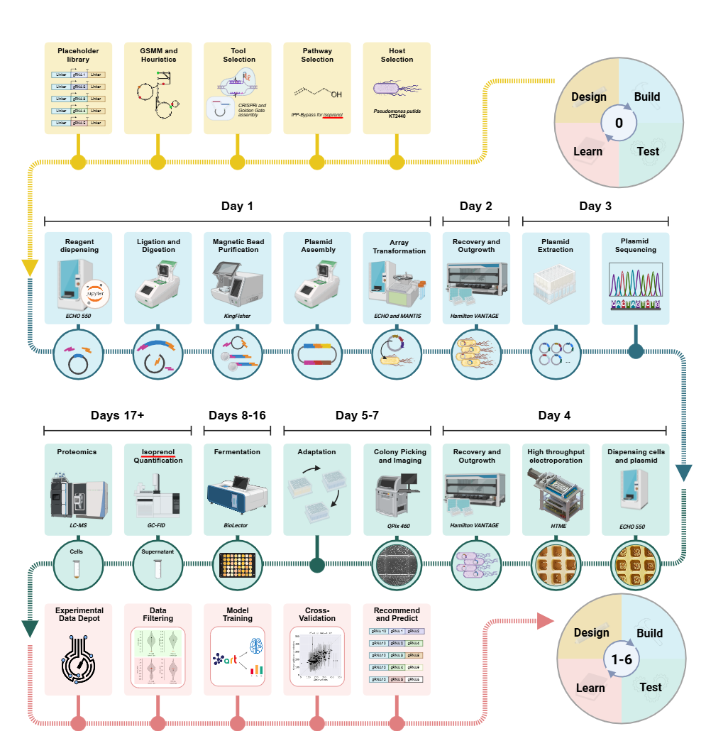

Fig. S1: A thorough breakdown of DBTL cycles with a DBT timeline. Lists of designs were generated by ART. Recommended CRISPRi arrays were then parsed by a Jupyter notebook to generate ECHO dispense lists that could readily be used with reagents for digestion, ligation, and transformation. Where possible, individual instruments used for each step are supplied and labeled. The timeline “days” are typical estimates based on average run time. Sometimes data collection, especially for proteomics and isoprenol, had extended wait times owing to machine availability. This image was generated using BioRender.com.

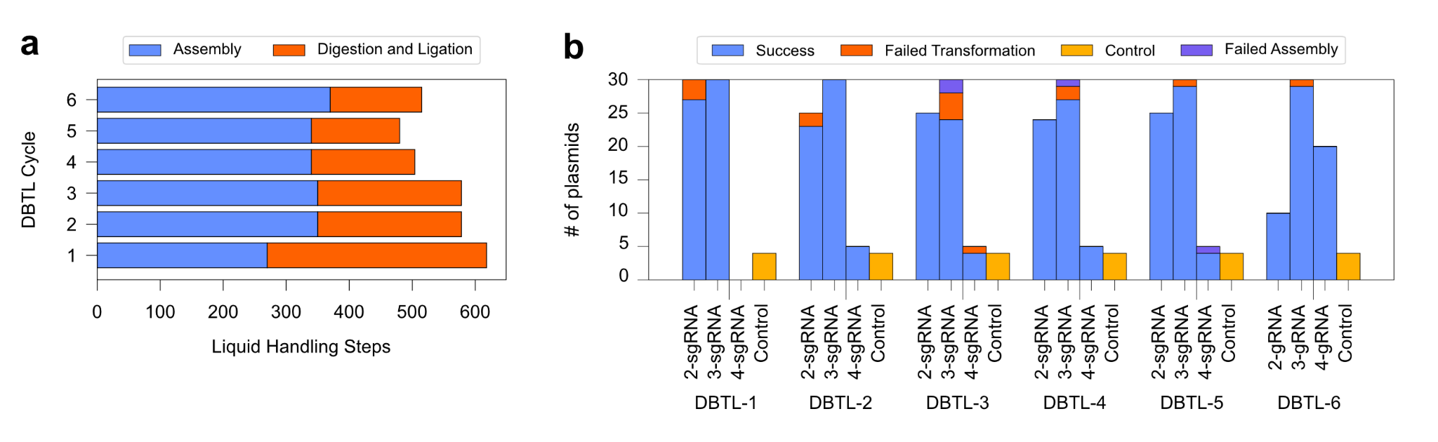

Fig. S2: Liquid handling movements performed by automated laboratory equipment and number of sgRNA units per cycle. a) More digestion/ligation dispenses were required in early cycles owing to an increased number of unique sgRNAs while assembly dispenses increased in later cycles as the sgRNA arrays lengthened. There were 3273 liquid handling steps made across all 6 cycles. b) Number of unique sgRNA arrays constructed each cycle with DBTL6 maintaining more four sgRNAs than earlier cycles. There was no clear evidence that longer assemblies had higher rates of failure

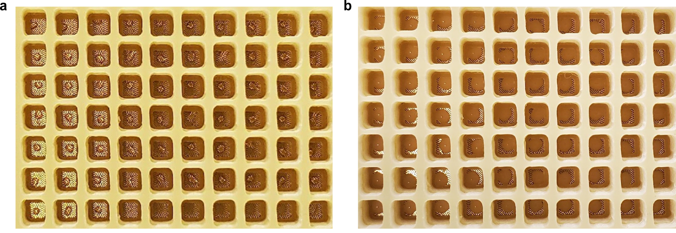

Fig. S3: Dispensing of plasmid and electrocompetent P. putida cells using the ECHO 550. a) A 200 nL aliquot of plasmid was first dispensed. b) 2 uL of electrocompetent cells were then dispensed on top of the plasmid droplet.

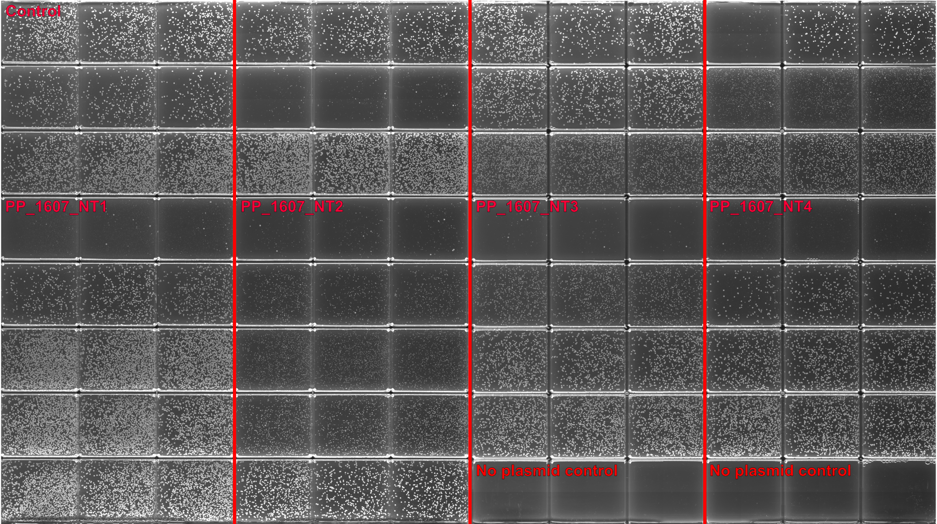
Fig. S4: An example Q-Tray of 32 transformations in triplicate. Image taken with QPix 460. Different PP_1607 sgRNAs, the non-target sgRNA (control), and no plasmid controls are annotated. Each triplicate transformed a different sgRNA harboring plasmid and there are clear differences in colony morphology between triplicates due to relative growth burden associated with those sgRNAs. In particular, PP_1607 encodes a subunit of acetyl-coenzyme A carboxylase. Downregulation of PP_1607 had a significant impact on viable CFUs and many failed the proteomics filter.

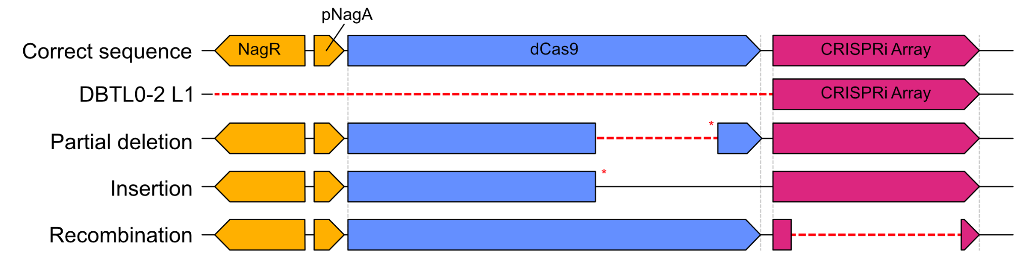

Fig. S5: Modes of CRISPRi failure across DBTL cycles. Initially, recombination in DBTL0-2 occurred across homologous linkers that flanked dCas9, resulting in a plasmid that lacked dCas9 altogether. This failure mode was repaired in DBTL3 onwards by replacing the flexible linker, “L1”, with a different linker, “L7”, which tended to improve dCas9 fidelity. Plasmids were sequenced after DBTL3 and revealed significant changes. Recombination often occurred due to homology of the dCas9 handle (40 bp), terminator (45 bp), and assembly scar (6 bp). While homologous recombination can be mitigated by using non-repetitive handles, terminators, and promoters, non-repetitive elements introduce positional dependent effects and do not necessarily improve sgRNA array fidelity. Other modes of failure included a partial deletion of dCas9 and single nucleotide insertion into dCas9, both of which resulted in a premature stop codon. Truncated proteins are especially troubling because they may be overlooked in -omics analysis (i.e., total abundance/counts may remain high in a partially truncated 5 kb gene). In short, P. putida is very capable of adapting to overcome the physiological burden imparted by CRISPRi.

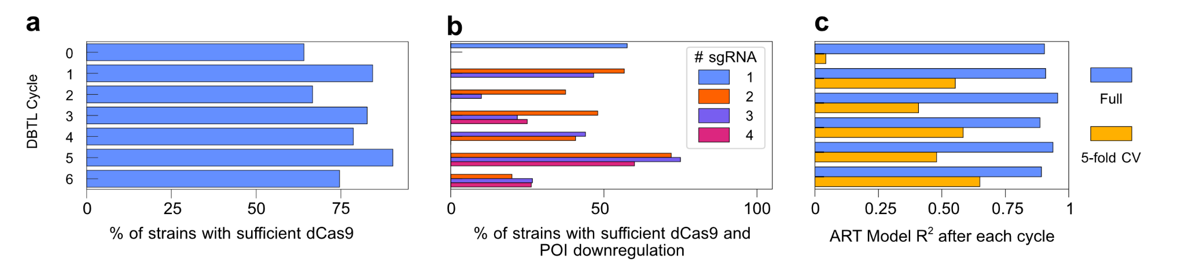

Fig. S6: Analysis of failing strains by failure mode with ART Model performance over each cycle. a) The percentage of strains with dCas9 below 50% of control across each DBTL cycle. The dCas9 plasmid was re-engineered after DBTL2 to improve fidelity. b) The overall filter passage rate is based on dCas9 expression and target downregulation for each cycle, split by the number of sgRNA in each strain. c) ART model performance measured by R² after DBTL cycles 1-6, when trained on the full dataset (blue) or trained using 5-fold cross validation. After DBTL3, only data from cycle 3 onward was used to train ART.

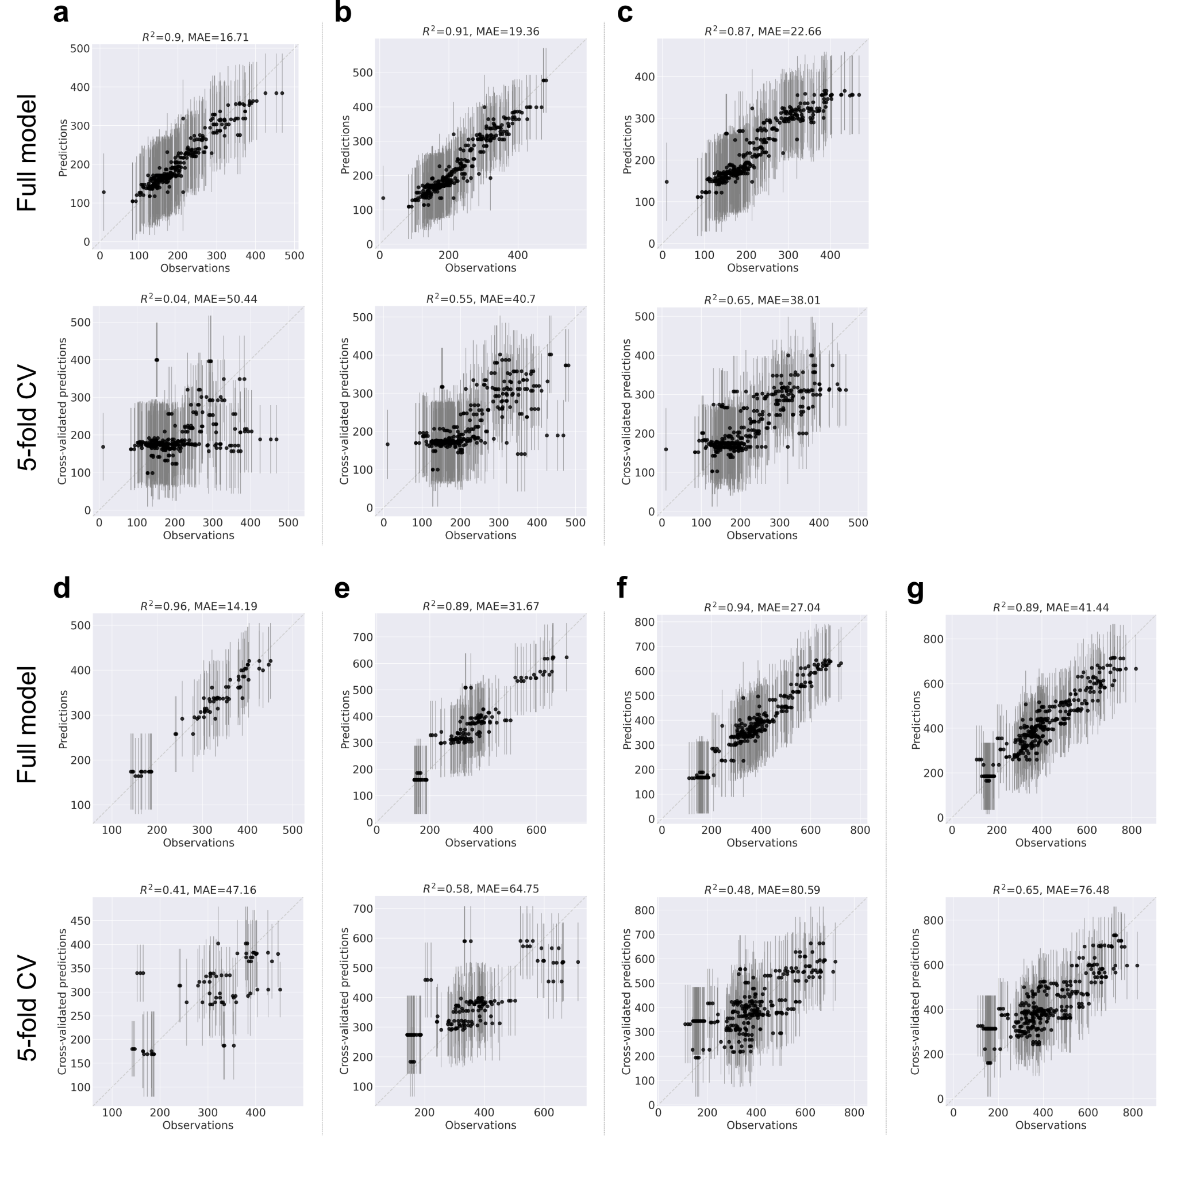

Fig. S7: Parity plot of the full and cross-validated ART models throughout the pipeline for predicted and observed isoprenol titers (mg/L). a) DBTL1 models. b) DBTL2 models. c) DBTL3 models using all data (DBTL1-3). d) DBTL3 models exclusively using data from DBTL3). e) DBTL4 models using DBTL3-4 data. f) DBTL5 models using DBTL3-5 data. G) DBTL6 models using DBTL3-6 data.

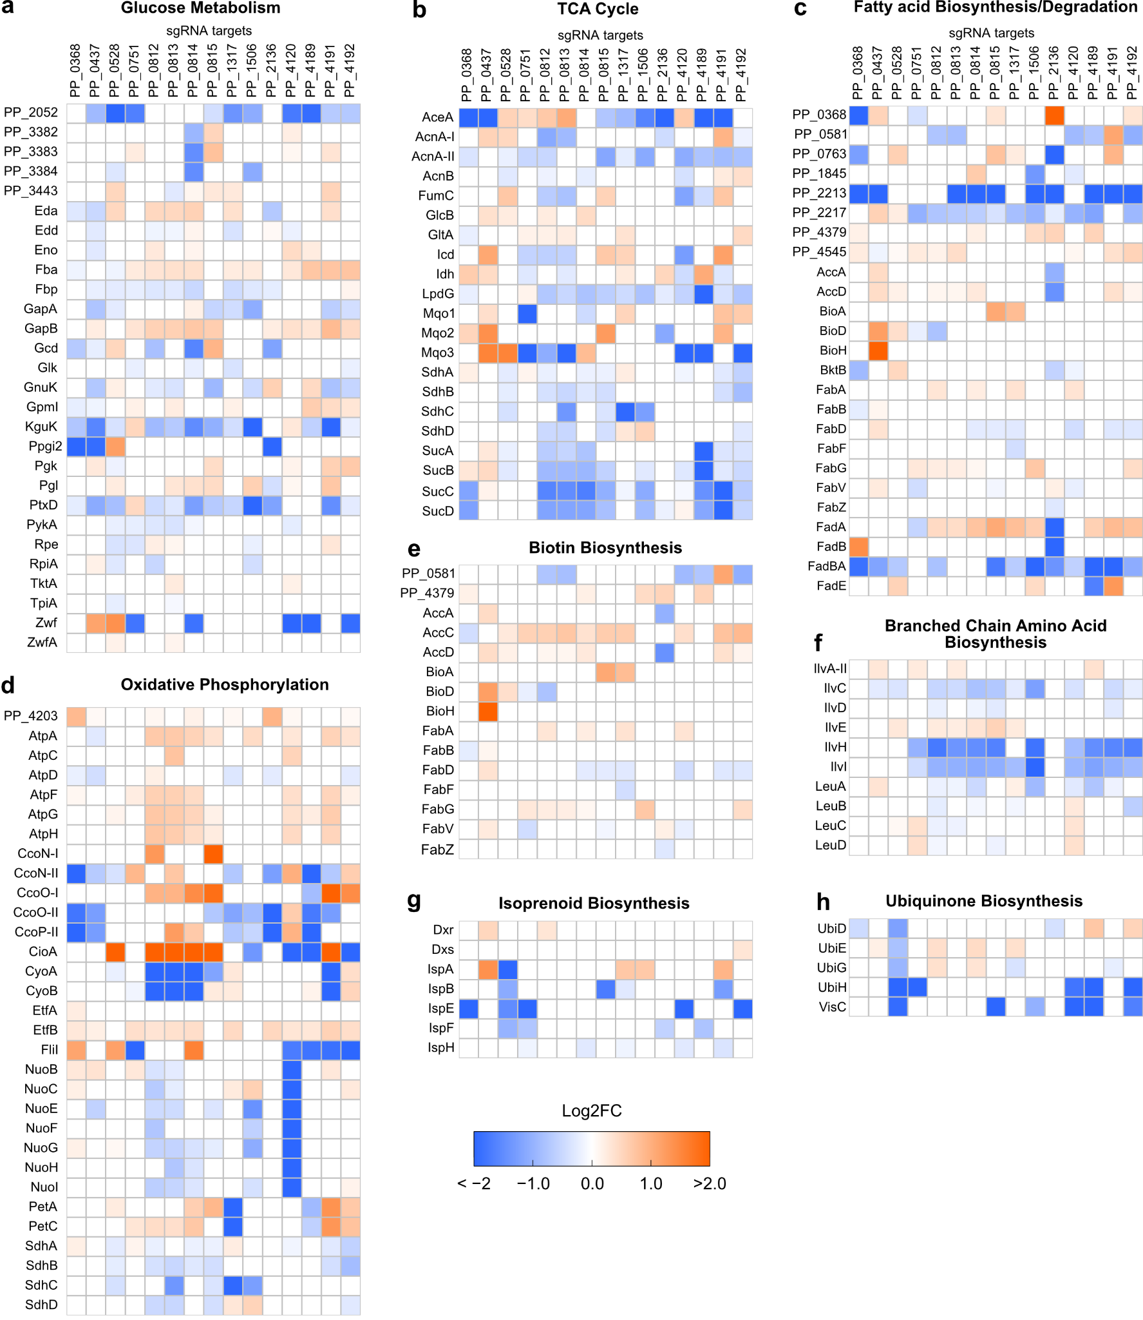
Fig. S8: Proteomics heatmaps of relevant pathways among best performing sgRNAs compared to the non-target control strain. a) Glucose metabolism. b) Tricarboxylic acid cycle proteins, notably with SucC-D downregulation and mixed glyoxylate shunt protein levels. c) Pooled fatty acid biosynthesis and degradation (beta-oxidation) proteins. Most notably PP_2213 and fadBA, which are coexpressed, were downregulated. PP_0368 tended to increase fadB (PP_2136) levels and vice versa. d) Oxidative phosphorylation had significant changes with terminal oxidase protein levels and downregulation of PP_4120 (nuoB) downregulated other subunits comprising NADH-quinone oxidoreductase. ATP subunits were typically unregulated when different ETC complex proteins were targeted. e) Biotin biosynthesis was most significantly impacted when, as expected, PP_0437 (bifunctional biotin-ACC ligase/biotin operon repressor) was downregulated. f) ilvH and ilvI were predominately downregulated within the branched chain amino acid biosynthesis pathway. g) Isoprenoid biosynthesis protein levels were most strongly impacted by downregulation of PP_0528. h) Ubiquinone biosynthesis was likewise largely impacted by PP_0528 downregulation, with several other sgRNA targets resulting in decreased protein levels.
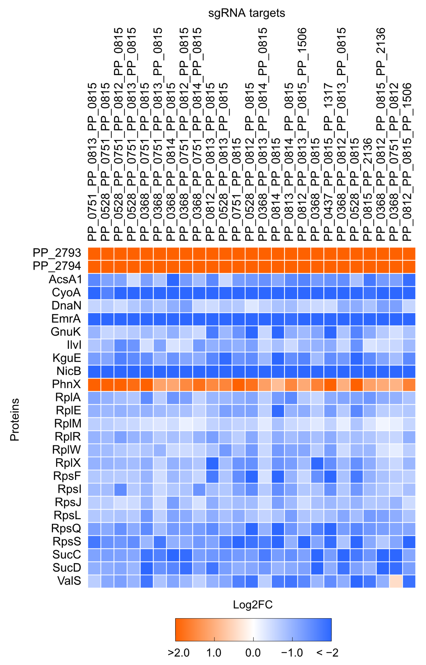

Fig. S9: Heatmap of significantly changed proteins present in all 25 best performing CRISPRi strains. Depicts the protein levels that were significantly changed across 25 of the best performing sgRNA combinations. Notably, significant ribosomal proteins (rps/rpl) were downregulated along with some glycolysis proteins (gnuK, kguE), and valine-tRNA ligase (valS), a protein also strongly suggested by STABL. An acyl-CoA synthetase (acsA1), sucC-D (succinyl-CoA synthetase), and ilvI (acetohydroxybutanoate synthase/acetolactate synthase) were also downregulated across all strains. Finally, phnX is a phosphonoacetaldehyde hydrolase while PP_2793-94 encodes proteins in the levulinate degradation pathway. This map is by no means comprehensive but instead reflects protein levels most reliably changed in our best performing strains.

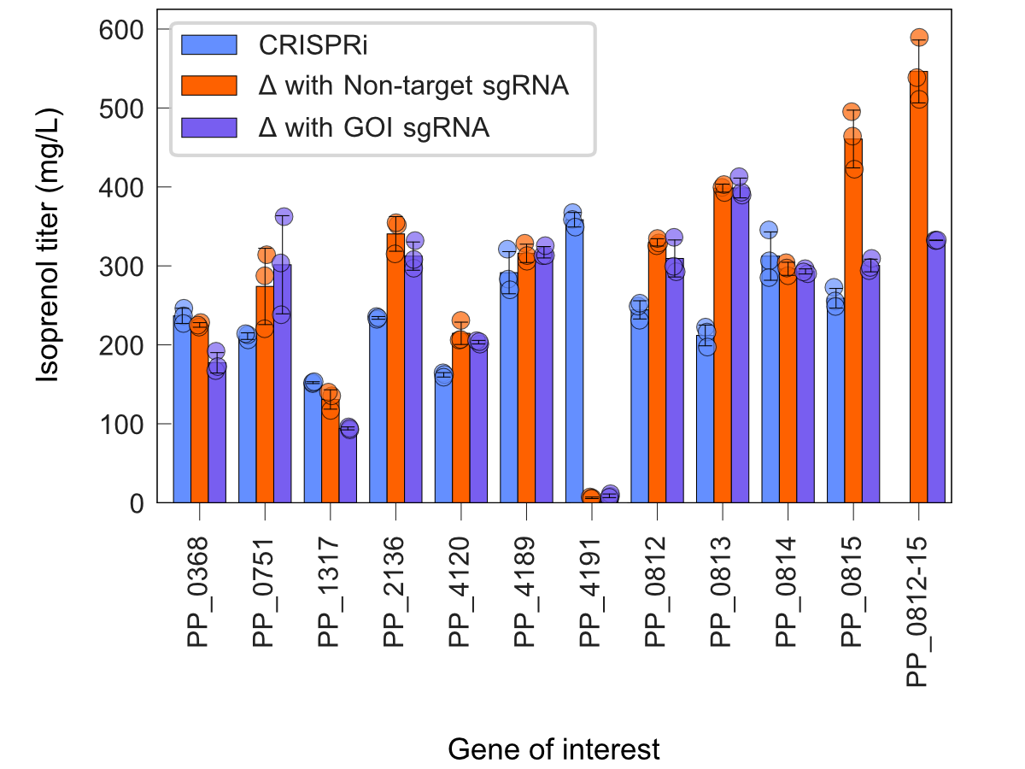

Fig. S10: Comparison of titers between KO strains harboring sgRNAs and their CRISPRi analogues. Most KO strains performed similarly with the non-target and target sgRNAs, indicating no obvious off-target effects.The ΔPP_2136, ΔPP_0812, and ΔPP_0813 strains showed higher performance than their CRISPRi analogues. ΔPP_0815 strains harboring the PP_0815 sgRNA showed clear increases in titer compared to the non-target sgRNA. Differences in isoprenol production by target and non-target sgRNAs are noted in Figure 6A.

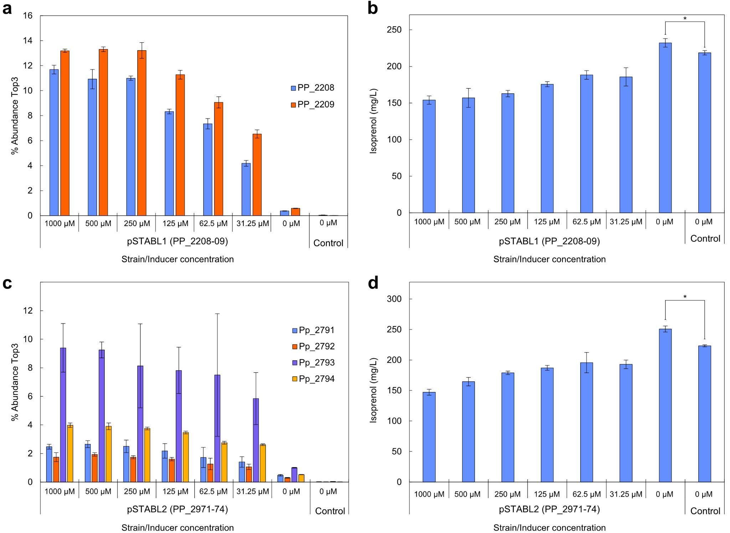

Fig. S11: Overexpression of genes (PP_2971-74 and PP_2208-09) that are highly expressed in high titer isoprenol strains. a) Top3 protein abundance of PP_2208-09 (PhnW-X; phosphonoacetylaldehyde hydrolyase) under various inducer concentrations. Induced expression led to exceptionally high protein abundance. b) Uninduced expression of PP_2207-08 yielded marginally more isoprenol compared to an RFP control c) Top3 protein abundance of PP_2791-94 (levulinic acid degradation pathway LvaA-D) under various induction concentrations. Induction also led to high pathway protein abundances. d) As with PP_2208-09, induction of PP_2791-94 broadly reduced titers, potentially due to sheer protein abundance. Uninduced expression, however, showed a ~10% increase in titer compared to the RFP control.

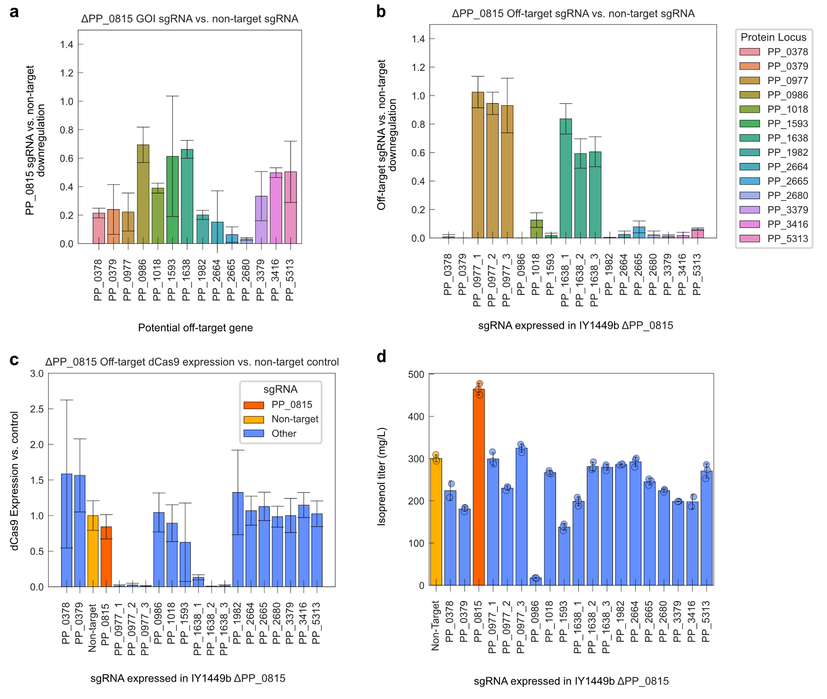Fig. S12: Investigation of potential PP_0815 sgRNA off-targets and the impact of their downregulation on isoprenol titer. a) Analysis of potential off-target gene expression in a ΔPP_0815 strain harboring the PP_0815 sgRNA compared to their expression in a strain with a non-target sgRNA. As before, all gene expression is substantially lower across potential off-target genes. b) Expression of various sgRNAs targeting the potential off-target genes in a ΔPP_0815 strain. Potential off-targets were typically downregulated with the exceptions of PP_0977 (valine tRNA-ligase) and PP_1638 (ferredoxin--NADP(+) reductase). These strains were cultured three times owing to poor transformation efficiency. c) dCas9 levels in all ΔPP_0815 derivatives. Notably, all strains harboring the PP_0977 and PP_1638 sgRNAs failed to adequately express dCas9, indicating that the colonies that survived transformation were able to eliminate dCas9. This is unsurprising as these genes are probably essential. d) Isoprenol titers of off-target sgRNA strains failed to recapitulate the observed titer of ΔPP_0815 harboring the PP_0815 sgRNA. At best, the off-target strains performed as well as the ΔPP_0815 strain harboring non-target sgRNA.

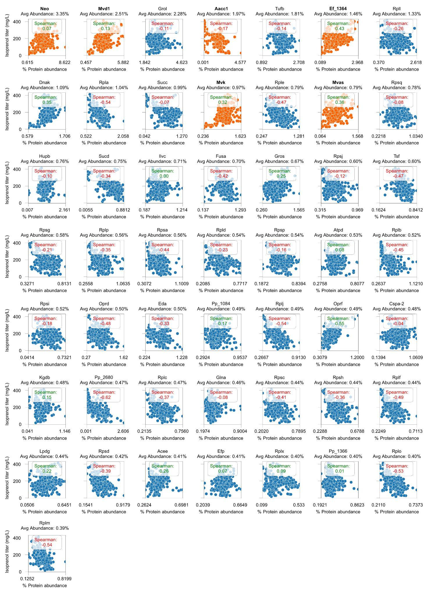
Fig. S13: Spearman rank correlation coefficients of the 50 most abundant proteins and isoprenol titer in DBTL0. Pathway proteins as well as antibiotic resistance proteins (Neo and Aac1) are highlighted in orange. Pathway proteins typically had a weakly positive correlation with isoprenol titer. Meanwhile, many of the other most abundant proteins had negative correlations with isoprenol titer. In particular, Rpla, Rplb, Rplc, Rpld, Rple, and PP_2680 had moderately negative (-0.37 to -0.62) correlations.

Table S2: sgRNA targets selected to investigate PP_0815 off-target effects.
# | Gene Target | Selection criteria | Function
1 | PP_0378 | Strongly downregulated | PQQ Biosynthesis; implicated in glucose and alcohol salvage proteins, improves fitness with growth on isoprenol
2 | PP_0379 | Strongly downregulated | PQQ Biosynthesis; implicated in glucose and alcohol salvage proteins, improves fitness with growth on isoprenol
3 | PP_0977 | Strongly downregulated, PP_0815 Stabl | Valine tRNA loading
4 | PP_1018 | Strongly downregulated, PP_1017, PP_1019 also downregulated | Glucose transport
5 | PP_2664 | Strongly downregulated, PP_2672, PP_2674 also downregulated | Regulatory protein in alcohol salvage cluster
6 | PP_2665 | Strongly downregulated, PP_2672, PP_2674 also downregulated | Regulatory protein in alcohol salvage cluster, upregulates PQQ Biosynthesis
7 | PP_2680 | Strongly downregulated | Alcohol/aldehyde salvage; PP_2675 used in isoprenol degradation
8 | PP_3379 | Strongly downregulated, Global Stabl, PP_3378 also downregulated | Glycolysis; repressor also downregulated
9 | PP_3416 | Strongly downregulated | Glycolysis (ED Pathway)
10 | PP_0986 | Stabl for PP_0815 | Aminomethyltransferase
11 | PP_1593 | Stabl for PP_0815 | Uridylate kinase
12 | PP_1638 | Stabl for PP_0815 | Ferrodoxin-NADP+ reductase
13 | PP_5313 | Stabl for PP_0815 | DNA-binding protein
14 | PP_1982 | Strongly downregulated | Heat shock protein

Table S3: List of oligonucleotides used in this study. Where applicable, sgRNA sequences are underlined.
Name | Sequence (5’ to 3’)
dCas9_chk_F | tccgcaagatgcagtgcatacg
dCas9_chk2_F | ttcttggtcgaaggcagcaagc
gRNA_Array_F | gtcagctaggaggtgactga
gRNA_Array_R | ggcaggctgacctaggtataaa
gRNA_Vector_F | tttatacctaggtcagcctgcc
gRNA_Vector_R | tcagtcacctcctagctgac
Linker7_R | agttcgagcctcaattgacataagc
Linker7_F | atctgtccgcttatcgatgagctc
Linker7_Insert_F | caattgaggctcgaacttttacgggtgccgactcactattacagacttactacaatctgtccgcttatcg
Linker7_Insert_R | cgataagcggacagattgtagtaagtctgtaatagtgagtcggcacccgtaaaagttcgagcctcaattg
PP_0368_F | gcgaatgcgtccgatcagacaa
PP_0368_R | acccagcagcagaaccaaggta
PP_0437_F | tgccaatgctcctccctgtgat
PP_0437_R | agtcgtcatagccattgcgcac
PP_0528_F | agttccagcccagctcttcgaa
PP_0528_R | caggccgaacagaaggtgcaaa
PP_0751_F | tgatcaagcgccaggcacaaaa
PP_0751_R | tggcaaacccaggtcctatgct
PP_0812_F | ttggtggtgctcagtgccattg
PP_0812_R | cgatcatggcaagcgtcaccat
PP_0813_F | ggcagcaaagatctggccacaa
PP_0813_R | agaacaggctcaggcagctcat
PP_0814_F | acttcttcgccacctccgttct
PP_0815_R | ggaagatcgcgatggcaaagct
PP_1317_F | tgccggggtaatcaccttgtca
PP_1317_R | tggttgaccagcaccagcaatg
PP_1506_F | tcctgcaactttgggacgcttg
PP_1506_R | ctgtgcggcctacaaacgacaa
PP_1769_F | acaaggtttcggctgacaacgg
PP_1769_R | gctgcatttaccactggtgcga
PP_2136_F | atacttccgactagcgcgctga
PP_2136_R | accttcaggaagccgttctcgt
PP_4120_F | gcgcctgtccgccaaattctat
PP_4120_R | acatcctggtcgtcagccttgt
PP_4189_F | aattcggtttcaggtgcgcgaa
PP_4189_R | actgcgtaaacgtttgcccgaa
PP_4191_F | aggaacggcttcaccttctcgt
PP_4191_R | acttcgtctggggtgtgcagat
PP_4192_F | aatgcgccgtcctggtttttca
PP_4192_R | tcatctccgtggtgctgatcgt
PP_0368_gRNA | aggtataatggatccgaatttctactgttgtagatacccccgattcgctccaggtgatttcaaataaaacgaaaggctcagtcgaaagac
PP_0437_gRNA | aggtataatggatccgaatttctactgttgtagatgaaacagctgcagcatctggaatttcaaataaaacgaaaggctcagtcgaaagac
PP_0528_gRNA | aggtataatggatccgaatttctactgttgtagatccgccgttcatcacgctgtagatttcaaataaaacgaaaggctcagtcgaaagac
PP_0751_gRNA | aggtataatggatccgaatttctactgttgtagatcttgagcttggcagcccaggcatttcaaataaaacgaaaggctcagtcgaaagac
PP_0812_gRNA | aggtataatggatccgaatttctactgttgtagatctcagtgggtgcaactggaccatttcaaataaaacgaaaggctcagtcgaaagac
PP_0813_gRNA | aggtataatggatccgaatttctactgttgtagatatgccaggtgcgcgcatcttcatttcaaataaaacgaaaggctcagtcgaaagac
PP_0814_gRNA | aggtataatggatccgaatttctactgttgtagatgtagctgttgaaacgctgttcatttcaaataaaacgaaaggctcagtcgaaagac
PP_0815_gRNA | aggtataatggatccgaatttctactgttgtagatcttcctgcacatggaccgctcatttcaaataaaacgaaaggctcagtcgaaagac
PP_1317_gRNA | aggtataatggatccgaatttctactgttgtagatccagtgccaaggcgaaagccgatttcaaataaaacgaaaggctcagtcgaaagac
PP_1506_gRNA | aggtataatggatccgaatttctactgttgtagatttcagctccaggcccagcgggatttcaaataaaacgaaaggctcagtcgaaagac
PP_1769_gRNA | aggtataatggatccgaatttctactgttgtagatcggtgaggtcgagctgcgtatatttcaaataaaacgaaaggctcagtcgaaagac
PP_2136_gRNA | aggtataatggatccgaatttctactgttgtagatccaagctggccaagacctctgatttcaaataaaacgaaaggctcagtcgaaagac
PP_4120_gRNA | aggtataatggatccgaatttctactgttgtagatcccatgaagatgttcttgtggatttcaaataaaacgaaaggctcagtcgaaagac
PP_4189_gRNA | aggtataatggatccgaatttctactgttgtagataggtggtaacgctgcatatgtatttcaaataaaacgaaaggctcagtcgaaagac
PP_4192_gRNA | aggtataatggatccgaatttctactgttgtagatctgttccaggcggtatgcggcatttcaaataaaacgaaaggctcagtcgaaagac
PP_419X_gRNA | aggtataatggatccgaatttctactgttgtagatcttgaccatggaacgggcaacatttcaaataaaacgaaaggctcagtcgaaagac
PP_0368_Repair | ccaagcgcgggtcaccccacagaactcacctagaggttcatcgcatactggcgctgtacccaaaacccgcctgccctgaccgggaggcgg
PP_0437_Repair | cagcccatggctatcatgcctgccttattccaagtcgagactggc atgattcttgagctcgattgcggtaacagcttcatcaagtggcgg
PP_0528_Repair | acagcttcacctatccctgtaggatcgggtttacccgcgaatgcgggcgaactggctgcccaacccttcgacgcggagccggaagcatga
PP_0751_Repair | cctatgctgtcaattaggtagctgtagattgtggagacgcgttaagccggtctgaaacgcaaaaacgcccctcggggcgttttttgtgcc
PP_0812_Repair | caaaacacaaattgcattgaagcaagctgatctagaggtcgtgaggagatgttcggtaaattaagcctggaggcgataccctatcacgag
PP_0813_Repair | gtggaatcgagtatgcaaccagctgccggtgcagaggagtaagagtcaatgtccagtcaagtaatgcacggcgctgctcatggtcacgac
PP_0814_Repair | ctgcctgccggcgcacgtgtcgaatcgtttgagcgggtgtaatcatggctaacgcacacgacactcatcacgaaggtaatcacggcagcg
PP_0815_Repair | ctggatctgcgtattcaccgtcgtttacctgctgggggttctgtaggtaagactgcatgtccgttaagcactttatccaaatcaccaaac
PP_1317_Repair | caggccaggtccaactggccaagcaagctgatgggagaggactgaatgagcaagttcatggactggattgatgctcgcttccccgccacc
PP_1506_Repair | tcgccgaatccattgaatttcatacaaaaatttgaggagcacaagtccggcgcctgacgcacctcgacaacggcccgcttgcgggccgtt
PP_1769_Repair | cggtagaagcgctggtaggctacatggctgaattcgagaaggagcttcaggggccttggggctgccttgcagcccttcgcgggcatgccc
PP_2136_Repair | cgatcggcgtgtacagttcagcttccatatcgtggagatcagttggcggtcaacgagctagagcgagagatttgatatgagcctgaatcc
PP_4120_Repair | ggtcgccgcaagcggcaagcgaagctgaaacaatgaggctttggctccagcgacctgccgcccgctcccgaaggagccggcggcctggct
PP_4189_Repair | gctgtggctctcgccgatcagtcccctaatcgagggtgaccaagccgccttcgcgcacctgaaaccgaatttaaggaaacacagataatg
PP_4191_Repair | gcttacttcgtctggggtgtgcagattctctggggtatctgatccgggtggctgctatgttgaaagtcgaagtttatcgttacaacccgg
PP_4192_Repair | tccatggctagcattccaaccatttccttcgacgccatcatcatcgatcgtcatctccgtggtgctgatcgttctggtgggagtttgggt
TEAM-1212 is "PP-1" | aatttcaaataaaacgaaaggctcagtcgaaag
TEAM-1213 is "PP-2 | atctacaacagtagaaattcggatccattatacctagg
TEAM-1904 | tttgcctggcggcagtagcg
PP_0812-15_Repair | caaaacacaaattgcattgaagcaagctgatctagaggtcgtgagggtaagactgcatgtccgttaagcactttatccaaatcaccaaac
PP_0378_CRISPRi_F | tctgggtctcttagccacgtggtacgggtgatggatggtttggagaccatcg
PP_0378_CRISPRi_R | cgatggtctccaaaccatccatcacccgtaccacgtggctaagagacccaga
PP_0379_CRISPRi_F | tctgggtctcttagctgtccgtgcaccacacctgatggtttggagaccatcg
PP_0379_CRISPRi_R | cgatggtctccaaaccatcaggtgtggtgcacggacagctaagagacccaga
PP_0977_CRISPRi_F | tctgggtctcttagcaccaggaagtttcgattgcgtggtttggagaccatcg
PP_0977_CRISPRi_R | cgatggtctccaaacctgttccgtcattccgttggttgctaagagacccaga
PP_0986_CRISPRi_F | tctgggtctcttagccgtgcacccagttccagatgcagtttggagaccatcg
PP_0986_CRISPRi_R | cgatggtctccaaactcgtatccttcaaaccccgttagctaagagacccaga
PP_1018_CRISPRi_F | tctgggtctcttagcgcttggcatcgaggttggacaggtttggagaccatcg
PP_1018_CRISPRi_R | cgatggtctccaaacatcaggttttgaacgcgattctgctaagagacccaga
PP_1593_CRISPRi_F | tctgggtctcttagctaatgatcggtgacacccaccagtttggagaccatcg
PP_1593_CRISPRi_R | cgatggtctccaaacctgtttcgcgaagccatccacagctaagagacccaga
PP_1638_CRISPRi_F | tctgggtctcttagcgctgaacagggtgtcgttccaggtttggagaccatcg
PP_1638_CRISPRi_R | cgatggtctccaaactggtggatatttccaaactcgagctaagagacccaga
PP_1982_CRISPRi_F | tctgggtctcttagcaaccaacggaatgacggaacaggtttggagaccatcg
PP_1982_CRISPRi_R | cgatggtctccaaaccacgcaatcgaaacttcctggtgctaagagacccaga
PP_2664_CRISPRi_F | tctgggtctcttagctcgagtttggaaatatccaccagtttggagaccatcg
PP_2664_CRISPRi_R | cgatggtctccaaacctggaacgacaccctgttcagcgctaagagacccaga
PP_2665_CRISPRi_F | tctgggtctcttagctgtggatggcttcgcgaaacaggtttggagaccatcg
PP_2665_CRISPRi_R | cgatggtctccaaactggtgggtgtcaccgatcattagctaagagacccaga
PP_2680_CRISPRi_F | tctgggtctcttagctaacggggtttgaaggatacgagtttggagaccatcg
PP_2680_CRISPRi_R | cgatggtctccaaactgcatctggaactgggtgcacggctaagagacccaga
PP_3379_CRISPRi_F | tctgggtctcttagctggccacgttggcgcacaaagtgtttggagaccatcg
PP_3379_CRISPRi_R | cgatggtctccaaactggtgaagagttgcaagccaccgctaagagacccaga
PP_3416_CRISPRi_F | tctgggtctcttagcggtggcttgcaactcttcaccagtttggagaccatcg
PP_3416_CRISPRi_R | cgatggtctccaaacactttgtgcgccaacgtggccagctaagagacccaga
PP_5313_CRISPRi_F | tctgggtctcttagcagaatcgcgttcaaaacctgatgtttggagaccatcg
PP_5313_CRISPRi_R | cgatggtctccaaacctgtccaacctcgatgccaagcgctaagagacccaga

Table S4: List of plasmids used in this study outside of DBTL1-6.
Plasmid | JBEI Accession No. | Plasmid Description | Ref
pIY670 | JBx_264945 | pRK2-Kan-araC-P_{BAD}-MvaS_{Ef}-MvaE_{Ef}-TrpoH-Ptrc1-O-MK_{Mm}-PMD_{Sc}^{HKQ}-AphA | ²
pIY989 | JBx_249165 | pRSF1010-Gm-NagR-pNagAa-dCas9-thrLABC-sfGFP | ¹
pIY1006 | JBx_249575 | pRSF1010-Gm-NagR-pNagAa-dCas9-thrLABC-nontarget | ¹
pDBTL3-6_Vector | JBx_273384 | pRSF1010-Gm-L7-NagR-pNagAa-dCas9-thrLABC-sfGFP | This study
pIY1293 | JBx_249775 | pRSF1010-Gm-NagR-pNagAa-dCas9-thrLABC-PP_0001 | ¹
pIY1297 | JBx_249783 | pRSF1010-Gm-NagR-pNagAa-dCas9-thrLABC-PP_0103 | ¹
pIY1298 | JBx_249785 | pRSF1010-Gm-NagR-pNagAa-dCas9-thrLABC-PP_0104 | ¹
pIY1299 | JBx_249787 | pRSF1010-Gm-NagR-pNagAa-dCas9-thrLABC-PP_0105 | ¹
pIY1300 | JBx_249789 | pRSF1010-Gm-NagR-pNagAa-dCas9-thrLABC-PP_0106 | ¹
pIY1271 | JBx_249731 | pRSF1010-Gm-NagR-pNagAa-dCas9-thrLABC-PP_0168 | ¹
pIY1476 | JBx_249845 | pRSF1010-Gm-NagR-pNagAa-dCas9-thrLABC-PP_0225 | ¹
pIY1475 | JBx_249843 | pRSF1010-Gm-NagR-pNagAa-dCas9-thrLABC-PP_0226 | ¹
pIY1100 | JBx_249621 | pRSF1010-Gm-NagR-pNagAa-dCas9-thrLABC-PP_0338 | ¹
pIY1072 | JBx_249599 | pRSF1010-Gm-NagR-pNagAa-dCas9-thrLABC-PP_0362 | ¹
pIY1065 | JBx_249585 | pRSF1010-Gm-NagR-pNagAa-dCas9-thrLABC-PP_0368 | ¹
pIY1073 | JBx_249601 | pRSF1010-Gm-NagR-pNagAa-dCas9-thrLABC-PP_0437 | ¹
pIY1134 | JBx_249677 | pRSF1010-Gm-NagR-pNagAa-dCas9-thrLABC-PP_0528 | ¹
pIY1135 | JBx_249679 | pRSF1010-Gm-NagR-pNagAa-dCas9-thrLABC-PP_0548 | ¹
pIY1103 | JBx_249627 | pRSF1010-Gm-NagR-pNagAa-dCas9-thrLABC-PP_0582 | ¹
pIY1116 | JBx_249653 | pRSF1010-Gm-NagR-pNagAa-dCas9-thrLABC-PP_0597 | ¹
pIY1486 | JBx_249865 | pRSF1010-Gm-NagR-pNagAa-dCas9-thrLABC-PP_0654 | ¹
pIY1468 | JBx_249829 | pRSF1010-Gm-NagR-pNagAa-dCas9-thrLABC-PP_0658 | ¹
pIY1292 | JBx_249773 | pRSF1010-Gm-NagR-pNagAa-dCas9-thrLABC-PP_0691 | ¹
pIY1487 | JBx_249867 | pRSF1010-Gm-NagR-pNagAa-dCas9-thrLABC-PP_0751 | ¹
pIY1071 | JBx_249597 | pRSF1010-Gm-NagR-pNagAa-dCas9-thrLABC-PP_0774 | ¹
pIY1270 | JBx_249729 | pRSF1010-Gm-NagR-pNagAa-dCas9-thrLABC-PP_0806 | ¹
pIY1452 | JBx_249797 | pRSF1010-Gm-NagR-pNagAa-dCas9-thrLABC-PP_0812 | ¹
pIY1453 | JBx_249799 | pRSF1010-Gm-NagR-pNagAa-dCas9-thrLABC-PP_0813 | ¹
pIY1454 | JBx_249801 | pRSF1010-Gm-NagR-pNagAa-dCas9-thrLABC-PP_0814 | ¹
pIY1455 | JBx_249803 | pRSF1010-Gm-NagR-pNagAa-dCas9-thrLABC-PP_0815 | ¹
pIY1483 | JBx_249859 | pRSF1010-Gm-NagR-pNagAa-dCas9-thrLABC-PP_0897 | ¹
pIY1484 | JBx_249861 | pRSF1010-Gm-NagR-pNagAa-dCas9-thrLABC-PP_0944 | ¹
pIY1282 | JBx_249753 | pRSF1010-Gm-NagR-pNagAa-dCas9-thrLABC-PP_0999 | ¹
pIY1456 | JBx_249805 | pRSF1010-Gm-NagR-pNagAa-dCas9-thrLABC-PP_1023 | ¹
pIY1283 | JBx_249755 | pRSF1010-Gm-NagR-pNagAa-dCas9-thrLABC-PP_1031 | ¹
pIY1108 | JBx_249637 | pRSF1010-Gm-NagR-pNagAa-dCas9-thrLABC-PP_1157 | ¹
pIY1457 | JBx_249807 | pRSF1010-Gm-NagR-pNagAa-dCas9-thrLABC-PP_1240 | ¹
pIY1489 | JBx_249871 | pRSF1010-Gm-NagR-pNagAa-dCas9-thrLABC-PP_1251 | ¹
pIY1301 | JBx_249791 | pRSF1010-Gm-NagR-pNagAa-dCas9-thrLABC-PP_1317 | ¹
pIY1302 | JBx_249793 | pRSF1010-Gm-NagR-pNagAa-dCas9-thrLABC-PP_1318 | ¹
pIY1209 | JBx_249713 | pRSF1010-Gm-NagR-pNagAa-dCas9-thrLABC-PP_1319 | ¹
pIY1451 | JBx_249795 | pRSF1010-Gm-NagR-pNagAa-dCas9-thrLABC-PP_1319 | ¹
pIY1109 | JBx_249639 | pRSF1010-Gm-NagR-pNagAa-dCas9-thrLABC-PP_1394 | ¹
pIY1099 | JBx_249619 | pRSF1010-Gm-NagR-pNagAa-dCas9-thrLABC-PP_1444 | ¹
pIY1472 | JBx_249837 | pRSF1010-Gm-NagR-pNagAa-dCas9-thrLABC-PP_1457 | ¹
pIY1469 | JBx_249831 | pRSF1010-Gm-NagR-pNagAa-dCas9-thrLABC-PP_1506 | ¹
pIY1078 | JBx_249611 | pRSF1010-Gm-NagR-pNagAa-dCas9-thrLABC-PP_1607_NT1 | ¹
pIY1079 | JBx_249613 | pRSF1010-Gm-NagR-pNagAa-dCas9-thrLABC-PP_1607_NT2 | ¹
pIY1080 | JBx_249615 | pRSF1010-Gm-NagR-pNagAa-dCas9-thrLABC-PP_1607_NT3 | ¹
pIY1081 | JBx_249617 | pRSF1010-Gm-NagR-pNagAa-dCas9-thrLABC-PP_1607_NT4 | ¹
pIY1463 | JBx_249819 | pRSF1010-Gm-NagR-pNagAa-dCas9-thrLABC-PP_1610 | ¹
pIY1470 | JBx_249833 | pRSF1010-Gm-NagR-pNagAa-dCas9-thrLABC-PP_1620 | ¹
pIY1285 | JBx_249759 | pRSF1010-Gm-NagR-pNagAa-dCas9-thrLABC-PP_1664 | ¹
pIY1485 | JBx_249863 | pRSF1010-Gm-NagR-pNagAa-dCas9-thrLABC-PP_1755 | ¹
pIY1461 | JBx_249815 | pRSF1010-Gm-NagR-pNagAa-dCas9-thrLABC-PP_1769 | ¹
pIY1284 | JBx_249757 | pRSF1010-Gm-NagR-pNagAa-dCas9-thrLABC-PP_1770 | ¹
pIY1113 | JBx_249647 | pRSF1010-Gm-NagR-pNagAa-dCas9-thrLABC-PP_1777 | ¹
pIY1460 | JBx_249813 | pRSF1010-Gm-NagR-pNagAa-dCas9-thrLABC-PP_2095 | ¹
pIY1490 | JBx_249873 | pRSF1010-Gm-NagR-pNagAa-dCas9-thrLABC-PP_2112 | ¹
pIY1067 | JBx_249589 | pRSF1010-Gm-NagR-pNagAa-dCas9-thrLABC-PP_2136 | ¹
pIY1126 | JBx_249661 | pRSF1010-Gm-NagR-pNagAa-dCas9-thrLABC-PP_2137 | ¹
pIY1131 | JBx_249671 | pRSF1010-Gm-NagR-pNagAa-dCas9-thrLABC-PP_2213 | ¹
pIY1491 | JBx_249875 | pRSF1010-Gm-NagR-pNagAa-dCas9-thrLABC-PP_2339 | ¹
pIY1128 | JBx_249665 | pRSF1010-Gm-NagR-pNagAa-dCas9-thrLABC-PP_2471 | ¹
pIY1074 | JBx_249603 | pRSF1010-Gm-NagR-pNagAa-dCas9-thrLABC-PP_2589 | ¹
pIY1488 | JBx_249869 | pRSF1010-Gm-NagR-pNagAa-dCas9-thrLABC-PP_2925 | ¹
pIY1102 | JBx_249625 | pRSF1010-Gm-NagR-pNagAa-dCas9-thrLABC-PP_3071 | ¹
pIY1124 | JBx_249657 | pRSF1010-Gm-NagR-pNagAa-dCas9-thrLABC-PP_3122 | ¹
pIY1125 | JBx_249659 | pRSF1010-Gm-NagR-pNagAa-dCas9-thrLABC-PP_3123 | ¹
pIY1127 | JBx_249663 | pRSF1010-Gm-NagR-pNagAa-dCas9-thrLABC-PP_3280 | ¹
pIY1106 | JBx_249633 | pRSF1010-Gm-NagR-pNagAa-dCas9-thrLABC-PP_3282 | ¹
pIY1104 | JBx_249629 | pRSF1010-Gm-NagR-pNagAa-dCas9-thrLABC-PP_3355 | ¹
pIY1101 | JBx_249623 | pRSF1010-Gm-NagR-pNagAa-dCas9-thrLABC-PP_3394 | ¹
pIY1114 | JBx_249649 | pRSF1010-Gm-NagR-pNagAa-dCas9-thrLABC-PP_3578 | ¹
pIY1075 | JBx_249605 | pRSF1010-Gm-NagR-pNagAa-dCas9-thrLABC-PP_3744 | ¹
pIY1105 | JBx_249631 | pRSF1010-Gm-NagR-pNagAa-dCas9-thrLABC-PP_3754 | ¹
pIY1107 | JBx_249635 | pRSF1010-Gm-NagR-pNagAa-dCas9-thrLABC-PP_3755 | ¹
pIY1492 | JBx_249877 | pRSF1010-Gm-NagR-pNagAa-dCas9-thrLABC-PP_4011 | ¹
pIY1493 | JBx_249879 | pRSF1010-Gm-NagR-pNagAa-dCas9-thrLABC-PP_4012 | ¹
pIY1295 | JBx_249779 | pRSF1010-Gm-NagR-pNagAa-dCas9-thrLABC-PP_4043 | ¹
pIY1294 | JBx_249777 | pRSF1010-Gm-NagR-pNagAa-dCas9-thrLABC-PP_4116 | ¹
pIY1273 | JBx_249735 | pRSF1010-Gm-NagR-pNagAa-dCas9-thrLABC-PP_4119 | ¹
pIY1274 | JBx_249737 | pRSF1010-Gm-NagR-pNagAa-dCas9-thrLABC-PP_4120 | ¹
pIY1275 | JBx_249739 | pRSF1010-Gm-NagR-pNagAa-dCas9-thrLABC-PP_4121 | ¹
pIY1276 | JBx_249741 | pRSF1010-Gm-NagR-pNagAa-dCas9-thrLABC-PP_4122 | ¹
pIY1277 | JBx_249743 | pRSF1010-Gm-NagR-pNagAa-dCas9-thrLABC-PP_4123 | ¹
pIY1281 | JBx_249751 | pRSF1010-Gm-NagR-pNagAa-dCas9-thrLABC-PP_4128 | ¹
pIY1280 | JBx_249749 | pRSF1010-Gm-NagR-pNagAa-dCas9-thrLABC-PP_4130 | ¹
pIY1467 | JBx_249827 | pRSF1010-Gm-NagR-pNagAa-dCas9-thrLABC-PP_4159 | ¹
pIY1466 | JBx_249825 | pRSF1010-Gm-NagR-pNagAa-dCas9-thrLABC-PP_4160 | ¹
pIY1465 | JBx_249823 | pRSF1010-Gm-NagR-pNagAa-dCas9-thrLABC-PP_4161 | ¹
pIY1287 | JBx_249763 | pRSF1010-Gm-NagR-pNagAa-dCas9-thrLABC-PP_4174 | ¹
pIY1286 | JBx_249761 | pRSF1010-Gm-NagR-pNagAa-dCas9-thrLABC-PP_4175 | ¹
pIY1494 | JBx_249881 | pRSF1010-Gm-NagR-pNagAa-dCas9-thrLABC-PP_4185 | ¹
pIY1495 | JBx_249883 | pRSF1010-Gm-NagR-pNagAa-dCas9-thrLABC-PP_4186 | ¹
pIY1290 | JBx_249769 | pRSF1010-Gm-NagR-pNagAa-dCas9-thrLABC-PP_4187 | ¹
pIY1289 | JBx_249767 | pRSF1010-Gm-NagR-pNagAa-dCas9-thrLABC-PP_4188 | ¹
pIY1288 | JBx_249765 | pRSF1010-Gm-NagR-pNagAa-dCas9-thrLABC-PP_4189 | ¹
pIY1481 | JBx_249855 | pRSF1010-Gm-NagR-pNagAa-dCas9-thrLABC-PP_4191 | ¹
pIY1480 | JBx_249853 | pRSF1010-Gm-NagR-pNagAa-dCas9-thrLABC-PP_4192 | ¹
pIY1479 | JBx_249851 | pRSF1010-Gm-NagR-pNagAa-dCas9-thrLABC-PP_4193 | ¹
pIY1004 | JBx_249571 | pRSF1010-Gm-NagR-pNagAa-dCas9-thrLABC-PP_4194_NT1 | ¹
pIY1076 | JBx_249607 | pRSF1010-Gm-NagR-pNagAa-dCas9-thrLABC-PP_4194_NT2 | ¹
pIY1077 | JBx_249609 | pRSF1010-Gm-NagR-pNagAa-dCas9-thrLABC-PP_4194_NT3 | ¹
pIY1471 | JBx_249835 | pRSF1010-Gm-NagR-pNagAa-dCas9-thrLABC-PP_4266 | ¹
pIY1132 | JBx_249673 | pRSF1010-Gm-NagR-pNagAa-dCas9-thrLABC-PP_4487 | ¹
pIY1063 | JBx_249581 | pRSF1010-Gm-NagR-pNagAa-dCas9-thrLABC-PP_4549 | ¹
pIY1064 | JBx_249583 | pRSF1010-Gm-NagR-pNagAa-dCas9-thrLABC-PP_4550 | ¹
pIY1462 | JBx_249817 | pRSF1010-Gm-NagR-pNagAa-dCas9-thrLABC-PP_4635 | ¹
pIY1136 | JBx_249681 | pRSF1010-Gm-NagR-pNagAa-dCas9-thrLABC-PP_4636 | ¹
pIY1478 | JBx_249849 | pRSF1010-Gm-NagR-pNagAa-dCas9-thrLABC-PP_4650 | ¹
pIY1477 | JBx_249847 | pRSF1010-Gm-NagR-pNagAa-dCas9-thrLABC-PP_4651 | ¹
pIY1117 | JBx_249655 | pRSF1010-Gm-NagR-pNagAa-dCas9-thrLABC-PP_4667 | ¹
pIY1112 | JBx_249645 | pRSF1010-Gm-NagR-pNagAa-dCas9-thrLABC-PP_4678 | ¹
pIY1111 | JBx_249643 | pRSF1010-Gm-NagR-pNagAa-dCas9-thrLABC-PP_4679 | ¹
pIY1133 | JBx_249675 | pRSF1010-Gm-NagR-pNagAa-dCas9-thrLABC-PP_4702 | ¹
pIY1129 | JBx_249667 | pRSF1010-Gm-NagR-pNagAa-dCas9-thrLABC-PP_4737 | ¹
pIY1296 | JBx_249781 | pRSF1010-Gm-NagR-pNagAa-dCas9-thrLABC-PP_4862 | ¹
pIY1130 | JBx_249669 | pRSF1010-Gm-NagR-pNagAa-dCas9-thrLABC-PP_4894 | ¹
pIY1459 | JBx_249811 | pRSF1010-Gm-NagR-pNagAa-dCas9-thrLABC-PP_5064 | ¹
pIY1458 | JBx_249809 | pRSF1010-Gm-NagR-pNagAa-dCas9-thrLABC-PP_5128 | ¹
pIY1464 | JBx_249821 | pRSF1010-Gm-NagR-pNagAa-dCas9-thrLABC-PP_5186 | ¹
pIY1473 | JBx_249839 | pRSF1010-Gm-NagR-pNagAa-dCas9-thrLABC-PP_5203 | ¹
pIY1115 | JBx_249651 | pRSF1010-Gm-NagR-pNagAa-dCas9-thrLABC-PP_5288 | ¹
pIY1272 | JBx_249733 | pRSF1010-Gm-NagR-pNagAa-dCas9-thrLABC-PP_5335 | ¹
pIY1269 | JBx_249727 | pRSF1010-Gm-NagR-pNagAa-dCas9-thrLABC-PP_5416 | ¹
pIY1268 | JBx_249725 | pRSF1010-Gm-NagR-pNagAa-dCas9-thrLABC-PP_5417 | ¹
pIY1267 | JBx_249723 | pRSF1010-Gm-NagR-pNagAa-dCas9-thrLABC-PP_5419 | ¹
pIY1266 | JBx_249721 | pRSF1010-Gm-NagR-pNagAa-dCas9-thrLABC-PP_5420 | ¹
pIY1222 | JBx_249329 | pJET-Carb-PP_0168 | ¹
pIY1430 | JBx_249441 | pJET-Carb-PP_0226 | ¹
pIY1025 | JBx_249183 | pJET-Carb-PP_0368 | ¹
pIY1033 | JBx_249199 | pJET-Carb-PP_0437 | ¹
pIY1092 | JBx_249275 | pJET-Carb-PP_0528 | ¹
pIY1059 | JBx_249251 | pJET-Carb-PP_0597 | ¹
pIY1441 | JBx_249463 | pJET-Carb-PP_0654 | ¹
pIY1423 | JBx_249427 | pJET-Carb-PP_0658 | ¹
pIY1442 | JBx_249465 | pJET-Carb-PP_0751 | ¹
pIY1031 | JBx_249195 | pJET-Carb-PP_0774 | ¹
pIY1407 | JBx_249395 | pJET-Carb-PP_0812 | ¹
pIY1408 | JBx_249397 | pJET-Carb-PP_0813 | ¹
pIY1409 | JBx_249399 | pJET-Carb-PP_0814 | ¹
pIY1410 | JBx_249401 | pJET-Carb-PP_0815 | ¹
pIY1438 | JBx_249457 | pJET-Carb-PP_0897 | ¹
pIY1439 | JBx_249459 | pJET-Carb-PP_0944 | ¹
pIY1233 | JBx_249351 | pJET-Carb-PP_0999 | ¹
pIY1252 | JBx_249389 | pJET-Carb-PP_1317 | ¹
pIY1253 | JBx_249391 | pJET-Carb-PP_1318 | ¹
pIY1154 | JBx_249311 | pJET-Carb-PP_1319 | ¹
pIY1406 | JBx_249393 | pJET-Carb-PP_1319 | ¹
pIY1042 | JBx_249217 | pJET-Carb-PP_1444 | ¹
pIY1427 | JBx_249435 | pJET-Carb-PP_1457 | ¹
pIY1424 | JBx_249429 | pJET-Carb-PP_1506 | ¹
pIY1425 | JBx_249431 | pJET-Carb-PP_1620 | ¹
pIY1440 | JBx_249461 | pJET-Carb-PP_1755 | ¹
pIY1416 | JBx_249413 | pJET-Carb-PP_1769 | ¹
pIY1415 | JBx_249411 | pJET-Carb-PP_2095 | ¹
pIY1027 | JBx_249187 | pJET-Carb-PP_2136 | ¹
pIY1084 | JBx_249259 | pJET-Carb-PP_2137 | ¹
pIY1089 | JBx_249269 | pJET-Carb-PP_2213 | ¹
pIY1446 | JBx_249473 | pJET-Carb-PP_2339 | ¹
pIY1086 | JBx_249263 | pJET-Carb-PP_2471 | ¹
pIY1443 | JBx_249467 | pJET-Carb-PP_2925 | ¹
pIY1045 | JBx_249223 | pJET-Carb-PP_3071 | ¹
pIY1083 | JBx_249257 | pJET-Carb-PP_3123 | ¹
pIY1057 | JBx_249247 | pJET-Carb-PP_3578 | ¹
pIY1048 | JBx_249229 | pJET-Carb-PP_3754 | ¹
pIY1050 | JBx_249233 | pJET-Carb-PP_3755 | ¹
pIY1447 | JBx_249475 | pJET-Carb-PP_4011 | ¹
pIY1245 | JBx_249375 | pJET-Carb-PP_4116 | ¹
pIY1225 | JBx_249335 | pJET-Carb-PP_4120 | ¹
pIY1226 | JBx_249337 | pJET-Carb-PP_4121 | ¹
pIY1227 | JBx_249339 | pJET-Carb-PP_4122 | ¹
pIY1228 | JBx_249341 | pJET-Carb-PP_4123 | ¹
pIY1449 | JBx_249479 | pJET-Carb-PP_4185 | ¹
pIY1450 | JBx_249481 | pJET-Carb-PP_4186 | ¹
pIY1241 | JBx_249367 | pJET-Carb-PP_4187 | ¹
pIY1240 | JBx_249365 | pJET-Carb-PP_4188 | ¹
pIY1239 | JBx_249363 | pJET-Carb-PP_4189 | ¹
pIY1436 | JBx_249453 | pJET-Carb-PP_4191 | ¹
pIY1435 | JBx_249451 | pJET-Carb-PP_4192 | ¹
pIY1426 | JBx_249433 | pJET-Carb-PP_4266 | ¹
pIY1090 | JBx_249271 | pJET-Carb-PP_4487 | ¹
pIY1023 | JBx_249179 | pJET-Carb-PP_4549 | ¹
pIY1024 | JBx_249181 | pJET-Carb-PP_4550 | ¹
pIY1094 | JBx_249279 | pJET-Carb-PP_4636 | ¹
pIY1432 | JBx_249445 | pJET-Carb-PP_4651 | ¹
pIY1060 | JBx_249253 | pJET-Carb-PP_4667 | ¹
pIY1055 | JBx_249243 | pJET-Carb-PP_4678 | ¹
pIY1247 | JBx_249379 | pJET-Carb-PP_4862 | ¹
pIY1419 | JBx_249419 | pJET-Carb-PP_5186 | ¹
pIY1428 | JBx_249437 | pJET-Carb-PP_5203 | ¹
pIY1058 | JBx_249249 | pJET-Carb-PP_5288 | ¹
pIY1219 | JBx_249323 | pJET-Carb-PP_5417 | ¹
pTE452 | JBx_235116 | pORTMAGE-Pa1 pmp-Pa.recT,Pa.mutL-E36K BBR1 GmR 3MB inducible promoter. | ^{3,4}
pTE433β | JBx_236685 | pBBR1-Kan-RBSopt-Fn_Cpf1 sgRNA-PmeI-AgeI | ⁴
PP_0368_KO | JBx_273312 | pBBR1-Kan-RBSopt-Fn_Cpf1 sgRNA-PP_0368 | This study
PP_0437_KO | JBx_273313 | pBBR1-Kan-RBSopt-Fn_Cpf1 sgRNA-PP_0437 | This study
PP_0528_KO | JBx_273314 | pBBR1-Kan-RBSopt-Fn_Cpf1 sgRNA-PP_0528 | This study
PP_0751_KO | JBx_273315 | pBBR1-Kan-RBSopt-Fn_Cpf1 sgRNA-PP_0751 | This study
PP_0812_KO | JBx_273316 | pBBR1-Kan-RBSopt-Fn_Cpf1 sgRNA-PP_0812 | This study
PP_0813_KO | JBx_273317 | pBBR1-Kan-RBSopt-Fn_Cpf1 sgRNA-PP_0813 | This study
PP_0814_KO | JBx_273318 | pBBR1-Kan-RBSopt-Fn_Cpf1 sgRNA-PP_0814 | This study
PP_0815_KO | JBx_273319 | pBBR1-Kan-RBSopt-Fn_Cpf1 sgRNA-PP_0815 | This study
PP_1317_KO | JBx_273320 | pBBR1-Kan-RBSopt-Fn_Cpf1 sgRNA-PP_1317 | This study
PP_1506_KO | JBx_273321 | pBBR1-Kan-RBSopt-Fn_Cpf1 sgRNA-PP_1506 | This study
PP_1769_KO | JBx_273322 | pBBR1-Kan-RBSopt-Fn_Cpf1 sgRNA-PP_1769 | This study
PP_2136_KO | JBx_273323 | pBBR1-Kan-RBSopt-Fn_Cpf1 sgRNA-PP_2136 | This study
PP_4120_KO | JBx_273324 | pBBR1-Kan-RBSopt-Fn_Cpf1 sgRNA-PP_4120 | This study
PP_4189_KO | JBx_273325 | pBBR1-Kan-RBSopt-Fn_Cpf1 sgRNA-PP_4189 | This study
PP_4191_KO | JBx_273312 | pBBR1-Kan-RBSopt-Fn_Cpf1 sgRNA-PP_4191 | This study
PP_4192_KO | JBx_273313 | pBBR1-Kan-RBSopt-Fn_Cpf1 sgRNA-PP_4192 | This study
pTE519 | JBx_266188 | pRSF1010-Gm-mCherry | Gift from T. Eng
pSTABL1 | JBx_273326 | pRSF1010-Gm-NagR-PP_2791-94 | This study
pSTABL2 | JBx_273327 | pRSF1010-Gm-NagR-PP_2208-09 | This study
OTS_Screen_01 | JBx_273328 | pRSF1010-Gm-L7-NagR-pNagAa-dCas9-thrLABC-PP_0378 | This study
OTS_Screen_02 | JBx_273329 | pRSF1010-Gm-L7-NagR-pNagAa-dCas9-thrLABC-PP_0379 | This study
OTS_Screen_03 | JBx_273330 | pRSF1010-Gm-L7-NagR-pNagAa-dCas9-thrLABC-PP_0977 | This study
OTS_Screen_04 | JBx_273331 | pRSF1010-Gm-L7-NagR-pNagAa-dCas9-thrLABC-PP_1018 | This study
OTS_Screen_05 | JBx_273332 | pRSF1010-Gm-L7-NagR-pNagAa-dCas9-thrLABC-PP_2664 | This study
OTS_Screen_06 | JBx_273333 | pRSF1010-Gm-L7-NagR-pNagAa-dCas9-thrLABC-PP_2665 | This study
OTS_Screen_07 | JBx_273334 | pRSF1010-Gm-L7-NagR-pNagAa-dCas9-thrLABC-PP_2680 | This study
OTS_Screen_08 | JBx_273335 | pRSF1010-Gm-L7-NagR-pNagAa-dCas9-thrLABC-PP_3379 | This study
OTS_Screen_09 | JBx_273336 | pRSF1010-Gm-L7-NagR-pNagAa-dCas9-thrLABC-PP_3416 | This study
OTS_Screen_10 | JBx_273337 | pRSF1010-Gm-L7-NagR-pNagAa-dCas9-thrLABC-PP_0986 | This study
OTS_Screen_11 | JBx_273338 | pRSF1010-Gm-L7-NagR-pNagAa-dCas9-thrLABC-PP_1593 | This study
OTS_Screen_12 | JBx_273339 | pRSF1010-Gm-L7-NagR-pNagAa-dCas9-thrLABC-PP_1638 | This study
OTS_Screen_13 | JBx_273340 | pRSF1010-Gm-L7-NagR-pNagAa-dCas9-thrLABC-PP_5313 | This study
OTS_Screen_14 | JBx_273341 | pRSF1010-Gm-L7-NagR-pNagAa-dCas9-thrLABC-PP_1982 | This study

Table S5: List of sgRNA arrays built during cycles DBTL1-6.
Plasmid Name | JBEI Accession No. | DBTL Cycle | Construct | # sgRNAs | Vector
PP_1319_PP_4121_PP_4667 | JBx_267784 | 1 | 01 | 3 | pIY989
PP_2137_PP_4116_PP_4187 | JBx_268145 | 1 | 02 | 3 | pIY989
PP_0226_PP_0897_PP_5288 | JBx_268146 | 1 | 03 | 3 | pIY989
PP_4189_PP_4550_PP_4862 | JBx_268147 | 1 | 04 | 3 | pIY989
PP_1319_PP_1457_PP_4192 | JBx_268148 | 1 | 05 | 3 | pIY989
PP_0813_PP_1769_PP_4191 | JBx_268149 | 1 | 06 | 3 | pIY989
PP_2213_PP_2471_PP_4266 | JBx_268150 | 1 | 07 | 3 | pIY989
PP_0368_PP_4191_PP_4192 | JBx_268151 | 1 | 08 | 3 | pIY989
PP_3123_PP_4862_PP_5186 | JBx_268152 | 1 | 09 | 3 | pIY989
PP_0751_PP_1620_PP_4678 | JBx_268153 | 1 | 10 | 3 | pIY989
PP_0813_PP_4549_PP_5288 | JBx_268154 | 1 | 11 | 3 | pIY989
PP_0658_PP_1506_PP_3071 | JBx_268155 | 1 | 12 | 3 | pIY989
PP_2112_PP_2136_PP_4678 | JBx_268156 | 1 | 13 | 3 | pIY989
PP_2471_PP_3754_PP_4667 | JBx_268157 | 1 | 14 | 3 | pIY989
PP_0368_PP_0812_PP_0944 | JBx_268158 | 1 | 15 | 3 | pIY989
PP_0437_PP_0528_PP_3578 | JBx_268159 | 1 | 16 | 3 | pIY989
PP_0999_PP_3578_PP_5186 | JBx_268160 | 1 | 17 | 3 | pIY989
PP_2112_PP_4189_PP_5186 | JBx_268161 | 1 | 18 | 3 | pIY989
PP_2137_PP_4011_PP_4120 | JBx_268162 | 1 | 19 | 3 | pIY989
PP_0999_PP_4120_PP_4191 | JBx_268163 | 1 | 20 | 3 | pIY989
PP_0226_PP_0597_PP_4678 | JBx_268164 | 1 | 21 | 3 | pIY989
PP_0226_PP_0437_PP_0751 | JBx_268165 | 1 | 22 | 3 | pIY989
PP_0774_PP_1607_PP_3578 | JBx_268166 | 1 | 23 | 3 | pIY989
PP_0597_PP_1769_PP_4862 | JBx_268167 | 1 | 24 | 3 | pIY989
PP_0226_PP_2339_PP_3365 | JBx_268168 | 1 | 25 | 3 | pIY989
PP_2112_PP_4188_PP_4862 | JBx_268169 | 1 | 26 | 3 | pIY989
PP_0658_PP_0815_PP_4187 | JBx_268170 | 1 | 27 | 3 | pIY989
PP_0774_PP_2213_PP_5288 | JBx_268171 | 1 | 28 | 3 | pIY989
PP_1444_PP_4189_PP_4191 | JBx_268172 | 1 | 29 | 3 | pIY989
PP_1506_PP_4651_PP_4862 | JBx_268173 | 1 | 30 | 3 | pIY989
PP_0814_PP_4192 | JBx_268174 | 1 | 31 | 2 | pIY989
PP_0658_PP_2136 | JBx_268175 | 1 | 32 | 2 | pIY989
PP_0437_PP_3365 | JBx_268176 | 1 | 33 | 2 | pIY989
PP_3123_PP_5288 | JBx_268177 | 1 | 34 | 2 | pIY989
PP_0812_PP_4121 | JBx_268178 | 1 | 35 | 2 | pIY989
PP_2339_PP_4186 | JBx_268179 | 1 | 36 | 2 | pIY989
PP_0814_PP_5288 | JBx_268180 | 1 | 37 | 2 | pIY989
PP_4122_PP_4188 | JBx_268181 | 1 | 38 | 2 | pIY989
PP_0774_PP_1769 | JBx_268182 | 1 | 39 | 2 | pIY989
PP_0814_PP_3123 | JBx_268183 | 1 | 40 | 2 | pIY989
PP_1607_PP_4550 | JBx_268184 | 1 | 41 | 2 | pIY989
PP_0813_PP_4120 | JBx_268185 | 1 | 42 | 2 | pIY989
PP_0814_PP_1769 | JBx_268186 | 1 | 43 | 2 | pIY989
PP_1620_PP_4116 | JBx_268187 | 1 | 44 | 2 | pIY989
PP_3755_PP_4122 | JBx_268188 | 1 | 45 | 2 | pIY989
PP_2137_PP_4189 | JBx_268189 | 1 | 46 | 2 | pIY989
PP_0814_PP_4862 | JBx_268190 | 1 | 47 | 2 | pIY989
PP_0368_PP_0597 | JBx_268191 | 1 | 48 | 2 | pIY989
PP_0528_PP_5288 | JBx_268192 | 1 | 49 | 2 | pIY989
PP_0812_PP_2095 | JBx_268193 | 1 | 50 | 2 | pIY989
PP_4122_PP_5417 | JBx_268194 | 1 | 51 | 2 | pIY989
PP_3365_PP_3754 | JBx_268195 | 1 | 52 | 2 | pIY989
PP_0437_PP_4116 | JBx_268196 | 1 | 53 | 2 | pIY989
PP_3123_PP_3755 | JBx_268197 | 1 | 54 | 2 | pIY989
PP_0815_PP_1317 | JBx_268198 | 1 | 55 | 2 | pIY989
PP_1506_PP_5203 | JBx_268199 | 1 | 56 | 2 | pIY989
PP_1319_PP_4678 | JBx_268200 | 1 | 57 | 2 | pIY989
PP_0813_PP_4189 | JBx_268201 | 1 | 58 | 2 | pIY989
PP_3123_PP_4667 | JBx_268202 | 1 | 59 | 2 | pIY989
PP_0999_PP_4679 | JBx_268203 | 1 | 60 | 2 | pIY989
PP_0528_PP_0815_PP_1317_PP_4191 | JBx_268204 | 2 | 01 | 4 | pIY989
PP_0528_PP_0751_PP_0815_PP_1317 | JBx_268205 | 2 | 02 | 4 | pIY989
PP_0528_PP_0813_PP_0815_PP_1317 | JBx_268206 | 2 | 03 | 4 | pIY989
PP_0528_PP_0815_PP_1317_PP_1769 | JBx_268207 | 2 | 04 | 4 | pIY989
PP_0528_PP_0814_PP_0815_PP_1317 | JBx_268208 | 2 | 05 | 4 | pIY989
PP_0528_PP_0815_PP_1317 | JBx_268209 | 2 | 06 | 3 | pIY989
PP_0528_PP_0813_PP_4191 | JBx_268210 | 2 | 07 | 3 | pIY989
PP_0528_PP_0814_PP_4191 | JBx_268211 | 2 | 08 | 3 | pIY989
PP_0528_PP_0751_PP_4191 | JBx_268212 | 2 | 09 | 3 | pIY989
PP_0815_PP_1317_PP_4191 | JBx_268213 | 2 | 10 | 3 | pIY989
PP_0528_PP_0815_PP_4191 | JBx_268214 | 2 | 11 | 3 | pIY989
PP_0528_PP_1769_PP_4191 | JBx_268215 | 2 | 12 | 3 | pIY989
PP_0528_PP_0812_PP_4191 | JBx_268216 | 2 | 13 | 3 | pIY989
PP_0528_PP_4120_PP_4191 | JBx_268217 | 2 | 14 | 3 | pIY989
PP_0368_PP_0528_PP_4191 | JBx_268218 | 2 | 15 | 3 | pIY989
PP_0528_PP_0751_PP_0813 | JBx_268219 | 2 | 16 | 3 | pIY989
PP_0751_PP_0815_PP_1317 | JBx_268220 | 2 | 17 | 3 | pIY989
PP_0751_PP_0814_PP_4191 | JBx_268221 | 2 | 18 | 3 | pIY989
PP_0814_PP_0815_PP_1317 | JBx_268222 | 2 | 19 | 3 | pIY989
PP_0815_PP_1317_PP_1769 | JBx_268223 | 2 | 20 | 3 | pIY989
PP_0813_PP_0815_PP_1317 | JBx_268224 | 2 | 21 | 3 | pIY989
PP_0815_PP_1317_PP_4189 | JBx_268225 | 2 | 22 | 3 | pIY989
PP_0813_PP_4189_PP_4191 | JBx_268226 | 2 | 23 | 3 | pIY989
PP_0813_PP_0814_PP_4191 | JBx_268227 | 2 | 24 | 3 | pIY989
PP_0437_PP_0751_PP_4191 | JBx_268228 | 2 | 25 | 3 | pIY989
PP_0751_PP_0813_PP_4191 | JBx_268229 | 2 | 26 | 3 | pIY989
PP_0812_PP_0815_PP_1317 | JBx_268230 | 2 | 27 | 3 | pIY989
PP_0815_PP_1317_PP_2136 | JBx_268231 | 2 | 28 | 3 | pIY989
PP_0437_PP_0751_PP_0814 | JBx_268232 | 2 | 29 | 3 | pIY989
PP_0751_PP_0813_PP_4189 | JBx_268233 | 2 | 30 | 3 | pIY989
PP_0751_PP_0814_PP_1769 | JBx_268234 | 2 | 31 | 3 | pIY989
PP_0751_PP_0813_PP_0814 | JBx_268235 | 2 | 32 | 3 | pIY989
PP_0813_PP_1769_PP_4189 | JBx_268236 | 2 | 33 | 3 | pIY989
PP_0751_PP_1769_PP_4189 | JBx_268237 | 2 | 34 | 3 | pIY989
PP_0813_PP_0814_PP_1769 | JBx_268238 | 2 | 35 | 3 | pIY989
PP_0751_PP_0814 | JBx_268239 | 2 | 36 | 2 | pIY989
PP_0813_PP_0814 | JBx_268240 | 2 | 37 | 2 | pIY989
PP_0751_PP_4189 | JBx_268241 | 2 | 38 | 2 | pIY989
PP_0751_PP_0813 | JBx_268242 | 2 | 39 | 2 | pIY989
PP_1769_PP_4189 | JBx_268243 | 2 | 40 | 2 | pIY989
PP_0437_PP_0814 | JBx_268244 | 2 | 41 | 2 | pIY989
PP_0814_PP_4189 | JBx_268245 | 2 | 42 | 2 | pIY989
PP_0812_PP_0814 | JBx_268246 | 2 | 43 | 2 | pIY989
PP_0814_PP_2136 | JBx_268247 | 2 | 44 | 2 | pIY989
PP_0813_PP_1769 | JBx_268248 | 2 | 45 | 2 | pIY989
PP_0812_PP_4189 | JBx_268249 | 2 | 46 | 2 | pIY989
PP_2136_PP_4189 | JBx_268250 | 2 | 47 | 2 | pIY989
PP_0437_PP_4189 | JBx_268251 | 2 | 48 | 2 | pIY989
PP_0368_PP_0813 | JBx_268252 | 2 | 49 | 2 | pIY989
PP_0368_PP_4189 | JBx_268253 | 2 | 50 | 2 | pIY989
PP_4189_PP_4192 | JBx_268254 | 2 | 51 | 2 | pIY989
PP_1506_PP_4189 | JBx_268255 | 2 | 52 | 2 | pIY989
PP_4120_PP_4189 | JBx_268256 | 2 | 53 | 2 | pIY989
PP_0812_PP_1769 | JBx_268257 | 2 | 54 | 2 | pIY989
PP_0368_PP_1769 | JBx_268258 | 2 | 55 | 2 | pIY989
PP_1769_PP_2136 | JBx_268259 | 2 | 56 | 2 | pIY989
PP_1506_PP_1769 | JBx_268260 | 2 | 57 | 2 | pIY989
PP_0437_PP_1769 | JBx_268261 | 2 | 58 | 2 | pIY989
PP_1769_PP_4192 | JBx_268262 | 2 | 59 | 2 | pIY989
PP_0368_PP_0812 | JBx_268263 | 2 | 60 | 2 | pIY989
PP_0528_PP_0815_PP_1317_PP_4191 | JBx_268264 | 3 | 01 | 4 | DBTL3-6_Vector
PP_0528_PP_0751_PP_0815_PP_1317 | JBx_268265 | 3 | 02 | 4 | DBTL3-6_Vector
PP_0528_PP_0813_PP_0815_PP_1317 | JBx_268266 | 3 | 03 | 4 | DBTL3-6_Vector
PP_0528_PP_0815_PP_1317_PP_1769 | JBx_268267 | 3 | 04 | 4 | DBTL3-6_Vector
PP_0528_PP_0814_PP_0815_PP_1317 | JBx_268268 | 3 | 05 | 4 | DBTL3-6_Vector
PP_0528_PP_0815_PP_1317 | JBx_268269 | 3 | 06 | 3 | DBTL3-6_Vector
PP_0528_PP_0813_PP_4191 | JBx_268270 | 3 | 07 | 3 | DBTL3-6_Vector
PP_0528_PP_0814_PP_4191 | JBx_268271 | 3 | 08 | 3 | DBTL3-6_Vector
PP_0528_PP_0751_PP_4191 | JBx_268272 | 3 | 09 | 3 | DBTL3-6_Vector
PP_0815_PP_1317_PP_4191 | JBx_268273 | 3 | 10 | 3 | DBTL3-6_Vector
PP_0528_PP_0815_PP_4191 | JBx_268274 | 3 | 11 | 3 | DBTL3-6_Vector
PP_0528_PP_1769_PP_4191 | JBx_268275 | 3 | 12 | 3 | DBTL3-6_Vector
PP_0528_PP_0812_PP_4191 | JBx_268276 | 3 | 13 | 3 | DBTL3-6_Vector
PP_0528_PP_4120_PP_4191 | JBx_268277 | 3 | 14 | 3 | DBTL3-6_Vector
PP_0368_PP_0528_PP_4191 | JBx_268278 | 3 | 15 | 3 | DBTL3-6_Vector
PP_0528_PP_0751_PP_0813 | JBx_268279 | 3 | 16 | 3 | DBTL3-6_Vector
PP_0751_PP_0815_PP_1317 | JBx_268280 | 3 | 17 | 3 | DBTL3-6_Vector
PP_0751_PP_0814_PP_4191 | JBx_268281 | 3 | 18 | 3 | DBTL3-6_Vector
PP_0814_PP_0815_PP_1317 | JBx_268282 | 3 | 19 | 3 | DBTL3-6_Vector
PP_0815_PP_1317_PP_1769 | JBx_268283 | 3 | 20 | 3 | DBTL3-6_Vector
PP_0813_PP_0815_PP_1317 | JBx_268284 | 3 | 21 | 3 | DBTL3-6_Vector
PP_0815_PP_1317_PP_4189 | JBx_268285 | 3 | 22 | 3 | DBTL3-6_Vector
PP_0813_PP_4189_PP_4191 | JBx_268286 | 3 | 23 | 3 | DBTL3-6_Vector
PP_0813_PP_0814_PP_4191 | JBx_268287 | 3 | 24 | 3 | DBTL3-6_Vector
PP_0437_PP_0751_PP_4191 | JBx_268288 | 3 | 25 | 3 | DBTL3-6_Vector
PP_0751_PP_0813_PP_4191 | JBx_268289 | 3 | 26 | 3 | DBTL3-6_Vector
PP_0812_PP_0815_PP_1317 | JBx_268290 | 3 | 27 | 3 | DBTL3-6_Vector
PP_0815_PP_1317_PP_2136 | JBx_268291 | 3 | 28 | 3 | DBTL3-6_Vector
PP_0437_PP_0751_PP_0814 | JBx_268292 | 3 | 29 | 3 | DBTL3-6_Vector
PP_0751_PP_0813_PP_4189 | JBx_268293 | 3 | 30 | 3 | DBTL3-6_Vector
PP_0751_PP_0814_PP_1769 | JBx_268294 | 3 | 31 | 3 | DBTL3-6_Vector
PP_0751_PP_0813_PP_0814 | JBx_268295 | 3 | 32 | 3 | DBTL3-6_Vector
PP_0813_PP_1769_PP_4189 | JBx_268296 | 3 | 33 | 3 | DBTL3-6_Vector
PP_0751_PP_1769_PP_4189 | JBx_268297 | 3 | 34 | 3 | DBTL3-6_Vector
PP_0813_PP_0814_PP_1769 | JBx_268298 | 3 | 35 | 3 | DBTL3-6_Vector
PP_0751_PP_0814 | JBx_268299 | 3 | 36 | 2 | DBTL3-6_Vector
PP_0813_PP_0814 | JBx_268300 | 3 | 37 | 2 | DBTL3-6_Vector
PP_0751_PP_4189 | JBx_268301 | 3 | 38 | 2 | DBTL3-6_Vector
PP_0751_PP_0813 | JBx_268302 | 3 | 39 | 2 | DBTL3-6_Vector
PP_1769_PP_4189 | JBx_268303 | 3 | 40 | 2 | DBTL3-6_Vector
PP_0437_PP_0814 | JBx_268304 | 3 | 41 | 2 | DBTL3-6_Vector
PP_0814_PP_4189 | JBx_268305 | 3 | 42 | 2 | DBTL3-6_Vector
PP_0812_PP_0814 | JBx_268306 | 3 | 43 | 2 | DBTL3-6_Vector
PP_0814_PP_2136 | JBx_268307 | 3 | 44 | 2 | DBTL3-6_Vector
PP_0813_PP_1769 | JBx_268308 | 3 | 45 | 2 | DBTL3-6_Vector
PP_0812_PP_4189 | JBx_268309 | 3 | 46 | 2 | DBTL3-6_Vector
PP_2136_PP_4189 | JBx_268310 | 3 | 47 | 2 | DBTL3-6_Vector
PP_0437_PP_4189 | JBx_268311 | 3 | 48 | 2 | DBTL3-6_Vector
PP_0368_PP_0813 | JBx_268312 | 3 | 49 | 2 | DBTL3-6_Vector
PP_0368_PP_4189 | JBx_268313 | 3 | 50 | 2 | DBTL3-6_Vector
PP_4189_PP_4192 | JBx_268314 | 3 | 51 | 2 | DBTL3-6_Vector
PP_1506_PP_4189 | JBx_268315 | 3 | 52 | 2 | DBTL3-6_Vector
PP_4120_PP_4189 | JBx_268316 | 3 | 53 | 2 | DBTL3-6_Vector
PP_0812_PP_1769 | JBx_268317 | 3 | 54 | 2 | DBTL3-6_Vector
PP_0368_PP_1769 | JBx_268318 | 3 | 55 | 2 | DBTL3-6_Vector
PP_1769_PP_2136 | JBx_268319 | 3 | 56 | 2 | DBTL3-6_Vector
PP_1506_PP_1769 | JBx_268320 | 3 | 57 | 2 | DBTL3-6_Vector
PP_0437_PP_1769 | JBx_268321 | 3 | 58 | 2 | DBTL3-6_Vector
PP_1769_PP_4192 | JBx_268322 | 3 | 59 | 2 | DBTL3-6_Vector
PP_0368_PP_0812 | JBx_268323 | 3 | 60 | 2 | DBTL3-6_Vector
PP_0751_PP_0814_PP_1506_PP_1769 | JBx_268324 | 4 | 01 | 4 | DBTL3-6_Vector
PP_0751_PP_0814_PP_1506_PP_4120 | JBx_268325 | 4 | 02 | 4 | DBTL3-6_Vector
PP_0751_PP_0814_PP_1769_PP_4120 | JBx_268326 | 4 | 03 | 4 | DBTL3-6_Vector
PP_0751_PP_0814_PP_1769_PP_4192 | JBx_268327 | 4 | 04 | 4 | DBTL3-6_Vector
PP_0751_PP_0814_PP_4120_PP_4192 | JBx_268328 | 4 | 05 | 4 | DBTL3-6_Vector
PP_0368_PP_0437_PP_0812 | JBx_268329 | 4 | 06 | 3 | DBTL3-6_Vector
PP_0368_PP_0751_PP_0814 | JBx_268330 | 4 | 07 | 3 | DBTL3-6_Vector
PP_0368_PP_0812_PP_0813 | JBx_268331 | 4 | 08 | 3 | DBTL3-6_Vector
PP_0368_PP_0812_PP_0815 | JBx_268332 | 4 | 09 | 3 | DBTL3-6_Vector
PP_0368_PP_0812_PP_1506 | JBx_268333 | 4 | 10 | 3 | DBTL3-6_Vector
PP_0368_PP_0812_PP_1769 | JBx_268334 | 4 | 11 | 3 | DBTL3-6_Vector
PP_0368_PP_0812_PP_4120 | JBx_268335 | 4 | 12 | 3 | DBTL3-6_Vector
PP_0368_PP_0812_PP_4192 | JBx_268336 | 4 | 13 | 3 | DBTL3-6_Vector
PP_0368_PP_0815_PP_1317 | JBx_268337 | 4 | 14 | 3 | DBTL3-6_Vector
PP_0368_PP_4189_PP_4192 | JBx_268338 | 4 | 15 | 3 | DBTL3-6_Vector
PP_0437_PP_0815_PP_1317 | JBx_268339 | 4 | 16 | 3 | DBTL3-6_Vector
PP_0528_PP_0751_PP_0814 | JBx_268340 | 4 | 17 | 3 | DBTL3-6_Vector
PP_0528_PP_0812_PP_0815 | JBx_268341 | 4 | 18 | 3 | DBTL3-6_Vector
PP_0751_PP_0812_PP_0814 | JBx_268342 | 4 | 19 | 3 | DBTL3-6_Vector
PP_0751_PP_0813_PP_0814 | JBx_268343 | 4 | 20 | 3 | DBTL3-6_Vector
PP_0751_PP_0814_PP_1506 | JBx_268344 | 4 | 21 | 3 | DBTL3-6_Vector
PP_0751_PP_0814_PP_2136 | JBx_268345 | 4 | 22 | 3 | DBTL3-6_Vector
PP_0751_PP_0814_PP_4120 | JBx_268346 | 4 | 23 | 3 | DBTL3-6_Vector
PP_0751_PP_0814_PP_4189 | JBx_268347 | 4 | 24 | 3 | DBTL3-6_Vector
PP_0751_PP_0814_PP_4191 | JBx_268348 | 4 | 25 | 3 | DBTL3-6_Vector
PP_0751_PP_0814_PP_4192 | JBx_268349 | 4 | 26 | 3 | DBTL3-6_Vector
PP_0812_PP_0813_PP_0815 | JBx_268350 | 4 | 27 | 3 | DBTL3-6_Vector
PP_0813_PP_4189_PP_4192 | JBx_268351 | 4 | 28 | 3 | DBTL3-6_Vector
PP_0815_PP_1317_PP_1506 | JBx_268352 | 4 | 29 | 3 | DBTL3-6_Vector
PP_0815_PP_1317_PP_1769 | JBx_268353 | 4 | 30 | 3 | DBTL3-6_Vector
PP_0815_PP_1317_PP_2136 | JBx_268354 | 4 | 31 | 3 | DBTL3-6_Vector
PP_0815_PP_1317_PP_4120 | JBx_268355 | 4 | 32 | 3 | DBTL3-6_Vector
PP_0815_PP_1317_PP_4192 | JBx_268356 | 4 | 33 | 3 | DBTL3-6_Vector
PP_1506_PP_4189_PP_4192 | JBx_268357 | 4 | 34 | 3 | DBTL3-6_Vector
PP_4120_PP_4189_PP_4192 | JBx_268358 | 4 | 35 | 3 | DBTL3-6_Vector
PP_0368_PP_0528 | JBx_268359 | 4 | 36 | 2 | DBTL3-6_Vector
PP_0368_PP_0751 | JBx_268360 | 4 | 37 | 2 | DBTL3-6_Vector
PP_0368_PP_0814 | JBx_268361 | 4 | 38 | 2 | DBTL3-6_Vector
PP_0368_PP_0815 | JBx_268362 | 4 | 39 | 2 | DBTL3-6_Vector
PP_0368_PP_4191 | JBx_268363 | 4 | 40 | 2 | DBTL3-6_Vector
PP_0528_PP_0814 | JBx_268364 | 4 | 41 | 2 | DBTL3-6_Vector
PP_0528_PP_0815 | JBx_268365 | 4 | 42 | 2 | DBTL3-6_Vector
PP_0528_PP_4189 | JBx_268366 | 4 | 43 | 2 | DBTL3-6_Vector
PP_0751_PP_0815 | JBx_268367 | 4 | 44 | 2 | DBTL3-6_Vector
PP_0813_PP_0815 | JBx_268368 | 4 | 45 | 2 | DBTL3-6_Vector
PP_0813_PP_4189 | JBx_268369 | 4 | 46 | 2 | DBTL3-6_Vector
PP_0814_PP_0815 | JBx_268370 | 4 | 47 | 2 | DBTL3-6_Vector
PP_0814_PP_1317 | JBx_268371 | 4 | 48 | 2 | DBTL3-6_Vector
PP_0814_PP_1506 | JBx_268372 | 4 | 49 | 2 | DBTL3-6_Vector
PP_0814_PP_1769 | JBx_268373 | 4 | 50 | 2 | DBTL3-6_Vector
PP_0814_PP_4120 | JBx_268374 | 4 | 51 | 2 | DBTL3-6_Vector
PP_0814_PP_4189 | JBx_268375 | 4 | 52 | 2 | DBTL3-6_Vector
PP_0814_PP_4191 | JBx_268376 | 4 | 53 | 2 | DBTL3-6_Vector
PP_0814_PP_4192 | JBx_268377 | 4 | 54 | 2 | DBTL3-6_Vector
PP_0815_PP_4120 | JBx_268378 | 4 | 55 | 2 | DBTL3-6_Vector
PP_0815_PP_4189 | JBx_268379 | 4 | 56 | 2 | DBTL3-6_Vector
PP_1317_PP_4189 | JBx_268380 | 4 | 57 | 2 | DBTL3-6_Vector
PP_1506_PP_4189 | JBx_268381 | 4 | 58 | 2 | DBTL3-6_Vector
PP_4120_PP_4189 | JBx_268382 | 4 | 59 | 2 | DBTL3-6_Vector
PP_4189_PP_4191 | JBx_268383 | 4 | 60 | 2 | DBTL3-6_Vector
PP_0368_PP_0751_PP_0812_PP_0815 | JBx_268384 | 5 | 01 | 4 | DBTL3-6_Vector
PP_0368_PP_0812_PP_0813_PP_0815 | JBx_268385 | 5 | 02 | 4 | DBTL3-6_Vector
PP_0368_PP_0812_PP_0815_PP_1769 | JBx_268386 | 5 | 03 | 4 | DBTL3-6_Vector
PP_0368_PP_0812_PP_0815_PP_2136 | JBx_268387 | 5 | 04 | 4 | DBTL3-6_Vector
PP_0751_PP_0812_PP_0813_PP_0815 | JBx_268388 | 5 | 05 | 4 | DBTL3-6_Vector
PP_0368_PP_0528_PP_0812 | JBx_268389 | 5 | 06 | 3 | DBTL3-6_Vector
PP_0368_PP_0751_PP_0812 | JBx_268390 | 5 | 07 | 3 | DBTL3-6_Vector
PP_0368_PP_0751_PP_0813 | JBx_268391 | 5 | 08 | 3 | DBTL3-6_Vector
PP_0368_PP_0751_PP_0815 | JBx_268392 | 5 | 09 | 3 | DBTL3-6_Vector
PP_0368_PP_0751_PP_4189 | JBx_268393 | 5 | 10 | 3 | DBTL3-6_Vector
PP_0368_PP_0812_PP_0814 | JBx_268394 | 5 | 11 | 3 | DBTL3-6_Vector
PP_0368_PP_0812_PP_1317 | JBx_268395 | 5 | 12 | 3 | DBTL3-6_Vector
PP_0368_PP_0812_PP_2136 | JBx_268396 | 5 | 13 | 3 | DBTL3-6_Vector
PP_0368_PP_0812_PP_4189 | JBx_268397 | 5 | 14 | 3 | DBTL3-6_Vector
PP_0368_PP_0813_PP_0815 | JBx_268398 | 5 | 15 | 3 | DBTL3-6_Vector
PP_0368_PP_0813_PP_4189 | JBx_268399 | 5 | 16 | 3 | DBTL3-6_Vector
PP_0368_PP_0814_PP_0815 | JBx_268400 | 5 | 17 | 3 | DBTL3-6_Vector
PP_0368_PP_0815_PP_4189 | JBx_268401 | 5 | 18 | 3 | DBTL3-6_Vector
PP_0751_PP_0812_PP_0813 | JBx_268402 | 5 | 19 | 3 | DBTL3-6_Vector
PP_0751_PP_0812_PP_0815 | JBx_268403 | 5 | 20 | 3 | DBTL3-6_Vector
PP_0751_PP_0812_PP_4189 | JBx_268404 | 5 | 21 | 3 | DBTL3-6_Vector
PP_0751_PP_0813_PP_0815 | JBx_268405 | 5 | 22 | 3 | DBTL3-6_Vector
PP_0751_PP_0814_PP_0815 | JBx_268406 | 5 | 23 | 3 | DBTL3-6_Vector
PP_0751_PP_0814_PP_4189 | JBx_268407 | 5 | 24 | 3 | DBTL3-6_Vector
PP_0751_PP_0815_PP_4189 | JBx_268408 | 5 | 25 | 3 | DBTL3-6_Vector
PP_0812_PP_0813_PP_0814 | JBx_268409 | 5 | 26 | 3 | DBTL3-6_Vector
PP_0812_PP_0813_PP_1317 | JBx_268410 | 5 | 27 | 3 | DBTL3-6_Vector
PP_0812_PP_0813_PP_4189 | JBx_268411 | 5 | 28 | 3 | DBTL3-6_Vector
PP_0812_PP_0814_PP_0815 | JBx_268412 | 5 | 29 | 3 | DBTL3-6_Vector
PP_0812_PP_0815_PP_2136 | JBx_268413 | 5 | 30 | 3 | DBTL3-6_Vector
PP_0812_PP_0815_PP_4189 | JBx_268414 | 5 | 31 | 3 | DBTL3-6_Vector
PP_0813_PP_0814_PP_0815 | JBx_268415 | 5 | 32 | 3 | DBTL3-6_Vector
PP_0814_PP_0815_PP_1506 | JBx_268416 | 5 | 33 | 3 | DBTL3-6_Vector
PP_0814_PP_0815_PP_1769 | JBx_268417 | 5 | 34 | 3 | DBTL3-6_Vector
PP_0814_PP_0815_PP_2136 | JBx_268418 | 5 | 35 | 3 | DBTL3-6_Vector
PP_0368_PP_0437 | JBx_268419 | 5 | 36 | 2 | DBTL3-6_Vector
PP_0437_PP_0751 | JBx_268420 | 5 | 37 | 2 | DBTL3-6_Vector
PP_0437_PP_0812 | JBx_268421 | 5 | 38 | 2 | DBTL3-6_Vector
PP_0437_PP_0813 | JBx_268422 | 5 | 39 | 2 | DBTL3-6_Vector
PP_0437_PP_0815 | JBx_268423 | 5 | 40 | 2 | DBTL3-6_Vector
PP_0528_PP_0751 | JBx_268424 | 5 | 41 | 2 | DBTL3-6_Vector
PP_0528_PP_0812 | JBx_268425 | 5 | 42 | 2 | DBTL3-6_Vector
PP_0528_PP_0813 | JBx_268426 | 5 | 43 | 2 | DBTL3-6_Vector
PP_0528_PP_1317 | JBx_268427 | 5 | 44 | 2 | DBTL3-6_Vector
PP_0751_PP_0812 | JBx_268428 | 5 | 45 | 2 | DBTL3-6_Vector
PP_0751_PP_1317 | JBx_268429 | 5 | 46 | 2 | DBTL3-6_Vector
PP_0751_PP_1506 | JBx_268430 | 5 | 47 | 2 | DBTL3-6_Vector
PP_0751_PP_1769 | JBx_268431 | 5 | 48 | 2 | DBTL3-6_Vector
PP_0751_PP_2136 | JBx_268432 | 5 | 49 | 2 | DBTL3-6_Vector
PP_0751_PP_4120 | JBx_268433 | 5 | 50 | 2 | DBTL3-6_Vector
PP_0751_PP_4191 | JBx_268434 | 5 | 51 | 2 | DBTL3-6_Vector
PP_0751_PP_4192 | JBx_268435 | 5 | 52 | 2 | DBTL3-6_Vector
PP_0812_PP_0813 | JBx_268436 | 5 | 53 | 2 | DBTL3-6_Vector
PP_0812_PP_2136 | JBx_268437 | 5 | 54 | 2 | DBTL3-6_Vector
PP_0812_PP_4191 | JBx_268438 | 5 | 55 | 2 | DBTL3-6_Vector
PP_0813_PP_1317 | JBx_268439 | 5 | 56 | 2 | DBTL3-6_Vector
PP_0813_PP_2136 | JBx_268440 | 5 | 57 | 2 | DBTL3-6_Vector
PP_0815_PP_2136 | JBx_268441 | 5 | 58 | 2 | DBTL3-6_Vector
PP_0815_PP_4191 | JBx_268442 | 5 | 59 | 2 | DBTL3-6_Vector
PP_1317_PP_4191 | JBx_268443 | 5 | 60 | 2 | DBTL3-6_Vector
PP_0368_PP_0528_PP_0751_PP_0815 | JBx_268444 | 6 | 01 | 4 | DBTL3-6_Vector
PP_0368_PP_0814_PP_0815_PP_1769 | JBx_268445 | 6 | 02 | 4 | DBTL3-6_Vector
PP_0812_PP_0813_PP_0815_PP_1506 | JBx_268446 | 6 | 03 | 4 | DBTL3-6_Vector
PP_0751_PP_0814_PP_0815_PP_1769 | JBx_268447 | 6 | 04 | 4 | DBTL3-6_Vector
PP_0751_PP_0814_PP_0815_PP_1506 | JBx_268448 | 6 | 05 | 4 | DBTL3-6_Vector
PP_0751_PP_0813_PP_0815_PP_1769 | JBx_268449 | 6 | 06 | 4 | DBTL3-6_Vector
PP_0751_PP_0812_PP_0815_PP_1769 | JBx_268450 | 6 | 07 | 4 | DBTL3-6_Vector
PP_0751_PP_0812_PP_0815_PP_1506 | JBx_268451 | 6 | 08 | 4 | DBTL3-6_Vector
PP_0528_PP_0751_PP_0815_PP_1769 | JBx_268452 | 6 | 09 | 4 | DBTL3-6_Vector
PP_0528_PP_0751_PP_0812_PP_0815 | JBx_268453 | 6 | 10 | 4 | DBTL3-6_Vector
PP_0528_PP_0751_PP_0813_PP_0815 | JBx_268454 | 6 | 11 | 4 | DBTL3-6_Vector
PP_0368_PP_0814_PP_0815_PP_1506 | JBx_268455 | 6 | 12 | 4 | DBTL3-6_Vector
PP_0368_PP_0751_PP_0813_PP_0815 | JBx_268456 | 6 | 13 | 4 | DBTL3-6_Vector
PP_0368_PP_0751_PP_0814_PP_0815 | JBx_268457 | 6 | 14 | 4 | DBTL3-6_Vector
PP_0368_PP_0751_PP_0815_PP_1506 | JBx_268458 | 6 | 15 | 4 | DBTL3-6_Vector
PP_0368_PP_0751_PP_0815_PP_1769 | JBx_268459 | 6 | 16 | 4 | DBTL3-6_Vector
PP_0368_PP_0813_PP_0815_PP_1506 | JBx_268460 | 6 | 17 | 4 | DBTL3-6_Vector
PP_0368_PP_0751_PP_0815_PP_4120 | JBx_268461 | 6 | 18 | 4 | DBTL3-6_Vector
PP_0368_PP_0813_PP_0814_PP_0815 | JBx_268462 | 6 | 19 | 4 | DBTL3-6_Vector
PP_0368_PP_0812_PP_0815_PP_1506 | JBx_268463 | 6 | 20 | 4 | DBTL3-6_Vector
PP_0813_PP_0815_PP_1769 | JBx_268464 | 6 | 21 | 3 | DBTL3-6_Vector
PP_0812_PP_0815_PP_1506 | JBx_268465 | 6 | 22 | 3 | DBTL3-6_Vector
PP_0812_PP_0815_PP_1769 | JBx_268466 | 6 | 23 | 3 | DBTL3-6_Vector
PP_0813_PP_0815_PP_1506 | JBx_268467 | 6 | 24 | 3 | DBTL3-6_Vector
PP_0814_PP_0815_PP_4120 | JBx_268468 | 6 | 25 | 3 | DBTL3-6_Vector
PP_0813_PP_0815_PP_2136 | JBx_268469 | 6 | 26 | 3 | DBTL3-6_Vector
PP_0815_PP_1769_PP_4189 | JBx_268470 | 6 | 27 | 3 | DBTL3-6_Vector
PP_0814_PP_0815_PP_4189 | JBx_268471 | 6 | 28 | 3 | DBTL3-6_Vector
PP_0815_PP_1506_PP_1769 | JBx_268472 | 6 | 29 | 3 | DBTL3-6_Vector
PP_0815_PP_1506_PP_2136 | JBx_268473 | 6 | 30 | 3 | DBTL3-6_Vector
PP_0751_PP_0815_PP_4120 | JBx_268474 | 6 | 31 | 3 | DBTL3-6_Vector
PP_0815_PP_1506_PP_4120 | JBx_268475 | 6 | 32 | 3 | DBTL3-6_Vector
PP_0815_PP_1506_PP_4189 | JBx_268476 | 6 | 33 | 3 | DBTL3-6_Vector
PP_0815_PP_1506_PP_4192 | JBx_268477 | 6 | 34 | 3 | DBTL3-6_Vector
PP_0815_PP_1769_PP_2136 | JBx_268478 | 6 | 35 | 3 | DBTL3-6_Vector
PP_0751_PP_0815_PP_4192 | JBx_268479 | 6 | 36 | 3 | DBTL3-6_Vector
PP_0751_PP_0813_PP_0815 | JBx_268480 | 6 | 37 | 3 | DBTL3-6_Vector
PP_0751_PP_0815_PP_2136 | JBx_268481 | 6 | 38 | 3 | DBTL3-6_Vector
PP_0528_PP_0815_PP_2136 | JBx_268482 | 6 | 39 | 3 | DBTL3-6_Vector
PP_0368_PP_0815_PP_1506 | JBx_268483 | 6 | 40 | 3 | DBTL3-6_Vector
PP_0368_PP_0815_PP_1769 | JBx_268484 | 6 | 41 | 3 | DBTL3-6_Vector
PP_0368_PP_0815_PP_2136 | JBx_268485 | 6 | 42 | 3 | DBTL3-6_Vector
PP_0368_PP_0815_PP_4120 | JBx_268486 | 6 | 43 | 3 | DBTL3-6_Vector
PP_0528_PP_0751_PP_0815 | JBx_268487 | 6 | 44 | 3 | DBTL3-6_Vector
PP_0528_PP_0813_PP_0815 | JBx_268488 | 6 | 45 | 3 | DBTL3-6_Vector
PP_0751_PP_0815_PP_1769 | JBx_268489 | 6 | 46 | 3 | DBTL3-6_Vector
PP_0528_PP_0815_PP_1769 | JBx_268490 | 6 | 47 | 3 | DBTL3-6_Vector
PP_0751_PP_0812_PP_0815 | JBx_268491 | 6 | 48 | 3 | DBTL3-6_Vector
PP_0368_PP_0528_PP_0815 | JBx_268492 | 6 | 49 | 3 | DBTL3-6_Vector
PP_0751_PP_0815_PP_1506 | JBx_268493 | 6 | 50 | 3 | DBTL3-6_Vector
PP_0813_PP_1506 | JBx_268494 | 6 | 51 | 2 | DBTL3-6_Vector
PP_0528_PP_1769 | JBx_268495 | 6 | 52 | 2 | DBTL3-6_Vector
PP_0815_PP_1506 | JBx_268496 | 6 | 53 | 2 | DBTL3-6_Vector
PP_0528_PP_2136 | JBx_268497 | 6 | 54 | 2 | DBTL3-6_Vector
PP_0528_PP_4191 | JBx_268498 | 6 | 55 | 2 | DBTL3-6_Vector
PP_0368_PP_1506 | JBx_268499 | 6 | 56 | 2 | DBTL3-6_Vector
PP_0812_PP_1506 | JBx_268500 | 6 | 57 | 2 | DBTL3-6_Vector
PP_0815_PP_1769 | JBx_268501 | 6 | 58 | 2 | DBTL3-6_Vector
PP_0815_PP_4192 | JBx_268502 | 6 | 59 | 2 | DBTL3-6_Vector
PP_1506_PP_4120 | JBx_268503 | 6 | 60 | 2 | DBTL3-6_Vector

Strain | JBEI Registry Part ID | Genotype | Ref
IY1449b | JBx_273364 | KT2440 ΔphaABC, ΔmvaB, ΔhbdH, 4,538,575 Δ86,812 | This work
IY1449b ΔPP_0368 | JBx_273365 | IY1449b ΔPP_0368 | This work
IY1449b ΔPP_0751 | JBx_273366 | IY1449b ΔPP_0751 | This work
IY1449b ΔPP_0812 | JBx_273367 | IY1449b ΔPP_0812 | This work
IY1449b ΔPP_0813 | JBx_273368 | IY1449b ΔPP_0813 | This work
IY1449b ΔPP_0814 | JBx_273369 | IY1449b ΔPP_0814 | This work
IY1449b ΔPP_0815 | JBx_273370 | IY1449b ΔPP_0815 | This work
IY1449b ΔPP_0812-15 | JBx_273371 | IY1449b ΔPP_0812-15 | This work
IY1449b ΔPP_1317 | JBx_273372 | IY1449b ΔPP_1317 | This work
IY1449b ΔPP_2136 | JBx_273373 | IY1449b ΔPP_2136 | This work
IY1449b ΔPP_4120 | JBx_273374 | IY1449b ΔPP_4120 | This work
IY1449b ΔPP_4189 | JBx_273375 | IY1449b ΔPP_4189 | This work
IY1449b ΔPP_4191 | JBx_273376 | IY1449b ΔPP_4191 | This work
IY1449b ΔPP_0751, ΔPP_0812 | JBx_273377 | IY1449b ΔPP_0751, ΔPP_0812 | This work
IY1449b ΔPP_0812, ΔPP_1317 | JBx_273378 | IY1449b ΔPP_0812, ΔPP_1317 | This work
IY1449b ΔPP_0812-15, ΔPP_1317 | JBx_273379 | IY1449b ΔPP_0812-15, ΔPP_1317 | This work
IY1449b ΔPP_0368, ΔPP_0812-15 | JBx_273380 | IY1449b ΔPP_0368, ΔPP_0812-15 | This work
IY1449b ΔPP_0751, ΔPP_0812-15 | JBx_273381 | IY1449b ΔPP_0751, ΔPP_0812-15 | This work
IY1449b ΔPP_0368, ΔPP_0812-15, ΔPP_1317 | JBx_273382 | IY1449b ΔPP_0368, ΔPP_0812-15, ΔPP_1317 | This work
IY1449b ΔPP_0368, ΔPP_0751, ΔPP_0812-15 | JBx_273383 | IY1449b ΔPP_0368, ΔPP_0751, ΔPP_0812-15 | This work

Table S6: List of Pseudomonas putida strains constructed in this study

Table S7: ModelParamsTable; all parameters shown are ART defaults and any other parameters are sklearn/TPOT defaults.
Model | Model parameters
Neural regressor | Max_iter = 10000  hidden_layer_sizes = (10,10,10)
Random forest regressor | N/A
Support vector regressor | N/A
Kernel ridge regressor | Alpha = 0.5  Gamma = 0.1
K-nearest neighbor regressor | N_neighbors = 5
Gaussian process regressor | kernel = RBF(  length_scale = 1.0,  length_scale_bounds = [1e-2, 1e2]  ) *  WhiteKernel(  noise_level = 1e-5,  noise_level_bounds = [1e-10, 1e10]  )  alpha = 1e-10  n_restarts_optimizer = 2  normalize_y = True
Gradient boosted regressor | N/A
TPOT | generations = 20  population_size = 20  use_dask = False

Table S8: Specific settings for selecting sgRNA combinations in each cycle.
Cycle | Total recommendations | 2-sgRNA | 3-sgRNA | 4-sgRNA | # of occurrences of an sgRNA across all recommendations (ex: PP_0815 can only occur 10 times in all recommendations) | # of occurrences of an sgRNA across recommendations of a specific length (ex: PP_0815 can only occur 5 times in all 2x sgRNA recommendations)
2 | 60 | 25 | 30 | 5 | 15 | N/A
4 | 60 | 25 | 30 | 5 | 60 | N/A
5 | 60 | 25 | 30 | 5 | 25 | 15
6 | 60 | 10 | 30 | 20 | 25 | N/A

Table S9: Cpf1-mediated ssDNA recombineering for gene knockouts in P. putida. Colonies were screened via check primers in Table S1.
Parent Strain | KO Target | RB-Tn Seq Data? | # Colonies | # Screened | # Success | Seq Verified?
IY1449b | PP_0368 | Y | 16 | 16 | 2 | Y
IY1449b | PP_0437 | N | 100 + | 42 | 0 | -
IY1449b | PP_0528 | N | 100 + | 42 | 0 | -
IY1449b | PP_0751 | N | 6 | 6 | 3 | Y
IY1449b | PP_0812 | N | 41 | 41 | 35 | Y
IY1449b | PP_1317 | Y | 6 | 6 | 2 | Y
IY1449b | PP_1506 | N | 100 + | 42 | 0 | -
IY1449b | PP_1769 | N | 5 | 5 | 0 | -
IY1449b | PP_2136 | Y | 17 | 17 | 10 | Y
IY1449b | PP_4120 | Y | 73 | 42 | 39 | Y
IY1449b | PP_4189 | N | 100 + | 42 | 9 | Y
IY1449b | PP_0812-15 | N | 24 | 24 | 0 | -
IY1449b | PP_4191 | N | 14 | 14 | 1 | Y
IY1449b | PP_0813 | N | 100+ | 42 | 32 | Y
IY1449b | PP_0814 | N | 100+ | 42 | 36 | Y
IY1449b | PP_0815 | N | 100+ | 42 | 42 | Y
IY1449b | PP_4192 | N | 100+ | 42 | 0 | -
IY1449b ΔPP_0751 | PP_0812 | - | 18 | 18 | 5 | Y
IY1449b ΔPP_0812 | PP_0813-15 | - | 100+ | 42 | 16 | Y
IY1449b ΔPP_4191 | PP_4192 | - | 0 | 0 | 0 | -
IY1449b ΔPP_0812-15 | PP_0368 | - | 30 | 30 | 16 | Y
IY1449b ΔPP_0812-15 | PP_0751 | - | 9 | 9 | 3 | Y
IY1449b ΔPP_0812-15, ΔPP_0368 | PP_0751 | - | 11 | 11 | 10 | Y

Bibliography
1. Yunus, I. S. et al. Predictive genome-wide CRISPR-mediated gene downregulation for enhanced bioproduction. bioRxiv (2025).
2. Banerjee, D. et al. Genome-scale and pathway engineering for the sustainable aviation fuel precursor isoprenol production in Pseudomonas putida. Metab. Eng. 82, 157–170 (2024).
3. Wannier, T. M. et al. Improved bacterial recombineering by parallelized protein discovery. Proc Natl Acad Sci USA 117, 13689–13698 (2020).
4. Czajka, J. J. et al. Tuning a high performing multiplexed-CRISPRi Pseudomonas putida strain to further enhance indigoidine production. Metab. Eng. Commun. 15, e00206 (2022).

