Supplementary Information
Time-dependent Surface Polarization Breaks Static Scaling Relationship for Selective Acetylene Hydrogenation
Di Xu^{a,b}, Max J. Hülsey^{c}, Chen Chen^{a,b}, Chia Wei Limª, Hongqiu Chen^{d}, Geng Sun^{d}*, Philippe Sautet^{e}, Zhaolin Liu^{f}, and Ning Yan^{a,b} *

a. Department of Chemical and Biomolecular Engineering, National University of Singapore, Singapore, 117585, Singapore.
b. Joint School of National University of Singapore and Tianjin University, International Campus of Tianjin University, Binhai New City, Fuzhou, 350207, China.
c. Department of Chemistry, TUM School of Natural Sciences, Technical University of Munich, 85748 Garching, Germany.
d. School of Chemistry and Chemical Engineering, Chongqing University, Chongqing, 401331, China.
e. Department of Chemical and Biomolecular Engineering and Department of Chemistry and Biochemistry, University of California, Los Angeles, Los Angeles, California, 90095, United States.
f. Institute of Materials Research and Engineering (IMRE), A*STAR (Agency for Science, Technology and Research), 2 Fusionopolis Way, Singapore, 138634, Singapore.
*E-mail: sungengemail@cqu.edu.cn, ning.yan@nus.edu.sg

Performance comparison with previous publication
Table S1. Performance of reported high-selectivity Pd-based nanoparticle catalyst for acetylene semi-hydrogenation in ethylene streams.
Reference | Catalyst | T / °C | Reactants ratio |  |  |  | GHSV / mL g_{cat}⁻¹ h⁻¹ | Activity mol C₂H₂ g_{Pd}⁻¹ h⁻¹ | Selectivity / % | C₂H₄ yield / mol C₂H₄ g_{Pd}⁻¹ h⁻¹
Reference | Catalyst | T / °C | C₂H₂ / % | C₂H₄ / % | H₂ / % | N₂ / %
This work | Pd/C | 25 | 1 | 20 | 60 | 19 | 300000 | 9.918 | 80.5 | 7.525
Zou¹ | Pd_{1.0}/Bi₂O₃/TiO₂ | 45 | 1.0 | 20.0 | 20.0 | 59.0 | 120000 | 1.896 | 91.7 | 1.725
Zhang² | Pd@C/CNTs | 160 | 0.5 | 3 | 20 | 76.5 | 60,000 | 0.764 | 74.6 | 0.008
Yun³ | Pd/COP | 250 | 0.6 | 0.9 | 49.3 | 49.2 | / | 0.670 | 76.9 | 0.469
He⁴ | PdGa/MgO-Al₂O₃ | 55 | 0.32 | 0.60 | 32.88 | 66.2 | 40,224 | 9.740 | 88.7 | 8.494
Matselko⁵ | Pd₂Ga_{1–x}Sn_{x} | 200 | 0.5 | 5 | 50 | 44.5 | / | 0.088 | 87.0 | 0.074
Meunier⁶ | Pd-Zn/CeO₂ | 57 | 1.2 | 4.3 | 32 | 62.5 | 97,200 | 0.680 | 100.0 | 0.680
Hu⁷ | Pd/Ni(OH)₂ | 105 | 0.65 | 5 | 50 | 44.35 | 24,000 | 112.821 | 80.0 | 84.616
Bazzazzadegan⁸ | Pd/MWCNT | 180 | 3.18 | 3.82 | 93 | 0 | 27,000 | 5.523 | 87.0 | 4.696
Li⁹ | Pd₂Sn/C | 160 | 0.33 | 0.66 | 32.8 | 66.21 | 10,714 | 0.163 | 93.5 | 0.151
Luo¹⁰ | PdCu@S-1 | 180 | 1 | 10 | 30 | 59 | 40,000 | 15.097 | 80.0 | 11.323
Liu¹¹ | Ag@Pd/SiO₂ | 108 | 1 | 2 | 50 | 47 | 60,000 | 2.733 | 95.2 | 2.597
Feng¹² | PdAg/Mg–Ti | 70 | 0.33 | 0.66 | 33.8 | 65.2 | 100,500 | 1.466 | 86.1 | 1.228
*Note: Some articles reported selectivity in $selectivity=\left(1-\frac{C_{2}H_{6 effluent}-C_{2}H_{6 feed}}{C_{2}H_{2 feed}-C_{2}H_{2 effluent}}\right)×100\%$, which are converted to the selectivity used in this paper.
For a fair and meaningful comparison, we excluded catalysts that contain a large proportion of secondary metals likely to contribute additional activity in Figure 1 c and d, including Ref. 4 (Pd:Ga = 1:5), Ref. 7 (Ni(OH)2 used as support) and Ref. 10 (Pd:Cu = 1:7).
RHE performance validation
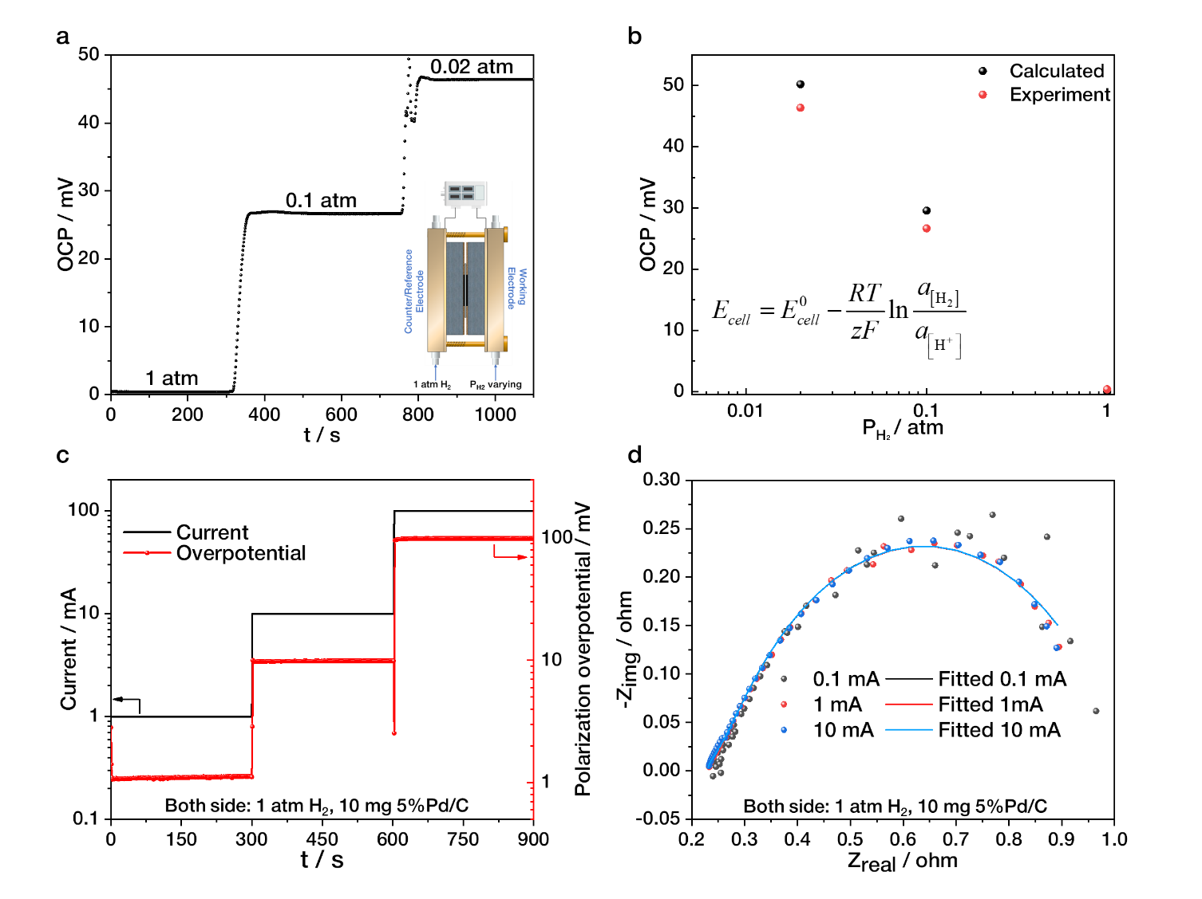
Figure S1. RHE validation: (a) OCP tests and (b) comparison with theoretical calculation under various hydrogen partial pressure on the working electrode; (c) polarization tests and (d) galvanostatic EIS under different current values.

The performance of the quasi-equilibrium RHE was firstly validated by open circuit potential (OCP) tests under different hydrogen pressures, as shown in Figure S1 a. The OCP across the cell was monitored with the working electrode exposed to gas flow containing 1 atm, 0.1 atm and 0.02 atm hydrogen, then the results were compared with theoretical values calculated from the Nernst equation (Figure S1 b). The measured and theoretical OCP values showed a disparity of less than 5 mV across the wide range of hydrogen pressures. Further, polarization tests (Figure S1 c) and galvanostatic electrochemical impedance spectroscopy (EIS, Figure S1 d) were conducted over a current range from 0.1 mA to 100 mA to evaluate the effects of polarization. Within the current range applied during hydrogenation tests (-10 mA to 10 mA), the polarization overpotential remain below 10 mV and the fitted resistance change was less than 0.1 ohm, indicating the polarization cause negligible effects and the RHE works stably under all tested conditions.

CV analysis
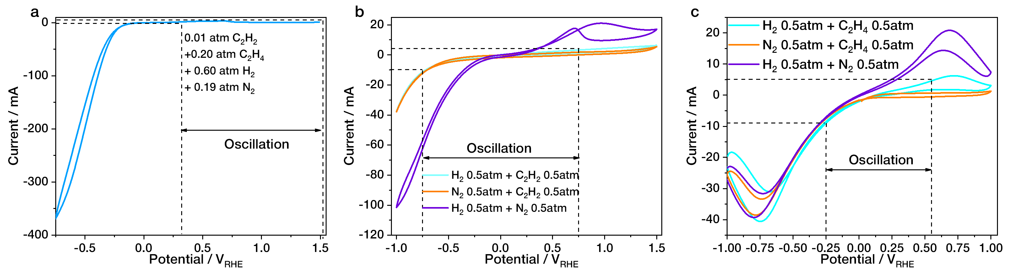
Figure S2. CV scanned under different atmosphere for (a) selective acetylene hydrogenation in excess ethylene stream, (b) pure acetylene hydrogenation and (c) pure ethylene hydrogenation.

Figure S2 b presents the CV curves obtained under acetylene + hydrogen atmosphere, revealing two distinct peaks: one in the negative potential region and another in the positive potential region. When hydrogen was replaced with nitrogen, the positive peak disappeared, indicating this peak represent hydrogen oxidation reaction (HOR). In this process, hydrogen is oxidized to protons, which enter the proton exchange membrane (PEM) and may be simultaneously reduced back to hydrogen at the counter/reference electrode. Conversely, substituting acetylene with nitrogen led to an increased positive peak, as the absence of acetylene on the electrode surface left more active sites available for HOR. Regarding the negative peak, question arises: does electrochemical acetylene hydrogenation occur at negative potentials? A comparative analysis of CV curves under nitrogen + hydrogen and nitrogen + acetylene atmospheres revealed no notable changes, suggesting a negligible electrochemical acetylene hydrogenation current, so the dominant reaction is the hydrogen evolution reaction (HER). Namely, applying a negative potential to the working electrode reduces protons from the membrane to form hydrogen, while hydrogen at the counter electrode side is oxidized to protons.

For ethylene hydrogenation, analogous results were observed in the CV curves shown in Figure S2 c. Two prominent peaks were observed. The positive peak corresponds to HOR, as no significant current was detected in the absence of hydrogen. Under ethylene + hydrogen conditions, the positive peak became lower due to the binding of ethylene on the Pd surface, limiting available active sites for HOR. Similarly, the binding of ethylene on Pd also reduced the HER current in the negative potential region when compared to nitrogen + hydrogen conditions. Importantly, no new peaks were observed in the presence of ethylene, indicating negligible electrochemical ethylene hydrogenation current. The dominant electrochemical reactions remained HER and HOR.

The CV for the selective acetylene hydrogenation within excess ethylene streams is shown in Figure S2 a. In the positive potential region, the current remained pretty low up to 1.5 V, consistent with the strong adsorption of acetylene and ethylene, similar to observations under acetylene + hydrogen conditions. This behavior suggests no substrate oxidation until potentials exceed 1.5 V.

Although electrochemical acetylene reduction has been reported as a promising strategy for selectively converting acetylene to ethylene at room temperature¹³, this process typically requires a proton-free electrolyte, such as KOH^{13,14} or DMF¹⁵, to avoid unwanted HER. In particular, when Pd was used as an electrode in H₂SO₄ electrolyte¹⁴, HER is the major reaction, leading to a very low Faradaic efficiency for the acetylene reduction. Thus, it is reasonable to neglect acetylene or ethylene reduction in the system of this work.

It is important to note that in order to ensure a maximum potential window for oscillation, the upper and lower potential limits were determined based on the CV curves to prevent excessive HER or HOR reactions (current < 10 mA). As a result, the oscillation range varied across the three reaction tests (-0.1 V to 1.5 V for acetylene/ethylene hydrogenation, -0.75 V to 0.75 V for acetylene hydrogenation and -0.25 V to 0.55 V for ethylene hydrogenation) due to differences in the potential–current relationship.

Supplementary data for acetylene hydrogenation in excess ethylene streams
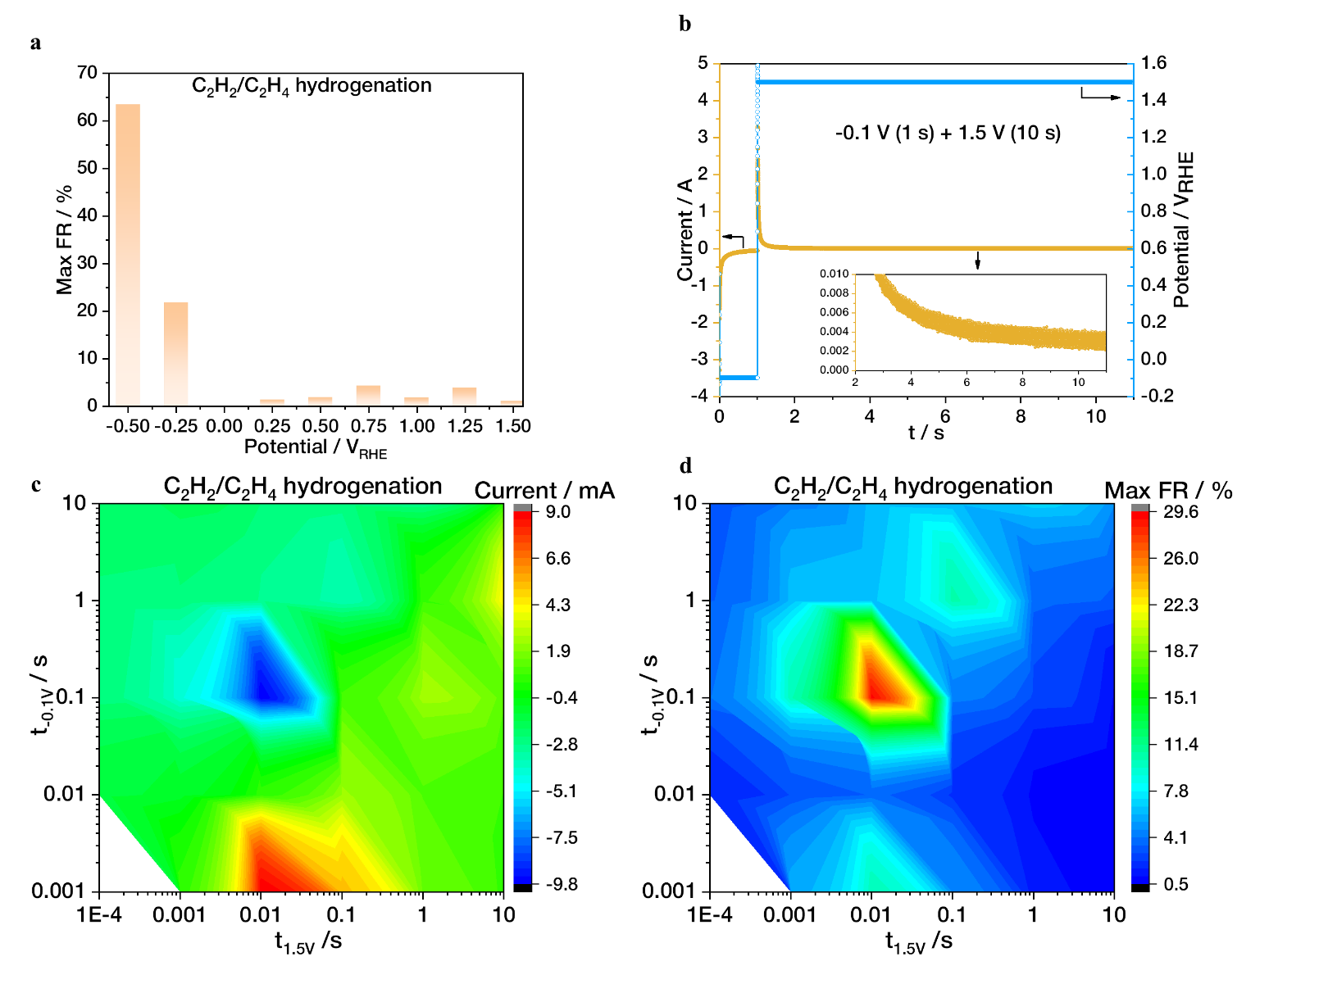
Figure S3. Supplementary data for selective acetylene hydrogenation in excess ethylene streams: (a) maximum FR for static polarization tests; (b) illustration of current variation in one period of 1.5 V + 1 s -0.1 V oscillation; (c) current and (d) maximum FRs under oscillating potentials (10 mg 1% Pd/AC, Nafion 117 PEM, 298.15 K, 1 atm, acetylene:ethylene:hydrogen:nitrogen = 1:20:60:19, total 50 mL/min).

In order to quantify the influence of electrochemical reactions on the observed reaction variations, the maximum Faradaic ratio is calculated. A representative calculation process is demonstrated using acetylene hydrogenation in ethylene-rich streams under a 10 s 1.5 V + 1 s -0.1 V oscillation (Figure S3 b).

Without applied potential, the acetylene conversion is 89.3% with an ethylene selectivity is 35.1%, corresponding to an acetylene semi-hydrogenation rate of 2.25*10⁻⁵ mol min⁻¹ and an ethylene hydrogenation rate of 4.35*10⁻⁵ mol min⁻¹. Under the 1.5 V + 1 s -0.1 V oscillation, the conversion decreases to 81.0%, while the selectivity increases to 78.3%, leading to an acetylene semi-hydrogenation rate of 2.03*10⁻⁵ mol min⁻¹ and an ethylene hydrogenation rate of 0.52*10⁻⁵ mol min⁻¹. Therefore, the rate variations for acetylene semi-hydrogenation and ethylene hydrogenation are -0.22*10⁻⁵ mol min⁻¹ and -3.83*10⁻⁵ mol min⁻¹, respectively. Assuming that hydrogenation reactions (C₂H₂ + H₂ → C₂H₄ and C₂H₄ + H₂ → C₂H₆) require two hydrogen atoms (protons) per molecule, the total equivalent current corresponding to the reaction rate variation is calculated as:
The recorded current at 5000 Hz during the 1.5 V (10 s)/-0.1 V (1 s) oscillating consisting of a sharp charging stage, followed by a steady electrochemical reaction stage under either negative or positive potentials (Figure S3 a). Since both hydrogenation processes are decelerated, only the positive potential region is considered in the calculation. After excluding the charging process, the average current in the reaction stage is 4.41 mA, yielding a maximum Faradaic ratio of:

The FRs remained below 10% under static positive polarizations or positive potential-dominated oscillating polarizations, indicating minimal contribution of positive electrochemical processes (mainly HOR) on the selectivity elevation (Figure S3 a and d).

Supplementary data for kinetic test of pure acetylene and ethylene hydrogenation
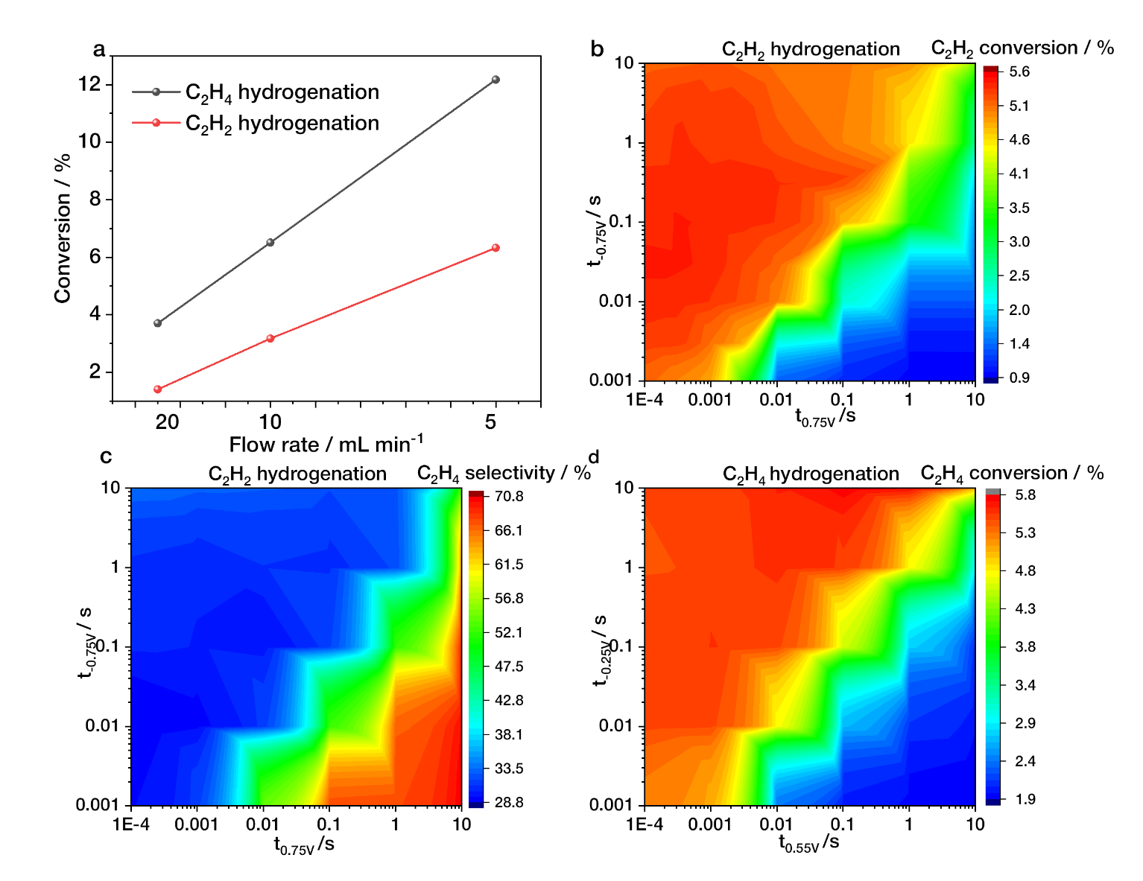
Figure S4. Supplementary data for kinetic analysis: (a) external mass transfer tests in hydrogenation of pure acetylene and ethylene using different flow rates; (b)acetylene conversion and (c) ethylene selectivity for acetylene hydrogenation under oscillating potentials; (d) ethylene conversion for ethylene hydrogenation under oscillating potentials (10 mg 5% Pd/AC for acetylene hydrogenation, 1 mg 5% Pd/AC for ethylene hydrogenation, Nafion 117 PEM, 298.15 K, 1 atm, 10 mL/min hydrogen and 10 mL/min substrate).

Space velocity tests, performed by halving or doubling the flow rate, confirmed the absence of external mass transfer limitations in the hydrogenation of both pure acetylene and pure ethylene, as the conversion was proportional to space time (Figure S4 a). Therefore, the conversion usually can be used to estimate the intrinsic reaction rate. For acetylene hydrogenation, dominant t_{-0.75 V} ratios under oscillating potential yield a maximum of 4.0-fold rate under a 0.01 s -0.75 V + 0.1 ms 0.75 V oscillation (5.6% conversion, Figure S4 b), surpassing the 2.5-fold rate (3.5% conversion, Figure 3 b) achieved under a static -0.75 V. Similarly, there is obvious increase in ethylene hydrogenation rates under oscillating potential when the t_{-0.25 V} dominates, reaching a maximum of 5.7% conversion under a 0.1 s -0.25 V + 0.1 ms 0.55 V oscillation, which is 1.6-fold compared with no potential conditions (Figure S4 d). This value also surpasses the 4.6% conversion obtained under a constant -0.25 V (Figure 3 c).

Although the negative current primarily originates from HER, as indicated by CV analysis, it is challenging to completely rule out the electrochemical reduction of ethylene or acetylene, both of which could contribute to increased product concentrations during their respective hydrogenation reactions. To further quantify the contribution of the negative current, a control experiment was conducted by replacing hydrogen in the reactants with nitrogen, ensuring that the product formation resulted solely from hydrogenation using hydrogen generated by HER or potential electroreduction of ethylene or acetylene. As shown in Table S2, the conversion under substrate + nitrogen conditions is compared with conversion promotion under substrate + hydrogen conditions. The results indicate that the contribution of negative electrochemical reactions to the acceleration of ethylene and acetylene hydrogenation is below 35% within the oscillating potential range.

Table S2. Contribution from negative electrochemical reactions (mainly HER) in the acceleration of ethylene and acetylene hydrogenation revealed by control experiment using substrate and nitrogen.
Potential | Conversion (C₂H₄+N₂) /% | ∆ Conversion in C₂H₄+H₂ /% | Ratio from HER | Conversion (C₂H₂+N₂) /% | ∆ Conversion in C₂H₂+H₂ /% | Ratio from HER
0 V | 0 | 0 | - | 0 | 0 | -
-0.25 V | 0.32 | 0.96 | 33.3% | 0.002 | 0.11 | 1.8%
-0.5 V | 0.85 | 1.91 | 44.5% | 0.03 | 0.8 | 3.8%
-0.75 V | 1.50 | 2.04 | 73.5% | 0.69 | 2.15 | 32.1%
Oscillating optimal | 0.31 | 2.01 | 15.4% | 0.97 | 4.24 | 22.9%

The primary acceleration arises from modulation of the reaction energy landscape. In negative potential-dominated oscillations, most reaction intermediates stay in high-energy states. When the system rapidly switches to positive polarization, the transition from a ground state under negative polarization to a transition state under positive polarization effectively reduces the energy barrier (illustrated on the left half of Figure 5 b). However, the several-fold rate increase is significantly smaller than the theoretical prediction based on the corresponding decrease in energy barrier (10⁵-fold increase for ~0.3 eV reduction). The main limitation lies in the relatively low oscillation frequency (~ms), constrained by current potentiostat capabilities. Since elementary surface reaction steps occur on a timescale from fs to ps, while adsorption/desorption equilibrium spans μs to s¹⁶, only a small fraction of reactants experience the dynamic energy modulation. Future improvements in switching technology that approach the turnover frequency of elementary steps could unlock much larger rate gains, further advancing the scope of dynamic catalysis.

Supplementary data for in-situ DRIFTS
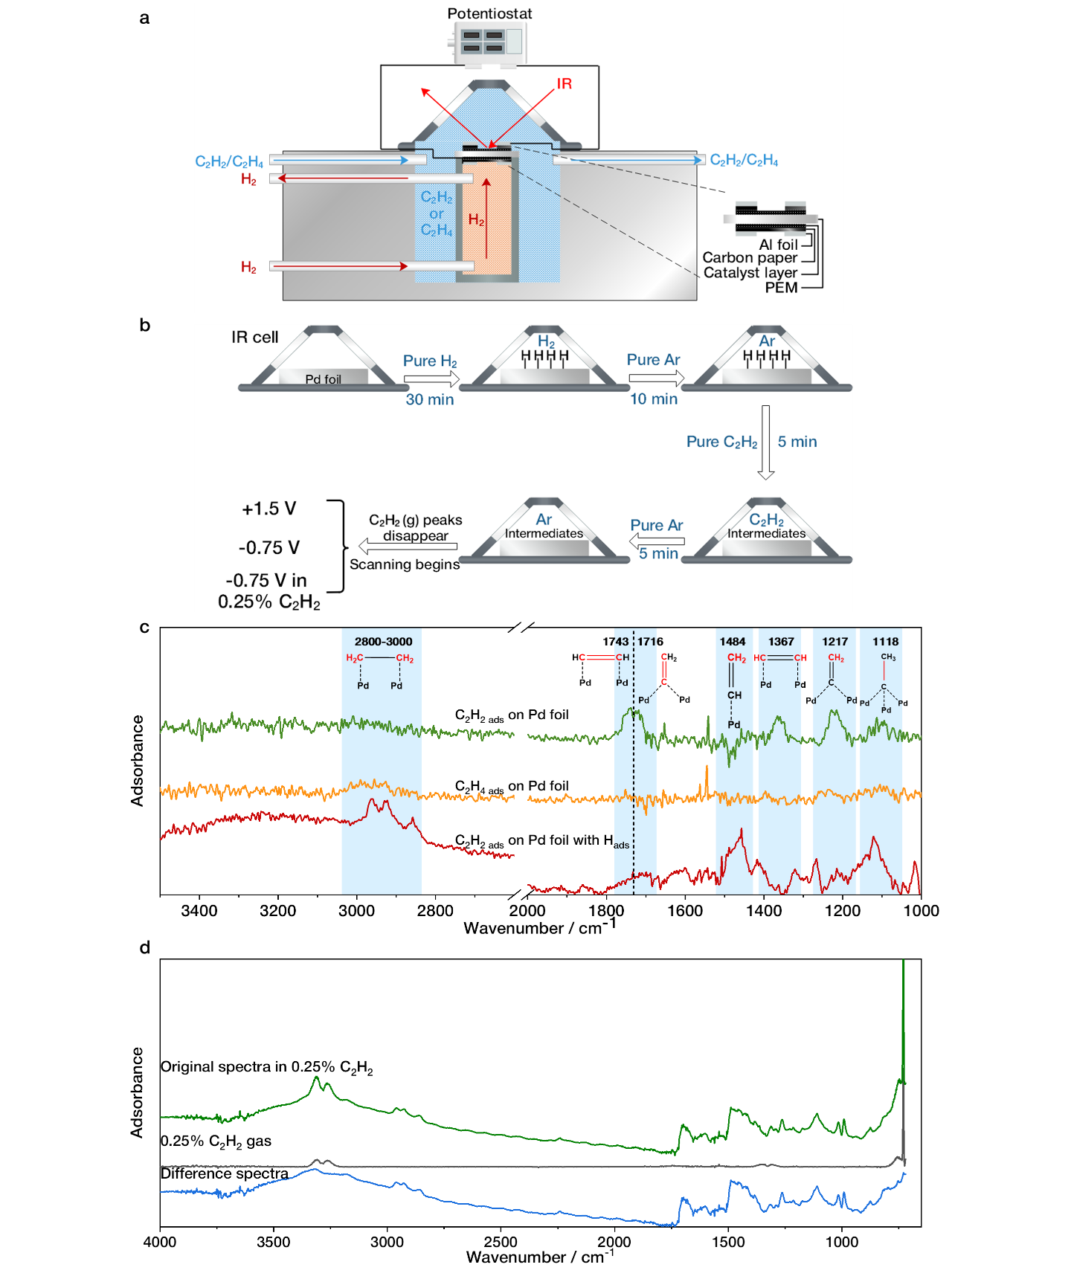
Figure S5. Supplementary data for in-situ DRIFTS: (a) in-situ DRIFTS cell; (b) illustration of time-resolved DRIFTS tests; (c) adsorbed acetylene, adsorbed ethylene and adsorbed acetylene with preabsorbed hydrogen on Pd foil; (d) adsorption spectra calculation through spectra subtraction in 0.25% C₂H₂ atmosphere.
Supplementary in-situ XAS data

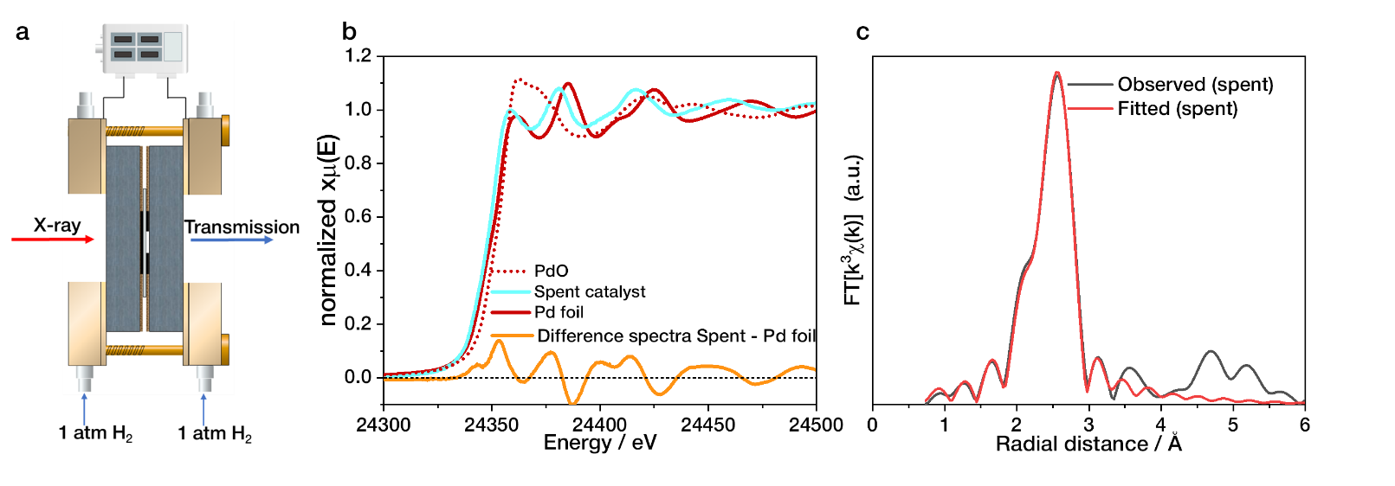
Figure S6. Supplementary in-situ XAS: (a) in-situ fuel cell; (b) XANES measurement of spent Pd/AC, Pd foil and PdO; (c) fitting of k2-weighted FT-EXAFS for spent Pd/AC.

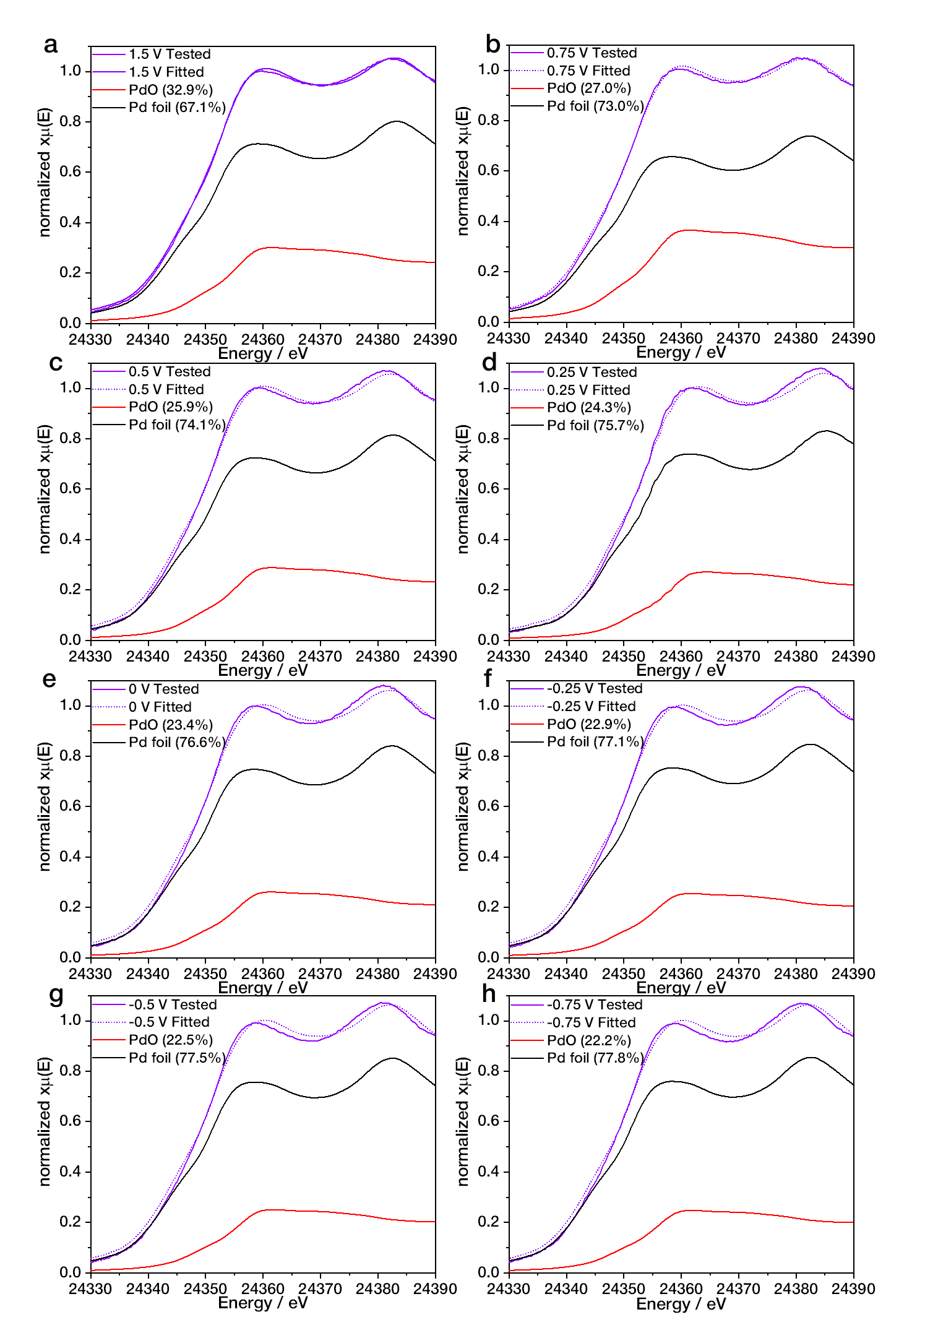
Figure S7. Linear combination fitting of XANES using PdO and Pd foil under different potentials.
TEM characterization under various potentials
The transmission electron microscopy (TEM, JEOL JEM-2010 TEM) was employed to examine both fresh and spent catalysts under different polarization conditions (Figure S8). The fresh catalysts exhibited an average particle diameter of approximately 2.70 nm. After the reaction without an applied potential, the particle diameter increased by about 1 nm in both ethylene and acetylene hydrogenation reactions, indicating some degree of particle growth during the catalytic process. However, a comparative analysis of the spent catalysts under various applied potentials—positive, negative, or dynamic—showed no significant differences in particle size. This observation suggests that the application of electric potentials does not substantially influence the diameter of the Pd particles, implying that the reaction variation didn’t come from Pd coordination structure, consistent with EXAFS results.
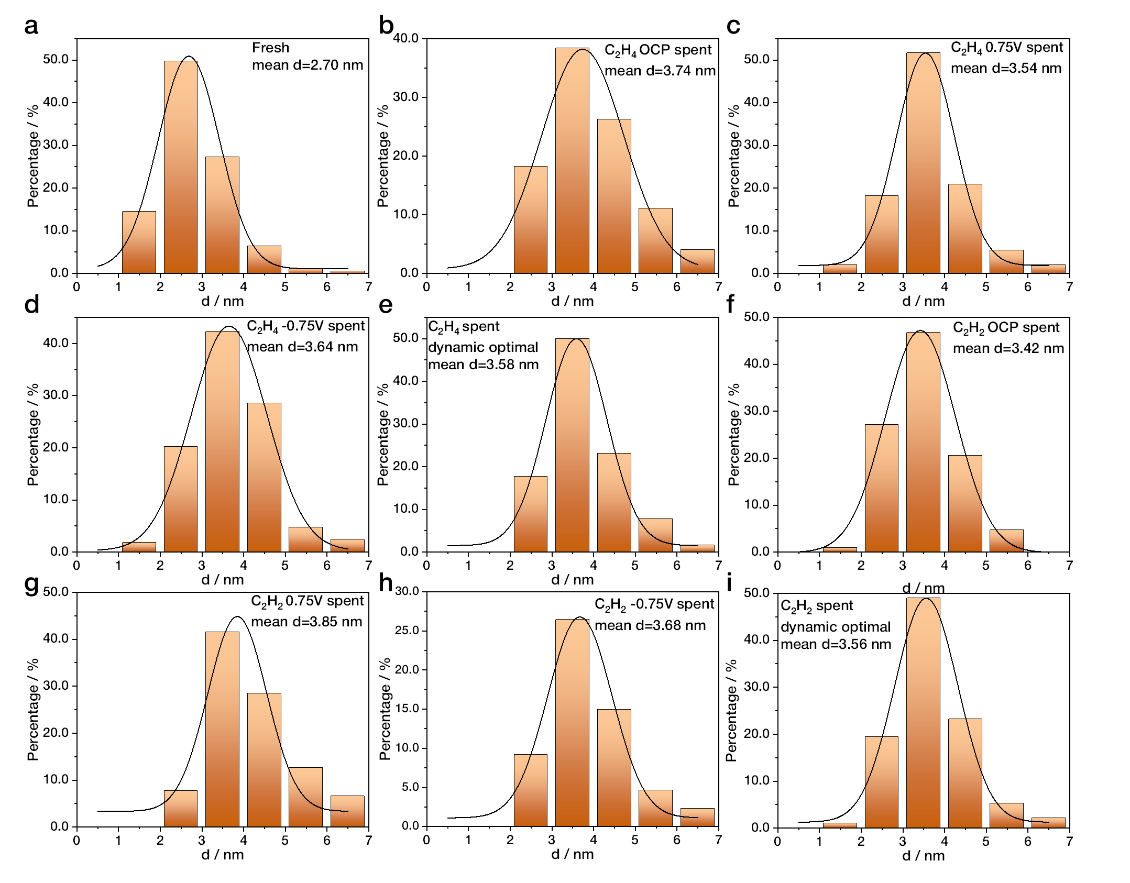
Figure S8. Diameter distribution of catalysts in different conditions (a) Fresh; after ethylene hydrogenation reaction under (b) OCP (c) 0.75 V (d) -0.75 V and (e) oscillating optimal conditions; after acetylene hydrogenation reaction under (f) OCP (g) 0.75 V (h) -0.75 V and (i) oscillating optimal conditions.

TOF of acetylene hydrogenation on Pd nanoparticles

Table S3. Reported TOF for semi-hydrogenation of acetylene on Pd-based nanoparticle catalysts.
Reference | Catalyst | Pd loading / wt% | Pd particle size / nm | TOF / s⁻¹
Duca¹⁷ | Pd/α-Al₂O₃ | 0.05 | 4 | 0.38
Borodziński¹⁸ | Pd/α-Al₂O₃ | 0.035 | 9 | 0.70
Borodziński¹⁸ | Pd/SiO₂ | 2.6 | 4.2 | 0.32
Borodziński¹⁸ | Pd/SiO₂ | 2.64 | 5.1 | 0.39
Borodziński¹⁸ | Pd/SiO₂ | 2.72 | 7.4 | 0.36
Benavidez¹⁹ | Pd/C | 1 | 0.6 | 0.47
 | Pd/α-Al₂O₃ | 1 | 0.8 | 0.54
Gulyaeva²⁰ | Pd/FG | 0.14 | 5 | 0.55

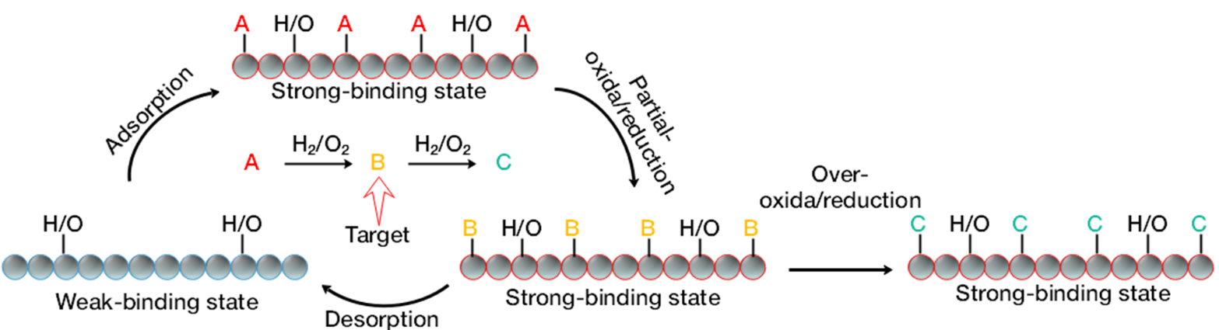
Figure S9. Generalized selectivity enhancement strategy in multistep redox reactions.

Reference
1 Zou, S. et al. Grafting nanometer metal/oxide interface towards enhanced low-temperature acetylene semi-hydrogenation. Nature Communications 12, 5770 (2021). https://doi.org:10.1038/s41467-021-25984-8
2 Zhang, L. et al. Pd@C core–shell nanoparticles on carbon nanotubes as highly stable and selective catalysts for hydrogenation of acetylene to ethylene. Nanoscale 9, 14317-14321 (2017). https://doi.org:10.1039/C7NR04992G
3 Yun, S. et al. Cross-Linked “Poisonous” Polymer: Thermochemically Stable Catalyst Support for Tuning Chemoselectivity. ACS Catalysis 6, 2435-2442 (2016). https://doi.org:10.1021/acscatal.5b02613
4 He, Y. et al. Partial hydrogenation of acetylene using highly stable dispersed bimetallic Pd–Ga/MgO–Al2O3 catalyst. Journal of Catalysis 309, 166-173 (2014). https://doi.org:https://doi.org/10.1016/j.jcat.2013.09.017
5 Matselko, O. et al. Revealing Electronic Influences in the Semihydrogenation of Acetylene. The Journal of Physical Chemistry C 122, 21891-21896 (2018). https://doi.org:10.1021/acs.jpcc.8b05732
6 Meunier, F., Maffre, M., Schuurman, Y., Colussi, S. & Trovarelli, A. Acetylene semi-hydrogenation over Pd-Zn/CeO2: Relevance of CO adsorption and methanation as descriptors of selectivity. Catalysis Communications 105, 52-55 (2018). https://doi.org:https://doi.org/10.1016/j.catcom.2017.11.012
7 Hu, M. et al. 50 ppm of Pd dispersed on Ni(OH)2 nanosheets catalyzing semi-hydrogenation of acetylene with high activity and selectivity. Nano Research 11, 905-912 (2018). https://doi.org:10.1007/s12274-017-1701-5
8 Bazzazzadegan, H., Kazemeini, M. & Rashidi, A. A high performance multi-walled carbon nanotube-supported palladium catalyst in selective hydrogenation of acetylene-ethylene mixtures. Applied Catalysis A: General 399, 184-190 (2011).
9 Li, R. et al. Selective hydrogenation of acetylene over Pd-Sn catalyst: Identification of Pd2Sn intermetallic alloy and crystal plane-dependent performance. Applied Catalysis B: Environmental 279, 119348 (2020). https://doi.org:https://doi.org/10.1016/j.apcatb.2020.119348
10 Luo, Q., Wang, H., Wang, L. & Xiao, F.-S. Alloyed PdCu Nanoparticles within Siliceous Zeolite Crystals for Catalytic Semihydrogenation. ACS Materials Au 2, 313-320 (2022). https://doi.org:10.1021/acsmaterialsau.1c00080
11 Liu, F. et al. Integration of Bimetallic Electronic Synergy with Oxide Site Isolation Improves the Selective Hydrogenation of Acetylene. Angewandte Chemie International Edition 60, 19324-19330 (2021). https://doi.org:https://doi.org/10.1002/anie.202105931
12 Feng, J. et al. Preparation and structure-property relationships of supported trimetallic PdAuAg catalysts for the selective hydrogenation of acetylene. Journal of Catalysis 344, 854-864 (2016). https://doi.org:https://doi.org/10.1016/j.jcat.2016.08.003
13 Shi, R. et al. Room-temperature electrochemical acetylene reduction to ethylene with high conversion and selectivity. Nature Catalysis 4, 565-574 (2021). https://doi.org:10.1038/s41929-021-00640-y
14 Liu, Z., Zhang, L., Ren, Z. & Zhang, J. Advances in Selective Electrocatalytic Hydrogenation of Alkynes to Alkenes. Chemistry – A European Journal 29, e202202979 (2023). https://doi.org:https://doi.org/10.1002/chem.202202979
15 Huang, B., Durante, C., Isse, A. A. & Gennaro, A. Highly selective electrochemical hydrogenation of acetylene to ethylene at Ag and Cu cathodes. Electrochemistry Communications 34, 90-93 (2013). https://doi.org:https://doi.org/10.1016/j.elecom.2013.05.036
16 Baldi, A. & Askes, S. H. C. Pulsed Photothermal Heterogeneous Catalysis. ACS Catalysis 13, 3419-3432 (2023). https://doi.org:10.1021/acscatal.2c05435
17 Duca, D., Arena, F., Parmaliana, A. & Deganello, G. Hydrogenation of acetylene in ethylene rich feedstocks: Comparison between palladium catalysts supported on pumice and alumina. Applied Catalysis A: General 172, 207-216 (1998). https://doi.org:https://doi.org/10.1016/S0926-860X(98)00123-9
18 Borodziński, A. The effect of palladium particle size on the kinetics of hydrogenation of acetylene–ethylene mixtures over Pd/SiO2 catalysts. Catalysis Letters 71, 169-175 (2001). https://doi.org:10.1023/A:1009061916463
19 Benavidez, A. D. et al. Improved selectivity of carbon-supported palladium catalysts for the hydrogenation of acetylene in excess ethylene. Applied Catalysis A: General 482, 108-115 (2014). https://doi.org:https://doi.org/10.1016/j.apcata.2014.05.027
20 Gulyaeva, Y. K., Kaichev, V. V., Zaikovskii, V. I., Suknev, A. P. & Bal’zhinimaev, B. S. Selective hydrogenation of acetylene over Pd/Fiberglass catalysts: Kinetic and isotopic studies. Applied Catalysis A: General 506, 197-205 (2015). https://doi.org:https://doi.org/10.1016/j.apcata.2015.09.016

