Supporting Information. Bandaru Peddiraju, Lakshmipriya Cannanbilla, Ashish Nambiar, Rishanth Kuruvankunath Ravi, Ashok Kumar Mani, Saravana Karuna Moorthy S, Sharath Prakash, Ranjana Gauri Muniraja, Malavika Kamath, Krishnadas, Meghna*
APPENDIX S1
Table S1. Species list of the study along with their family.
S.No | Scientific name | Species_code | Family name
1 | Artocarpus heterophyllus | ARTHET | Moraceae
2 | Calophyllum apetalum | CALAPE | Calophyllaceae
3 | Cinnamomum verum | CINVER | Lauraceae
4 | Eugenia gardneri | EUGGAR | Myrtaceae
5 | Garcinia gummi-gutta | GARGUM | Clusiaceae
6 | Hopea parviflora | HOPPAR | Dipterocarpaceae
7 | Lophopetalum wightianum | LOPWIT | Celastraceae
8 | Myristica malabarica | MYRMAL | Myristicaceae
9 | Schleichera oleosa | SCHOLE | Dipterocarpaceae
10 | Swietenia macrophylla | SWIMAC | Meliaceae
11 | Syzygium caryophyllatum | SYZCAR | Myrtaceae
12 | Syzygium cumini | SYZCUM | Myrtaceae
13 | Syzygium stomaticum | SYZSTO | Myrtaceae
14 | Syzygium zeylanicum | SYZZEY | Myrtaceae
15 | Vateria indica | VATIND | Dipterocarpaceae
16 | Artocarpus hirsutus | ARTHIR | Moraceae

Table S2. Soil moisture variation across treatments and habitats over time. Mean (± SE) soil moisture (%) recorded monthly under control and drought treatments at the forest edge and interior from March 2021 to January 2022 in a fragmented tropical forest, Western Ghats, India. Each value represents the monthly average (n = 39 per treatment) ± standard error.
Month | Edge_Control | Edge_Drought | Interior_Control | Interior_Drought
Mar-21 | 9.99 ± 0.61 | 12.05 ± 0.83 | 14.18 ± 1.11 | 14.82 ± 1.09
Apr-21 | 13.51 ± 0.83 | 6.91 ± 0.4 | 16.05 ± 1.16 | 8.39 ± 0.57
May-21 | 16.34 ± 1.19 | 7.73 ± 0.63 | 19.36 ± 1.2 | 9.06 ± 0.62
Jun-21 | 23.77 ± 1.08 | 12.65 ± 1.16 | 26.99 ± 1.15 | 16.4 ± 1.19
Jul-21 | 30.81 ± 0.91 | 15.13 ± 1.3 | 33.7 ± 1.03 | 20.29 ± 1.44
Aug-21 | 32.95 ± 0.59 | 13.61 ± 0.9 | 34.82 ± 0.93 | 20.17 ± 1.45
Sep-21 | 26.6 ± 1.24 | 16.02 ± 1.48 | 29.53 ± 1.05 | 20.09 ± 1.49
Oct-21 | 26.33 ± 0.86 | 15.02 ± 1.23 | 28.83 ± 1.25 | 21.92 ± 1.61
Nov-21 | 25.26 ± 0.75 | 14.72 ± 1.29 | 24.61 ± 1.75 | 17.7 ± 2.36
Dec-21 | 22.46 ± 1.36 | 7.46 ± 0.72 | 28.04 ± 1.15 | 17.62 ± 2.32
Jan-22 | 7.21 ± 0.6 | 5.02 ± 0.52 | 8.47 ± 0.78 | 7.56 ± 0.56

Table S3. Monthly predicted soil moisture (%), with confidence intervals, across forest habitats and treatments. Predicted soil moisture percent/100 values and 95% confidence intervals at the forest edge and interior under control and drought treatments from March 2021 to January 2022. Estimates were derived from a generalized linear mixed-effects model with a beta distribution, including treatment, forest habitat, and their interaction as fixed effects, and random intercepts for plot ID and random slopes for treatment across months. Soil moisture values were rescaled to proportions for model fitting. Bold values in the table indicate significant differences (p ≤ 0.05) between treatments within a given month and habitat.
 | Edge |  | Interior
Month | Soil moisture %/100 (CIs) in Control | Soil moisture %/100 (CIs) in Drought | Soil moisture %/100 (CIs) in Control | Soil moisture %/100 (CIs) in Drought
Mar-21 | 0.11(0.10 - 0.13) | 0.11(0.09 - 0.12) | 0.13(0.11 - 0.15) | 0.15(0.13 - 0.18)
Apr-21 | 0.13(0.12 - 0.15) | 0.06(0.05 - 0.07) | 0.15(0.13 - 0.18) | 0.09(0.08 - 0.11)
May-21 | 0.16(0.14 - 0.18) | 0.07(0.06 - 0.08) | 0.18(0.16 - 0.21) | 0.1(0.09 - 0.12)
Jun-21 | 0.23(0.21 - 0.26) | 0.12(0.10 - 0.13) | 0.26(0.23 - 0.29) | 0.17(0.15 - 0.19)
Jul-21 | 0.3(0.27 - 0.33) | 0.14(0.12 - 0.16) | 0.33(0.30 - 0.37) | 0.2(0.18 - 0.23)
Aug-21 | 0.32(0.28 - 0.35) | 0.13(0.11 - 0.15) | 0.35(0.32 - 0.39) | 0.19(0.17 - 0.22)
Sep-21 | 0.26(0.23 - 0.29) | 0.14(0.12 - 0.16) | 0.29(0.26 - 0.32) | 0.2(0.18 - 0.23)
Oct-21 | 0.27(0.24 - 0.31) | 0.16(0.14 - 0.18) | 0.31(0.27 - 0.34) | 0.22(0.20 - 0.25)
Nov-21 | 0.23(0.20 - 0.26) | 0.12(0.10 - 0.13) | 0.26(0.23 - 0.29) | 0.17(0.15 - 0.20)
Dec-21 | 0.25(0.22 - 0.28) | 0.11(0.10 - 0.13) | 0.28(0.25 - 0.32) | 0.16(0.14 - 0.19)
Jan-22 | 0.07(0.06 - 0.09) | 0.05(0.04 - 0.06) | 0.08(0.07 - 0.10) | 0.08(0.06 - 0.09)

Table S4. Effects of forest habitat (effect), drought treatment, and their interaction on soil physical and chemical properties. Estimates and 95% confidence intervals from linear mixed-effects models (Gaussian family) for nine soil variables: organic carbon (Org_C), pH, electrical conductivity (E_cond), available phosphorus (Available_P), potassium (Available_K), zinc (Available_Zn), iron (Available_Fe), copper (Available_Cu), and manganese (Available_Mn). Models included forest habitat (edge or interior), drought treatment (control or drought), and their interaction as fixed effects, with plot ID as a random intercept. Significant effects (p ≤ 0.05) are highlighted in bold in each table.
 | PC1
Predictors | Estimates | CI | p
(Intercept) | 0.04 | -0.82 – 0.91 | 0.924
effect [INT] | -0.58 | -1.86 – 0.70 | 0.376
treatment [drought] | 0.04 | -1.18 – 1.27 | 0.947
effect [INT] × treatment  [drought] | 0.88 | -0.93 – 2.69 | 0.339

 | PC2
Predictors | Estimates | CI | p
(Intercept) | -0.45 | -1.16 – 0.25 | 0.210
effect [INT] | 1.32 | 0.28 – 2.36 | 0.013
treatment [drought] | 0.52 | -0.48 – 1.52 | 0.307
effect [INT] × treatment  [drought] | -1.81 | -3.28 – -0.34 | 0.016
 | Org_C
Predictors | Estimates | CI | p
(Intercept) | 5.04 | 4.15 – 5.94 | <0.001
effect [INT] | -0.17 | -1.50 – 1.15 | 0.800
treatment [drought] | -0.09 | -1.36 – 1.18 | 0.887
effect [INT] × treatment  [drought] | 0.66 | -1.21 – 2.54 | 0.487

 | pH
Predictors | Estimates | CI | p
(Intercept) | 5.49 | 5.37 – 5.62 | <0.001
effect [INT] | -0.08 | -0.27 – 0.10 | 0.384
treatment [drought] | -0.04 | -0.22 – 0.14 | 0.674
effect [INT] × treatment  [drought] | 0.20 | -0.06 – 0.47 | 0.135

 | E_cond
Predictors | Estimates | CI | p
(Intercept) | 0.14 | 0.12 – 0.17 | <0.001
effect [INT] | -0.01 | -0.05 – 0.02 | 0.531
treatment [drought] | -0.00 | -0.04 – 0.03 | 0.896
effect [INT] × treatment  [drought] | 0.01 | -0.04 – 0.06 | 0.636

 | Available_P
Predictors | Estimates | CI | p
(Intercept) | 13.23 | 7.59 – 18.87 | <0.001
effect [INT] | 5.68 | -2.65 – 14.01 | 0.182
treatment [drought] | 1.92 | -6.05 – 9.90 | 0.637
effect [INT] × treatment  [drought] | -8.01 | -19.79 – 3.77 | 0.182

 | Available_K
Predictors | Estimates | CI | p
(Intercept) | 139.38 | 116.61 – 162.16 | <0.001
effect [INT] | -11.20 | -44.84 – 22.43 | 0.514
treatment [drought] | 17.23 | -14.97 – 49.43 | 0.294
effect [INT] × treatment  [drought] | 7.22 | -40.34 – 54.79 | 0.766
 | Available_Zn
Predictors | Estimates | CI | p
(Intercept) | 3.13 | 2.28 – 3.97 | <0.001
effect [INT] | 1.23 | -0.02 – 2.48 | 0.054
treatment [drought] | 0.65 | -0.54 – 1.85 | 0.284
effect [INT] × treatment  [drought] | -1.68 | -3.45 – 0.08 | 0.061

 | Available_Fe
Predictors | Estimates | CI | p
(Intercept) | 72.66 | 59.25 – 86.06 | <0.001
effect [INT] | 11.05 | -8.75 – 30.85 | 0.274
treatment [drought] | 7.95 | -11.01 – 26.90 | 0.411
effect [INT] × treatment  [drought] | -32.70 | -60.70 – -4.70 | 0.022

 | Available_Cu
Predictors | Estimates | CI | p
(Intercept) | 2.66 | 2.04 – 3.28 | <0.001
effect [INT] | 0.14 | -0.77 – 1.06 | 0.757
treatment [drought] | -0.06 | -0.93 – 0.82 | 0.897
effect [INT] × treatment  [drought] | 0.44 | -0.85 – 1.73 | 0.507

 | Available_Mn
Predictors | Estimates | CI | p
(Intercept) | 45.60 | 36.31 – 54.89 | <0.001
effect [INT] | 17.09 | 3.36 – 30.81 | 0.015
treatment [drought] | 2.68 | -10.46 – 15.82 | 0.690
effect [INT] × treatment  [drought] | -17.36 | -36.77 – 2.04 | 0.080
Observations | 48

Table S5. Effects of forest habitat, drought treatment, and their interaction on sapling survival. Results from a generalized linear mixed-effects model (binomial family with logit link) testing the effects of forest habitat (edge or interior), drought treatment (control or drought), and their interaction on sapling survival. The model includes species as a random effect with varying intercepts and slopes for habitat and treatment. Odds ratios, 95% confidence intervals, and p-values are reported. Significant effects (p ≤ 0.05) are indicated in bold.
 | Survival
Predictors | Odds Ratios | CI | p
(Intercept) | 3.96 | 1.36 – 11.53 | 0.012
effect [Interior] | 0.67 | 0.35 – 1.30 | 0.237
treatment [Drought] | 0.67 | 0.33 – 1.34 | 0.253
effect [Interior] × treatment [Drought] | 1.72 | 0.70 – 4.26 | 0.238

Table S6. Species-wise predicted survival probabilities under control and drought treatments across forest edge and interior habitats. Predicted survival probabilities (with 95% confidence intervals) for native tree seedling species under control and drought (throughfall exclusion) treatments at forest edge and interior locations. Predictions were obtained from a generalized linear mixed-effects model (binomial family with logit link), which included random intercepts and random slopes for treatment and habitat per species to account for species-specific responses. Significant effects (p ≤ 0.05) are indicated in bold.
 | Edge |  | Interior
Species | Predicted survival (CIs) in Control | Predicted survival (CIs) in Drought | Predicted survival (CIs) in Control | Predicted survival (CIs) in Drought
ARTHET | 0.95(0.83, 0.99) | 0.87(0.69, 0.95) | 0.9(0.72, 0.97) | 0.92(0.78, 0.97)
ARTHIR | 0.95(0.83, 0.99) | 0.87(0.69, 0.95) | 0.9(0.72, 0.97) | 0.92(0.78, 0.97)
CALAPE | 0.95(0.79, 0.99) | 0.84(0.62, 0.94) | 0.91(0.70, 0.98) | 0.91(0.75, 0.97)
CINVER | 0.56(0.38, 0.73) | 0.56(0.37, 0.73) | 0.53(0.36, 0.70) | 0.55(0.39, 0.70)
EUGGAR | 0.65(0.45, 0.80) | 0.6(0.39, 0.79) | 0.61(0.41, 0.77) | 0.61(0.45, 0.76)
GARGUM | 0.99(0.90, 1.00) | 0.97(0.82, 0.99) | 0.97(0.82, 1.00) | 0.98(0.87, 1.00)
HOPPAR | 0.95(0.81, 0.99) | 0.91(0.73, 0.98) | 0.88(0.69, 0.96) | 0.93(0.79, 0.98)
LOPWIT | 0.94(0.80, 0.98) | 0.89(0.71, 0.96) | 0.87(0.69, 0.95) | 0.91(0.77, 0.97)
MYRMAL | 0.82(0.64, 0.92) | 0.79(0.58, 0.91) | 0.72(0.52, 0.86) | 0.79(0.63, 0.89)
SCHOLE | 0.78(0.60, 0.89) | 0.67(0.46, 0.82) | 0.73(0.51, 0.88) | 0.72(0.56, 0.85)
SWIMAC | 0.49(0.28, 0.71) | 0.59(0.34, 0.80) | 0.44(0.25, 0.64) | 0.51(0.34, 0.69)
SYZCAR | 0.17(0.07, 0.36) | 0.24(0.11, 0.45) | 0.23(0.11, 0.43) | 0.2(0.09, 0.38)
SYZCUM | 0.77(0.58, 0.89) | 0.75(0.55, 0.88) | 0.67(0.47, 0.83) | 0.74(0.58, 0.86)
SYZSTO | 0.74(0.56, 0.86) | 0.65(0.45, 0.80) | 0.69(0.49, 0.84) | 0.69(0.52, 0.82)
SYZZEY | 0.1(0.03, 0.28) | 0.17(0.06, 0.38) | 0.17(0.07, 0.38) | 0.13(0.05, 0.30)
VATIND | 0.43(0.26, 0.63) | 0.41(0.24, 0.61) | 0.47(0.29, 0.66) | 0.42(0.26, 0.60)

Table S7. Trait-mediated seedling survival between treatments at edge vs interior. Seedling survival was modelled as an interaction of plant functional traits, treatments (control and throughfall exclousure) and forest habitat (Edge and Interior) using generalized linear mixed effect model using binomial family and log link. Table contains Odds Ratios estimates, CIs written in parenthesis. Significant relationships with alpha ≤ 0.05 were written in bold and significant relationships with alpha ≤ 0.1 were written in bold and italics.
Trait | Intercept | Trait | Edge | Drought | Trait*Edge | Trait*Drought | Edge*Drought | Trait*Edge*Drought
PC1 | 4.33(1.77 – 10.59) | 0.83(0.49 – 1.41) | 1.25(0.64 – 2.41) | 0.96(0.49 – 1.90) | 1.38(0.95 – 2.02) | 1.09(0.74 – 1.59) | 0.76(0.35 – 1.65) | 0.61(0.38 – 0.99)
PC2 | 4.31(1.73 – 10.72) | 0.92(0.39 – 2.16) | 1.42(0.69 – 2.89) | 1(0.51 – 1.96) | 2.57(1.23 – 5.36) | 1.3(0.70 – 2.44) | 0.62(0.28 – 1.37) | 0.44(0.18 – 1.07)
LMA | 7.49(0.59 – 94.54) | 0.4(0.01 – 18.22) | 0.5(0.08 – 3.03) | 1.13(0.18 – 7.17) | 4.51(0.31 – 65.62) | 0.78(0.05 – 11.84) | 3.39(0.34 – 34.34) | 0.08(0.00 – 2.64)
LDMC | 127.73(3.93 – 4148.22) | 0(0.00 – 0.66) | 0.15(0.01 – 2.29) | 0.51(0.03 – 9.29) | 682.54(0.28 – 1683477.71) | 6.36(0.00 – 22427.29) | 10.39(0.34 – 315.62) | 0(0.00 – 6.37)
LA | 4.01(0.35 – 45.61) | 1(0.97 – 1.03) | 2.27(0.42 – 12.29) | 1.05(0.19 – 5.93) | 0.99(0.98 – 1.01) | 1(0.98 – 1.02) | 0.18(0.02 – 1.46) | 1.02(0.99 – 1.04)
SSD | 9.01(0.52 – 155.96) | 0.22(0.00 – 48.37) | 0.22(0.03 – 1.51) | 0.47(0.06 – 3.45) | 31.86(0.90 – 1132.67) | 4.44(0.12 – 169.80) | 6.78(0.63 – 72.60) | 0.01(0.00 – 1.00)
MRSD | 0.83(0.04 – 19.63) | 55.51(0.02 – 128866.74) | 0.88(0.09 – 8.75) | 0.58(0.05 – 6.63) | 2.76(0.01 – 955.01) | 4.25(0.01 – 2007.99) | 2.27(0.12 – 44.19) | 0.05(0.00 – 93.53)
FRSD | 3.11(0.63 – 15.26) | 2.56(0.03 – 211.63) | 0.33(0.10 – 1.10) | 0.69(0.22 – 2.17) | 150.16(2.64 – 8530.29) | 4.27(0.15 – 123.04) | 2.38(0.56 – 10.01) | 0.01(0.00 – 1.18)

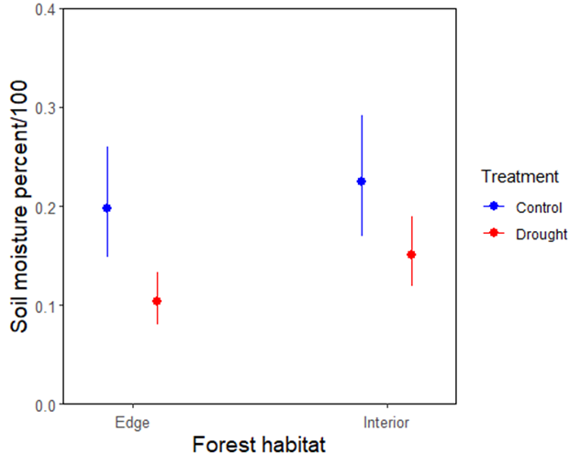

Fig. S1. Predicted soil moisture across forest habitats and treatments. Predicted values of soil moisture (%/100) from generalised linear mixed-effects models are shown for paired control (blue) and drought (red) treatments across forest edge and interior habitats. Models included forest habitat and treatment as fixed effects, with plot identity as a random intercept and treatment as a random slope within month.

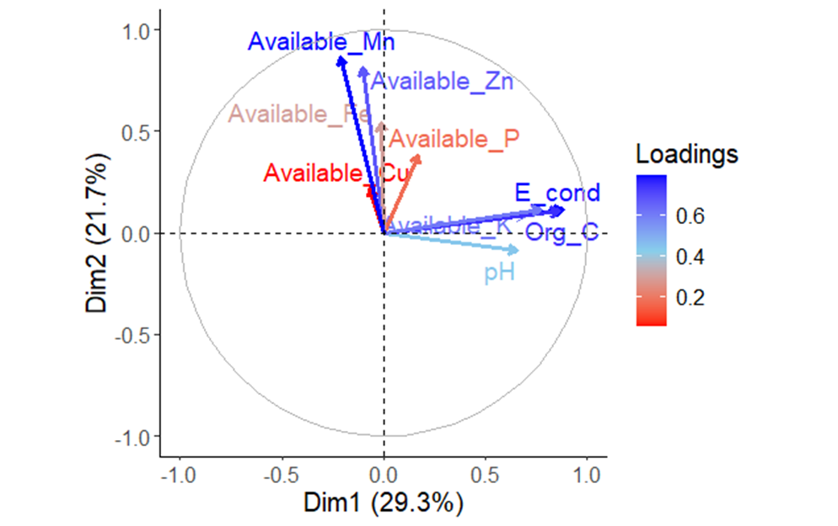

Fig. S2. Principal Component Analysis (PCA) of Soil Physical and Chemical Properties. PCA was performed on nine soil properties to derive composite axes that capture the primary sources of variation in soil conditions. The vectors represent the direction and magnitude of each soil property’s contribution to the multivariate space, with longer vectors indicating a stronger influence on the overall variation. The soil properties analysed include organic carbon (Org_C), electrical conductivity (E_cond), pH, available potassium (Available_K), available phosphorus (Available_P), available copper (Available_Cu), available iron (Available_Fe), available manganese (Available_Mn), and available zinc (Available_Zn).

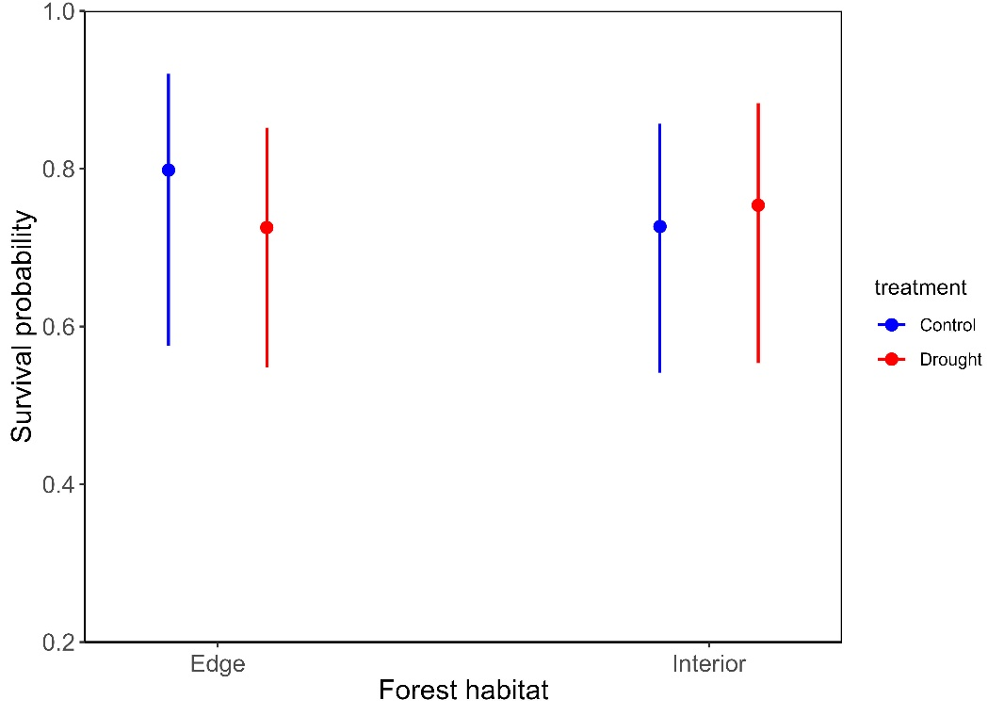

Fig. S3. Model-predicted mean survival probabilities of seedlings across forest habitats and treatments. Predicted survival probabilities from generalised linear mixed-effects models (with binomial errors) are shown for seedlings in control (orange) and drought (red) treatments across forest edge and interior habitats. Models included forest habitat and treatment as fixed effects, with species identity as a random intercept and random slopes to account for species-specific variation in treatment responses.

Fig. S4. Principal Component Analysis (PCA) of seedling functional traits. PCA was performed on six functional traits to derive composite axes of trait variation. Arrows indicate the direction and strength of each trait's contribution to the multivariate trait space—longer arrows represent greater influence. Traits include: leaf mass per area (LMA), leaf dry matter content (LDMC), stem specific density (SSD), leaf area (Leaf_Area), main root specific density (MRSD), and fine root specific density (FRSD).

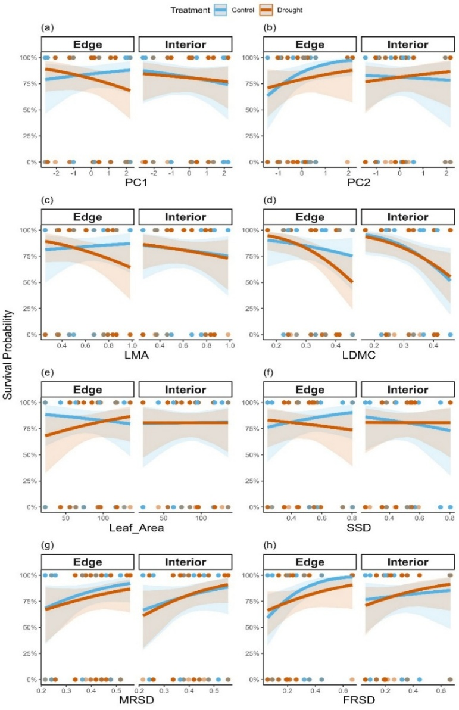

Fig. S5. Relationship between seedling survival and functional traits across forest habitats and drought treatments. Survival, modelled as a binary response (alive, dead), was analysed using a generalised linear mixed-effects model with a logit link to examine three-way interactions between traits, forest habitat (edge vs interior), and treatment (drought vs control). Trait values, habitat, and treatment were included as fixed effects, while species identity was included as a random intercept with random slopes for habitat and treatment. Panels show drought response as a function of: (a) PC1 and (b) PC2 from a principal component analysis (PCA) of six traits; (c) leaf mass per area (LMA); (d) leaf dry matter content (LDMC); (e) leaf area; (f) stem specific density (SSD); (g) main root specific density (MRSD); and (h) fine root specific density (FRSD).

