Supplementary materials

Methods
A. B.

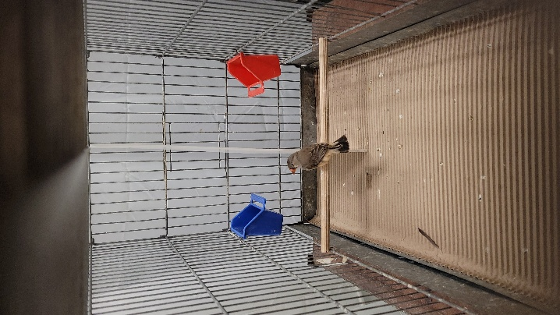
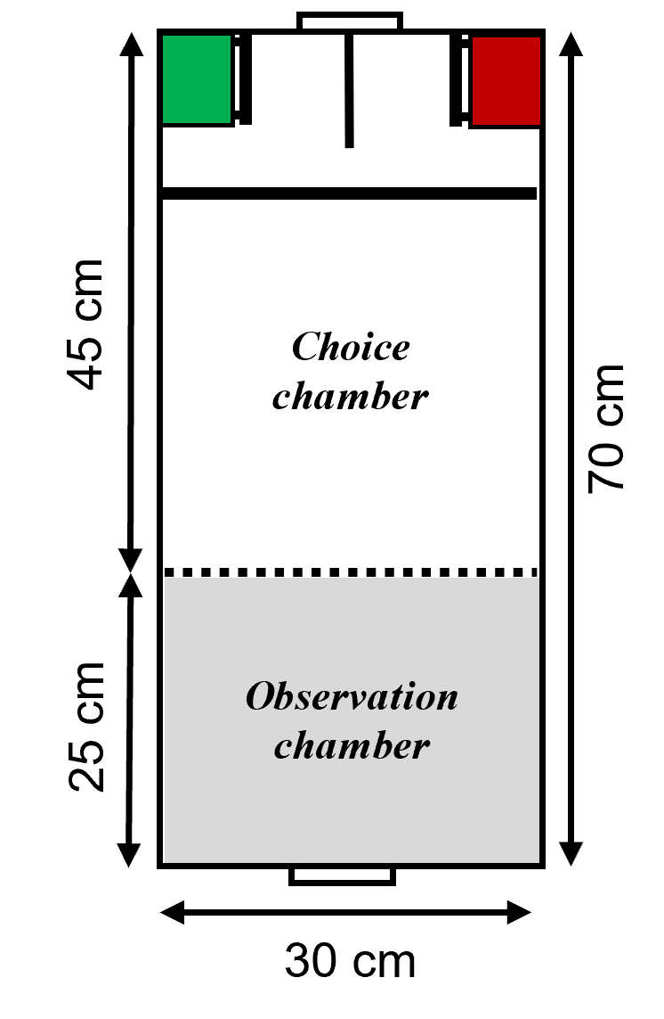
Figure 1. Schematic illustration of the testing cage. A) The observation chamber and choice chamber are shown. The dashed line represents the removable mesh divider, the thick black line the perch and the horizontal line the divider between the two feeders. There are two doors on each side of the cage to access either chamber. Green and red boxes represent the opaque colour feeders (6.5 x 7 cm and 7 cm high), each with a small perch in front of it. One feeder was rewarded, and the other was empty during a given test session. B) Photo of the test cage during a test session, showing the subject in the choice chamber before making a decision.

Results of the corticosterone (CORT) and associative learning test
The results shown are from the final models used and reported based on the comparison between the AIC values of all the models constructed based on various fixed and random factors. Non-significant fixed factors and random variables that did not explain the variations were removed from the final models.

Juveniles associative learning

Structural equation analyses

Latency to choice
Table S1. The structural equation model with factors of Origin (temperature treatment condition: Stable vs Variable), CORT (log-transformed corticosterone concentrations pg/mg), and Latency (log-transformed value of latency to choice: seconds).
Coefficients:
Response | Predictor | Estimate | Std. Error | DF | Crit. Value | P. Value | Std. Estimate
CORT | Origin | 0.3035 | 0.0814 | 66 | 3.7278 | 0.0004 | 0.2792 | ***
Latency | Origin | 0.654 | 0.2176 | 61 | 3.0058 | 0.0038 | 0.2768 | **
Latency | CORT | -0.3148 | 0.1684 | 103 | -1.8694 | 0.0644 | -0.1448

Participation rate
Table S2. The structural equation model with factors of Origin (temperature treatment condition: Stable vs Variable), CORT (log-transformed corticosterone concentrations pg/mg), and Participation (participation rate of individuals: 1 = participated, 0 = inactive).
Coefficients:
Response | Predictor | Estimate | Std. Error | DF | Crit. Value | P. Value | Std. Estimate
CORT | Origin | 0.3035 | 0.0814 | 66.1154 | 3.7278 | 0.0004 | 0.2781 | ***
Participation | Origin | -0.0262 | 0.0797 | 68.2719 | -0.3282 | 0.7437 | -0.028
Participation | CORT | -0.1209 | 0.0549 | 239.3294 | -2.2025 | 0.0286 | -0.1412 | *

Temperature treatments affecting CORT
Table S3. The summary output from the linear mixed effect model (LMM) with the response variable of CORT (log-transformed pg/mg). The temperature condition (Origin: Stable vs Variable) was included as the fixed factor and Box (family ID) as the random factor (N = 246).
Fixed effects:
 | Estimate |  | Std. Error | df | t value | Pr(>|t|)
(Intercept) | 8.48498 |  | 0.05787 | 65.23496 | 146.623 | < 2e-16 | ***
OriginVariable | 0.29569 |  | 0.08244 | 65.35104 | 3.587 | 0.000641 | ***
Random effects:
Groups |  | Variance |  | Std.Dev.
Box (Intercept) |  | 0.04965 |  | 0.2228
Residual |  | 0.22729 |  | 0.4768

Participation rate
Table S4. The summary output from the generalized linear mixed model (GLMM) with the temperature condition, CORT, and start time (centered) as the fixed factors. BoxID was included as a random factor (N = 246).
Fixed effects:
 | Estimate | Std. Error | z value | Pr(>|z|)
(Intercept) | 10.89 | 3.5848 | 3.038 | 0.00238 | **
OriginVariable | -0.2298 | 0.446 | -0.515 | 0.60644
CORT | -1.1159 | 0.4125 | -2.706 | 0.00682 | **
Start time | 1.0949 | 0.2645 | 4.14 | 3.48E-05 | ***
Random effects:
Groups | Variance | Std.Dev.
BoxID (Intercept) | 1.152 | 1.073

Latency to choice
Table S5. The summary output from the LMM with the temperature condition and CORT as the fixed factors. BoxID was included as a random factor (N = 167).
Fixed effects:
 | Estimate | Std. Error | df | t value | Pr(>|t|)
(Intercept) | 6.7345 | 1.425 | 162.3791 | 4.726 | 4.94E-06 | ***
OriginVariable | 0.654 | 0.2176 | 62.1361 | 3.006 | 0.00382 | **
CORT | -0.3148 | 0.1684 | 161.684 | -1.869 | 0.06338 | .
Random effects:
Groups | Variance | Std.Dev.
BoxID (Intercept) | 0.2708 | 0.5203
Residual | 1.0397 | 1.0196

Table S6. The summary output from the LMM with the temperature condition as the fixed factor. BoxID was included as a random factor (N = 177).
Fixed effects:
 | Estimate | Std. Error | df | t value | Pr(>|t|)
(Intercept) | 4.0782 | 0.1431 | 57.3612 | 28.508 | <2e-16 | ***
OriginVariable | 0.4877 | 0.2033 | 60.7168 | 2.398 | 0.0196 | *
Random effects:
Groups | Variance | Std.Dev.
BoxID (Intercept) | 0.2386 | 0.4885
Residual | 1.0906 | 1.0443

Learning performance
Table S7. The summary output from the GLMM with the temperature condition and CORT as the fixed factors. BoxID was included as a random factor (N = 167).
Fixed effects:
 | Estimate | Std. Error | z value | Pr(>|z|)
(Intercept) | 5.63049 | 7.99814 | 0.704 | 0.481
OriginVariable | 0.34528 | 1.50257 | 0.23 | 0.818
CORT | 0.09639 | 0.92931 | 0.104 | 0.917
Random effects:
Groups | Variance | Std.Dev.
BoxID (Intercept) | 29.12 | 5.396

Adulthood - Memory assessment

1-Month post learning

Participation rate
Table S8. The summary output from the generalized linear mixed model (GLMM) with the temperature condition and CORT as the fixed factors. BoxID was included as a random factor (N = 150).
Fixed effects:
 | Estimate | Std. Error | z value | Pr(>|z|)
(Intercept) | -2.0624 | 2.8252 | -0.730 | 0.465
OriginVariable | 0.5310 | 0.3868 | 1.373 | 0.170
CORT | 0.3001 | 0.3346 | 0.897 | 0.370
Random effects:
Groups | Variance | Std.Dev.
BoxID (Intercept) | 0.0688 | 0.2623

Latency to choice
Table S9. The summary output from the LMM with the temperature condition and CORT as the fixed factors. BoxID was included as a random factor (N = 101).
Fixed effects:
 | Estimate | Std. Error | df | t value | Pr(>|t|)
(Intercept) | -1.2862 | 2.5940 | 91.6850 | -0.496 | 0.6212
OriginVariable | -0.4891 | 0.2999 | 46.4553 | -1.631 | 0.1097
CORT | 0.5974 | 0.3039 | 90.6543 | 1.966 | 0.0524
Random effects:
Groups | Variance | Std.Dev.
BoxID (Intercept) | 0.3716 | 0.6096
Residual | 1.3872 | 1.1778

Learning performance
Table S10. Generalized linear model (GLM) of the memory performance at 1-month post learning with temperature condition and CORT as fixed factors. BoxID as a random factor did not contribute to the variance of the model and was removed from the final analysis (N = 101).
Coefficients:
 | Estimate | Std. Error | z value | Pr(>|z|)
(Intercept) | 10.911 | 2478.488 | 0.004 | 0.996
OriginVariable | -18.622 | 2478.470 | -0.008 | 0.994
CORT | 1.152 | 1.179 | 0.977 | 0.329

4-Month memory assessment

Participation (N = 96)
Fisher’s exact test for count data: p = 0.6998. No difference between groups.

Table S11. The distribution of the number of participated (1) and non-participated (0) birds across the four treatment groups.
 | Stable-Stable | Stable-Variable | Variable-Stable | Variable-Variable
0 | 2 | 3 | 2 | 0
1 | 23 | 22 | 29 | 15

Latency to choice
Table S12. LMM of the latency to choice at 4 months post learning with Group as the fixed factor. ColourID was included as a random factor (N = 89).
Fixed effects:
 | Estimate | Std. Error | df | t value | Pr(>|t|)
(Intercept) | 4.3366 | 0.3105 | 44.8269 | 13.966 | < 2e-16 | ***
GroupStable Variable | -0.6636 | 0.3735 | 70.4332 | -1.777 | 0.07991 | .
GroupVariable Stable | -0.3233 | 0.3727 | 84.5427 | -0.868 | 0.38806
GroupVariable Variable | -1.4874 | 0.4387 | 81.9827 | -3.390 | 0.00108 | ***
Random effects:
Groups | Variance | Std.Dev.
colours (Intercept) | 0.403 | 0.6348
Residual | 1.459 | 1.2079

Learning performance
Table S13. GLMM of the memory performance at 4 months post learning with Group as the fixed factor. BoxID was included as a random factor (N = 89).
Fixed effects:
 | Estimate | Std. Error | z value | Pr(>|z|)
(Intercept) | 9.7681 | 3.7009 | 2.639 | 0.00831 | **
GroupStable Variable | -1.9912 | 2.7940 | -0.713 | 0.47606
GroupVariable Stable | -2.3990 | 3.2282 | -0.743 | 0.45740
GroupVariable Variable | -0.6776 | 3.5993 | -0.188 | 0.85067
Random effects:
Groups | Variance | Std.Dev.
BoxID (Intercept) | 86.89 | 9.322

10-Month memory assessment

Participation
Table S14. GLM of the participation rate at 10 months post learning with Group as the fixed factor. BoxID was included as a random factor (N = 76).
Fixed effects:
 | Estimate | Std. Error | z value | Pr(>|z|)
(Intercept) | 2.89037 | 1.02737 | 2.813 | 0.0049
GroupStable Variable | 0.05407 | 1.45190 | 0.037 | 0.9703
GroupVariable Stable | -0.53900 | 1.26614 | -0.426 | 0.6703
GroupVariable Variable | -1.09861 | 1.28016 | -0.858 | 0.3908

Latency to choice
Table S15. LMM of the latency to choice at 10 months post learning with Group as the fixed factor. BoxID was included as a random factor (N = 70).
Fixed effects:
 | Estimate | Std. Error | df | t value | Pr(>|t|)
(Intercept) | 3.2693 | 0.2605 | 49.4307 | 12.549 | <2e-16 | ***
GroupStable Variable | -0.3928 | 0.3565 | 51.3646 | -1.102 | 0.276
GroupVariable Stable | -0.2704 | 0.3541 | 54.8944 | -0.763 | 0.448
GroupVariable Variable | -0.6222 | 0.4103 | 58.2062 | -1.516 | 0.135
Random effects:
Groups | Variance | Std.Dev.
BoxID (Intercept) | 0.05799 | 0.2408
Residual | 1.14032 | 1.0679

Learning performance
Table S16. GLM of the memory performance at 10 months post learning with Group as the fixed factor. BoxID was included as a random factor (N = 70).
Fixed effects:
 | Estimate | Std. Error | z value | Pr(>|z|)
(Intercept) | 2.833e+00 | 1.029e+00 | 2.753 | 0.0059 | ***
GroupStable Variable | 5.716e-02 | 1.454e+00 | 0.039 | 0.9686
GroupVariable Stable | 1.625e-01 | 1.452e+00 | 0.112 | 0.9109
GroupVariable Variable | 1.673e+01 | 3.104e+03 | 0.005 | 0.9957

Adulthood - Pattern associative learning

Participation
Table S17. GLMM of the participation rate in pattern associative learning test with Group and start time as fixed factors. BoxID was included as a random factor (N = 251).
Fixed effects:
 | Estimate | Std. Error | z value | Pr(>|z|)
(Intercept) | 0.2382 | 0.3027 | 0.787 | 0.4313
GroupStable Variable | 0.9805 | 0.427 | 2.296 | 0.0217 | *
GroupVariable Stable | 0.8957 | 0.4521 | 1.981 | 0.0476 | *
GroupVariable Variable | 0.8277 | 0.4682 | 1.768 | 0.0771 | .
Start time | 0.3949 | 0.1674 | 2.359 | 0.0183 | *
Random effects:
Groups Name | Variance | Std.Dev.
BoxID (Intercept) | 0.5885 | 0.7671

Latency to choice
Table S18. Linear mixed model (LMM) of the latency to choice in pattern associative learning test with Group as the fixed factor. BoxID did not explain the variance and was removed from the random factor (N = 172).
Coefficients:
 | Estimate | Std. Error | t value | Pr(>|t|)
(Intercept) | 3.2001 | 0.146 | 21.925 | <2e-16 | ***
GroupStable Variable | -0.1381 | 0.1972 | -0.7 | 0.485
GroupVariable Stable | -0.2648 | 0.1945 | -1.361 | 0.175
GroupVariable Variable | -0.1851 | 0.2051 | -0.902 | 0.368

Learning performance
Table S19. GLMM of the learning performance in pattern associative learning test with Group as the fixed factor. BoxID was included as a random factor (N = 172).
Fixed effects:
 | Estimate | Std. Error | z value | Pr(>|z|)
(Intercept) | 0.80671 | 0.37561 | 2.148 | 0.0317 | *
GroupStable Variable | 0.04175 | 0.48959 | 0.085 | 0.932
GroupVariable Stable | -0.04061 | 0.49172 | -0.083 | 0.9342
GroupVariable Variable | -0.41651 | 0.50778 | -0.82 | 0.4121
Random effects:
Groups | Variance | Std.Dev.
BoxID (Intercept) | 0.21 | 0.4583

