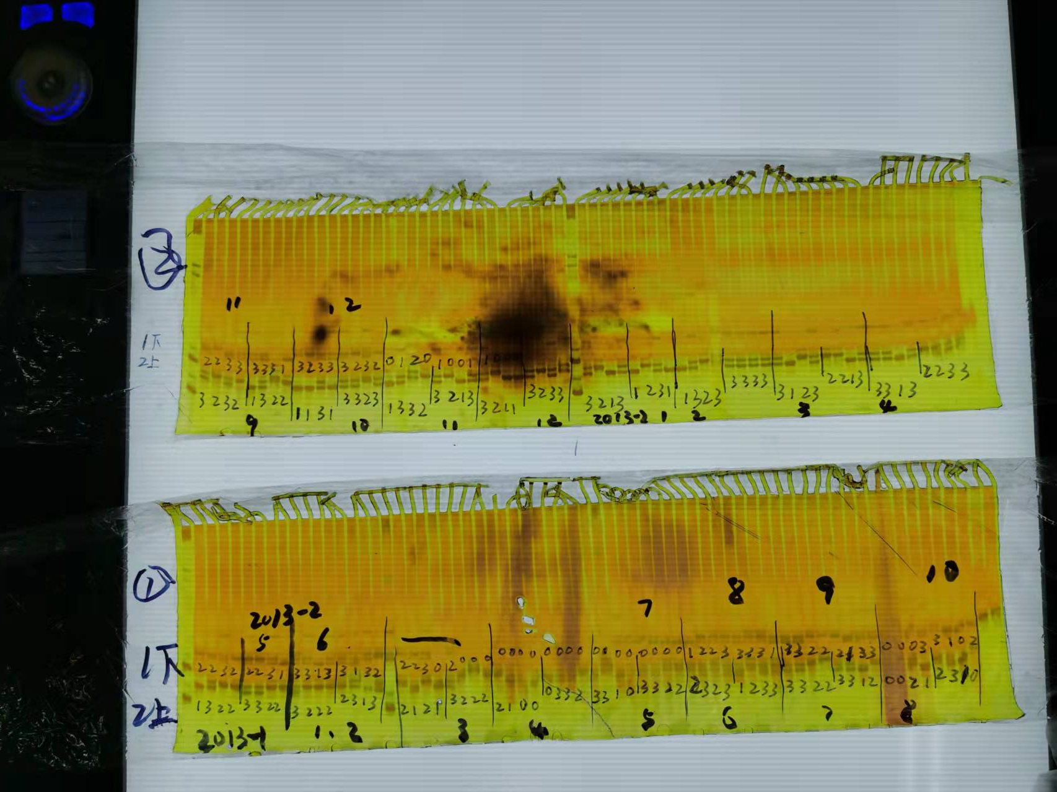
Fig1. SCM3indel-2 molecular marker gel

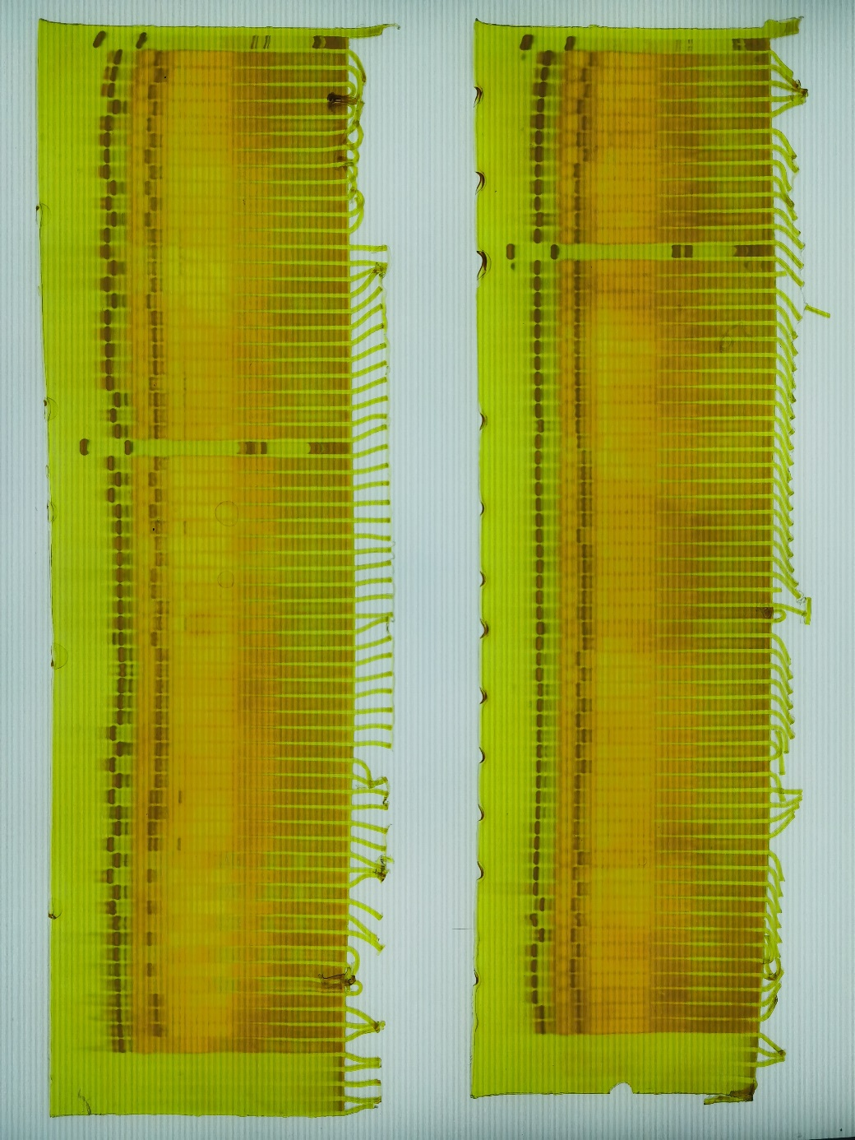
Fig2. SCM3indel-2 molecular marker gel (Two sample applications were conducted with a 20-minute interval in between.)

