Supplemental Table S.1. Simulated Medical Waste Items and Their Characteristics. RMW – Regulated Medical Waste; MW – Municipal Waste.
Item | Simulated Contaminate | Contamination Level | Stream
Drape | Blood | Heavy/Soaked | RMW
Drape | Blood | Light/Spattered | MW
Napkin | Blood | Medium/3 ml | MW
Napkin | Blood | Medium/6 ml | MW
Napkin | Blood | Light/Splattered | MW
Napkin | Blood | Light/1 ml | MW
Rag | Blood | Heavy/Soaked | RMW
Rag | Blood | Light/Splattered | MW
Gloves | Blood | Heavy/Soaked | RMW
Gloves | Blood | Light/Splattered | MW
Mask | Blood | Light/Splattered | MW
Mask | Blood | Heavy/Soaked | RMW
Bandage | Blood | Heavy/Soaked | RMW
Bandage | Blood | Heavy/20 ml | RMW
Bandage | Blood | Light/5 ml | MW
Bandage | Blood | Light/Splattered | MW
Rag | Urine | Heavy/Soaked | MW
Rag | Urine | Light/1 ml | MW
Sample Bottle | Urine | Full | MW
Diaper | Feces | Bloody | RMW
Diaper | Feces | Normal | MW
Napkin | Feces | Bloody/Soaked | RMW
Napkin | Feces | Normal/ Soaked | MW
Rag | Vomit | Heavy/Soaked | MW
Empty Syring (No sharp) | None | Used | MW
Endotracheal tube | None | Used | MW
Packaging | None | Open | MW
Packaging | None | Sealed | None
PHI | None | Used | MW
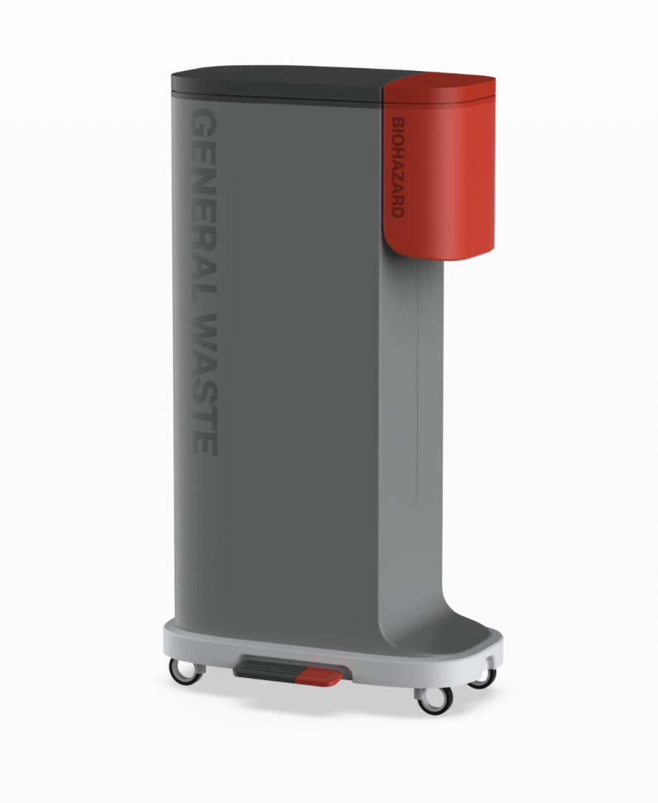

Supplemental Figure S.1. Concept Design of the Novel Adapted Bin System Utilized During the Intervention Simulation.

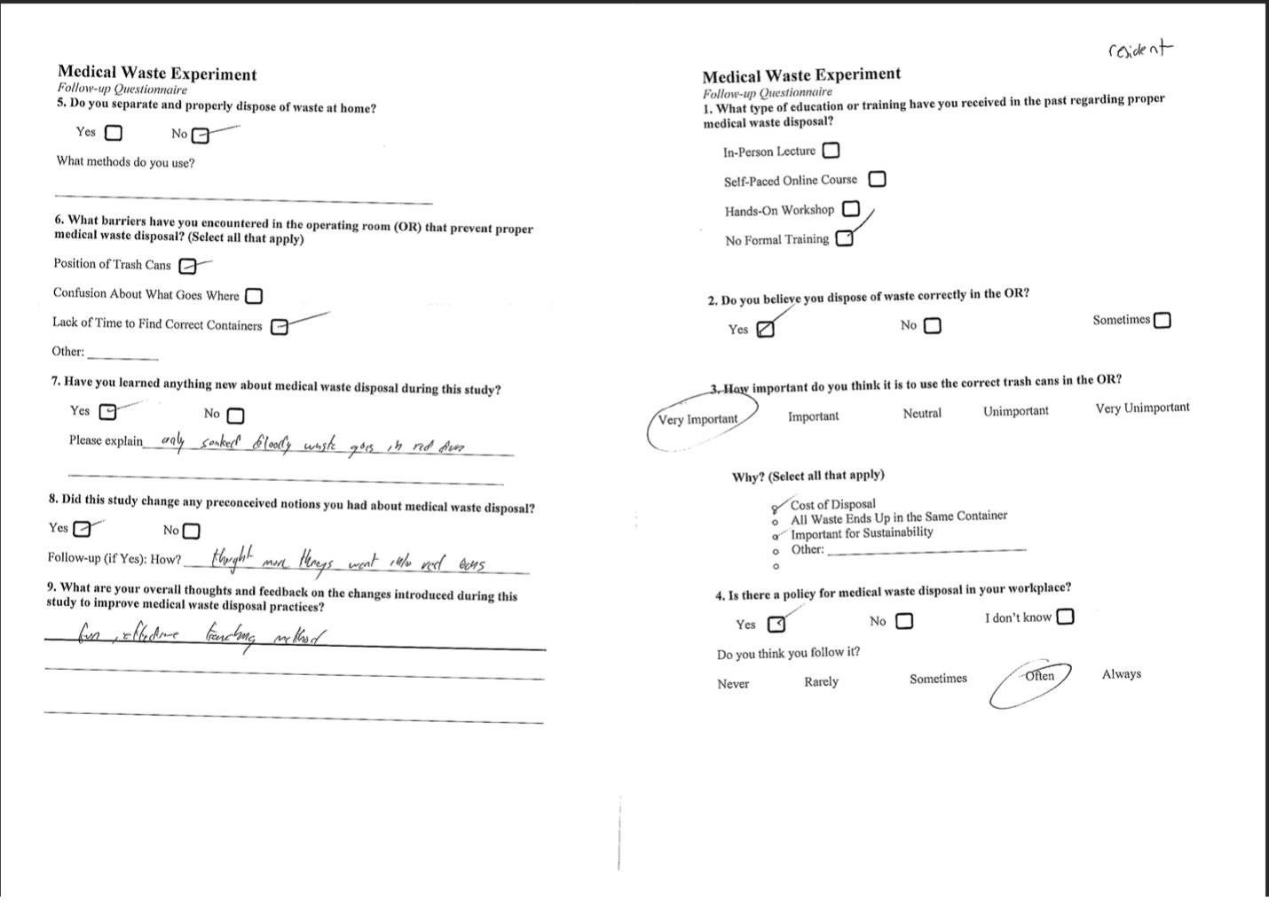

Supplemental Figure S.2. Example Survey that Participants Filled Out After Simulation Completion

Supplemental Table S.2. Themes from Open-ended Survey Responses
Theme | Example Quote
Waste Sorting
Proper Bin Usage  (n=2) [8.7%] | “thought more things went into red bins than should”  “great explains what trash needs to go into which bins”
Improved Understanding of Blood-contaminated Waste (n=6) [26.1%] | “Blood sometimes fine”  “only soaked bloody waste goes into the RMW”  “lightly soaked blood goes into different bin”  “light blood can go in regular bin”  “light blood, heavy blood”  “it is important to ensure the difference between soaked v. not soaked v. a little soaked”
Improved Understanding of Urine and Feces Waste  (n=6) [26.1%] | “urine/feces ok for normal trash”  “feces/urine/vomit in normal trash cans”  “feces goes in municipal  “emesis and urine w/o blood in regular trash”  “the feces with blood vs. Feces"  “urine, vomit, feces go in regular trash”
Implementation Concerns  (n=2) [8.7%] | “people might be hard to convince to change their habits”  “would need to make sure people actually read them”
Educational Value  (n=8) [34.8%] | “great educational resource”  “the signs were helpful for the first simulation”  “great explains what trash needs to go into which bins  “really helpful”  “signns with emojis are helpful”  “fun and informative”  “great study to show the importance of waste and separation”  “important”
Positive Feelings  (n=12) [52.17%] | “good experiment”  “Great educational resource”  “Great study to show the importance of waste and seperation”  “The signs were helpful for the first simulation”  “signns with emojis are helpful”  “great set up”  “Fun effective tracking method  “It was fun”  “It was a fun experience”  “Really helpful”  “Great explains what trans needs to go in which bins”  “Fun and informative”

