Supplementary Material

Comparative analysis of daily and hourly temperature variability in association with all-cause and cardiorespiratory mortality in 45 US cities

Yong Yu ^{a, 1}, Siqi Luo ^{b, 1}, Yunquan Zhang ^{b}, Linjiong Liu ^{b}, Ke Wang ^{c}, Le Hong ^{b}, Qun Wang ^{a, *}

ª School of Public Health, Hubei University of Medicine, Shiyan 442000, China
^{b} Department of Epidemiology and Biostatistics, School of Public Health, Wuhan University of Science and Technology, Wuhan 430065, China
^{c} Department of Nursing, Medical College, Wuhan University of Science and Technology, Wuhan 430065, China

¹ These authors are co-first authors who contributed equally to this paper.

Table of contents
Fig. S1 Locations of 45 metropolises in United States and daily temperature variability of each city (7 regions were divided by dotted lines)
Fig. S2 Mortality changes (%, 95% CIs) associated with per 1 °C increase in TV_{daily} and TV_{hourly} along various exposure days. The solid dots are the average effect estimates and the error bars represent the 95% confidence intervals.
Table S1 Location-specific summary statistics (mean and range) for daily deaths, average temperatures, relative humidity and temperature variability (daily and hourly) in 45 US cities, 1987–2000.
Table S2 Summary characteristics of daily number of cause-specific deaths (mean and range) in 45 US cities.
Table S3 Cause-specific attributable fractions (%, 95% CIs) from lag 0−1 days to lag 0−10 days between two composite indexes.
Table S4 All-cause and cause-specific attributable fractions (%, 95% CIs) at lag 0–7 days stratified by three age groups.
Table S5 Sensitivity Analysis by changing df for calendar time, maximum lag and internal knots for temperature in the first-stage regression.

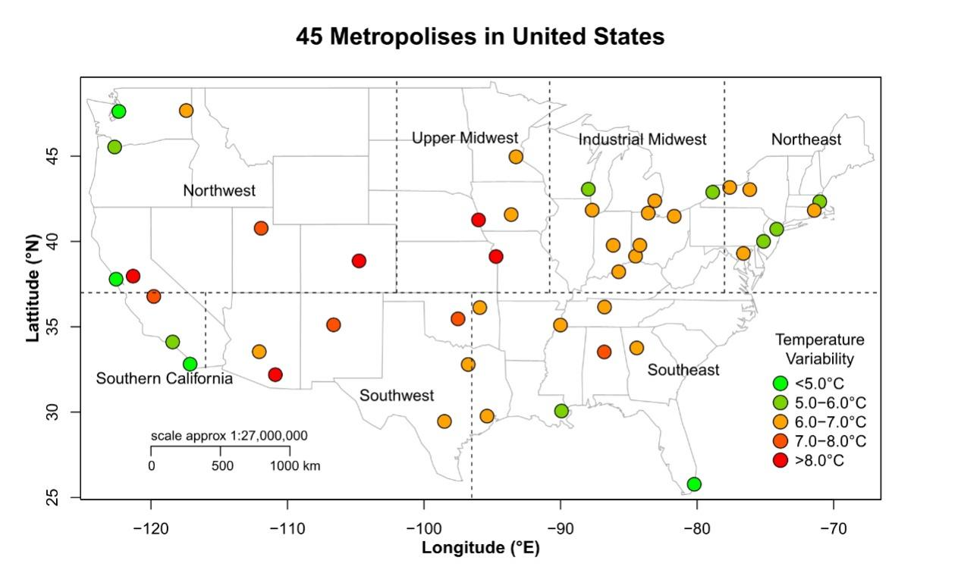
Fig. S1 Locations of 45 metropolises in United States and daily temperature variability of each city (7 regions were divided by dotted lines)

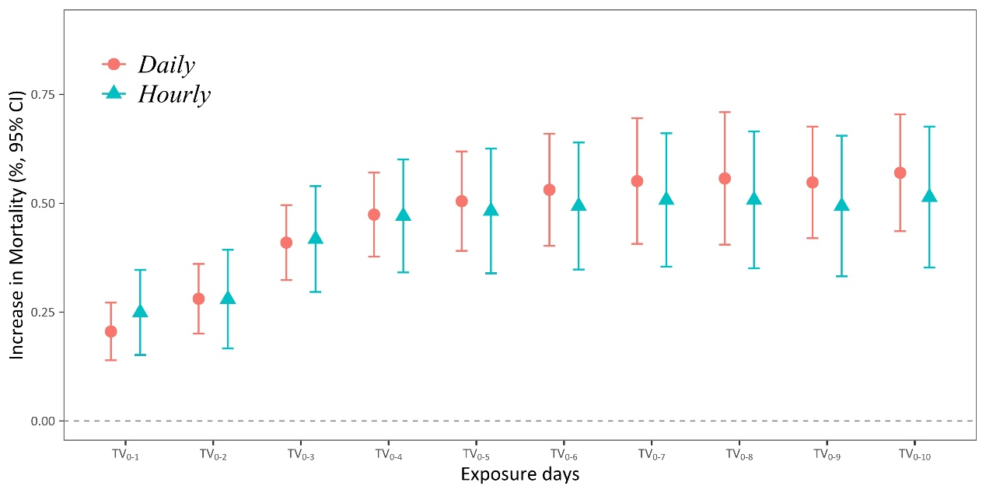
Fig. S2 Mortality changes (%, 95% CIs) associated with per 1 °C increase in TV_{daily} and TV_{hourly} along various exposure days. The solid dots are the average effect estimates and the error bars represent the 95% confidence intervals.

Table S1 Location-specific summary statistics (mean and range) for daily deaths, average temperatures, relative humidity and temperature variability (daily and hourly) in 45 US cities, 1987–2000.

City | Daily number of deaths (count) | Temperature  (°C) | Humidity  (%) | TV_{hourly} | TV_{daily}
Albuquerque | 5.3 (0–23) | 15.8 (− 11.9 to 36.3) | 37.2 (4.4–98.0) | 5.1 (2.5–8.9) | 7.6 (3.9–11.8)
Atlanta | 12.4 (0–48) | 18.5 (− 9.7 to 34.8) | 61.6 (17.5–100) | 4.5 (2.0–10.4) | 6.2 (3.1–11.6)
Baltimore | 10.7 (0–46) | 14.0 (− 16.1 to 34.4) | 66.6 (17.2–100) | 4.8 (2.0–9.9) | 6.6 (2.9–11.5)
Birmingham | 9.1 (0–51) | 17.3 (− 13.5 to 33.4) | 69.4 (21.8–100) | 5.1 (2.0–11.1) | 7.1 (2.8–11.9)
Boston | 6.7 (0–32) | 11.2 (− 15.8 to 34.2) | 65.5 (15.5–100) | 4.2 (1.4–9.3) | 5.5 (2.3–10.3)
Buffalo | 12.8 (0–50) | 9.8 (−19.5 to 32.0) | 69.2 (23.0–100) | 4.5 (1.3–9.9) | 6.0 (1.9–11.3)
Chicago | 60.0 (8–434) | 10.5 (− 25.9 to 34.9) | 69.2 (25.6–100) | 4.8 (1.5–12.5) | 6.5 (1.7–13.0)
Cincinnati | 10.4 (0–43) | 13.4 (− 24.5 to 33.8) | 66.4 (24.9–100) | 5.2 (1.6–10.7) | 6.7 (2.3–12.3)
Cleveland | 19.0 (1–68) | 11.2 (− 23.9 to 34.4) | 69.6 (25.1–100) | 4.7 (1.1–10.2) | 6.3 (1.6–11.3)
Colorado Springs | 3.5 (0–17) | 9.6 (−26.9 to 29.6) | 52.6 (7.4–100) | 5.9 (1.9–14.1) | 8.3 (3.3–16.0)
Dallas/Fort Worth | 28.9 (0–108) | 20.2 (− 12.5 to 37.0) | 58.4 (20.1–100) | 4.9 (2.2–11.5) | 7.0 (3.2–13.7)
Dayton | 6.7 (0–28) | 12.3 (− 27.6 to 34.7) | 67.5 (24.8–100) | 5.0 (1.6–11.5) | 6.6 (2.5–12.1)
Des Moines | 4.1 (0–18) | 11.3 (− 27.2 to 34.7) | 66.4 (18.2–100) | 5.1 (1.1–13.8) | 6.8 (1.5–14.6)
Detroit | 24.6 (2–86) | 11.0 (− 22.2 to 33.8) | 66.6 (23.1–100) | 4.6 (1.2–10.0) | 6.2 (1.9–11.0)
Fresno | 6.6 (0–34) | 20.0 (− 1.9 to 39.2) | 53.6 (14.9–100) | 5.1 (1.1–7.9) | 7.4 (1.9–11.0)
Houston | 23.2 (1–80) | 21.3 (− 8.1 to 34.3) | 70.9 (21.5–100) | 4.8 (1.3–11.4) | 6.7 (2.2–12.8)
Indianapolis | 9.3 (0–36) | 12.9 (− 26.5 to 35.4) | 67.5 (26.5–100) | 4.9 (1.3–11.9) | 6.6 (2.0–13.0)
Kansas City, KS | 2.3  (0–12) | 13.9 (− 23.7 to 35.8) | 62.9 (16.5–100) | 5.2 (1.6–12.9) | 8.4 (2.5–15.9)
Los Angeles | 77.3 (14–280) | 17.5 (5.4 to 30.7) | 71.6 (9.5–100) | 2.6 (1.0–6.3) | 5.8 (2.2–9.9)
Louisville | 8.8 (0–35) | 15.5 (− 22.5 to 34.9) | 63.4 (22.5–100) | 4.9 (1.3–11.2) | 6.5 (2.0–12.0)
Memphis | 9.9 (0–40) | 17.7 (− 15.5 to 34.2) | 65.0 (20.9–100) | 4.7 (1.6–11.4) | 6.4 (2.5–12.5)
Miami | 23.1 (1–84) | 25.1 (4.0 to 33.1) | 71.2 (22.6–98.1) | 2.8 (1.3–8.8) | 4.2 (2.3–10.1)
Milwaukee | 11.4 (0–56) | 9.3 (− 26.1 to 35.6) | 70.3 (19.9–100) | 4.4 (1.0–12.8) | 5.8 (1.3–11.6)
Minneapolis/St. Paul | 14.5 (0–57) | 8.8 (− 30.0 to 35.5) | 64.6 (17.0–100) | 4.8 (1.0–13.4) | 6.5 (1.2–14.3)
Nashville | 6.1 (0–27) | 16.2 (− 18.5 to 34.7) | 65.8 (18.0–100) | 5.0 (1.8–11.1) | 6.9 (2.8–12.2)
New Orleans | 6.4 (0–27) | 20.6 (− 7.5 to 32.5) | 75.2 (27.8–100) | 4.1 (1.4–10.1) | 5.8 (2.6–11.3)
Newark | 9.8 (0–42) | 13.8 (− 15.8 to 35.9) | 61.6 (14.4–100) | 4.3 (1.7–9.2) | 5.8 (2.6–10.7)
Oklahoma City | 7.4 (0–33) | 16.8 (− 17.7 to 36.6) | 62.0 (14.6–100) | 5.1 (1.8–11.6) | 7.0 (2.5–13.7)
Omaha | 4.5 (0–21) | 12.3 (− 27.9 to 36.0) | 65.1 (23.4–100) | 5.4 (1.4–13.3) | 8.2 (2.5–14.6)
Philadelphia | 22.4 (1–85) | 14.0 (− 17.0 to 34.7) | 64.2 (18.6–100) | 4.4 (1.9–9.5) | 6.0 (2.7–12.7)
Phoenix | 23.3 (1–94) | 26.5 (4.2 to 46.2) | 28.9 (5.5–96.4) | 4.7 (2.3–8.1) | 7.0 (3.5–10.1)
Portland | 9.8 (0–43) | 13.6 (− 10.8 to 32.4) | 69.2 (19.4–100) | 3.8 (1.2–8.7) | 5.5 (2.0–10.3)
Providence | 7.4 (0–38) | 11.0 (− 16.1 to 32.4) | 68.5 (17.1–100) | 4.4 (1.7–8.6) | 6.1 (2.9–10.2)
Rochester | 7.8 (0–34) | 9.5 (− 20.6 to 32.8) | 70.5 (25.2–100) | 4.8 (1.1–9.8) | 6.4 (1.6–12.0)
Salt Lake City | 5.4 (0–27) | 12.7 (− 20.8 to 35.2) | 53.2 (10.6–99.6) | 4.9 (1.2–8.8) | 7.0 (2.3–10.5)
San Antonio | 11.4 (0–50) | 22.3 (− 8.0 to 35.9) | 58.8 (16.7–99.6) | 4.9 (1.8–11.0) | 6.9 (3.2–12.6)
San Diego | 22.7 (1–91) | 17.6 (7.7 to 29.7) | 73.8 (11.9–100) | 2.4 (0.9–6.1) | 3.8 (1.5–7.9)
San Francisco | 9.2 (0–39) | 14.2 (1.1 to 29.3) | 74.5 (22.5–100) | 2.9 (1.1–6.3) | 4.6 (2.0–8.7)
Seattle | 13.6 (0–51) | 12.3 (− 10.8 to 31.1) | 71.5 (17.8–100) | 3.3 (1.2–8.1) | 4.8 (1.9–8.9)
Spokane | 5.1 (0–23) | 9.8 (− 23.0 to 33.6) | 62.5 (14.6–100) | 4.6 (1.0–11.8) | 6.5 (1.7–12.8)
Stockton | 5.2 (0–23) | 18.4 (− 2.6 to 35.7) | 54.9 (17.0–100) | 5.0 (1.0–8.3) | 10.1 (3.8–15.3)
Syracuse | 5.7 (0–27) | 9.6 (− 22.6 to 31.7) | 69.5 (26.0–100) | 5.0 (1.1–10.5) | 6.6 (1.9–12.1)
Toledo | 5.6 (0–27) | 11.1 (− 24.6 to 35.6) | 68.9 (23.2–100) | 5.0 (1.1–10.1) | 6.7 (1.9–11.7)
Tucson | 8.0 (0–38) | 23.2 (− 0.3 to 41.9) | 32.9 (5.0–99.5) | 5.8 (3.0–8.9) | 8.4 (4.8–11.9)
Tulsa | 5.8 (0–31) | 17.3 (− 16.6 to 39.5) | 60.8 (19.1–100) | 5.1 (1.7–12.5) | 6.9 (2.1–14.0)

Table S2 Summary characteristics of daily number of cause-specific deaths (mean and range) in 45 US cities.

City | Non-accidental | Cardiorespiratory | Cardiovascular | Respiratory
Albuquerque | 5.0 (0–23) | 2.3 (0–14) | 1.9 (0–13) | 0.4 (0–6)
Atlanta | 11.8 (0–48) | 5.2 (0–27) | 4.3 (0–24) | 0.9 (0–8)
Baltimore | 10.4 (0–46) | 4.6 (0–31) | 3.9 (0–29) | 0.7 (0–7)
Birmingham | 8.7 (0–38) | 4.1 (0–29) | 3.4 (0–22) | 0.7 (0–8)
Boston | 6.6 (0–32) | 3.0 (0–20) | 2.5 (0–19) | 0.6 (0–8)
Buffalo | 12.5 (0–50) | 6.7 (0–34) | 5.8 (0–30) | 0.9 (0–10)
Chicago | 57.7 (8–411) | 28.9 (1–327) | 24.5 (1–312) | 4.3 (0–34)
Cincinnati | 10.1 (0–43) | 5.1 (0–28) | 4.2 (0–22) | 0.9 (0–9)
Cleveland | 18.4 (0–68) | 9.4 (0–45) | 8.2 (0–40) | 1.2 (0–11)
Colorado Springs | 3.4 (0–16) | 1.4 (0–11) | 1.0 (0–9) | 0.4 (0–6)
Dallas/Fort Worth | 27.5 (1–103) | 13.6 (0–66) | 11.4 (0–52) | 2.2 (0–28)
Dayton | 6.5 (0–27) | 3.2 (0–18) | 2.7 (0–17) | 0.5 (0–7)
Des Moines | 3.9 (0–18) | 2.2 (0–13) | 1.9 (0–11) | 0.3 (0–6)
Detroit | 23.8 (2–81) | 12.5 (0–52) | 10.8 (0–50) | 1.7 (0–12)
Fresno | 6.15 (0–28) | 3.1 (0–20) | 2.5 (0–17) | 0.6 (0–10)
Houston | 22.1 (1–78) | 10.2 (0–46) | 8.8 (0–39) | 1.4 (0–13)
Indianapolis | 9.0 (0–34) | 4.4 (0–24) | 3.6 (0–19) | 0.8 (0–9)
Kansas City, KS | 2.2 (0–12) | 0.8 (0–9) | 0.6 (0–9) | 0.1 (0–3)
Los Angeles | 74.0 (13–269) | 39.8 (2–176) | 33.3 (1–149) | 6.6 (0–64)
Louisville | 8.5 (0–34) | 4.3 (0–22) | 3.5 (0–19) | 0.8 (0–9)
Memphis | 9.5 (0–38) | 4.9 (0–23) | 4.2 (0–21) | 0.7 (0–8)
Miami | 22.1 (1–81) | 11.1 (0–52) | 9.5 (0–48) | 1.6 (0–14)
Milwaukee | 11.0 (0–47) | 5.7 (0–37) | 4.7 (0–29) | 0.9 (0–8)
Minneapolis/St. Paul | 13.93 (0–57) | 6.4 (0–32) | 5.1 (0–25) | 1.3 (0–10)
Nashville | 5.8 (0–26) | 2.9 (0–20) | 2.4 (0–16) | 0.5 (0–7)
New Orleans | 6.2 (0–27) | 2.7 (0–16) | 2.4 (0–15) | 0.4 (0–5)
Newark | 9.4 (0–40) | 4.0 (0–22) | 3.5 (0–20) | 0.6 (0–10)
Oklahoma City | 7.1 (0–31) | 3.7 (0–21) | 3.0 (0–18) | 0.6 (0–9)
Omaha | 4.4 (0–21) | 2.2 (0–14) | 1.8 (0–13) | 0.4 (0–6)
Philadelphia | 21.4 (1–77) | 9.9 (0–49) | 8.5 (0–48) | 1.4 (0–11)
Phoenix | 22.0 (0–90) | 11.0 (0–54) | 8.7 (0–44) | 2.3 (0–20)
Portland | 9.4 (0–43) | 4.5 (0–29) | 3.7 (0–22) | 0.9 (0–13)
Providence | 7.3 (0–38) | 3.6 (0–24) | 3.0 (0–20) | 0.6 (0–9)
Rochester | 7.6 (0–34) | 3.7 (0–22) | 3.0 (0–18) | 0.7 (0–12)
Salt Lake City | 5.2 (0–24) | 2.4 (0–16) | 1.9 (0–13) | 0.5 (0–7)
San Antonio | 10.9 (0–50) | 5.2 (1–31) | 4.4 (0–24) | 0.8 (0–11)
San Diego | 21.7 (0–89) | 11.0 (0–61) | 8.8 (0–44) | 2.2 (0–26)
San Francisco | 8.8 (0–38) | 3.8 (0–22) | 3.1 (0–21) | 0.7 (0–8)
Seattle | 13.1 (0–51) | 6.3 (0–33) | 5.0 (0–26) | 1.2 (0–11)
Spokane | 4.9 (0–23) | 2.3 (0–15) | 1.8 (0–13) | 0.4 (0–7)
Stockton | 4.7 (0–22) | 2.5 (0–16) | 2.0 (0–13) | 0.4 (0–7)
Syracuse | 5.5 (0–26) | 2.6 (0–21) | 2.1 (0–17) | 0.5 (0–6)
Toledo | 5.4 (0–26) | 2.9 (0–19) | 2.5 (0–17) | 0.4 (0–7)
Tucson | 7.6 (0–36) | 3.9 (0–23) | 3.1 (0–19) | 0.8 (0–11)
Tulsa | 5.6 (0–30) | 2.9 (0–19) | 2.4 (0–17) | 0.5 (0–7)

Table S3 Cause-specific attributable fractions (%, 95% CIs) from lag 0−1 days to lag 0−10 days between two composite indexes.

TVdaily
Lag | Total | Non-accidental | Cardiorespiratory | Cardiovascular | Respiratory
0−1 | 1.26 (0.86−1.66) | 1.08 (0.66−1.48) | 1.26 (0.66−1.85) | 1.24 (0.51−1.97) | 1.54 (−0.29−3.33)
0−2 | 1.48 (1.04−1.91) | 1.30 (0.84−1.76) | 1.44 (0.79−2.09) | 1.39 (0.60−2.18) | 1.70 (−0.10−3.48)
0−3 | 1.80 (1.34−2.26) | 1.65 (1.15−2.14) | 1.77 (1.04−2.48) | 1.67 (0.81−2.53) | 2.19 (0.38−3.96)
0−4 | 2.06 (1.57−2.55) | 1.92 (1.40−2.44) | 2.06 (1.30−2.82) | 1.94 (1.07−2.80) | 2.64 (0.79−4.45)
0−5 | 2.26 (1.73−2.78) | 2.12 (1.56−2.68) | 2.28 (1.50−3.05) | 2.15 (1.23−3.05) | 2.87 (0.96−4.74)
0−6 | 2.42 (1.85−2.98) | 2.28 (1.68−2.87) | 2.42 (1.59−3.24) | 2.30 (1.34−3.25) | 2.96 (1.02−4.85)
0−7 | 2.55 (1.94−3.15) | 2.41 (1.77−3.05) | 2.55 (1.67−3.42) | 2.43 (1.42−3.43) | 3.07 (1.11−4.99)
0−8 | 2.65 (2.00−3.29) | 2.52 (1.86−3.17) | 2.67 (1.74−3.58) | 2.55 (1.49−3.60) | 3.16 (1.15−5.13)
0−9 | 2.73 (2.07−3.38) | 2.60 (1.92−3.29) | 2.75 (1.79−3.69) | 2.63 (1.52−3.72) | 3.22 (1.15−5.24)
0−10 | 2.80 (2.13−3.47) | 2.68 (1.97−3.39) | 2.82 (1.82−3.81) | 2.70 (1.55−3.83) | 3.29 (1.15−5.39)
TVhourly
Lag | Total | Non-accidental | Cardiorespiratory | Cardiovascular | Respiratory
0−1 | 0.86 (0.53−1.20) | 0.74 (0.40−1.08) | 0.90 (0.42−1.38) | 0.89 (0.30−1.40) | 1.26 (−0.10−2.59)
0−2 | 0.95 (0.57−1.33) | 0.84 (0.46−1.22) | 0.91 (0.40−1.43) | 0.90 (0.29−1.51) | 1.14 (−0.21−2.46)
0−3 | 1.17 (0.76−1.57) | 1.07 (0.66−1.48) | 1.12 (0.56−1.67) | 1.06 (0.42−1.69) | 1.45 (0.11−2.77)
0−4 | 1.34 (0.91−1.77) | 1.26 (0.83−1.70) | 1.33 (0.75−1.90) | 1.25 (0.59−1.91) | 1.73 (0.37−3.07)
0−5 | 1.47 (1.01−1.93) | 1.39 (0.92−1.86) | 1.48 (0.87−2.10) | 1.42 (0.71−2.13) | 1.81 (0.42−3.18)
0−6 | 1.56 (1.08−2.05) | 1.49 (0.99−1.98) | 1.58 (0.92−2.24) | 1.53 (0.77−2.29) | 1.84 (0.41−3.24)
0−7 | 1.65 (1.14−2.15) | 1.57 (1.05−2.08) | 1.67 (0.97−2.37) | 1.63 (0.82−2.43) | 1.89 (0.43−3.34)
0−8 | 1.71 (1.19−2.23) | 1.64 (1.10−2.18) | 1.75 (1.01−2.49) | 1.72 (0.86−2.56) | 1.93 (0.42−3.41)
0−9 | 1.76 (1.21−2.30) | 1.69 (1.13−2.25) | 1.82 (1.05−2.59) | 1.79 (0.90−2.67) | 1.94 (0.38−3.47)
0−10 | 1.81 (1.25−2.36) | 1.75 (1.17−2.32) | 1.88 (1.08−2.68) | 1.85 (0.92−2.77) | 1.97 (0.36−3.55)

Table S4 All-cause and cause-specific attributable fractions (%, 95% CIs) at lag 0–7 days stratified by three age groups.
TV_{daily}
Age(years) | Total | Non-accidental | Cardiorespiratory | Cardiovascular | Respiratory
All ages | 2.55 (1.94–3.15) | 2.41 (1.77–3.05) | 2.55 (1.67–3.42) | 2.43 (1.42–3.43) | 3.07 (1.11–4.99)
0–64 | 2.55 (1.94–3.16) | 2.42 (1.77–3.06) | 2.57 (1.69–3.45) | 2.45 (1.43–3.46) | 3.10 (1.12–5.04)
65–74 | 2.57 (1.95–3.18) | 2.43 (1.78–3.07) | 2.57 (1.69–3.45) | 2.45 (1.43–3.46) | 3.10 (1.12–5.04)
≥75 | 2.54 (1.93–3.14) | 2.41 (1.76–3.04) | 2.54 (1.67–3.41) | 2.43 (1.41–3.42) | 3.06 (1.10–4.97)
TV_{hourly}
Age(years) | Total | Non-accidental | Cardiorespiratory | Cardiovascular | Respiratory
All ages | 1.65 (1.14–2.15) | 1.57 (1.05–2.08) | 1.67 (0.97–2.37) | 1.63 (0.82–2.43) | 1.89 (0.43–3.34)
0–64 | 1.64 (1.14–2.15) | 1.57 (1.05–2.08) | 1.69 (0.98–2.40) | 1.65 (0.83–2.46) | 1.94 (0.44–3.41)
65–74 | 1.66 (1.15–2.17) | 1.59 (1.06–2.11) | 1.69 (0.98–2.39) | 1.65 (0.83–2.46) | 1.92 (0.43–3.38)
≥75 | 1.64 (1.14–2.14) | 1.56 (1.05–2.07) | 1.66 (0.96–2.35) | 1.62 (0.81–2.41) | 1.88 (0.42–3.30)

Table S5 Sensitivity Analysis by changing df for calendar time, maximum lag and internal knots for temperature in the first-stage regression.

lag=7 days
 | ERR (%, 95%CI) |  | AF (%, 95%CI)
 | TV_{daily} | TV_{hourly} | TV_{daily} | TV_{hourly}
df/year
6 | 0.54 (0.42–0.65) | 0.49 (0.33–0.65) | 2.51 (1.90–3.11) | 1.62 (1.11–2.12)
8 | 0.54 (0.42–0.65) | 0.50 (0.34–0.66) | 2.51 (1.90–3.11) | 1.62 (1.11–2.12)
Maximum lag
14 days | 0.54 (0.42–0.66) | 0.49 (0.33–0.65) | 2.53 (1.94–3.12) | 1.62 (1.10–2.14)
28 days | 0.56 (0.41–0.71) | 0.52 (0.36–0.70) | 2.58 (1.94–3.21) | 1.67 (1.16–2.18)
Internal knots
25th, 50th, 75th | 0.55 (0.41–0.70) | 0.51 (0.36–0.67) | 2.57 (1.97–3.16) | 1.67 (1.15–2.18)

1 * Corresponding author: Q. Wang, School of Public Health, Hubei University of Medicine, Shiyan 442000, China. E-mail: hbmu@hbmu.edu.cn

