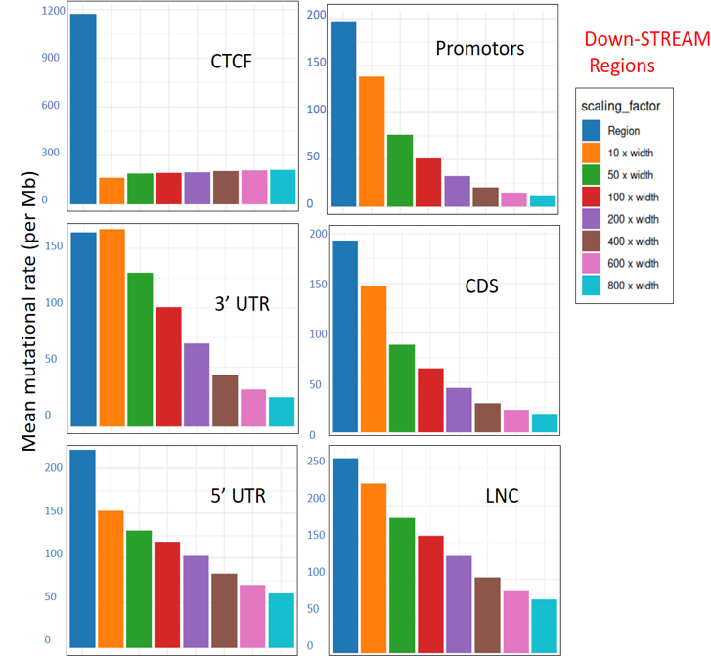
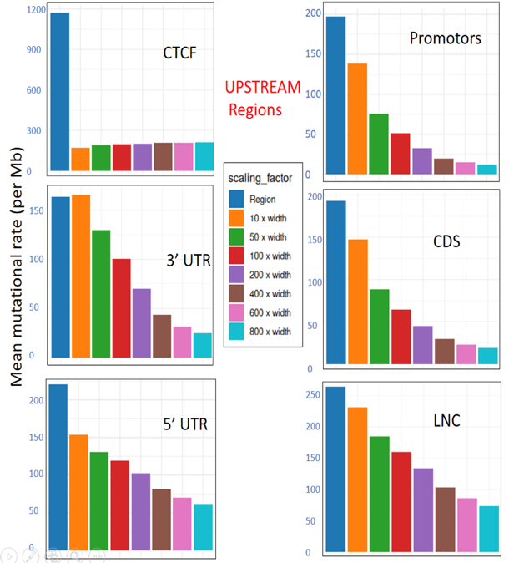
Supplementary Figure 1 (Genomic elements scaling upstream and Downstream): Mutation rate across various genomic regions/elements and their surrounding regions using various scaling factors. This figure illustrates the mutation rate (per megabase) for six different genomic regions, i.e. CTCF, 3' UTR, 5' UTR, promoter regions, long non-coding regions, and CDS) and their surrounding regions defined by scaling factors (10x, 50x, 100x, 200x, 400x, 600x, 800x). The plot highlights mean mutation rate across all samples, revealing differences in mutation patterns between genomic elements and their surrounding regions at various scaling factors.

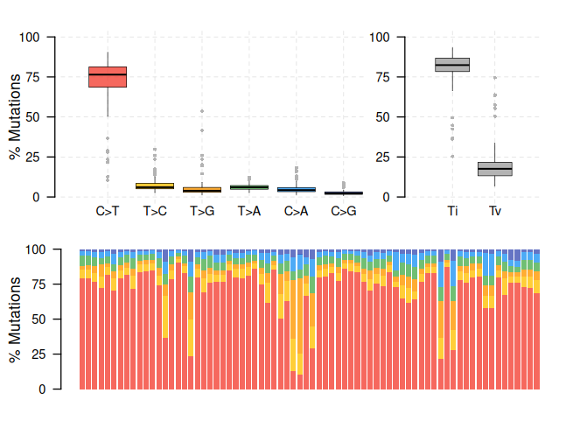
Supplementary Figure 2 (Overall substitution types per sample): This stacked bar chart shows the proportion of each substitution type (overall) across different samples. The data is grouped by substitution type (e.g., C>A, C>T, T>C, etc.) and normalized within each sample to show the relative fraction of each mutation type. Where each bar represents a sample, and the segments within each bar show the fraction of each substitution type in that sample. The fill color corresponds to the substitution type, allowing you to visually compare how the substitution profile differs across samples.

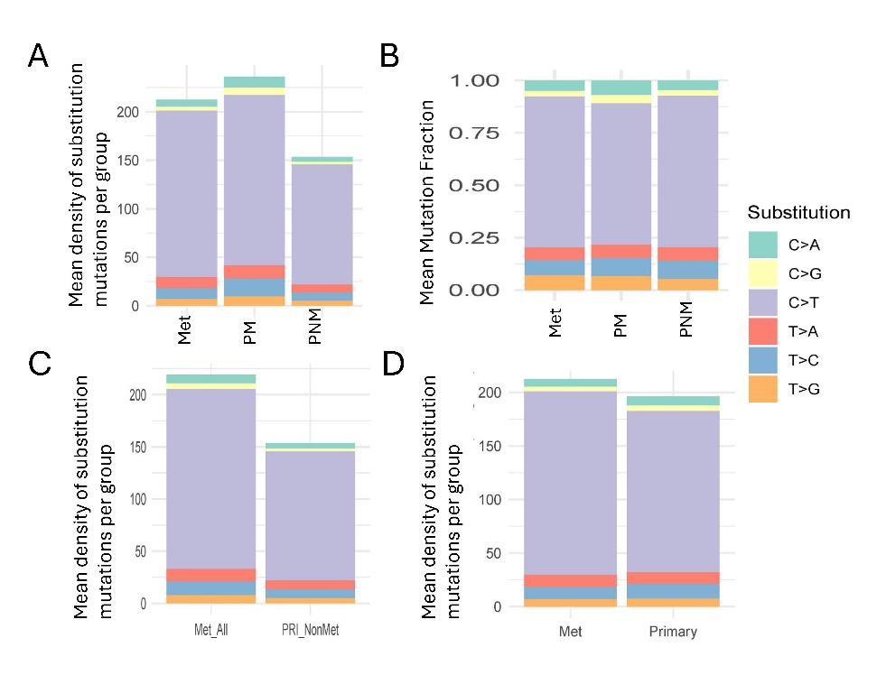
Supplementary Figure 3. Mean density and fraction of substitution mutations across sample groups. (A) Stacked bar plot showing the mean density of substitution mutations per group: LNM (Met), PM, and PNM. (B) Mean mutation fraction of each substitution type across the same groups. (C) Comparison of mean substitution mutation density between Met_All (combined LNM and PM) and PNM. (D) Comparison between LNM (Met) and Primary (combined PM and PNM). Although different substitution types contribute variably across groups, no significant difference in the overall mutation proportions is observed.
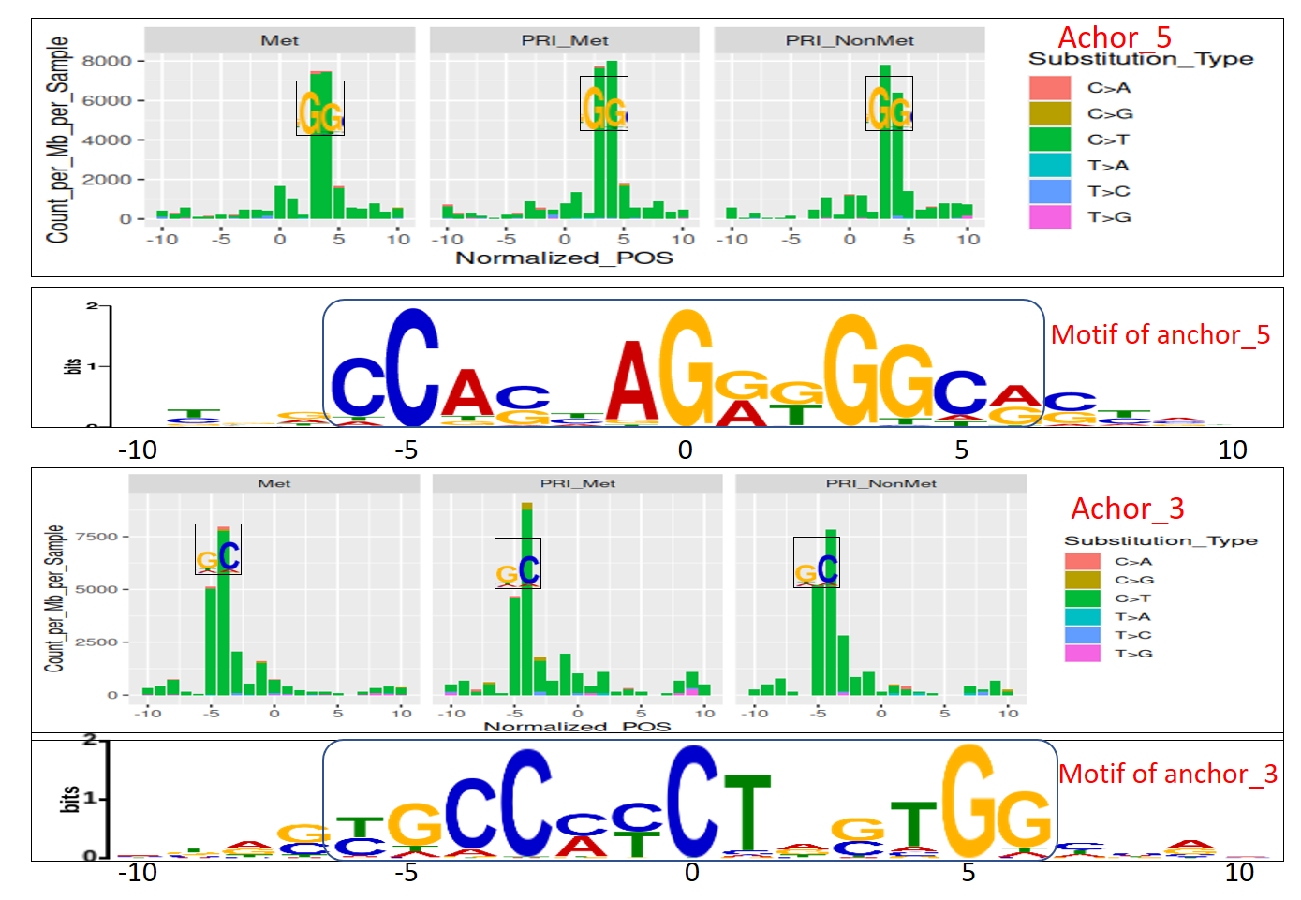
Supplementary Figure 4: Mutation Distribution at CTCFbs Regions (Top Panels): Distribution of mutation counts per megabase per sample (Count_per_Mb_per_Sample) across normalized positions (Normalized_POS) surrounding Anchor5. Data is shown for three clinical groups: Lymph node metastasis (LNM/Met), primary metastasis (PRI_Met), and primary non-metastasis (PRI_NonMet). The colors represent different nucleotide substitution types, as indicated in the legend. The black box highlights the prominent C>T transition peak at position 3/4. (Middle Panel): Sequence logo representing the motif of Anchor5, demonstrating nucleotide frequencies at each position. (Bottom Panels): Distribution of mutation counts per megabase per sample (Count_per_Mb_per_Sample) across normalized positions (Normalized_POS) surrounding Anchor3, shown for the same clinical groups and substitution types as in the top panels. The black box highlights the prominent C>T transition peak at position -4.
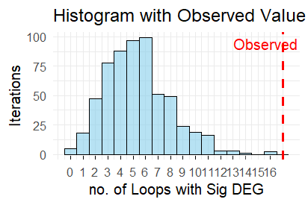
Supplementary Figure 5: This figure displays the results of a permutation test conducted to evaluate the significance of the observed association between CTCF binding site (CTCFbs) mutations and differential gene expression (DEG). The histogram represents the distribution of the number of loops with significant DEG across 1000 iterations of the permutation test.

