Supplemental Figures

SUPPLEMENTAL FIGURE 1. Lung metastases develop in all mice in the 4T1 model regardless of treatment to the primary tumor. (A) H&E staining. (B) CD8 staining. Bar = 5mm, magnification box 1.3mm
SUPPLEMENTAL FIGURE 2. Treatment responses after early imaging with CD8 immunoPET. (A) Growth curves for individual tumors treated with 8 Gy x3 + anti-CTLA4 (n=12). (B) Representative coronal maximum intensity projections CD8 immunoPET imaging 1 day post-treatment. Left, 2 mice with subsequent complete response of primary tumor (“responder”); middle, two mice with subsequent partial response and eventual tumor outgrowth (“partial responder”); right, two untreated mice with size-matched tumors. Pink arrow, tumor; yellow arrowheads, ipsilateral inguinal lymph nodes. (C) Mean %ID/cc for complete responders was 3.1 (n=2) vs 3.8 (n=10) for partial responders (p=0.234). (D) CD8 staining for residual tumor tissue in responders and two representative partial responders (bar = 500mm). CD8⁺ cell count/mm² at the final endpoint was calculated for both tumors that had partially responded and those with visible regression by caliper measurement but small residual tissue on dissection.

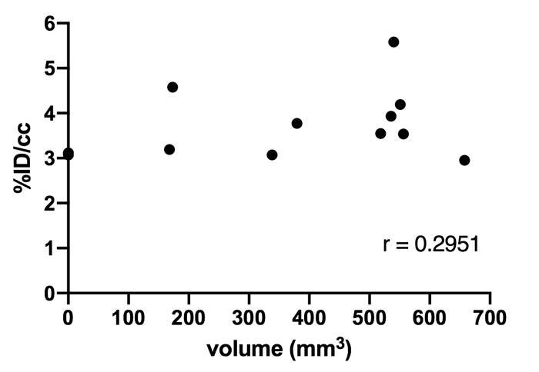

SUPPLEMENTAL FIGURE 3. Late tumor responses do not correlate with tumor PET signal at early imaging timepoint. Tumor size at final endpoint (36 days) was plotted against %ID/cc from imaging timepoint at day 15 for all tumors treated with 8 Gy x3 + anti-CTLA4 (n=12).

