Supplementary materials for “ASET: An end-to-end pipeline for quantification and visualization of allele specific expression”

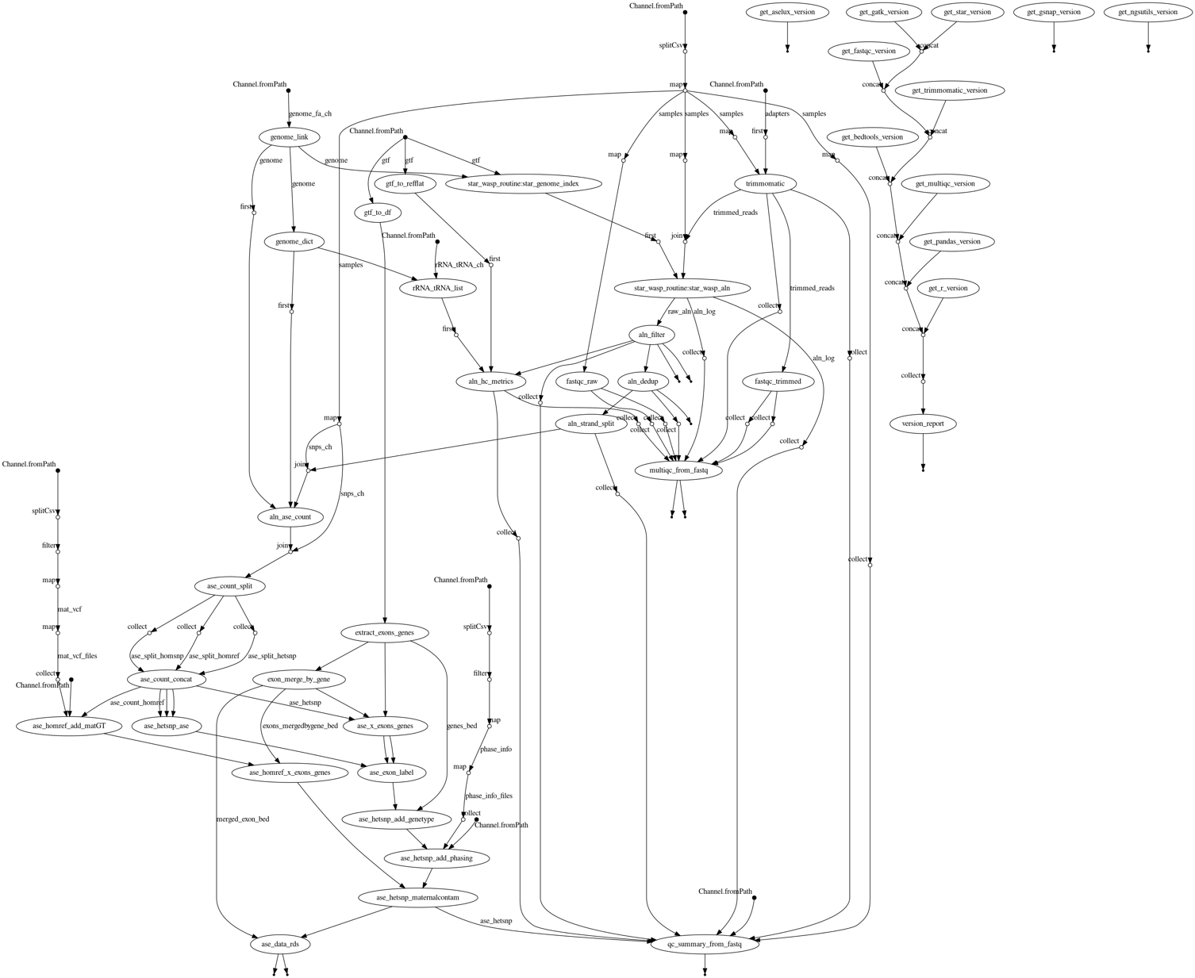
Supplementary Figure 1. ASET Nextflow pipeline DAG (STAR+WASP alignment approach).
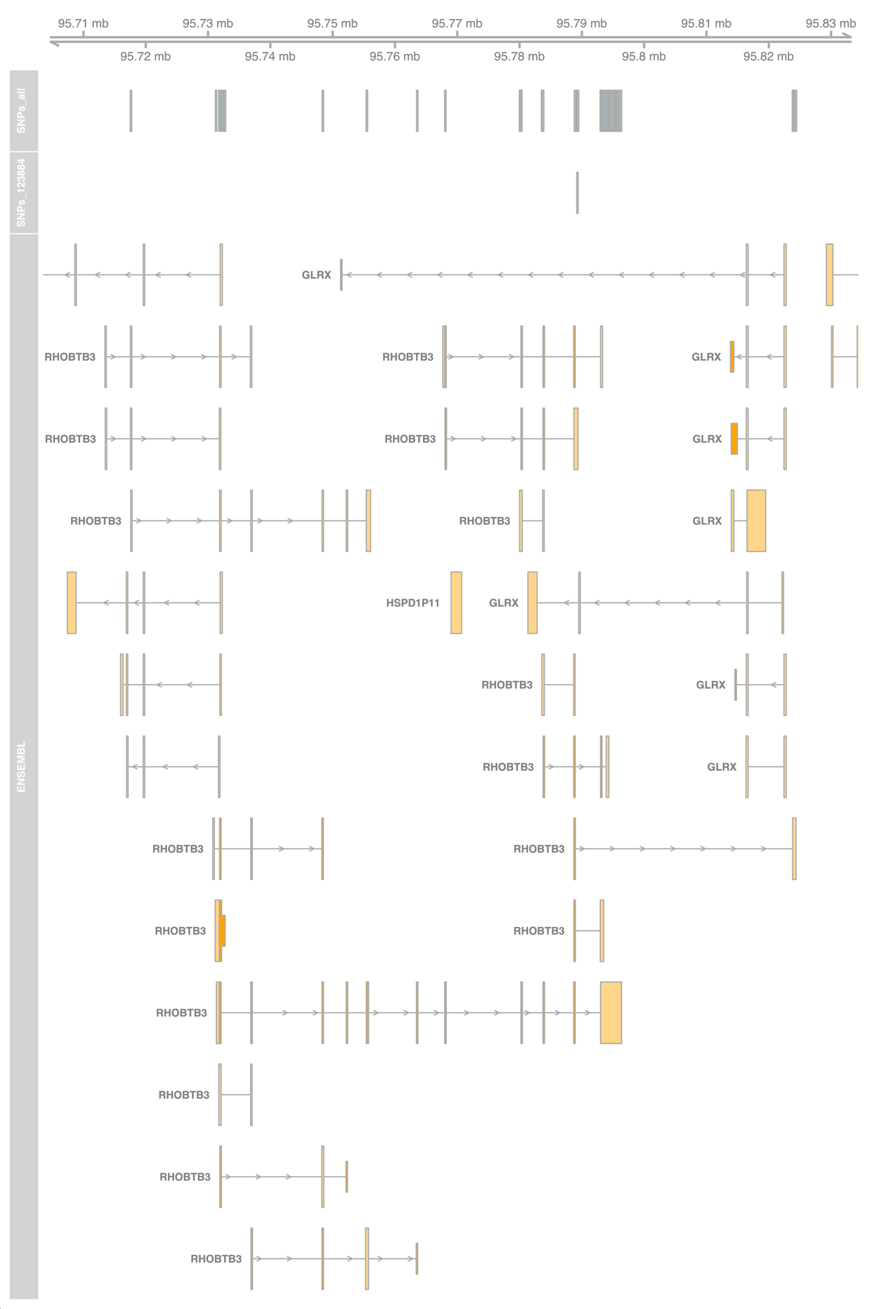
Supplementary Figure 2. SNP locations in the RHOBTB3 gene locus, with each isoform shown separately.

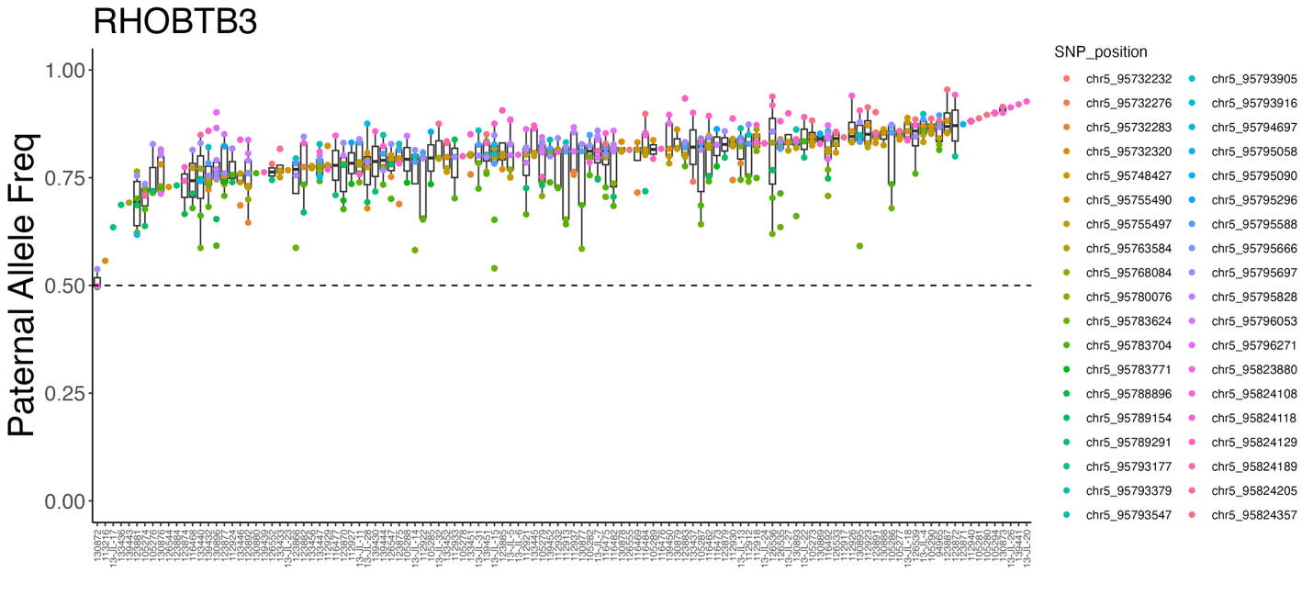
Supplementary Figure 3. Distribution of SNP-level paternal allele frequency across different samples in a gene, shown as a boxplot where each unique SNP position is indicated

