Supplementary data

S1. The experimental design for photocatalytic degradation of azithromycin utilizing Fe/Zn-CNFs includes levels of independent variables.
Variables | Symbols | Levels
Variables | Symbols | -1 | +1
pH | A | 3 | 11
Time (min) | B | 10 | 120
Catalyst concentration (mg/L) | C | 0.5 | 30
Azithromycin concentration (mg/L) | D | 10 | 100

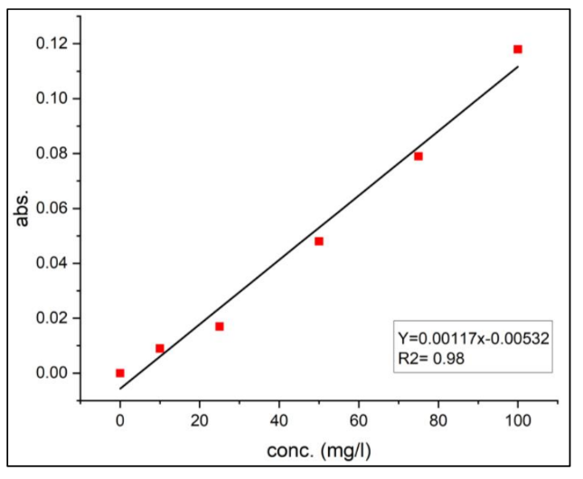
S2. Calibration curve of absorbance values read at a wavelength of 462 nm for varying concentrations of azithromycin

S3. The results of the BET analysis of the synthesized samples
Total pore Volume  (cm³/g) | Average pore diameter  (nm) | BET surface area  (m²/g) | Sample
0.4866 | 3.5121 | 554.18 | Fe/Zn (1:2)
0.4733 | 7.5165 | 251.89 | Fe/Zn (2:1)

S4. The results of Dynamic Light Scattering and Zeta potential experiments
Electrophoretic mobility (cm²/Vs) | Size  (nm) | zeta potential  (mV) | sample
0.000421- | 261 | -54.4 | Fe/Zn (2:1)
0.000359- | 374 | -46.3 | Fe/Zn (1:2)

S5. Actual values of interacting variables and their corresponding predicted electrical conductivity responses
Run | Independent Variables (Actual Values) |  |  |  | Response |  | Residual
Run | pH | Time (min) | Catalyst concentration (mg/L) | Azithromycin concentration (mg/L) | Actual Values (%) | Predicted Values | Residual
 | 3 | 120 | 15.25 | 55 | 97.5 | 100 | -4.87
 | 11 | 120 | 15.25 | 55 | 59.78 | 66.17 | -6.39
 | 3 | 10 | 15.25 | 55 | 94.95 | 84.15 | 10.80
 | 7 | 65 | 15.25 | 55 | 65.85 | 75.16 | -9.31
 | 7 | 65 | 30 | 10 | 89.32 | 86.70 | 2.62
 | 7 | 65 | 30 | 100 | 78.25 | 76.98 | 1.27
 | 11 | 10 | 15.25 | 55 | 33.16 | 47.95 | -14.79
 | 7 | 65 | 0.5 | 10 | 83.2 | 73.34 | 9.86
 | 7 | 65 | 15.25 | 55 | 79.02 | 75.16 | 3.86
 | 7 | 65 | 0.5 | 100 | 70.58 | 63.62 | 6.96
 | 7 | 120 | 0.5 | 55 | 78.14 | 77.72 | 0.4215
 | 11 | 65 | 15.25 | 10 | 69.36 | 62.04 | 7.32
 | 7 | 120 | 30 | 55 | 91.37 | 91.08 | 0.2915
 | 7 | 65 | 15.25 | 55 | 72.37 | 75.29 | -2.92
 | 7 | 10 | 0.5 | 55 | 66.27 | 59.49 | 6.78
 | 7 | 65 | 15.25 | 55 | 70.48 | 75.29 | -4.81
 | 11 | 65 | 15.25 | 100 | 60.87 | 52.33 | 8.54
 | 3 | 65 | 15.25 | 10 | 83.99 | 98.25 | -14.26
 | 7 | 10 | 30 | 55 | 68.21 | 72.85 | -4.64
 | 3 | 65 | 15.25 | 100 | 91.8 | 88.53 | 3.27
 | 7 | 10 | 15.25 | 10 | 61.78 | 61.91 | -0.1318
 | 7 | 65 | 15.25 | 55 | 61.75 | 66.17 | -4.42
 | 3 | 65 | 30 | 55 | 95.36 | 90.95 | 4.41
 | 7 | 120 | 15.25 | 100 | 67.39 | 70.42 | -3.03
 | 3 | 65 | 0.5 | 55 | 71.36 | 77.59 | -6.23
 | 7 | 120 | 15.25 | 10 | 85.32 | 80.14 | 5.18
 | 7 | 10 | 15.25 | 100 | 45.78 | 52.20 | -6.42
 | 11 | 65 | 30 | 55 | 60.89 | 54.75 | 6.14
 | 11 | 65 | 0.5 | 55 | 33.69 | 41.39 | -7.70
 | 7 | 65 | 15.25 | 55 | 78.34 | 66.17 | 12.17

S6. ANOVA results for the linear model of azithromycin photocatalytic degradation
Source | Sum of Squares | Mean Square | F-value | p-value
Block | 547.00 | 273.50
Model | 5746.84 | 1436.71 | 22.09 | < 0.0001 | Significant (at 1% level)
A-pH | 3931.68 | 3931.68 | 60.46 | < 0.0001 | Significant (at 1% level)
B-Time | 996.45 | 996.45 | 15.32 | 0.0007 | Significant (at 1% level)
C-Catalyst dose | 535.47 | 535.47 | 8.23 | 0.0087 | Significant (at 1% level)
D-Pollution dose | 283.24 | 283.24 | 4.36 | 0.0482 | Significant (at 5% level)
Residual | 1495.58 | 65.03
Lack of Fit | 1269.45 | 63.47 | 0.8421 | 0.6603 | Not significant

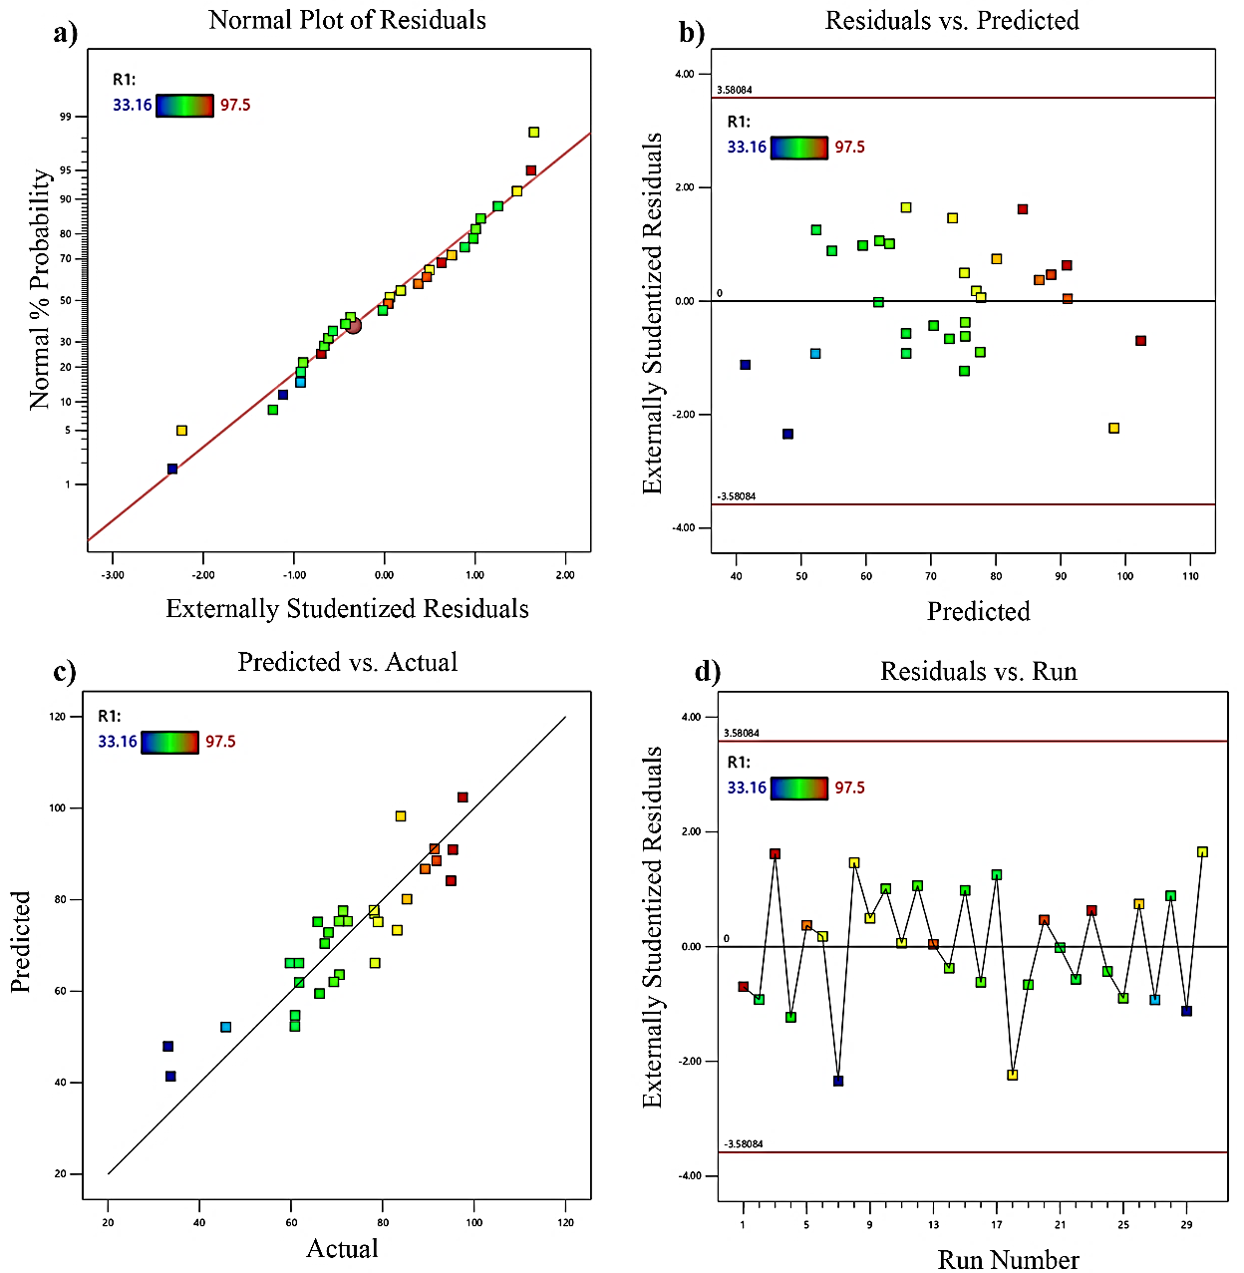
S7. Diagnostic plots for model validation: (a) residuals normality, (b) residuals vs. predicted, (c) predicted vs. actual, and (d) residuals vs. run

