SUPPLEMENTARY MATERIAL

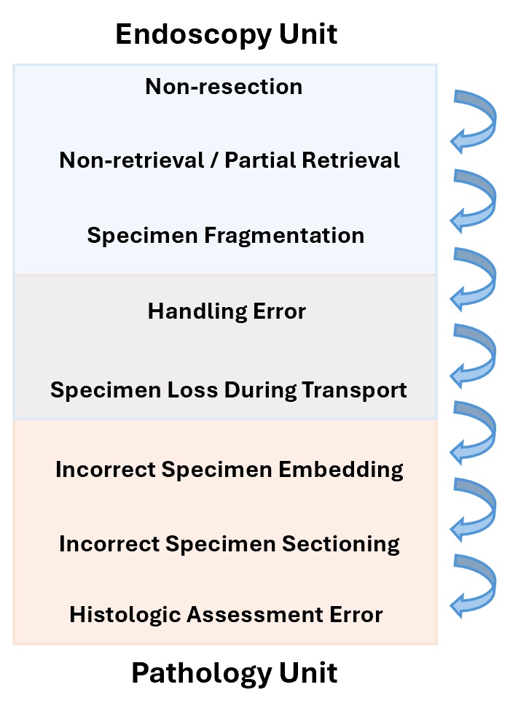
Supplementary Figure 1. Procedural chain of events that could lead to inaccurate pathology diagnosis.

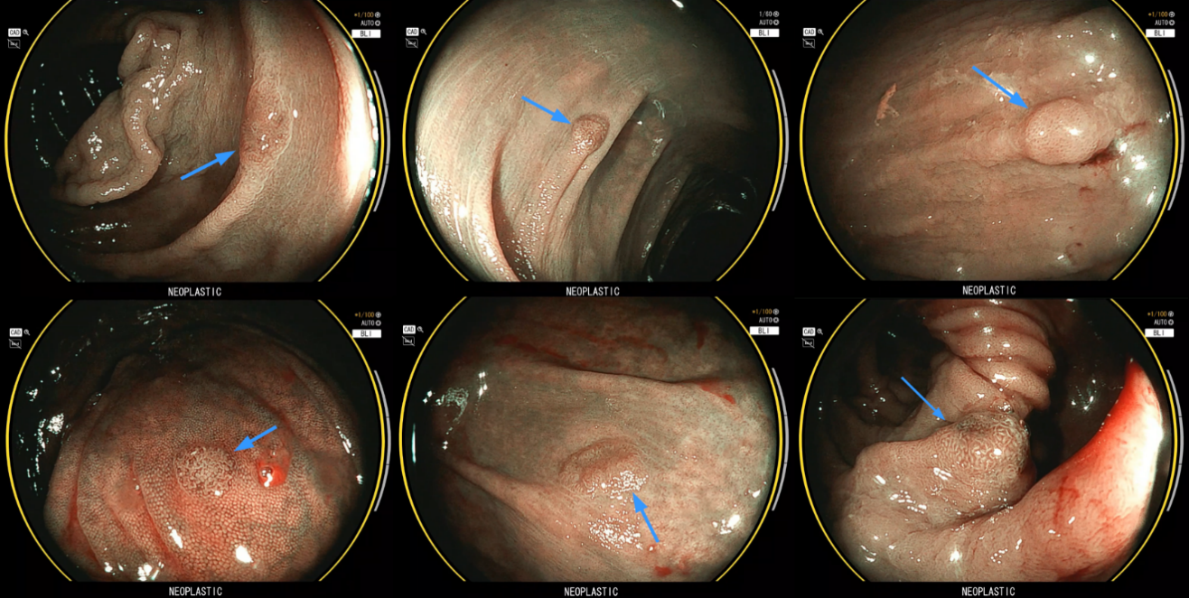
Supplementary Figure 2. Polyps diagnosed as hyperplastic polyps by pathology with unanimous adenoma/neoplastic diagnosis by both expert consensus and computer-aided optical polyp diagnosis (CADx).

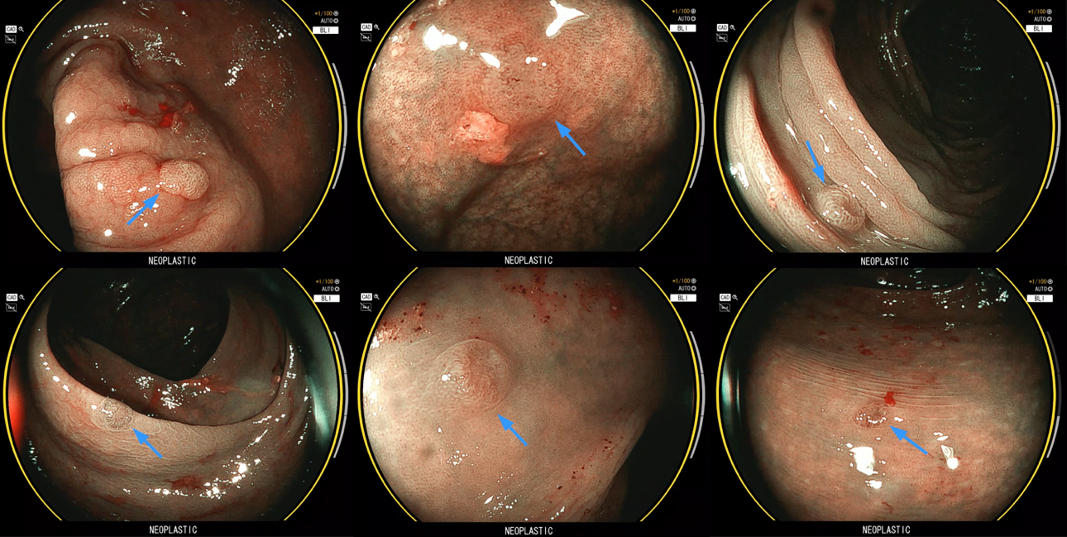
Supplementary Figure 3. Polyps diagnosed as normal mucosa by pathology with unanimous adenoma/neoplastic diagnosis by both expert consensus and computer-aided optical polyp diagnosis (CADx).

