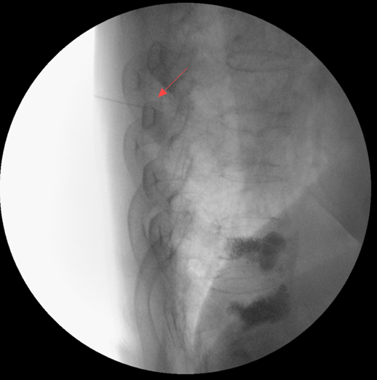

Figure S1 Temporary puncture positioning using a syringe needle under the C-arm,Determine the puncture height to ensure that the puncture passes through the pedicle and enters the vertebral body

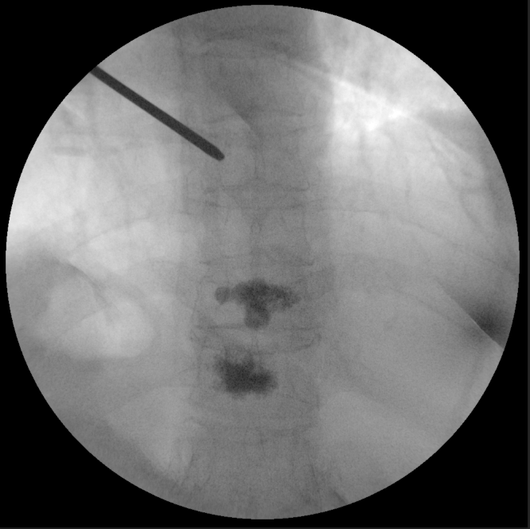

Figure S2 When the needle tip of the puncture needle on the lateral view reaches the posterior edge of the vertebral body, it is best not to break through the inner edge of the cat's eye on the frontal view

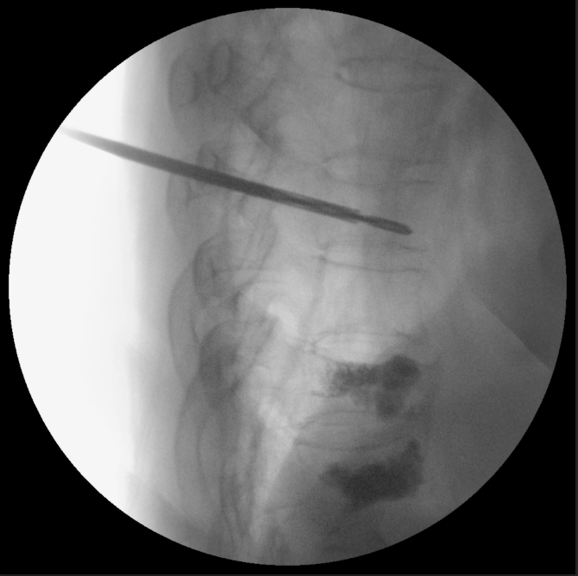

Figure S3 Stop needle insertion when the head of the expanded bone drill is located in the anterior 1/5 of the vertebral body

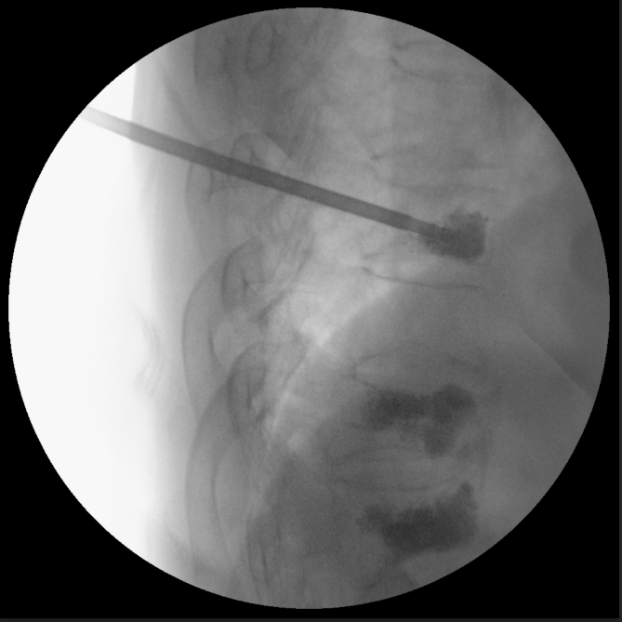

Figure S4 Inject bone cement under C-arm monitoring

