Supplementary material
Table s1 Primers used in this study
Primer name | Sequence 5′–3′
ITS1 | 5’-CCGTAGGTGAACCTGCGG-3’
ITS4 | 5’-TCCTCCGCTTATTGATATGC-3’
OX-f | 5’-TCGATATCCCTTCCTCCAC-3’
OX-r | 5’-AGTGGTGGCAGCACCACTAAAG-3’
AAT1-f | 5’-TTCAAGCAGAAAACTGGAATG-3'
AAT1-r | 5’-ATTGGTAAAACTTGCTGAG-3’
GFP-f | 5'-CGACGTAAACGGCCACAAG-3'
GFP-r | 5'-CTGTCGGCCATGATATA-3'

Table s2 Plasmids and their purposes
Plasmid name | Purpose
pDHt/sk-PE (addgene #92126) | Express Cas9 protein , eGFP and hygromycin resistance
Htb2-GFP (addgene #117669) | Express hygromycin resistance

Table s3 The peak areas of all oxalic acid relative standards and samples

Concentration (µg ml⁻¹) | Peak area (µAU.s)
800 | 2207131
867 (WT) | 2326636
900 | 2488549
1000 | 3817236
2000 | 7906438
2807 (AAT1 -MT) | 12235626
3000 | 12859658

Supplementary fig. s1 a
Fig. S2 a Multiple sequence alignment with the six fungal AAT1 proteins
The multiple sequence alignment of the protein sequences of “A0001768” and the six fungal AAT1 proteins built by an online version of Clustal Omega and visualized by Mview using K. marxianus as a reference sequence. Each row shows the coverage, percent identity and residues of alignment that seven protein sequences with the reference genome. Only those residues that are identical to the reference sequence can be colored.
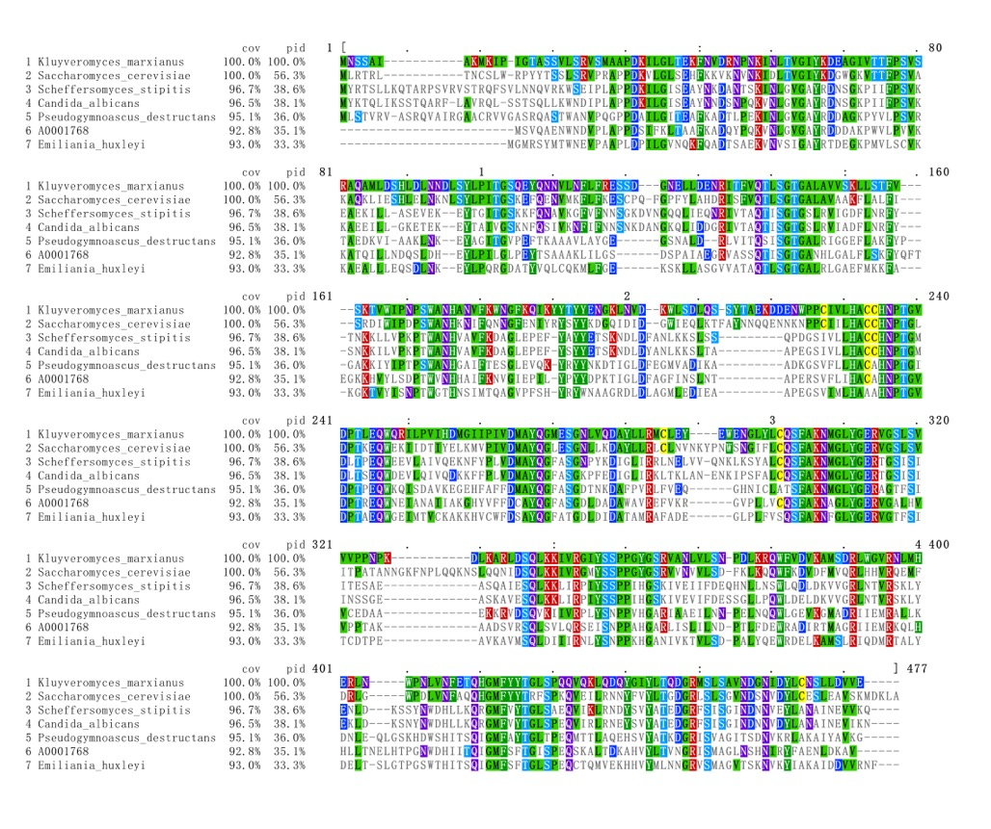

Supplementary fig. s1 b
Fig. S2 b Gene structure of the AAT1 gene
Delineation of the AAT1 gene (A0001768) into seven exons was obtained by aligning the coding region of A0001768 against the assembled genome of A. rolfsii obtained from NCBI (accession ID: GCA_000961905.2). The black boxes indicate exons, and the red line under exon2 indicates the gRNA. The numbers above the exons indicate their positions on the coding region.

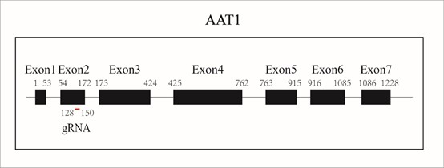

Supplementary fig. s2

Fig. S1 Standard curve and equation of linear regression

Equation of linear regression was generated by drawing the standard curve with the concentration of oxalic acid standards（µg/mL） as the abscissa and the chromatographic peak area (µAU.s) as the ordinate. Standard oxalic acid solutions were prepared more appropriately with concentrations of 800 µg/mL, 900 µg/mL, 1000 µg/mL, 2000 µg/mL and 3000 µg/mL for further precise calculation of concentrations of WT and AAT1-MT with external standard method.

Supplementary fig. s3
Fig. S3 Comparison of WT and AAT1-MT with respect to AKG level
(a) HPLC analysis of standard solutions of AKG showed peaks atretention time 1.5 min. (b and c) Compared with the extraction of WT (Figure S3 b), the extraction AAT1-MT (Figure S3 c) showed decreased level of AKG.

a
AKG
Standards
b
AKG
WT
c
AKG
AAT1-MT

Supplementary fig. s4

Fig. S4 Determination by Mass spectrograms of peaks related to oxalic acid and AKG

(a and b) Mass spectrograms of WT and AAT1-MT oxalic acid relative peaks are acquired in negative ionization mode (ESI−). (c and d) Mass spectrograms of WT and AAT1-MT AKG relative peaks are acquired in positive ionization mode (ESI+). HPLC-MS analysis further showed that the oxalic acid and AKG with [M-H]⁻ m/z 89 and [M+Na]⁺ m/z 169, respectively.

a
WT
Oxalic acid
→
b
Oxalic acid
→
AAT1-MT

c
WT
AKG
→
d
AKG
→
AAT1-MT

