Journal: Translational Psychiatry
Running title: Gamma features in Children with ADHD

Low-Frequency Gamma Oscillations in ADHD Children: Neural Features and Digital Training Effects
Supplementary material
S1. Analysis electrodes
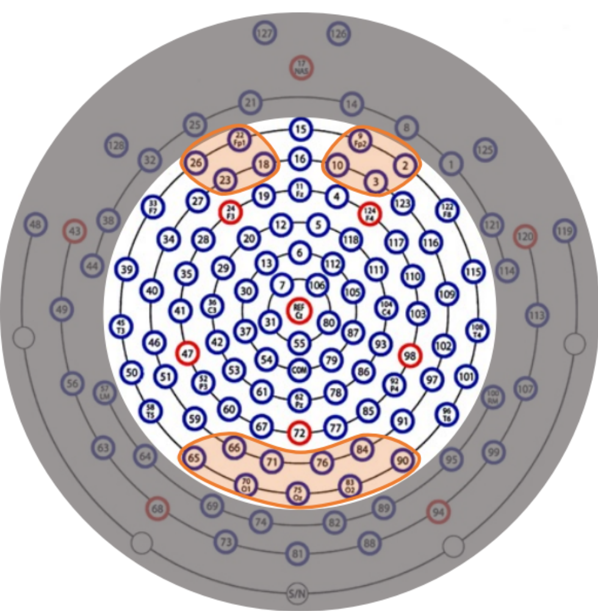
Figure S1. Electrodes used to analysis. The electrodes circled in the orange area were selected in analyzing gamma in the frontal (2, 3, 9, 10, 18, 22, 23, 26) and occipital (65, 66, 70, 71, 75, 76, 83, 84, 90) region according to their topographic map. The shaded areas are 38 peripheral electrodes that are not included in the data analysis.

S2. Comparison of pre- and post-training with different training program
Frontal Region
The analysis of absolute power revealed that only the main effect between different conditions remained significant (F = 25.393, p < 0.001, η² = 0.320), with Gamma levels significantly higher during the eyes-open condition compared to the eyes-closed condition. No other main effects or interactions were significant. The results of relative power analysis were consistent with those of absolute power (main effect of condition: F = 25.393, p < 0.001, η² = 0.320), specific results are presented in the following table S1-S4.
Table S1. Frontal gamma absolutely power
 | Eyes closed |  | Eyes open
Pre-training | Mean | SD | Mean | SD
NFT | 1.46 | 1.03 | 2.28 | 1.43
CCT | 1.67 | 0.98 | 3.00 | 1.76
COM | 2.00 | 1.51 | 3.03 | 1.60
Post-training
NFT | 1.68 | 1.09 | 2.84 | 2.54
CCT | 1.73 | 1.03 | 3.27 | 2.33
COM | 1.79 | 1.08 | 3.47 | 3.56

Table S2. Statistics of the frontal gamma absolutely power
 | Training (Pre-training, Post-training) | Condition (Eyes closed, Eyes open) | Group(NFT, CCT, COM)
F | 0.775 | 25.393 | 1.184
p | 0.383 | <0.001 | 0.314
η² | 0.014 | 0.32 | 0.042
 | Training*Condition | Training*Group | Condition*Group
F | 1.026 | 0.107 | 0.285
p | 0.316 | 0.899 | 0.753
η² | 0.019 | 0.004 | 0.01
 | Training*Condition*Group
F | 0.109
p | 0.897
η² | 0.004

Table S3. Frontal gamma relative power
 | Eyes closed |  | Eyes open
Pre-training | Mean | SD | Mean | SD
NFT | 0.02 | 0.01 | 0.04 | 0.02
CCT | 0.02 | 0.01 | 0.04 | 0.03
COM | 0.02 | 0.02 | 0.05 | 0.03
Post-training
NFT | 0.02 | 0.01 | 0.05 | 0.05
CCT | 0.02 | 0.01 | 0.05 | 0.04
COM | 0.02 | 0.01 | 0.05 | 0.05

Table S4. Statistics of the frontal gamma relative power
 | Training(Pre-training, Post-training) | Condition(Eyes closed, Eyes open) | Group(NFT, CCT, COM)
F | 0.94 | 37.472 | 0.187
p | 0.337 | <0.001 | 0.83
η² | 0.017 | 0.41 | 0.007
 | Training*Condition | Training*Group | Condition*Group
F | 0.905 | 0.634 | 0.079
p | 0.346 | 0.534 | 0.925
η² | 0.016 | 0.023 | 0.003
 | Training*Condition*Group
F | 0.128
p | 0.88
η² | 0.005

Occipital Region
No significant interaction was found in the absolute power analysis of the occipital region (p > 0.05, supplementary material S2). The main effect of training was significant (F = 6.678, p = 0.012, η² = 0.110), as well as the main effect of condition (F = 8.696, p = 0.005, η² = 0.139) and the main effect of group (F = 5.215, p = 0.008, η² = 0.162). Similarly, no significant interaction was observed in the relative power analysis. Additionally, the main effect of condition was significant (F = 30.807, p < 0.001, η² = 0.363), and the main effect of group was also significant (F = 3.906, p = 0.026, η² = 0.126). However, the main effect of training was no longer significant (F = 3.863, p = 0.055, η² = 0.067) , specific results are presented in the following table S5-S8.
Table S5. Occipital gamma absolutely power
 | Eyes closed |  | Eyes open
Pre-training | Mean | SD | Mean | SD
NFT | 2.19 | 2.66 | 3.02 | 2.93
CCT | 3.49 | 2.80 | 3.81 | 2.52
COM | 3.60 | 3.04 | 5.52 | 4.07
Post-training
NFT | 2.00 | 1.69 | 2.01 | 1.22
CCT | 1.69 | 1.06 | 2.78 | 1.98
COM | 3.88 | 2.90 | 4.37 | 2.77

Table S6. Statistics of the occipital gamma absolutely power
 | Training(Pre-training, Post-training) | Condition(Eyes closed, Eyes open) | Group(NFT, CCT, COM)
F | 6.678 | 8.696 | 5.215
p | 0.012 | 0.005 | 0.008
η² | 0.11 | 0.139 | 0.162
 | Training*Condition | Training*Group | Condition*Group
F | 1.58 | 0.979 | 0.741
p | 0.214 | 0.382 | 0.481
η² | 0.028 | 0.035 | 0.027
 | Training*Condition*Group
F | 2.982
p | 0.059
η² | 0.099

Table S7. Occipital gamma relative power
 | Eyes closed |  | Eyes open
Pre-training | Mean | SD | Mean | SD
NFT | 0.02 | 0.02 | 0.04 | 0.04
CCT | 0.03 | 0.03 | 0.05 | 0.03
COM | 0.04 | 0.03 | 0.08 | 0.06
Post-training
NFT | 0.02 | 0.02 | 0.04 | 0.03
CCT | 0.02 | 0.01 | 0.04 | 0.03
COM | 0.04 | 0.04 | 0.06 | 0.05

Table S8. Statistics of the occipital gamma relative power
 | Training(Pre-training, Post-training) | Condition(Eyes closed, Eyes open) | Group(NFT, CCT, COM)
F | 3.863 | 30.807 | 3.906
p | 0.055 | <0.001 | 0.026
η² | 0.067 | 0.363 | 0.126
 | Training*Condition | Training*Group | Condition*Group
F | 1.769 | 0.267 | 0.792
p | 0.189 | 0.767 | 0.458
η² | 0.032 | 0.01 | 0.028
 | Training*Condition*Group
F | 2.634
p | 0.081
η² | 0.089

