Table of Contents
Table of Contents 1
Supplementary tables 3
Table S1a-b Exposure correlation matrix 3
a) Before eruption (1 Jan 2010-august 31 2014) 3
b) After eruption (31 August 2014-31 December 2014) 3
Table S2 Dates with high SO2 and strikes in primary care and hospital 4
Table S3 Sensitivity analyses: Outcome variable definitions and lag-days 5
Table S4 Sensitivity analyses: Exposure definitions and subset analyses 6
Supplementary figures 8
Figure S1 Time series of daily exposure and outcomes 2010-2014. 8
Figure S2 a-d High SO₂ (>125 ug/m³) days and associations with respiratory health outcomes across lags 0-10 (plotted using DLNM) 10
Figure S3 a-c Concentration-response for SO₂ and health outcomes (plotted using DLNM) 11
Figure S4 a-d Associations between high SO₂ days (>125 ug/m³) and subcategories of PCMD and HED (plotted using DLNM) 12
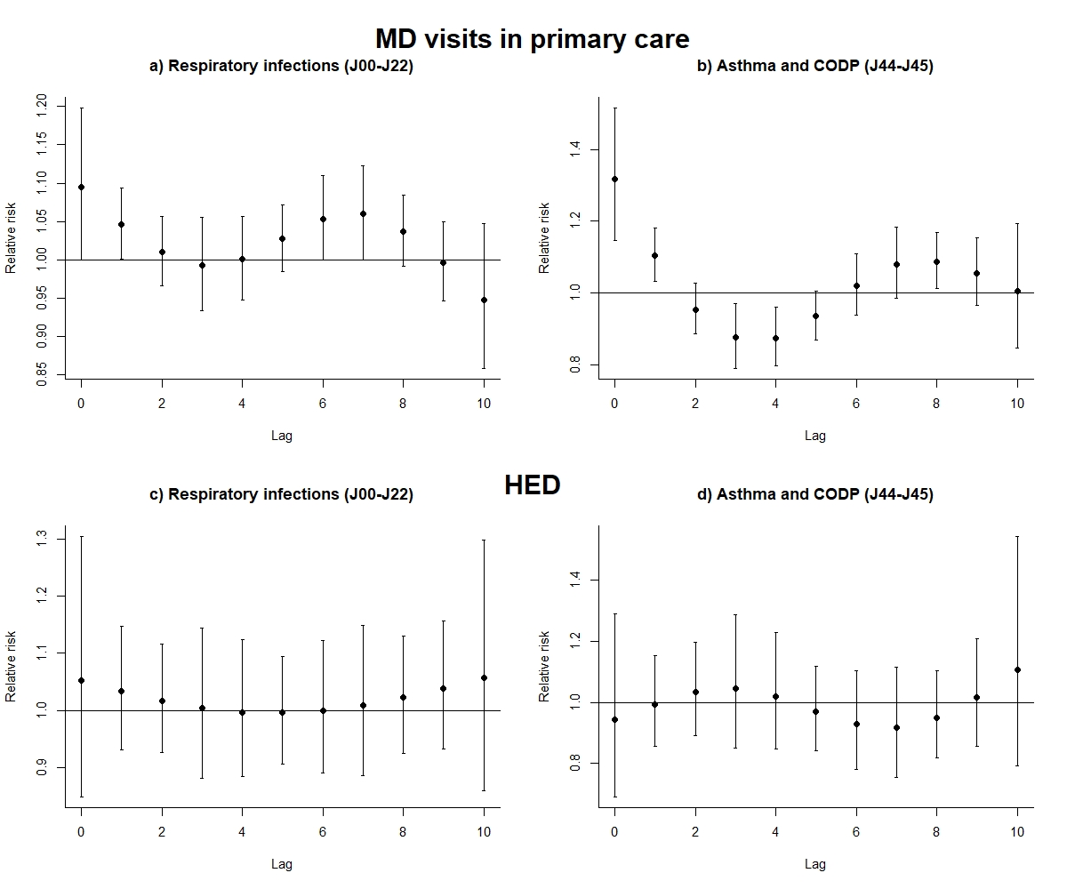 Figure S5 a-d Lag-associations to lag 20 (plotted using DLNM) 12
Data selection flow diagrams 14
Flow diagram 1: Anti-asthma medication dispensing (AMD data) 14
Flow diagram 2: Primary care center MD visits (PCMD data) for respiratory diagnoses 15
Flow diagram 3: Hospital emergency department visits (HED data) for respiratory diagnoses 16

Supplementary tables

Table S1a-b Exposure correlation matrix

Before eruption (1 Jan 2010-august 31 2014)
n=1466 | SO₂ | PM₁₀ | NO₂ | Temperature | Relative humidity
SO₂ | 1
PM₁₀ | -0.006 | 1
NO₂ | 0.429* | 0.002 | 1
Temperature | -0.092* | -0.155* | -0.502* | 1
Relative humidity | 0.103* | -0.164* | 0.103* | 0.065* | 1

After eruption (31 August 2014-31 December 2014)
n=109 | SO₂ | PM₁₀ | NO₂ | Temperature | Relative humidity
SO₂ | 1
PM₁₀ | 0.403* | 1
NO₂ | 0.075 | 0.400* | 1
Temperature | -0.036 | -0.129 | -0.620* | 1
Relative humidity | -0.556* | -0.352* | -0.050 | 0.081 | 1
* p<0.05

Table S2 Dates with high SO2 and strikes in primary care and hospital
Date | Daily mean SO₂ > 125 µg/m³ | Strike (Primary care) | Strike  (Hospital)
2014-10-08 | yes | - | -
2014-10-10 | yes | - | -
2014-10-14 | yes | - | -
2014-10-15 | yes | - | -
2014-10-16 | yes | - | -
2014-10-27 | - | yes | yes
2014-10-28 | - | yes | yes
2014-10-29 | yes | yes | yes
2014-10-30 | yes | yes | yes
2014-11-03 | - | yes | yes
2014-11-04 | yes | yes | yes
2014-11-05 | - | yes | yes
2014-11-06 | - | yes | yes
2014-11-09 | yes | - | yes
2014-11-13 | yes | - | yes
2014-11-17 | - | yes | yes
2014-11-18 | - | yes | yes
2014-11-19 | - | yes | yes
2014-11-20 | - | yes | yes
2014-11-26 | - | yes | yes
2014-11-27 | - | yes | yes
2014-12-08 | - | yes | yes
2014-12-09 | - | yes | yes
2014-12-10 | - | yes | yes
2014-12-11 | - | yes | yes
2014-11-24 | - | - | yes
2014-11-25 | - | - | yes

Table S3 Sensitivity analyses: Outcome variable definitions and lag-days
Association between SO₂ as both continuous variables and as indicator of days with high levels (SO₂>125 µg/m³) and changes in anti-asthma medication dispensing, respiratory primary care center contacts including recurring contacts and hospital emergency admissions due to respiratory illness.
 |  | SO₂ (per 10 µg/m³) |  |  |  | SO₂ levels >125 ug/m³
 | Mean (sd) | % |  | 95% CI |  |  |  | % | 95% CI
Primary care – All contacts (lag 0-2)
All | 192.3 (91.2) | 1.15% | 0.64% |  | 1.67% |  | 17.4% |  | 9.4% | 26.0%
Children 0-17 | 46.2 (22.1) | 1.01% | 0.20% |  | 1.82% |  | 12.4% |  | 0.6% | 25.5%
Adults 18-65 | 116.4 (56.0) | 1.14% | 0.59% |  | 1.68% |  | 19.1% |  | 10.5% | 28.4%
Elderly >65 | 29.7 (19.1) | 1.28% | 0.49% |  | 2.06% |  | 17.8% |  | 5.3% | 31.8%
Primary care - including recurring contacts (lag 0-2)
All |  | 1.29% | 0.79% |  | 1.80% |  | 20.3% |  | 12.2% | 28.9%
Children 0-17 |  | 0.40% | -0.13% |  | 0.93% |  | 4.2% |  | -2.9% | 11.9%
Adults 18-65 |  | 1.14% | 0.59% |  | 1.68% |  | 19.1% |  | 10.5% | 28.4%
Elderly >65 |  | 1.37% | 0.86% |  | 1.87% |  | 21.4% |  | 13.3% | 30.1%
Hospital emergency department visits (HED, lag 2-4)
All |  | 1.06% | 0.03% |  | 2.10% |  | 9.7% |  | -4.0% | 25.5%
Children 0-17 |  | 2.12% | 0.30% |  | 3.97% |  | 25.3% |  | -2.4% | 60.8%
Adults 18-65 |  | 0.50% | -1.09% |  | 2.10% |  | -0.3% |  | -19.2% | 23.0%
Elderly >65 |  | 0.28% | -1.44% |  | 2.03% |  | 5.2% |  | -16.1% | 31.9%
Admissions from Hospital emergency department (lag 0-2)
All |  | 0.76% | -0.81% |  | 2.34% |  | 15.6% |  | -11.3% | 50.6%
Children 0-17 |  | 3.76% | -0.75% |  | 8.27% |  | 65.9% |  | -34.1% | 317.6%
Adults 18-65 |  | 0.88% | -1.75% |  | 3.50% |  | 5.4% |  | -35.5% | 72.1%
Elderly >65 |  | 0.65% | -1.22% |  | 2.51% |  | 13.9% |  | -17.7% | 57.7%
Admissions from Hospital emergency department (lag 2-4)
All |  | 1.71% | -0.18% |  | 3.60% |  | 17.8% |  | -9.4% | 53.1%
Children 0-17 |  | 6.61% | 1.27% |  | 11.96% |  | 157.4% |  | 10.3% | 500.7%
Adults 18-65 |  | 2.09% | -0.80% |  | 4.99% |  | 22.5% |  | -21.8% | 92.1%
Elderly >65 |  | 1.08% | -1.20% |  | 3.35% |  | 6.9% |  | -23.0% | 48.3%
Models are adjusted for NO₂, PM₁₀, and relative humidity at the same lags as SO₂, odd holidays, day of week, the outcome at lag1, and with splines for temperature, season, and overall time trend. n=1547 for all.

Table S4 Sensitivity analyses: Exposure definitions and subset analyses
Association between SO₂ as both continuous variables and as indicator of days with high levels (SO₂>125 ug/m³) and changes in anti-asthma medication dispensing, respiratory PCMD and visits and hospital emergency visits and admissions
 | SO₂ (per 10 µg/m³) |  |  |  |  |  | SO₂ levels >125 ug/m³
 | % | 95% CI |  |  | % |  |  | 95% CI
Excluding the first day in series of consecutive high SO₂ exposure days
Asthma medication (AMD, lag 0 – 2)
All | 1.37% | 0.70% | 2.05% |  |  | 13.5% |  |  | 2.9% | 25.3%
Children 0 – 17 | 1.31% | 0.31% | 2.32% |  |  | 17.3% |  |  | 1.5% | 35.7%
Adults 18 – 65 | 0.66% | -0.10% | 1.42% |  |  | 11.4% |  |  | -0.2% | 24.4%
Elderly >65 | 1.25% | 0.43% | 2.07% |  |  | 16.9% |  |  | 3.1% | 32.6%
Primary care MD visits (PCMD, lag 0-2)
All | 1.22% | 0.06% | 2.38% |  |  | 18.2% |  |  | 8.8% | 28.3%
Children 0-17 | 2.02% | 0.33% | 3.74% |  |  | 17.0% |  |  | 3.1% | 32.7%
Adults 18-65 | 0.87% | -0.40% | 2.16% |  |  | 16.7% |  |  | 6.7% | 27.6%
Elderly >65 | 0.51% | -1.68% | 2.74% |  |  | 24.4% |  |  | 7.0% | 44.7%
Excluding the first week of high SO₂ exposure
Anti – asthma medication (AMD, lag 0 – 2)
All | 0.95% | 0.25% | 1.65% |  |  | 9.0% |  |  | -0.5% | 19.5%
Children 0 – 17 | 1.48% | 0.47% | 2.50% |  |  | 11.2% |  |  | -3.1% | 27.5%
Adults 18 – 65 | 0.95% | 0.17% | 1.75% |  |  | 10.4% |  |  | -0.3% | 22.3%
Elderly >65 | 0.65% | -0.26% | 1.57% |  |  | 9.1% |  |  | -2.9% | 22.6%
Primary care MD visits (PCMD, lag 0-2)
All | 1.37% | 0.69% | 2.06% |  |  | 15.7% |  |  | 7.1% | 25.0%
Children 0 – 17 | 1.07% | 0.02% | 2.14% |  |  | 9.8% |  |  | -2.6% | 23.9%
Adults 18 – 65 | 1.39% | 0.65% | 2.14% |  |  | 18.0% |  |  | 8.6% | 28.3%
Elderly >65 | 1.69% | 0.46% | 2.94% |  |  | 14.9% |  |  | -0.5% | 32.6%
Years 2012-14
Asthma medication (AMD, lag 0 – 2)*
All | 1.24% | 0.47% | 2.01% |  |  | 12.0% |  |  | 1.9% | 23.1%
Children 0 – 17 | 0.65% | -0.40% | 1.72% |  |  | 15.1% |  |  | 0.9% | 31.4%
Adults 18 – 65 | 1.27% | 0.40% | 2.14% |  |  | 12.0% |  |  | 0.7% | 24.7%
Elderly >65 | 1.66% | 0.67% | 2.66% |  |  | 11.8% |  |  | -1.2% | 26.4%
Primary care MD visits (PCMD, lag 0-2)
All | 1.23% | 0.63% | 1.82% |  |  | 17.5% |  |  | 8.8% | 26.9%
Children 0 – 17 | 0.54% | -0.36% | 1.44% |  |  | 5.9% |  |  | -5.7% | 18.9%
Adults 18 – 65 | 1.47% | 0.84% | 2.11% |  |  | 24.2% |  |  | 14.3% | 34.8%
Elderly >65 | 1.28% | 0.24% | 2.33% |  |  | 14.6% |  |  | -0.9% | 32.5%
Hospital emergency department (HED, lag 0-2)
All | 0.31% | -0.69% | 1.32% |  |  | 2.4% |  |  | -10.0% | 16.6%
Children 0-17 | -0.75% | -2.78% | 1.32% |  |  | -11.7% |  |  | -31.9% | 14.4%
Adults 18-65 | -0.08% | -1.54% | 1.40% |  |  | 4.8% |  |  | -13.6% | 27.0%
Elderly >65 | 1.60% | 0.06% | 3.16% |  |  | 13.2% |  |  | -8.4% | 39.9%
Models are adjusted for NO₂, PM₁₀, and relative humidity at the same lags as SO₂, odd holidays, day of week, the outcome at lag1, and with splines for temperature, season, and overall time trend (k=5 was set for AMD). n=1544 and 1017 for the analysis of the years 2012-14.

Supplementary figures

Figure S1 Time series of daily exposure and outcomes 2010-2014.
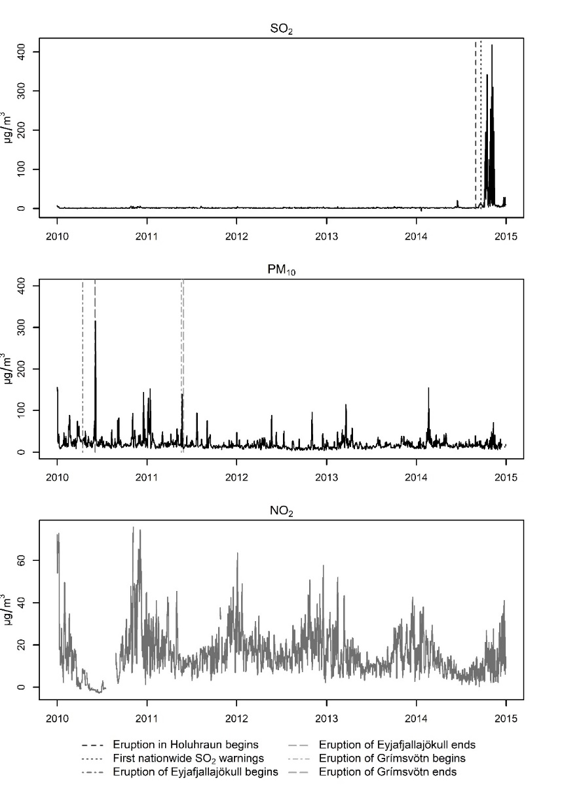
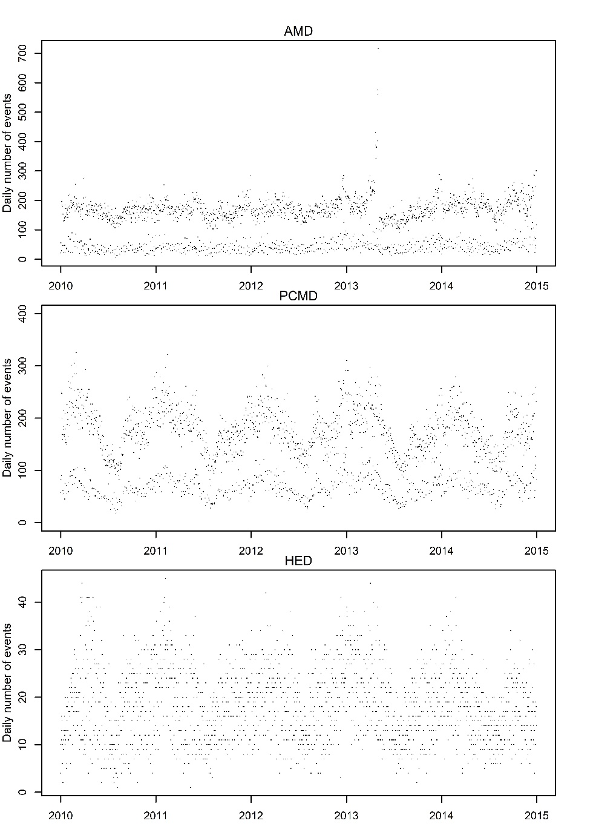

Figure S2 a-d High SO₂ (>125 ug/m³) days and associations with respiratory health outcomes across lags 0-10 (plotted using DLNM)
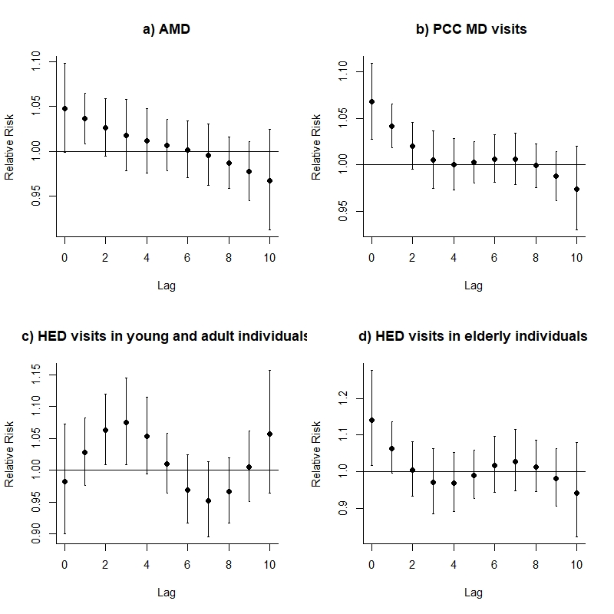

Figure S3 a-c Concentration-response for SO₂ and health outcomes (plotted using DLNM)
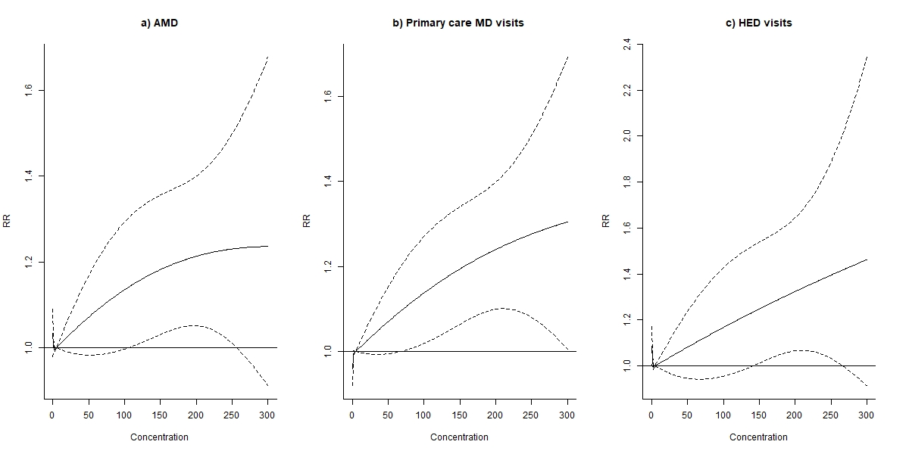

Figure S4 a-d Associations between high SO₂ days (>125 ug/m³) and subcategories of PCMD and HED (plotted using DLNM)

Figure S5 a-d Lag-associations to lag 20 (plotted using DLNM)
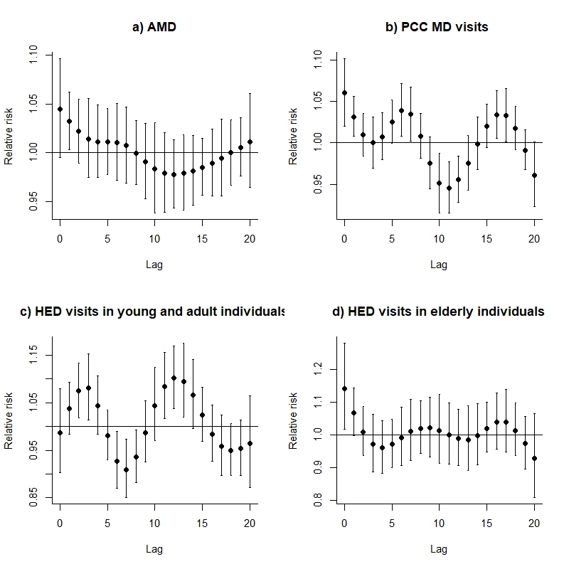

Data selection flow diagrams
Flow diagrams of data selection of register data extracted for the study period 2010-01-01 to 2014-12-31.
First the data was selected based on the data set of events (instances, diagnoses, or, in data terms, lines), then the number of unique individuals in the data were identified* for extracting demographic information for the description of the study population characteristics found in Table 1.The time series used in Table 2 and further analysis was aggregated from the events based data.**

Flow diagram 1: Anti-asthma medication dispensing (AMD data)
 | In data |  | Excluded | Cause
Total events: | 436 579
 |  |  | 13 419 | No valid id
Valid ID: | 423 160
 |  |  |  | (3803 No post code)
 |  |  | 3856 | (2602 No age)
 |  |  |  | (2643 No sex)
Not missing data: | 419 304
 |  |  | 158 835 | Lives outside capital region
Residence in capital area: | 260 469
Aggregate to unique individuals* |  |  | Aggregate to time series**
Individuals: | 48 014 |  | 1826 days

Flow diagram 2: Primary care center MD visits (PCMD data) for respiratory diagnoses
 | In data |  | Excluded | Cause
Total events: | 1 427 011 |  |  | Missing demographic info:  Age, n=3,  Not in the national population register, n=3311,  No Icelandic postcode, n=21463
 |  |  | 21 507
Not missing data: | 1 405 504
 |  |  | 568 001 | Lives outside capital region
Residence in capital area: | 837 503
 |  |  | 383 955 | Other, non-respiratory diagnoses
Respiratory diagnoses | 453 548
 |  |  | 102 439 | Excluding visits from patients returning within 14 days for same diagnosis type
Non-recurring | 351 109
 |  |  | 91 055 | Telephone consultations or “other”
MD consultations | 260 054
Aggregate to unique individuals* |  |  | Aggregate to time series**
 | 110 806 |  | 1826 days

Flow diagram 3: Hospital emergency department visits (HED data) for respiratory diagnoses
 | In data |  | Excluded | Cause
Total events: | 361 512
 |  |  | 0 | No valid id
 | 361 512
 |  |  | 14 370 | No postcode
Not missing data: | 347 142
 |  |  | 211 440 | Patients returning within 14 days for same diagnosis type
Non-recurring | 135 702
 |  |  | 56 084 | Lives outside capital region
Residence in capital area: | 79 618
 |  |  | 46 207 | Non-respiratory diagnoses
Respiratory diagnosis | 33 411*
Aggregate to unique individuals* |  |  | Aggregate to time series**
 | 20 725
*for analysis of admissions only, 6471 admissions were selected, and 4322 individuals were found in this data.

Crossbasis defined to predict for values of SO₂ from 0 to125 µg/m³ with a natural spline with four degrees of freedom for the lag-structure up to lag 10. Models were adjusted for time trends as the main models (Table 3), but not for weather or other pollutants. Crosspred function was centered at 5 and set to predict to 125 µg/m³.
Crossbasis for variable values have four degrees of freedom, lags 0- lag 2 for AMD and PCC, lag 0- lag 4 for HED. Model is adjusted for time trend as the main model (Table 3), but not weather or other pollutants. Crosspred function was centered at 5 and set to predict to 300.
Crossbasis defined to predict for values of SO₂ from 0 to125 µg/m³ with a natual spline with four degrees of freedom for the lag-structure up to lag 10. Models were adjusted for time trends as the main models (Table 3), but not for weather or other pollutants. Crosspred function was centered at 5 and set to predict to 125 µg/m³.
Crossbasis defined to predict for values of SO₂ from 0 to125 µg/m³ with a natural spline with four degrees of freedom for the lag-structure up to lag 20. Models were adjusted for time trends as the main models (Table 3), but not for weather or other pollutants. Crosspred function was centered at 5 and set to predict to 125 µg/m³.

