Supporting information for:
Identification of ferredoxin PA1551 in the bacterial iron uptake pathway and exploration of its antibacterial synergistic as target for biofilm inhibitors against Pseudomonas aeruginosa infection

Authors: Jun Liu^{1,#,}*, Anmin Ren^{2,#} , Zhiying Miao¹, Tian Zhou², Chenhui Zhang², Yiqun Chang^{1,3}, Siyu Zhao¹, Xibing Hu¹, Xiaoyi Zhang¹, Tianyuan Jia², Zhao Cai², Zhengqiu Li¹, Jing Lin¹, Liang Yang^{2,}*, Weimin Chen^{1,}*
Affiliations:
¹ State Key Laboratory of Bioactive Molecules and Druggability Assessment, College of Pharmacy, Institute for Advanced and Applied Chemical Synthesis, Jinan University, Guangzhou 510632, P. R. China
² College of Medicine, Southern University of Science and Technology, Shenzhen 518055, P. R. China
³ Faculty of Medicine and Health, The University of Sydney, Sydney, NSW 2006, Australia
# These authors made equal contributions to this work.
* Corresponding authors
Email addresses: liujun__jnu@163.com (J.Liu), yangl@sustech.edu.cn (L.Yang), twmchen@jnu.edu.cn (WM. Chen).

Table of Contents

Supplementary Figures 3
Supplementary Tables 8
Chemical Synthesis (General Notes) 11
¹H NMR spectra, ¹³C NMR spectra and HRMS of compounds. 24
HPLC data of probes used in biological assays. 47

Supplementary Figures
Supplementary Figure 1. The toxicity of compound 10d in mice
Supplementary Figure 1. The toxicity of compound 10d in mice. (A) In vivo toxicity of control (saline), 10d, tobramycin (0.5 mg/mL), tobramycin (0.0025 mg/mL), and the tobramycin (0.0025 mg/mL) -10d. (B) In vivo toxicity of control (saline), ciprofloxacin (1 mg/mL), ciprofloxacin (0.01 mg/mL), ciprofloxacin (0.001 mg/mL), ciprofloxacin (0.01 mg/mL) -10d, and ciprofloxacin (0.001 mg/mL) -10d. (C) In vivo toxicity of P. aeruginosa PAO1 (or △ferredoxin) infection treated with control (saline) (or 0.0025 mg/mL Tob, 0.01mg/mL, and 0.001mg/mL CIP).

Supplementary Figure 2. Binding site analysis of 10d (10 μM) with a synthetic peptide, SYWCDFENTQHRMK (400 μM), by LC−MS/MS.
Supplementary Figure 2. Binding site analysis of 10d (10 μM) with a synthetic peptide, SYWCDFENTQHRMK (400 μM), by LC−MS/MS. (A) P42257 (B) Q9I3G6 (C) Q9HX18 (D) Q9HWP8.

Supplementary Figure 3. The puried N-GST-ferredoxin protein migrated as a single band with a molecular mass of 79.6 kDa.

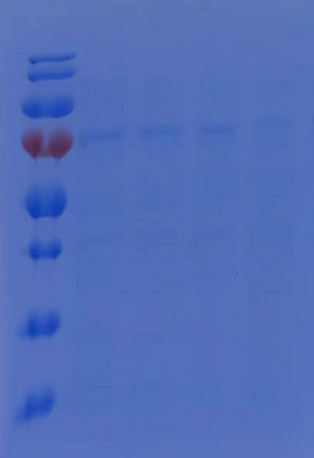
Supplementary Figure 3. The puried N-GST-ferredoxin protein migrated as a single band with a molecular mass of 79.6 kDa.

Supplementary Figure 4. Trajectory-based scan.
Supplementary Figure 4. (A) Sequence coverage of PA1551. (B) LDDT per residues of the top ranked models from AlphaFold. (C) RMSD of PA1551 Cα and the convergence of the N-termius loop, membrane is hidden.

Supplementary Figure 5. Representative swarming, swimming and twitching motility image of P. aeruginosa PAO1, PA1551 deficient mutant and PA1551-overexpressing strain.
Supplementary Figure 5. Representative swarming, swimming and twitching motility image of P. aeruginosa PAO1, PA1551 deficient mutant and PA1551-overexpressing strain.

Supplementary Tables

Supplementary Table 1. Docking and MMGBSA results of 10d and potential sites.
Entry | Docking Score | Glide Ligand Efficiency | Glide Gscore | XP GScore | XP HBond | MMGBSA dG Bind
sitemap_2
10d | -8.409 | -0.42 | -10.463 | -10.463 | -3.39 | -61.08
10d | -8.091 | -0.405 | -10.145 | -10.145 | -2.643 | -59.33
10d | -7.948 | -0.397 | -10.211 | -10.211 | -2.742 | -59.15
10d | -7.845 | -0.392 | -9.899 | -9.899 | -2.963 | -60.94
10d | -7.494 | -0.375 | -8.286 | -8.286 | -2.105 | -46.36
10d | -6.834 | -0.342 | -8.889 | -8.889 | -2.371 | -62.84
10d | -6.569 | -0.328 | -8.623 | -8.623 | -3.161 | -60.3
10d | -6.532 | -0.327 | -8.586 | -8.586 | -3.027 | -54.34
10d | -6.505 | -0.325 | -8.559 | -8.559 | -3.793 | -63.18
10d | -6.468 | -0.323 | -6.735 | -6.735 | -3.742 | -56.19
10d | -6.445 | -0.322 | -8.499 | -8.499 | -2.484 | -56.45
sitemap_5
10d | -4.9 | -0.245 | -5.166 | -5.166 | 0 | -29.52
10d | -4.248 | -0.212 | -4.515 | -4.515 | -0.48 | -42.28
10d | -4.212 | -0.211 | -5.005 | -5.005 | -0.48 | -34.04
10d | -4.126 | -0.206 | -4.392 | -4.392 | -1.739 | -38.98
10d | -4.078 | -0.204 | -4.345 | -4.345 | -1.44 | -16.71
10d | -3.969 | -0.198 | -4.235 | -4.235 | -1.096 | -38.47
10d | -3.92 | -0.196 | -4.187 | -4.187 | -0.96 | -37.01
10d | -3.878 | -0.194 | -4.67 | -4.67 | -0.96 | -29.33
10d | -3.848 | -0.192 | -4.115 | -4.115 | -0.625 | -35.74
10d | -3.803 | -0.19 | -4.596 | -4.596 | -1.44 | -25.9
10d | -3.773 | -0.189 | -4.04 | -4.04 | -0.48 | -31.76
sitemap_9
10d | -3.743 | -0.187 | -4.01 | -4.01 | -0.96 | -22.25
10d | -3.452 | -0.173 | -4.245 | -4.245 | -2.46 | 10.98
10d | -3.256 | -0.163 | -3.523 | -3.523 | -0.96 | -25.46
10d | -3.226 | -0.161 | -3.493 | -3.493 | -2.251 | 18.94
10d | -3.166 | -0.158 | -3.433 | -3.433 | -2.971 | -23.22
10d | -3.138 | -0.157 | -3.405 | -3.405 | -2.382 | -25.63
10d | -3.12 | -0.156 | -3.387 | -3.387 | -2.628 | -18.79
10d | -2.992 | -0.15 | -3.259 | -3.259 | -2.703 | -20.44
10d | -2.913 | -0.146 | -3.179 | -3.179 | -1.264 | -17.63
10d | -2.872 | -0.144 | -3.139 | -3.139 | -3.113 | -18.77
10d | -2.86 | -0.143 | -3.127 | -3.127 | -2.231 | -25.74
sitemap_11
10d | -4.413 | -0.221 | -4.68 | -4.68 | -1.982 | -33.45
10d | -4.333 | -0.217 | -4.6 | -4.6 | -2.55 | -30.76
10d | -4.223 | -0.211 | -4.49 | -4.49 | -1.874 | -36.51
10d | -4.154 | -0.208 | -4.421 | -4.421 | -2.2 | -31.96
10d | -4.102 | -0.205 | -4.894 | -4.894 | -0.63 | -39.73
10d | -4.095 | -0.205 | -4.362 | -4.362 | -1.528 | -19.22
10d | -3.981 | -0.199 | -4.248 | -4.248 | -1.556 | -29.09
10d | -3.963 | -0.198 | -4.23 | -4.23 | -1.397 | -28.86
10d | -3.892 | -0.195 | -4.684 | -4.684 | -1.625 | -43.48
10d | -3.859 | -0.193 | -4.126 | -4.126 | -1.67 | -22.3
10d | -3.85 | -0.192 | -4.116 | -4.116 | -1.559 | -25.99
sitemap_16
10d | -4.675 | -0.234 | -6.938 | -6.938 | -1.111 | -24.54
10d | -4.501 | -0.225 | -6.763 | -6.763 | -2.626 | -26.45
10d | -4.434 | -0.222 | -6.696 | -6.696 | -2.021 | -15.63
10d | -4.349 | -0.217 | -4.616 | -4.616 | -2.08 | -33.01
10d | -4.257 | -0.213 | -4.523 | -4.523 | -2.008 | -26.97
10d | -4.198 | -0.21 | -4.465 | -4.465 | -2.477 | -34.87
10d | -4.141 | -0.207 | -4.408 | -4.408 | -0.157 | -24.19
10d | -4.116 | -0.206 | -4.383 | -4.383 | -3.235 | -31.34
10d | -4.103 | -0.205 | -4.37 | -4.37 | -2.659 | -31.45
10d | -4.018 | -0.201 | -4.285 | -4.285 | -1.582 | -19.87
10d | -4.017 | -0.201 | -4.284 | -4.284 | -1.782 | -33.8
Supplementary Table 2. Strains and plasmids used in this study.
Strain or plasmid | Genotype and/or relevant characteristics | Source or reference
P. aeruginosa | Wild type strain | Laboratory store
Δferredoxin | ferredoxin in frame deletion strain | This study
ferredoxin-overexpressing | pUCP20 carrying Ferredoxin encoding gene | This study
pGEX-6P-1-GST-Ferredoxin(BL21) | pGEX-6P-1 carrying Ferredoxin encoding gene | This study
E. coli
DH5α | E. coli, F-, φ 80dlacZ ΔM15, Δ(lacZYA -argF)U169, deoR,  recA1, endA1, hsdR17 (rK-, mK+), phoA, supE44, λ-, thi -1,  gyrA96 , relA1 | Sangon
BL21 | E. coli，F- ompT hsdSB(r_{B}⁻ m_{B}⁻)gal dcm(DE3) | Sangon
Plasmids
pRK600 | Helper plasmid, Cm^{r} | Laboratory store
pK18-Gm | Suicide knock-out plasmid, Gm^{r} | Laboratory store
pUCP20-Amp | E. coli-P. aeruginosa shuttle cloning vector | Laboratory store
pGEX-6P-1-GST- Amp | Expression vector with N-terminal GST tag | Laboratory store
Supplementary Table 3. Primers used in this study.
Primers | Sequence | Purpose
Ferredoxin up F | AGCTCGGTACCCGGGGATCCTCTATTCATGCTGTTCGTCGGCACCCTG | For construction of PK18- Ferredoxin
Ferredoxin up R | CGGACTGCATGCTCAAGTTACTCACATCAGTGCGTACCACGGCAGTGG | For construction of PK18- Ferredoxin
Ferredoxin low F | CCACTGCCGTGGTACGCACTGATGTGAGTAACTTGAGCATGCAGTCCG | For construction of PK18- Ferredoxin
Ferredoxin low R | AACGACGGCCAGTGCCAAGCTTGCCAGTTCGCCAAGCAACTGGCTGAG | For construction of PK18- Ferredoxin
F1 | AGCTATGACCATGATTACGAATTCGATGAGCAAACAGATTCCCGTTCA | For construction of PUCP20- Ferredoxin
R1 | AAAACGACGGCCAGTGCCAAGCTTTCAACGGGTGCGTGGGCCAATGAA | For construction of PUCP20- Ferredoxin
Ferredoxin F1 | TTCCAGGGGCCCCTGGGATCCATGAGCAAACAGATTCCCGTTCA | For construction of PUCP20- Ferredoxin
Ferredoxin R1 | GAACTTGCGCTCGGGTAGGTCCCAACCGCCCACCATGCGCAGTCGGCG | For construction of pGEX-6P-1-GST-Ferredoxin
Ferredoxin F2 | CGCCGACTGCGCATGGTGGGCGGTTGGGACCTACCCGAGCGCAAGTTC | For construction of pGEX-6P-1-GST-Ferredoxin
Ferredoxin R2 | GAGCAGCTCGGGAATCAGCTCGCGGCTGTGCTTGGCGGTCTTGCGCAG | For construction of pGEX-6P-1-GST-Ferredoxin
Ferredoxin F3 | CTGCGCAAGACCGCCAAGCACAGCCGCGAGCTGATTCCCGAGCTGCTC | For construction of pGEX-6P-1-GST-Ferredoxin
Ferredoxin R3 | CTCGAGTCGACCCGGGAATTCTCAACGGGTGCGTGGGCCAATGAA | For construction of pGEX-6P-1-GST-Ferredoxin

Chemical Synthesis (General Notes)
All chemicals were obtained from commercial vendors and used without further purification unless indicated otherwise. All reactions involving anhydrous conditions were carried out under an argon or nitrogen atmosphere using oven-dried glassware. AR-grade solvents were used for all reactions. ¹H NMR and ¹³C NMR spectra were recorded on BrukerAvance III HD-400 spectrometer. Chemical shifts (δ) were reported in parts per million (ppm) relative to the internal standard tetramethylsilane or residual solvent peaks (CDCl₃ = 7.26 ppm, DMSO-d₆ = 2.50 ppm). The following abbreviations were used in reporting spectra, brs (broad singlet), s (singlet), d (doublet), t (triplet), q (quartet), m (multiplet), dd (doublet of doublets). Reaction progress was monitored by thin layer chromatography (TLC) on pre-coated Merck 60 F254 silica gel plates and spots were visualized by UV, iodine or other suitable stains. High-resolution mass spectra (HRMS) were obtained on ABSCIEX Triple Quad 4500 LC/MS mass spectrometer. Melting point analysis was determined with a microscopic melting point apparatus (JHX-5Plus). Melting points are uncorrected. High-performance liquid chromatography (HPLC) analyses were conducted with a Thermo Scientific Dionex Ultimate 3000 series consisting of an RS pump, an automatic solvent degasser, and a manual injector. Separations were carried out using a reversed-phase C₁₈ analytical column. All final compounds were detected at 254 nm with an SPD-M20A diode array detector and obtained with a purity of > 95%.
Supplementary Scheme 1. Synthesis of key intermediate 1-6.

Supplementary Scheme 2. Synthesis of key intermediate 2-8.

Supplementary Scheme 3. Synthesis of compound 10d-1.
Supplementary Scheme 4. Synthesis of compound 10d-2.
Supplementary Scheme 5. Synthesis of compound 10d-3.

Supplementary Scheme 6. Synthesis of compound 10d-4.
Supplementary Scheme 7. Synthesis of compound 10d-5.
Supplementary Scheme 8. Synthesis of the Negative Probe NP.

Scheme S9. Synthesis of the Negative Probe NP-1.

Supplementary Scheme 10. Synthesis of the Negative Probe NP-2.
2-(Aminomethyl)-3-(benzyloxy)-1,6-dimethylpyridin-4(1H)-one (1-6): Key intermediates 1-1 to 1-6 were synthesized by following previously published procedures¹⁻².
5-Hydroxy-2-(((tetrahydro-2H-pyran-2-yl)oxy)methyl)-4H-pyran-4-one (2-1): Kojic acid (20.00 g, 140.74 mmol) was dissolved in anhydrous DCM (200 mL), 3,4-dihydropyran (15.4 mL, 168.89 mmol) and a catalytic amount of p-toluenesulfonic acid monohydrate (1.34 g, 7.04 mmol) were added, then allowed to react at room temperature for 3 h. Subsequently, the reaction solution was washed twice with brine, dried over Na₂SO₄, filtered, and concentrated under reduced pressure to give a crude product. The crude product was recrystallized from isopropyl ether (15 mL), afford the yellow granular solid 2-1 (25.88 g, 81.31%). ¹H NMR (400 MHz, CDCl₃) δ 7.83 (s, 1H), 6.56 (s, 1H), 4.83 – 4.69 (m, 1H), 4.54 (d, J = 14.5 Hz, 1H), 4.35 (d, J = 14.5 Hz, 1H), 3.86 – 3.78 (m, 1H), 3.57 – 3.51 (m, 1H), 1.94 – 1.54 (m, 6H). ¹³C NMR (101 MHz, CDCl₃) δ 174.38, 165.80, 145.86, 138.18, 110.61, 98.24, 64.44, 62.05, 30.11, 25.17, 18.78. HRMS (ESI): calcd for C₁₁H₁₄O₅ [M + H]⁺ = 227.0914, found [M + H]⁺ =227.0931.
3-Hydroxy-2-(hydroxymethyl)-6-(((tetrahydro-2H-pyran-2-yl)oxy)methyl)-4H-pyran-4-one (2-2): Compound 2-1 (20.00 g, 88.41 mmol) was dissolved in water (200 mL) and NaOH (4.24 g, 106.09 mmol) was added, 37% aqueous formaldehyde solution (14.3 mL) was added dropwise, and the mixture was stirred at room temperature overnight. After the reaction was completed, the pH was adjusted to 6 with concentrated HCl and the mixture was extracted with CH₂Cl₂ (5×100 mL). The organic phase was combined together, washed with brine, dried over Na₂SO₄, filtered, and the filtrate was concentrated under reduced pressure to give 2-2 as a yellow oil (16.80 g, 74.16%). ¹H NMR (400 MHz, DMSO-d₆) δ 9.05 (s, 1H), 6.38 (s, 1H), 5.38 (s, 1H), 4.78 – 4.67 (m, 1H), 4.49 – 4.34 (m, 4H), 3.81 – 3.71 (m, 1H), 3.51 – 3.43 (m, 1H), 1.78 – 1.46 (m, 6H). ¹³C NMR (101 MHz, DMSO-d₆) δ 174.31, 164.10, 150.26, 142.38, 111.21, 98.21, 64.74, 61.84, 55.49, 30.33, 25.31, 19.21. HRMS (ESI): calcd for C₁₂H₁₆O₆ [M + H]⁺ = 257.1020, found [M + H]⁺ =257.1027.
3-(Benzyloxy)-2-(hydroxymethyl)-6-(((tetrahydro-2H-pyran-2-yl)oxy)methyl)-4H-pyran-4-one (2-3): Compound 2-2 (16.80 g, 65.56 mmol) was dissolved in MeOH (200 mL), NaOH (5.24 g, 131.12 mmol) was added, and benzyl chloride (13.6 mL, 118.01 mmol) was slowly added dropwise. The reaction was completed after reflux for 12 h. The reaction solution was concentrated under reduced pressure, and the residue was dissolved in H₂O (100 mL) and extracted three times with DCM. The combined organic layers were washed with brine and dried over anhydrous Na₂SO₄. Upon solvent evaporation, the residue was purified by flash column chromatography (DCM:MeOH:TEA = 160:1:0.1) to afford the yellow oil 2-3 (14.50 g, 63.91%). ¹H NMR (400 MHz, CDCl₃) δ 7.38 – 7.30 (m, 5H), 6.47 (s, 1H), 5.16 (s, 2H), 4.71 – 4.63 (m, 1H), 4.47 (d, J = 14.7 Hz, 1H), 4.34 – 4.26 (m, 3H), 3.82 – 3.74 (m, 1H), 3.54 – 3.47 (m, 1H), 1.85 – 1.51 (m, 6H). ¹³C NMR (101 MHz, CDCl₃) δ 176.20, 164.46, 158.74, 142.52, 136.40, 129.27, 128.71, 128.66, 113.73, 98.34, 73.95, 64.15, 62.10, 57.37, 30.14, 25.22, 18.82. HRMS (ESI): calcd for C₁₉H₂₂O₆ [M + H]⁺ = 347.1489, found [M + H]⁺ =347.1492.
3-(Benzyloxy)-2-(hydroxymethyl)-1-methyl-6-(((tetrahydro-2H-pyran-2-yl)oxy)methyl)pyridin-4(1H)-one (2-4): The yellow oil 2-3 (14.50 g, 41.86 mmol) was dissolved in EtOH (60 mL) and 40% methylamine aqueous solution (32.5 mL). The reaction mixture was sealed in a thick-walled glass tube and stirred at 75 °C for 12 h. Next, the mixture was concentrated in vacuo and crude product was purified by flash column chromatography (DCM:MeOH:TEA = 120:1:0.2) to give a grey solid. The grey solid was recrystallized from acetone to afford 2-4 as off white powder (7.37 g, 48.94%). ¹H NMR (400 MHz, CDCl₃) δ 7.29 (s, 5H), 6.50 (s, 1H), 5.02 (s, 2H), 4.66 – 4.60 (m, 1H), 4.56 (d, J = 13.4 Hz, 1H), 4.50 (d, J = 13.7 Hz, 2H), 4.22 (d, J = 13.1 Hz, 1H), 3.82 – 3.77 (m, 1H), 3.62 (s, 3H), 3.57 – 3.51 (m, 1H), 1.80 – 1.49 (m, 6H). ¹³C NMR (101 MHz, CDCl₃) δ 174.00, 146.13, 145.69, 144.07, 137.32, 129.14, 128.28, 128.01, 118.43, 98.30, 73.20, 65.52, 62.56, 55.06, 35.38, 30.32, 25.19, 19.20. HRMS (ESI): calcd for C₂₀H₂₅NO₅ [M + H]⁺ = 360.1805, found [M + H]⁺ =360.1845.
2-(Aminomethyl)-3-(benzyloxy)-1-methyl-6-(((tetrahydro-2H-pyran-2-yl)oxy)methyl) pyridin-4(1H)-one (2-5): Compound 2-4 (5.86 g, 16.30 mmol), phthalimide (3.36 g, 22.83 mmol), and triphenylphosphine (5.98 g, 22.83 mmol) were placed in a dry 250 mL two-neck flask and protected under nitrogen. Subsequently, 100 mL of anhydrous THF was added and the reaction mixture was placed in ice H₂O at 0 °C for 30 min, and then diisopropyl azodicarboxylate (4.6 mL, 22.83 mmol) was slowly added dropwise. The mixture was slowly raised to room temperature for 16h. After the reaction was completed, the mixture was concentrated under reduced pressure. The residue was dissolved in 50 mL H₂O, extracted with CH₂Cl₂ (3×100 mL), washed with brine, dried over anhydrous Na₂SO₄ and filtered. Upon solvent evaporation, the residue was purified by flash column chromatography (DCM:MeOH:TEA = 100:1:0.2) to afford an orange oil. The orange oil was dissolved in EtOH (60 mL), 16 mL of 80% hydrazine hydrate was added and the mixture was heated to reflux for 4h. Then the reaction mixture was concentrated under reduced pressure. H₂O (25 mL) was added to the residue, followed by 10N NaOH solution, adjusting to pH = 12, extracted with DCM (3×100 mL), dried over anhydrous Na₂SO₄, filtered, and the filtrate was concentrated under reduced pressure. Column chromatography eluted with DCM:MeOH:TEA = 50:1:0.1. 2-5 was a colorless crystal (5.15 g, 88.15%). ¹H NMR (400 MHz, CDCl₃) δ 7.37 – 7.26 (m, 5H), 6.50 (s, 1H), 5.25 (s, 2H), 4.67 – 4.63 (m, 1H), 4.58 (d, J = 13.0 Hz, 1H), 4.30 (d, J = 13.0 Hz, 1H), 3.85 – 3.73 (m, 3H), 3.67 (s, 3H), 3.55 – 3.49 (m, 1H), 1.80 – 1.48 (m, 6H). ¹³C NMR (101 MHz, CDCl₃) δ 173.70, 145.72, 145.26, 144.37, 137.47, 129.42, 128.49, 128.27, 119.02, 98.32, 72.88, 65.89, 62.65, 37.07, 35.06, 30.34, 25.18, 19.26. HRMS (ESI): calcd for C₂₀H₂₆N₂O₄ [M + H]⁺ = 359.1965, found [M + H]⁺ =359.2026.
N-((3-(benzyloxy)-1-methyl-4-oxo-6-(((tetrahydro-2H-pyran-2-yl)oxy)methyl)-1,4-dihydropyridin-2-yl)methyl)heptanamide (2-6): Compound 2-5 (5.15 g, 14.37 mmol), EDCI (3.32 g, 17.24 mmol), HOBt (2.34 g, 17.24 mmol), DMAP (2.11 g, 17.24 mol) and 6-Heptynoic acid (2.24 mL, 15.81 mmol) were dissolved in anhydrous DCM (60 mL) under nitrogen atmosphere. The mixture was stirred for 12 h at room temperature. Subsequently, the reaction was quenched by saturated aqueous NH₄Cl solution (30 mL) and then extracted with CH₂Cl₂ (3×100 mL). The organic phase was combined together, washed with saturated aqueous NH₄Cl and dried over Na₂SO₄. Upon solvent evaporation, the residue was purified by flash column chromatography (DCM:MeOH:TEA = 40:1:0.1) to afford the pale yellow oil 2-6 (6.16 g, 90.99%). ¹H NMR (400 MHz, CDCl₃) δ 7.28 (s, 5H), 6.39 (s, 1H), 5.13 (s, 2H), 4.63 – 4.60 (m, 1H), 4.51 (d, J = 13.1 Hz, 1H), 4.35 (d, J = 5.6 Hz, 2H), 4.21 (d, J = 13.1 Hz, 1H), 3.79 – 3.72 (m, 1H), 3.53 – 3.47 (m, 4H), 2.08 (t, J = 7.6 Hz, 2H), 1.79 – 1.65 (m, 2H), 1.59 – 1.47 (m, 6H), 1.27 – 1.21 (m, 6H), 0.82 (t, J = 6.7 Hz, 3H). ¹³C NMR (101 MHz, CDCl₃) δ 173.36, 173.07, 146.30, 146.10, 141.68, 137.27, 129.29, 128.61, 128.41, 118.87, 98.42, 72.82, 65.73, 62.65, 36.18, 35.76, 34.52, 31.53, 30.31, 28.99, 25.51, 25.16, 22.49, 19.22, 14.04. HRMS (ESI): calcd for C₂₇H₃₈N₂O₅ [M + H]⁺ = 471.2853, found [M + H] ⁺ =471.2890.
N-((3-(benzyloxy)-6-(hydroxymethyl)-1-methyl-4-oxo-1,4-dihydropyridin-2-yl)methyl)heptanamide (2-7): The pale yellow oil 2-6 (6.16 g, 13.10 mmol) was dissolved in EtOH (50 mL), and 2N HCl (19 mL) was added. After heated to reflux for 4h, the solvent was concentrated in vacuo prior to addition of H₂O (40 mL). Subsequent adjustment of the aqueous fraction to pH = 9 with 10N NaOH solution was followed by extraction with DCM (5×100 mL). The organic phase was dried over anhydrous Na₂SO₄, filtered, and the filtrate was concentrated under reduced pressure. The residue was purified by flash column chromatography (DCM:MeOH = 20:1) to give compound 2-7 as a yellow solid (4.23 g, 83.56%). ¹H NMR (400 MHz, DMSO-d₆) δ 8.05 (t, J = 4.9 Hz, 1H), 7.46 – 7.27 (m, 5H), 6.34 (s, 1H), 5.65 (t, J = 5.5 Hz, 1H), 5.09 (s, 2H), 4.41 (d, J = 5.2 Hz, 2H), 4.38 (d, J = 4.9 Hz, 2H), 3.47 (s, 3H), 2.08 (t, J = 7.4 Hz, 2H), 1.53 – 1.43 (m, 2H), 1.27 – 1.19 (m, 6H), 0.83 (t, J = 6.8 Hz, 3H). ¹³C NMR (101 MHz, DMSO-d₆) δ 172.73, 172.69, 150.62, 146.34, 141.32, 138.17, 128.83, 128.69, 128.31, 116.46, 72.70, 60.57, 35.52, 35.11, 34.65, 31.45, 28.84, 25.63, 22.44, 14.37. HRMS (ESI): calcd for C₂₂H₃₀N₂O₄ [M + H]⁺ = 387.2278, found [M + H]⁺ =387.2287.
N-((6-(aminomethyl)-3-(benzyloxy)-1-methyl-4-oxo-1,4-dihydropyridin-2-yl)methyl)heptanamide (2-8): The synthetic procedures of compound 2-8 were similar to compound 2-5. The crude product was purified by column chromatography (DCM:MeOH:TEA = 20:1:0.05) to afford white solid 2-8 (2.92 g, 69.49%). ¹H NMR (400 MHz, DMSO-d₆) δ 8.05 (t, J = 4.9 Hz, 1H), 7.50 – 7.27 (m, 5H), 6.36 (s, 1H), 5.09 (s, 2H), 4.38 (d, J = 5.0 Hz, 2H), 3.65 (s, 2H), 3.49 (s, 3H), 2.09 (t, J = 7.4 Hz, 2H), 1.53 – 1.43 (m, 2H), 1.31 – 1.20 (m, 6H), 0.87 – 0.79 (m, 3H). ¹³C NMR (101 MHz, DMSO-d₆) δ 172.77, 172.68, 152.47, 146.15, 141.05, 138.23, 128.81, 128.68, 128.28, 116.38, 72.69, 43.46, 35.53, 34.94, 34.73, 31.45, 28.81, 25.64, 22.45, 14.37. HRMS (ESI): calcd for C₂₂H₃₁N₃O₃ [M + H]⁺ = 386.2438, found [M + H]⁺ =386.2475.
N-((3-(benzyloxy)-1,6-dimethyl-4-oxo-1,4-dihydropyridin-2-yl)methyl)-3-(3-(but-3-yn-1-yl)-3H-diazirin-3-yl)propanamide (1-7): Compound 1-6 (142.0 mg, 0.55 mmol), 1-ethyl-3(3-dimethylpropylamine) carbodiimide hydrochloride (EDCI) (126.5 mg, 0.66 mmol), 1-Hydroxybenzotriazole (HOBt) (89.2 mg, 0.66 mmol), 4-(N,N-dimethylamino)pyridine (DMAP) (80.6 mg, 0.66 mmol) and 3-(3-(but-3-yn-1-yl)-3H-diazirin-3-yl)propanoic acid (100.0 mg, 0.60 mmol) were dissolved in dichloromethane (5 mL) under nitrogen atmosphere. The mixture was stirred for 12 h at room temperature in the dark. Subsequently, the reaction was quenched by saturated aqueous NH₄Cl solution (10 mL) and then extracted with CH₂Cl₂ (3×50 mL). The organic phase was combined together, washed with saturated aqueous NH₄Cl and dried over Na₂SO₄. Upon solvent evaporation, the residue was purified by flash column chromatography (DCM:MeOH = 40:1) to afford the pale yellow oil 1-7 (220.6 mg, 98.67%). ¹H NMR (400 MHz, CDCl₃) δ 7.39 – 7.33 (m, 5H), 6.24 (s, 1H), 5.12 (s, 2H), 4.41 (d, J = 5.4 Hz, 2H), 3.48 (s, 3H), 2.26 (s, 3H), 2.08 – 1.94 (m, 5H), 1.82 (t, J = 7.5 Hz, 2H), 1.66 (t, J = 7.3 Hz, 2H). ¹³C NMR (101 MHz, CDCl₃) δ 173.17, 171.29, 147.46, 146.12, 140.84, 137.22, 128.73, 128.48, 128.19, 118.34, 82.73, 72.90, 69.18, 36.23, 34.81, 32.32, 29.64, 27.96, 27.93, 20.84, 13.26. HRMS (ESI): calcd for C₂₃H₂₆N₄O₃ [M + H]⁺ = 407.2078, found [M + H]⁺ =407.2095.
3-(3-(But-3-yn-1-yl)-3H-diazirin-3-yl)-N-((3-hydroxy-1,6-dimethyl-4-oxo-1,4-dihydropyridin-2-yl)methyl)propanamide (10d-1): Compound 1-7 (220.0 mg, 0.54 mmol) was dissolved in 5 mL trifluoroacetic acid and stirred for 4h at 50 °C in the dark. Then, 10N NaOH was added dropwise to adjust pH = 5 under ice bath. The mixture was extracted with CH₂Cl₂ (3×50 mL) and the combined organic layers were washed with brine, dried over NaSO₄. Upon solvent evaporation in vacuo, the residue was purified by flash column chromatography (DCM:MeOH = 30:1) to afford light red powder 10d-1 (108.0 mg, 63.22%). ¹H NMR (400 MHz, DMSO-d₆) δ 8.21 (t, J = 4.6 Hz, 1H), 6.12 (s, 1H), 4.42 (d, J = 4.9 Hz, 2H), 3.47 (s, 3H), 2.82 (t, J = 2.6 Hz, 1H), 2.29 (s, 3H), 2.02 – 1.90 (m, 4H), 1.66 (t, J = 7.6 Hz, 2H), 1.56 (t, J = 7.4 Hz, 2H). ¹³C NMR (101 MHz, DMSO-d₆) δ 171.23, 169.83, 146.55, 146.22, 129.03, 112.79, 83.64, 72.21, 35.94, 34.56, 31.89, 29.66, 28.71, 28.47, 20.73, 13.12. HRMS (ESI): calcd for C₁₆H₂₀N₄O₃ [M + H]⁺ = 317.1608, found [M + H]⁺ =317.1585. Mp: 170.1−171.8 °C.
N-((3-(benzyloxy)-6-((3-(3-(but-3-yn-1-yl)-3H-diazirin-3-yl)propanamido)methyl)-1-methyl-4-oxo-1,4-dihydropyridin-2-yl)methyl)heptanamide (2-9): The reaction was conducted as described for compound 1-7, using compound 2-8 (212.0 mg, 0.55 mmol) and 3-(3-(but-3-yn-1-yl)-3H-diazirin-3-yl)propanoic acid (100.0 mg, 0.60 mmol). The crude product was purified by column chromatography (DCM:MeOH = 20:1) to afford light yellow oil 2-9 (255.0 mg, 86.88%). ¹H NMR (400 MHz, DMSO-d₆) δ 8.43 (t, J = 5.8 Hz, 1H), 8.05 (t, J = 4.9 Hz, 1H), 7.51 – 7.31 (m, 5H), 6.20 (s, 1H), 5.08 (s, 2H), 4.39 (d, J = 4.9 Hz, 2H), 4.26 (d, J = 5.7 Hz, 2H), 3.45 (s, 3H), 2.84 (t, J = 2.6 Hz, 1H), 2.09 (t, J = 7.4 Hz, 2H), 2.06 – 1.95 (m, 4H), 1.70 (t, J = 7.6 Hz, 2H), 1.58 (t, J = 7.4 Hz, 2H), 1.51 – 1.41 (m, 2H), 1.29 – 1.20 (m, 6H), 0.84 (t, J = 6.7 Hz, 3H). ¹³C NMR (101 MHz, DMSO-d₆) δ 172.70, 172.48, 171.39, 148.11, 146.36, 141.35, 138.12, 128.85, 128.70, 128.34, 116.31, 83.64, 72.70, 72.25, 35.54, 35.47, 34.72, 31.97, 31.44, 29.70, 28.81, 28.69, 28.35, 25.61, 22.44, 14.38, 13.14. HRMS (ESI): calcd for C₃₀H₃₉N₅O₄ [M + H]⁺ = 534.3075, found [M + H]⁺ =534.3081.
N-((6-((3-(3-(but-3-yn-1-yl)-3H-diazirin-3-yl)propanamido)methyl)-3-hydroxy-1-methyl-4-oxo-1,4-dihydropyridin-2-yl)methyl)heptanamide (10d-2): The synthetic procedures of compound 10d-2 were similar to compound 10d-1, using compound 2-9 (245.0 mg, 0.46 mmol) and trifluoroacetic acid (5 mL). The crude product was purified by column chromatography (DCM:MeOH = 20:1) to afford light red powder 10d-2 (136.0 mg, 66.66%). ¹H NMR (400 MHz, DMSO-d₆) δ 8.42 (s, 1H), 8.15 (s, 1H), 6.14 (s, 1H), 4.43 (d, J = 4.6 Hz, 2H), 4.25 (d, J = 4.6 Hz, 2H), 3.49 (s, 3H), 2.84 (t, J = 2.5 Hz, 1H), 2.09 (t, J = 7.4 Hz, 2H), 2.04 – 1.97 (m, 4H), 1.70 (t, J = 7.6 Hz, 2H), 1.58 (t, J = 7.4 Hz, 2H), 1.51 – 1.45 (m, 2H), 1.23 (s, 6H), 0.85 (t, J = 6.7 Hz, 3H). ¹³C NMR (101 MHz, DMSO-d₆) δ 172.78, 171.33, 169.91, 146.54, 146.33, 129.90, 111.38, 83.63, 72.24, 40.30, 35.55, 35.32, 34.36, 31.96, 31.45, 29.69, 28.82, 28.69, 28.36, 25.65, 22.45, 14.39, 13.13. HRMS (ESI): calcd for C₂₃H₃₃N₅O₄ [M + H]⁺ = 444.2605, found [M + H]⁺ =444.2610. Mp: 205.3−206.6 °C.
N-((3-(benzyloxy)-1,6-dimethyl-4-oxo-1,4-dihydropyridin-2-yl)methyl)hept-6-ynamide (1-8): Compound 1-6 (400.0 mg, 1.55 mmol), EDCI (356.6 mg, 1.86 mmol), HOBt (251.3 mg, 1.86 mmol), DMAP (227.2 mg, 1.86 mmol) and 6-Heptynoic acid (0.22 mL, 1.71 mmol) in anhydrous dichloromethane (10 mL) were stirred under nitrogen gas at room temperature. After completion (by TLC), saturated aqueous NH₄Cl solution was added. The organic phase was separated, washed with brine and dried over Na₂SO₄. The solvent was removed in vacuo, then the residue was purified by flash column chromatography (DCM:MeOH = 20:1) to afford the Colorless oil 1-8 (530.0 mg, 93.30%). ¹H NMR (400 MHz, CDCl₃) δ 7.37 – 7.28 (m, 5H), 6.24 (s, 1H), 5.14 (s, 2H), 4.35 (d, J = 5.6 Hz, 2H), 3.42 (s, 3H), 2.21 (s, 3H), 2.19 – 2.08 (m, 4H), 1.91 (t, J = 2.6 Hz, 1H), 1.72 – 1.62 (m, 2H), 1.54 – 1.46 (m, 2H). ¹³C NMR (101 MHz, CDCl₃) δ 173.50, 173.02, 147.85, 146.22, 141.52, 137.71, 129.72, 129.04, 128.82, 119.00, 84.50, 73.33, 69.02, 36.72, 35.87, 35.10, 28.48, 25.01, 21.37, 18.63. HRMS (ESI): calcd for C₂₂H₂₆N₂O₃ [M + H]⁺ = 367.2016, found [M + H]⁺ =367.2031.
N-((3-hydroxy-1,6-dimethyl-4-oxo-1,4-dihydropyridin-2-yl)methyl)hept-6-ynamide (10d-3): Compound 1-8 (470.0 mg, 1.28 mmol) was dissolved in 6 mL trifluoroacetic acid and stirred at 50 °C for 4h. After that, 10N NaOH was added dropwise to adjust pH = 5 under ice bath. The mixture was extracted with CH₂Cl₂ (3×50 mL) and the combined organic layers were washed with brine, dried over NaSO₄, filtered, concentrated, and purified by flash column chromatography (DCM:MeOH = 15:1) to afford light red powder 10d-3 (200.0 mg, 65.67%). ¹H NMR (400 MHz, DMSO-d₆) δ 8.16 (t, J = 4.9 Hz, 1H), 6.12 (s, 1H), 4.42 (d, J = 5.0 Hz, 2H), 3.46 (s, 3H), 2.75 (t, J = 2.6 Hz, 1H), 2.29 (s, 3H), 2.18 – 2.08 (m, 4H), 1.63 – 1.53 (m, 2H), 1.44 – 1.37 (m, 2H). ¹³C NMR (101 MHz, DMSO-d₆) δ 172.50, 169.85, 146.54, 146.20, 129.21, 112.79, 84.82, 71.73, 35.92, 34.89, 34.47, 28.04, 24.84, 20.72, 17.90. HRMS (ESI): calcd for C₁₅H₂₀N₂O₃ [M + H]⁺ = 277.1547, found [M + H]⁺ =277.1549. Mp: 179.8−181.3 °C.
N-((3-(benzyloxy)-1,6-dimethyl-4-oxo-1,4-dihydropyridin-2-yl)methyl)oct-7-ynamide (1-9): To a solution of the lithium acetylide ethelenediamine complex (920.0 mg, 8.99 mmol) in DMSO (3 mL) was added 6-bromohexanoic acid (616.0 mg, 3.00 mmol) in DMSO (3 mL) at 0 °C. After stirring at room temperature for 2h, the mixture was poured into brine with ice and acidified with 2N HCl. The aqueous layer was extracted with CH₂Cl₂ (3×100 mL). The combined organic layers were dried over Na₂SO₄ and concentrated under reduced pressure. The crude product 7-octynoic acid (420.5 mg, quantitative) dissolved in DMSO was directly used in the next step. Compound 1-6 (502.0 mg, 1.95 mmol), EDCI (449.0 mg, 2.34 mmol), HOBt (316.2 mg, 2.34 mmol), DMAP (286.0 mg, 2.34 mmol) and 7-octynoic acid (420.5 mg, 3.00 mmol) were dissolved in DMSO (8 mL) under nitrogen atmosphere. The mixture was stirred for 12 h at room temperature. Subsequently, the reaction was quenched by saturated aqueous NH₄Cl solution (15 mL) and then extracted with CH₂Cl₂ (3×50 mL). The organic phase was combined together, washed with saturated aqueous NH₄Cl (3×100 mL) and dried over Na₂SO₄. Upon solvent evaporation, the residue was purified by flash column chromatography (DCM:MeOH=40:1) to afford the Colorless oil 1-9 (353.0 mg, 30.93%). ¹H NMR (400 MHz, CDCl₃) δ 7.29 (s, 5H), 6.17 (s, 1H), 5.08 (s, 2H), 4.35 (d, J = 5.5 Hz, 2H), 3.40 (s, 3H), 2.19 (s, 3H), 2.16 – 2.11 (m, 4H), 1.90 (t, J = 2.6 Hz, 1H), 1.61 – 1.46 (m, 4H), 1.41 – 1.33 (m, 2H). ¹³C NMR (101 MHz, CDCl₃) δ 173.23, 173.07, 147.42, 146.02, 141.06, 137.22, 128.85, 128.48, 128.21, 118.37, 84.43, 72.91, 68.35, 36.20, 35.79, 34.67, 28.37, 28.14, 24.98, 20.83, 18.24. HRMS (ESI): calcd for C₂₃H₂₉N₂O₃ [M + H]⁺ = 381.2173, found [M + H]⁺ =381.2209.
N-((3-hydroxy-1,6-dimethyl-4-oxo-1,4-dihydropyridin-2-yl)methyl)oct-7-ynamide (10d-4): The synthetic procedures of compound 10d-4 were similar to compound 10d-3, using compound 1-9 (290.0 mg, 0.76 mmol) and trifluoroacetic acid (5 mL). The crude product was purified by column chromatography (DCM:MeOH = 20:1) to afford light red powder 10d-4 (130.0 mg, 58.91%). ¹H NMR (400 MHz, DMSO-d₆) δ 8.16 (s, 1H), 6.12 (s, 1H), 4.42 (d, J = 4.7 Hz, 2H), 3.46 (s, 3H), 2.73 (t, J = 2.5 Hz, 1H), 2.28 (s, 3H), 2.22 – 1.94 (m, 4H), 1.58 – 1.37 (m, 4H), 1.35 – 1.24 (m, 2H). ¹³C NMR (101 MHz, DMSO-d₆) δ 172.66, 169.84, 146.54, 146.20, 129.26, 112.80, 84.97, 71.61, 35.94, 35.38, 34.47, 28.27, 28.15, 25.19, 20.72, 18.06. HRMS (ESI): calcd for C₁₆H₂₂N₂O₃ [M + H]⁺ = 291.1703, found [M + H]⁺ =291.1705. Mp: 184.8−186.0 °C.
N-((5-(benzyloxy)-6-(heptanamidomethyl)-1-methyl-4-oxo-1,4-dihydropyridin-2-yl)methyl)hept-6-ynamide (2-10): The reaction was conducted as described for compound 1-8, using compound 2-8 (0.50 g, 1.30 mmol) and 6-Heptynoic acid (0.18 mL, 1.43 mmol). The crude product was purified by column chromatography (DCM:MeOH = 20:1) to afford white solid 2-10 (0.61 g, 95.05%). ¹H NMR (400 MHz, CDCl₃) δ 8.18 (t, J = 5.0 Hz, 1H), 7.39 – 7.28 (m, 5H), 6.26 (s, 1H), 5.18 (s, 2H), 4.28 (t, J = 5.3 Hz, 4H), 3.43 (s, 3H), 2.37 (t, J = 7.5 Hz, 2H), 2.20 (td, J = 7.1, 2.6 Hz, 2H), 1.99 – 1.90 (m, 3H), 1.83 – 1.74 (m, 2H), 1.61 – 1.47 (m, 4H), 1.32 – 1.24 (m, 6H), 0.87 (t, J = 6.9 Hz, 3H). ¹³C NMR (101 MHz, CDCl₃) δ 173.27, 172.93, 172.80, 147.94, 145.28, 142.22, 136.62, 129.64, 128.88, 128.86 117.81, 84.09, 72.92, 68.71, 41.01, 36.08, 39.91, 35.46, 34.40, 31.52, 29.03, 28.09, 25.49, 24.70, 22.49, 18.19, 14.05. HRMS (ESI): calcd for C₂₉H₃₉N₃O₄ [M + H]⁺ = 494.3013, found [M + H]⁺ =494.3021.
N-((6-(heptanamidomethyl)-5-hydroxy-1-methyl-4-oxo-1,4-dihydropyridin-2-yl)methyl)hept-6-ynamide (10d-5): The synthetic procedures of compound 10d-5 were similar to compound 10d-3, using compound 2-10 (0.50 g, 1.01 mmol) and trifluoroacetic acid (10 mL). The crude product was purified by column chromatography (DCM:MeOH = 20:1) to afford light red powder 10d-5 (0.26 g, 63.80%). ¹H NMR (400 MHz, DMSO-d₆) δ 8.38 (s, 1H), 8.15 (t, J = 4.5 Hz, 1H), 6.12 (s, 1H), 4.43 (d, J = 4.7 Hz, 2H), 4.25 (d, J = 5.4 Hz, 2H), 3.49 (s, 3H), 2.75 (t, J = 2.4 Hz, 1H), 2.27 – 1.99 (m, 6H), 1.76 – 1.55 (m, 2H), 1.55 – 1.41 (m, 4H), 1.23 (s, 6H), 0.85 (t, J = 6.7 Hz, 3H). ¹³C NMR (101 MHz, DMSO-d₆) δ 172.78, 172.58, 169.84, 146.54, 146.44, 129.91, 111.23, 84.75, 71.76, 35.51, 35.29, 35.06, 34.36, 31.46, 28.83, 28.06, 25.66, 24.81, 22.45, 17.93, 14.39. HRMS (ESI): calcd for C₂₂H₃₃N₃O₄ [M + H]⁺ = 404.2544, found [M + H]⁺ =404.2541. Mp: 235.6−237.0 °C.
3-(3-(But-3-yn-1-yl)-3H-diazirin-3-yl)-N-phenylpropanamide (NP): Negative Probe NP was synthesized by modification of previously published procedures³. Aniline (0.033 mL, 0.36 mmol), EDCI (69.0 mg, 0.36 mmol), HOBt (48.6 mg, 0.36 mmol), DMAP (44.0 mg, 0.36 mmol) and 3-(3-(but-3-yn-1-yl)-3H-diazirin-3-yl)propanoic acid (50.0 mg, 0.30 mmol) were dissolved in dichloromethane (5 mL) under nitrogen atmosphere. The mixture was stirred for 12 h at room temperature in the dark. Subsequently, the reaction was quenched by saturated aqueous NH₄Cl solution (10 mL) and then extracted with CH₂Cl₂ (2×50 mL). The organic phase was combined together, washed with brine and dried over Na₂SO₄. Upon solvent evaporation, the residue was purified by flash column chromatography (PE:EA=5:1) to afford Off white solid NP (68.0 mg, 93.94%). ¹H NMR (400 MHz, CDCl₃) δ 7.82 (s, 1H), 7.40 (d, J = 7.9 Hz, 2H), 7.21 (t, J = 7.6 Hz, 2H), 7.01 (t, J = 7.3 Hz, 1H), 2.02 (t, J = 7.6 Hz, 2H), 1.95 – 1.89 (m, 3H), 1.80 (t, J = 7.6 Hz, 2H), 1.55 (t, J = 7.2 Hz, 2H). ¹³C NMR (101 MHz, CDCl₃) δ 169.95, 137.72, 129.00, 124.55, 120.32, 82.75, 69.38, 32.33, 31.22, 28.30, 27.88, 13.29.
N-benzylhept-6-ynamide (NP-1): The reaction was conducted as described for compound 1-8, using benzylamine (0.18 mL, 1.71 mmol) and 6-Heptynoic acid (0.19 mL, 1.50 mmol). The crude product was purified by column chromatography (PE:EA=3:1) to afford white solid NP-1 (248.0 mg, 76.79%). ¹H NMR (400 MHz, CDCl₃) δ 7.42 – 7.21 (m, 5H), 6.02 (s, 1H), 4.43 (d, J = 5.7 Hz, 2H), 2.28 – 2.17 (m, 4H), 1.96 (t, J = 2.6 Hz, 1H), 1.84 – 1.74 (m, 2H), 1.63 – 1.53 (m, 2H). ¹³C NMR (101 MHz, CDCl₃) δ 172.53, 138.37, 128.71, 127.81, 127.50, 84.08, 68.66, 43.58, 36.05, 27.97, 24.78, 18.20. HRMS (ESI): calcd for C₁₄H₁₇NO [M + H]⁺ = 216.1383, found [M + H]⁺ =216.1381. Mp: 60.6−61.5 °C.
N-benzyloct-7-ynamide (NP-2): The synthetic procedures of compound NP-2 were similar to compound 1-9. The crude product was purified by column chromatography (PE:EA=3:1) to afford light yellow solid NP-2 (63.0 mg, 15.43%). ¹H NMR (400 MHz, CDCl₃) δ 7.36 – 7.22 (m, 5H), 5.95 (s, 1H), 4.41 (d, J = 5.7 Hz, 2H), 2.23 – 2.14 (m, 4H), 1.91 (t, J = 2.6 Hz, 1H), 1.70 – 1.62 (m, 2H), 1.56 – 1.49 (m, 2H), 1.46 – 1.39 (m, 2H). ¹³C NMR (101 MHz, CDCl₃) δ 172.77, 138.42, 128.70, 127.81, 127.48, 84.40, 68.39, 43.57, 36.53, 28.35, 28.14, 25.20, 18.27. HRMS (ESI): calcd for C₁₅H₁₉NO [M + H]⁺ = 230.1539, found [M + H]⁺ =230.1538. Mp: 43.6−45.1 °C.

¹H NMR spectra, ¹³C NMR spectra and HRMS of compounds.

Supplementary Figure 6. ¹H NMR spectrum of compound 1-7 in Chloroform-d (400 MHz).

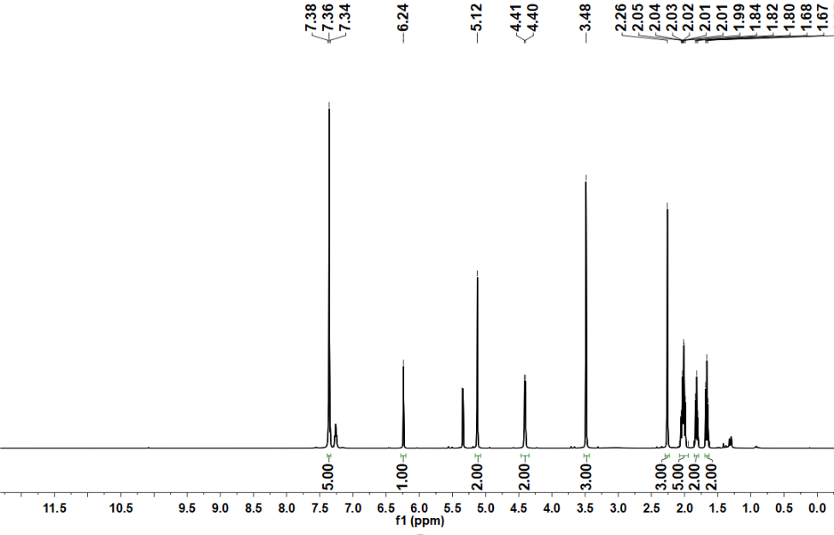
Supplementary Figure 7. ¹³C NMR spectrum of compound 1-7 in Chloroform-d (101 MHz).

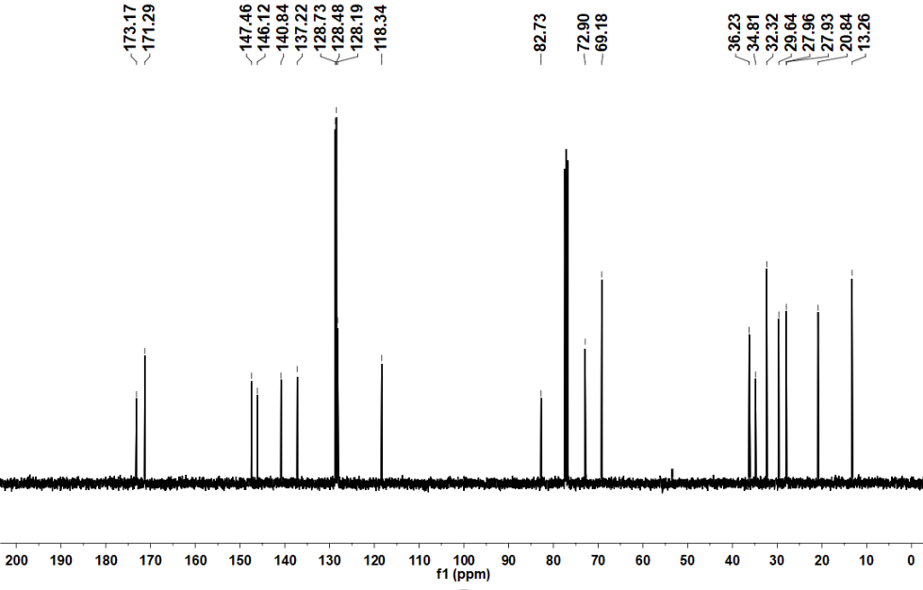
Supplementary Figure 8. ¹H NMR spectrum of compound 10d-1 in DMSO-d₆ (400 MHz).

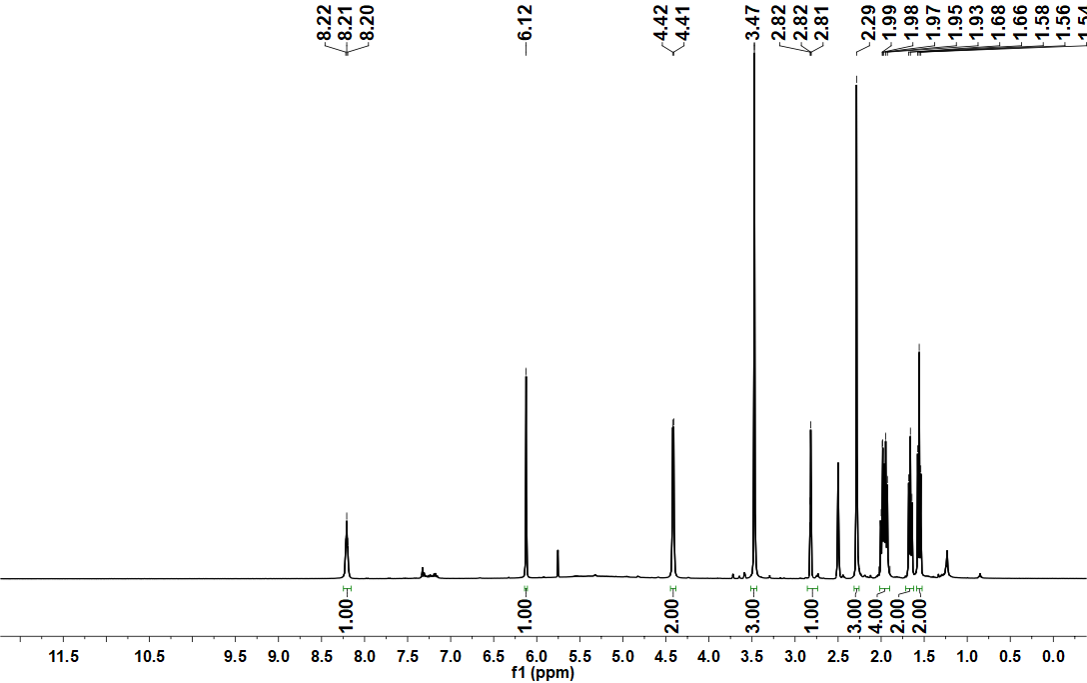

Supplementary Figure 9. ¹³C NMR spectrum of compound 10d-1 in DMSO-d₆ (101 MHz).

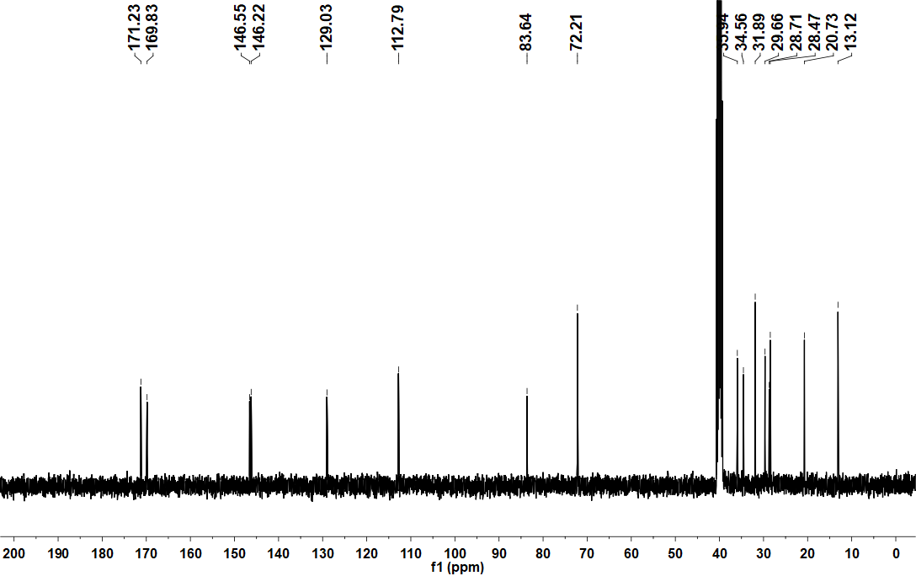

Supplementary Figure 10. ¹H NMR spectrum of compound 1-8 in Chloroform-d (400 MHz).

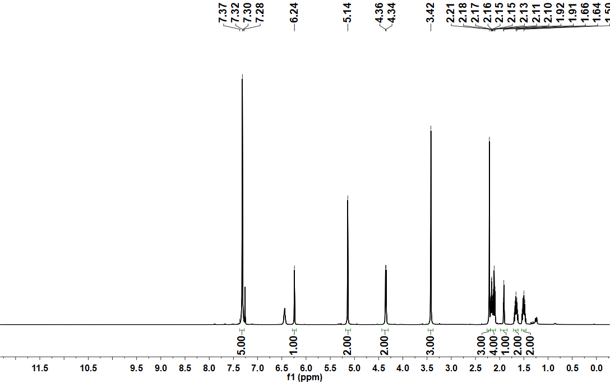

Supplementary Figure 11. ¹³C NMR spectrum of compound 1-8 in Chloroform-d (101 MHz).
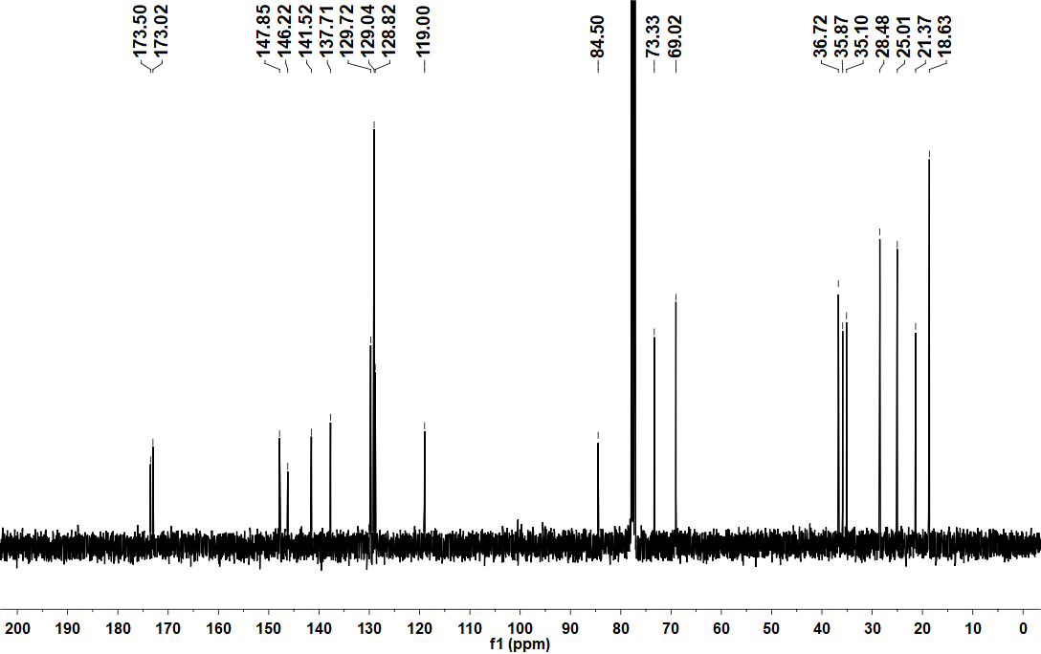

Supplementary Figure 12. ¹H NMR spectrum of compound 10d-3 in DMSO-d₆ (400 MHz).

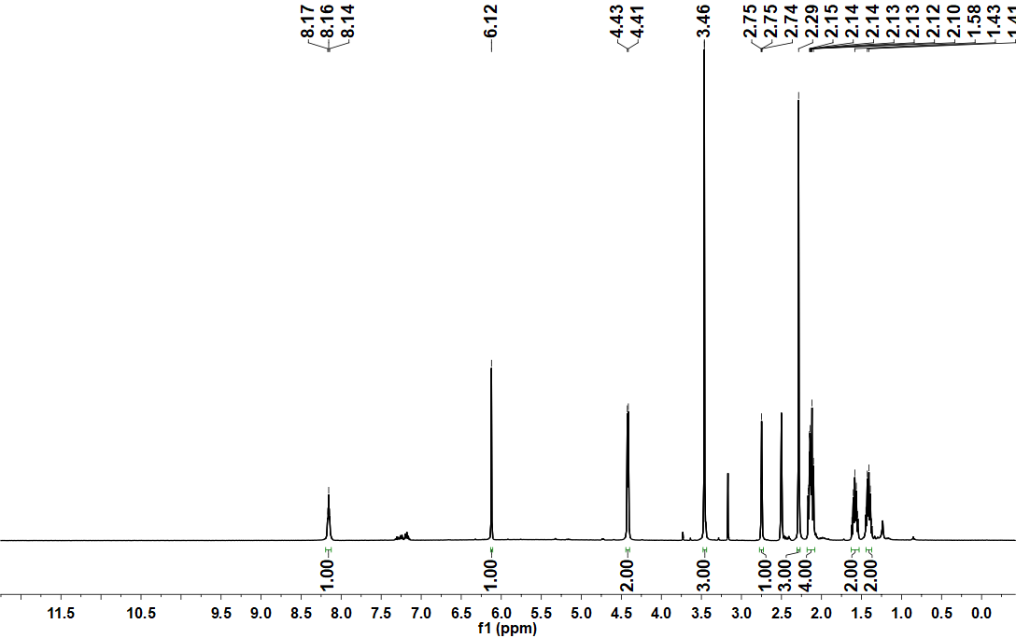

Supplementary Figure 13. ¹³C NMR spectrum of compound 10d-3 in DMSO-d₆ (101 MHz).

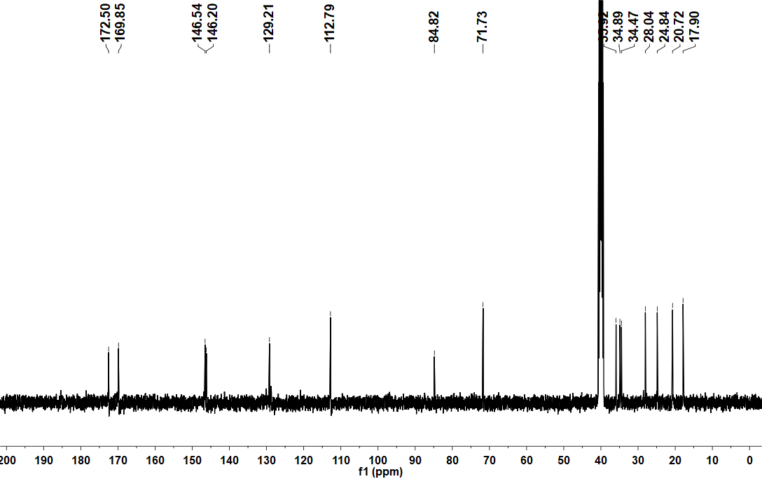

Supplementary Figure 14. ¹H NMR spectrum of compound 1-9 in Chloroform-d (400 MHz).

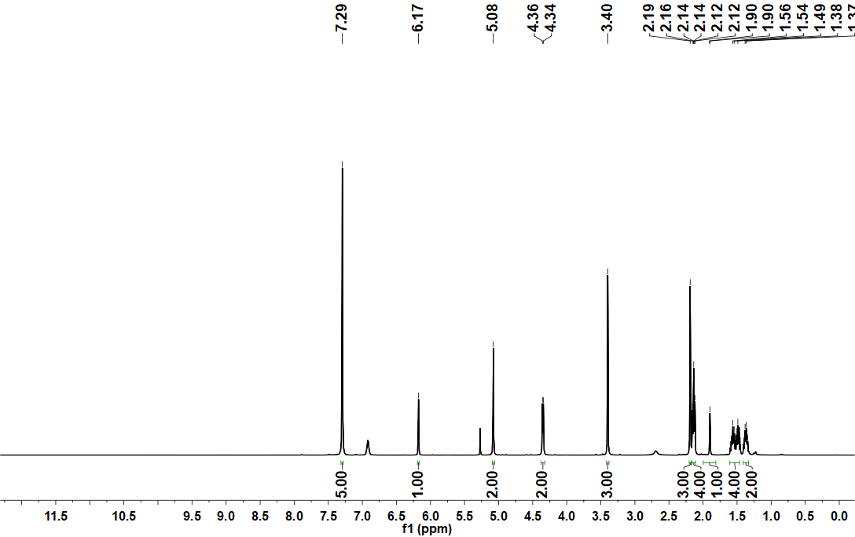

Supplementary Figure 15. ¹³C NMR spectrum of compound 1-9 in Chloroform-d (101 MHz).

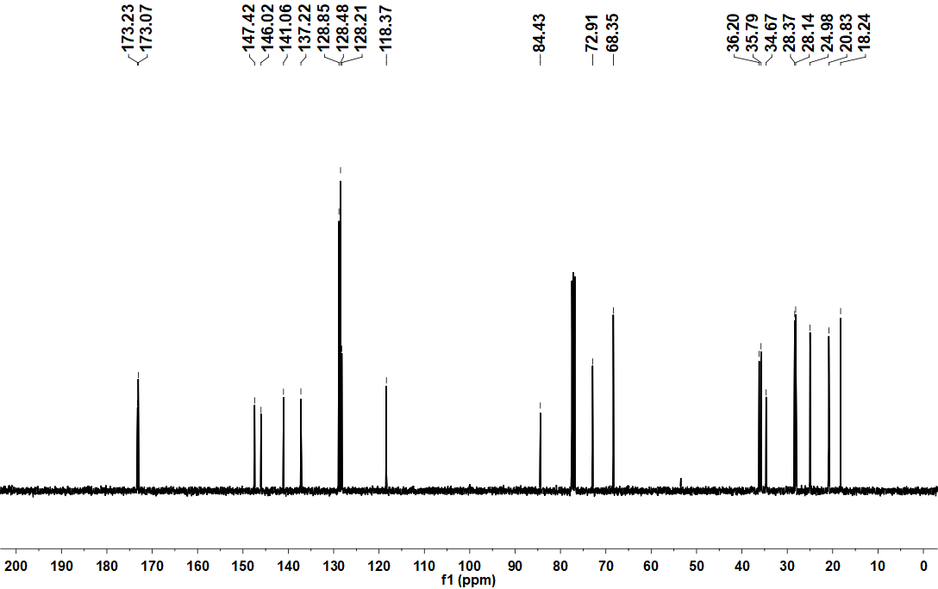

Supplementary Figure 16. ¹H NMR spectrum of compound 10d-4 in DMSO-d₆ (400 MHz).
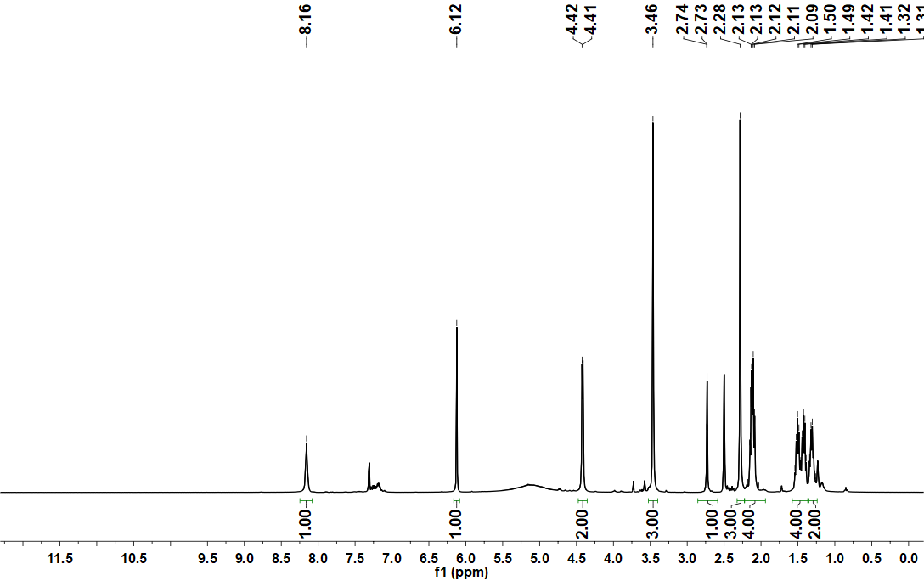

Supplementary Figure 17. ¹³C NMR spectrum of compound 10d-4 in DMSO-d₆ (101 MHz).

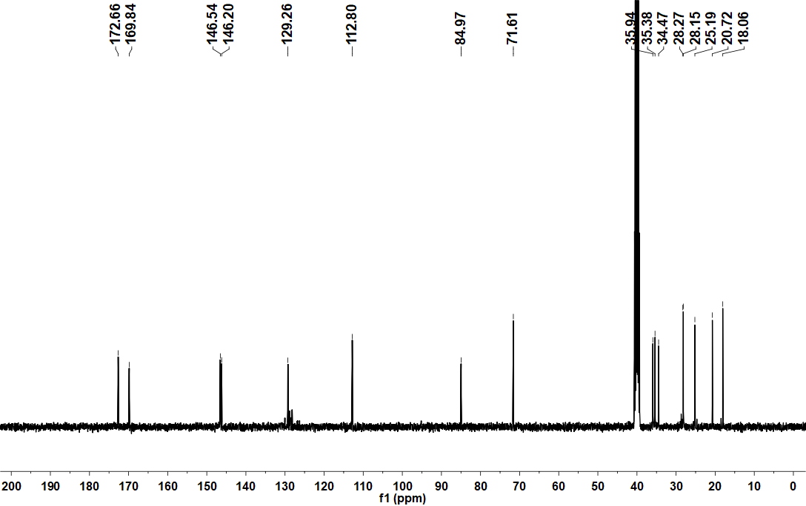

Supplementary Figure 18. ¹H NMR spectrum of compound 2-1 in Chloroform-d (400 MHz).

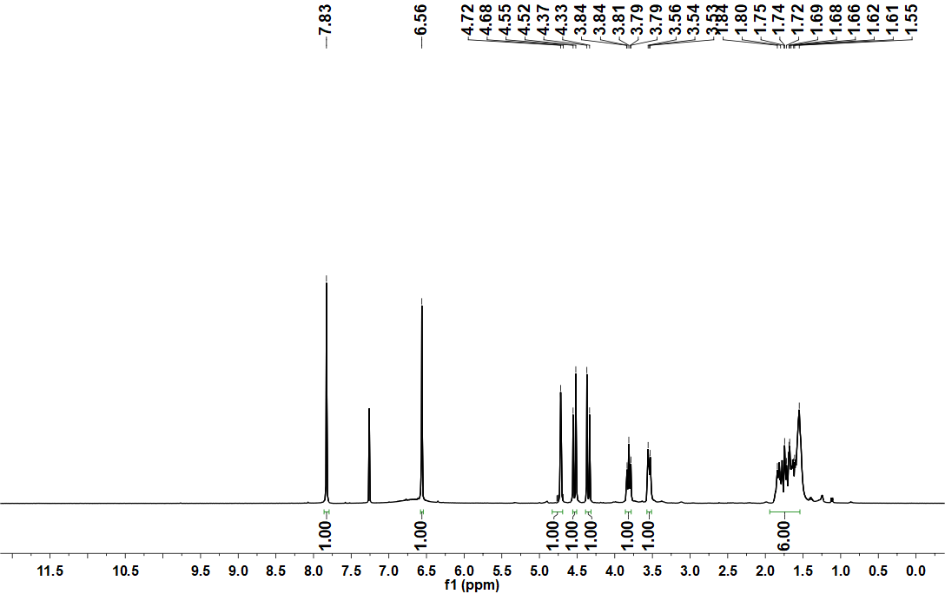

Supplementary Figure 19. ¹³C NMR spectrum of compound 2-1 in Chloroform-d (101 MHz).

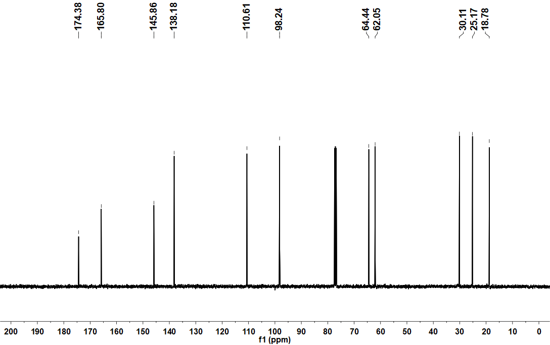

Supplementary Figure 20. ¹H NMR spectrum of compound 2-2 in DMSO-d₆ (400 MHz).

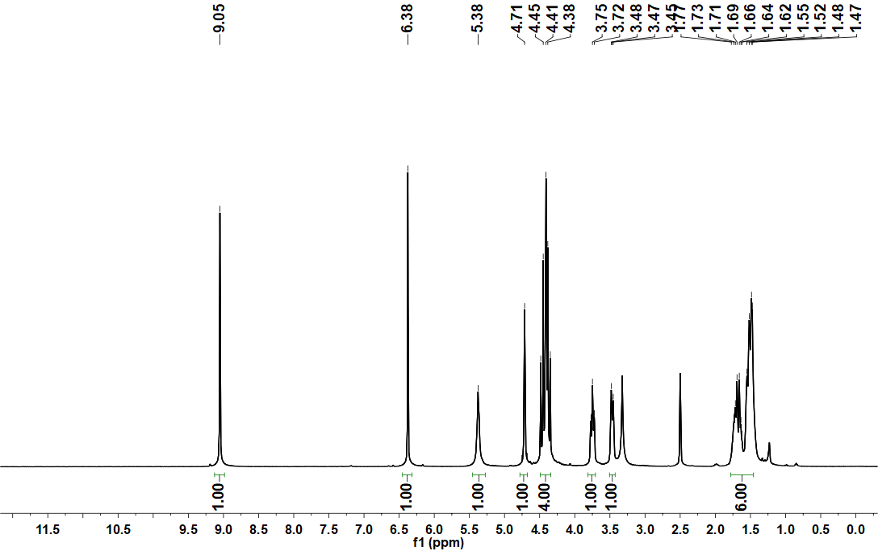

Supplementary Figure 21. ¹³C NMR spectrum of compound 2-2 in DMSO-d₆ (101 MHz).

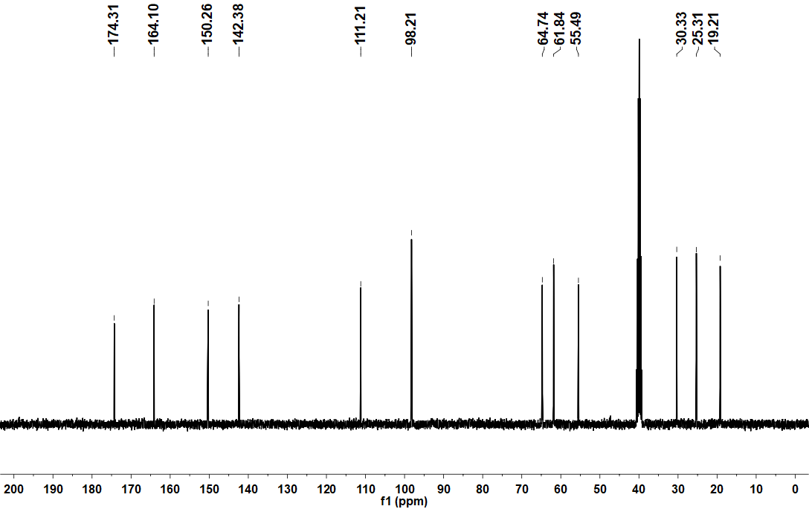

Supplementary Figure 22. ¹H NMR spectrum of compound 2-3 in Chloroform-d (400 MHz).

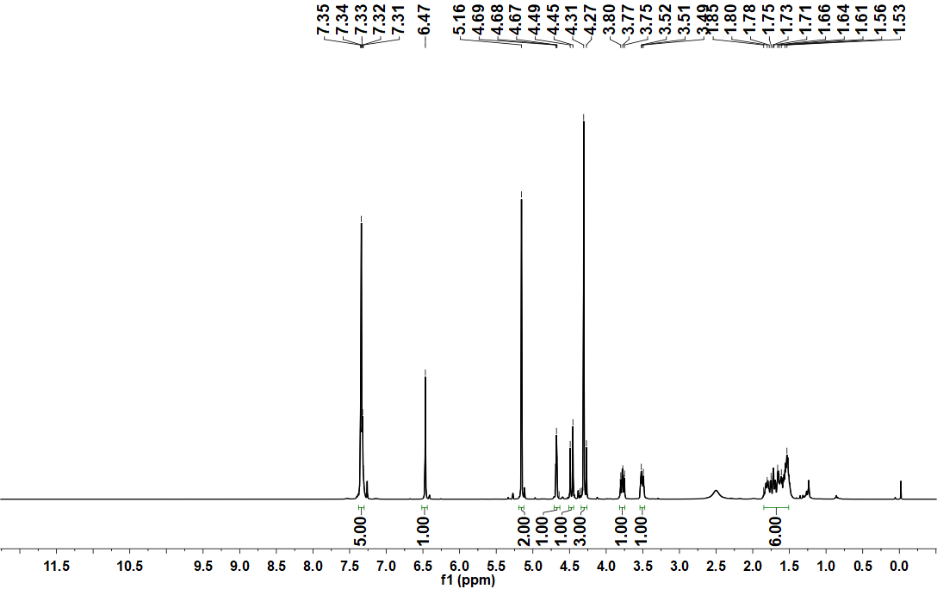

Supplementary Figure 23. ¹³C NMR spectrum of compound 2-3 in Chloroform-d (101 MHz).

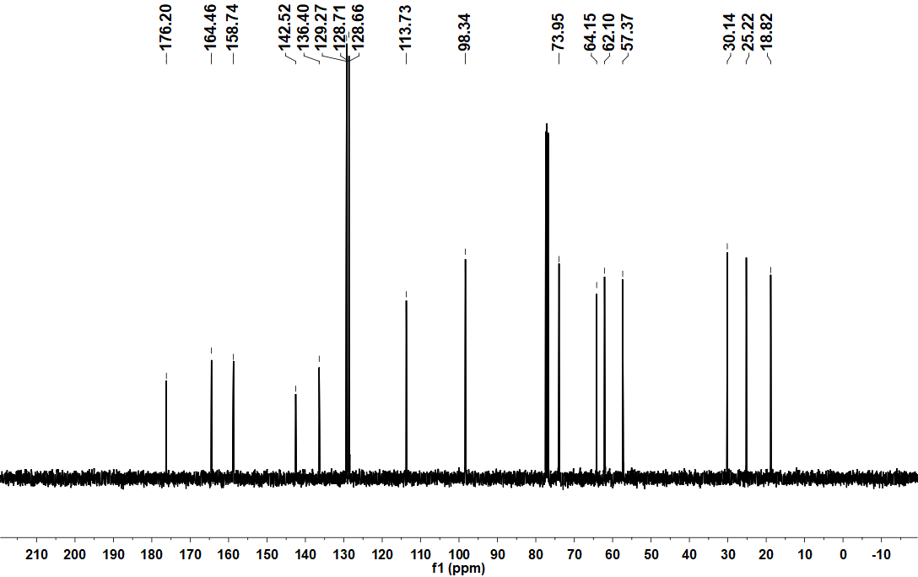

Supplementary Figure 24. ¹H NMR spectrum of compound 2-4 in Chloroform-d (400 MHz).

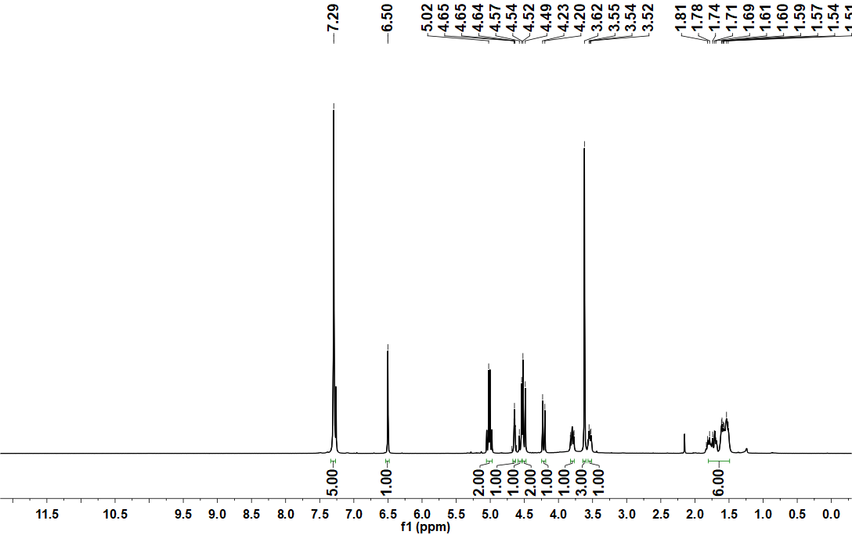

Supplementary Figure 25. ¹³C NMR spectrum of compound 2-4 in Chloroform-d (101 MHz).

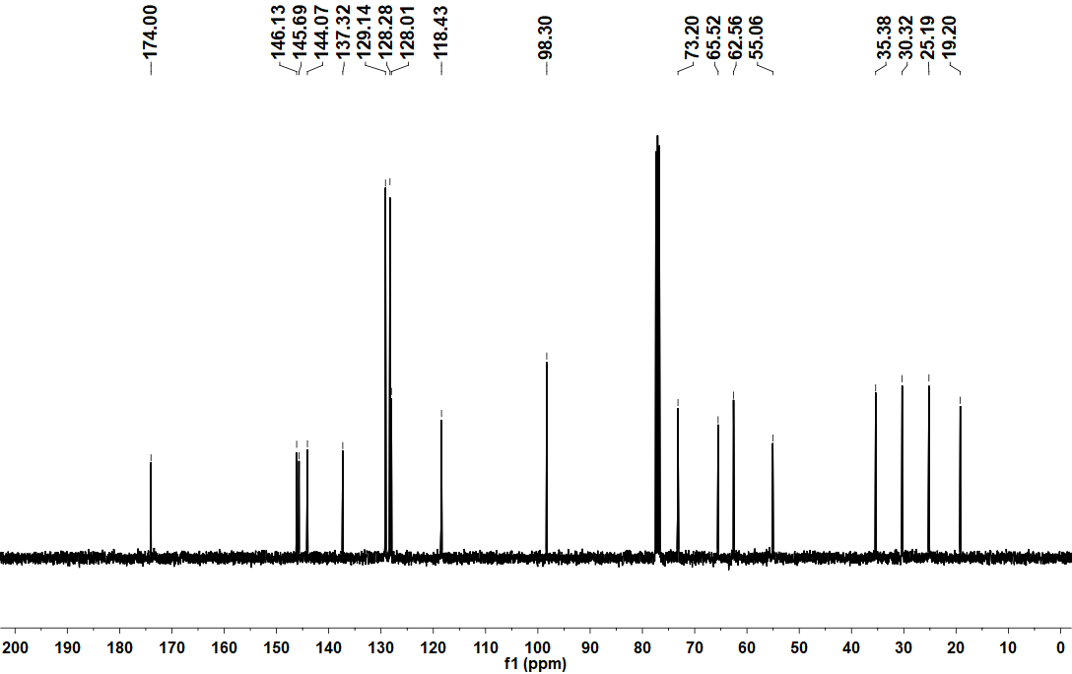

Supplementary Figure 26. ¹H NMR spectrum of compound 2-5 in Chloroform-d (400 MHz).

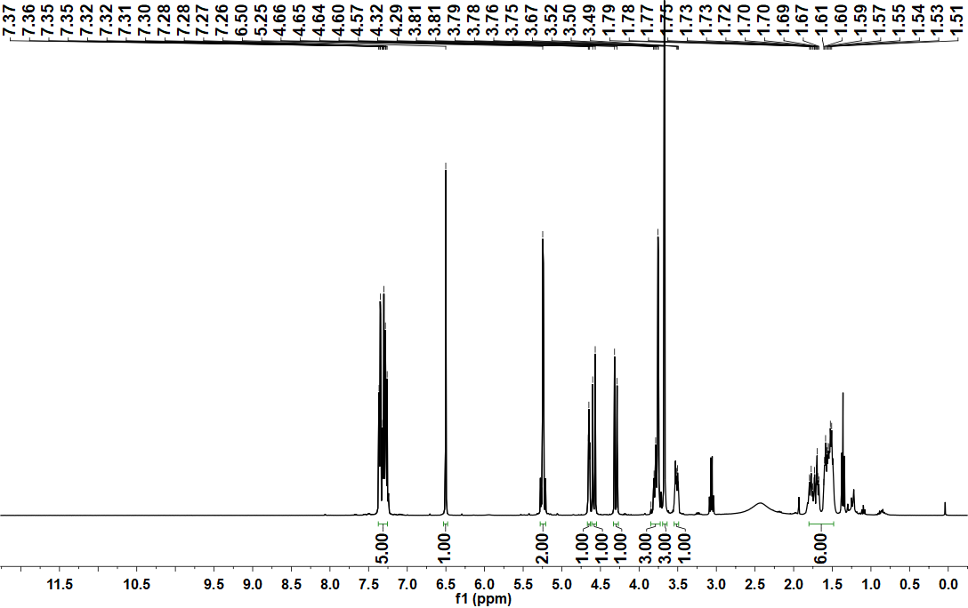

Supplementary Figure 27. ¹³C NMR spectrum of compound 2-5 in Chloroform-d (101 MHz).

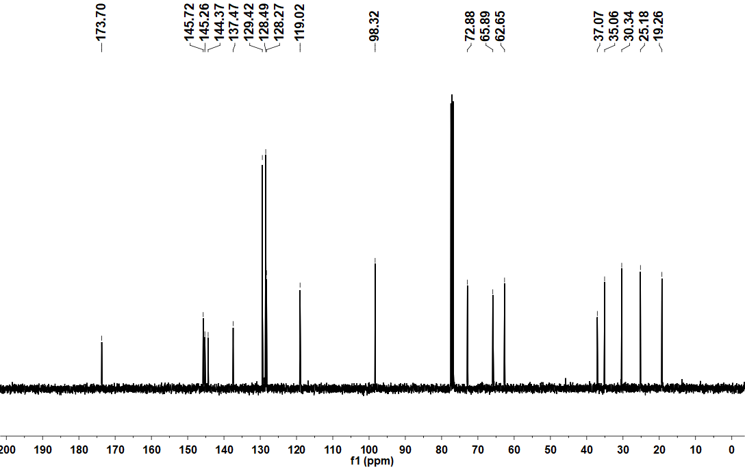

Supplementary Figure 28. ¹H NMR spectrum of compound 2-6 in Chloroform-d (400 MHz).

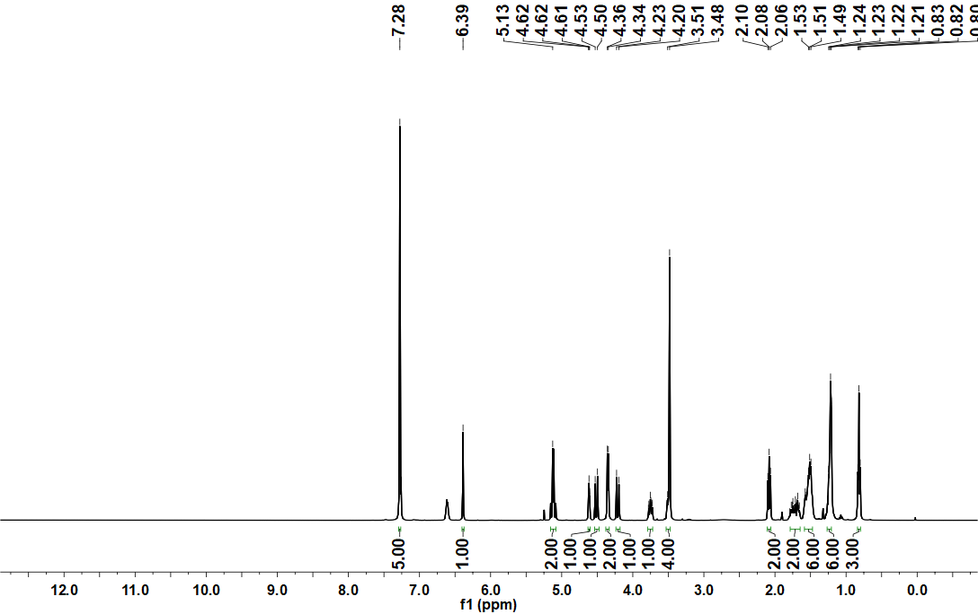

Supplementary Figure 29. ¹³C NMR spectrum of compound 2-6 in Chloroform-d (101 MHz).

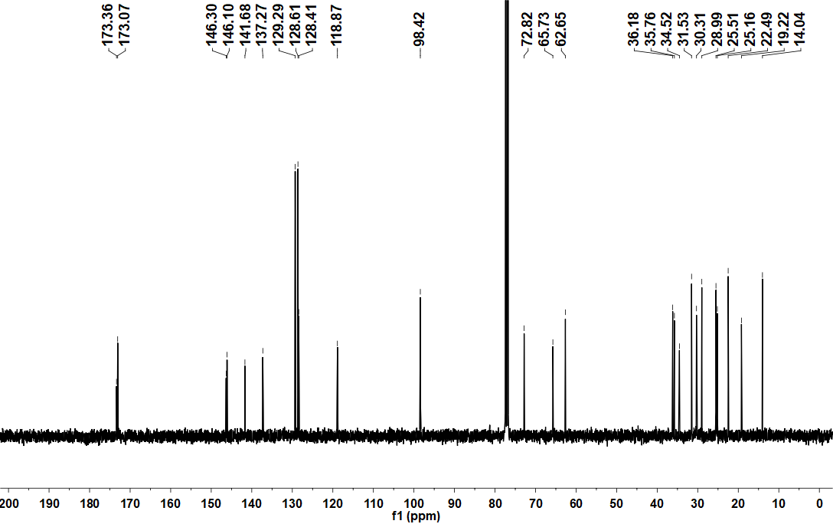

Supplementary Figure 30. ¹H NMR spectrum of compound 2-7 in DMSO-d₆ (400 MHz).

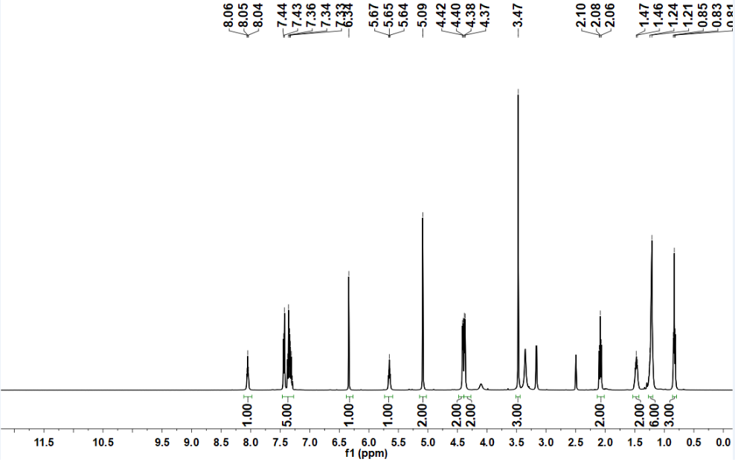

Supplementary Figure 31. ¹³C NMR spectrum of compound 2-7 in DMSO-d₆ (101 MHz).

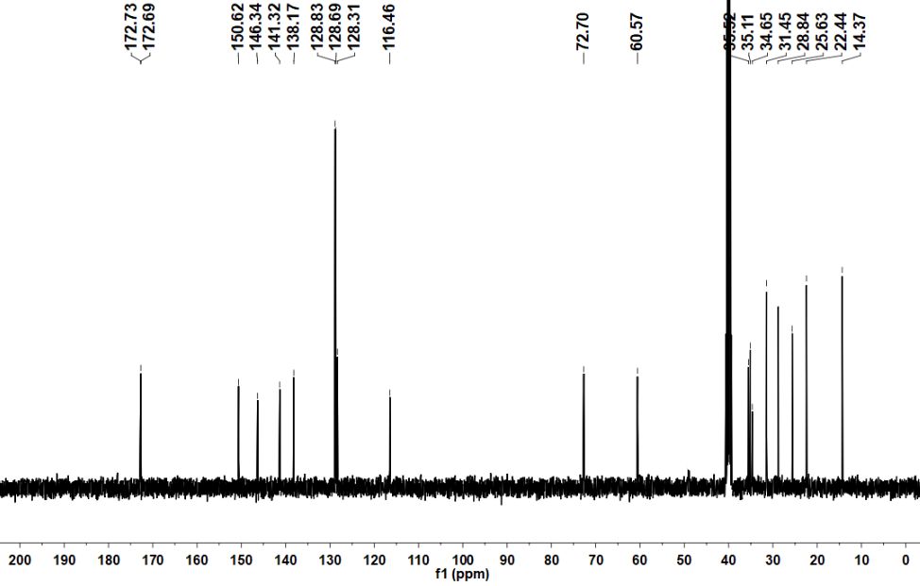
Supplementary Figure 32. ¹H NMR spectrum of compound 2-8 in DMSO-d₆ (400 MHz).

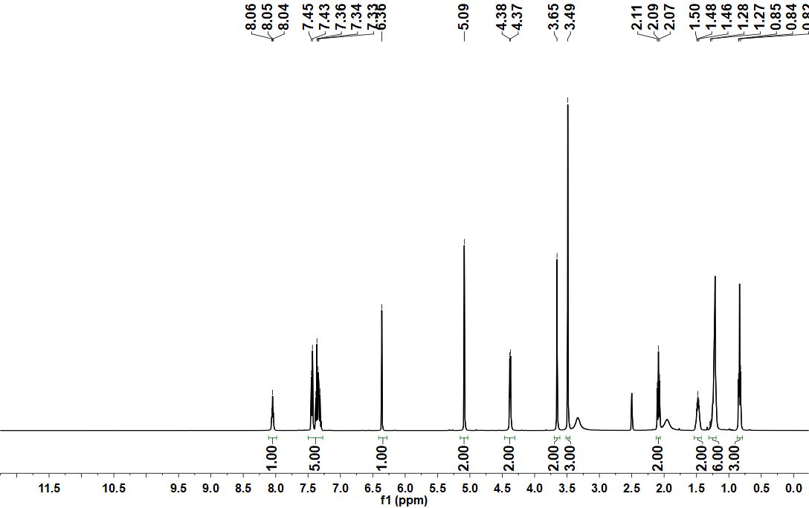

Supplementary Figure 33. ¹³C NMR spectrum of compound 2-8 in DMSO-d₆ (101 MHz).
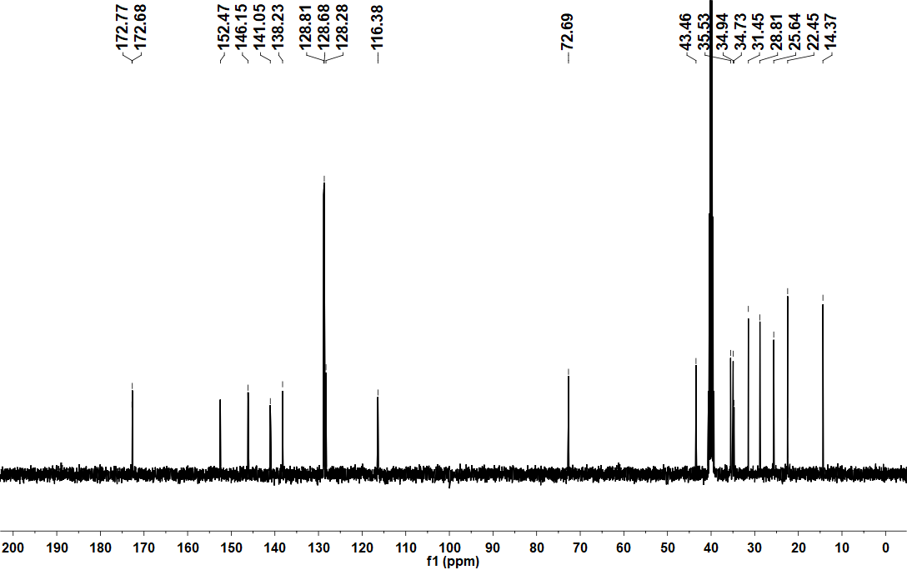

Supplementary Figure 34. ¹H NMR spectrum of compound 2-9 in Chloroform-d (400 MHz).

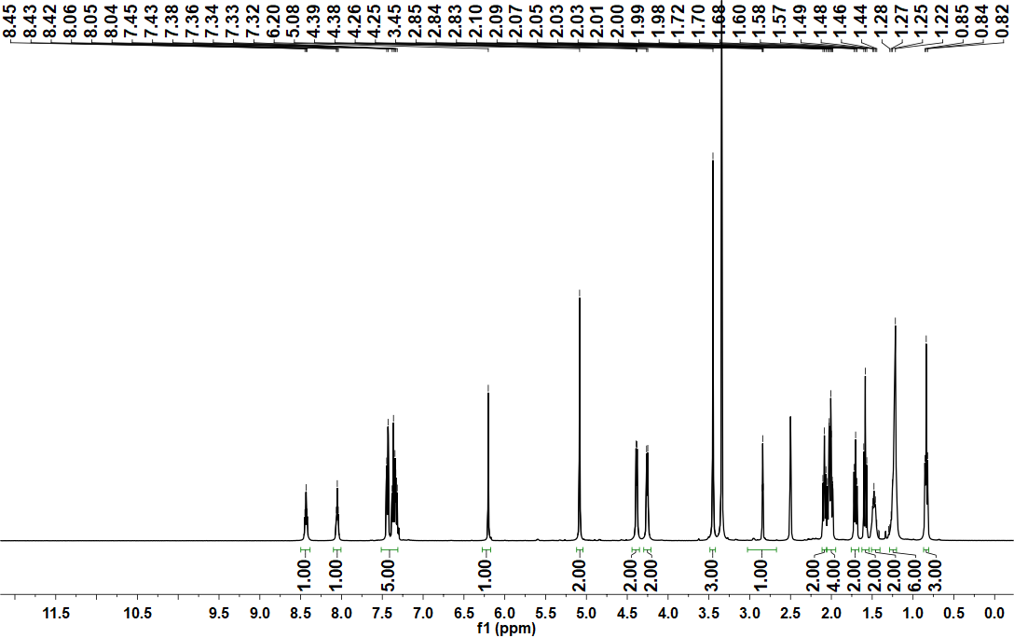

Supplementary Figure 35. ¹³C NMR spectrum of compound 2-9 in Chloroform-d (101 MHz).

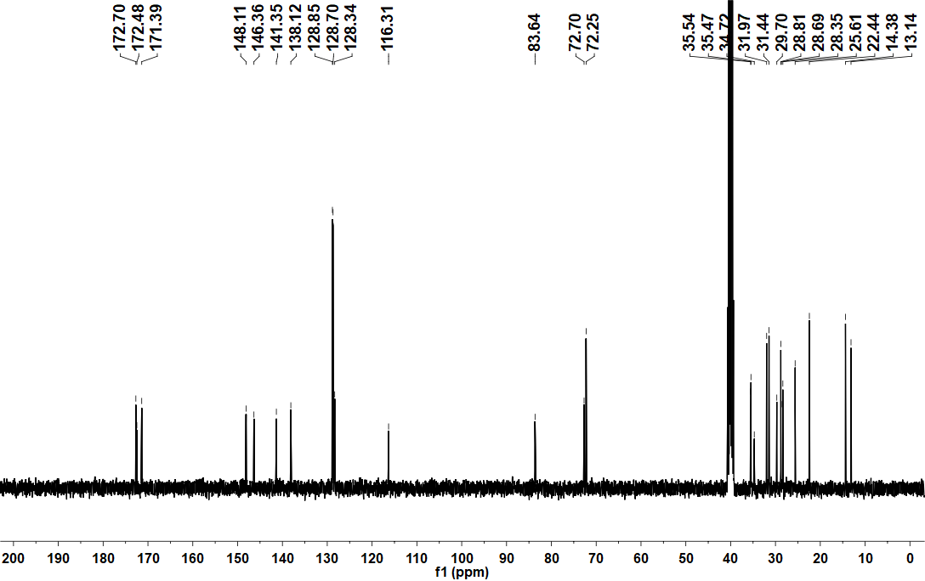

Supplementary Figure 36. ¹H NMR spectrum of compound 10d-2 in DMSO-d₆ (400 MHz).

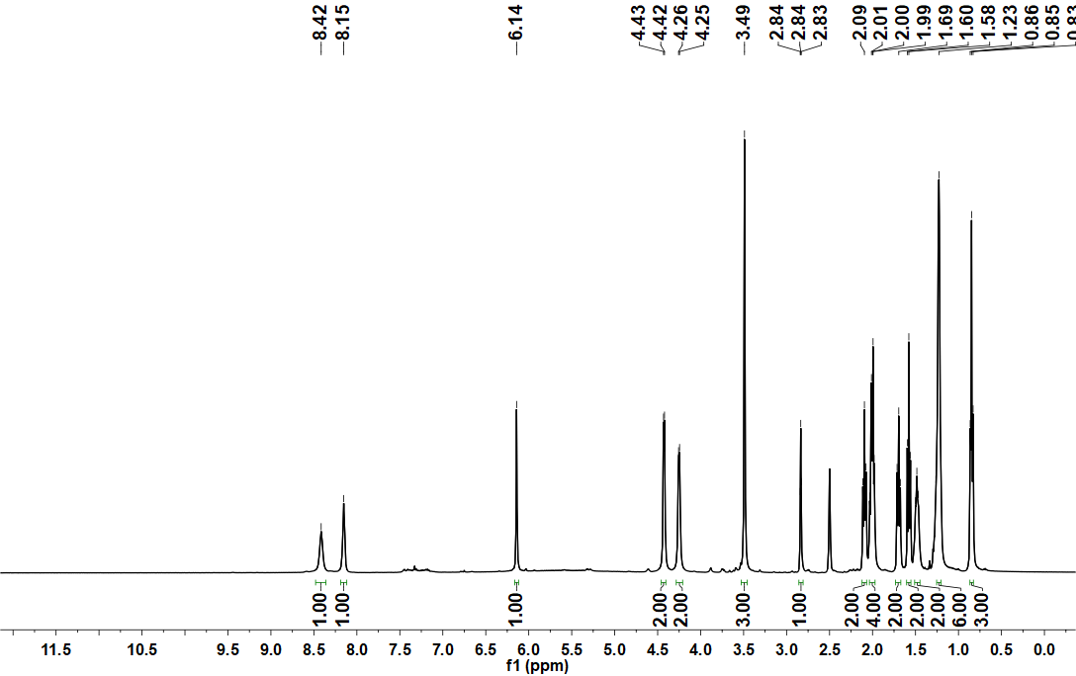

Supplementary Figure 37. ¹³C NMR spectrum of compound 10d-2 in DMSO-d₆ (101 MHz).

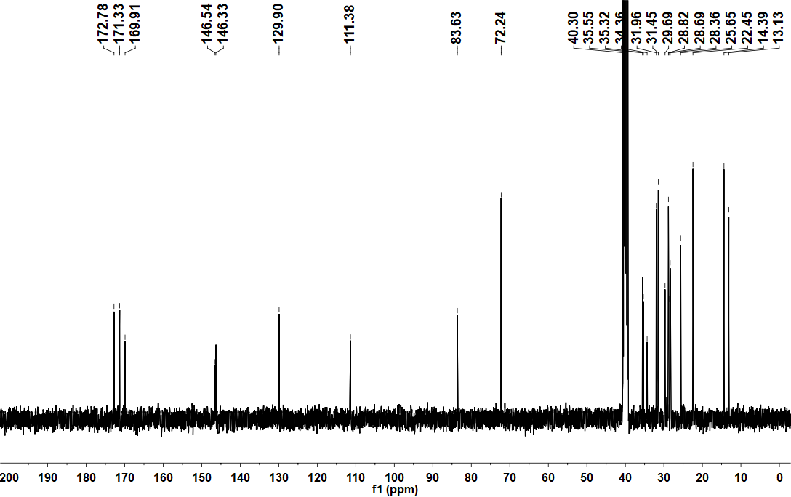

Supplementary Figure 38. ¹H NMR spectrum of compound 2-10 in Chloroform-d (400 MHz).

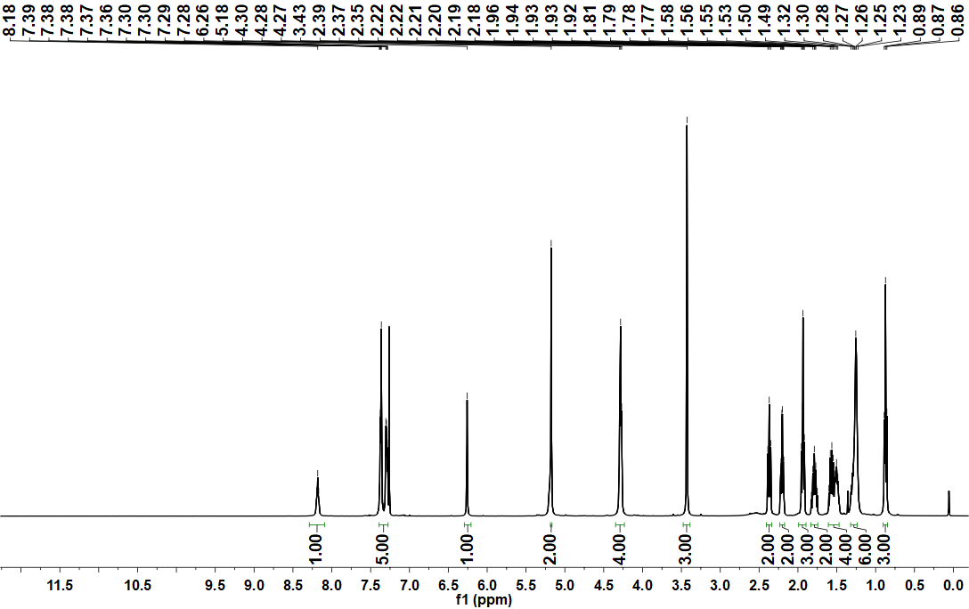

Supplementary Figure 39. ¹³C NMR spectrum of compound 2-10 in Chloroform-d (101 MHz).

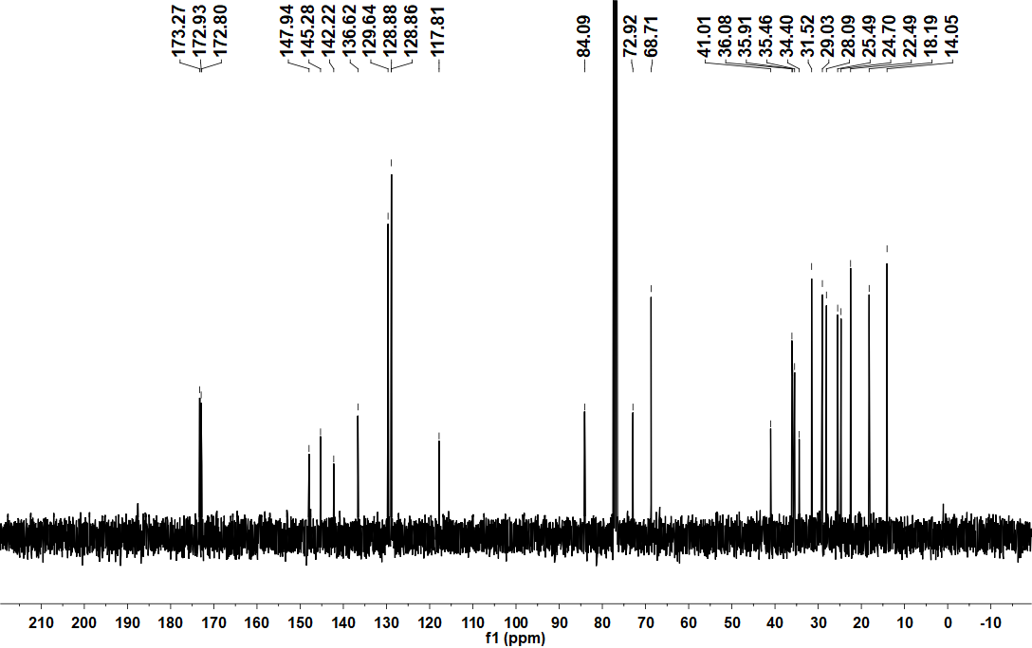

Supplementary Figure 40. ¹H NMR spectrum of compound 10d-5 in DMSO-d₆ (400 MHz).

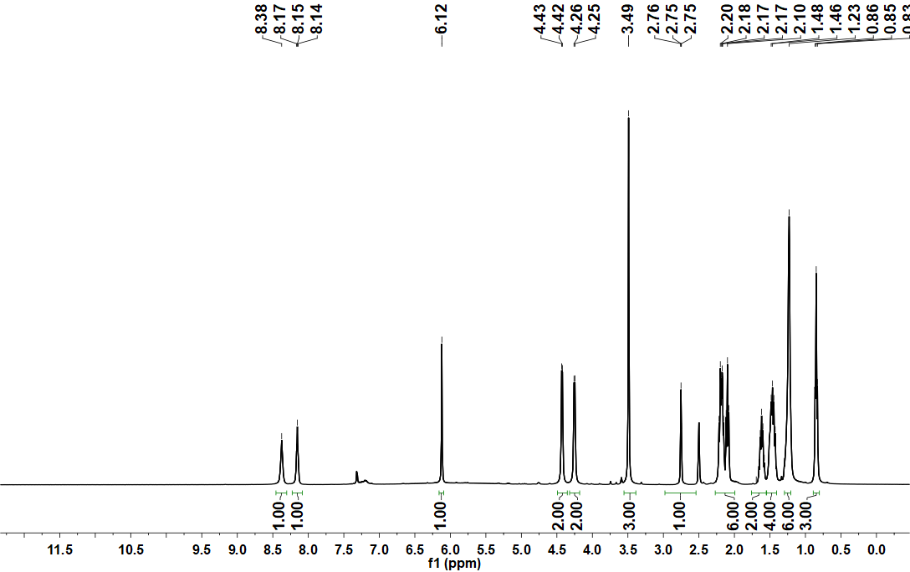

Supplementary Figure 41. ¹³C NMR spectrum of compound 10d-5 in DMSO-d₆ (101 MHz).

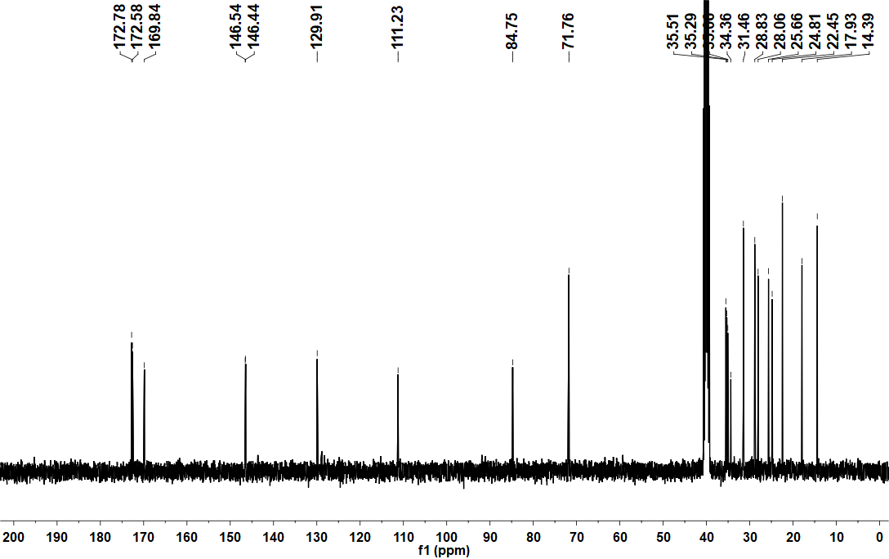

Supplementary Figure 42. ¹H NMR spectrum of compound NP in Chloroform-d (400 MHz).

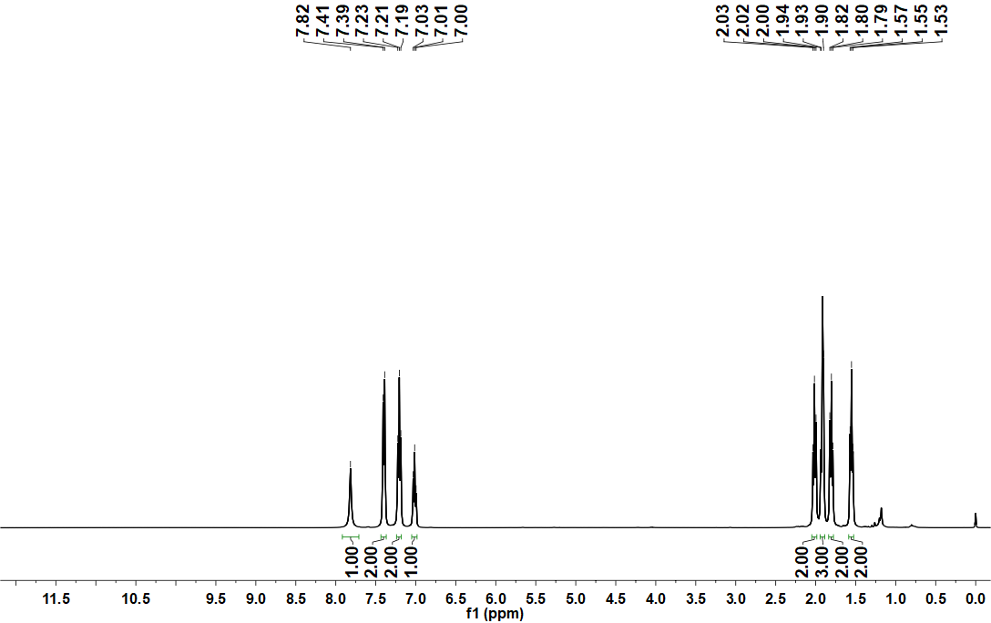

Supplementary Figure 43. ¹³C NMR spectrum of compound NP in Chloroform-d (101 MHz).

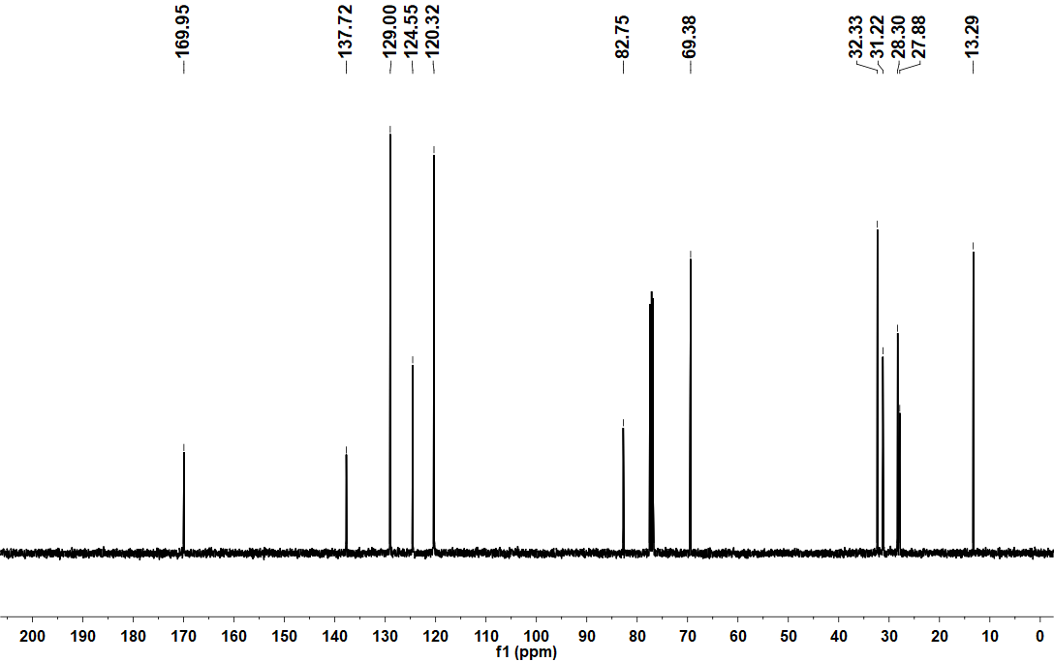

Supplementary Figure 44. ¹H NMR spectrum of compound NP-1 in Chloroform-d (400 MHz).

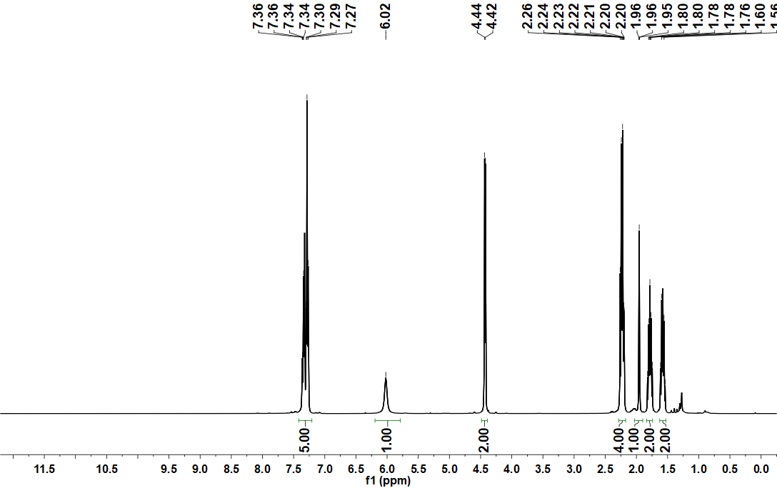

Supplementary Figure 45. ¹³C NMR spectrum of compound NP-1 in Chloroform-d (101 MHz).

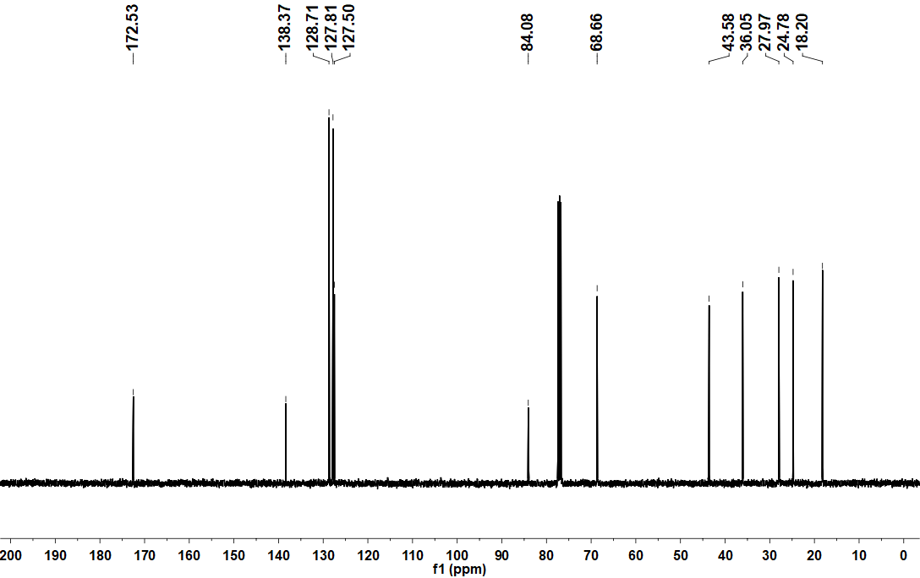

Supplementary Figure 46. ¹H NMR spectrum of compound NP-2 in Chloroform-d (400 MHz).

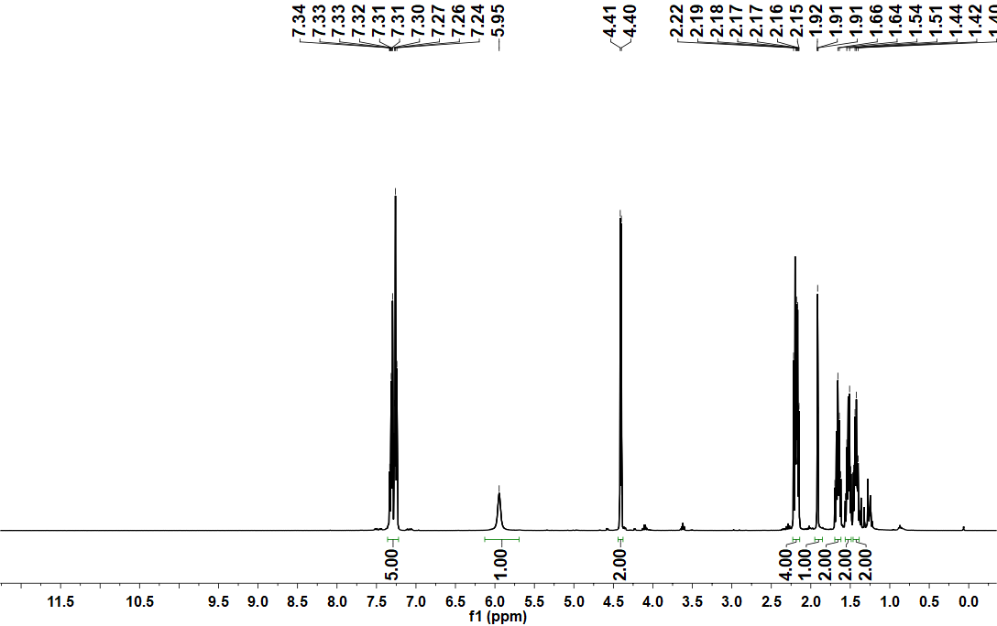

Supplementary Figure 47. ¹³C NMR spectrum of compound NP-2 in Chloroform-d (101 MHz).

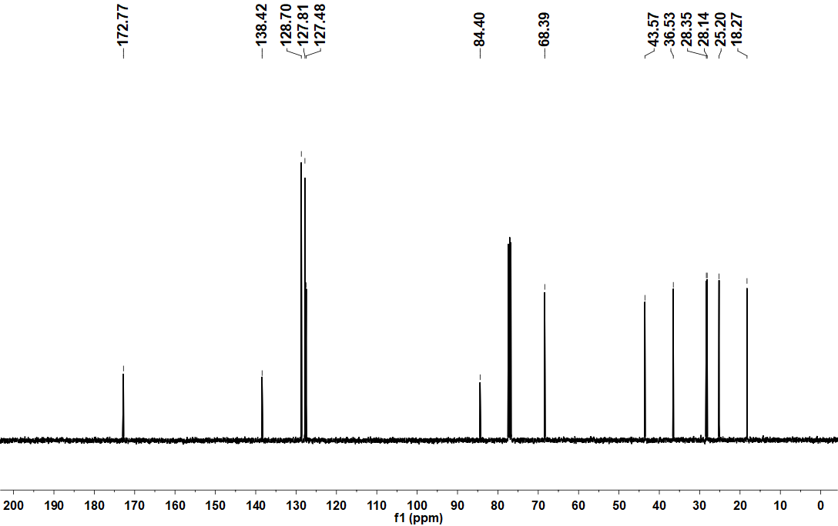

Supplementary Figure 48. HRMS spectrum of compound 10d-1.
Supplementary Figure 49. HRMS spectrum of compound 10d-2.
Supplementary Figure 50. HRMS spectrum of compound 10d-3.
Supplementary Figure 51. HRMS spectrum of compound 10d-4.
Supplementary Figure 52. HRMS spectrum of compound 10d-5.
Supplementary Figure 53. HRMS spectrum of compound NP-1.
Supplementary Figure 54. HRMS spectrum of compound NP-2.

HPLC data of probes used in biological assays.
Supplementary Table 5 overviewed the results of detection and the purity of all the probes used in biological assays. The purity of each compound was calculated from a surface integral of detected peaks. These purities were satisfied more than 95%.
Supplementary Table 5. Results of HPLC detection and purity.
Compound | Isocratic solvent | Retention time (min) | Purity (%)
10d-1 | 90% MeOH | 2.957 | 95.20
10d-2 | 90% MeOH | 3.333 | 95.84
10d-3 | 90% MeOH | 2.990 | 97.13
10d-4 | 90% MeOH | 3.013 | 95.82
10d-5 | 90% MeOH | 3.280 | 96.25
NP | 90% MeOH | 3.387 | 99.68
NP-1 | 90% MeOH | 3.280 | 96.69
NP-2 | 90% MeOH | 3.383 | 95.21

Supplementary Figure 55. HPLC trace of compound 10d-1 (Retention time: 2.957 min, Purity: 95.20%).
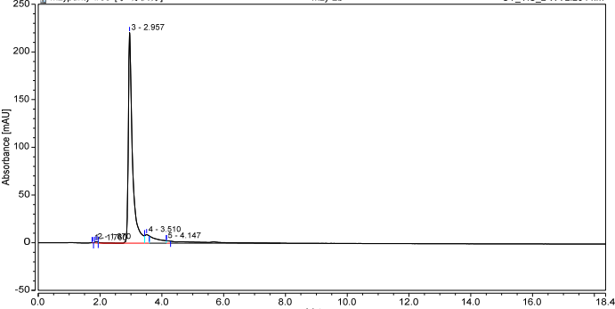
Supplementary Figure 56. HPLC trace of compound 10d-2 (Retention time: 3.333 min, Purity: 95.84%).
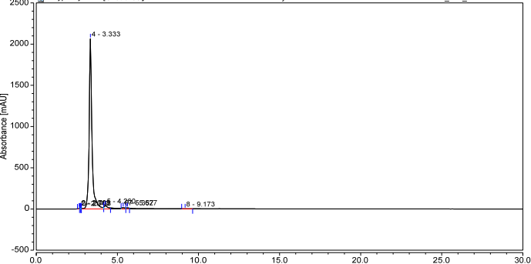
Supplementary Figure 57. HPLC trace of compound 10d-3 (Retention time: 2.990 min, Purity: 97.13%).
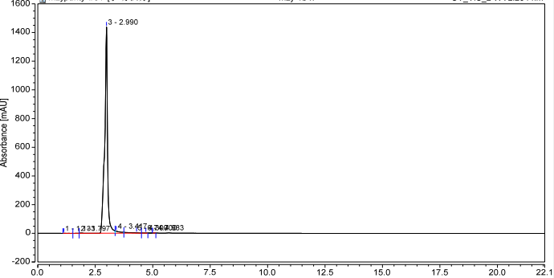
Supplementary Figure 58. HPLC trace of compound 10d-4 (Retention time: 3.013 min, Purity: 95.82%).
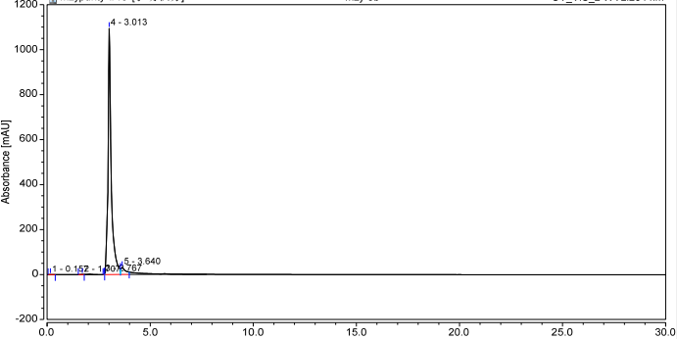
Supplementary Figure 59. HPLC trace of compound 10d-5 (Retention time: 3.280 min, Purity: 96.25%).
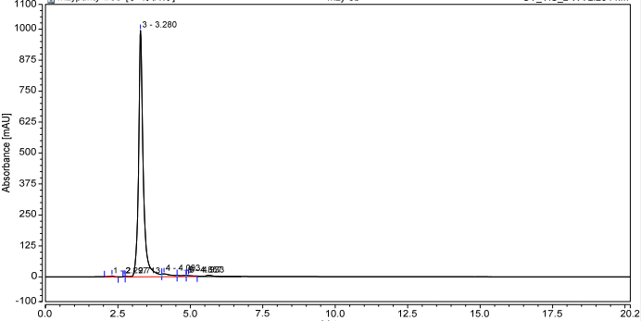
Supplementary Figure 60. HPLC trace of compound NP (Retention time: 3.387 min, Purity: 99.68%).
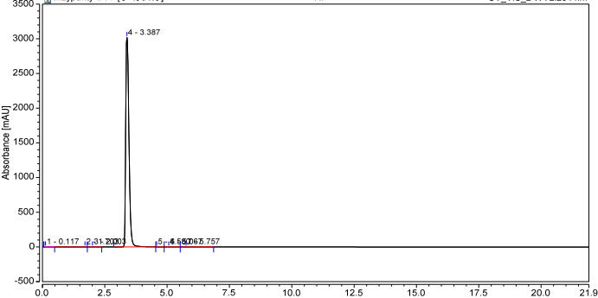
Supplementary Figure 61. HPLC trace of compound NP-1 (Retention time: 3.280 min, Purity: 96.69%).
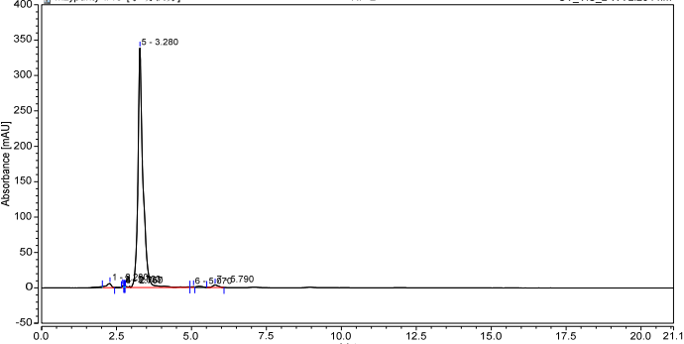
Supplementary Figure 62. HPLC trace of compound NP-2 (Retention time: 3.383 min, Purity: 95.21%).
