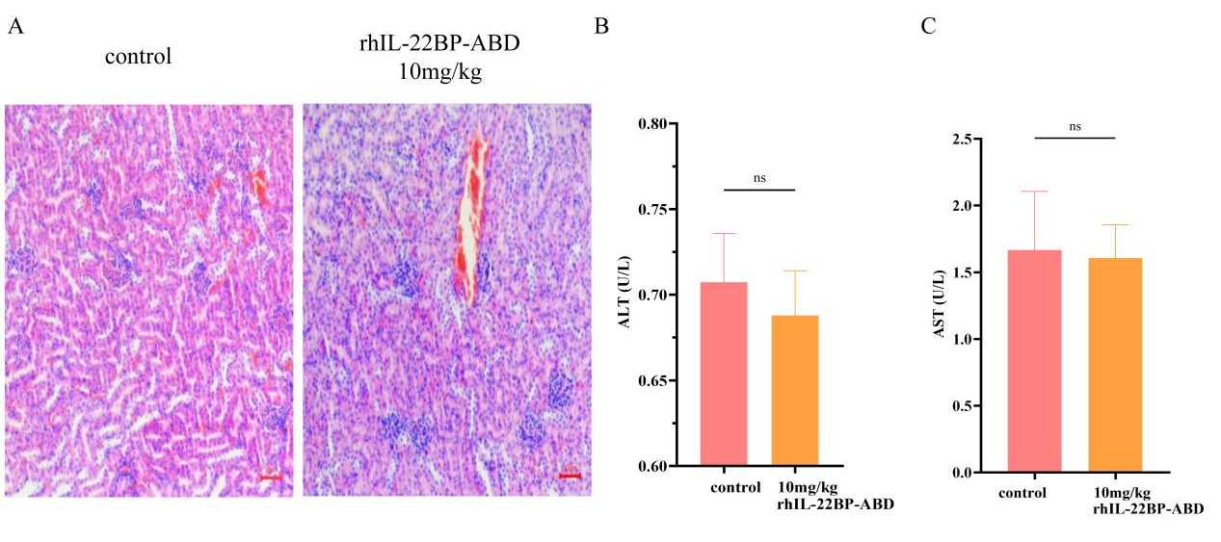
Supplementary data 2 rhIL-22BP-ABD has no significant toxic effect on normal wild-type mice. A Representative images of H&E-stained kidney sections in normal mice injected with 20 mM Tris-HCl or 10 mg/kg rhIL-22BP-ABD, respectively. B The content of serum ALT in normal mice injected with 20 mM Tris-HCl or 10 mg/kg rhIL-22BP-ABD respectively was compared by ELISA (n=5). C The content of serum ALT in normal mice after injection of 20 mM Tris-HCl and 10 mg/kg rhIL-22BP-ABD respectively was compared by ELISA (n=5).

