Supporting Information

Bifunctional asymmetric Fe-O₄/Co-O₄ sites in 2D porphyrin-based monolayer for deep mineralization of contaminants
Zhi-Hui Zhao¹, De-Ren Yang^{2*}, Juan-Juan Qi^{1*}, Qian Bai¹, Qiang-Wei Li¹, Xiu-Ze Li¹, Jian-Hui Wang³, Li-Dong Wang^{1*}
¹ MOE Key Laboratory of Resources and Environmental Systems Optimization, College of Environmental Science and Engineering, North China Electric Power University, Beijing 102206, P. R. China.
² Institute of Energy Power Innovation, North China Electric Power University, 2 Beinong Road, Beijing 102206, P. R. China.
³ Institute of Energy Resources, Hebei Academy of Sciences, Shijiazhuang 050081, China.

Experimental Section
Chemicals
Fe (NO₃)₃·9H₂O (99.9%), Co(NO₃)₂·6H₂O (99.9%), ZrCl₄ (99.5%), Vulcan XC72 carbon (99.9%), PVP (M.W. 10000, 99.9%), pyrrole (99%) and Nafion D-521 dispersion (5% w/w in water and 1-propanol) were purchased from Alfa Aesar. Formic acid (98%), KHCO₃ (99.7%), KCl (99.8%), KOH (≥85%), benzoic acid (99.5%), toluene (≥99.5%), anhydrous ethanol (≥ 99.7%), methanol (≥99.7%), tetrahydrofuran (≥99.8%), propionic acid (≥99.5%) and N. N-dimethylformamide (DMF, ≥99.5%) were purchased from Sinopharm. Deionized water was used throughout all the experiments. All chemicals were purchased commercially and used without additional purification except tetrakis (4-carboxyphenyl)-porphyrin (TCPP).
Synthesis of TCPP
TCPP was synthesized by two steps as blow:
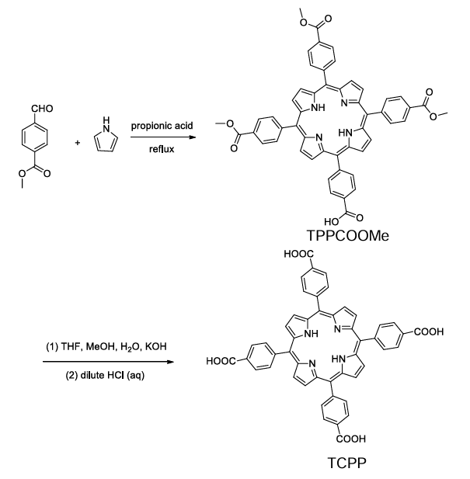
Firstly, 3.0 g pyrrole (0.043 mol) and 6.9 g methyl p-formylbenzoate (0.042 mol) were successively added to 100 mL of reflux propionic acid in a 500 mL three necked flask. The solution was refluxed at 120 ºC for 12 h. When the system was cooled down, the purple crystals (TPPCOOMe) were obtained by suction-filtration. The crystals were cleaned three times with methanol, ethyl acetate and tetrahydrofuran respectively, and vacuum dried at room temperature for further use.
Secondly, 0.75 g crystals were stirred in 50 mL tetrahydrofuran-methanol solvent with a volume ratio of 1:1. Then, 25 mL water solution of 2.63 g KOH (46.95 mmol) was added. The mixture was refluxed 120 ºC for 12 h. THF and MeOH were evaporated during cooling process. Adding 100 mL water to the remaining mixture, then the homogeneous solution was acidified with 1 M HCl until no further precipitate was formed. The green precipitate was collected by filtration, washed with water and dried in vacuum. Finally, the purple crystal (TCPP) was obtained.
Synthesis of PML-Fe
2.4 mg Fe(NO₃)₃·9H₂O, 20 μL formic acid and 10 mg PVP were dissolved in 12 mL DMF-ethanol solution with a volume ratio of 3:1. Then, 4.4 mg TCPP, 3 mL DMF and 1 mL ethanol were added to a 12 mL Teflon-lined autoclave under stirring. After that, 6 mL DMF-ethanol solution was added into the autoclave and stirred for 10 minutes at room temperature. Next, the mixture was heated at 80 ºC for 6h. Finally, PML-Fe was collected via centrifugation at 8000 rpm for 3 minutes and further washed by ethanol for three times. The solid product was obtained after drying at 60 ºC for 4 h.
Synthesis of PML-Fe-Co
2.02 mg Fe(NO₃)₃·9H₂O, 1.45 mg Co(NO₃)₂·6H₂O, 20 μL formic acid and 10 mg PVP were dissolved in 12 mL DMF-ethanol solution with a volume ratio of 3:1. Then, 4.4 mg TCPP, 3 mL DMF and 1 mL ethanol were added to a 12 mL Teflon-lined autoclave under stirring. After that, 6 mL DMF-ethanol solution was added into the autoclave and stirred for 10 minutes at room temperature. Next, the mixture was heated at 80 ºC for 6 h. Finally, PML-Fe-Co was collected via centrifugation at 8000 rpm for 3 minutes and further washed by ethanol for three times. The solid product was obtained after drying at 60 ºC for 4 h.
Characterization
Scanning electron microscopy (SEM, JEOL), transmission electron microscopy (TEM, JEOL), and high-angle annular dark-field scanning TEM (HAADF-STEM, Titan Themis G3) were performed for morphological analysis of the prepared samples. Kelvin probe force microscopy (KPFM, Bruker Dimension Icon) was used to measure the surface potential of the prepared samples. The element composition of the sample was analyzed using an Energy dispersive X-ray spectrum (EDX) and elemental mapping in a Super-XTM system. X-ray diffraction (XRD) data were obtained by a RU-200B (Rigaku) with Cu Kα radiation (λ = 0.15406 nm). Electron spin resonance (ESR) spectra were obtained using a BRUKER A300 instrument. X-ray photoelectron spectroscopy (XPS) was carried out on a Kratos AXIS Ultra DLD system under ultrahigh vacuum (UHV) conditions. The radicals were identified by using an electron spin resonance (ESR, Bruker A200), DMPO and TEMP were used as the spin-trapping agents of •OH, •O₂⁻, and ¹O₂. The photoluminescence spectra (PL) were determined by a fluorescence spectrometer (Hitachi F-7000). The electrochemical properties of catalysts were analyzed by cyclic voltammetry (CV), photocurrent time on an electrochemical workstation (PP211, Zahner Co., Germany) using conductive glass electrode coated with catalyst powder as the working electrodes and using 0.1 M Na₂SO₄ as the bath solution. UV-vis diffuse reflectance spectrum was obtained using a UV-vis spectrophotometer (UV-3600, Shimadzu). Raman spectroscopies were measured using a Laser Microscopic Confocal Raman Spectrometer (HR-800, Horiba) under excitation by laser light at λ = 325 nm.
Soft XAS Measurements
All the presented soft XANES spectra (C K-edge and N K-edge) in this paper were performed at beamline BL12B of National Synchrotron Radiation Laboratory (NSRL). The preparation of measured samples was conducted by depositing samples onto double-sided carbon tape for X- ray spectroscopy. A bending magnet was connected to the beamline BL12B, which was equipped with three gratings covering photon energies from 100 to 1,000 eV with an energy resolution of ~0.2 eV. The data were recorded in the total electron yield mode by collecting the sample drain current. The resolving power of the grating was typically E/ΔE = 1,000, and the photon flux was 1 × 10⁻¹⁰ photons per second.
Ex-situ XAFS measurements
The X-ray absorption fine structure spectra data (XAFS, Co K-edge) were measured at BL1W1B station in Beijing Synchrotron Radiation Facility (BSRF, operated at 2.5 GeV with a maximum current of 250 mA). And the XAFS spectra data were performed at 14W1 station in Shanghai Synchrotron Radiation Facility (SSRF, operated at 3.5 GeV with a maximum current of 250 mA). The XAFS data of all the samples were measured at room temperature in fluorescence excitation mode using a Lytle detector All samples were prepared as plates of 13 mm diameter with 1mm thickness with the addition of graphite powder as a binder.
XAFS Analysis and Results
The acquired EXAFS data were processed according to the standard procedures using the Athena and Artemis implemented in the IFEFFIT software packages. The fitting detail is described below:
The obtained EXAFS spectra underwent the subtraction of post-edge background from the overall absorption and then normalization with respect to the edge-jump step. Subsequently, the χ(k) data of were Fourier transformed to real (R) space using a hanning windows (dk=1.0 Å⁻¹) to separate the EXAFS contributions from different coordination shells. To obtain the quantitative structural parameters around central atoms, least-squares curve parameter fitting was performed using the ARTEMIS module of IFEFFIT software packages.
The following EXAFS equation was used:
$$χ\left(k\right)=\sum_{j}{\frac{N_{j}S_{o}^{2}F_{j}\left(k\right)}{kR_{j}^{2}}\exp\left[-2k^{2}σ_{j}^{2}\right]\exp\left[\frac{-2R_{j}}{λ\left(k\right)}\right]\sin\left[2kR_{j}+ϕ_{j}\left(k\right)\right]}$$
S₀² is the amplitude reduction factor, F_{j}(k) is the effective curved-wave backscattering amplitude, N_{j} is the number of neighbors in the j^{th} atomic shell, R_{j} is the distance between the X-ray absorbing central atom and the atoms in the j^{th} atomic shell (backscattered), λ is the mean free path in Å, ϕ _{j}(k) is the phase shift (including the phase shift for each shell and the total central atom phase shift), σ_{j} is the Debye-Waller parameter of the j^{th} atomic shell (variation of distances around the average R_{j}). The functions F_{j}(k), λ and ϕ _{j}(k) were calculated with the ab initio code FEFF8.2. The coordination numbers of model samples were fixed as the nominal values. The obtained S₀² was fixed in the subsequent fitting. While the internal atomic distances R, Debye-Waller factor σ², and the edge-energy shift ΔE₀ were allowed to run freely.
Analytical methods
The concentration of acetaminophen (APAP) was determined by high-performance liquid chromatography (HPLC, Agilent CA, USA) equipped with a reversed phase C18 column. The mobile phase consisted of methanol and water (V/V = 70:30), and was at a flow rate of 1.0 mL·min⁻¹. The detection wavelength was 243 nm.
The pseudo-first-order kinetics model:
ln(C/C₀) = -kt
where C₀, C and k represent the initial concentration, instant concentration at reaction time, and rate constant, respectively.
Degradation Experiment
The kinetic assessment of APAP removal through the activation of PMS using a catalyst was conducted. In a standard reaction process, 100 mL water was placed in a 250 mL beaker. Subsequently, 50 µL PMS solution at a concentration of 0.05 g L⁻¹ was introduced into the system under continuous stirring. The initial pH was adjusted to 7.0 using NaOH and dilute HCl. After stirring for 5 minutes, 1 mL APAP solution with 1 mM was added to the aforementioned solution. 10 mg of the catalyst was introduced into the beaker to initiate the reaction. At predetermined intervals, 1 mL suspension was sampled and filtered through a 0.22 µm nylon syringe filter. The filtrate was then thoroughly mixed with 100 µL of a 100 mM Na₂S₂O₃ solution to quench any excess PMS and reactive oxygen species (ROS).
The effect of pH and salt ions on the APAP degradation
The influence of initial pH on APAP removal was systematically examined by pH 3.0 and 11.0 utilizing dilute HCl and NaOH. Under strong Alkali conditions, the loss of Co ions as active sites in the surface of the Co9S8-3 catalyst might happen, which would make it difficult to activate PMS and eventually lead to the decline of Co9S8-3 degradation ability. Additionally, the effect of coexisting cations (Na⁺, Ca²⁺, Zn²⁺, and Mg²⁺) and anions (Cl⁻, NO₃⁻, SO₄²⁻, HA) were explored at 2 mM.
DFT calculations
Ab initio calculations were performed with the periodic density functional theory (DFT) code Vienna ab initio simulation package (VASP). The exchange and correlation energy was calculated within the generalized gradient approximation (GGA) using the Perdew−Burke−Ernzerhof (PBE) functional. To include van der Waals forces, we added the D3 correction as implemented by Grimme et al. The electron-core interaction was described with the projector augmented wave (PAW) method. The electronic wave functions were expanded using a plane wave basis set with an energy cutoﬀ of 400 eV. All structures were relaxed until the residual forces on the free atoms were smaller than 0.02 eV/Å.
The Brillourin zone was sampled with a gamma-centered grid 1×1×3 for PML-Fe-Co and PML-Fe through all the computational process (Monkhorst and Pack, 1976). The increased kpoints of 2×2×6 was used to analysis electronic structure.
Meanwhile, the differential charge density of the three models were calculated based on the following equations:
To evaluate the PML-Fe and PML-Fe-Co adsorption ability for HSO₅–, the adsorption energy was calculated whose expression was defined as Equation:
E_{ads} = E (PML-Fe-Co or PML-Fe -HSO₅ –)–E (HSO₅ –)–E (PML-Fe-Co or PML-Fe)
Furthermore, atomic simulation environment (ASE) package was employed to aid the model building. The partial charge densities were evaluated by the Bader charge analysis, the VASPKIT package and VESTA were employed to aid in the analysis of electronic structure.
Calculation of the number of unpaired electrons (n) and the effective magnetic moment (μ_{eff})
The paramagnetism susceptibility (χ_{m}) is calculated based on the Curie-Weiss law as follows:
$$χ_{m}=\frac{C}{T-T_{c}}$$
where T is the absolute temperature and T_{C} is the Curie temperature.
When the T exceeds the T_{C}, the material becomes paramagnetic, and calculations can be performed.
The effective magnetic moment (μ_{eff}) can be obtained using the following equation:
$μ_{eff}=\sqrt{8}Cμ_{B}$
where μ_{B} is the Bohr magneton.
The number of unpaired 3d electrons (n) at the Co center is calculated from the μ_{eff} using the following formula:
$μ_{eff}=\sqrt{n*(n+2)}μ_{B}$
The test temperature is 0–300K.
Experiment in a microreactor via a continuous flow system
Polyester fiber balls (about 3 cm in diameter) were immersed in 0.5 L aqueous solution with 100 mg dispersed PML-Fe-Co powder. This solution was then ultrasonicated for 30 min and dried at 180 °C for 6 h to obtain the catalyst fiber balls in a vacuum drying oven. To avoid the escape of the catalyst powder from the fibers during the continuous-flow operation, the fiber balls obtained above were repeatedly immersed in pure water three times to obtain the final products (with a catalyst loading of ∼35 mg per fiber ball) The oxidation reaction occurs when the APAP-containing solution and PMS-containing solution pass through the porous catalyst-loaded fiber balls in the fixed bed at a flow rate of 30 mL min⁻¹, respectively.
Determination of PMS concentrations
Residual PMS was quantified. First, 0.5 mL of the solution was removed and mixed with 4.5 mL of 1.11 g/L KI aqueous solution. The mixed solution was shaken for 30 minutes to ensure a complete reaction between I⁻ and HSO₅⁻ to form I₃⁻. The concentration of I₃⁻ is proportional to PMS. It was determined by a UV-Vis spectrophotometer at λ_{max} = 352 nm.
2I⁻ + HSO₅⁻ + 2H⁺ → HSO₄⁻ + I₂ + H₂O
I₂ + I⁻ → I₃⁻
Quantification of SO₄^{•−}
The SO₄^{•−} generated in the catalytic reaction system was quantified by detecting the reaction byproduct, namely BQ, generated from the oxidation of HBA by SO₄^{•−}. The method could be used for the critical assessment of the treatment system. The 𝐶_{SO4•−} was estimated by quantitative evaluation of the major degradation byproduct generated from the reaction between SO₄^{•−} and a chemical probe, namely HBA, using HPLC. Based on the reaction stoichiometry, 1 mol of HBA reacted with 1 mol of SO₄^{•−} to form hydroquinone which was immediately transformed into a stable byproduct, namely BQ by the excess PMS.
HBA (excess) + SO₄^{•−} → hydroquinone + PMS (excess) → BQ
Generally, the 𝐶_{𝐵𝑄} was proportional to the 𝐶SO₄^{•−}. The generated BQ was relatively stable when excess HBA (𝐶_{𝐻𝐵𝐴} > 𝐶_{𝐵𝑄}) was present because HBA inhibited the reaction between BQ and SO₄^{•−} (k(SO₄^{•−}+HBA) = 2.5×109 M⁻¹S⁻¹, k(SO₄^{•−}+BQ) = 1.0×108 M⁻¹S⁻¹). As the produced BQ was stable and could be detected by HPLC, the results strongly suggested that the proposed method based on the determination of 𝐶_{𝐵𝑄} was applicable to estimate the 𝐶_{SO4•−}.
Specifically, the solution (50 mL) containing HBA and PMS (the mole ratio of PMS and p-HBA was 1:2) was prepared in a reaction vessel (100 mL), followed by the addition of 5 mg of catalyst to initiate the reaction (25 °C). At fixed times, a 0.5 mL sample was extracted using a syringe with a filter (0.22 µm) to determine the concentration of BQ.

Figures and tables
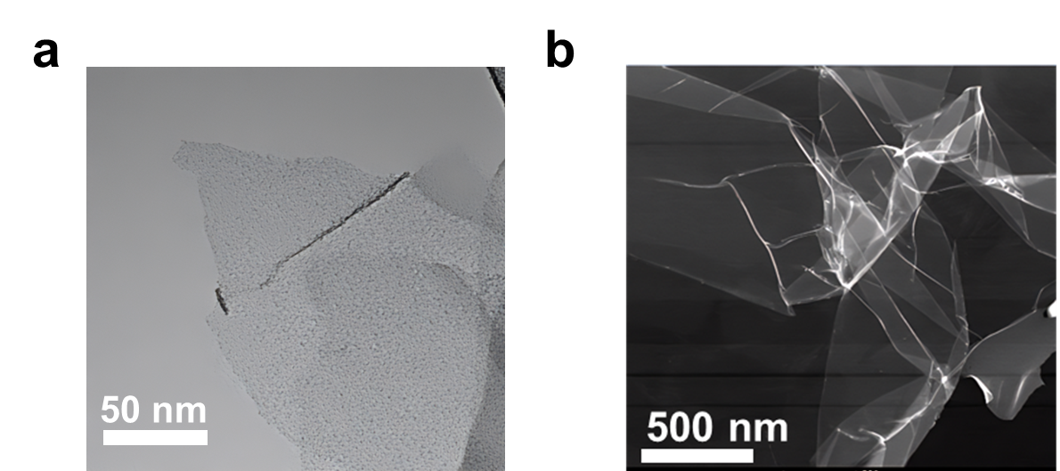
Fig 1. (a) TEM image of PML-Fe-Co. (b) AC-TEM image of PML-Fe.

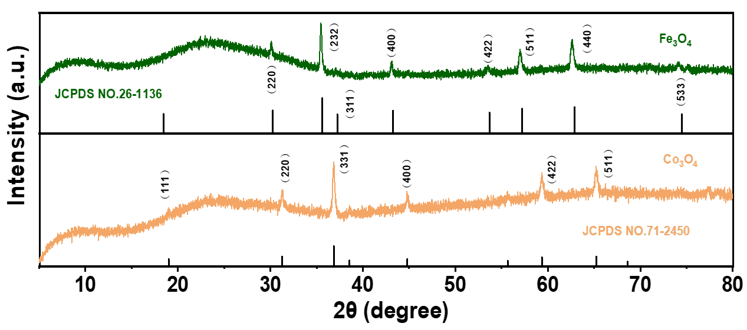
Fig 2. XRD spectra of Fe₃O₄, Co₃O₄.

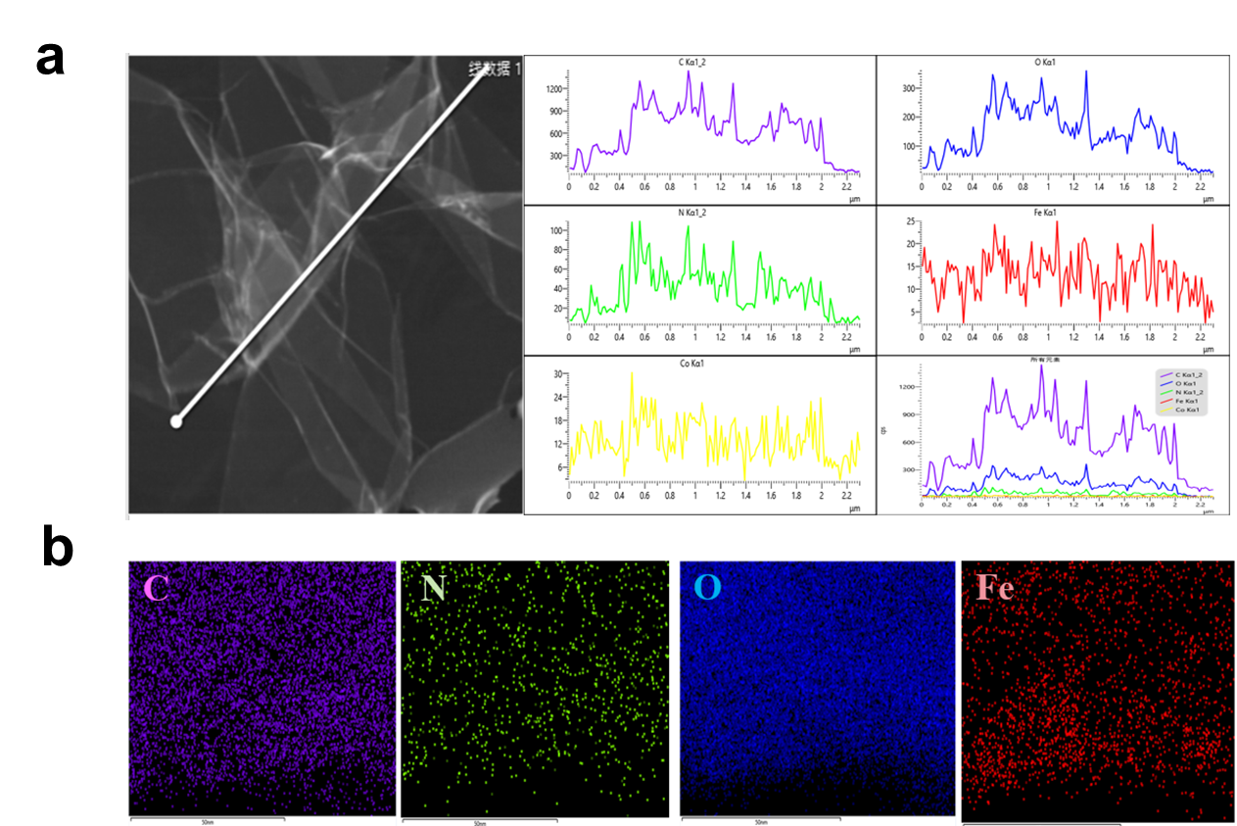
Fig 3. (a) The Line-scanning spectra of PML-Fe. (b) The EDS-Mapping images of PML-Fe.

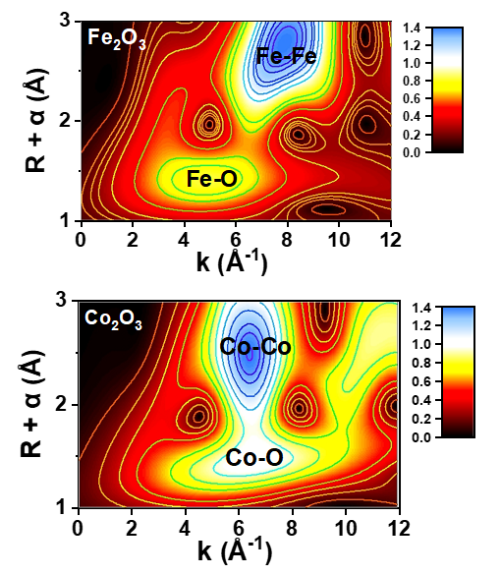
Fig 4. Wavelet transform (WT) of (a) Fe K-edge and (b) Co K-edge EXAFS data of Fe₂O₃ and Co₂O₃

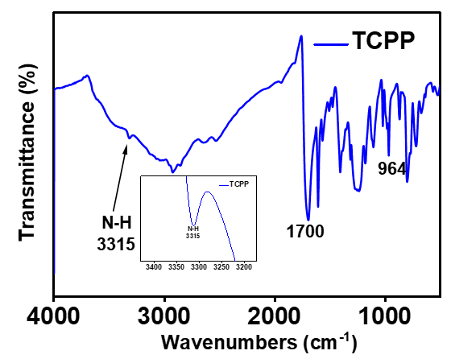
Fig 5. FTIR spectra of TCPP.
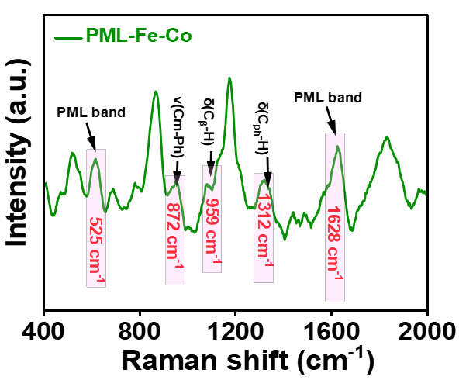
Fig 6. Raman spectrum of PML-Fe-Co.

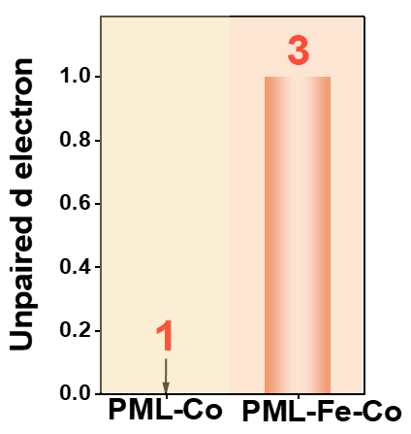
Fig 7. The corresponding unpaired d electron number.

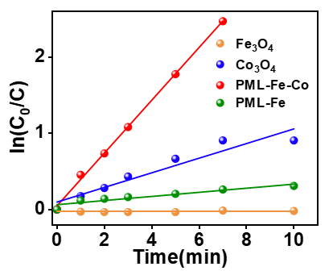
Figure 8. The reaction rate constants (k₁) for degradation of APAP by different catalysts.

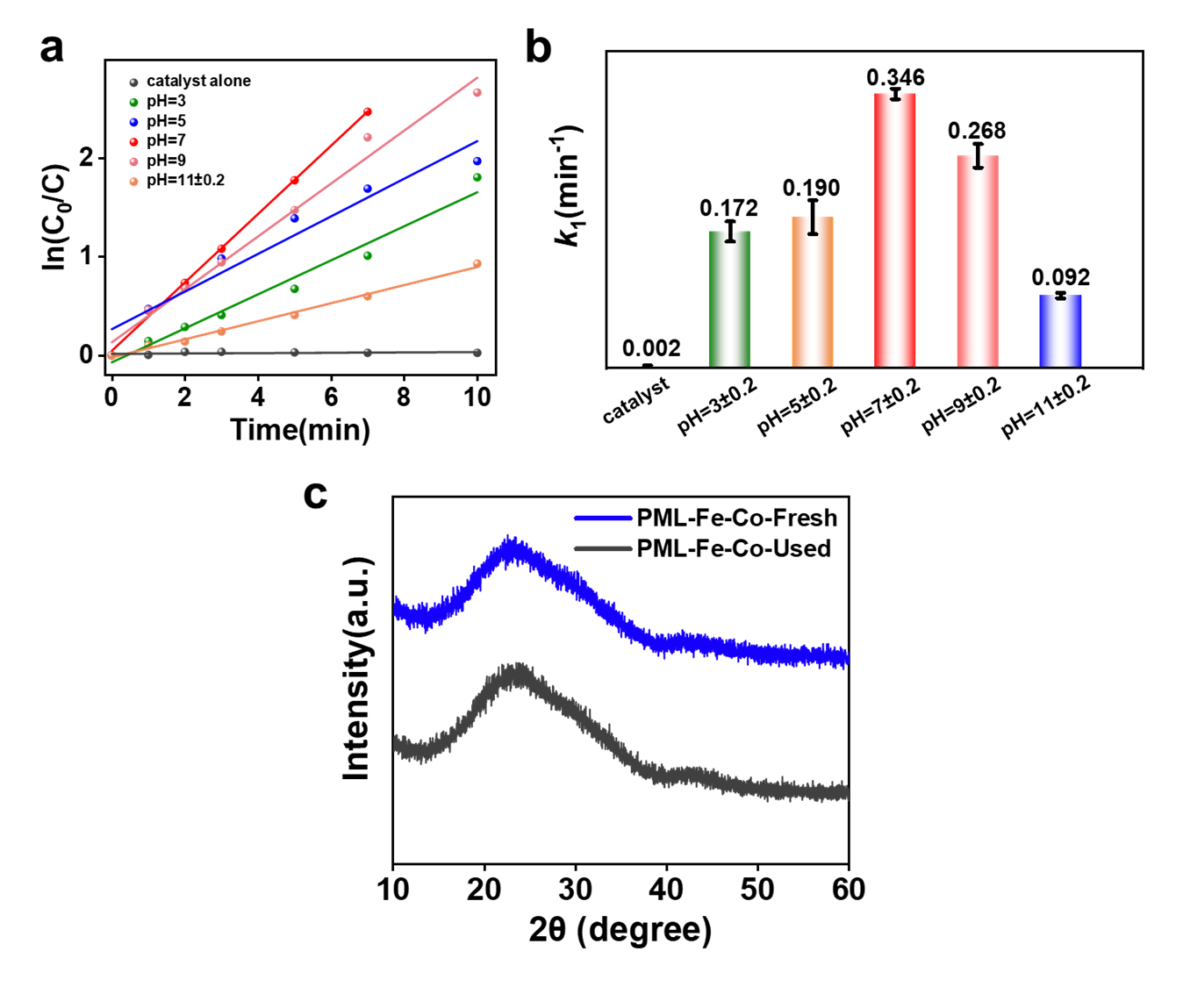
Fig 9. (a-b) The reaction rate constants (k₁) for degradation of APAP by PML-Fe-Co at different pH. (c) The XRD spectra of fresh and used PML-Fe-Co.

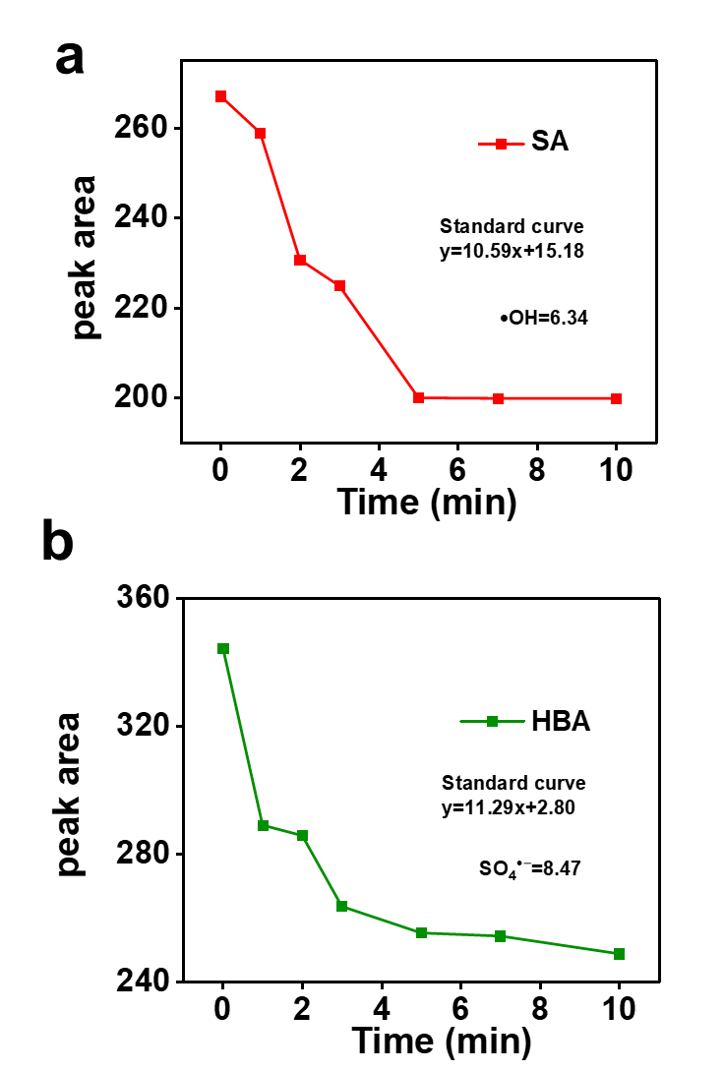
Fig 10. Quantitative analysis of •OH, SO₄^{•−} present in PML-Fe-Co/PMS system.

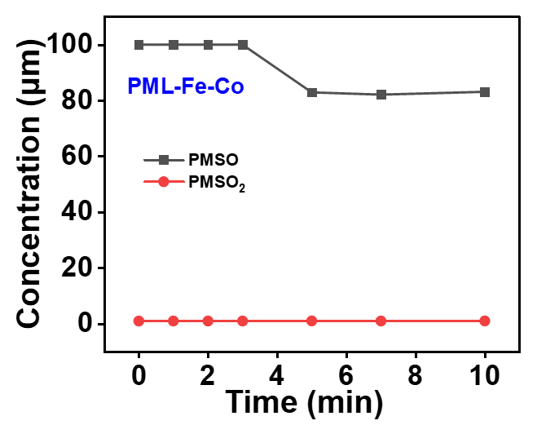
Fig 11. PMSO₂ in PMS systems activated by different catalysts ([PMS] = 0.05 g/L, [catalyst] = 0.1 g/L, [DMSO] = 10 mM, [PMSO] = 50 μM)

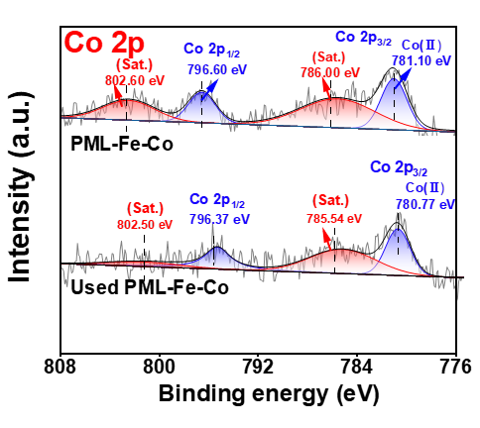
Fig 12. The Co 2p XPS spectra of fresh and used PML-Fe-Co.

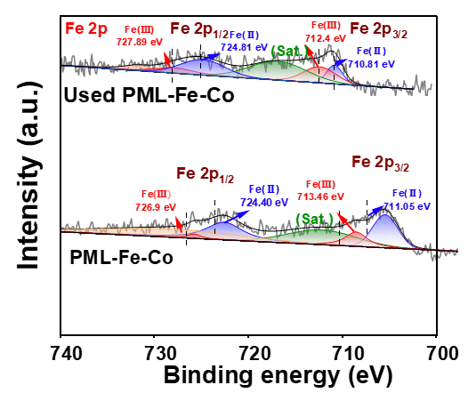
Fig 13. The Fe 2p XPS spectra of fresh and used PML-Fe-Co.

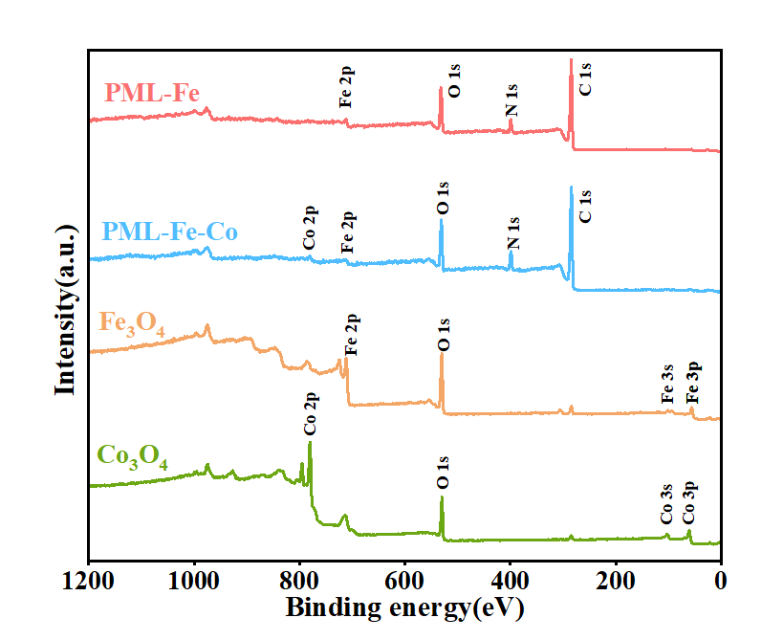
Fig 14. XPS spectra of PML-Fe-Co, PML-Fe, Fe₃O₄, Co₃O₄.

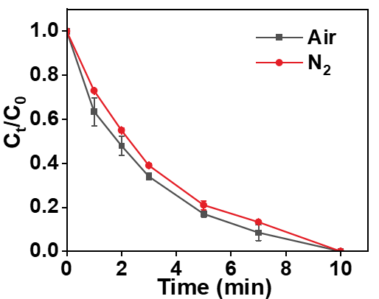
Fig 15. APAP degradation of PML-Fe-Co in N₂ and Air.

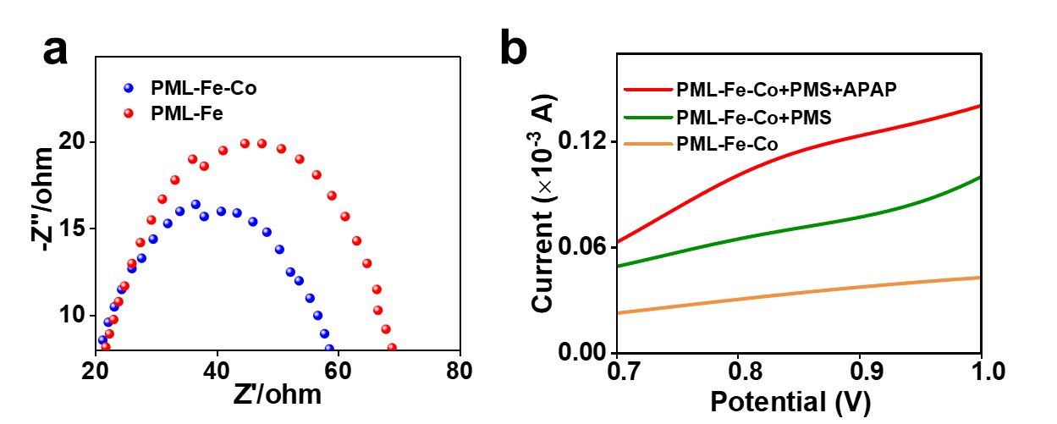
Fig 16. (a) EIS curves of PML-Fe-Co and PML-Fe in the10 mmol/L Na₂SO₄ solution, with a frequency of 1000-0.01 Hz. (b) LSV analysis at a scanning rate of 50 mV/s.

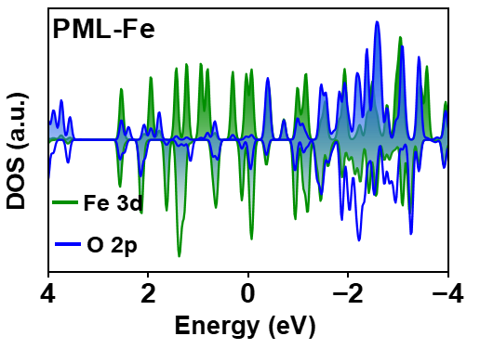
Fig 17. The DOS interactions and Fe-O bond between PMS and PML-Fe.

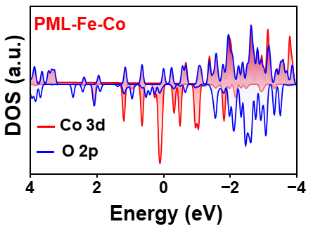
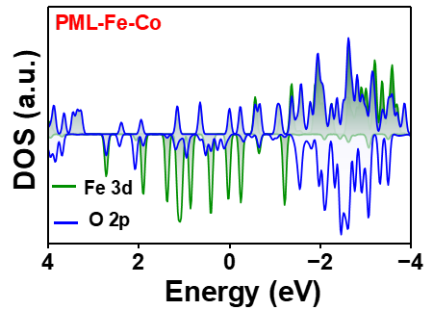
Fig 18. The DOS interactions between PMS and PML-Fe-Co.

Tab 1. Structural parameters extracted from Fe K-edge EXAFS fitting. (S₀²=0.84).
Sample | Path | CN | R(Å) | σ²(10⁻³Å²) | ΔE₀(eV) | R factor
Fe foil | Fe-Fe | 12 | 2.46 | 7.7 | 1.4 | 0.011
PML-Fe-Co | Fe-O | 2.6 | 1.90 | 5.2 | 4.4 | 0.002
S₀² is the amplitude reduction factor; CN is the coordination number; R is interatomic distance (the bond length between Fe central atoms and surrounding coordination atoms); σ² is Debye-Waller factor (a measure of thermal and static disorder in absorber-scatterer distances); ΔE₀ is edge-energy shift (the difference between the zero kinetic energy value of the sample and that of the theoretical model). R factor is used to value the goodness of the fitting. This value is fixed during EXAFS fitting, based on the known structure. Error bounds that characterize the structural parameters obtain by EXAFS spectroscopy are estimated as N±20%, R±1%, σ²±20%, ΔE₀±20%.

Tab 2. Structural parameters extracted from Co K-edge EXAFS fitting. (S₀²=0.85).
Sample | Path | CN | R(Å) | σ²(10⁻³Å²) | ΔE₀(eV) | R factor
Co foil | Co-Co | 12 | 2.49 | 4.9 | 1.2 | 0.002
PML-Fe-Co | Co-O | 2.5 | 1.93 | 3.7 | 6.2 | 0.006
S₀² is the amplitude reduction factor; CN is the coordination number; R is interatomic distance (the bond length between Co central atoms and surrounding coordination atoms); σ² is Debye-Waller factor (a measure of thermal and static disorder in absorber-scatterer distances); ΔE₀ is edge-energy shift (the difference between the zero kinetic energy value of the sample and that of the theoretical model). R factor is used to value the goodness of the fitting. This value is fixed during EXAFS fitting, based on the known structure. Error bounds that characterize the structural parameters obtain by EXAFS spectroscopy are estimated as N±20%, R±1%, σ²±20%, ΔE₀±20%.

Tab 3. Water quality parameters of simulated municipal wastewater (influent quality) without organic compounds (#1 sample, municipal wastewater-TDS-COD, pH=5.8~6.2, (COD) = 90 mg/L).
Concentration | Reagents | Manufacture
58.4 mg/L | Monopotassium phosphate (KH₂PO₄) | Beijing Chemical Works AR
570 mg/L | Potassium chloride (KCl) | Beijing Chemical Works AR
200 mg/L | Magnesium sulfate heptahydrate (MgSO₄•7H₂O) | Beijing Chemical Works AR
300 mg/L | Calcium dichloride (CaCl₂•2H₂O) | Sinopharm Chemical Reagent Co, Ltd,AR
30 mg/L | Ammonium chloride (NH₄Cl) | Beijing Chemical Works AR
115.4 mg/L | Sodium acetate (CH₃COONa) | Beijing Chemical Works AR
1273.8 mg/L | Total dissolved solid (TDS)

Tab 4. Details of different pollutants.
Contaminats | Mobile  phase | Detection Wavelength | Flow rate  (mL/min)
APAP | Methanol:water = 30:70 | 243 | 1.0
P-Cresol | Methanol:water = 20:80 | 280 | 0.7
2,4-DCP | Methanol:water = 30:70 | 285 | 1.0
2,2’-Biphenol | Methanol:water = 40:60 | 275 | 1.0
BPA | Methanol:water = 30:70 | 276 | 0.7

Tab 5. The kinetics of pollutant degradation in recently reported Fenton-like catalysts for pollutant degradation. The modified kinetic rate constant (k-value) was calculated through dividing the observed rate constant of organic contaminants by the catalyst dosage and PMS concentration followed by multiplying organic contaminant concentration.
Catalyst  (g/L) | PMS  (mM) | Pollutants  (mg/L) | Removal efficiency | K-value  (min⁻¹ M⁻¹)
PML-Fe-Co | 0.32 | APAP (10) | 100% | 109.375
Co₃O₄-Bi₂O₃ | 0.32 | BPA (20) | 100% | 0.120
Fe₃Co₇@C-650 | 0.64 | BPA (20) | 100% | 0.132
Fe_{0.8}Co_{2.2}O₄ | 0.64 | BPA (20) | 100% | 0.049
CuFe₂O₄ | 0.96 | BPA (50) | 100% | 0.980
CoMnAl-MMO | 0.48 | BPA (10) | 95.8% | 0.058
SA-Co CNP | 1.60 | APAP (20) | 100% | 0.500
Fe₃O₄ MNPs | 0.25 | APAP (10) | 100% | 0.011
CoFeO/mpg-CN | 0.19 | APAP (15) | 98.9% | 0.010
SFC | 0.125 | BPA (20) | 98% | 0.009

Tab 6 The calculation of the cost for pollutant treatment (1 tonne)
Materials | Unit  Price($) | Quality  required | Cost for 1 tonne  pollutant (10⁻³$)
Fe(NO₃)₃•9H₂O | 476 tonne⁻¹ | 0.0202 g | 0.0096
Co(NO₃)₂•6H₂O | 1400 tonne⁻¹ | 0.0145 g | 0.0203
PVP | 7560 tonne⁻¹ | 0.1000 g | 0.756
Formic acid | 1036 tonne⁻¹ | 0.244 g | 0.253
Ethanol | 252 tonne⁻¹ | 32.4 g | 8.164
DMF | 560 tonne⁻¹ | 26.088 g | 14.609
 |  |  | 23.81
2 g Materials (TCPP catalyst) | Unit  Price($) | Quality  required | Cost for 1 tonne  pollutant (10⁻³$)
Pyrrole | 1400 tonne⁻¹ | 3.0 g | 4.200
Methyl p-formylbenzoate | 1708 tonne⁻¹ | 6.9 g | 11.79
Propanoic acid | 1064 tonne⁻¹ | 99.3 g | 105.655
Methanol | 386.4 tonne⁻¹ | 19.75 g | 7.631
Ethyl acetate | 70 tonne⁻¹ | 225.5 g | 15.785
Tetrahydrofuran | 1680 tonne⁻¹ | 22.175 g | 37.254
KOH | 840 | 2.63 g | 2.209
 |  |  | 184.524
The price of 0.044g TCPP is 4.06*10⁻³$
Estimated cost for 100 mg catalyst is 27.87*10⁻³$
PMS | 1379.3 tonne⁻¹ | 2.46 g | 3.393
The unit prices of these chemicals are based on the average prices on website (www.made-in-china.com and www.100ppi.com/mprice, May. 2024). The data is calculated excluding the cost and mass of packaging materials.
References
1 Jia, H. et al. Understanding the role of spin state in cobalt oxyhydroxides for water oxidation. Angew. Chem Int. Ed. 63, e202408005.
2 Yang, D. et al. Tailoring layer number of 2D porphyrin-based MOFs towards photocoupled electroreduction of CO₂. Adv. Mater. 34, 2107293.
3 Yang, D., Zuo, S., Yang, H., Zhou, Y. & Wang, X. Freestanding millimeter-scale porphyrin-based monoatomic layers with 0.28 nm thickness for CO₂ electrocatalysis. Angew. Chem Int. Ed. 59, 18954-18959.
4 Li, Y. et al. Asymmetric coordination regulating d-orbital spin-electron filling in single-atom iron catalyst for efficient oxygen reduction. Angew. Chem Int. Ed. 63, e202405334.
5 Fang, Z. et al. Defect engineering-mediated Co₉S₈ with unexpected catalytic selectivity for heterogeneous Fenton-like reaction: Unveiling the generation route of ¹O₂ in V_{S} active site. Appl. Catal., B 338, 123084.
6 Zhang, L. et al. Constructing hollow multishelled microreactors with a nanoconfined microenvironment for ofloxacin degradation through peroxymonosulfate activation: evolution of high-valence cobalt-oxo species. Sci. Total Environ. 57, 16141-16151.
7 Qi, J. et al. Interface engineering of Co(OH)₂ nanosheets growing on the KNbO₃ perovskite based on electronic structure modulation for enhanced peroxymonosulfate activation. Environ. Sci. Technol. 56, 5200-5212.
8 Yang, X. et al. Modulating the electron structure of Co-3d in Co₃O₄−x/WO_{2.72} for boosting peroxymonosulfate activation and degradation of sulfamerazine: Roles of high-valence W and rich oxygen vacancies. J. Hazard. Mater. 445, 130576.
9 Zhu, H.-J. et al. Efficient electron transmission in covalent organic framework nanosheets for highly active electrocatalytic carbon dioxide reduction. Nat. Commun. 11, 497.
10 Wang, L., Li, Y., Wang, L., Wang, D. & Zhang, W. Fabrication of Fe-CoTiO₃/TiO₂/Ti catalytic membrane for peroxymonosulfate activation to efficient sulfamethoxazole degradation. Sep.Purif 339, 126617.
11 Yang, Z. et al. Oxygen and chlorine dual vacancies enable photocatalytic O₂ dissociation into monatomic reactive oxygen on BiOCl for refractory aromatic pollutant removal. Environ. Sci. Technol. 56, 3587-3595.
12 Hu, L. et al. Facile synthesis of novel Co₃O₄-Bi₂O₃ catalysts and their catalytic activity on bisphenol a by peroxymonosulfate activation. Chem. Eng. J. 326, 1095-1104.
13 Miao, D. et al. Removal of atorvastatin in water mediated by CuFe₂O₄ activated peroxymonosulfate. Chem. Eng. J. 346, 1-10.
14 Liao, G. et al. Synthesis of single atom cobalt dispersed on 2D carbon nanoplate and degradation of acetaminophen by peroxymonosulfate activation. Chem. Eng. J. 427, 132027.
15 Li, W. et al. Catalytic degradation of bisphenol a by CoMnAl mixed metal oxides catalyzed peroxymonosulfate: Performance and mechanism. Chem. Eng. J. 279, 93-102.
16 Mittal, H., Parashar, V., Mishra, S. B. & Mishra, A. K. Fe₃O₄ MNPs and gum xanthan based hydrogels nanocomposites for the efficient capture of malachite green from aqueous solution. Chem. Eng. J. 255, 471-482.
17 Yanalak, G. et al. Ternary nanocomposites of mesoporous graphitic carbon nitride/black phosphorus/gold nanoparticles (mpg-CN/BP-Au) for photocatalytic hydrogen evolution and electrochemical sensing of paracetamol. Appl. Surf. Sci. 557, 149755.
18 Su, X. et al. Complementary operando spectroscopy identification of in-situ generated metastable charge-asymmetry Cu₂-CuN₃ clusters for CO₂ reduction to ethanol. Nat. Commun. 13, 1322.
19 Liu, S. et al. Efficient electrochemical reduction of CO₂ to HCOOH over Sb 2nm SnO₂ quantum wires with exposed ghrain boundaries. Angew. Chem. Int. Ed. 58, 8499-8503.
20 Kumar, B. et al. Reduced SnO₂ porous nanowires with a high density of grain boundaries as catalysts for efficient electrochemical CO₂-into-HCOOH conversion. Angew. Chem. Int. Ed. 56, 3645-3649.

