Supplementary Table 1. Baseline characteristics of participants in PSM cohort.
 | Overall | Non-AF | New-onset AF | P
 | n= 376 | n= 282 | n= 94 | P
Male (%) | 293 (77.9%) | 222 (78.7%) | 71 (75.5%) | 0.615
Age，years | 59.4 ±10.2 | 58.2±10.4 | 62.9± 8.4 | <0.001
BMI, kg/m2 | 25.7± 3.0 | 25.7± 3.0 | 25.6± 3.1 | 0.775
Clinical history
Previous MI | 84 (22.3%) | 56 (19.9%) | 28 (29.8%) | 0.063
Previous PCI | 90 (23.9%) | 56 (19.9%) | 34 (36.2%) | 0.002
Previous CABG | 12 (3.2%) | 8 (2.8%) | 4 (4.3%) | 0.735
Comorbidity
Hypertension | 239 (63.6%) | 174 (61.7%) | 65 (69.1%) | 0.24
Hyperlipidemia | 254 (67.6%) | 192 (68.1%) | 62 (66.0%) | 0.799
Diabetes | 126 (33.5%) | 95 (33.7%) | 31 (33.0%) | 1
CVD | 44 (11.7%) | 31 (11.0%) | 13 (13.8%) | 0.578
PAD | 37 (9.8%) | 22 (7.8%) | 15 (16.0%) | 0.036
Anemia | 40 (10.6%) | 28 (9.9%) | 12 (12.8%) | 0.562
COPD | 220 (58.5%) | 175 (62.1%) | 45 (47.9%) | 0.022
Smoking | 239 (63.6%) | 174 (61.7%) | 65 (69.1%) | 0.24
Clinical presentation |  |  |  | 0.157
ACS | 235 (62.5%) | 182 (64.5%) | 53 (56.4%)
CCS | 141 (27.5%) | 100 (35.5%) | 41 (43.6%)
LVEF < 40% | 8 (2.1%) | 6 (2.1%) | 2 (2.1%) | 1
Laboratory results
HbA1C, % | 6.7± 1.2 | 6.7± 1.1 | 6.7± 1.3 | 0.833
hsCRP, mg/L | 3.0± 3.7 | 3.0± 3.7 | 3.0± 3.6 | 0.975
LDL, mmol/L | 2.5± 0.9 | 2.5± 0.9 | 2.5± 1.0 | 0.944
HDL, mmol/L | 1.0± 0.3 | 1.0 ± 0.3 | 1.1± 0.3 | 0.336
Lpa, mg/L | 184 (83-400) | 172 (80-349) | 225 (88-554) | 0.183
eGFR < 60 | 12 (3.2%) | 9 (3.2%) | 3 (3.2%) | 1
ACS, acute coronary syndrome; AF, atrial fibrillation; BMI, body mass index; CABG, coronary artery bypass graft; CCS, chronic coronary syndrome; COPD, chronic obstructive pulmonary disease; CVD, cerebrovascular disease; eGFR, estimated Glomerular Filtration Rate; HbA1c, glycosylated hemoglobin A1c; HDL, high density lipoprotein; hsCRP, high-sensitivity C-reactive protein; LDL, low density lipoprotein; LVEF, left ventricular ejection fraction; MI, myocardial infarction; PAD, peripheral arterial disease; PCI, percutaneous coronary intervention; PSM, propensity score matching.

Supplementary Table 2. Percutaneous coronary intervention procedure data in PSM cohort.
 | Overall | Non-AF | New-onset AF | P
 | n= 376 | n= 282 | n= 94 | P
PCI data
Emergency PCI | 0 | 0 | 0 | -
IABP | 2 (0.5%) | 2(0.7%) | 0 | 1
LM stenosis | 25 (6.6%) | 17 (6.0%) | 8 (8.5%) | 0.55
Multivessel disease | 269 (71.5%) | 195 (69.1%) | 74 (78.7%) | 0.099
Syntax | 10 (6-17) | 10 (7-18) | 9 (5-16) | 0.156
TIMI 0 before PCI | 60 (16.0%) | 47 (16.7%) | 13 (13.8%) | 0.626
No. of Stents | 1(1-2) | 1(1-2) | 1(1-2) | 0.812
Discharge therapy
DAPT | 364 (96.8%) | 273 (96.8%) | 91 (96.8%) | 1
Beta-blocker | 339 (90.2%) | 257 (91.1%) | 82 (87.2%) | 0.368
Statins | 367 (97.6%) | 276 (97.9%) | 91 (96.8%) | 0.846
AF, atrial fibrillation; DAPT, dual antiplatelet therapy; LM, left main; IABP, intra-aortic balloon pump; PCI, percutaneous coronary intervention; PSM, propensity score matching.

Supplementary Table 3. Other clinical outcomes during follow-up.
 | Overall | Non-AF | New-onset AF | P
 | n= 8367 | n= 8273 | n= 94 | P
Acute myocardial infarction (%) | 90 (1.1%) | 89 (1.1%) | 1 (1.1%) | 1
Revascularization (%) | 741 (8.9%) | 738 (8.9%) | 3 (3.2%) | 0.078
Death (%) | 68 (0.8%) | 68 (0.8%) | 0 (0.0%) | 0.76
Stroke (%) | 122 (1.5%) | 117 (1.4%) | 5 (5.3%) | 0.007

Supplementary Table 4.
Model | Variables | Points
The POAF Score
 | Age 60–69 y | 1
 | Age 70–79 y | 2
 | Age ≥ 80 y | 2
 | Chronic obstructive pulmonary disease | 1
 | eGFR < 15 mL/min/1.73 m2 or dialysis | 1
 | Emergency | 1
 | Preoperative intra-aortic balloon pump | 1
 | Left ventricular ejection fraction < 30% | 1
 | Valve surgery | 1
The CHA2DS2-VASc Score
 | Congestive heart failure/left ventricular dysfunction | 1
 | Hypertension | 1
 | Age ≥ 75 y | 2
 | Diabetes mellitus | 1
 | Stroke/transient ischemic attack/thromboembolism | 2
 | Vascular disease | 1
 | Age 65–74 y | 1
 | Sex category (female) | 1
The Atrial Fibrillation Risk Index
 | Age (y): males >60, females >66 | 1
 | Weight (kg): males >76, females >64 | 1
 | Height (cm): males >176, females >168 | 1
 | Peripheral vascular disease | 1
eGFR, estimated glomerular filtration rate; POAF, postoperative atrial fibrillation.

Supplementary table 5. Comparison of POAF, CHA2DS2-VASc, and AFRI Scores between two patient groups.
 | Overall | Non-AF | New-onset AF | P
 | n= 8367 | n= 8273 | n= 94 | P
POAF sore | 0 (0-1) | 0 (0-1) | 1 (0-1) | <0.001
CHA2DS2-VASc score | 3 (2-3) | 3 (2-3) | 3 (2-4) | 0.012
AFRI | 1 (0-2) | 1 (0-2) | 1 (1-2) | 0.008
AF, atrial fibrillation.

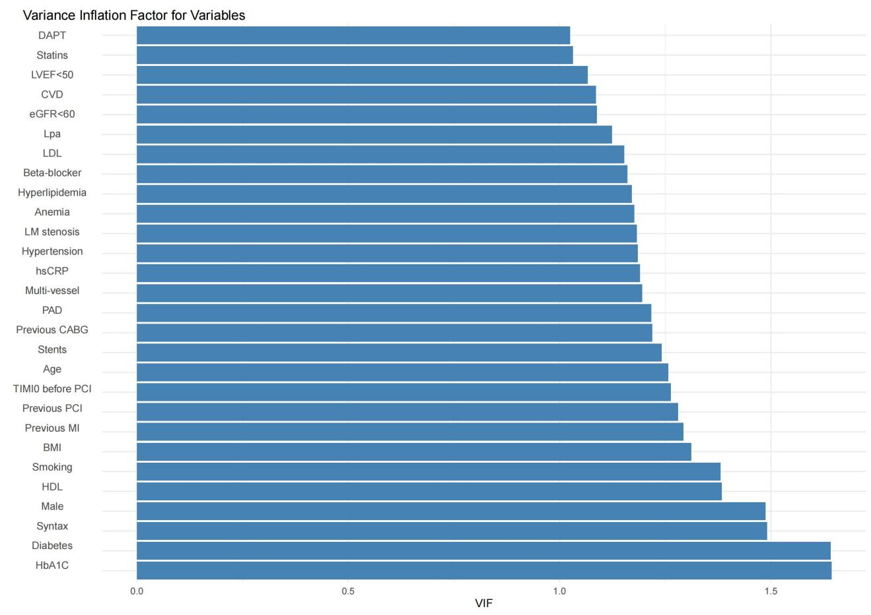
Supplementary figure 1. The variance inflation factors for variables with P < 0.2 in the univariate Cox regression.

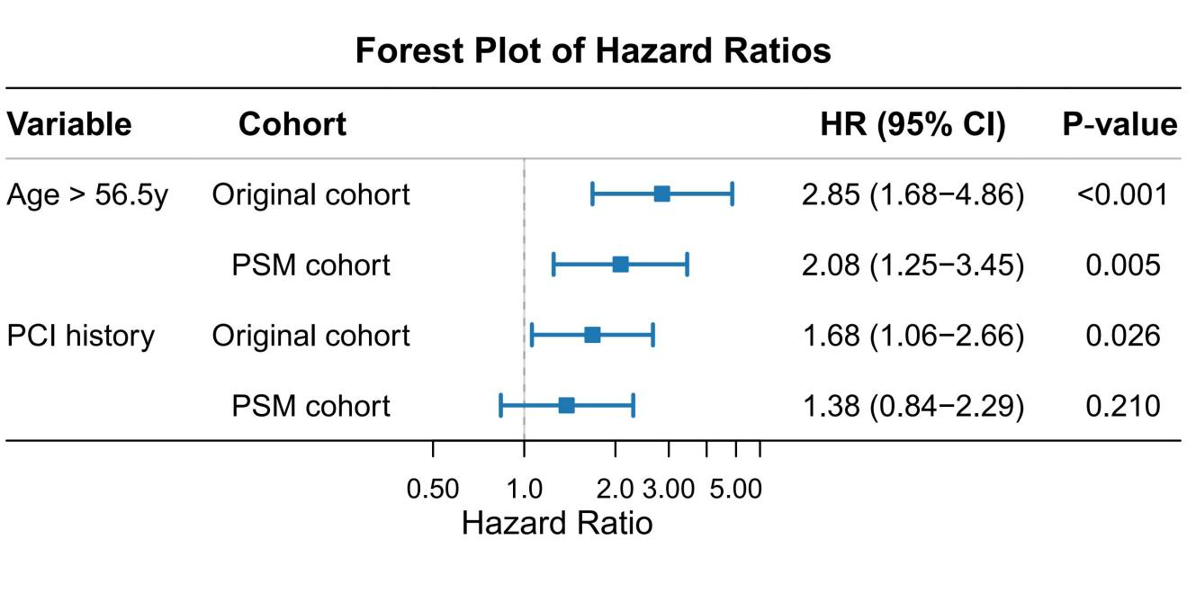
Supplementary figure 2. Association between age > 56.5 years old, PCI history, and new-onset atrial fibrillation in the competing risk model.

