Supplemental material

Metabolomic methods
Widely targeted UPLC-MS/MS-based metabolic profiling
Serum samples were thawed at 4 °C; then, 100 μL of each serum sample was extracted with 300 μL of methanol. The mixture was vortexed and centrifuged (12000 rpm, *4 °C, *10 min); hereafter, the supernatant was extracted into new centrifuge tubes and centrifuged (12000 rpm, *4 °C, *3 min) again. The extracted supernatant was transferred into the UPLC (Shim-pack UFLC SHIMADZU CBM30A) – MS/MS (Applied Biosystems 6500 QTRAP) system for analysis. Quality control (QC) samples were obtained by mixing an equal volume of serum samples and pretreated as described above.
A Waters ACQUITY UPLC system coupled with electrospray ionization (ESI)-mass spectrometer was used for separation and metabolic analysis. The injection volume was 2 μL, the column temperature was set to 40 °C with the flow rate of 0.35 mL/min. The chromatography columns in the positive and negative ion modes were HSS C18 and HSS T3, respectively. Ultra-pure water and acetonitrile (both containing 0.04% formic acid) were utilized as mobile phases A and B. The starting composition was 5% B, which was increased to 95% at 11.0 min for a 1.0 min wash, followed by returning to 5% B in 0.1 min and held until 14 min for a re-equilibration step. For metabolite analysis, the ESI temperature was 500 °C. The mass spectrometry voltage was 5.5 kV. The curtain gas was 25 psi. The parameter of collision-activated dissociation was high. In the triple quadrupole, each ion pair was scanned based on the optimized declustering potential and collision energy. The quality control (QC) samples were inserted into the analysis sequence every 20 samples and analyzed to evaluate the analytical quality. The principal component analysis (PCA) model with DM, DR, and QC samples was utilized to assess the robustness of the detection system (Figure S4A).

Biological Interpretation methods
Chemical Similarity Enrichment Analysis (ChemRICH)
ChemRICH is a novel pathway mapping tool based on chemical similarity. In ChemRICH, chemical ontologies and structural similarities were applied to cluster metabolites instead of determination by pre-defined metabolic pathway database. Self-contained Kolmogorov-Smirnov (KS) test was performed to calculate the enrichment p-values of identified metabolite clusters, which were generally applied to determine whether a cluster was represented more than expected by chance.

MetaMapp
MetaMapp was applied for integrating information from metabolite pathways (KEGG reactant pair database), chemical structures and mass spectral similarity. The metabolites’ encoded chemical structures of MetaMapp were retrieved from the PubChem compound database according to compound identifiers and the NCBI Batch Entrez Utility. The similarity among encoded structures in the MetaMapp was assessed by Tanimoto chemical similarity coefficient (range 0.0 to 1.0), which was represented by the size and 0.7 was defined as the threshold of the similarity among metabolites.
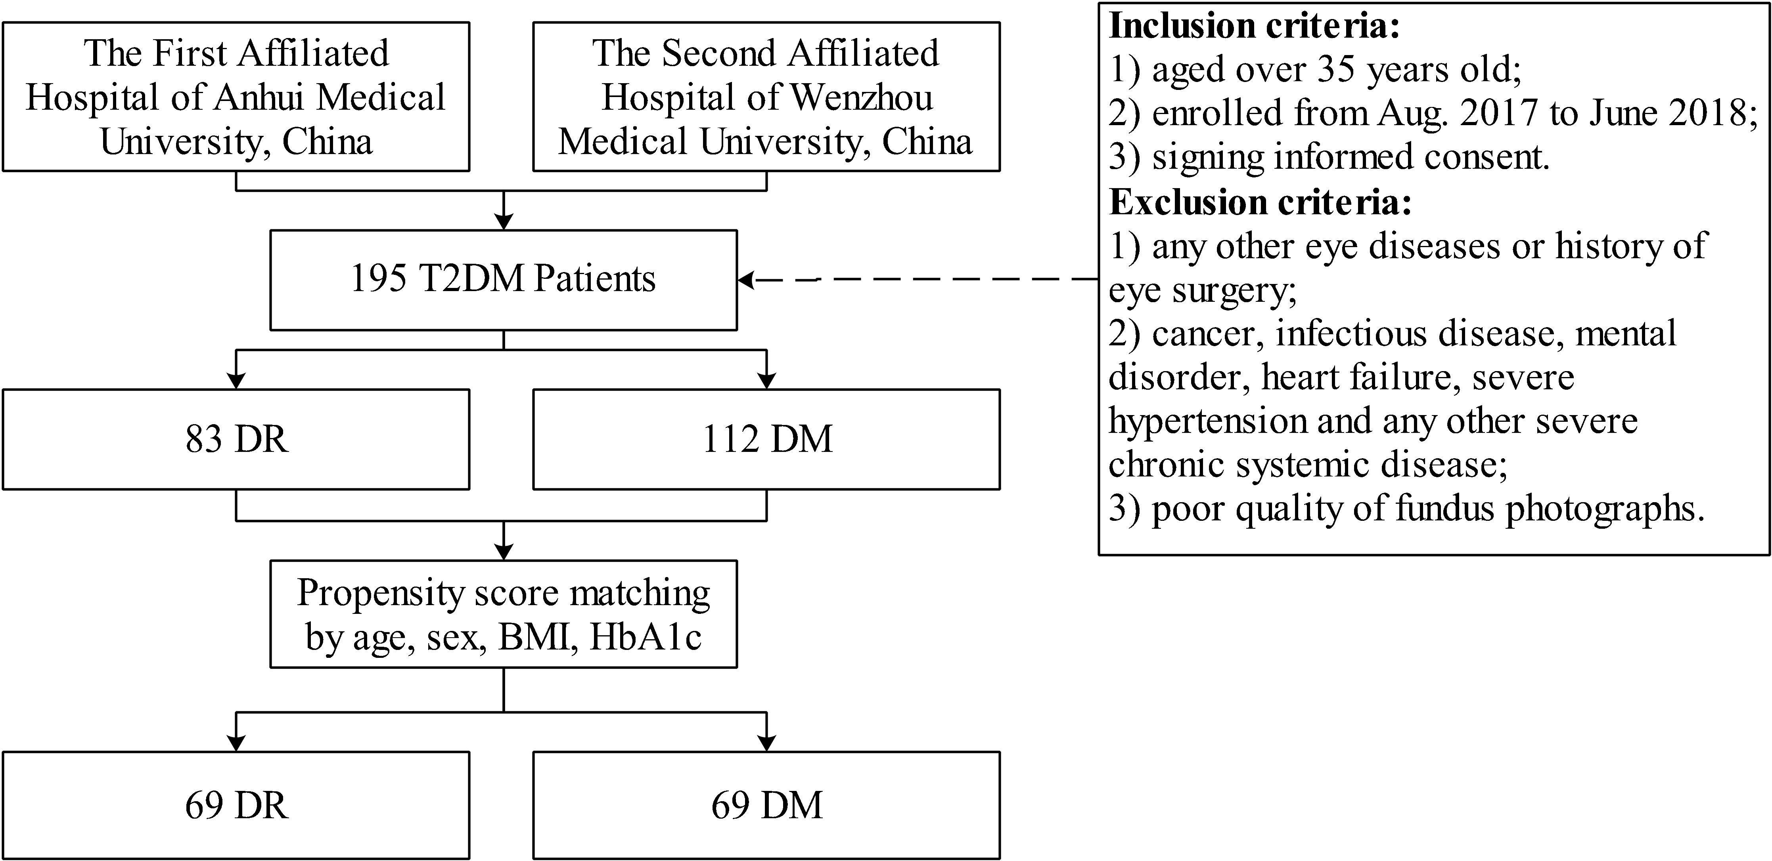
Figure S1. The flowchart of the study design.
Abbreviations: T2DM: type 2 diabetes mellitus; DM: T2DM without diabetic retinopathy; DR: T2DM with diabetic retinopathy; BMI: body mass index; HbA1c: glycated hemoglobin.

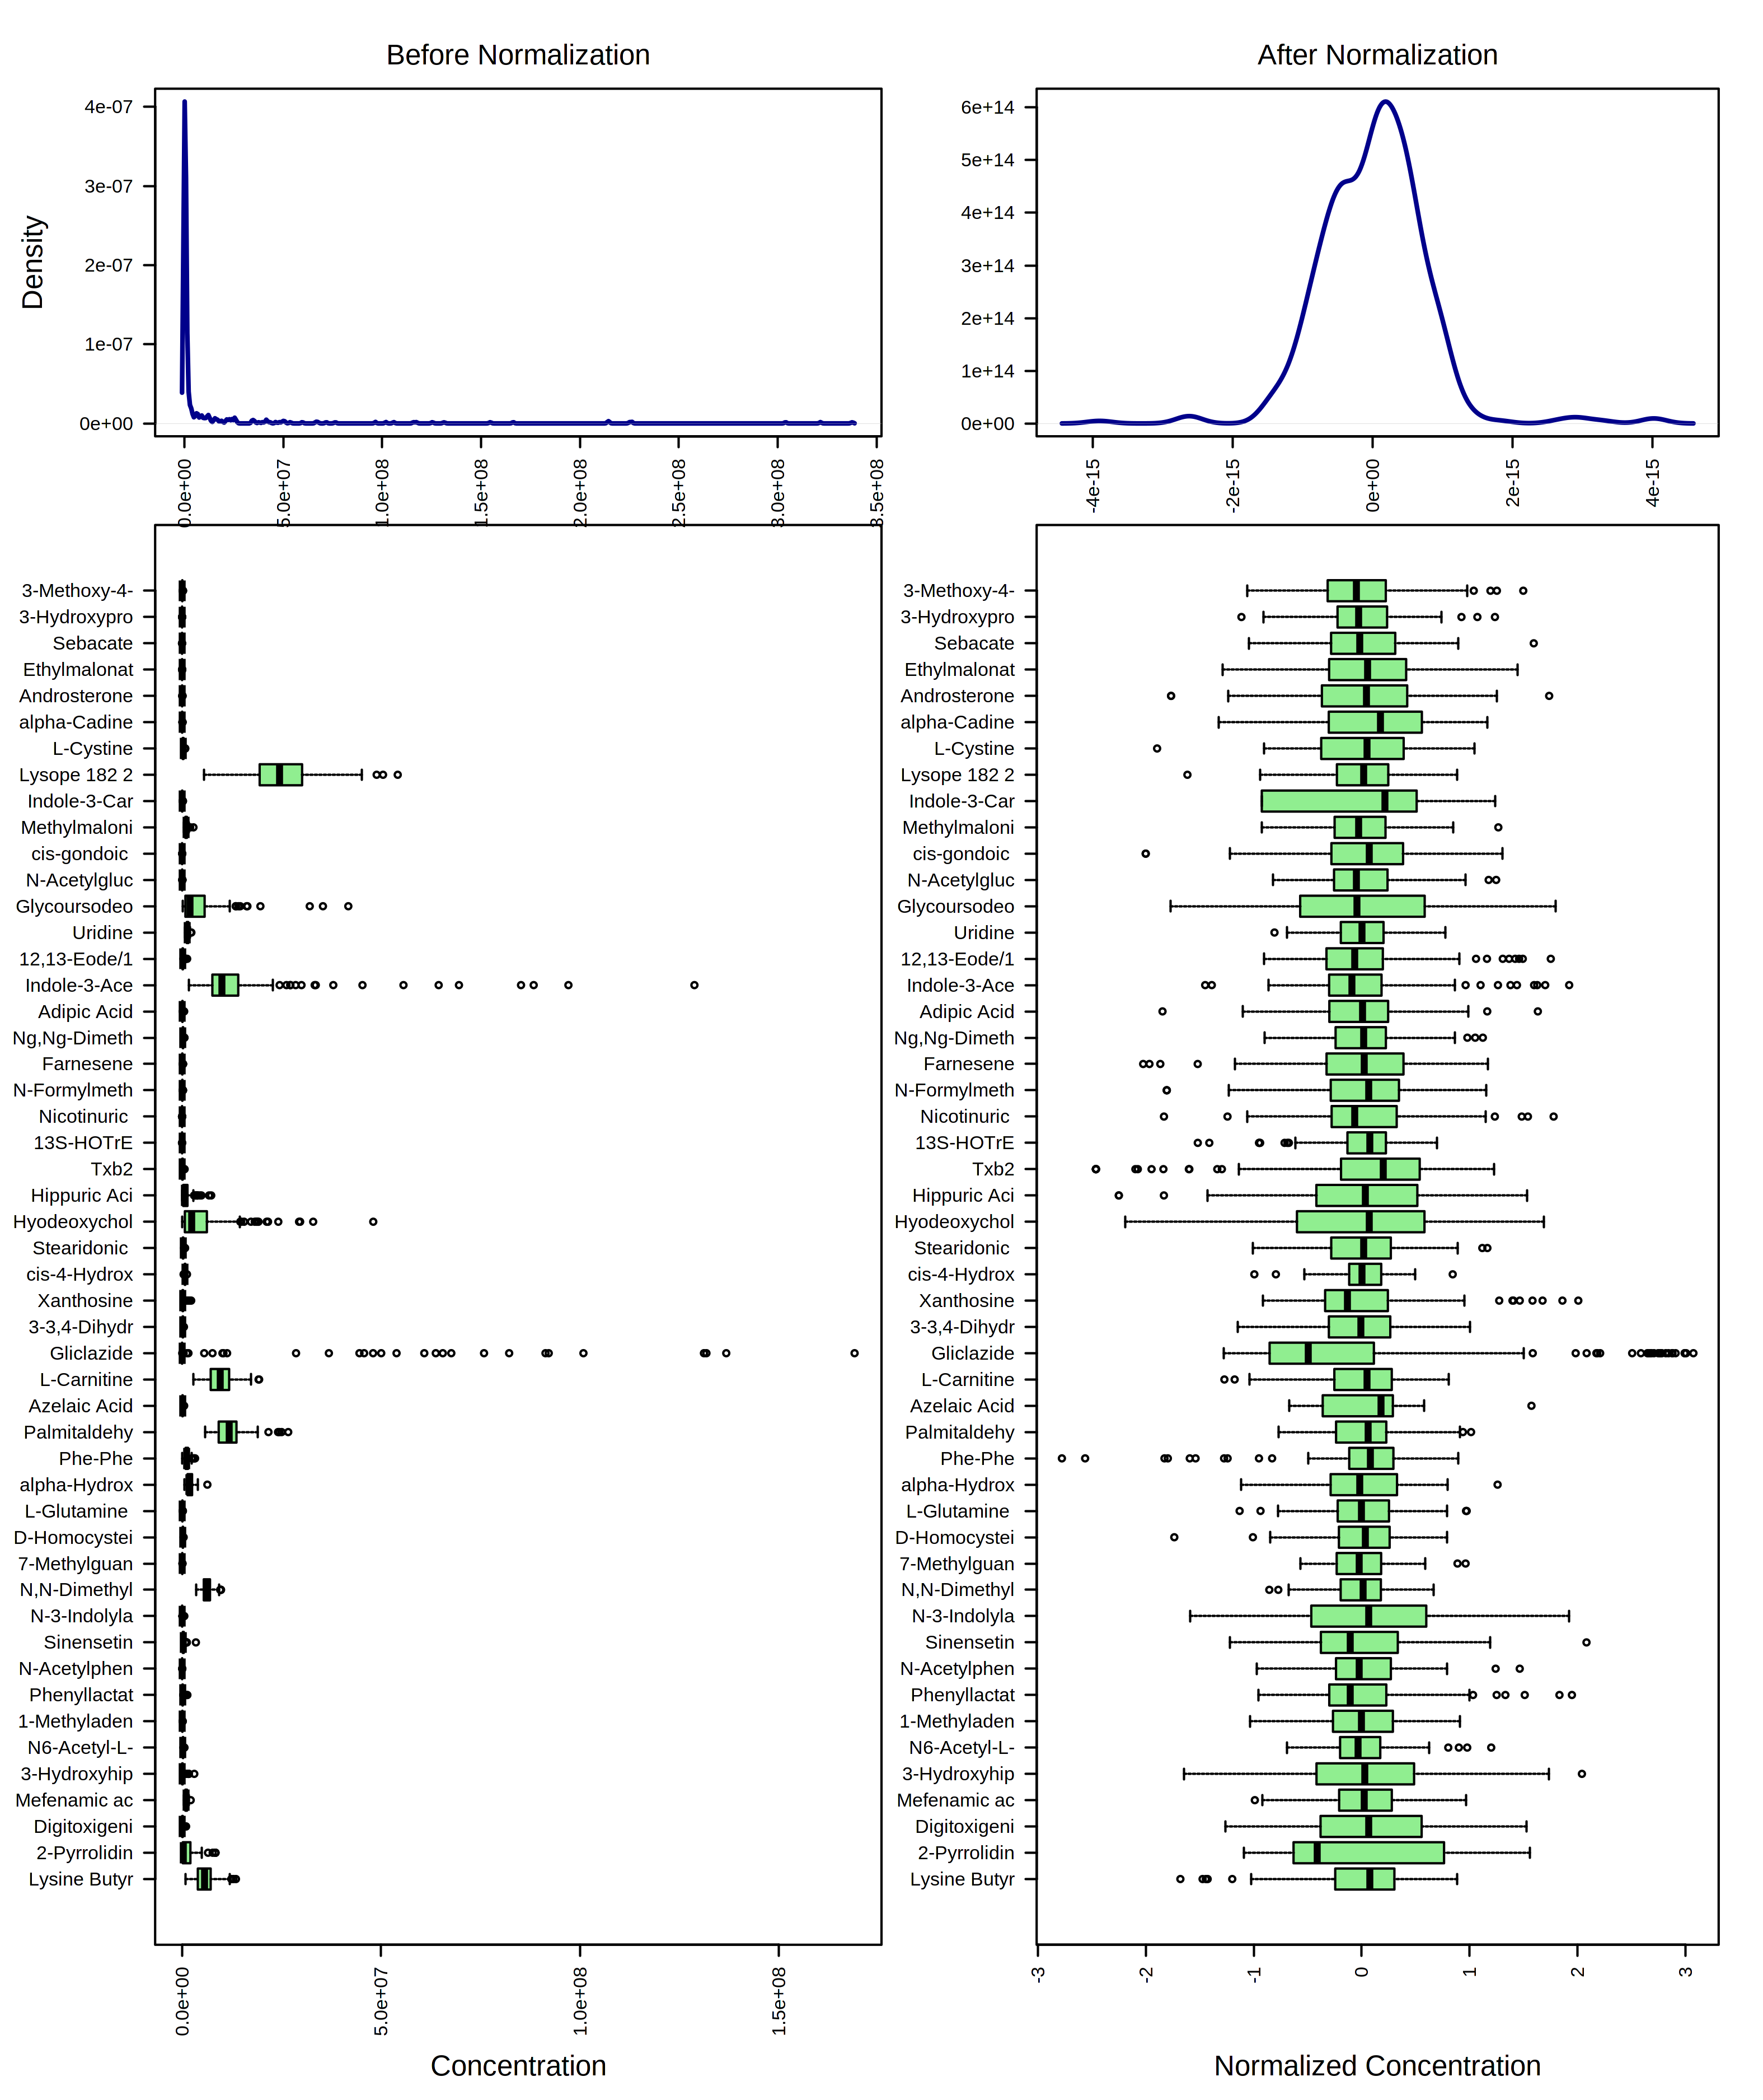
Figure S2. Box plots and kernel density plots before and after variable transformation. The density plots are based on all samples. Selected methods: Log10 transformation; Pareto scaling (mean-centered and divided by the square root of the standard deviation of each variable).

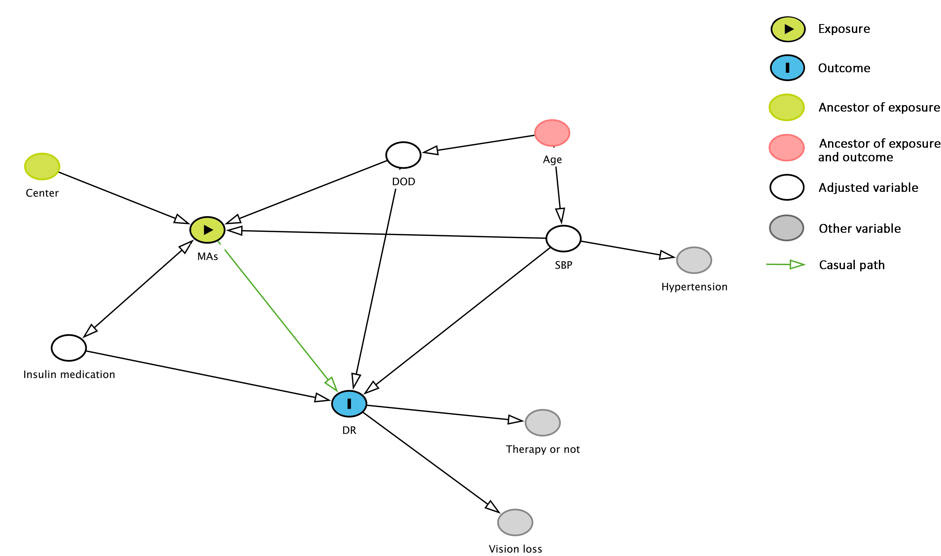
Figure S3. DAG illustrating modeling variables selection. Potential confounders evaluated were DoD, SBP, and insulin first. We choose the above three potential confounders and MAs for modeling because the other potentially meaningful variables (P<0.1) can be explained by the above variables or the latter part of the event. The DAG was drawn with DAGitty (http://www.dagitty.net/).
Abbreviations: DAG: Directed acyclic graph; DOD: duration of diabetes; SBP: systolic blood pressure; MA: metabolite alterations; DR: T2DM with diabetic retinopathy.

Figure S4. (A) PCA score plot of DM, DR, and QC groups. It shows the UPLC-MS/MS platform using in the study is relatively robust. (B) PLS-DA score plot of DM vs. DR. It shows a clear separation of metabolites between DM patients and DR patients. The model was established using three principal components. Cumulative R2 archived 90.2%, Q2 achieved 77.9%, and accuracy achieved 97.2% with permutation test p-values less than 0.001, shown in picture (C). Red: DM patients; Green: DR patients; Black: QC samples. The explained variances are shown in brackets.
Abbreviations: PCA: Principal component analysis; PLS-DA: Partial least square–discriminant analysis; DM: diabetes mellitus; DR: diabetic retinopathy; QC: quality control; UPLC-MS/MS: ultra-performance liquid chromatography-tandem mass spectrometry.

Figure S5. Feature selection using the LASSO-based logistic regression model. (A) LASSO coefficient profiles of the 25 differentially expressed metabolites. (B) Tuning parameter (λ) selection in the LASSO model used 10-fold cross-validation via minimum criteria.
Abbreviations: LASSO: least absolute shrinkage and selection operator.

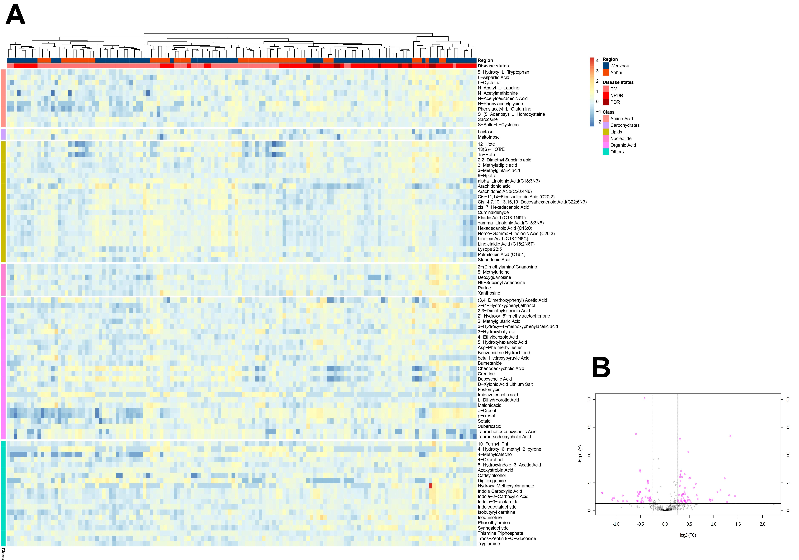
Figure S6. (A) Heatmap for intensities of all 89 differentially expressed metabolites between DM and DR patients with q value less than 0.05, fold change value greater than 1.2 or less than 0.8 and VIP greater than 1. Euclidean distance metric and Ward’s clustering method were applied for the hierarchical clustering of patients. Red represents increased intensities and blue represents decreased intensities. Metabolites of the same category are expressed together. (B) Volcano plot with metabolites that were significantly altered in DR patients compared to DM patients. The fuchsia dots represent metabolites above the threshold. The further the metabolite’s position away from the (0, 0), the more significant the metabolite is. The volcano plot visualizes the -log10 transformed q value and log2 fold changes. Metabolites with a q value less than 0.05 and a fold change greater than 1.2 or less than 0.8 are highlighted and labeled.
Abbreviations: DM: diabetes mellitus group; DR: diabetic retinopathy group; QC: quality control group.

Figure S7. KEGG global metabolic network highlighting DR altered pathways (raw p-value < 0.05). The thickness of the line represents the number of enriched metabolites in the pathway. The KEGG global metabolic network was drawn with iPath (https://pathways.embl.de/).

Abbreviations: KEGG: Kyoto Encyclopedia of Genes and Genomes database; DR: diabetic retinopathy; iPath: Interactive Pathways Explorer.

Table S1. DR altered metabolic pathway (raw p-value < 0.05) of KEGG global metabolic network.
Pathway | Hits | P value
Biosynthesis of unsaturated fatty acids | 7 | 0.00000673
Glycine, serine and threonine metabolism | 4 | 0.00447
Thiamine metabolism | 2 | 0.00512
Tryptophan metabolism | 4 | 0.0138
Fatty acid biosynthesis | 2 | 0.0214
alpha-Linolenic acid metabolism | 2 | 0.0305
Abbreviations: KEGG: Kyoto Encyclopedia of Genes and Genomes database; DR: diabetic retinopathy.

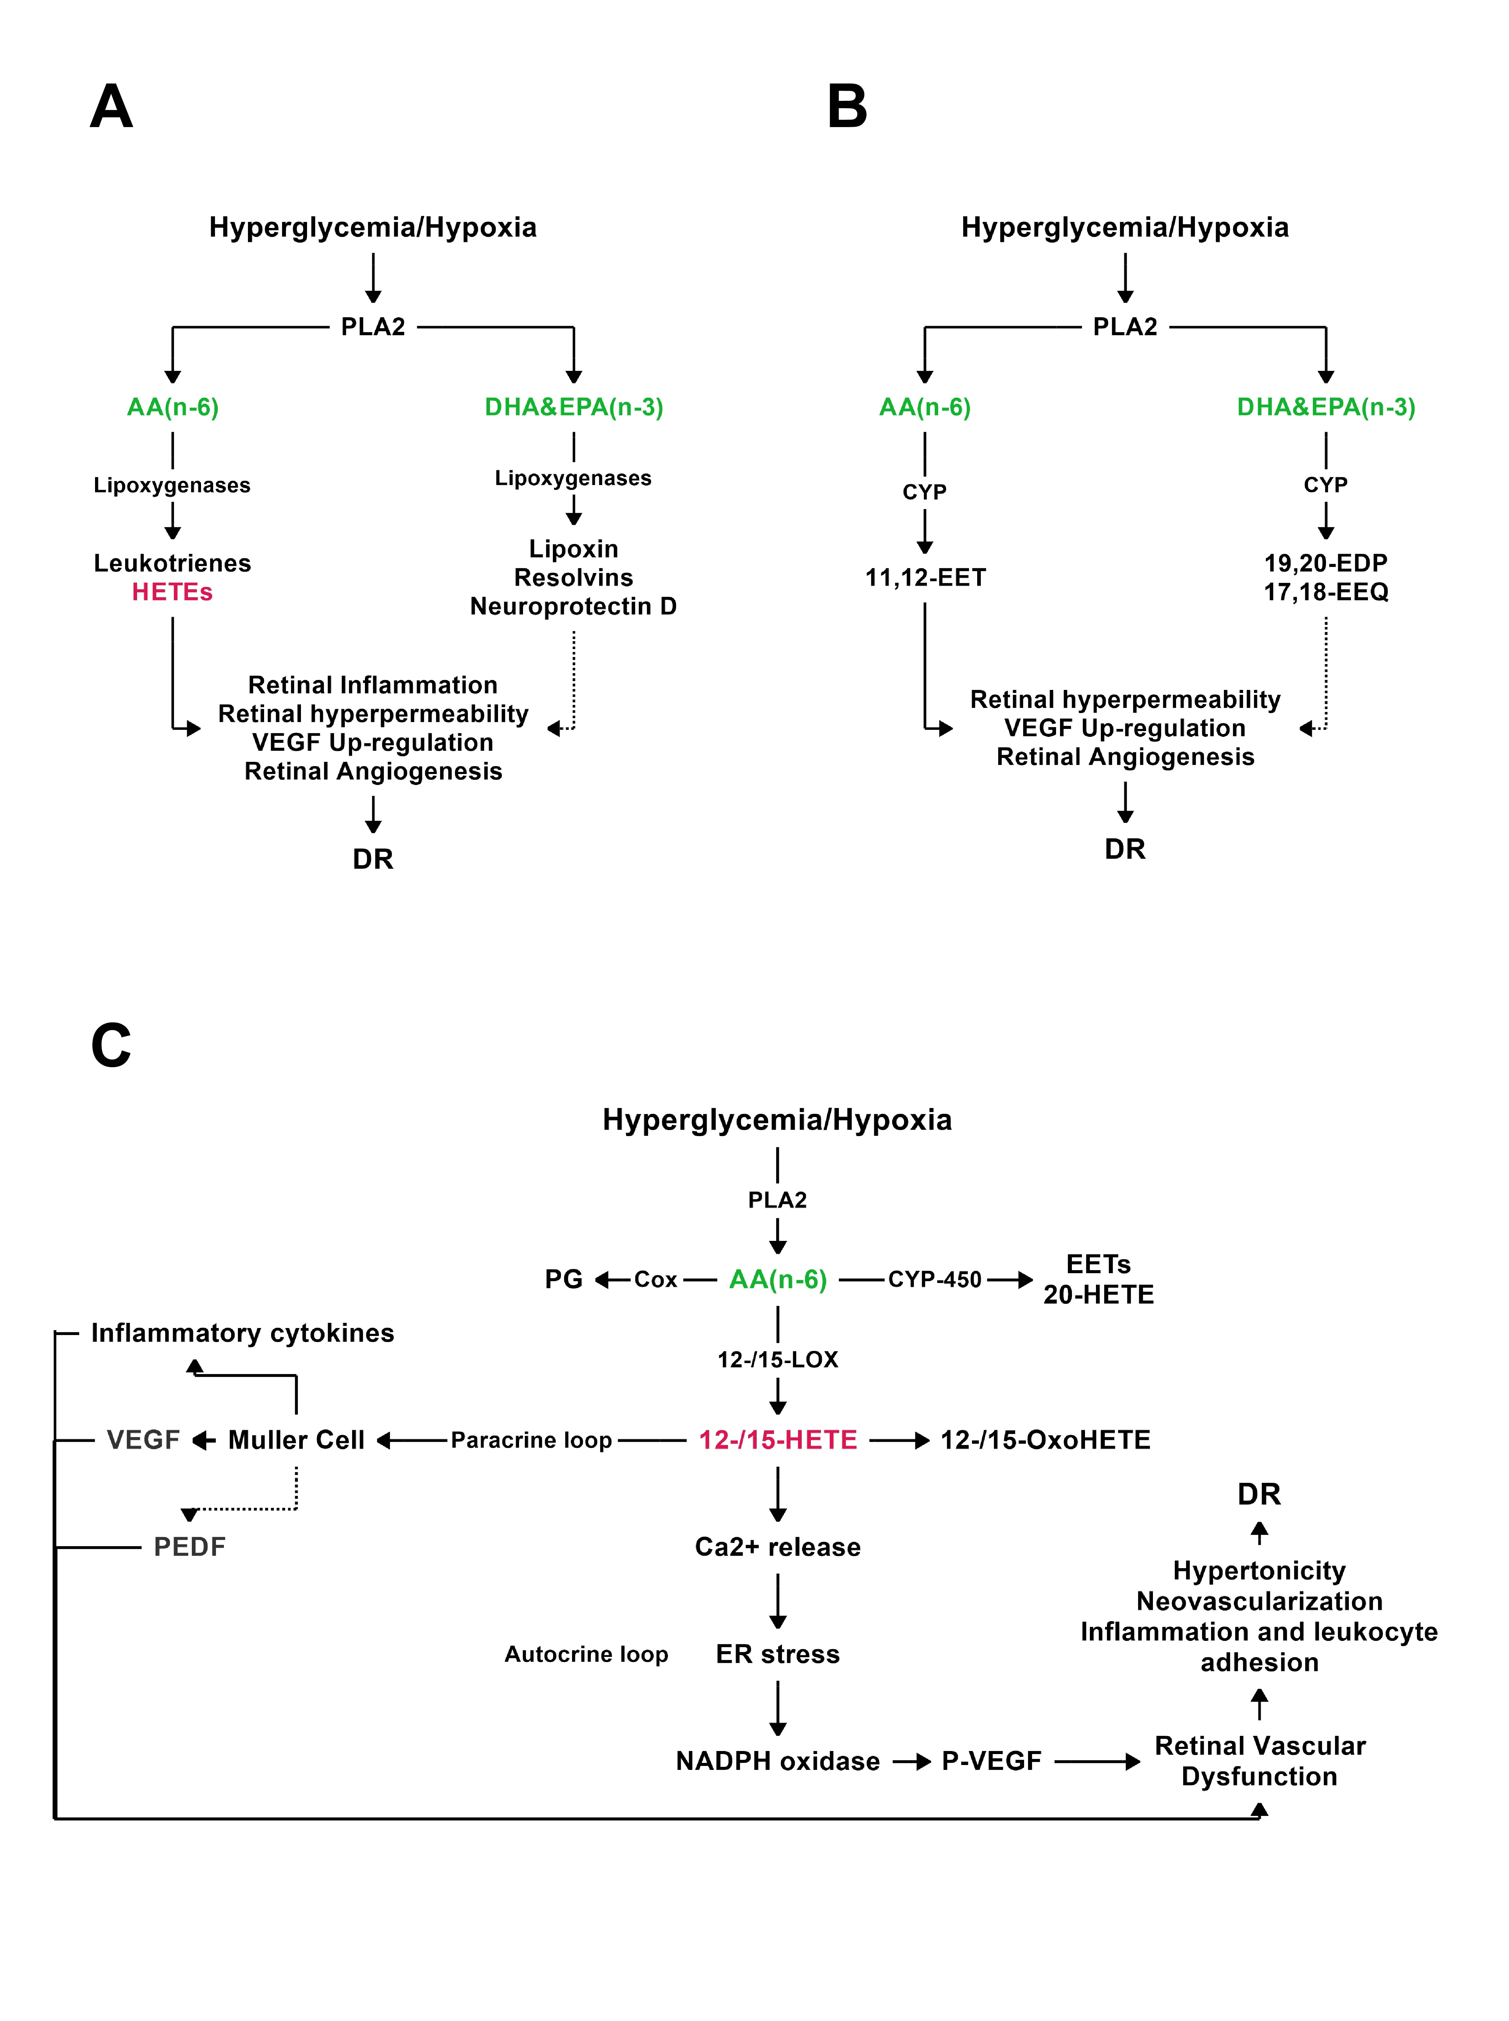
Figure S8. PUFAs-derived cascade events involved in the pathogenesis of DR. Red text represents significant increase; green text represents significant decrease; the dashed line represents inhibition.

Abbreviations: PUFAs: ploy unsaturated fatty acid; DR: diabetic retinopathy.

