Fig. S1. The K-mer distribution of ~25X Illumina paired-end reads using GenomeScope based on k value of 21. K-mer occurrences (x axis) were plotted against their frequencies (y axis).
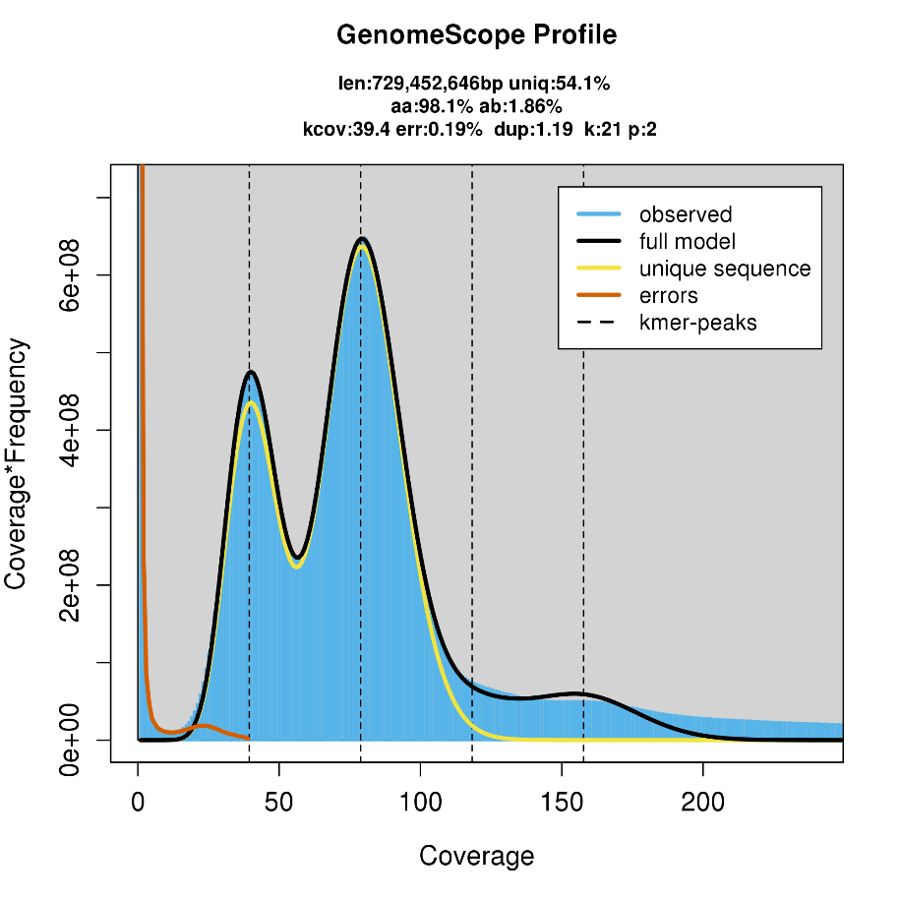

Fig. S2 The Hi-C interaction heatmap plot of each A. odoratissima chromosome.
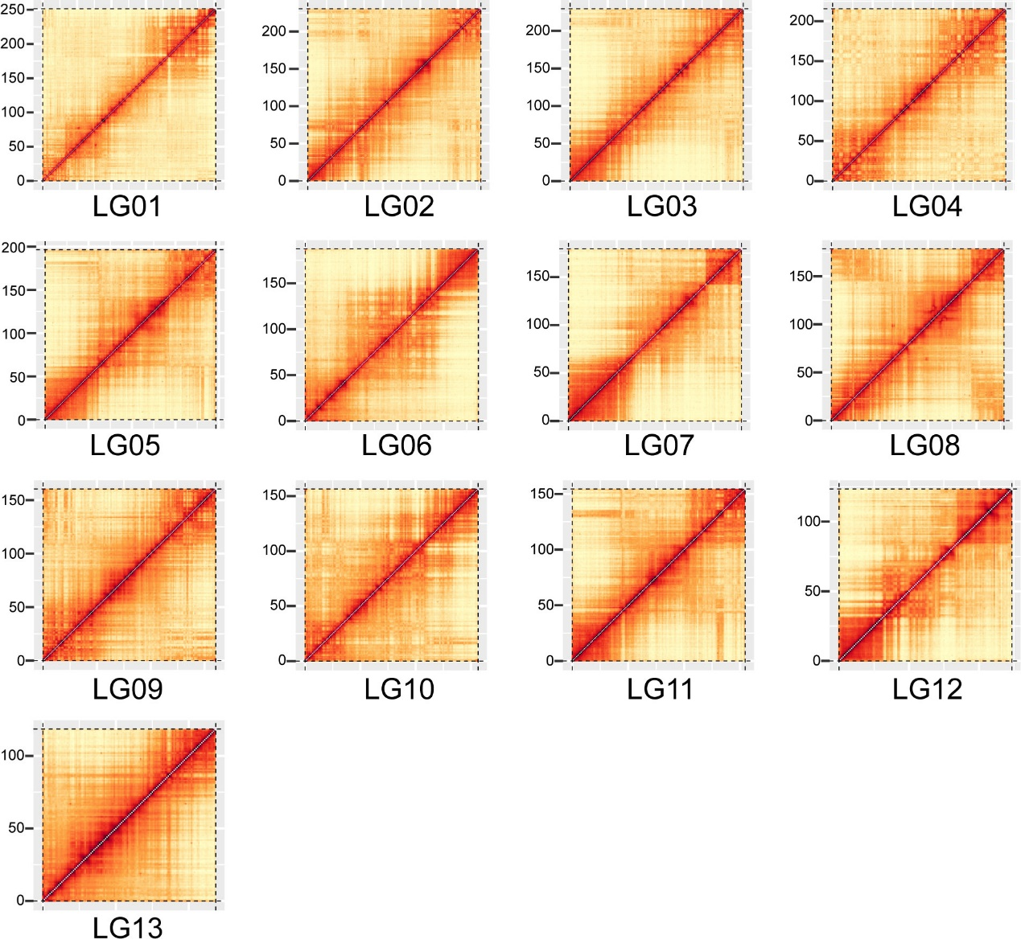

Fig. S3 Number of gene function annotations in different databases of A. odoratissima.
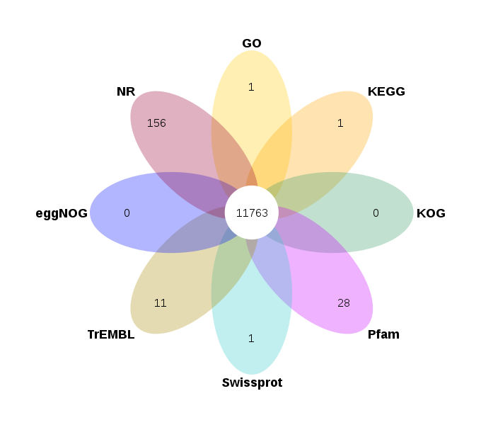

Fig. S4 Classification of intact LTR-RTs in the A. odoratissima genome
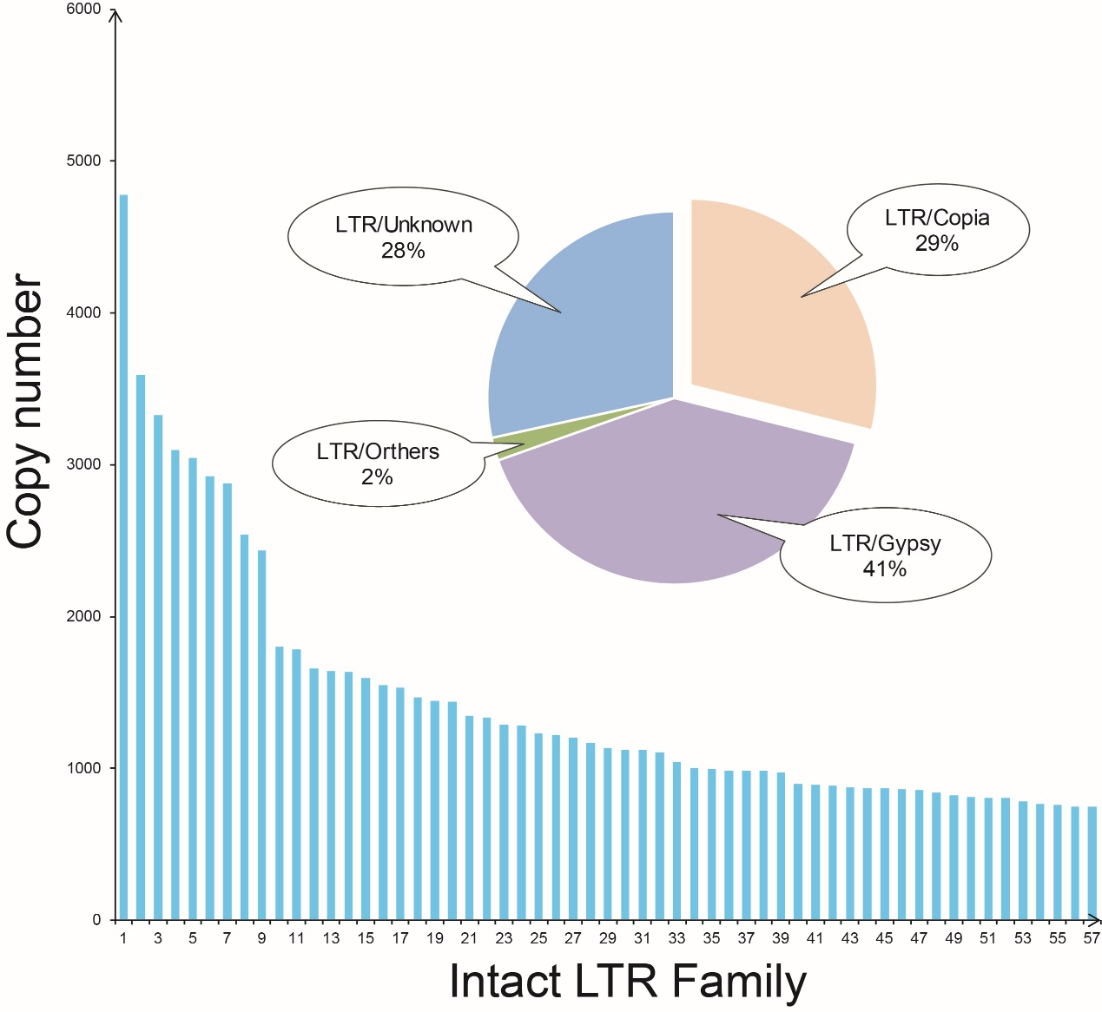

Fig. S5 Petal diagrams of gene family clustering
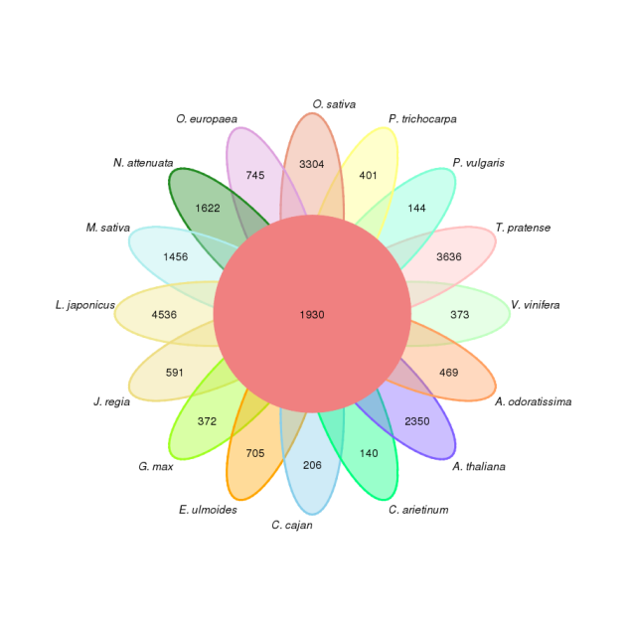

Fig. S6 KEGG term enrichment of A. odoratissima -specific gene families.
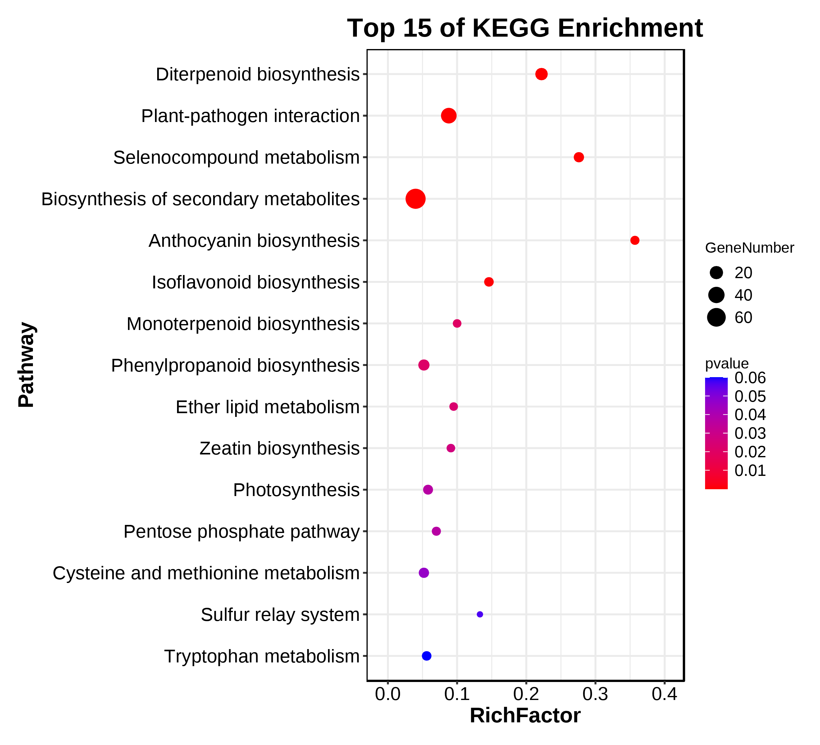

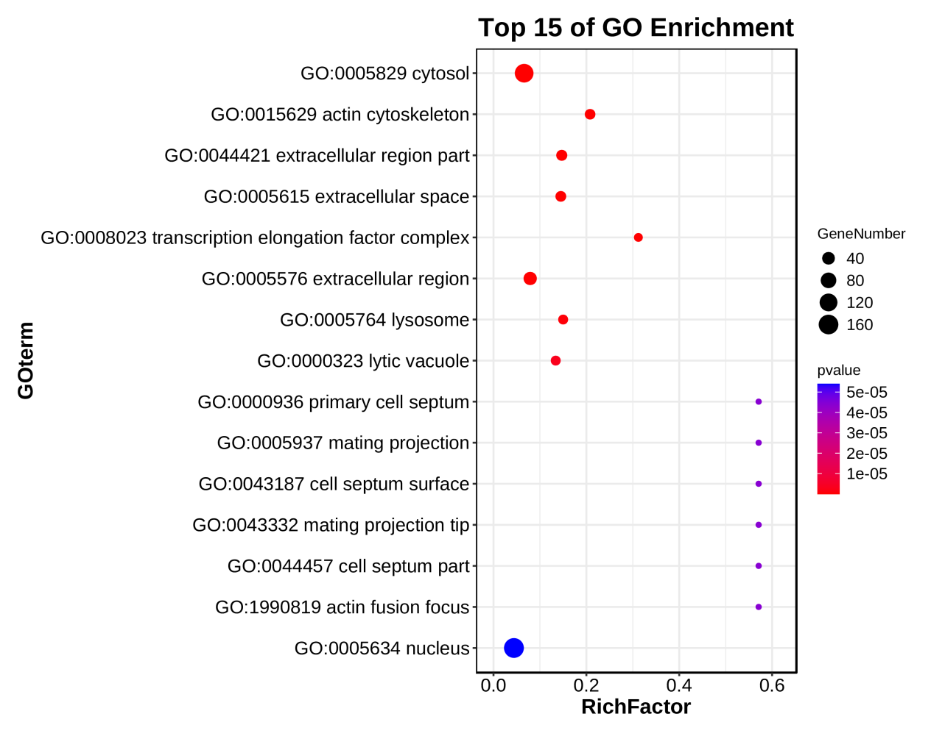
Fig. S7 GO term enrichment of A. odoratissima -specific gene families.
Fig. S8 KEGG term enrichment of A. odoratissima expansion gene families.
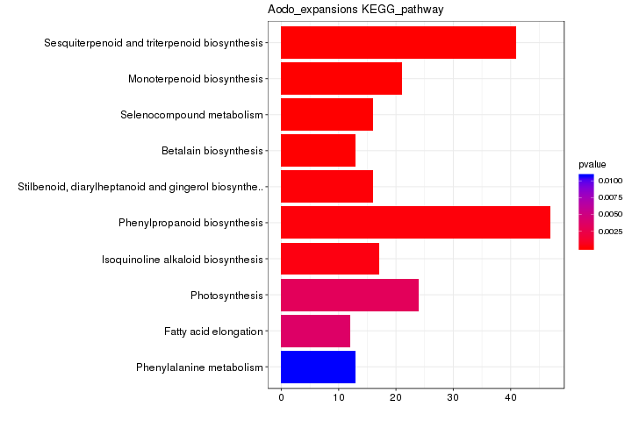
Fig. S9 GO term enrichment of A. odoratissima expansion gene families.
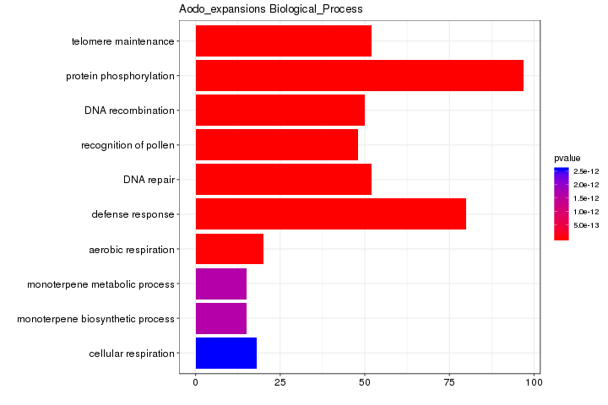

Fig. S10 Transcriptome analysis. A, Principal component analysis (PCA); B, Sample correlation analysis.
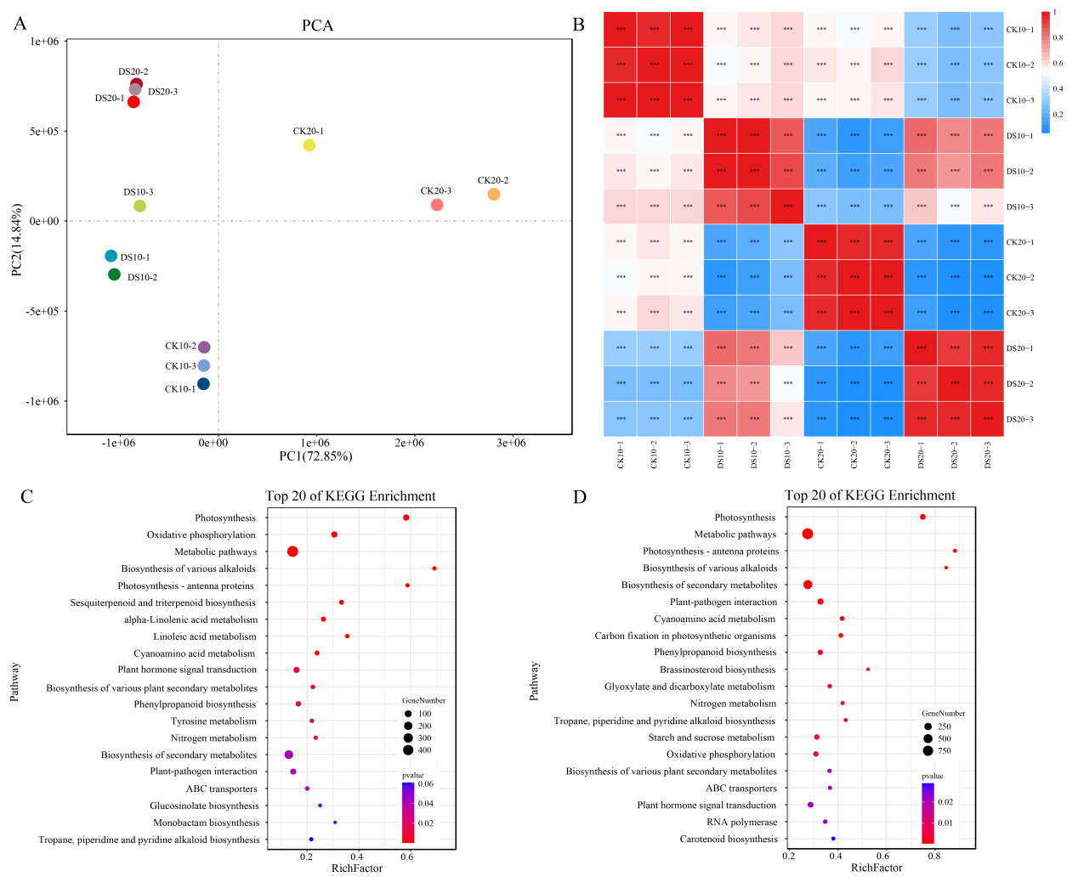

Fig. S11 Metabolome analysis. A: Principal component analysis (PCA) analysis; B: Permutation test; C: Classification of metabolites in leaves of A. odoratissima under drought stress.
