Table of Contents
Table S1. Summary of literature information on ER and PER treatment of PFAS. 2
Table S2. Bader charge and corresponding oxidation states for different elements 4
Table S3. Full names, abbreviations, CAS registry numbers, method detection limit (MDL) 5
Table S4. Cost breakdown of the Pd-TiO₂ cathode in different configurations. 6
Table S5. Composition of WWTP ROC and AFFF diluted by tap water. 6

Fig. S1. Band structure of Pd-TiO₂ heterojunction electrocatalyst under different scenarios. 7
Fig. S2. Control tests to rule out removal mechanisms unrelated to ER and PER processes. 8
Fig. S3. Cyclic voltammetry of the plate-type Pd–TiO₂ cathode in 100 mM Na₂SO₄ electrolyte. 10
Fig. S4. (a) PFOS desulfonation efficiencies after eight hours for ER and PER treatment. (b) Mass balance of fluorine from PFOS before and after ER treatment. 10
Fig. S5. Change of PFOS concentrations by ER and post-ER. . 11
Fig. S6. Impact of Pd/Ti ratios on (a) PFOS removal and (b) defluorination.. 11
Fig. S7. Decay of PFOS concentrations under different current densities. 12
Fig. S8. Change of pH during the PER treatment in dual and single chamber reactors. 12
Fig. S9. Impacts of e⁻_{aq} quencher on PFOS removal and defluorination.. 13
Fig. S10. Reduction of ClO₄– and ClO₃– in the catholyte by ER and PER. . 14
Fig. S11. Impacts of dissolved oxygen (DO) on (a) PFOS removal and (b) defluorination in the absence and presence of air purging (0.1 L/min). . 14
Fig. S12. Defluorination and chain-shortening Pathways of perfluorooctyl $(C8F17*)$ fragment on Pd (111) surface at pH 3 and potential -0.5 V vs. RHE.. 15
Fig. S13. Time-dependent concentration profiles of PFOS and its detected transformation products (TPs) were monitored during the PER degradation process. . 15
Fig. S14. (a) Decay of PFOS at different NOM concentrations (mg/L as TOC). (c) Photos NOM (100 mg/L as TOC) spiked electrolyte, containing 10 µM PFOS in 100 mM Na₂SO₄, before and after PER treatment, compared with photolysis treatment. 16
Fig. S15. Decay of PFOS at different NO₃⁻ concentrations. . 16
Fig. S16. (a) Decay of PFOS concentrations under different Ca²⁺ concentrations. 17
Fig. S17. Stability test of PFOS removal by Pd-TiO₂ over five consecutive PER batches (8 h per batch). 17
Fig. S18. Treatment of PFOS using a bare Ti tube cathode in the PER mode. 18
Fig. S19. Degradation and defluorination of PFOS in PER-EO tandem treatment process. 18
Fig. S20. PFOS degradation as a function of specific charge (Ah/L) using tube and mesh Pd-TiO₂ electrodes.. 19
Fig. S21. Variation of Q-ToF-MS peak areas of precursors as functions of reaction time in the PER-EO treatment process. 19
Fig. S22. Thermodynamic Hess cycle used to incorporate the free energy of deprotonation and solvation of C₈F₁₇SO₃ (PFOS), allowing calculation of adsorption free energy of PFOS on surfaces. 20

Table S1. Summary of literature information on ER and PER treatment of PFAS.
 | References | Configuration | Mechanisms | Half-life, t_{1/2} | Max. RE* | Max. DeF | EEO*
PER | This Study | Cathode: Pd-TiO₂ tube in Na₂SO₄  Anode: Ir_{0.3}Ta_{0.7}O_{x} in Na₂SO₄  Reactor: single cell + 16 W UV lamp  Targets: PFOS | Cathodic adsorption and e_{aq}-mediated reduction | PFOS: 1.1 h | PFOS: 100% @ pH 6 | PFOS: 41% @ pH 6 | 178 Wh/L†
PER | Su et al (2019)¹ | Cathode: CNT with cationic surfactants in NaClO₄  Anode: Pt in NaClO₄  Reactor: single-cell + 450 W UV lamp  Target: PFOS | Surfactant-mediated adsorption and e_{aq}-mediated defluorination | NA | PFOS: not measured @ pH 8.5 | PFOS: 7.5% @ pH 8.5 | 2244 Wh/L
PER | Rao et al. (2020)² | Cathode: CNT with cationic surfactants in NaClO₄  Anode: Pt in NaClO₄  Reactor: single-cell + 450 W UV lamp  Targets: PFOS, PFBS, PFHxS PFHpA, PFOA, PFNA | Surfactant-mediated adsorption and e_{aq}-mediated defluorination | NA | NA | PFOS: 20% @ pH 11  PFOA: 27% @ pH 11 | NA
PER | Liu et al (2022)³** | Cathode: diamond in deionized water with PFOA  Anode: Pt in KI solution  Reactor: H-cell + 500 W UV lamp  Target: PFOA | e_{aq} generated from diamond for defluorination | 1 h | PFOA: 100% | PFOA: 60% | NA
ER | Calvillo Solís et al (2024)⁴ | Cathode: Au in KHCO₃  Anode: TiO₂ in KHCO₃  Reactor: H-cell  Target: PFOA | Direct electron transfer and H/F exchange | NA | NA | NA | NA
ER | Ackerman Grunfeld et al⁵  (2024) | Cathode: granular activated carbon in Na₂SO₄  Anode: stainless steel in Na₂SO₄  Reactor: H-cell or single-cell  Target: PFMeUPA, PFOS | Not confirmed | No reaction at room temperature. | NA | NA at room temperature | NA
ER | Yue Wang⁶ (2023) | Cathode: CNT with surfactants in phosphate-buffered solution (PBS)  Anode: Pt in PBS  Targets: PFMeUPA, PFOA | Adsorption via surfactant and defluorination via direct electron transfer | PFMeUPA: 5 h  PFOA: 40 h | PFMeUPA: 100%  PFOA: 60% | PFMeUPA: 80%  PFOA: no defluorination | NA
ER | Jaixin Zhu⁷ (2022) | Cathode: Rh/Ni in organic solvents with PFAS  Anode: Pt in organic solvents  Reactor: dual-chamber cell  Target: PFOA | Direct electron transfer and H/F exchange. | PFOA: 12 h | PFOA: 50% | PFOA: 2% | NA

* RE: Removal efficiency; EEO: electrical energy per order of removal.
** The authors express concerns about the cited study. As shown in Figure S1 of the cited article, an H-cell with a porous glass frit was used to separate the anodic and cathodic chambers. However, the study employs KI as the anolyte, which raises potential issues. KI could diffuse into the cathodic chamber and initiate homogeneous UV/I⁻ reactions, a well-known reaction to generate e_{aq}.⁸ Consequently, it is unclear whether the defluorination of PFOA observed in this study is primarily due to the e_{aq} yield from the UV/I⁻ reaction or from the diamond cathode.
† EEO of PFOS removal for the PER process using Pd-TiO₂ mesh cathode is calculated as the sum of energy consumed by electrochemical oxidation (EO) and UV lamp.
$$Total Energy \left(Wh/L\right)=EO Energy (Wh/L)+UV Energy (Wh/L)$$
$$EO Energy (kWh/L)=\frac{Current \left(A\right)×Voltage \left(V\right) ×Treatment time to achieve>90\% removal (h)}{Water volume (L)}$$
$$UV Energy \left(kWh/L\right)= \frac{UV lamp Power \left(W\right) ×Treatment time to achieve>90\% removal (h)}{Water volume (L)} ×0.5$$
The calculation is based on the results of Fig. S20. The parameters include current (1.5 A), average voltage (8.5 V), treatment time (6 h), volume (0.7 L), and UV lamp power (16 W). Since only half of the UV lamp was submerged in water, a coefficient of 0.5 was applied to account for the effective UV energy contribution.

Table S2. Bader charge and corresponding oxidation states for different elements
Atom | Bader Charge | Oxidation State
F | -0.6 | -1
H | -0.62 to -0.65 | +1
O | < -1.27 | -1
O | -1.35 to -1.40 | -2
S | +3 to +3.3 | +5
Ti | +2 to +2.11 | +4

Table S3. Full names, abbreviations, CAS registry numbers, method detection limit (MDL)
No. | Full name | Abbr. | CAS No. | RT (min)ª | MDL (µg/L)
1 | Perfluoro-n-butanoic acid | PFBA | 375-22-4 | 0.77 | 0.004
2 | Perfluoro-n-pentanoic acid | PFPeA | 2706-90-3 | 0.67 | 0.004
3 | Perfluoro-n-hexanoic acid | PFHxA | 307-24-4 | 2.07 | 0.004
4 | Perfluoro-n-heptanoic acid | PFHpA | 375-85-9 | 2.57 | 0.004
5 | Perfluoro-n-octanoic acid | PFOA | 335-67-1 | 2.78 | 0.004
6 | Perfluoro-n-nonaoic acid | PFNA | 375-95-1 | 2.96 | 0.004
7 | Perfluoro-n-decanoic acid | PFDA | 335-76-2 | 3.03 | 0.004
8 | Perfluoro-n-undecanoic acid | PFUdA | 2058-94-8 | 3.17 | 0.004
9 | Perfluoro-n-dodecanoic acid | PFDoA | 307-55-1 | 3.29 | 0.004
10 | Perflluoro-n-tridecanoic acid | PFTrDA | 72629-94-8 | 3.41 | 0.004
11 | Perflluoro-n-tetradecanoic acid | PFTeDA | 376-06-7 | 3.53 | 0.004
12 | Potassium perfluoro-1-butanesulfonate | PFBS | 375-73-5 | 1.35 | 0.004
13 | Sodium perfluoro-1-pentanesulfonate | PFPeS | 630402-22-1 | 2.4 | 0.004
14 | Sodium perfluoro-1-hexanesulfonate | PFHxS | 355-46-4 | 2.63 | 0.004
15 | Sodium-perfluoro-1-heptanesulfonamide | PFHpS | 375-92-8 | 2.78 | 0.004
16 | Sodium perfluoro-1-octanesulfonate | PFOS | 1763-23-1 | 2.91 | 0.004
17 | Sodium perfluoro-1-nonanesulfonate | PFNS | 98789-57-2 | 3.02 | 0.004
18 | Sodium-perfluoro-1-decanesulfonate | PFDS | 335-77-3 | 3.13 | 0.004
19 | Sodium 1H,1H,2H,2H-perfluorohexane sulfonate | 4:2 FTS | 757124-72-4 | 1.26 | 0.004
20 | Sodium 1H,1H,2H,2H-perfluorooctane sulfonate | 6:2 FTS | 27619-97-2 | 2.61 | 0.004
21 | Sodium 1H,1H,2H,2H-perfluorodecane sulfonate | 8:2 FTS | 39108-34-4 | 2.92 | 0.004
22 | Sodium 1H,1H,2H,2H-perfluorododecane sulfonate* | 10:2 FTS | N/A | 3.18 | 0.004
23 | Perfluoro-1-octanesulfonamide | FOSA-1 | 754-91-6 | 3.87 | 0.004
24 | Perfluoro-1-octanesulfonamidoacetic acid* | FOSAA | 2806-24-8 | 3.2 | 0.004
25 | N-methylperfluoro-1-octanesulfonamidoacetic acid | N-MeFOSAA | 2355-31-9 | 3.43 | 0.004
26 | N-methylperfluoro-1-octanesulfonamide* | N-MeFOSA-M | 31506-32-8 | 4.36 | 0.004
27 | N-ethylperfluoro-1-octanesulfonamidoacetic acid | N-EtFOSAA | 2991-50-6 | 3.48 | 0.004
28 | N-ethylperfluoro-1-octanesulfonamide* | N-EtFOSA-M | 4151-50-2 | 4.45 | 0.004
29 | Trifluoroacetate | TFA | 2923-18-4 | 0.46 | 0.004
30 | Perfluoropropanoic acid | PFPA | 422-64-0 | 0.48 | 0.004

Table S4. Cost breakdown of the Pd-TiO₂ cathode in different configurations.
Electrode type | Ti Substrate ($/m²)ª | Pd-TiO₂ Coating ($/m²)^{b} | Total Cathode Cost ($/m²)
Plate | 185 | 134 | 319
Tube | 826 | 132 | 958
Mesh | 65 | 122 | 187
ª The costs of the Ti plate (Grade 2 Titanium Sheet, 0.02" × 12" × 12"), Ti tube (Grade 9 Titanium tube; Ø 0.55"), and Ti mesh (Grade 2 100 mesh opening) were normalized by the double-sided projected surface area. The double-sided surface areas for Ti plate and tube are 16 and 48 cm². For the Ti mesh, the surface area was calculated as twice the projected area, resulting in 256 cm².
^{b} The preparation of 50 mL Pd/TiO₂ sol-gel precursor at a Pd/Ti molar ratio of 0.2 requires citric acid (11.5 g; $0.076/g), PdCl₂ (0.035 g; $88/g), ethylene glycol (25 mL; $0.081/mL), titanium butoxide (0.34 mL; $0.24/mL), and ethanol (5 mL; $0.12/mL). The total cost of the precursor is $0.13/mL. The coating process consumed 1.7 mL, 4.8 mL, and 24 mL of the solution for the Ti plate (16 cm²), Ti tube (48 cm²), and Ti mesh (256 cm²), respectively. The cost of Pd-coating is calculated using the formula:
Cost of coating ($/m²) = [Cost of precursor ($/mL)] × [Consumed precursor volume (mL)]/[Double-sided surface area (m²)]
For reference, the commercial Ir_{0.3}Ta_{0.7}O_{x} anode used in this study is priced at approximately $600/m².

Table S5. Composition of WWTP ROC and AFFF diluted by tap water.
 | WWTP ROC |  | Tap water w/ AFFF*
 | Before Treatment | After PER | Before Treatment | After PER | After EO
Conductivity (mS/cm) | 8.1 | 8.0 | 0.27 | 0.31 | 2.5
pH | 8.4 | 9.3 | 6.2 | 6.8 | 6.5
TOC (mg/L) | 50.4 | 24.6 | 38.8 | 17.5 | 0.4
Cl⁻ (mg/L) | 1950 | 2044 | 1.8 | 2 | N.D.
NO₃⁻ (mg/L) | 37 | 13 | 7.4 | N.D. | N.D.
SO₄²⁻ (mg/L) | 1312 | 1330 | 44 | 52 | 8750
ClO₃⁻ (mg/L) | 3 | N.D. | N.D. | N.D. | N.D.
ClO₄⁻ (mg/L) | N.D. | N.D. | N.D. | N.D. | 3.2
F⁻ (mg/L) | 1.9 | 2.6 | 0 | 0.47 | 2.05
* AFFF (Platinum Plus C6 3% AFFF Buckeye MIL-SPEC) was diluted 5000 times by tap water to simulate firefighting equipment cleaning solution.⁹

Fig. S1. Band structure of Pd-TiO₂ heterojunction electrocatalyst under different scenarios. (a) The original band structures of TiO₂ and Pd before forming the heterojunction. (b) Pd-TiO₂ electrocatalyst at open circuit and under UV 254 nm irradiation. (c) Pd-TiO₂ electrocatalyst at -0.5 V_{NHE} and under UV 254 nm irradiation. E_{vac}, E_{v}, and E_{c} represent the vacuum energy level, conduction band edge, and valence band edge; E_{f} is the Fermi level; Φ is the work function; e⁻_{hot_TiO2} and e⁻_{hot_Pd} refer to hot electrons generated from UV-excited TiO₂ and Pd, respectively.

Extended Discussion of Fig. S1.
The E_{c} and E_{v} of anatase TiO₂ were obtained from literature values.¹⁰ The E_{f} of TiO₂ (E_{f_TiO2}) is close E_{c}, owing to the n-type semiconductor nature of TiO₂.¹¹ The E_{f} of Pd (E_{f_}Pd) was calculated to be 0.66 V_{NHE} based on its Φ_{Pd} of 5.1 eV relative to E_{vac}.¹² The band structures are illustrated in both electron energy and potential scales in Fig. S1a.
The Pd-TiO₂ catalysts developed in this study form heterojunctions. Upon contact between Pd and TiO₂, a Schottky barrier is formed, leading to downward band bending in TiO₂.¹³ As a result, the E_{f_TiO2} aligns with E_{f_Pd} at 0.66 V_{NHE}. In an aqueous electrochemical system, the E_{f} values of electrocatalysts correspond to electrochemical potentials.¹¹ We experimentally measured the open-circuit potential of the Pd-TiO₂ cathode in a 100 mM Na₂SO₄ electrolyte, obtaining a value of 0.60 V_{NHE}, which is in good agreement with the calculated E_{f_Pd} of 0.66 V_{NHE}, as shown in Fig. S1b.
Under 254 nm UV irradiation (photon energy = 4.88 eV), photoexcitation can promote electrons from the TiO₂ valence band to generate hot electrons (e⁻_{hot_TiO2}). As shown in Fig. S1b, the maximum reduction potential of e⁻_{hot_TiO2} can be estimated by subtracting the photon energy from the E_{v} (3.28 V_{NHE}), yielding a potential of approximately -1.6 V_{NHE}. In addition, 4d-band electrons in Pd can also be excited by UV light via interband transitions,¹⁴ resulting in the generation of e⁻_{hot_Pd}. The reduction potential of these e⁻_{hot} can be estimated by subtracting UV₂₅₄ photon energy from the E_{f_Pd},¹⁴ leading to a maximum potential of -4.22 V_{NHE}.
In addition to UV_{254 nm} irradiation, applying a cathodic potential of -0.5 V_{NHE} on the Pd-TiO₂ catalyst (i.e., the condition of PER treatment of PFAS in the main text) shifts E_{f} of TiO₂ and Pd upward to -0.5 V_{NHE} (Fig. S1c). Correspondingly, the reduction potentials of e⁻_{H} are also shifted to more negative values. Notably, the reduction potential of e⁻_{hot} is -4.72 V_{NHE}, which significantly exceeds the -2 V_{NHE} threshold required for the reductive defluorination of PFOS.¹⁵
It is important to note that the reduction potentials of e⁻_{hot} estimated above correspond to electrons excited into higher-energy states within the conduction band. These excited electrons remain within the solid state and will rapidly relax to energy levels near E_{c}__{TiO2} or E_{f_Pd} within femtoseconds to picoseconds.^{16,17} Under UV irradiation alone, the e⁻_{hot_TiO2} clearly lacks sufficient reducing power for PFOS defluorination. While e⁻_{hot_Pd} initially possesses a highly negative reduction potential, it rapidly loses energy before it can effectively react with PFOS in the aqueous phase. Consequently, UV irradiation on the Pd-TiO₂ electrode at open-circuit does not result in PFOS degradation in our experimental observation (Fig. S2b). Without UV irradiation, applying only a cathodic potential of -0.5 V_{NHE} (i.e., shifting E_{f} to -0.5 V_{NHE} without generating e⁻_{hot}) is also insufficient to meet the thermodynamic threshold of -2 V_{NHE} required for PFOS defluorination. This observation is consistent with the experimental result showing no PFOS degradation under ER mode (Fig. 2b in the main text).
However, under simultaneous UV irradiation and application of a cathodic potential (PER mode), several synergistic effects are involved. Specifically, cathodic adsorption of PFOS and C–S bond cleavage on TiO₂, along with the transfer of perfluoroalkyl groups to Pd, facilitate intimate contact between the perfluoroalkyl group and highly reducing e⁻_{hot_Pd}. These combined factors enable reductive PFOS removal and defluorination.
Moreover, since the energy of e⁻_{hot_Pd} exceeds the E_{vac}, it is sufficiently high to allow electron emission from the solid phase into the aqueous phase, generating hydrated electrons (e⁻_{aq}) at the electrode-solution interface to react with adsorbed PFOS and Pd immobilized perfluoroalkyl group.¹⁸ Therefore, e⁻_{hot} and e_{aq}⁻ may jointly contribute as active reductive species responsible for PFOS defluorination.
The photogenerated holes (h⁺) on UV-excited TiO₂ and Pd are likely rapidly neutralized by electrons supplied through the cathodic current and therefore, do not contribute significantly to PFAS degradation.

Fig. S2. Control tests to rule out removal mechanisms unrelated to ER and PER processes. Change of PFOS concentration (a) under open circuit potential, (b) by UV photolysis, and (c) under H₂ with and without UV light irradiation. Data with error bars are presented as the mean values of triplicate samples ± standard deviation.

Fig. S3. Cyclic voltammetry of the plate-type Pd–TiO₂ cathode in 100 mM Na₂SO₄ electrolyte. Ir_{0.3}Ta_{0,7}O_{x} was used as an anode and a Ag/AgCl (3 M KCl) electrode was used as the reference. The applied cathodic potential (Eₐ) was corrected for iR drop using the uncompensated resistance (Rᵤ = 1.2 Ω), determined by electrochemical impedance spectroscopy at 100 kHz with a 20 mV sine wave. The potential was further converted to the reversible hydrogen electrode (RHE) scale.

Fig. S4. (a) PFOS desulfonation efficiencies after eight hours for ER and PER treatment. (b) Mass balance of fluorine from PFOS before and after ER treatment. The blue, pink, and orange colors of the stacked plots represent the PFOS residual in the solution, adsorbed on the cathode and desulfonated parts of PFOS separately, and the rest (grey) represent the unknowing loss in PFOS. Reaction conditions: 10 µM PFOS were spiked in 100 mL NaClO₄ (10 mM) catholyte. A current density of 15 mA/cm² was applied to a 16 cm² Pd-TiO₂ cathode in a dual-chamber reactor. An Ir_{0.3}Ta_{0.7}O_{x} anode (16 cm²) served as the counter electrode, with 100 mL of 100 mM H₂SO₄ used as the anolyte. Data are presented as the mean values of triplicates ± standard deviation.

Fig. S5. Change of PFOS concentrations by ER and post-ER. After 8 h of ER treatment, the current was stopped. Reaction conditions: PFOS (10 µM) was spiked into 100 mL of 100 mM Na₂SO₄ catholyte. A current density of 15 mA/cm² was applied to a 16 cm² Pd-TiO₂ cathode in a dual-chamber reactor. An Ir_{0.3}Ta_{0.7}O_{x} anode (16 cm²) served as the counter electrode, with 100 mL of 100 mM H₂SO₄ used as the anolyte. All data are presented as the mean values of triplicate tests ± standard deviation.

Fig. S6. Impact of Pd/Ti ratios on (a) PFOS removal and (b) defluorination. Reaction conditions: PFOS (10 µM) was spiked into 100 mL of 100 mM Na₂SO₄ catholyte. A current density of 15 mA/cm² was applied to a 16 cm² cathode with different Pd/Ti ratios in a dual-chamber reactor. An Ir_{0.3}Ta_{0.7}O_{x} anode (16 cm²) served as the counter electrode, with 100 mL of 100 mM H₂SO₄ used as the anolyte. All data are presented as the mean values of triplicate tests ± standard deviation.

Fig. S7. Decay of PFOS concentrations under different current densities. Reaction conditions: PFOS (10 µM) was spiked into 100 mL of 100 mM Na₂SO₄ catholyte. Different current densities were applied to a 16 cm² Pd-TiO₂ cathode in a dual-chamber reactor. An Ir_{0.3}Ta_{0.7}O_{x} anode (16 cm²) served as the counter electrode, with 100 mL of 100 mM H₂SO₄ used as the anolyte. All data are presented as the mean values of triplicate tests ± standard deviation.

Fig. S8. Change of pH during the PER treatment in dual and single chamber reactors.

Fig. S9. Impacts of e⁻_{aq} quencher on PFOS removal and defluorination. Impacts of (a+b) Na₂SeO₄ and (c+d) Cd(ClO₄)₂ on the PER removal and defluorination of PFOS. Reaction conditions: The PER treatment was conducted in a dual-chamber reactor. 10 μM PFOS were spiked in 100 mL Na₂SO₄ (100 mM) catholyte amended with either Na₂SeO₄ or Cd(ClO₄)₂. A current density of 15 mA/cm² was applied to a 16 cm² Pd-TiO₂ cathode. An Ir_{0.3}Ta_{0.7}O_{x} anode (16 cm²) served as the counter electrode, with 100 mL of 100 mM H₂SO₄ used as the anolyte. All data are presented as the mean values of triplicate tests ± standard deviation.

Fig. S10. Reduction of ClO₄– and ClO₃– in the catholyte by ER and PER. Reaction conditions: 1 mM ClO₄– or ClO₃– were spiked in 100 mL Na₂SO₄ (100 mM) catholyte. A current density of 15 mA/cm² was applied to a 16 cm² Pd-TiO₂ cathode in a dual-chamber reactor. An Ir_{0.3}Ta_{0.7}O_{x} anode (16 cm²) served as the counter electrode, with 100 mL of 100 mM H₂SO₄ used as the anolyte. The applied total current was 0.24 A. All data are presented as the mean values of triplicate tests ± standard deviation.

Fig. S11. Impacts of dissolved oxygen (DO) on (a) PFOS removal and (b) defluorination in the absence and presence of air purging (0.1 L/min). The DO levels were monitored throughout the reaction using an IDS ProODO® probe (YSI). Reaction conditions: PFOS (10 µM) was spiked into 100 mL of 100 mM Na₂SO₄ catholyte. A current density of 15 mA/cm² was applied to a 16 cm² Pd-TiO₂ cathode in a dual-chamber reactor. An Ir_{0.3}Ta_{0.7}O_{x} anode (16 cm²) served as the counter electrode, with 100 mL of 100 mM H₂SO₄ used as the anolyte. All data are presented as the mean values of triplicate tests ± standard deviation.

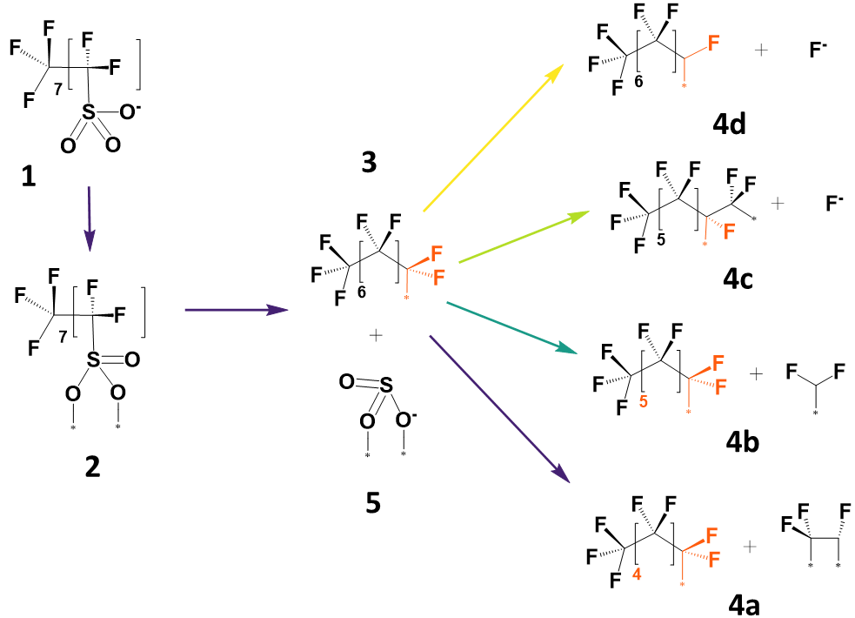
Fig. S12. Defluorination and chain-shortening Pathways of perfluorooctyl $(C_{8}F_{17}^{*})$ fragment on Pd (111) surface at pH 3 and potential -0.5 V vs. RHE. The asterisks indicate the surface (Pd or TiO₂) to which the adsorbate atom is bonded.

Fig. S13. Time-dependent concentration profiles of PFOS and its detected transformation products (TPs) were monitored during the PER degradation process. TP1 concentrations were measured using HPLC/QToF-MS and estimated assuming the same mass spectrometric response factor as PFOS. TP2 (PFOA) was quantified by UPLC-MS/MS.

Fig. S14. (a) Decay of PFOS at different NOM concentrations (mg/L as TOC). (c) Photos NOM (100 mg/L as TOC) spiked electrolyte, containing 10 µM PFOS in 100 mM Na₂SO₄, before and after PER treatment, compared with photolysis treatment. For PER tests, a 15 mA/cm² current density was applied to a 16 cm² Pd-TiO₂ plate-type cathode. The PER treatment was conducted in a dual-chamber reactor at a current of 0.24 A. Direct photolysis treatment was performed by irradiating the catholyte with a 16-W UV lamp for eight hours in the absence of the cathode and without applying any current. Data are presented as the mean values of triplicate tests ± standard deviation.

Fig. S15. Decay of PFOS at different NO₃⁻ concentrations. Reaction conditions: PFOS (10 µM) was spiked into 100 mL of 100 mM Na₂SO₄ catholyte. A current density of 15 mA/cm² was applied to a 16 cm² Pd-TiO₂ cathode in a dual-chamber reactor. An Ir_{0.3}Ta_{0.7}O_{x} anode (16 cm²) served as the counter electrode, with 100 mL of 100 mM H₂SO₄ used as the anolyte. All data are presented as the mean values of triplicate tests ± standard deviation.

Fig. S16. (a) Decay of PFOS concentrations under different Ca²⁺ concentrations. (b) Changes in anionic concentration over time. Reaction conditions: PFOS (10 µM) was spiked into 100 mL of 100 mM Na₂SO₄ catholyte. A current density of 15 mA/cm² was applied to a 16 cm² Pd-TiO₂ cathode in a dual-chamber reactor. An Ir_{0.3}Ta_{0.7}O_{x} anode (16 cm²) served as the counter electrode, with 100 mL of 100 mM H₂SO₄ used as the anolyte. All data are presented as the mean values of triplicate tests ± standard deviation.

Fig. S17. Stability test of PFOS removal by Pd-TiO₂ over five consecutive PER batches (8 h per batch). Reaction conditions: PFOS (10 µM) was spiked into 100 mL of 100 mM Na₂SO₄ catholyte. A current density of 15 mA/cm² was applied to a 16 cm² Pd-TiO₂ cathode in a dual-chamber reactor. An Ir_{0.3}Ta_{0.7}O_{x} anode (16 cm²) served as the counter electrode, with 100 mL of 100 mM H₂SO₄ used as the anolyte. All data are presented as the mean values of triplicate tests ± standard deviation.

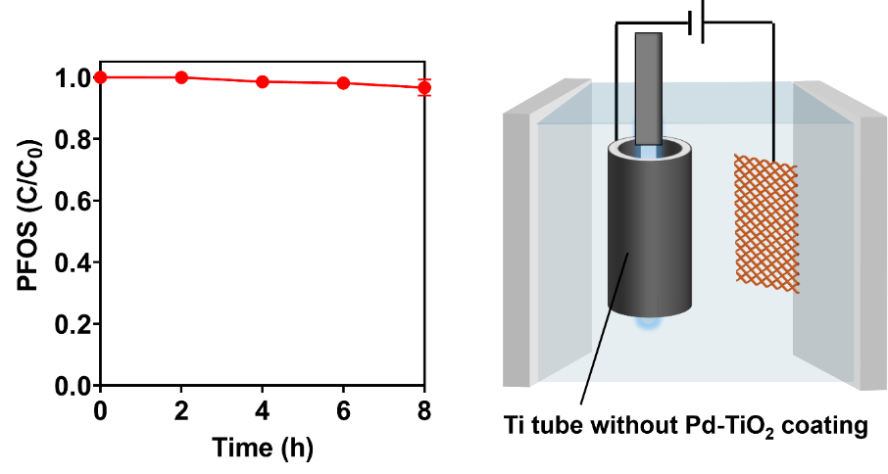
Fig. S18. Treatment of PFOS using a bare Ti tube cathode in the PER mode. Reaction conditions: 10 µM PFOS were spiked in 100 mL Na₂SO₄ (100 mM) electrolyte. A 15 mA/cm² current density was applied to a 48 cm² bare Ti tube paired with an Ir_{0.3}Ta_{0.7}O_{x} anode (16 cm²). The PER treatment was conducted in a single-chamber cell with a current of 0.72 A, and an average cell voltage of 6.5 V. Data are presented as the mean values of triplicates ± standard deviation.

Fig. S19. Degradation and defluorination of PFOS in PER-EO tandem treatment process. Reaction conditions: 10 µM PFOS were spiked in 100 mL Na₂SO₄ (100 mM) electrolyte. For the PER tests, a 15 mA/cm² current density was applied to a 48 cm² Pd-TiO₂ tube electrode. The PER treatment using a tube cathode was conducted in a beaker at a current of 0.72 A and an average cell voltage of 6.5 V. For the EO post-treatment of the 100 mL PER treated electrolyte, a current density of 15 mA/cm² was applied to a 16 cm² plate type BDD anode (Element Six) paired with a stainless steel cathode. Data are presented as the mean values of triplicates ± standard deviation. DeF reached 38.5% after PER treatment and 99.6% after EO treatment.

Fig. S20. PFOS degradation as a function of specific charge (Ah/L) using tube and mesh Pd-TiO₂ electrodes. Reaction conditions: 10 µM PFOS were spiked in 100 mL Na₂SO₄ (100 mM) electrolyte for the tube electrode (48 cm²) and in 700 mL Na₂SO₄ (100 mM) electrolyte for the mesh electrode (256 cm²). The PER treatment using a tube cathode was conducted in a single-chamber reactor at a current of 0.72 A and an average cell voltage of 6.5 V. The PER treatment using a mesh cathode was conducted in a single-chamber reactor at a current of 1.5 A and an average cell voltage of 8.5 V. The specific charge was calculated based on the applied current, reaction time, and the volume of the electrolyte. Data are presented as the mean values of triplicate tests ± standard deviation.

Fig. S21. Variation of Q-ToF-MS peak areas of precursors as functions of reaction time in the PER-EO treatment process. The structures of precursors are shown on the side.

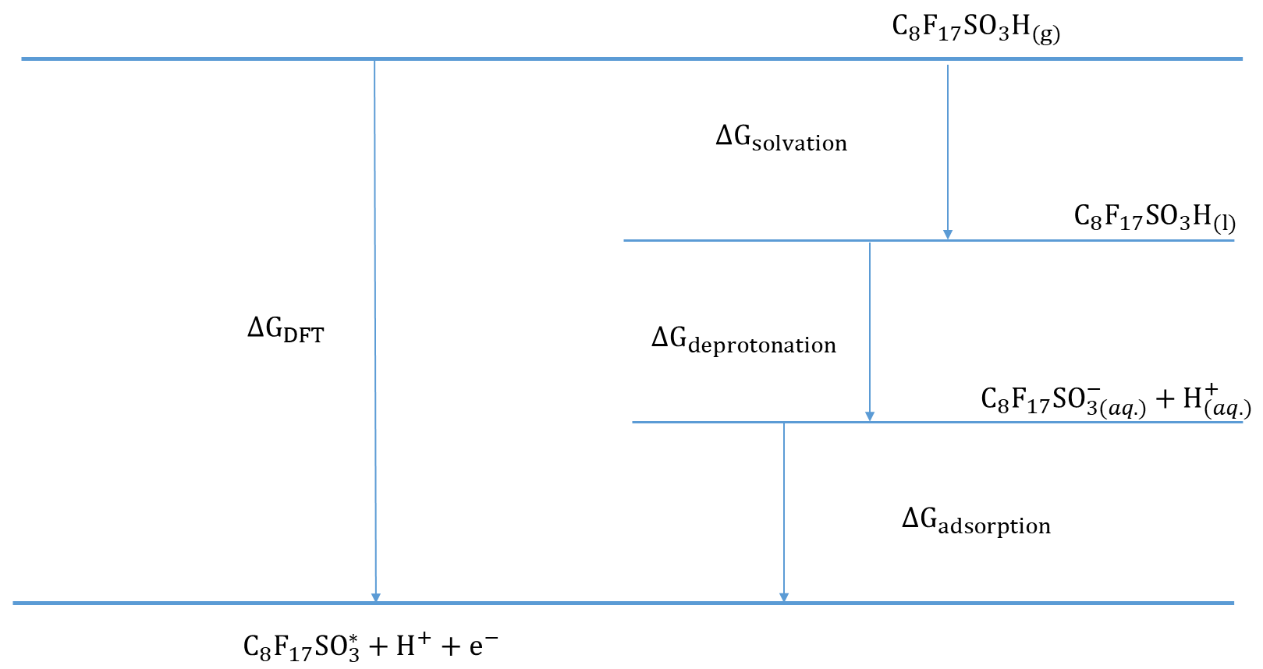

Fig. S22. Thermodynamic Hess cycle used to incorporate the free energy of deprotonation and solvation of C₈F₁₇SO₃ (PFOS), allowing calculation of adsorption free energy of PFOS on surfaces.

References
(1) Su, Y.; Rao, U.; Khor, C. M.; Jensen, M. G.; Teesch, L. M.; Wong, B. M.; Cwiertny, D. M.; Jassby, D. Potential-Driven Electron Transfer Lowers the Dissociation Energy of the C–F Bond and Facilitates Reductive Defluorination of Perfluorooctane Sulfonate (PFOS). ACS Appl. Mater. Interfaces 2019, 11 (37), 33913–33922. https://doi.org/10.1021/acsami.9b10449.
(2) Rao, U.; Su, Y.; Khor, C. M.; Jung, B.; Ma, S.; Cwiertny, D. M.; Wong, B. M.; Jassby, D. Structural Dependence of Reductive Defluorination of Linear PFAS Compounds in a UV/Electrochemical System. Environ. Sci. Technol. 2020, 54 (17), 10668–10677. https://doi.org/10.1021/acs.est.0c02773.
(3) Liu, G.; Feng, C.; Shao, P. Degradation of Perfluorooctanoic Acid with Hydrated Electron by a Heterogeneous Catalytic System. Environ. Sci. Technol. 2022, 56 (10), 6223–6231. https://doi.org/10.1021/acs.est.1c06793.
(4) Calvillo Solís, J. J.; Sandoval-Pauker, C.; Bai, D.; Yin, S.; Senftle, T. P.; Villagrán, D. Electrochemical Reduction of Perfluorooctanoic Acid (PFOA): An Experimental and Theoretical Approach. J. Am. Chem. Soc. 2024, 146 (15), 10687–10698. https://doi.org/10.1021/jacs.4c00443.
(5) Grunfeld, D. A.; M. Jones, A.; Sun, J.; Thao Le, S.; Pickford, R.; Huang, Q.; Manefield, M.; Kumar, N.; J. Lee, M.; M. O’Carroll, D. Electrochemical Degradation of a C6-Perfluoroalkyl Substance (PFAS) Using a Simple Activated Carbon Cathode. Environ. Sci. Water Res. Technol. 2024, 10 (1), 272–287. https://doi.org/10.1039/D3EW00543G.
(6) Wang, Y.; Xiao, Y.; Wang, Y.; Lin, Q.; Zhu, Y.; Ni, Z.; Qiu, R. Electroreductive Defluorination of Unsaturated PFAS by a Quaternary Ammonium Surfactant-Modified Cathode via Direct Cathodic Reduction. Environ. Sci. Technol. 2023, 57 (19), 7578–7589. https://doi.org/10.1021/acs.est.2c08182.
(7) Zhu, J.; Chen, Y.; Gu, Y.; Ma, H.; Hu, M.; Gao, X.; Liu, T. Feasibility Study on the Electrochemical Reductive Decomposition of PFOA by a Rh/Ni Cathode. J. Hazard. Mater. 2022, 422, 126953. https://doi.org/10.1016/j.jhazmat.2021.126953.
(8) Liu, Z.; Chen, Z.; Gao, J.; Yu, Y.; Men, Y.; Gu, C.; Liu, J. Accelerated Degradation of Perfluorosulfonates and Perfluorocarboxylates by UV/Sulfite + Iodide: Reaction Mechanisms and System Efficiencies. Environ. Sci. Technol. 2022, 56 (6), 3699–3709. https://doi.org/10.1021/acs.est.1c07608.
(9) Guan, Y.; Liu, Z.; Yang, N.; Yang, S.; Quispe-Cardenas, L. E.; Liu, J.; Yang, Y. Near-Complete Destruction of PFAS in Aqueous Film-Forming Foam by Integrated Photo-Electrochemical Processes. Nat. Water 2024, 2 (5), 443–452. https://doi.org/10.1038/s44221-024-00232-7.
(10) Xu, Y.; Schoonen, M. A. A. The Absolute Energy Positions of Conduction and Valence Bands of Selected Semiconducting Minerals. Am. Mineral. 2000, 85 (3–4), 543–556. https://doi.org/10.2138/am-2000-0416.
(11) Neamen, D. A.; Biswas, D. Semiconductor Physics and Devices, 2nd ed.; The McGraw-Hill Companies, Inc., 1997.
(12) Michaelson, H. B. The Work Function of the Elements and Its Periodicity. J. Appl. Phys. 1977, 48 (11), 4729–4733. https://doi.org/10.1063/1.323539.
(13) Zhang, Z.; Yates, J. T. Band Bending in Semiconductors: Chemical and Physical Consequences at Surfaces and Interfaces. Chem. Rev. 2012, 112 (10), 5520–5551. https://doi.org/10.1021/cr3000626.
(14) Lyu, P.; Espinoza, R.; Khan, M. I.; Spaller, W. C.; Ghosh, S.; Nguyen, S. C. Mechanistic Insight into Deep Holes from Interband Transitions in Palladium Nanoparticle Photocatalysts. iScience 2022, 25 (2). https://doi.org/10.1016/j.isci.2022.103737.
(15) King, J. F.; Chaplin, B. P. Electrochemical Reduction of Per- and Polyfluorinated Alkyl Substances (PFAS): Is It Possible? Applying Experimental and Quantum Mechanical Insights from the Reductive Defluorination Literature. Curr. Opin. Chem. Eng. 2024, 44, 101014. https://doi.org/10.1016/j.coche.2024.101014.
(16) Hartland, G. V. Optical Studies of Dynamics in Noble Metal Nanostructures. Chem. Rev. 2011, 111 (6), 3858–3887. https://doi.org/10.1021/cr1002547.
(17) Baldini, E.; Palmieri, T.; Pomarico, E.; Auböck, G.; Chergui, M. Clocking the Ultrafast Electron Cooling in Anatase Titanium Dioxide Nanoparticles. ACS Photonics 2018, 5 (4), 1241–1249. https://doi.org/10.1021/acsphotonics.7b00945.
(18) Zhu, D.; Zhang, L.; Ruther, R. E.; Hamers, R. J. Photo-Illuminated Diamond as a Solid-State Source of Solvated Electrons in Water for Nitrogen Reduction. Nat. Mater. 2013, 12 (9), 836–841. https://doi.org/10.1038/nmat3696.

