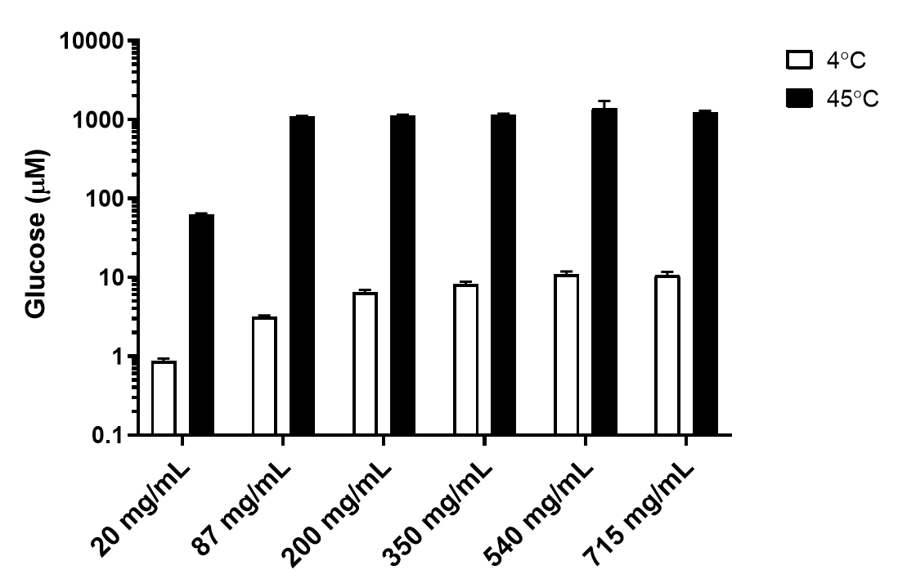
Figure S1 Sucrose samples were made up in water at various concentrations from 20 to 715 mg/ml and stored at both 4 °C and 45 °C for 7 days. Glucose concentrations were then measured using the bioluminescence assay. Error bars show the standard deviations from two measurements.

Supplementary Table S1. The concentration of glucose in vaccines and its fold-change increase after 7-days exposure to elevated temperatures. These four vaccines showed a statistically significant increase in glucose at the elevated temperatures (Ordinary one-way ANOVA with Dunnett’s multiple comparisons tests p<0.05).
Vaccine | Glucose concentration* (μM) |  |  | Fold-change
Vaccine | 2-8 °C | 37 °C | 45 °C | 37 vs 2-8 °C | 45 vs 2-8 °C
Bexsero | 5.63 | 25.49 | 51.59 | 4.5 | 9.2
COMIRNATY | 2.34 | 22.13 | 64.08 | 9.6 | 27.6
COVISHIELD | 26.21 | 73.46 | 164.85 | 2.8 | 6.3
Nimenrix | 0.43 | 0.47 | 0.51 | 1.1 | 1.2
*Mean concentration of N=2
Supplementary Table S2. Concentrations of seven analytes measured in vaccine samples using a biochemical analyser after exposure to different altered temperature conditions. Values in bold indicate if the analytes could be detected and quantified showing their mean concentrations (± standard deviation) of eight measurements. All other values with the less than symbol (<) were below the limit of quantitation and the lower limit of quantitation is shown.
Condition | Calcium (mM) | Chloride (mM) | Magnesium (mM) | Phosphate (mM) | Potassium (mM) | Protein (mg/L) | Sodium (mM)
Bexsero*
4 °C | < 0.50 | 110.92 ± 1.09 | < 0.74 | < 1.50 | 2.52 ± 0.04 | < 68 | 107.30 ± 1.25
3× FT | < 0.50 | 110.10 ± 0.81 | < 0.74 | < 1.50 | 2.52 ± 0.04 | < 68 | 106.93 ± 0.73
RT | < 0.50 | 110.17 ± 0.82 | < 0.74 | < 1.50 | 2.52 ± 0.04 | < 68 | 106.73 ± 0.92
37 °C | < 0.50 | 110.70 ± 0.95 | < 0.74 | < 1.50 | 2.52 ± 0.04 | < 68 | 107.18 ± 0.94
45 °C | < 0.50 | 110.95 ± 1.01 | < 0.74 | < 1.50 | 2.57 ± 0.07 | < 68 | 107.68 ± 1.21
COMIRNATY
4 °C | < 0.50 | < 20.0 | < 0.74 | < 1.50 | < 1.0 | 184.88 ± 13.41 | < 20.0
3× FT | < 0.50 | < 20.0 | < 0.74 | < 1.50 | < 1.0 | 170.63 ± 7.19 | < 20.0
RT | < 0.50 | < 20.0 | < 0.74 | < 1.50 | < 1.0 | 186.63 ± 5.24 | < 20.0
37 °C | < 0.50 | < 20.0 | < 0.74 | < 1.50 | < 1.0 | 190.88 ± 9.91 | < 20.0
45 °C | < 0.50 | < 20.0 | < 0.74 | < 1.50 | < 1.0 | 194.50 ± 10.24 | < 20.0
COVISHIELD
4 °C | < 0.50 | 39.26 ± 0.26 | 1.04 ± 0.02 | < 1.50 | < 1.0 | < 68 | 34.84 ± 0.67
3× FT | < 0.50 | 39.25 ± 0.29 | 1.04 ± 0.04 | < 1.50 | < 1.0 | < 68 | 34.89 ± 1.12
RT | < 0.50 | 39.28 ± 0.24 | 1.03 ± 0.03 | < 1.50 | < 1.0 | < 68 | 35.31 ± 1.39
37 °C | < 0.50 | 39.44 ± 0.27 | 1.04 ± 0.01 | < 1.50 | < 1.0 | < 68 | 35.21 ± 1.21
45 °C | < 0.50 | 39.33 ± 0.26 | 1.03 ± 0.03 | < 1.50 | < 1.0 | < 68 | 35.18 ± 0.65
*Calculation based on six measurements due to the limited sample; 3× FT, three cycles of freeze-thaw; RT, room temperature (20 ± 1 °C).

