Supporting information for
Synthesis, spectral characterization, DFT, antimicrobial, cell cycle and molecular docking studies on benzothiazole derivatives and its nano-sized platinum (IV) mixed ligand complex

Sharah A. Aldulmaniª, Afaf Y. Khormiª, Abdel-Nasser M. A. Alaghaz^{b*}, and Mohamed R. Shaaban^{c,d}
ªDepartment of Chemistry, College of Science, King Khalid University, Abha, Saudi Arabia
^{b}Department of Physical Sciences, Chemistry Division, College of Science, Jazan University, P.O. Box. 114, Jazan 45142, Saudi Arabia
^{c}Department of Chemistry, Faculty of Applied Science, Umm Al-Qura University, Almukaramah, Makkah, Saudi Arabia
^{d}Department of Chemistry, Faculty of Science, Cairo University, Giza 12613, Egypt

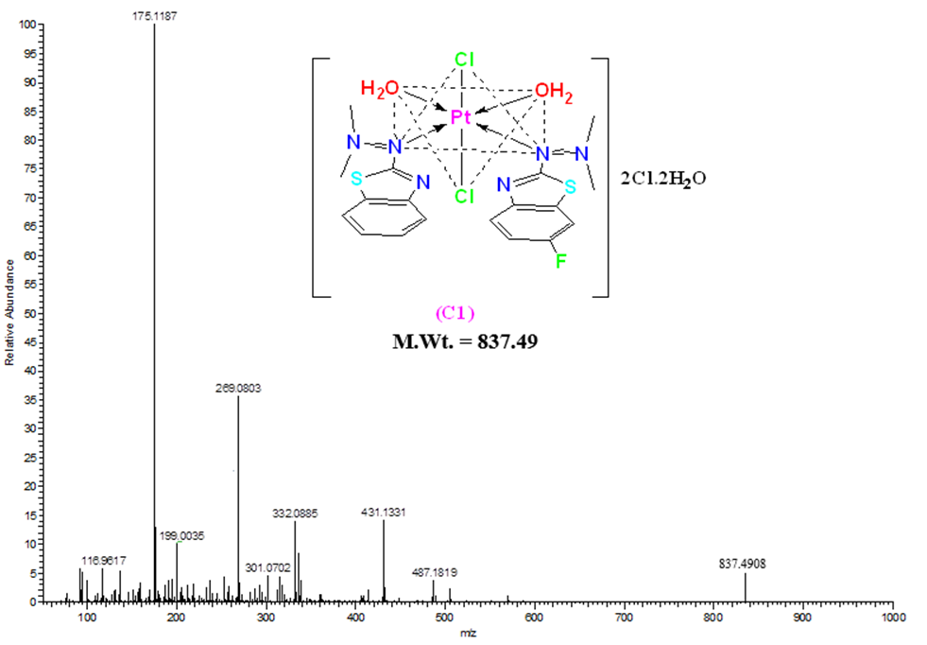
Figure S1. Mass spectrum of the platinum (IV) complex C.

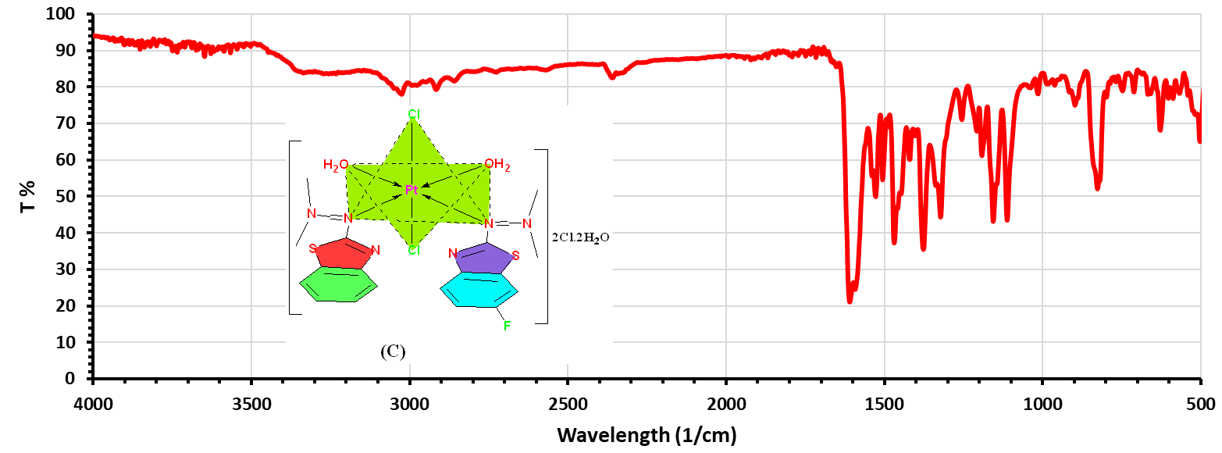
Figure S2. FTIR spectrum of the platinum (IV) complex C.

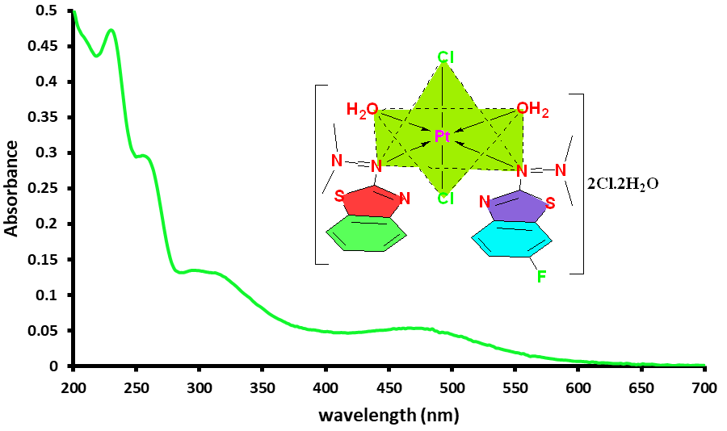
Figure S3. UV-Vis absorption spectrum of C complex in DMSO (5×10⁻⁵ M).

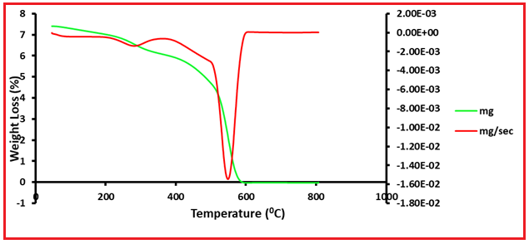
Figure S4. TGA curves of the platinum (IV) complex C.

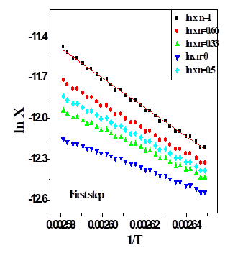 | 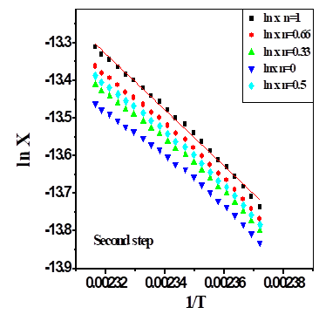
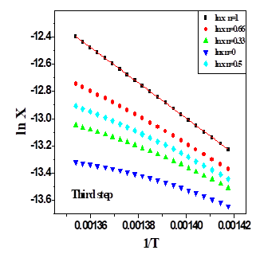

Figure S5. Coats–Redfern (CR) of the Pt(IV) complex.

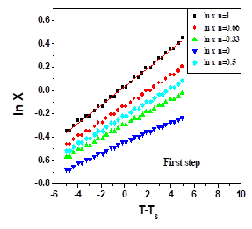 | 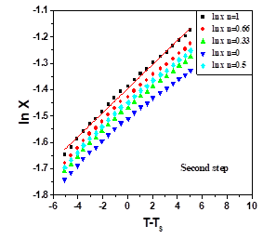
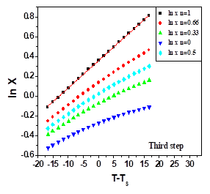
Figure S6. Horowitz-Metzger (HM) of the Pt(IV) complex.

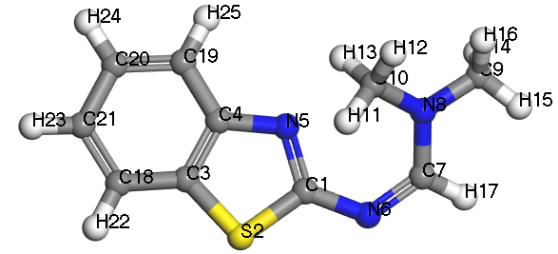 | 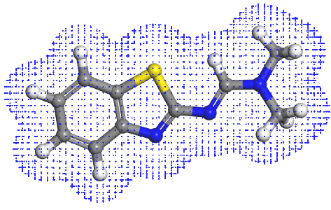
Molecular structure of L1 | Electron density
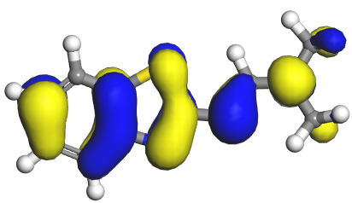 | 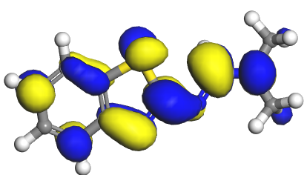
HOMO | LUMO
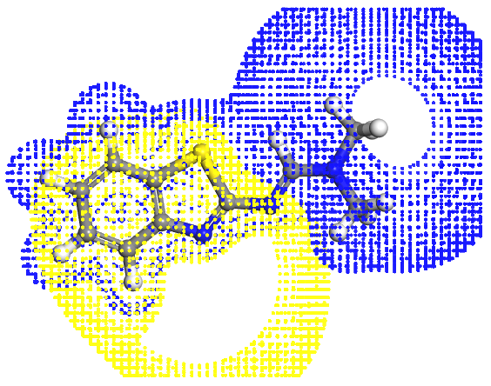
Electrostatic potential

Figure S7. The LUMO, HOMO, electron density, electrostatic potential, and molecular structure of the ligand (L1).

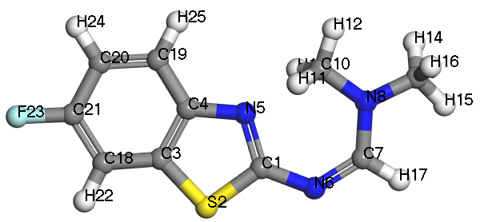 | 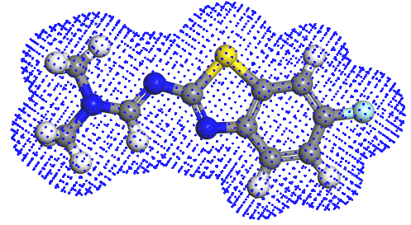
Molecular structure of L2 | Electron density
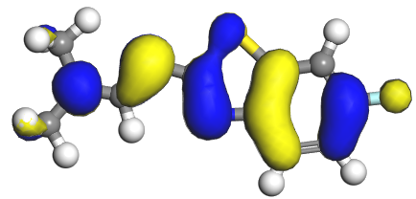 | 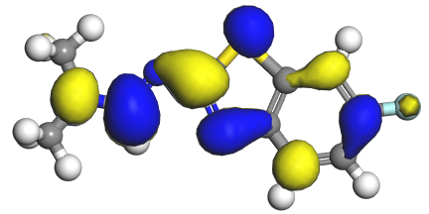
HOMO | LUMO
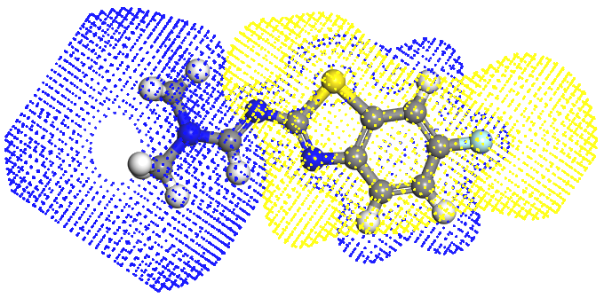

Electrostatic potential

Figure S8. The LUMO, HOMO, electron density, electrostatic potential, and molecular structure of the ligand (L2).

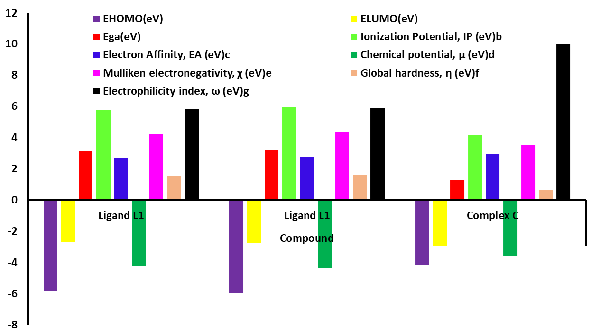

Figure S9. Calculated energy of HOMO, LUMO, ionization potentials and energy gaps (ΔE) of the ligands (L¹ and L²) and nano-sized Pt(IV) complex (C).

Figure S10. Powder XRD patterns of the Pt(IV) complex.

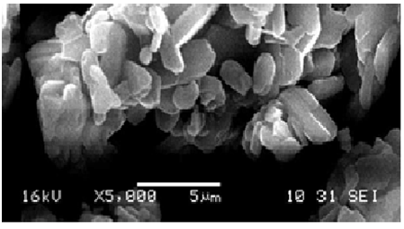
Figure S11. SEM image of the mixed ligand Pt(IV) complex C.

Table S1 Thermogravimetric data (TGA) of the platinum (IV) complex (C)
Compound | step | Temperature range (ºC) | decomposed | Weight loss; Calcd (Found %)
C-[Pt(L₁L₂)(H₂O)₂Cl₂]Cl₂.2H₂O | ¹st | 26‒223 | 2H₂O | 4.30(4.29)
 | ²nd | 223‒318 | 2H₂O + 2Cl₂ | 21.23(21.22)
 | ³rd | 318‐512 | C₁₆H₂₁N₆FS₂ | 45.43(45.42)
 | Residue | 512‒798 | Pt+4C | 29.03(29.00)

Table S2
C complex' Kinetic parameters derived from Coats–Redfern (CR) and Horowitz-Metzger (HM) methods.
∆G*  KJ\mol | ∆S*  KJ\mol.K | ∆H*  KJ\mol | A  (S⁻¹) | Ea  KJ\mol | Mid  Temp(K) | Peak | Method
98.47 | ‒0.1752 | 48.02 | 2.14x10³ | 35.47 | 206 | 1st | CR
192.12 | ‒0.1865 | 58.89 | 2.21x10³ | 65.82 | 273 | 2nd | CR
231.89 | ‒0.1222 | 134.63 | 2.39x10⁷ | 139.99 | 487 | 3rd | CR
261.65 | ‒0.0787 | 182.01 | 7.14x10⁸ | 191.79 | 683 | 4th | CR
98.48 | ‒0.1763 | 48.77 | 2.40x10³ | 35.12 | 206 | 1st | HM
192.47 | ‒0.1877 | 59.14 | 2.28x10³ | 65.71 | 273 | 2nd | HM
232.04 | ‒0.1243 | 135.07 | 2.10x10⁷ | 138.39 | 487 | 3rd | HM
260.76 | ‒0.0796 | 181.75 | 6.93 x10⁸ | 192.07 | 206 | 4th | HM

Table S3. Thermogravimetric data (TGA) of the platinum (IV) complex C
Complex | step | Temperature range (ºC) | decomposed | Weight loss; Calcd (Found %)
[Pt(L₁L₂)(H₂O)₂Cl₂]Cl₂.2H₂O | ¹st | 26‒223 | 2H₂O | 4.30 (4.29)
 | ²nd | 223‒318 | 2H₂O + 2Cl₂ | 21.23 (21.22)
 | ³rd | 318‐512 | C₁₆H₂₁N₆FS₂ | 45.43 (45.42)
 | Residue | 512‒798 | Pt+4C | 29.03 (29.00)

Table S4. Kinetic parameters of the platinum (IV) complex C.
Complex | Step | Mid temp (K) | order (n) | R² | Ea | A | ∆H* | ∆S* | ∆G*
 |  |  |  |  | KJ/mol | (S⁻¹) | KJ/mol | J/Kmol | KJ/mol
[Pt(L¹)(L²)(H₂O)₂(Cl)₂].2Cl.2H₂O | 1st | 352.14 | 0.00 | 0.9940063 | 69.32 | 6.3510¹¹ | 71.26 | -111.25 | 95.33
[Pt(L¹)(L²)(H₂O)₂(Cl)₂].2Cl.2H₂O | 2nd | 456.43 | 1.50 | 0.9899747 | 77.53 | 5.20×10¹³ | 78.25 | -105.98 | 102.45
[Pt(L¹)(L²)(H₂O)₂(Cl)₂].2Cl.2H₂O | 3rd | 582.92 | 1.00 | 0.9999867 | 89.67 | 8.88×10¹¹ | 82.74 | -96.58 | 187.10

Table S5. Selected bond length (Å) of L¹.
Bond | Length(Å) | Bond | Length(Å) | Bond | Length(Å)
N(8)-C(10) | 1.376 | N(8)-C(9) | 1.363 | N(8)-C(7) | 1.223
N(6)-C(7) | 1.493 | N(6)-C(1) | 1.507 | N(5)-C(1) | 1.335
N(5)-C(4) | 1.338 | S(2)-C(1) | 1.681 | S(2)-C(3) | 1.673
C(3)-C(4) | 1.406 | C(18)-C(21) | 1.407 | C(19)-C(20) | 1.412

Table S6. Selected bond angle (°) of L¹
Angle | Degree (°) | Angle | Degree (°) | Angle | Degree (°)
C(9)-N(8)-C(10) | 119.356 | N(8)-C(7)-N(6) | 114.666 | C(10)-N(8)-C(7) | 119.786
N(8)-C(1)-N(5) | 174.712 | C(1)-N(5)-C(4) | 127.108 | N(5)-C(4)-C(19) | 118.146
C1(16)-S(2)-C(3) | 118.352 | N(6)-C(1)-S(2) | 136.456 | S(2)-C(3)-C(18) | 169.574

Table S7. Selected bond length (Å) of L².
Bond | Length(Å) | Bond | Length(Å) | Bond | Length(Å)
N(8)-C(10) | 1.372 | N(8)-C(9) | 1.369 | N(8)-C(7) | 1.222
N(6)-C(7) | 1.496 | N(6)-C(1) | 1.512 | N(5)-C(1) | 1.338
N(5)-C(4) | 1.333 | S(2)-C(1) | 1.684 | S(2)-C(3) | 1.679
C(21)-F(23) | 1.603 | C(18)-C(21) | 1.407 | C(19)-C(20) | 1.413

Table S8. Selected bond angle (°) of L²
Angle | Degree (°) | Angle | Degree (°) | Angle | Degree (°)
C(9)-N(8)-C(10) | 119.343 | N(8)-C(7)-N(6) | 114.666 | C(10)-N(8)-C(7) | 119.786
N(8)-C(1)-N(5) | 174.712 | C(1)-N(5)-C(4) | 127.108 | N(5)-C(4)-C(19) | 118.146
C1(16)-S(2)-C(3) | 118.352 | N(6)-C(1)-S(2) | 136.456 | S(2)-C(3)-C(18) | 169.574
F(23)-C(21)-C(18) | 123.639

Table S9. Selected bond length (Å) of complex (C).
Bond | Length(Å) | Bond | Length(Å) | Bond | Length(Å)
Pt(25)-O(29) | 1.911 | Pt(25)-O(28) | 1.924 | Pt(25)-Cl(27) | 2.247
Pt(25)-Cl(26) | 2.245 | Pt(25)-C(20) | 1.383 | Pt(25)-Cl(10) | 1.348
N(22)-C(23) | 1.372 | N(8)-C(24) | 1.369 | N(8)-C(21) | 1.221
N(12)-C(13) | 1.370 | N(8)-C(14) | 1.367 | N(8)-C(11) | 1.223
N(16)-C(15) | 1.496 | N(16)-C(17) | 1.512 | N(16)-C(15) | 1.332
N(10)-C(11) | 1.493 | N(10)-C(1) | 1.512 | N(5)-C(1) | 1.338
N(5)-C(4) | 1.332 | S(19)-C(15) | 1.683 | S(19)-C(18) | 1.677
S(2)-C(1) | 1.686 | S(2)-C(3) | 1.678 | C(7)-F(47) | 1.608

Table S10. Selected bond angle (°) of complex (C).
Angle | Degree (°) | Angle | Degree (°) | Angle | Degree (°)
O(28)-Pt(25)-O(29) | 126.584 | O(29)-Pt(25)-Cl(27) | 74.306 | O(28)-Pt(25)-Cl(27) | 97.246
O(29)-Pt(25)-Cl(26) | 168.582 | O(28)-Pt(25)-Cl(26) | 96.804 | Cl(26)-Pt(25)-Cl(27) | 174.993
Cl(27)-Pt(25)-N(10) | 158.056 | Cl(27)- Pt(25)-N(20) | 89.053 | Cl(26)- Pt(25)-N(10) | 154.828
Cl(26)- Pt(25)-N(20) | 89.108 | O(37)-Cu(41)-S(19) | 96.421 | O(37)-Cu(41)-N(4) | 166.634
O(28)-Pt(25)-N(10) | 125.364 | O(28)-Pt(25)-N(20) | 124.994 | C(10)-Pt(25)-N(20) | 111.580
C(11)-N(10)-Pt(25) | 130.421 | C(21)-N(20)-Pt(25) | 114.526 | C(23)-N(22)-C(24) | 123.042
C(14)-N(12)-C(13) | 118.479 | C(15)-N(16)-C(17) | 119.342 | N(22)-C(21)-N(20) | 114.675
N(12)-C(11)-N(10) | 114.672 | C(15)-S(19)-C(18) | 117.473 | C(1)-S(2)-C(3) | 118.655

Table S11. The Mulliken charge distribution for L¹ ligand

Atom | Charge | Atom | Charge | Atom | Charge
C(1) | 0.165 | S(2) | -0.369 | C(3) | -0.049
C(4) | -0.068 | N(5) | -0.407 | N(6) | 0.224
C(7) | -0.138 | N(8) | -0.135 | C(9) | -0.205
C(10) | -0.212 | H(11) | -0.102 | H(12) | -0.107
H(13) | 0.126 | H(14) | 0.339 | H(15) | 0.229
H(16) | 0.092 | H(17) | 0.112 | C(18) | 0.124
C(19) | 0.108 | C(20) | 0.106 | C(21) | 0.129
C(22) | 0.149 | H(23) | 0.097 | H(24) | 0.067
H(25) | 0.086

Table S12. The Mulliken charge distribution for L² ligand
Atom | Charge | Atom | Charge | Atom | Charge
C(1) | 0.162 | S(2) | -0.368 | C(3) | -0.052
C(4) | -0.067 | N(5) | -0.408 | N(6) | 0.226
C(7) | -0.133 | N(8) | -0.133 | C(9) | -0.208
C(10) | -0.217 | H(11) | -0.104 | H(12) | -0.101
H(13) | 0.124 | H(14) | 0.342 | H(15) | 0.234
H(16) | 0.096 | H(17) | 0.116 | C(18) | 0.124
C(19) | 0.1084 | C(20) | 0.111 | C(21) | 0.131
C(22) | 0.147 | F(23) | -0.492 | H(24) | 0.072
H(25) | 0.082

Table S13. The Mulliken charge distribution for Pt(IV) complex

Atom | Charge | Atom | Charge | Atom | Charge
C(1) | 0.324 | S(2) | -0.293 | C(3) | 0.029
C(4) | -0.125 | N(5) | -0.292 | C(6) | -0.265
C(7) | -0.002 | C(8) | -0.309 | C(9) | -0.183
N(10) | -0.295 | C(11) | 0.334 | N(12) | -0.163
C(13) | -0.133 | C(14) | -0.120 | C(15) | -0.295
N(16) | -0.298 | C(17) | -0.328 | C(18) | 0.319
S(19) | -0.276 | N(20) | 0.228 | C(21) | -0.138
N(22) | -0.297 | C(23) | -0.288 | N(24) | -0.338
Pt(25) | 0.784 | Cl(26) | -0.127 | Cl(27) | -0.131
O(28) | 0.227 | O(29) | -0.233 | H(30) | -0.095
H(31) | -0.137 | H(32) | -0.075 | H(33) | -0.292
H(34) | 0.134 | H(35) | 0.136 | H(36) | -0.643
H(37) | 0.640 | H(38) | 0.134 | H(39) | 0.095
H(40) | 0.096 | H(41) | 0.136 | H(42) | 0.183
H(43) | -0.136 | H(44) | -0.074 | H(45) | -0.293
H(46) | 0.134 | F(47) | -0.596 | H(48) | -0.643
H(49) | 0.642 | C(50) | -0.132 | C(51) | -0.125
C(52) | -0.326 | C(53) | 0.026 | H(54) | 0.183
H(55) | -0.298 | H(56) | -0.076 | H(57) | -0.073

