Supplementary Information

Supplementary Figure 1: Sources used to search for discrimination estimates
Supplementary Figure 2: Funnel plot to test small-study bias using unadjusted correlations.
Supplementary Figure 3: Funnel plot to test small-study bias for each era.
Supplementary Figure 4: Funnel plot to test small-study bias using Fisher’s Z.
Supplementary Figure 5: Distribution of effect sizes compared to normal and exponential curves using unadjusted correlation coefficient
Supplementary Note 1: Algorithm to recover r-values from known favorable treatment rates.
Supplementary Note 2: Algorithm to recover r-values from survey summary data
Supplementary Note 3: Assessing which estimates to use from papers
Supplementary Note 4: Definition of racism

Supplementary Figure 1: Sources used to search for discrimination estimates


Supplementary Figure 2: Funnel plot to test small-study bias using unadjusted correlations. This figure uses the unadjusted correlation coefficients with the random effects Hunter-Schmidt method of calculating variance
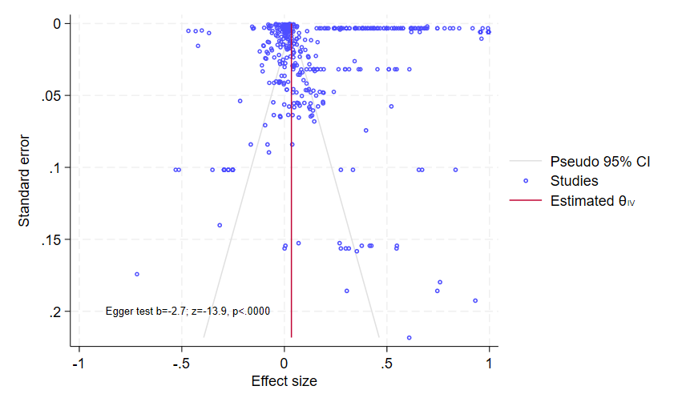

Supplementary Figure 3: Funnel plot to test small-study bias for each era. This figure uses the unadjusted correlation coefficients with the random effects Hunter-Schmidt method of calculating variance

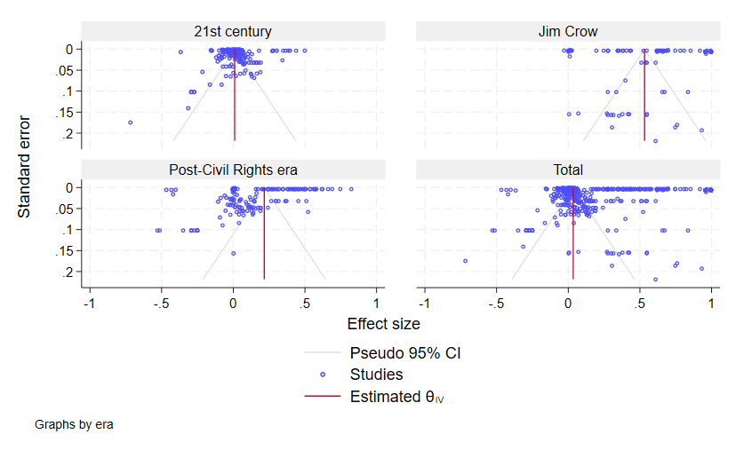

Supplementary Figure 4: Funnel plot to test small-study bias using Fisher’s Z. This figure uses Fisher’s Z with the random effects Hunter-Schmidt method of calculating variance

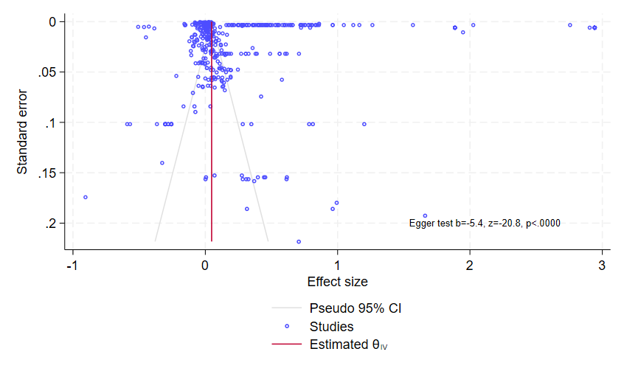

Supplementary Figure 5: Distribution of effect sizes compared to normal and exponential curves using unadjusted correlation coefficient. Skewness=0.8 and Kurtosis=3

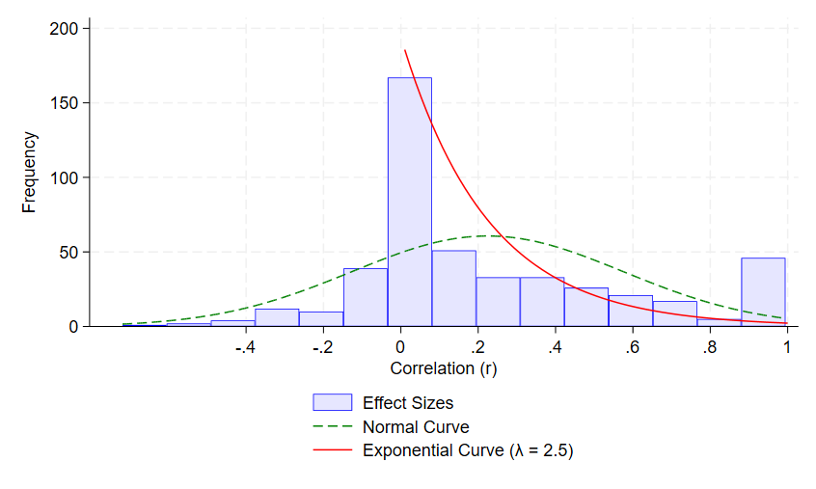
Supplementary Note 1: Algorithm to recover r-values from known favorable treatment rates.
For any given study, you need to know the sample size for each group $N_{b} or N_{w}$, where b stands for Black subjects and w for White subjects (or their population shares and the total) and the “risk rate” (p), which may be favorable or not, as in the hit rate from a police study, the call back rate from a hiring audit, or loan approval rate among qualified candidates. With those data, the mean difference, standard error, and r-value can be recovered using this algorithm in Stata V18.5.
local obs = $N_{w}+N_{b}$
local w_poprate = $N_{w}/`obs'$
local b_poprate = $N_{b}/`obs'$
local w_hitrate = $p_{w}$
local b_hitrate = $p_{b}$
local wn = round(`w_poprate'*`obs')
local bn = round(`b_poprate'*`obs')
local w_start =`bn'+1
local w = round(`w_hitrate'*`wn')
local b = round(`b_hitrate'*`bn')
set obs `obs'
gen hire = 0
replace hire = 1 in 1/`b'
gen black=0
local b_start=1
replace black=1 in `b_start'/`bn'
gen white=0
local w_start = `bn'+1
local w_end = `obs'
local w_hire_end=`w_start'+`w'-1
replace white=1 in `w_start'/`w_end'
replace hire = 1 in `w_start'/`w_hire_end'
cor hire black
reg hire black
Supplementary Note 2: Algorithm to recover r-values from survey summary data
To recover r-values from survey data, consider an example with a population of size “N.” The percentage of respondents who say they discriminate in a given domain is defined as “d.” This could be the percentage who say they would prefer White candidates over equally qualified Black candidates or who disapprove of interracial marriage between Black and White adults.
The insight is to think of the discrimination rate as measuring the percent of minority subjects who qualify for favorable treatment (e.g. consideration for hiring, marriage, admission, an elected office).
The relative population share is important to the calculation (w_pop_share). In general, the discrimination effect size (correlation) will increase as the population share decreases, for a given rate of discrimination. The reason is that samples dominated by a majority group reduce variation, since all majority group members qualify for the favorable treatment. For several measures, I set the population shares as 50-50, since the survey item asks about political candidacy or a job in a small number of occupations. For others, where the survey item refers to the entire population of adults, I use more realistic population shares, such as 80-20, since White adults were roughly 80 to 90% of the population around the middle of the 20th century, depending on when the item was fielded.
local obs [N]
local w_rate = [w_pop_share]
local b_rate = [b_pop_share]
local wn = round(`w_rate'*`obs')
local bn = round(`b_rate'*`obs')
local w_start =`bn'+1
*set discrimination rate
local p = [d]
local dis_rate=`p'/100
set obs `obs'
gen black=0
replace black=1 in 1/`bn'
gen white=0
replace white=1 in `w_start'/`obs'
*setting hiring/favorable treatment boundaries based on level of discrimination
local h_start=1
local h_end=round((1-`dis_rate')*`bn')
di `h_end'
*They accept all Whites and (1-d)% of Blacks
gen hire = 0
replace hire = 1 in 1/`h_end'
local w_hire_start = `bn'+1
replace hire=1 in `w_hire_start'/`obs'
cor hire black
reg hire black

Supplementary Note 3: Assessing which estimates to use from papers
For a meta-analysis to be reliable, it needs to be based on consistent methods and definitions. In reviewing the literature on discrimination, we came across various papers that assessed discrimination along unusual reporting margins that made comparisons difficult with benchmark estimates, such as hit rates and risk ratios from audits. This was usually not a problem, but in a handful of papers, we had to make judgment calls about which model to include. The goal was always to give preference to point estimates that relied on the most common methods in the literature or those that made clear advances by, for example, including variables that other papers did not have access to (e.g. credit scores, the quality of an applicant’s cover letter or essay). In some cases, we used unadjusted estimates or simple summary statistics over preferred estimates, as several papers attempted to make methodological contributions to the literature, but so much so that they created estimates that were conceptually distinct and difficult to compare to those in the literature.

For example, Arnold, Dobbie, and Yang (2017) report (in Table 1) that Black defendants released on bail are more likely to be re-arrested than White defendants released on bail, suggesting anti-White discrimination in bail release decisions (r = -.078), using the well-established success rate test. These data are structured like those found in the literature on success rate and hit rates and use the same basic method as those papers. Thus, we believe these data present the most relevant discrimination estimate for the purposes of our study.

Yet, this is not their preferred result. Instead, they use the bail release rates of the judge’s previous cases to estimate predicted bail release and argue that predicted bail release is higher for Black defendants, which only suggests that Black defendants were given judges with a more lenient record. Using predicted bail release instead of actual bail release, they find that marginally released Black defendants are less likely to be re-arrested than marginally released White defendants, the opposite of the observed result. While statistically significant, the estimated difference has a low t-stat (2.1) based on a large sample (287,003 defendants). Thus, the r-value is approximately 0.004, suggesting no racial discrimination, but since their p-value test is significant at 95% CI, they report the results of their analysis as evidence of anti-Black bias in the abstract.

Their first-stage model does not include defendant characteristics that an actual judge would use to determine bail and offense risk, which presumably affect judicial leniency. Moreover, the comparison with only model-determined marginal candidates raises external validity concerns there is no objective standard for “margin of release” and a defendant on the margin of release is not the same as the average set of all released defendants; the latter is the relevant group for determining the main effect of racial discrimination, consistent with guidelines for our meta-analysis.

Moreover, in addition to reporting a summary conclusion that contradicts the hit rate analysis, Arnold, Dobbie, and Yang’s (2017) preferred result is only robust (to the 95% CI threshold test) by counting Hispanic defendants as “White” (see Appendix Table 4). The t-stat falls to 1.5 when non-Hispanic White defendants are compared to Black defendants (r=0.004). Strikingly, using their preferred method, their supplementary analysis (Appendix Table 1) shows that non-Hispanic White defendants are discriminated against relative to Hispanic defendants, but they decided to exclude this from the main text and findings.

Supplementary Note 4: Definition of racism
As defined by Dictionary.com, racism is (Dictionary.com):
1) a belief or doctrine that inherent differences among the various human racial groups determine cultural or individual achievement, usually involving the idea that one's own race is superior and has the right to dominate others or that a particular racial group is inferior to the others.
2) Also called institutional, structural, systemic racism, a policy, system of government, etc., that is associated with or originated in such a doctrine, and that favors members of the dominant racial or ethnic group, or has a neutral effect on their life experiences, while discriminating against or harming members of other groups, ultimately serving to preserve the social status, economic advantage, or political power of the dominant group.
3) an individual action or behavior based upon or fostering such a doctrine; racial discrimination.
4) racial or ethnic prejudice or intolerance.

References
Arnold, D., Dobbie, W., & Yang, C. S. (2018). Racial bias in bail decisions. The Quarterly Journal of Economics, 133(4), 1885-1932.
Dictionary.Com, available https://www.dictionary.com/browse/racism (Accessed November 3, 2022)

