Supplementary Material

Impacts of larval environment on the adult dispersal syndrome

Delphine Legrand¹, Elise Mazé-Guilmo¹, Fabien Aubret^{1,2}, Michel Baguette^{1,3}, Julien Cote^{1,4}
¹ Centre National de la Recherche Scientifique (CNRS), Station d’Ecologie Théorique et Expérimentale (SETE), UAR2029, 2 route du CNRS, 09200, Moulis, France
² School of Agricultural, Environmental and Veterinary Sciences, Charles Sturt University, Port
Macquarie, NSW 2444, Australia
³ Institut Systématique, Évolution, Biodiversité (ISEB), UMR 7205, Museum National d’Histoire Naturelle (MNHN) – Centre National de la Recherche Scientifique (CNRS) – Sorbonne Université – École Pratique des Hautes Études (EPHE) – Université des Antilles, F-75005, Paris, France
⁴ Centre National de la Recherche Scientifique (CNRS), Institut de Recherche pour le Développement (IRD), Institut National Polytechnique de Toulouse (TINP), Université Toulouse 3 (UT3), Centre de Recherche sur la Biodiversité et l'Environnement (CRBE), UMR 5300, 31062, Toulouse Cedex 9, France

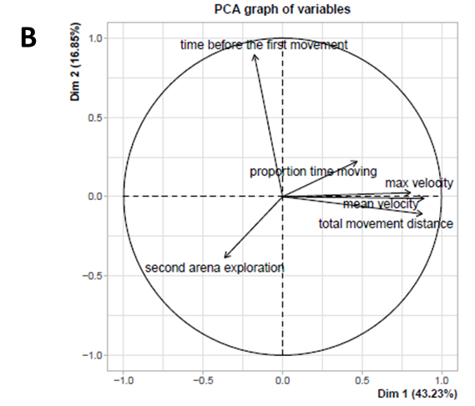
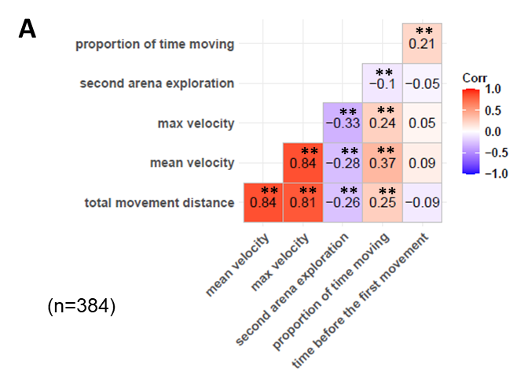

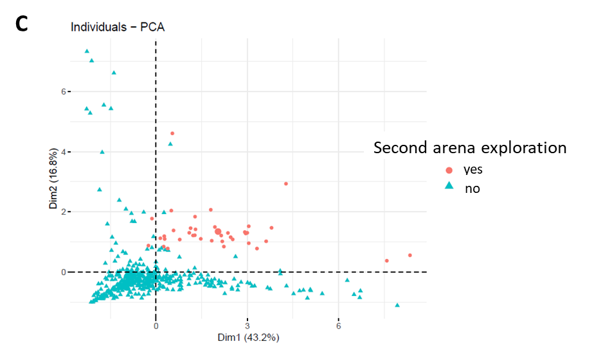

Figure S1: Relationships between the caterpillar variables obtained in the double arena test. A) Pearson correlation matrix, correlation coefficients are indicated in each case and significant values at a 0.05 threshold have a double asterisk. B) Contribution of each these caterpillar variables on the two first axes of a PCA (accounting for 60% of the total variance). C) Position of each individual as a function of these two first axes, with individuals having explored the second arena in red and the others in blue.

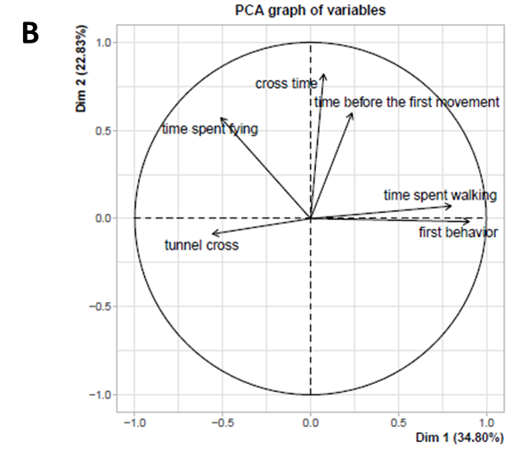
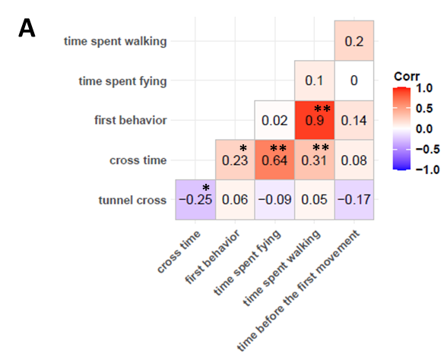

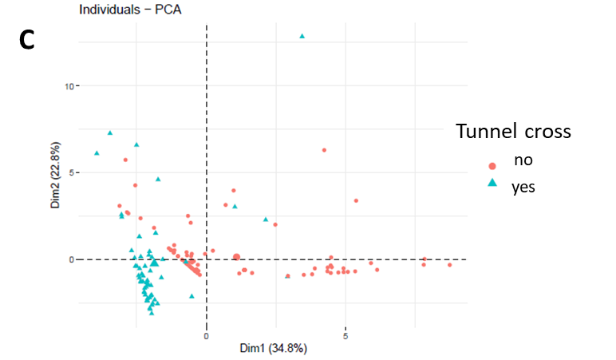

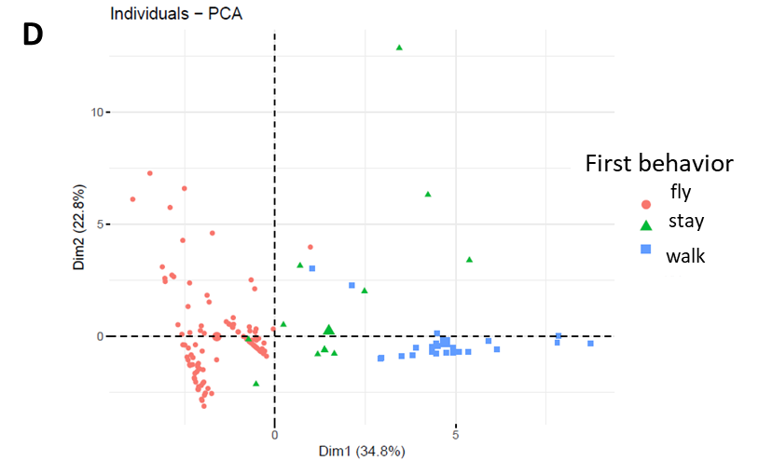

Figure S2: Relationships between the tunnel variables. A) Pearson correlation matrix, correlation coefficients are indicated in each case, significant values at a 0.05 and 0.1 threshold have a double and simple asterisk respectively. B) Contribution of each tunnel variable to the two first axes of a PCA (accounting for 58% of the total variance). C) Position of each individual as a function of these two first axes, with individuals having crossed the tunnel in blue and the others in red. D) Same plot as in C), but with colors representing individuals’ first behavior (fly in red, stay in green, walk in blue).

Table S1: Results of LMMs and GLMMs testing the existence of indirect carry-over effects mediated by larval traits on adults’ traits exhibiting significant carry-over effects.

