Graphical Abstract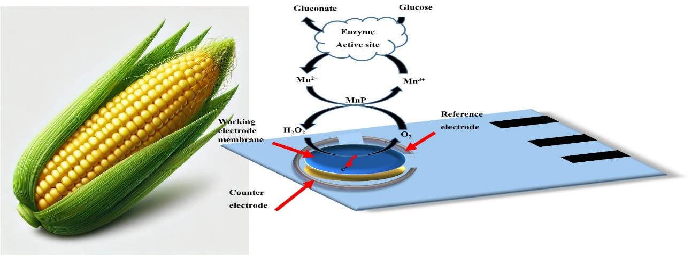
Schematic of recombinant enzyme integration from corn for glucose sensing on a screen-printed electrode (SPE). It shows extraction of PPMP enzyme from corn, immobilization on a gold SPE, and subsequent enzymatic glucose detection.

