Supplemental Materials
Passive Smoking Increases Exposure to Polycyclic Aromatic Hydrocarbons and Leads to Prolonged Lipid Oxidation: Lessons from a Natural Experiment in Travelers from Los Angeles to Beijing

Yan Lin,^{1#} Yifang Zhu,^{1#} Xinghua Qiu*,² Fen Yin,³ Chi-Hong Tseng,³ and Jesus A. Araujo*^{1,3}
- Department of Environmental Health Sciences, Jonathan and Karin Fielding School of Public Health, University of California, Los Angeles, Los Angeles, California 90095, United States
- State Key Joint Laboratory for Environmental Simulation and Pollution Control, College of Environmental Sciences and Engineering, and Center for Environment and Health, Peking University, Beijing 100871, P. R. China
- Division of Cardiology, Department of Medicine, School of Medicine, University of California, Los Angeles, Los Angeles, California 90095, United States

# Yan Lin and Yifang Zhu contribute equally to this paper.
* Co-corresponding authors:
Jesus A. Araujo, MD, PhD  Division of Cardiology, David Geffen School of Medicine at UCLA, 10833 Le Conte Avenue, CHS 43-264, P.O. Box 951679, Los Angeles, CA 90095.  Phone number (310) 825-3222  Fax number (310) 206-9133  E-mail address: JAraujo@mednet.ucla.edu | Xinghua Qiu, PhD  College of Environmental Sciences and Engineering, Peking University  Phone number 86-10-62751285  Fax number 86-10-62760755  E-mail address: xhqiu@pku.edu.cn

Table S1. Demographic characteristic of study participants
 | 2014 | 2015 | Total
Number of subjects | 14 | 13 | 27
Age (years) | 23.3±5.6ª | 27.8±13.6 | 25.4±10.3
BMI (kg/m²) | 21.7±2.8 | 21.3±2.1 | 21.5±2.4
Race (Asian/Others) | 8/6 | 12/1 | 20/7
Gender (males/females) | 9/5 | 3/10 | 12/15
^{a.} mean±SD

Table S2. Variables associated with log urinary cotinine in mixed-effect model with random intercept of participants
Variables | β(SE) | p-value
Beijing vs. LA-before | 0.99 (0.12) | <0.001
LA-after vs. LA-before | 0.14 (0.08) | 0.08
Year (2015 vs. 2014) | -0.27 (0.12) | 0.02
Year × City (Beijing in 2015=1) | 0.12 (0.11) | 0.30
Time in cooking (h) | 0.01 (0.02) | 0.73
Time in barbecuing (h) | -0.02 (0.08) | 0.84
Barbecue intake (kg) | -0.04 (0.09) | 0.69
Baked food intake (kg) | -0.04 (0.03) | 0.22
Driving time (h) | 0.07 (0.02) | <0.001
Time near heavy traffic (h) | -0.00 (0.02) | 0.88
Time in public transport (h) | -0.00 (0.02) | 1.00
Time near smokers (h) | 0.00 (0.02) | 0.92

Table S3. Self-reported physical activities in Los Angeles and Beijing
 | In 2014 |  |  |  | In 2015
 | In Los Angeles | In Beijing | p-valueª |  | In Los Angeles | In Beijing | p-value
 | (n=48) | (n=64) | p-valueª |  | (n=48) | (n=37) | p-value
Time in cooking (h) | 1.63±1.27^{b} | 0.08±0.42 | <0.01 |  | 1.70±1.96 | 0.40±0.82 | <0.01
Time in barbecuing (h) | 0.23±0.51 | 0.23±0.63 | 0.63 |  | 0.13±0.48 | 0.01±0.08 | 0.28
Barbecue intake (kg) | 0.23±0.46 | 0.18±0.51 | 0.32 |  | 0.15±0.44 | 0.17±0.84 | 0.35
Baked food intake (kg) | 0.62±0.73 | 0.92±1.15 | 0.4 |  | 0.45±0.97 | 0.70±1.43 | 0.65
Driving time (h) | 2.01±2.46 | 0.77±1.92 | <0.01 |  | 0.85±1.83 | 0.53±1.28 | 0.77
Time near heavy traffic (h) | 0.55±0.70 | 2.81±2.07 | <0.01 |  | 0.57±0.97 | 1.49±1.18 | <0.01
Time in public transport (h) | 0.38±1.04 | 3.38±2.09 | <0.01 |  | 0.86±1.51 | 2.08±1.83 | <0.01
Time near smokers (h) | 0.14±0.54 | 1.09±1.78 | <0.01 |  | 0.00±0.00 | 0.93±2.00 | <0.01
^{a.}Mann-Whitney test, two-tailed
^{b.}Mean ± standard deviation

Table S4. Comparison of urinary cotinine concentration among non-smoking population from different countries
Population Description | Location | Abbreviation | Sample size | Year | Urinary cotinine concentration (µg/g creatinine, geometric mean) | Reference
Visiting students | Los Angeles, United States | US | 98 | 2014-2015 | 0.18 | Current study
Children | Sweden | SE | 97 | 2011-2012 | 0.22 | (Den Hond et al. 2015)
Children | Germany | DE | 120 | 2011-2012 | 0.28 | (Den Hond et al. 2015)
Children | Luxembourg | LU | 59 | 2011-2012 | 0.39 | (Den Hond et al. 2015)
Children | Slovenia | SI | 120 | 2011-2012 | 0.44 | (Den Hond et al. 2015)
Children | Switzerland | SZ | 119 | 2011-2012 | 0.49 | (Den Hond et al. 2015)
Children | Belgium | BE | 125 | 2011-2012 | 0.57 | (Den Hond et al. 2015)
Children | Ireland | IE | 120 | 2011-2012 | 0.66 | (Den Hond et al. 2015)
Children | Denmark | DK | 144 | 2011-2012 | 0.68 | (Den Hond et al. 2015)
Preschool children | Tokyo, Japan | JP | 134 | 2007 | 0.70 | (Mori et al. 2011)
Healthy adults | United Kingdom | UK | 86 | 2005-2007 | 0.78ª | (Aquilina et al. 2010)
Children | Cyprus | CY | 60 | 2011-2012 | 0.80 | (Den Hond et al. 2015)
Children | Slovak Republic | SK | 127 | 2011-2012 | 0.91 | (Den Hond et al. 2015)
Children | Korea | KR | 214 | 2008-2010 | 1.05ª | (Joo et al. 2016)
Children | Portugal | PT | 116 | 2011-2012 | 1.19 | (Den Hond et al. 2015)
Visiting students | Beijing, China | CN | 99 | 2014-2015 | 1.50 | Current study
Children | Hungary | HU | 117 | 2011-2012 | 1.59 | (Den Hond et al. 2015)
Children | Poland | PL | 115 | 2011-2012 | 1.60 | (Den Hond et al. 2015)
Children | Spain | ES | 119 | 2011-2012 | 1.60 | (Den Hond et al. 2015)
Children | Czech Republic | CZ | 120 | 2011-2012 | 1.62 | (Den Hond et al. 2015)
Children | Romania | RO | 119 | 2011-2012 | 1.72 | (Den Hond et al. 2015)
Healthy adults | Italy | IT | 197 | 2013-2014 | 5.70^{b} | (Tranfo et al. 2017)
^{a.} Data reported as ng/mL was converted to μg/g creatinine by using the average creatinine concentrations for the U.S. population of 113.5 mg/dL
^{b.} Data reported as median concentration

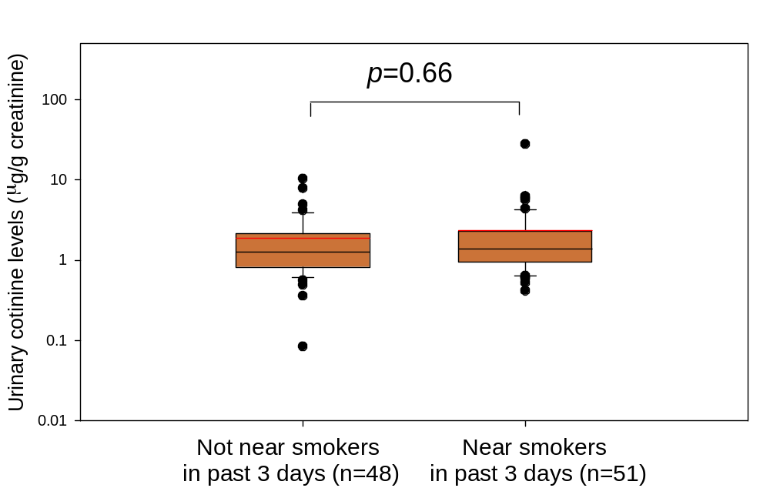
Figure S1. Comparison of urinary cotinine concentration among participants who have self-reportedly spent or not spent time near smokers in Beijing (p-value was based on Mann-Whitney U test. black line - median of each date; red line - mean of each date; box - 25th and75th percentiles; whiskers - 10th and 90th percentiles)

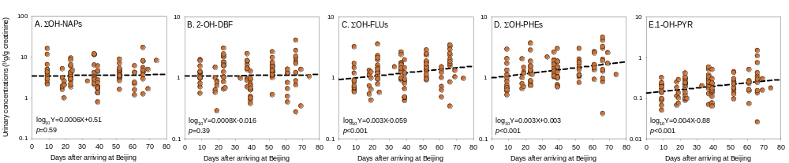
Figure S2. Effects of days in Beijing on urinary OH-PAHs concentrations (Associations were tested in mixed-effect models with random intercepts of study participant)
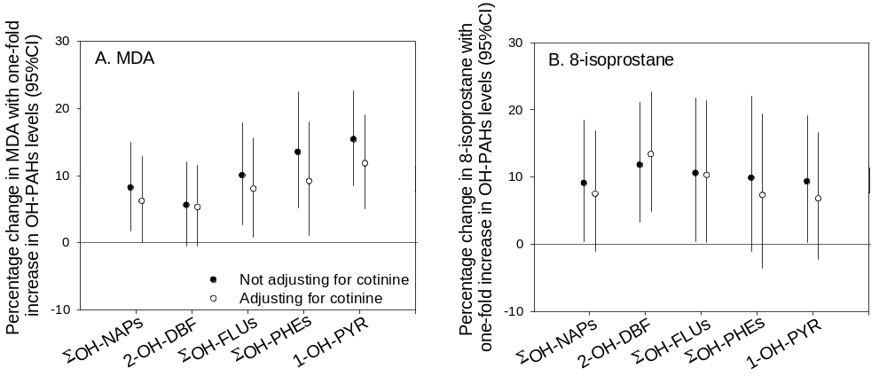
Figure S3. Percentage changes of urinary concentrations of MDA (Part A) and 8-isoprostane (Part B) associated with one-fold increases in urinary OH-PAHs concentrations with or without the adjustment of urinary cotinine concentrations. (associations were tested in mixed-effect models with random intercepts of study participant and phase.)
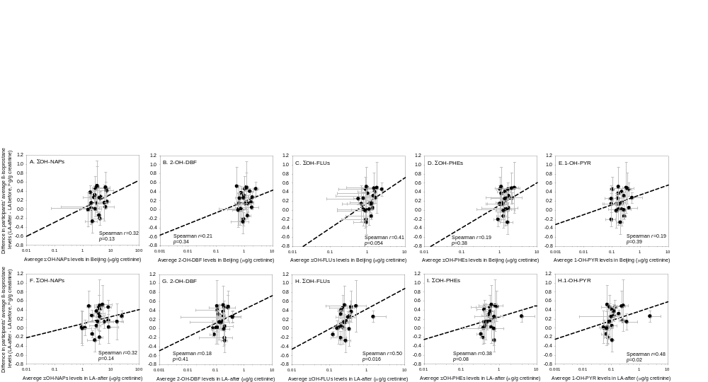
Figure S4. Spearman correlation between increments of 8-isoprostane concentrations in LA-after from LA-before and average OH-PAHs concentrations in Beijing (Parts A-E) and in LA-after (Parts F-H) (Error bars indicate standard deviations).

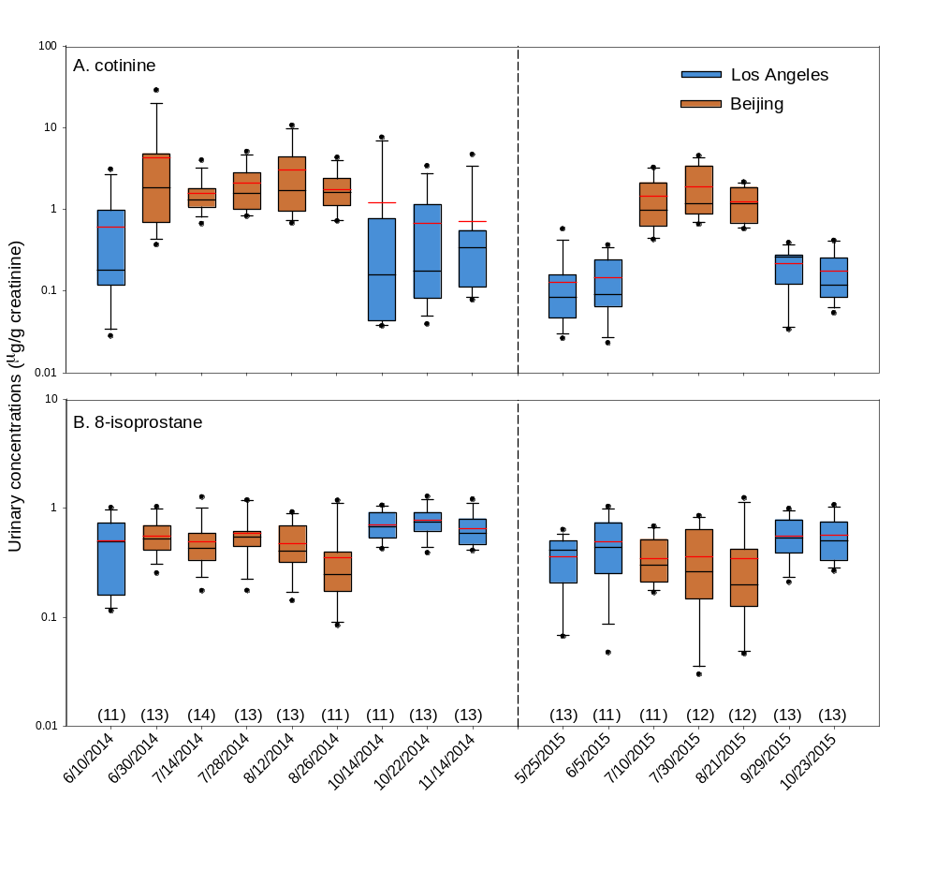
Figure S5. Temporal trend of urinary cotinine (panel A) and 8-isoprostane (panel B) concentrations. (urine sample was collected within +/- four days of the dates on x-axis; numbers in brackets indicate sample size; black line - median of each date; red line - mean of each date; box - 25th and75th percentiles; whiskers - 10th and 90th percentiles)
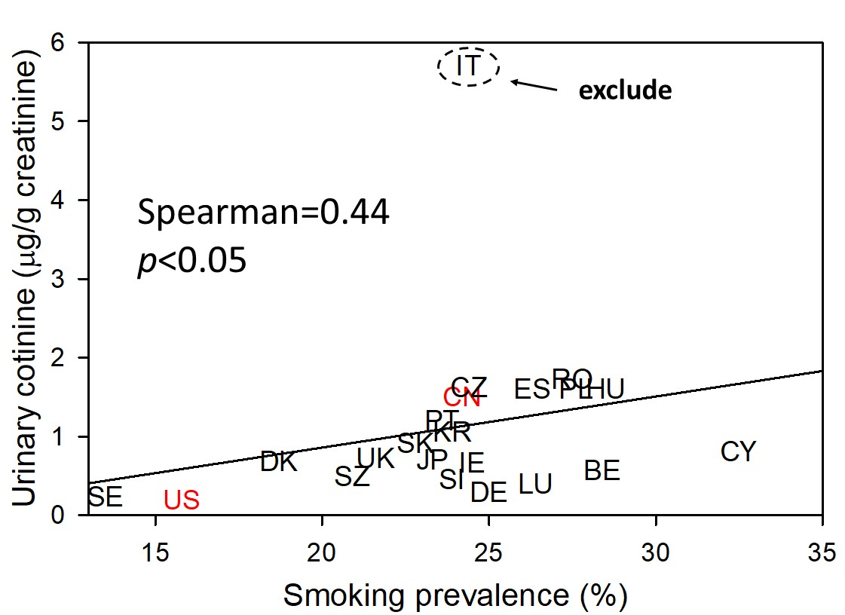
Figure S6. Correlation between population’s geometric mean concentration of cotinine in urines and the corresponding national smoking prevalence in 2012. Detailed information on the population was shown in Table S4. National Smoking prevalence data was obtained from Ng et al. Red symbols indicate data from our study. Abbreviations: US – United States; SE – Sweden; LU – Luxembourg; SI – Slovenia; SZ - Switzerland; BE - Belgium; IE – Ireland; DK – Denmark; JP – Japan; UK – United Kingdom; CY – Cyprus; SK – Slovak Republic; KR – Korea; PT – Portugal; CN – China; HU – Hungary; PL – Poland; ES – Spain; CZ – Czech Republic; RO – Romania; IT – Italy. Data in Italy was considered as an outlier and was removed from the correlation analysis.
References
Aquilina NJ, Delgado-Saborit JM, Meddings C, Baker S, Harrison RM, Jacob P, et al. 2010. Environmental and biological monitoring of exposures to PAHs and ETS in the general population. Environ Int 36:763–771; doi:10.1016/j.envint.2010.05.015.
Den Hond E, Govarts E, Willems H, Smolders R, Casteleyn L, Kolossa-Gehring M, et al. 2015. First steps toward harmonized human biomonitoring in Europe: Demonstration project to perform human biomonitoring on a European scale. Environ Health Perspect 123:255–263; doi:10.1289/ehp.1408616.
Joo H, Lim M-H, Ha M, Kwon H-J, Yoo SJ, Choi K-H, et al. 2016. Secondhand Smoke Exposure and Low Blood Lead Levels in Association With Attention-Deficit Hyperactivity Disorder and Its Symptom Domain in Children: A Community-Based Case–Control Study. Nicotine Tob Res 94–101; doi:10.1093/ntr/ntw152.
Mori T, Yoshinaga J, Suzuki K, Mizoi M, Adachi S ichi, Tao H, et al. 2011. Exposure to polycyclic aromatic hydrocarbons, arsenic and environmental tobacco smoke, nutrient intake, and oxidative stress in Japanese preschool children. Sci Total Environ 409:2881–2887; doi:10.1016/j.scitotenv.2011.04.028.
Tranfo G, Pigini D, Paci E, Marini F, Bonanni RC. 2017. Association of exposure to benzene and smoking with oxidative damage to nucleic acids by means of biological monitoring of general population volunteers. Environ Sci Pollut Res 24:13885–13894; doi:10.1007/s11356-016-6366-1.

