Supplementary Materials:
Supplementary Table 1. Summary of mouse Kcnq and Kcne primer sequences used for conventional PCR and qRT-PCR.

Gene | Accession No. | Primer sequence | Amplicon length (base pairs)
Kcnq1 | NM_000218.2 | 5′-CATCACCCACATCTCACAGC-3′ | 124
Kcnq1 | NM_000218.2 | 5′-GTCCCGCACATCGTAAGG-3′ | 124
Kcnq2 | NM_004518.3 | 5′-GACAAGGACCGCACCAAG-3′ | 123
Kcnq2 | NM_004518.3 | 5′-CACCAGGAAGTCCAGCTTCT-3′ | 123
Kcnq3 | NM_004519.2 | 5′-CGAGTTTGCTTTGAGGATCTG-3′ | 119
Kcnq3 | NM_004519.2 | 5′-AGGCAATCAGCACAAAGATGT-3′ | 119
Kcnq4 | NM_004700.2 | 5′-TGCCCCCTCAGAGGAAGT-3′ | 119
Kcnq4 | NM_004700.2 | 5′-CCACCAGGAACTTGAGAATCC-3′ | 119
Kcnq5 | NM_019842.2 | 5′-AGTCCCACCAAAGTGCAGA-3′ | 120
Kcnq5 | NM_019842.2 | 5′-AGTGCCAAGGGCTGTGTC-3′ | 120
Kcne1 | NM_000219.2 | 5′-GTCCTTTGATGCAAGGGTCTA-3′ | 123
Kcne1 | NM_000219.2 | 5′-CTGGTCTCTTCCTCCTGAGC-3′ | 123
Kcne2 | NM_172201.1 | 5′-ATCCTGCCCACACACTGC-3′ | 114
Kcne2 | NM_172201.1 | 5’-CGCCAATTGTCCATATAAGTAATAAAA-3′ | 114
Kcne3 | NM_005472.4 | 5′-TCCAGAGACATCCTGAAGAGG-3′ | 123
Kcne3 | NM_005472.4 | 5′-GGGGAAGACTCGGTAGAAGC-3′ | 123
Kcne4 | NM_080671.1 | 5′-CCTCTTGGACTGGACGATTT-3′ | 107
Kcne4 | NM_080671.1 | 5′-GTGCTGTTCAGAGGCTCCAT-3′ | 107
Kcne5 | NM_012282.2 | 5′-AACTCTGGGCCGTCTAACTG-3′ | 113
Kcne5 | NM_012282.2 | 5′-AAGGCAACTGGAAGCTGGA-3′ | 113

Supplementary Table 2. Antibodies used for a detection of KV7x and KCNEx proteins in human myometrium using immunohistochemistry.

Antibody | Supplier  (Cat. No.) | Target species | Species raised in | Optimal concentration (dilution)
Anti-Kv7.3 | Santa Cruz Biotechnology Inc (SC-7794) | Human | Goat | 20 μg/ml (1:10)
Anti-Kv7.4 | StressMarq Biosciences Inc. (SMC-309D) | Human | Mouse | 20 μg/ml (1:10)
Anti-KCNE3 | Santa Cruz Biotechnology Inc (SC-10674) | Human | Goat | 20 μg/ml (1:10)
Anti-KCNE4 | Santa Cruz Biotechnology Inc (SC-34915) | Human | Goat | 20 μg/ml (1:10)

Supplementary Table 3. Summary of secondary antibodies used for immunohistochemistry studies.
Antibody | Supplier (Cat. No.) | Serum block | Concentration used (dilution)
Rabbit anti-goat | Dako UK Ltd. (P0449) | Rabbit | (1:100)
Goat anti-mouse | Dako UK Ltd. (P0447) | Goat | (1:100)

Supplementary Table 4. Antibodies used to K_{V}7x and KCNEx proteins in Western Blot studies.

Antibody | Supplier  (Cat. No.) | Target species | Species raised in | Optimal concentration (dilution)
Anti-Kv7.1 | Santa Cruz Biotechnology Inc (SC-10646) | Human | Goat | 1 μg/ml (1:200)
Anti-Kv7.3 | Santa Cruz Biotechnology Inc (SC-7794) | Human | Goat | 1 μg/ml (1:200)
Anti-Kv7.4 | Santa Cruz Biotechnology Inc (SC-50417) | Human | Rabbit | 1 μg/ml (1:200)
Anti-KCNE2 | Santa Cruz Biotechnology Inc (SC-25703) | Human | Rabbit | 1 μg/ml (1:200)
Anti-KCNE2 | Alomone (APC-054) | Human | Rabbit | 3 μg/ml (1:200)
Anti-KCNE3 | Santa Cruz Biotechnology Inc (SC-10647) | Human | Goat | 1 μg/ml (1:200)
Anti-KCNE4 | Santa Cruz Biotechnology Inc (SC-34915) | Human | Goat | 1 μg/ml (1:200)
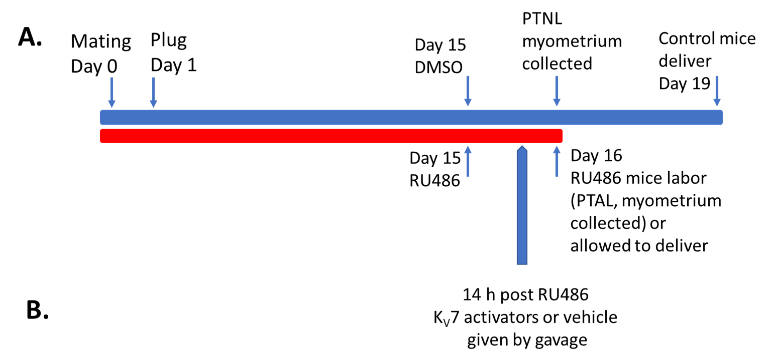

Supplementary Figure 1. Experimental protocol for assessing impact of K_{V}7 activators on preterm birth in mice. (A) Schematic of the experimental protocol used to induce preterm labor and birth in pregnant C57BL/6J mice. Mice were mated (day 0) with plug confirmed on day1 followed by daily weighing up to days 8-10; female mice were approximately 13 weeks old. On day 15, mice were injected intraperitonially with either RU486 (150 µg dissolved in DMSO at a concentration of 1 µg/ml) or DMSO (150 µl) alone. For organ bath experiments, animals were sacrificed, and myometrium was collected on day 16 from DMSO controls (preterm not in labor, PNL) and RU486 treated animals at the time of delivery (preterm in labor, PTAL). Other mice were used for timing of gestation length, telemetry experiments and assessment of the effect of K_{V}7 activator treatments (see methods for details) given by gavage. (B) Effect of RU486 administration on gestation length. Using CCTV, the delivery of the first pup defined end of gestation. RU486 treated mice (n=6) consistently delivered on day 16, control animals (n=6) on day 19 (** p<0.001). Data are expressed as mean ± SEM.

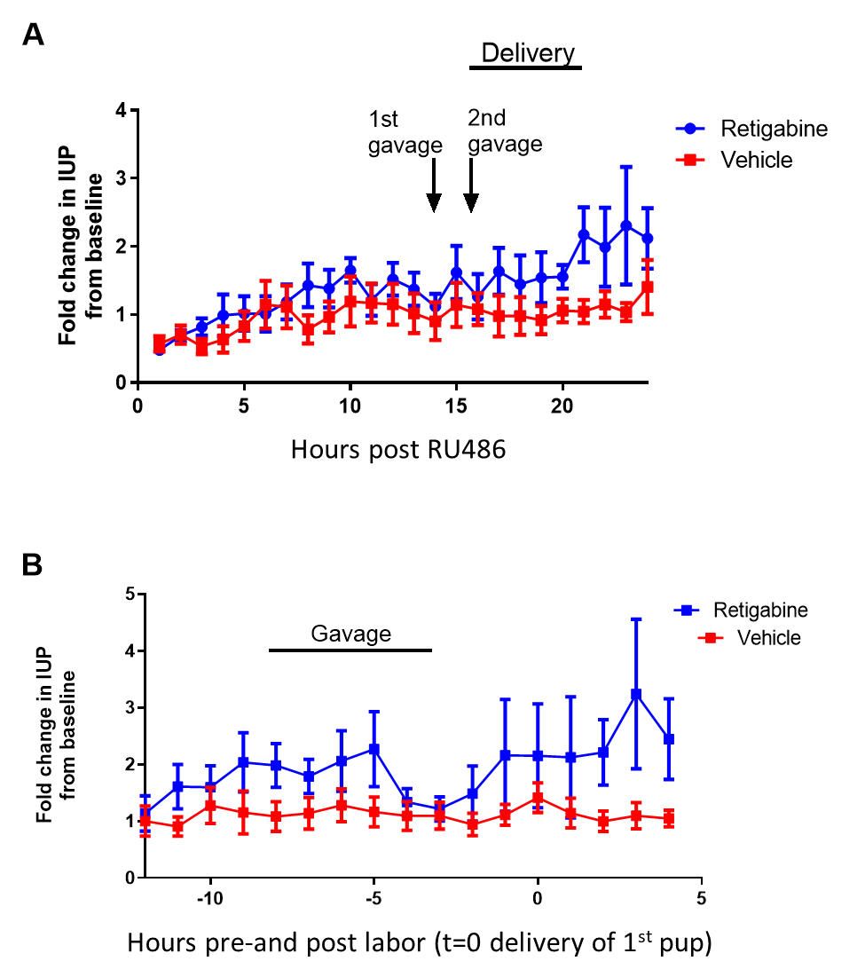
Supplementary Figure 2. K_{V}7 activator retigabine affects intrauterine pressure (IUP) in CB57BL/6J pregnant mice following RU486 administration. Hourly averages of continuous IUP measurements recorded during the 24 hours following RU486 administration are presented relative to the administration of RU486 (A) or time of delivery (B) (n=6 for both). As the onset of delivery was not identical in all mice, the straight black line in (A) indicates the spread of delivery times in mice administered RU486. In (B), the red and blue lines represent DMSO-injected and RU486-injected mice, respectively. The hourly averages for DMSO-injected mice in (B) are of an equivalent time point to those of the RU486-injected mice.

Supplementary Figure 3. Effect of K_{V}7 channel activation on fetal ductus arteriosus (DA) tone. (A). Isolated DAs from term gestation fetal mice were mounted on glass pipettes for pressure myography. (B). Representative tracing of an isolated fetal DA in response to 50 mM KCl to verify vessel reactivity, followed by exposure to increasing concentrations of ML213 (10-4 to 10-8 M). (C). Cumulative concentration-response curves show that exposure to increasing concentrations of ML213 had no effect on DA diameter under fetal oxygen conditions. Constriction of the isolated DA was noted after exposure to the highest concentrations of retigabine (p<0.005 compared to ML213). *** p<0.0005 compared to baseline diameter. Data are mean ± S.E.M., representing DA tissues from 5 different litters.

