Supporting information for

Protocell-Loaded Phase-Separated Synthetic Organelles: Light-Triggered Inter-Organelle Communication Guiding Structural and Catalytic Transformations
Huiying Xue^{1,#}, Yunlong Qin^{2,#}, Shijun Xu¹, Itamar Willner²*, Fan Xia¹*, and Fujian Huang¹*
¹ State Key Laboratory of Geomicrobiology and Environmental Changes, Faculty of Materials Science and Chemistry, China University of Geosciences, Wuhan 430074, China
² The Institute of Chemistry, The Hebrew University of Jerusalem, Jerusalem 91904, Israel
# These authors contributed equally.

*email: huangfj@cug.edu.cn; xiafan@cug.edu.cn; itamar.willner@mail.huji.ac.il

Table S1: Oligonucleotide sequences of DNA origami nanopore.
Name | Sequence (5'-3')
P1 | AGCGAACGTGGATTTTGTCCGACATCGGCAAGCTCCCTTTTTCGACTATT-chol
P2 | CCGATGTCGGACTTCCCAGGTTTTTACTCCGCTTACACGATCTTCGCCTGCTGGGTTTTGGGAGCTTG
P3 | CGAAGATCGTGTTTTTCCACAGTTGATTGCCCTTCACTTTTCCCAGCAGG-chol
P4 | AATCAACTGTGGTTTTTCTCACTGGTGATTAGAATGCTTTTGTGAAGGGC-chol
P5 | TCACCAGTGAGATTCCCAGGTTTTTACTCCGCTTTGTCGTACCAGGTGCATGGATTTTTGCATTCTAA
P6 | CCTGGTACGACATTTTTCCACGTTCGCTAATAGTCGATTTTATCCATGCA-chol
P | Cy5-ACCTGGGGTGGTATTGCGGAGTGAGGTTTTACCTGGGGTGGTATTGCGG
P’ | CCGCAATACCACCCCAGGTAAAACCTCACTCCGCAATACCACCCCAGGT
Table S2: Oligonucleotide sequences of DNA microdroplet condensates skeleton.
Name | Sequence (5'-3')
L₁ | Phos-GATTAGAGACCGTACCTACATATAGCTACTGATACTCT
X | FAM-AGCTATATGTAGGTACGGTCTCT
M₁ | Phos-AATCAGAGTATCTTTTTCGAATAGAGG
L₂ | Phos-ATGAAGAGACCGTACCTACATATAGCTACTACTTGATA
Y | AGCTATATGTAGGTACGGTCTCT
M₂ | Phos-TCATTATCAAGTTTTTTCCTCTATTCG
L₃ | Phos-GTCAAGAGACCGTACCTACATATAGCTACTCATTCCAA
W | Cy5-AGCTATATGTAGGTACGGTCTCT
M₃ | Phos-TGACTTGGAATGTTTTTCTGTGACTGT
L₄ | Phos-CTTAAGAGACCGTACCTACATATAGCTACTCCTATGTG
Z | AGCTATATGTAGGTACGGTCTCT
M₄ | Phos-TAAGCACATAGGTTTTTACAGTCACAG
Table S3: Oligonucleotide sequences for dynamic organelles reocnfiguration.
Y+Bs1 | TGTCTTCAGGATAGAAGCTATATGTAGGTACGGTCTCT
Z+Bs2 | GACTGTACGAGTTCAAGCTATATGTAGGTACGGTCTCT
T₁ | Cy3-GTGTGATGAGTGTGATTGCTTCAC/PC-Linker/TCTATCCTGAAGACA
H₁ | GTGTGATGAGTGTGATTG/PC-Linker /GTGAAGCAATCACACTCATCACACTGAACTCGTACAGTC
T₂ | Cy3-GTCCAGGCAAGCTACAAAGATGTGCGGAGCT/PC-Linker/TCTATCCTGAAGACA
S₁ | BHQ1-CATGCACA/rG/TGGACCAG/6-FAM/TTTTTGAACTCGTACAGTC
H₂ | CTGGTCCAGGCAAGCTACAACGATGTGCATG/PC-Linker/AGCTCCGCACATCTTTGTAGCTTGCCTGGAC
H₃ | Cy3-GTGTGATGAGTGTGATTG/PC-Linker /TATTAGCAATCACACTCATCACAC/PC-Linker/TGAACTCGTACAGTC
T₃ | GTGTGATGAGTGTGATTGCTAATACGACTCACTATAGGGGATCCCGACTGGCGAGAGCCAGGTAACGAATGGATCCTTTTTCTATCCTGAAGACA
T₃ | TGTCTTCAGGATAGAAAAAGGATCCATTCGTTACCTGGCTCTCGCCAGTCGGGATCCCCTATAGTGAGTCG

Figure S1. Preparation of locked/unlocked DNA origami nanopore. (a) Schematic assembly of Cy5-labeled P-locked DNA nanopore and the P’-fueled unlocking of the nanopore. (b) Gel electrophoretic image corresponding to the stepwise assembly of locked/unlocked DNA nanopore: Lane 1, P1; Lane 2, P1+P2; Lane 3: P1+P2+P3; Lane 4: P1+P2+P3+P4; Lane 5: P1+P2+P3+P4+P5; Lane 6: P1+P2+P3+P4+P5+P6; Lane 7: P1+P2+P3+P4+P5+P6+P; Lane 8: P1+P2+P3+P4+P5+P6+P+P’; Lane 9: P+P’; Lane L: 20 bp marker.
The assembly of locked DNA origami nanopore and the fuel-driven unlocking of the nanopore are depicted in Figure S1(a). Locked DNA origami nanopore includes a hexagonal prism-shaped DNA origami structure, where DNA strands P1, P2, P3, P4, P5, and P6 assemble to act as six faces of the prism, and DNA strand P hybridizes with P2 and P5 to block the hexagonal prism nanopore. The components P1, P3, P4, and P6 are modified with the cholesterol functional groups, leading to the assembled DNA hexagonal prism nanopore, where the middle part of the DNA hexagonal prism nanopore is modified with cholesterol to allow the integration of the DNA nanopore into the liposome membrane. Moreover, the strand P were modified with the Cy5 fluorophore labels to follow the locking state of the DNA nanopores in the liposome membrane. Subjecting the locked DNA nanopore to fuel strand P’ complementary to the locking strand P, results in the displaced P/P’ duplex and unlocked DNA nanopore allowing the transportation of the small molecules, e.g. Rhodamine 6G (R6G) or Mg²⁺-ions. Figure S1(b) depicts the gel electrophoretic analysis of the assembly of the DNA nanopore and the locking/unlocking processes. Lanes 1 ~ 6 depict the stepwise assembly of the DNA hexagonal prism nanopore. Lane 7 shows the locking strand P-locked DNA nanopore structure, while lane 8 demonstrates the fuel strand P’ induced unlocking of the DNA nanopore unit (c.f. lane 6) and formation of the waste duplex P/P’ (c.f. lane 9).

Figure S2. Optimization of the concentration of DNA nanopores associated with the liposome membrane. (a) Confocal fluorescence microscopy images corresponding to liposomes modified with various (100-500nM) concentrations of P-locked DNA nanopore units. (b) The integrated fluorescence intensities of Cy5-labeled P locking strand associated with the liposome nanopores.
The concentration effect of the DNA origami nanopore units associated with the liposome membrane was investigated in Figure S2. Incubation of the liposome with variable concentrations of fluorophore Cy5-labeled cholesterol-modified DNA origami nanopore leads to the liposome modified with red fluorescent DNA nanopore units, as shown in confocal fluorescence microscopy images in Figure S2(a). The respective statistical integrated fluorescence intensities were analyzed in Figure S2(b). Obviously, as the concentration of DNA nanopore units increased from 100 nM to 300 nM, the fluorescence intensities of the nanopore associated with the membrane increased rapidly, and then, the fluorescence intensities leveled off to a saturated value. Therefore, the incubation concentration of the DNA nanopore units with the liposome was chosen to be 300 nM for subsequent experiments.

Figure S3. Zeta potential values of liposomes in different configurations: unmodified liposomes; P-locked nanopore-modified liposomes; P-locked nanopore-modified liposomes subjecting to unlocking strand P’.
The integration of the cholesterol-modified DNA nanopore into the liposome membrane was also demonstrated with the zeta potential analysis. Figure S3 depicts the zeta potential values of the liposome before and after modification with locked/unlocked DNA nanopore units. The pure liposomes show an average zeta potential value of -15 mV. In contrast, the liposomes modified with the locked DNA nanopore or unlocked nanopore reveal an average zeta potential value of -22 mV or -32 mV, respectively. The negative shifting of the zeta potential demonstrates the successful modification of the liposomes with the negatively-charged DNA nanopore units.

Figure S4. Temporal Time dependent confocal fluorescence microscopy images corresponding to Cy5-labeled P-locked DNA nanopore-modified liposome subjected to R6G. (R6G emission: 543 nm; Cy5 emission: 633 nm.) The low fluidity of DPPC/cholesterol liposome membrane at 20 °C ensures that R6G cannot permeate through the phospholipid membranes to core volume.
The small molecule, rhodamine 6G (R6G), was chosen as a fluorescent dye to probe the permeation properties of the DNA nanopore associated with the liposomes. Firstly, the permeability of the R6G to the liposome modified with locked DNA nanopore is investigated. The permeation capability of the native liposome is generally dependent on the fluidic properties of the constituents of the liposome, which could be probed by the fluorescence recovery after photobleaching experiment. As depicted by the confocal fluorescence microscopy images in Figure S4, the locked Cy5-labeled DNA nanopore modified DPPC/cholesterol liposome was subjected to the R6G solution, revealing a liposome with a red fluorescent rim, an empty core and surrounded by the blue fluorescent R6G solution. Then, the confined red rectangular region containing part of the liposome membrane was photobleached by an intensified confocal laser, followed by the time-dependent recording of the fluorescent confocal images of the liposome. Obviously, the photobleached red fluorescent rim of the liposome did not recover after 20 min, revealing low fluidity of the liposome membrane, and concomitantly, the core volume of the liposome remained empty without fluorescence. That is, the R6G could not permeate through the liposome membrane, due to the locked DNA nanopore units and low fluidity of the liposome membrane.
Figure S5. The permeation capability of R6G into liposomes by DNA nanopore channels. (a) Schematic permeation of R6G into liposomes by P’-unlocking of the P-caged DNA nanopore units associated with the liposome membrane. (b) Temporal merged (blue R6G + red Cy5) confocal fluorescence microscopy images corresponding to the liposomes of different configurations subjected to R6G: Panel I-liposomes without modification; Panel II-liposomes modified with opened DNA nanopore units; Panel III: liposomes modified with P-locked DNA nanopore units; Panel IV: liposomes modified with P-locked DNA nanopore units subjected to P’ unlocking strand.
To examine the integration of the DNA nanopore into the liposome membrane and it’s transportation behavior upon unlocking, R6G permeation experiments were conducted. Figure S5(a) depicts the schematic permeation of the fluorescent dye R6G into the liposome core volume through the unlocked DNA nanopore-modified liposomes. The liposomes were modified with the Cy5-labeled P-locked DNA nanopore units, which does not allow the permeation of the R6G. Subjecting the P-locked DNA nanopore-modified liposomes to the unlocking strand P’ that is complementary to the P locking strand, leads to the formation of P/P’ duplex and the opened state of the DNA nanopore associated with the liposome membrane, allowing the permeation of the R6G molecules into the liposome through the DNA nanopore channel. Figure S5(b) presents the fluorescence confocal microscopy images of the permeation of the R6G into the P’-unlocked P-caged DNA nanopore-modified liposomes (Panel IV), in comparison to with different control systems, liposomes without modification (Panel I), liposomes modified with the opened DNA nanopore (Panel II), and liposomes modified with the P-caged DNA nanopore (Panel III). Obviously, within 20 min, the core volume of the liposomes modified with opened DNA nanopore (Panel II and Panel IV) was occupied with the blue fluorescent R6G molecules, due to the transportation of the R6G molecules through the DNA nanopore channels. In contrast, the core volume of the liposomes without DNA nanopore (Panel I) or modified with locked DNA nanopore (Panel III) revealed blank fluorescence features, demonstrating the blocked transportation of the R6G through the P-locked DNA nanopore channels. Thus, the controlled permeability of the small molecules (e.g., R6G, or Mg²⁺-ions) into the liposome containment, could be realized by switching the unlocking/locking state of the DNA nanopore units associated with the liposome membrane.

Figure S6. T4-DNA ligase-catalyzed ligation of the DNA module into DNA polymer. (a) Schematic ligation of the DNA module, L₁+X/M₁ and L₂+Y/M₂ into respective DNA polymers. (b) Agarose gel electrophoresis characterization of the DNA module and ligated DNA polymers: Lane L: 50 bp marker; Lane 1: L₁+X/M₁+T4 DNA ligase, reacted for 0 h; Lane 2: L₁+X/M₁+T4 DNA ligase, reacted for 2 h at 37 °C; Lane 3: L₂+Y/M₂+T4 DNA ligase, reacted for 0 h; Lane 4: L₂+Y/M₂+T4 DNA ligase, reacted for 2 h at 37 °C.
The T4 DNA ligase-catalyzed ligation of the DNA constituents into DNA polymer chains (Figure S6(a), also depicted in Figure 1(a) and (b)) were probed by the gel electrophoretic experiments, Figure S6. Lane 1 and 3 depict the DNA constituents, L₁+X/M₂, and L₂+Y/M₂, respectively, before the ligation process. And after the ligation process, evidently, the products revealed discrete high-molecular-weight bands in Lane 2 and 4, respectively, demonstrating the formation of the ligated DNA polymer chains.

Figure S7. Temporal time-dependent confocal fluorescence microscopy images of phase-separated DNA microdroplet condensate O₁ in bulk solution.
The Mg²⁺-ion dependent, ligase-catalyzed ligation of DNA constituents (L₁+X/M₂ and L₂+Y/M₂) into the multivalent polymer chains, and the two inter-hybridized polymer chains induced liquid-liquid phase separation process, were investigated and optimized in the bulk solution, Figure S7 ~ S9. Figure S7 presented the temporal confocal fluorescence microscopy images of the phase-separated DNA microdroplets upon the ligase-catalyzed ligation of the DNA constituents. Evidently, the sizes of DNA microdroplets increase dramatically in the first 2 h, and reach a saturated size after 2 h.
Figure S8. Confocal fluorescence microscopy images of phase-separated DNA microdroplet condensate O₁ in bulk solution at different concentrations of Mg²⁺-ions (4 mM ~ 10 mM).
Figure S8 depicts the Mg²⁺-ion dependent confocal fluorescence microscopy image features of the phase separated DNA microdroplet. Obviously, below the 5 mM of Mg²⁺-ions, no phase separation of the DNA microdroplet is formed, indicating no ligation reaction proceeds due to the inhibited T4 ligase activity. As the Mg²⁺-ions increases from 5 mM to 10 mM, the sizes of DNA microdroplets increase gradually, and then level off at 10 mM, indicating the elevated T4 ligase activity. Thus, the formation of ligase-catalyzed phase-separated DNA microdroplets could be controlled by the concentration of Mg²⁺-ions, allowing the further experiments of evolution of phase-separated DNA microdroplet organelles in liposome containment by Mg²⁺-ion transportation through the DNA nanopore associated with the liposome membrane.

Figure S9. Confocal fluorescence microscopy images of phase-separated DNA microdroplet condensate O₁ in bulk solution using different concentrations of DNA module L₁+X (5 μM ~ 12 μM).
Figure S9 depicts the fluorescence confocal microscopy images upon formation of the phase separated DNA microdroplets in solution using different concentrations of the DNA tile L₁+X. Evidently, as the concentration of the DNA module L₁+X increases from 5 μM to 10 μM, the sizes of the microdroplets increase gradually. Further increase of the DNA module L₁+X to 12 μM leads, however, to the overgrowth of the DNA microdroplets. Therefore, the concentration of the DNA tile L₁+X, is used as 10 μM in further experiments of evolving organelles in liposomes.

Figure S10. Zoom-out confocal fluorescence microscopy images of the evolved organelle O₁ in the liposomes of different configurations: Panel I-liposomes without modification; Panel II-liposomes modified with opened DNA nanopore units; Panel III: liposomes modified with P-locked DNA nanopore units; Panel IV: liposomes modified with P-locked DNA nanopore units subjected to P’ unlocking strand.
Figure S10 depicts the zoom-out confocal fluorescence microscopy images of formation of the organelle O₁ in the unlocked DNA nanopore-modified liposome carrier by the transportation of Mg²⁺-ions through the DNA nanopore channel, and the control systems, c.f. Figure 1(c).
Figure S11. Zoom-out confocal fluorescence microscopy images of the evolved organelle O₁ and O₂ in the liposomes of different configurations: Panel I-liposomes without modification; Panel II-liposomes modified with opened DNA nanopore units; Panel III: liposomes modified with P-locked DNA nanopore units; Panel IV: liposomes modified with P-locked DNA nanopore units subjected to P’ unlocking strand.
Figure S11 depicts the zoom-out confocal fluorescence microscopy images of orthogonal formation of two organelles, O₁ and O₂, in the unlocked DNA nanopore-modified liposome carrier by the transportation of Mg²⁺-ions through the DNA nanopore channel, and the control systems, c.f. Figure 2(c).
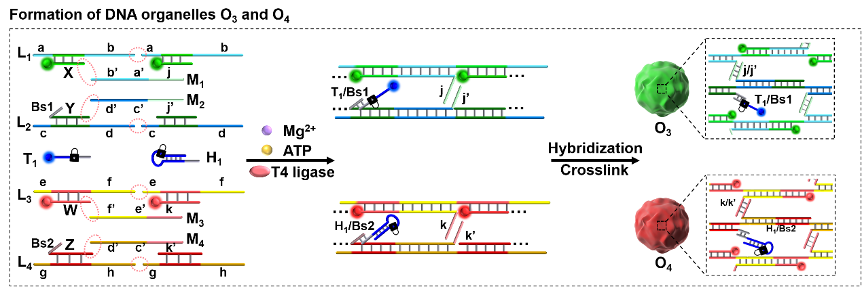
Figure S12. Schematic assembly process of DNA organelles O₃ and O₄ in liposomes.

Figure S13. Polyacrylamide gel electrophoresis image (native) of the light-induced strand intercommunication depicted in Figure 3(a): Lane 1: T₁; Lane 2: T₁+UV; Lane 3: H₁; Lane 4: H₁+UV; Lane 5: T₁ + H₁; Lane 6: T₁ + H₁+UV; Lane L: 20 bp marker.
The light-induced strand intercommunication process between the organelles O₃ and O₄ was also characterized by the gel electrophoretic experiments, Figure S13. The UV-uncaging of the o-nitrobenzyl phosphate ester-modified T₁ strand generates two band corresponding to fragmented T₁’ and waste (lane 2 vs. lane 1). Also, the UV-uncaging of the o-nitrobenzyl phosphate ester-modified DNA hairpin H₁ strand generated DNA duplex H_{1a}/H_{1b}, exhibiting similar electrophoretic rates (lane 4 vs. lane 3). Incubation of the T₁ strand with hairpin H₁ in the dark generates the inert two separated band of T₁ and H₁ (see lane 5), respectively. Subjecting the mixture of the T₁ strand and hairpin H₁ to UV irradiation leads, however, to the formation of uncaged T₁’ and DNA duplex H_{1a}/H_{1b}, followed by the toehold-mediated strand displacement formation of T₁’/ H_{1a} that exhibits slower migrating band, and respective wastes bands (see lane 6). The result is consistent with the mechanism introduced in Figure 3(a).
Figure S14. Zoom-out confocal fluorescence microscopy images probing the phase separation of the two organelles O₃/O₄ in the liposome containment and their light triggered reconfiguration into the O₃’/O₄’ organelles. Panel I-The constituent-loaded liposome prior to the triggered opening of the pores and the Mg²⁺-ion evolution of organelles O₃/O₄. Panel II-After opening the pores in the liposome boundary and the Mg²⁺-ions activation of the ligation of the constituents and self-assembly of phase-separated O₃/O₄ organelles. Panel III-After UV-light triggered activation of organelles O₃/O₄ and their intercommunication reconfiguration into organelles O₃’/O₄’. FAM: 488 nm, Green; Cy3: 543 nm, Blue; Cy5: 633 nm, red.
Figure S14 depicts the zoom-out confocal fluorescence microscopy images of light-induced strand intercommunication and dictated reconfiguration of two organelles, O₃ and O₄, in the liposomes with different configurations, c.f. Figure 3(b).

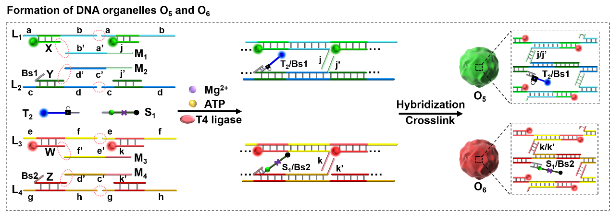
Figure S15. Schematic assembly process of DNA organelles O₅ and O₆ in liposomes.

Figure S16. (a) Polyacrylamide gel electrophoresis image (native) corresponding to the light-triggered evolution of DNAzyme catalytic units depicted in Figure 4(b): Lane 1: T₂; Lane 2: S₁; Lane 3: H₂; Lane 4: H₂+T₂; Lane 5: H₂+T₂+UV; Lane 6: H₂+T₂+S₁; Lane 7: H₂+T₂+S₁+UV; Lane L: 20 bp marker. (b) Fluorescence spectra of the substrate S₁ in the mixture of H₂, T₂ and S₁ (each 50nM), incubated at 37 °C for 1 h, in the absence of UV (black curve) or with the UV irradiation for 5 min.
The light-induced, DNAzyme-mediated, intercommunication and reconfiguration between the organelles O₅ and O₆ was also characterized by the gel electrophoretic experiment, Figure S16(A), and DNAzyme-cleaved fluorescent substrate experiments, Figure S16(B). As shown in Figure S16(A), Incubation of the T₂ strand with hairpin H₂ in the dark generates the inert overlapped band of T₂ and H₂ (see lane 4 vs. lane 1 and lane 3). Subjecting the mixture of T₂/H₂ to UV irradiation leads, however, to the formation of uncaged T₂’ and DNA duplex H_{2a}/H_{2b}, followed by the toehold-mediated strand displacement formation of T₂’/H_{2a} that exhibits slower migrating band, H_{2b} that exhibits faster migrating band, and respective waste band (see lane 5). Furthermore, subjecting the mixture of T₂/H₂/S₁ to UV irradiation leads to the formation of T₂’/H_{2a}, and H_{2b} strand that acts as DNAzyme units recognizing and cleaving substrate S₁ to generate waste bands (see lane 7 vs. lane 6 and lane 2).
Figure S16(B) depicts the fluorescence spectra of the FAM/BHQ-1 pair-modified substrate S₁ in the mixture of T₂/H₂/S₁ before and after UV irradiation. Evidently, upon UV activation, released DNAzyme unit H_{2b} catalyzes the cleavage of the substrate S₁, generating increased FAM fluorescence intensity (red curve). In contrast, without UV activation, the substrate S₁ remain intact, revealing quenched low fluorescence intensity of FAM (black curve).
These results are consistent with the mechanism introduced in Figure 4(a) and (b).

Figure S17. Zoom-out confocal fluorescence microscopy images corresponding to: Panel I-the constituents in the pore-locked liposomes, prior to phase separation; Panel II-after unlocking the pores and inducing the phase-separated organelles O₅/O₆; Panel III-Panel V-after light-induced activation of organelles O₅/O₆ and recording at time-intervals the fluorescence features of the liposome, upon dynamic reconfiguration into the O₅’/O₆’ state (Panel III-after 0 min, Panel IV-after 20 min, Panel V-after 60 min). FAM: 488 nm, Green; Cy3: 543 nm, Blue; Cy5: 633 nm, red.
Figure S17 depicts the zoom-out confocal fluorescence microscopy images of light-induced DNAzyme-mediated, intercommunication and reconfiguration between the organelles O₅ and O₆ in the liposomes of different configurations, c.f. Figure 4(c).

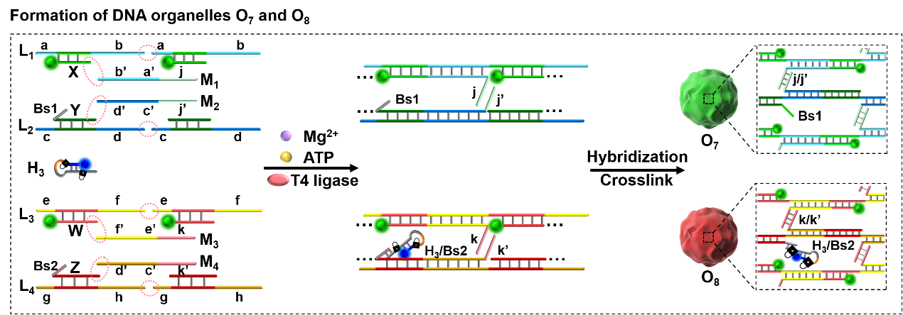
Figure S18. Schematic assembly process of DNA organelles O₇ and O₈ in liposomes.

Figure S19. Temporal fluorescence spectra of MG/aptamer generated from the light-induced active transcription machinery and the control system without UV activation. T₃ is rapidly annealed in 1×PBS to form incomplete dsDNA transcription template. 200nM T₃, 500 nM H₃, 500 nM NTP, 1 U/µL T7 RNA Polymerase was irradiated with UV for 5 minutes, and then incubated at 37 °C for transcription process.
Figure S19 depicts the temporal fluorescence spectra of malachite green (MG)/RNA aptamer complex, where the MG RNA aptamer is generated by the light-induced reconfiguration and formation of active transcription machinery from the mixture of T₃/H₃, T7 RNA polymerase (T7 RNAp), NTPs. Evidently, upon UV light irradiation, the fluorescence intensity of MG/RNA aptamer increases significantly from t = 0 to t = 4 h, and then levels off to a constant value from t = 4 h to t = 8 h, originating from the light-induced formation of complete H_{3a}/T₃ primer/transcription template module and active transcription machinery. In contrast, without UV irradiation, the mixture reveals a negligible background fluorescence intensity of MG/RNA aptamer after 8 h incubation, due to the incomplete transcription machinery.
These results are consistent with the mechanism introduced in Figure 4(a) and (b).
Figure S20. Zoom-out confocal fluorescence microscopy images corresponding to: Panel I-the constituents in the pore-locked liposomes, prior to phase separation; Panel II-after unlocking the pores and Mg²⁺-ions induced phase-separated organelles O₇/O₈; Panel III-Panel VI-after light-induced activation of organelles O₇/O₈ and recording at time-intervals the fluorescence features of the liposome, upon dynamic reconfiguration into the O₇’/O₈’ state (Panel III-after 0 min, Panel IV-after 30 min, Panel V-after 2 h, Panel VI-after 6 h,). (d) Time-dependent integrated fluorescence intensities of the red MG-RNA aptamer fluorescence upon dynamic formation of organelle O₇’. FAM: 488 nm, Green; Cy3: 543 nm, Blue; Cy5 or MG/aptamer: 633 nm, red.
Figure S20 depicts the zoom-out confocal fluorescence microscopy images of light-induced transcription machinery-guided, intercommunication and reconfiguration between the organelles O₇ and O₈ in the liposomes of different configurations, c.f. Figure 5(c).

