Contrails inside cirrus clouds predominate with uncertain climate impact
- Supplementary information

Andreas Petzold^{1, 2}, Neelam F. Khan^{1,3}, Yun Li¹, Susanne Rohs¹, Susanne Crewell³, Andreas Wahner¹, and Martina Krämer^{4, 5}
¹ Institute of Climate and Energy Systems 3 – Troposphere, Forschungszentrum Jülich GmbH, Jülich, Germany
² Institute for Atmospheric and Environmental Research, University of Wuppertal, Wuppertal, Germany
³ Institute for Geophysics and Meteorology, University of Cologne, Cologne, Germany
⁴ Institute of Climate and Energy Systems 4 – Stratosphere, Forschungszentrum Jülich GmbH, Jülich, Germany
⁵ Institute for Atmospheric Physics, Johannes Gutenberg-University Mainz, Mainz, Germany
Correspondence to: Andreas Petzold (a.petzold@fz-juelich.de)
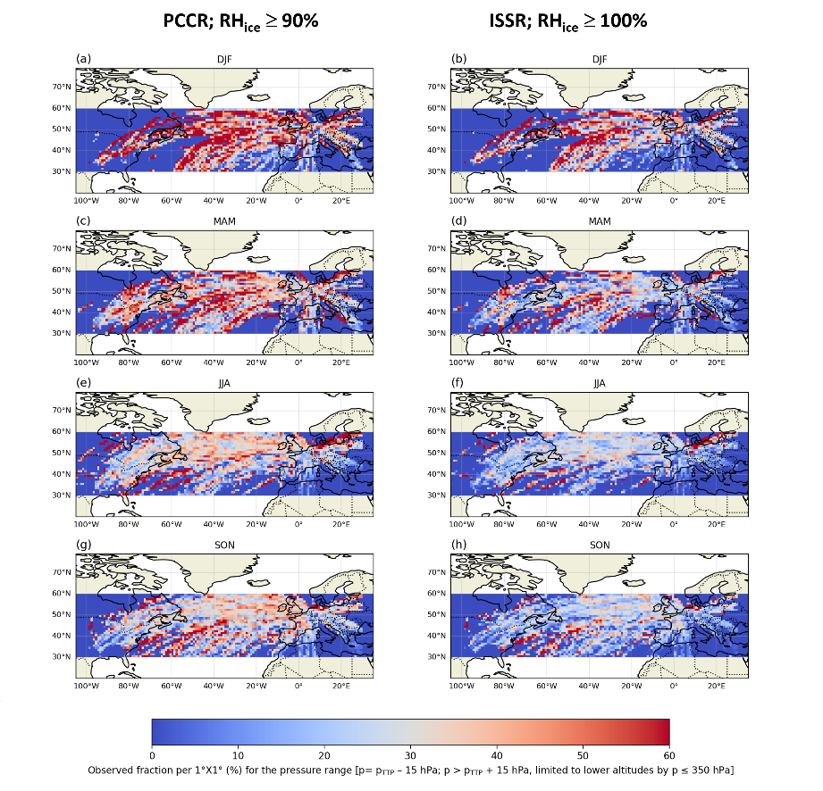

Figure S1. Observed fraction of potential contrail-cirrus regions (PCCR: RH_{ice} ≥ 90%, SAC fulfilled, panels a, c, e, and g) and ice-supersaturated regions (ISSR: RH_{ice} ≥ 100% , SAC fulfilled, panels b, d, f, and h) per 1° x 1° grid box in % for the North Atlantic region, including Eastern North America and Western Europe for the uppermost troposphere and the thermal tropopause (TTP) layer.

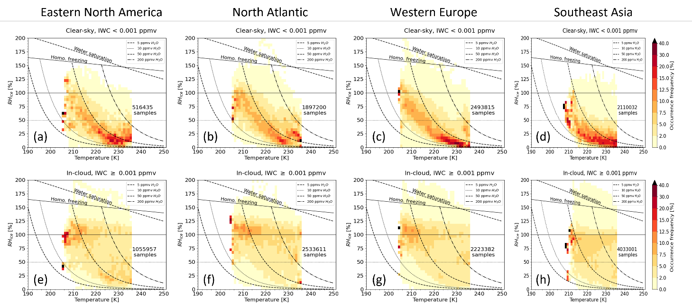
Figure S2. Observed RHI_{ice} for clear-sky ((a) – (d)) and in-cloud ((e) - (h)) conditions in the respective regions; the classification into clear-sky and in-cloud used the ERA5 CIWC - based cloud index; data were analysed relative to the thermal tropopause TTP for p < 350 hPa < p_{TTP} – 15 hPa.

The influence of air temperature on the distribution of RH_{ice} inside clouds and in clear sky is further analysed in S2. Here, we sorted the RH_{ice} data into temperature bins of 1 K width and calculated the occurrence distribution per temperature bin. The iso-lines shown in S1 correspond to lines of constant water vapour volume mixing ratio as function of temperature. For clear-sky conditions (S1a to d), the most frequently observed RH_{ice} values represent dry conditions with RH_{ice} < 25% at temperatures above 225 K, while the coldest air masses probed at temperatures below 215 K are frequently close to ice-saturation. It should be noted that the latter conditions were sampled only at midlatitudes (S1a to c), whereas in the subtropics (S1d), air temperatures below 215 K are sparse, and ice-saturation is rarely reached. Inside cirrus clouds at midlatitudes (S1e - g), most frequent RH_{ice} values scatter around ice-saturation with a slight tendency towards ice-supersaturation up to 120% at the colder temperatures below 215 K. For the subtropics (S1h), the most frequent RH_{ice} values are found slightly below ice-saturation, independent of the air temperature.

Table S1. Fractions of clear-sky and in-cloud areas for the analysed regions with the respective status of contrail existence added, for in-istu observations and ERA5 model fields; regions are Eastern North America (Region 1), the North Atlantic (Region 2), Western Europe (Region 3) and Southeast Asian Subtropics (Region 4).
 |  | PCCR |  |  |  |  |  | ISSR
Region |  | clear sky |  |  | in-cloud |  |  | Clear sky |  |  | In-cloud
1 | Total no. samples | 516435 |  |  | 1055957 |  |  | 516435 |  |  | 1055957
 | Fraction of total, % | 32.84 |  |  | 67.15 |  |  | 32.84 |  |  | 67.15
 | Contrail status | no | shortlived | persistent | no | shortlived | persistent | no | shortlived | persistent | No | shortlived | persistent
 | No. sub-samples | 7303 | 478645 | 30487 | 20629 | 625719 | 409609 | 7303 | 494626 | 14506 | 20629 | 741278 | 294050
 | Fraction of total, % | 0.5 | 30.4 | 1.9 | 1.3 | 39.8 | 26.1 | 0.5 | 31.5 | 0.9 | 1.3 | 47.1 | 18.7
2 | Total no. samples | 1897200 |  |  | 2533611 |  |  | 1897200 |  |  | 2533611
 | Fraction of total, % | 42.81 |  |  | 57.18 |  |  | 42.81 |  |  | 57.18
 | Contrail status | no | shortlived | persistent | no | shortlived | persistent | no | shortlived | persistent | no | shortlived | persistent
 | No. sub-samples | 14454 | 1697360 | 185386 | 13782 | 1238696 | 1281133 | 14454 | 1788430 | 94316 | 13782 | 1556229 | 963600
 | Fraction of total, % | 0.3 | 38.3 | 4.2 | 0.3 | 28.0 | 28.9 | 0.3 | 40.4 | 2.1 | 0.3 | 35.1 | 21.7
3 | Total no. samples | 2493815 |  |  | 2223382 |  |  | 2493815 |  |  | 2223382
 | Fraction of total, % | 52.86 |  |  | 47.13 |  |  | 52.86 |  |  | 47.13
 | Contrail status | no | shortlived | persistent | no | shortlived | persistent | no | shortlived | persistent | no | shortlived | persistent
 | No. sub-samples | 52119 | 2262212 | 179484 | 32461 | 1292813 | 898108 | 52119 | 2349596 | 92100 | 32461 | 1556928 | 633993
 | Fraction of total, % | 1.1 | 48.0 | 3.8 | 0.7 | 27.4 | 19.0 | 1.1 | 50.0 | 2.0 | 0.7 | 33.0 | 13.4
4 | Total no. samples | 2110032 |  |  | 4033001 |  |  | 2110032 |  |  | 4033001
 | Fraction of total, % | 34.34 |  |  | 65.65 |  |  | 34.34 |  |  | 65.65
 | Contrail status | no | shortlived | persistent | no | shortlived | persistent | no | shortlived | persistent | no | shortlived | persistent
 | No. sub-samples | 299869 | 1795636 | 14527 | 593448 | 2588775 | 850778 | 299869 | 1804491 | 5672 | 593448 | 3022954 | 416599
 | Fraction of total, % | 4.9 | 29.2 | 0.2 | 9.7 | 42.1 | 13.9 | 4.9 | 29.4 | 0.1 | 9.7 | 49.2 | 6.8

