Supplementary Materials
Tong Ye¹, Hongzhi Shen¹, Junwen Ren¹, Dehui Li^{1,2*}
¹School of Optical and Electronic Information, Huazhong University of Science and Technology, Wuhan 430074, China.
²Wuhan National Laboratory for Optoelectronics, Huazhong University of Science and Technology, Wuhan 430074, China.

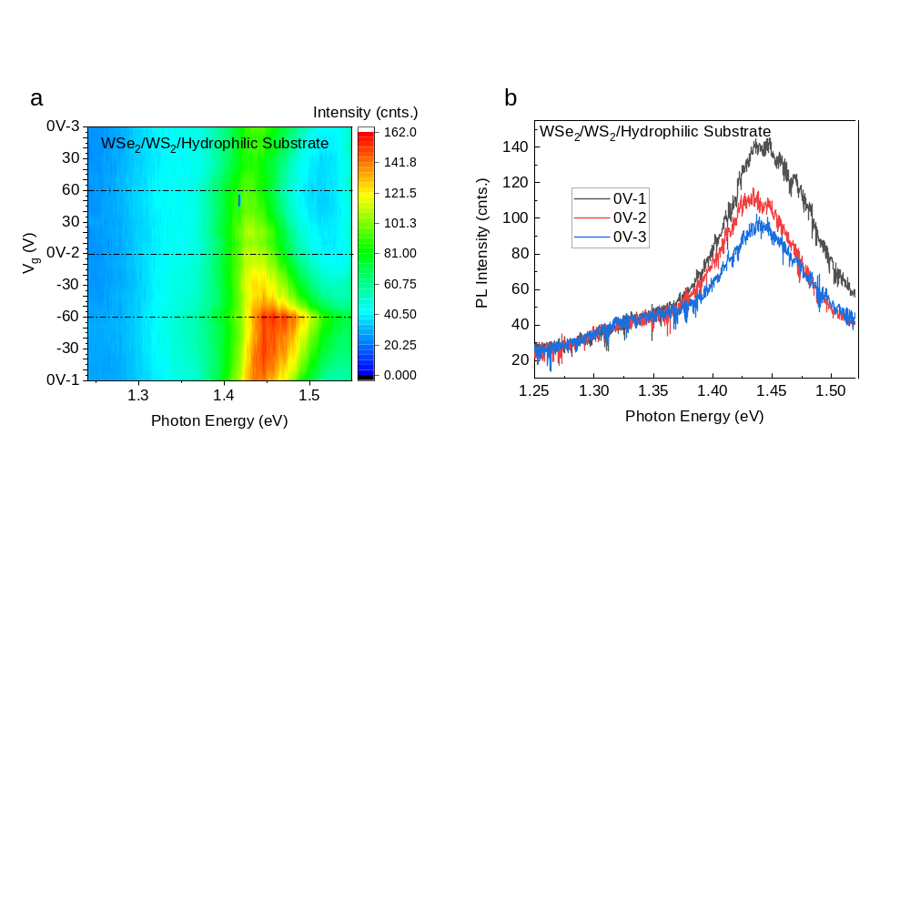
Fig. S1|Gate-dependent PL spectra for a stacking-order inversed HS (WSe₂/WS₂) on a hydrophilic substrate. The device shows contrary behaviors to that of WS₂/WSe₂ HS shown in Fig. 2a, thus proving the Stark effect. However, this device exhibits no excitonic hysteresis during the cyclic-V_{g} sweeping. This might be resulted from the Coulomb screening of electrons that are transferred from WSe₂ due to the type-II band alignment.

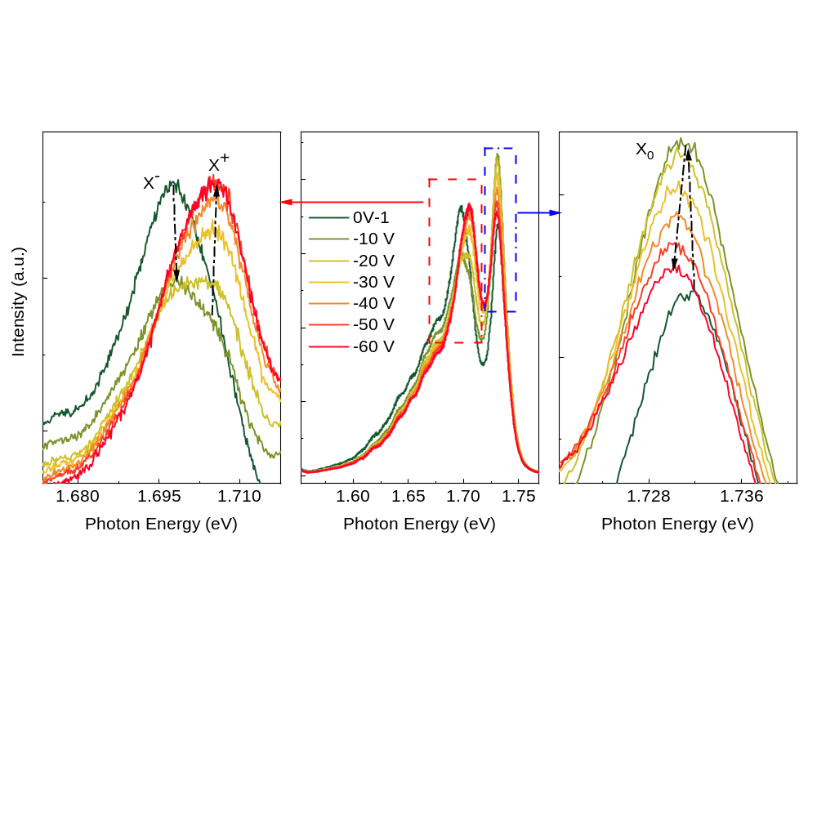
Fig. S2|PL spectra of the WSe₂ monolayer under gate voltages from 0 V to −60 V shown in Fig. 3a. The trion peak ($X^{-}$/$X^{+}$) and the neutral exciton ($X_{0}$) evolve non-monotonously as V_{g} changes. The $X^{-}$ peak is gradually suppressed while the $X^{+}$ peak is enhanced. Meanwhile, the $X_{0}$ peak is abnormally strengthened at first and then weakened gradually. Such peculiar features strongly suggest that the WSe₂ is preliminarily n-doped, and gradually become p-doped by the efficient gate control.

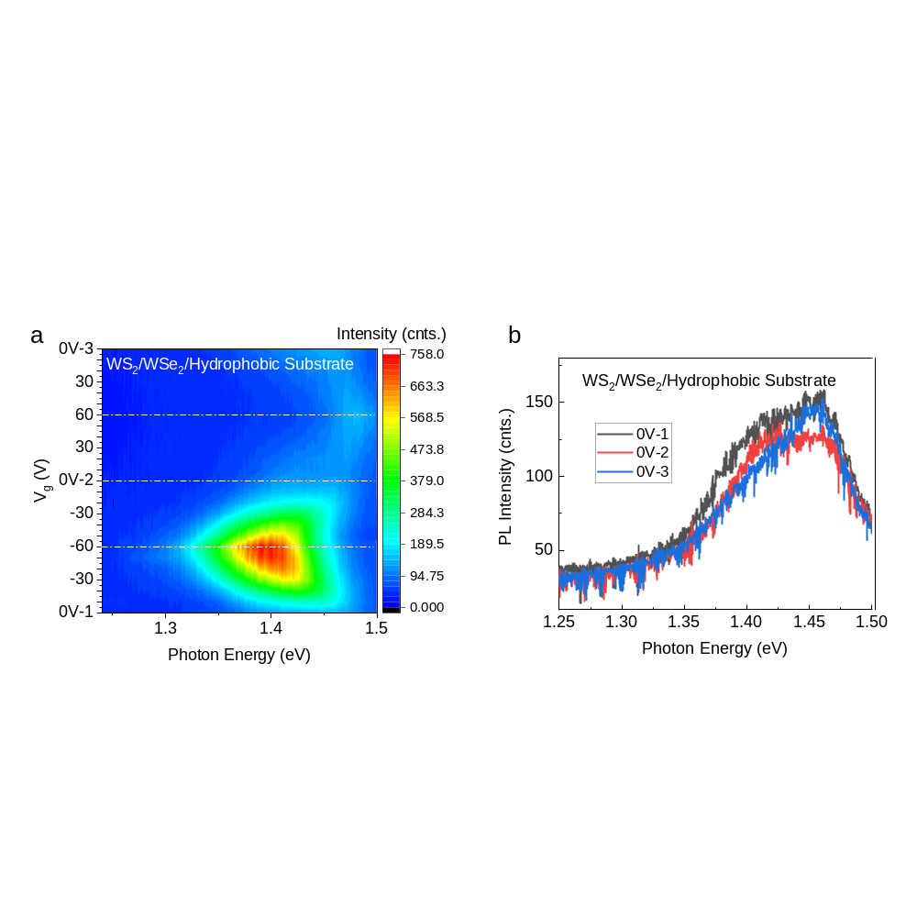
Fig. S3|Gate-dependent PL spectra for a WS₂/WSe₂ HS on a hydrophobic substrate. The device shows similar behaviors to that of WS₂/WSe₂ on hydrophilic substrate shown in Fig. 2a, but with no hysteresis, thus proving the importance role of O₂/H₂O molecules.
Fig. S4|Gate-dependent PL spectra of a WS₂/WSe₂/BN HS. The WS₂/WSe₂ HS was transferred on a hydrophilic SiO₂/Si substrate with a region insulated by a thin layer BN as a and d shows. b-c, Gate-dependent PL spectra of the WS₂/WSe₂ HS region. e-f, Gate-dependent PL spectra of the WS₂/WSe₂/BN HS region.
The hysteresis was observed only in the region where WS₂/WSe₂ HS is directly contacted with the hydrophilic substrate, other than the region that is insulated by BN, thus proving the important role of O₂/H₂O molecules.

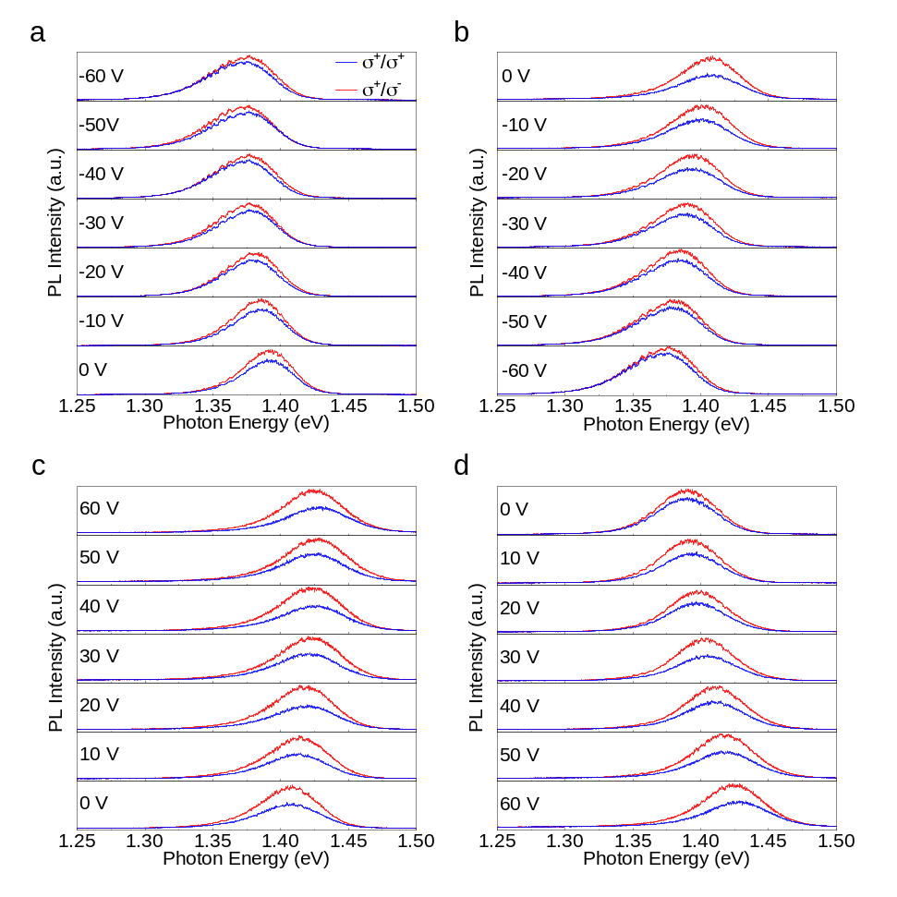
Fig. S5|Helicity–resolved PL spectra of the WS₂/WSe₂ HS. The valley-polarized degree can be efficiently modulated by V_{g}, and shows a strong hysteresis. a-d, The helicty-resolved PL spectra upon V_{g} sweeping from 0 V ~ −60 V, −60 V ~ 0 V, 0 V ~ 60 V, 60 V ~ 0 V, respectively.

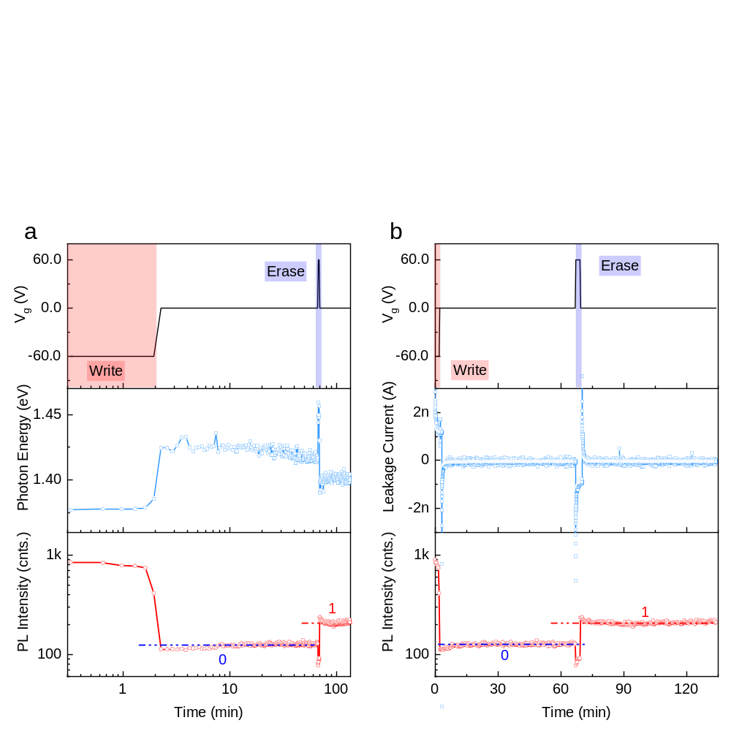
Fig. S6|Electrically controlled memory operation in the HS. a, Fig. 5b that is replot in logarithmic timescale; b, Leakage current and PL intensity upon V_{g} varied with time. The retention time should be much longer than 60 minutes, because both the energy and intensity of IX emission gradually level off as time went by. The leakage current changes exponentially near the edges of writing and reading V_{g}, suggesting that the dynamic evolution of IX emission is resulted from charging and discharging processes.
Fig. S7|Memory performance of the WS₂/WSe₂ HS under different temperatures. a, Contour plot of the PL spectra under cyclic writing/reading/erasing operations at 150 K, 200 K, 250 K and 300 K, respectively. b, Circularly polarized PL spectra of IX under different temperatures. c, Absolute circular polarization degree of IX upon temperature.
The memory performance of IX degrades as the temperature increases. Intriguingly, the information encoding ability of the device can host up to 250 K with good energy difference of the 1 and 0 bits.

