Supplementary Data A
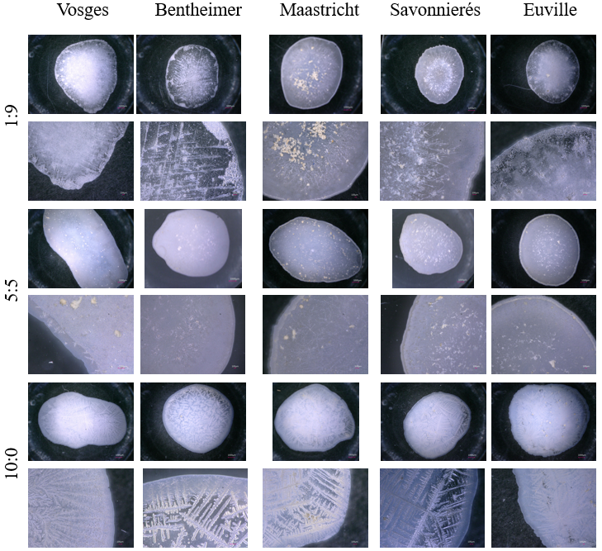
Figure A. Microscopic images of crystallization on glass surfaces from bacterial solutions previously incubated with stone samples (Vosges, Bentheimer, Maastricht, Savonnières, and Euville). Rows indicate different PE:LE ratios (1:9, 5:5, 10:0), while columns represent the bacterial communities originating from each stone.

Supplementary Data B
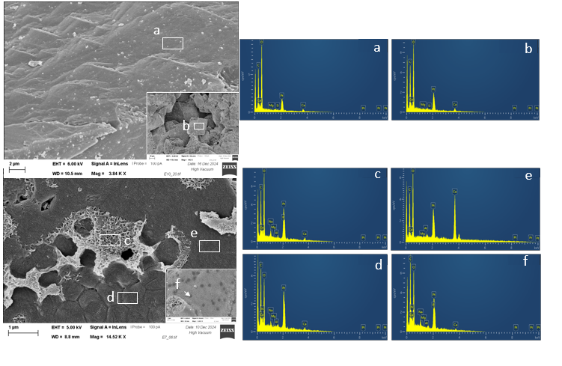
Figure B.1 EDS Spectrum of untreated (up) and treated (down) Euville stone.
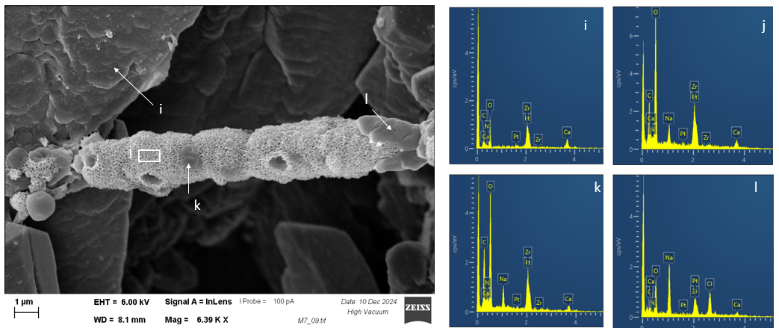
Figure B.2. EDS Spectrum of treated Maastricht stone.
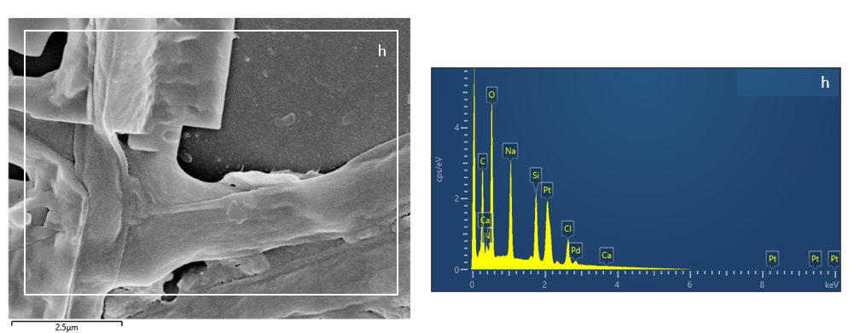
Figure B.3. EDS spectrum of treated Bentheimer stone.

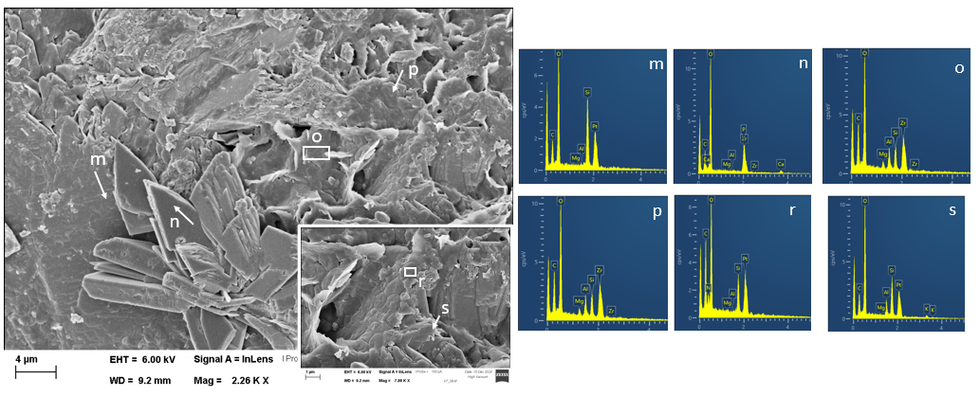
Figure B.4. EDS spectrum of treated Vosges stone.

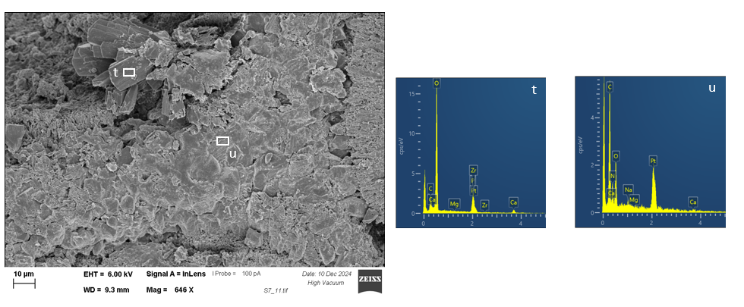
Figure B.5. EDS spectrum of treated Savonnierés stone.
Supplementary Data C

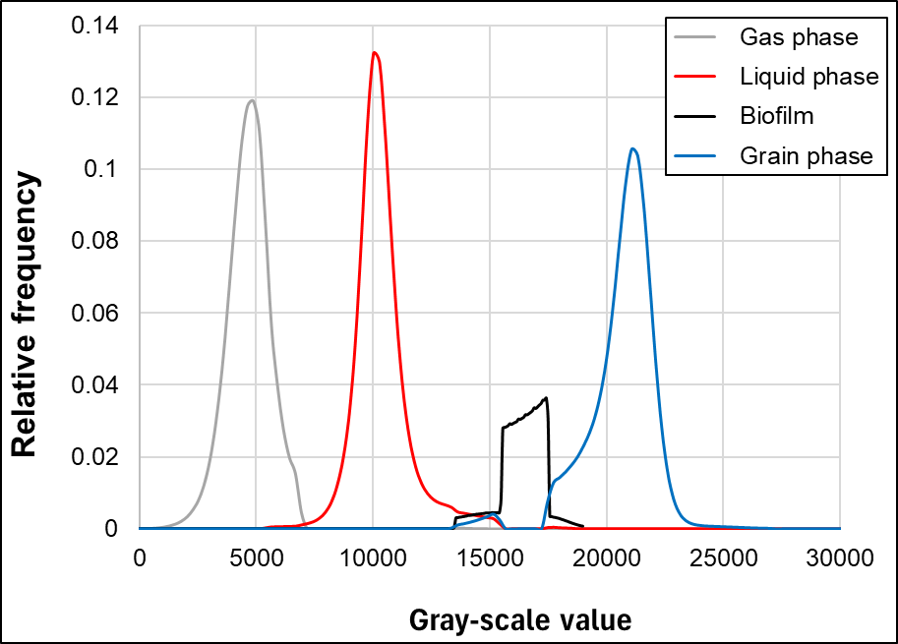
Figure C.1 Intensity histograms of different phases (gas, liquid, biofilm, and grain) observed in the image of the sample treated with Lugol.

