Supplementary Materials
Keyhole fluctuation and pore formation mechanisms during laser powder bed fusion additive manufacturing

Yuze Huang^{1,2*}, Tristan G. Fleming³, Samuel J. Clark^{1,2,4}, Sebastian Marussi^{1,2}, Kamel Fezzaa⁴, Jeyan Thiyagalingam⁵, Chu Lun Alex Leung^{1,2*}, Peter D. Lee^{1,2*}
¹UCL Mechanical Engineering, University College London, WC1E 7JE, UK
²Research Complex at Harwell, Harwell Campus, Didcot, OX11 0FA, UK
³Department of Physics, Queen's University, Kingston, Ontario, K7L 3N6, Canada
⁴X-ray Science Division, Argonne National Laboratory, Lemont, IL 60439, US
⁵Science and Technology Facilities Council, Harwell Campus, Didcot, OX11 0FA, UK
*emails: peter.lee@ucl.ac.uk, yuze.huang@ucl.ac.uk, and alex.leung@ucl.ac.uk

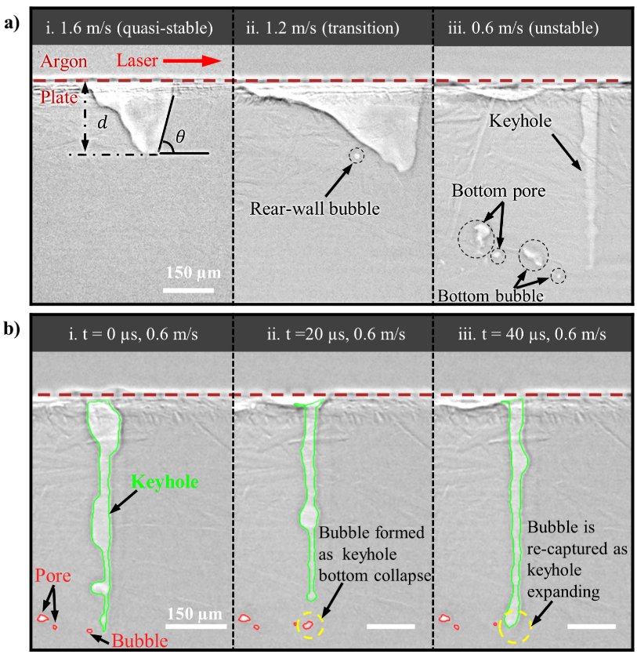
Fig S.1. a) Keyhole morphology variations with different kinds of bubble formation by changing laser velocities during laser melting with bare aluminium plate. Laser power 500 W. $d$ and $θ$ represent the keyhole depth and keyhole front-wall angle, respectively. b) Re-captured bubble by the expanding keyhole.
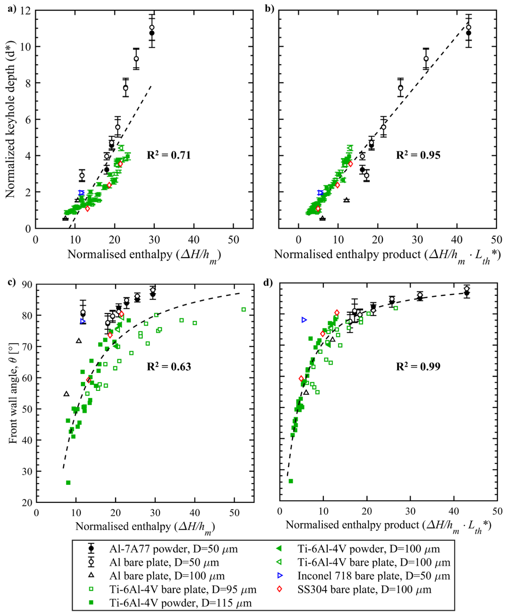
Fig S.2. Comparing the scaling relations of keyhole depth (normalised by laser beam size) and keyhole front-wall angle with normalised enthalpy and normalised enthalpy product. Normalised keyhole depth as a function of (a) normalised enthalpy and (b) normalised enthalpy product for 9 datasets with 4 different materials. Front-wall angle as a function of normalised enthalpy (c) and normalised enthalpy product (d) for 9 datasets with 4 different materials. (d) has been shown in Fig 2 (b), which is used here for compare. The synchrotron X-ray radiography was achieved via LPBF with and without Al7A77 powder, where laser power and laser beam diameter are 500 W and 50 µm, respectively. The data of Ti-6Al-4V material with LPBF were cited from Cunningham et al.¹ (Figs.4, S5 and S7) and Zhao et al.² (Movie S1 -Movie S5) with permission by AAAS. Data for LPBF with Inconel 718, SS 304 and aluminium bare plate were cited from Kouraytem et al.³, Parab et al.⁴, and Hojjatzadeh et al.⁵, respectively.
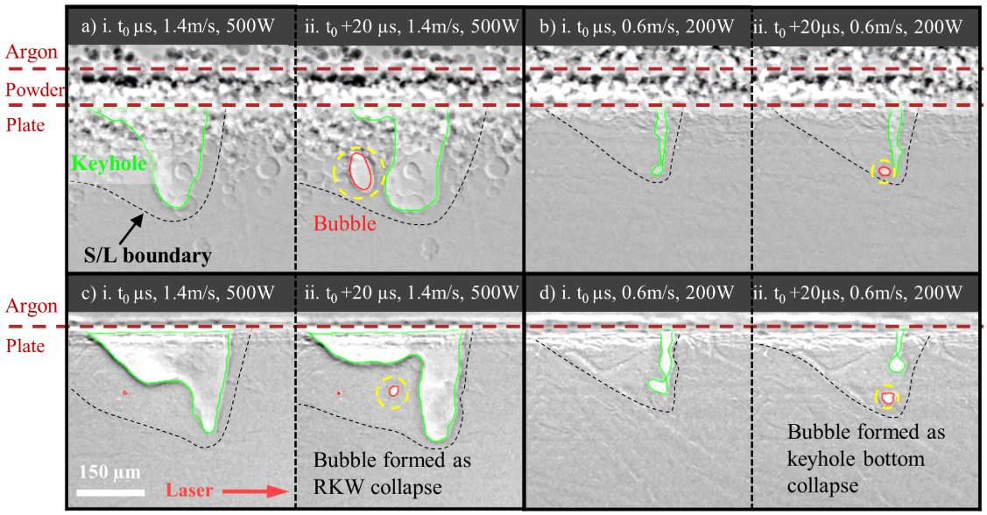
Fig S. 3. Keyhole morphology variations with different kinds of bubble formation at (a), (c) high-power-velocity (high-PV) and (b), (d) low-power-velocity (low-PV) while keeping same energy density $ED=7 MJ∙m^{-2}$ during LPBF with and without powder layer. t₀ is the time moment that the RKW starts to grow. The keyhole and bubble are tracked by the developed algorithm shown in Method section, coloured by green and red, respectively. The interested bubbles are highlighted with yellow-dash-line circle.
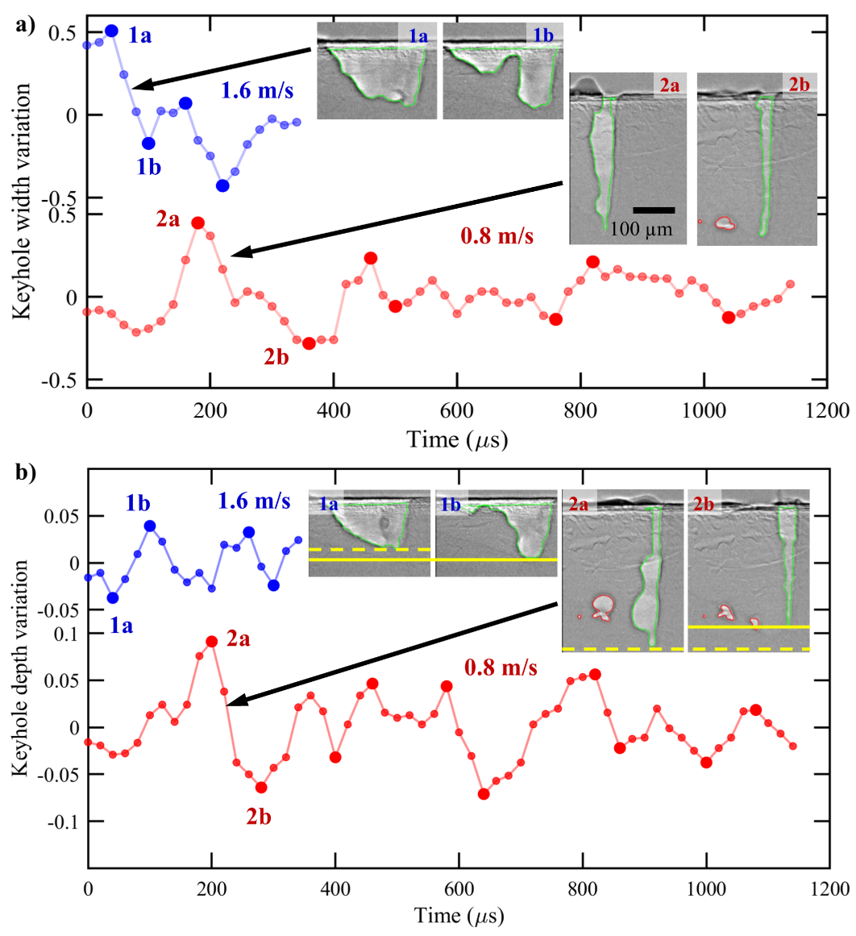
Fig S.4. Temporal keyhole width a) and keyhole depth b) relative to the mean. Laser melting with scan speeds of 1.6 m/s (top, blue) and 0.8 m/s (bottom, red) with pure aluminium plate. Laser power 500 W.

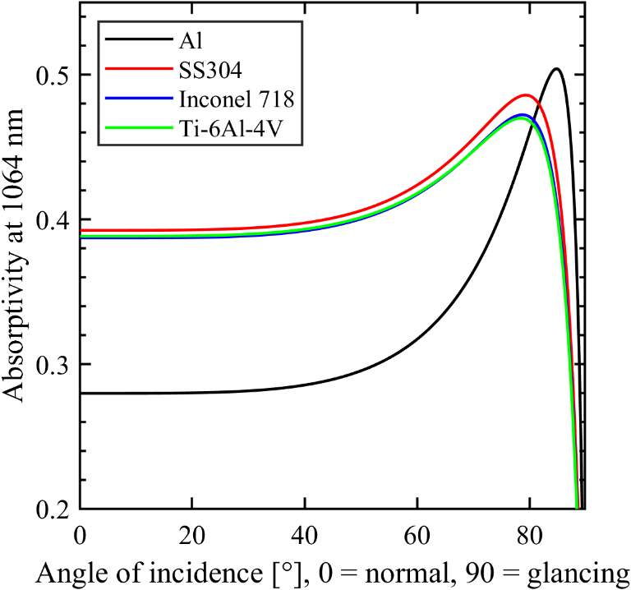
Fig S.5. Laser absorptivity (Fresnel absorption) variations for a surface of molten metal with varying angle of incidence, for the studied materials, showing Brewster angles are ~84.8°, 79.3°, 78.7° and 78.4° for Al, SS304, Inconel 718 and Ti-6Al-4V, respectively. The associated physical property values for the absorptivity calculation are shown in the Table S. 1 (material density) and Table S. 2.
Fig S.6. Compared the average keyhole depth with that of the average pore depth (distance from top of powder bed to the centre of pore) at different normalised enthalpy products.
Fig S.7. Compared the tracked bubble numbers from the in situ synchrotron X-ray images with and without powder at different normalised enthalpy products. Only the bubbles were induced by keyhole collapse were tracked here, excluding the latterly formed bubbles by bubble splitting. Track length 5 mm.
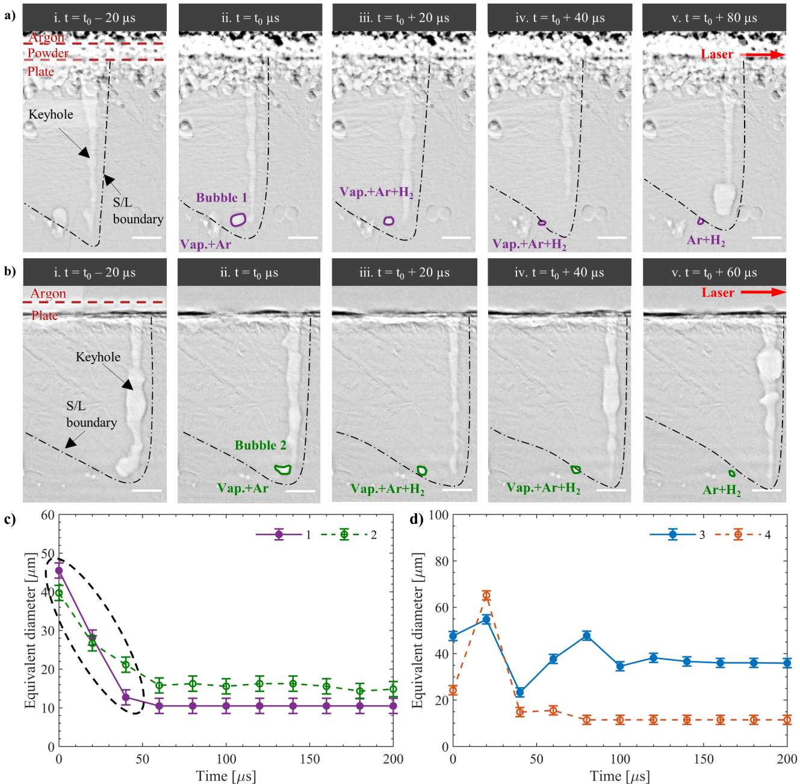
Fig S.8. Keyhole bubble lifetime dynamics during LPBF. Laser velocity 0.6 m/s and laser power 500 W. (a) and (b) are radiographs with Al7A77 powder and bare aluminium plate, respectively. (c) and (d) show the equivalent diameter changes of some tracked bubbles in LPBF with (solid line) and without (dash line) Al7A77 powder. The equivalent diameter is calculated as $\sqrt{{6A}/π}$, $A$ is the bubble area measured from X-ray image by the processing algorithms listed in Methods. Note the bubble size error is calculated as ± 2 pixels (1.96 µm/pixel), equivalent to the segmentation uncertainty. The total tracked bubble numbers are 15 and 17 for the powder and bare plate cases (see Fig S. 9 b), respectively, using a criterion where the minimum number of frames that a bubble is identified is 6. The time t₀=0 is set to the moment a bubble is first identified. The black dashed circles show stage (ii) bubble shrink due to vapour condensation. The interested keyhole pores shown in (a) and (b) are marked by purple and red colours, which are also shown with same colours in (c) and (d), respectively. Vap.: Vapour; Ar: Argon; H₂: Hydrogen. All white scale bars correspond to 100 µm.

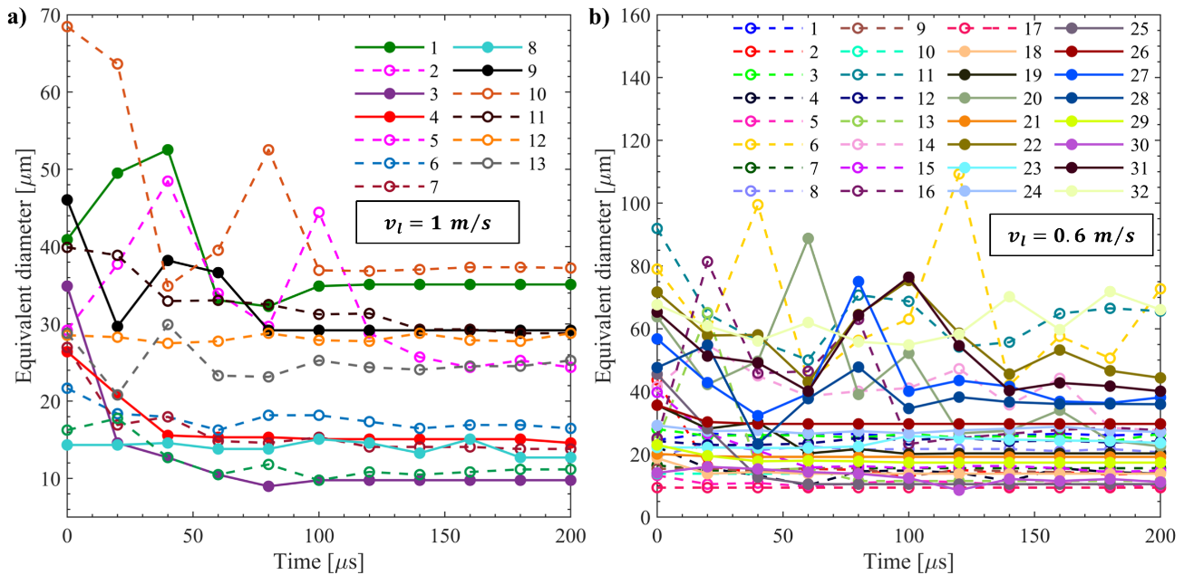
Fig S. 9. Equivalent diameter variations of all tracked keyhole bubbles during LPBF over the 1.29 mm long FOV. (a) Laser velocity 1 m/s and laser power 500 W. (b) Laser velocity 0.6 m/s and laser power 500 W. Note that the melting with and without Al7A77 powder are presented as solid and dash lines, respectively. Note identical graphs with error bars in Fig.3 and Fig S.8. The equivalent diameter is calculated as $\sqrt{{6A}/π}$, $A$ is the bubble area measured from X-ray image by the processing algorithms listed in Methods. In tracking (Methods), the minimum number of frames that a bubble is identified is set as 6. The time 0 is set to the moment that a bubble is first identified.

Supplementary Methods
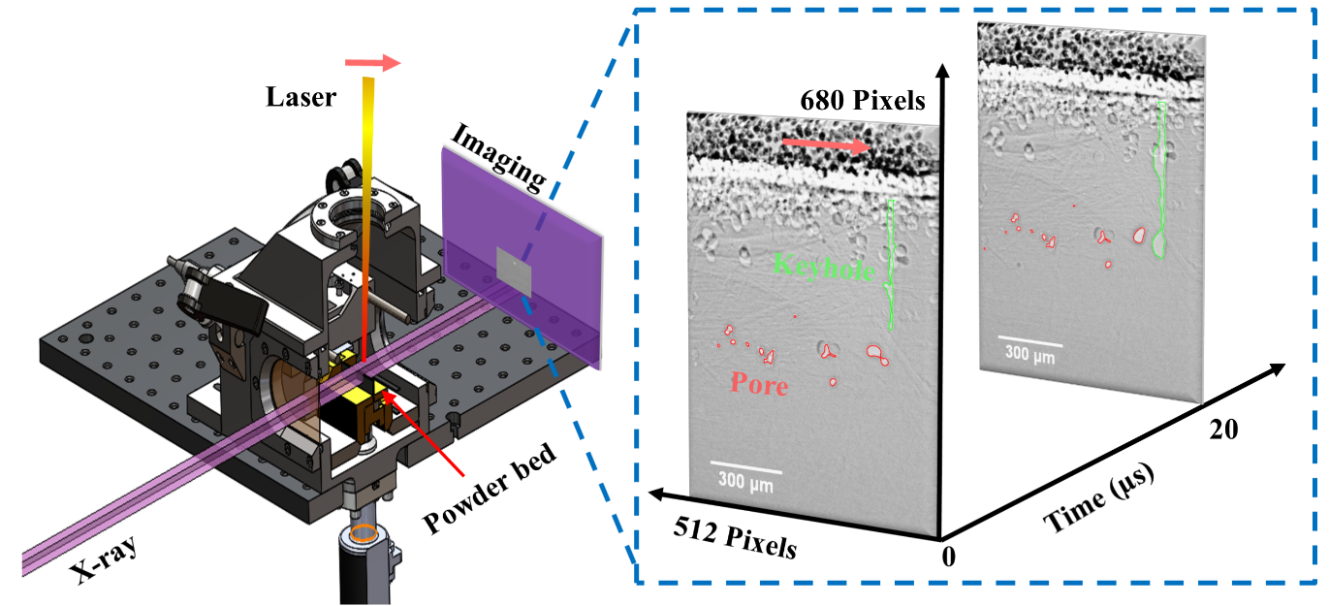
Fig S.10. Schematic of the in situ synchrotron X-ray imaging experiments with time-series radiographs acquisition.
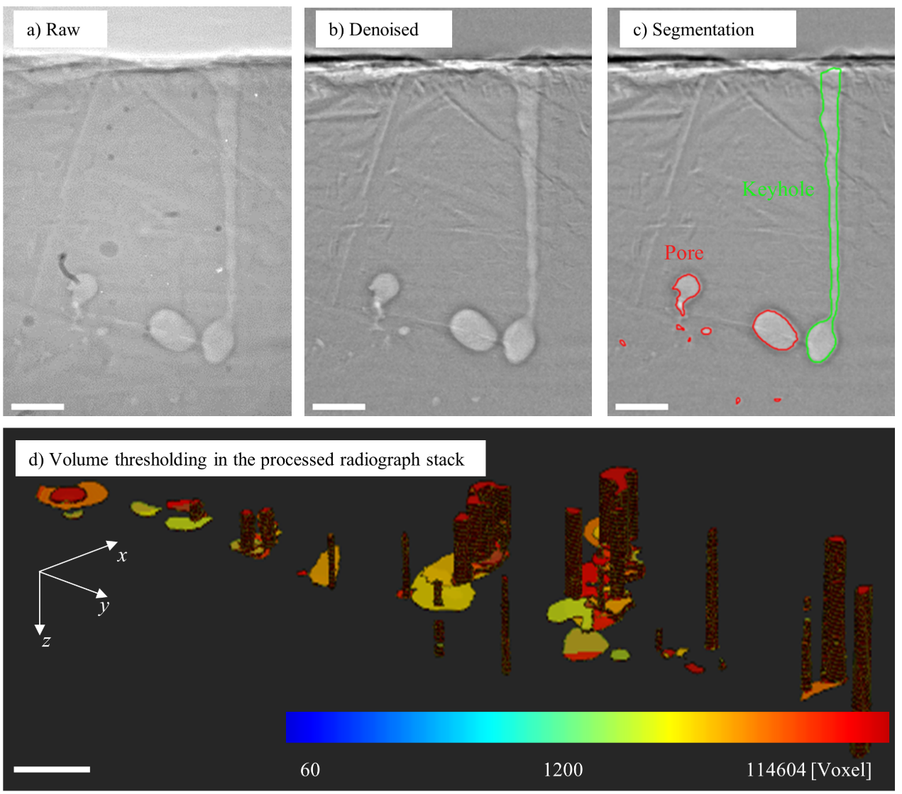
Fig S.11. Image processing sequence on a frame of radiographs video stack with scanning speed 0.6 m/s and laser power 500 W. (a) The original image. (b) Flat field correction, subtracting the offset background, followed by Gaussian filtering. (c) Feature segmentation. (d) Frame stack integration with voxel thresholding. Keyhole is marked by green boundary while pores are marked by red boundary. All white scale bars correspond to 100 µm.
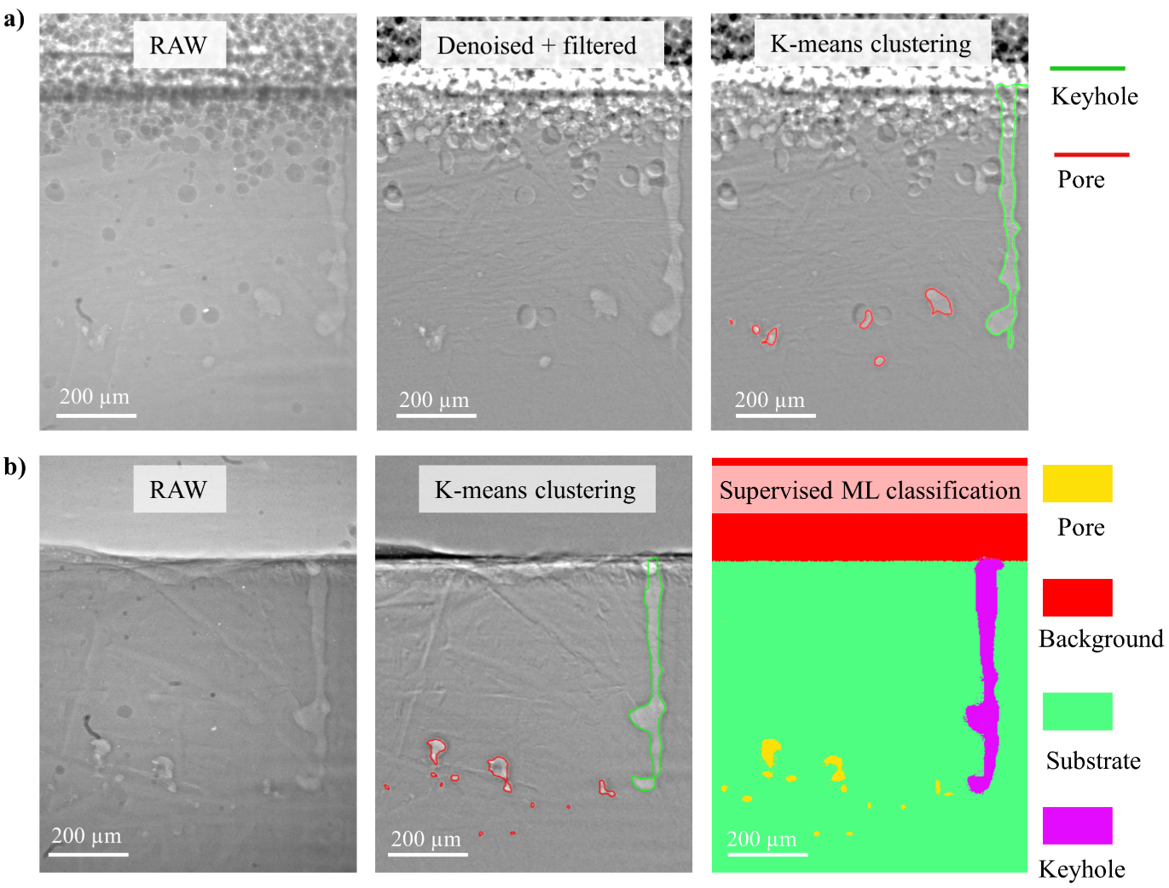
Fig S.12. Analysis and feature extraction for X-ray synchrotron radiograph videos of LPBF with different segmentation methodologies. a) Keyhole and keyhole pore extraction via K-means clustering for LPBF with Al7A77 powder. b) Keyhole and keyhole pore extraction via K-means clustering and supervised machine leaning (random decision forests) for laser melting without powder. Laser power 500 W, scan velocity 0.6 m/s, laser beam diameter 50 µm.

Supplementary Note 1: The relationship of normalised enthalpy product to keyhole front-wall angle.
Based on the energy balance in the LPBF process, the melting pool advanced distance in axial direction during the dwell time of ${r_{l}}/{v_{l}}$ ($r_{l}$ is laser beam radius, $v_{l}$ the laser velocity), being equal to the melt depth $d_{m}$, can be estimated as⁶,
 | $$d_{m}=K_{1}∙\left(\frac{∆H}{h_{m}}\right)∙L_{th}$$ | (S1-1)
where $K_{1}$ is a coefficient to account for differences between the actual and modelled melt pool geometry, $L_{th}=\sqrt{{(α_{l}⋅r_{l})}/{v_{l}}}$ the thermal diffusion length and ${ΔH}/{h_{m}}={(β⋅P_{l})}/{\left(h_{m}\sqrt{π⋅α_{l}⋅v_{l}⋅r_{l}^{3}}\right)}$ ($P_{l}$ the laser power, $β$ the laser absorptivity, $α_{l}$ the liquid thermal diffusivity) is the normalised enthalpy.
In the keyhole melting regime, the keyhole depth $d$ is approximately equal to the melt pool depth⁷ and any difference being incorporated into coefficient $K_{2}$, $d≈K_{1}∙K_{2}∙\left(\frac{∆H}{h_{m}}\right)∙L_{th}$. This relation can be made independent of laser beam size by normalizing with respect to the laser beam diameter $d_{l}$,
 | $$\frac{d}{d_{l}}=K_{1}∙K_{2}∙\frac{1}{2}∙\left(\frac{∆H}{h_{m}}\right)∙\left(\frac{L_{th}}{r_{l}}\right)=K_{3}∙\frac{∆H}{h_{m}}∙L_{th}^{*}$$ | (S1-2)
where $K_{3}={K_{1}∙K_{2}}/2$ is coefficient and $L_{th}^{*}=\sqrt{α/{\left(u⋅r_{l}\right)}}$ is the normalised thermal diffusion length.
The inclination of front keyhole wall (FKW) is determined by its equilibrium kinematic condition, described as $\tan{θ}={v_{d}}/{v_{l}}$ ($θ$ the FKW angle, $v_{d}$ the drilling velcoity), which can be also estimated based on keyhole geometry as⁸, $tan θ≈d/{d_{l}}$. Recent studies^{1,2} also reported linear relations between the $\tan{θ}$ and the keyhole depth $d$ over different materials under keyhole melting regime during LPBF. Zhao et al.² found that the projection of keyhole front wall $s$, defined as $s=d/{tan θ}$, can fluctuate around an effective laser spot size and then decrease with a decrease of scan velocity, but the linear relation between $\tan{θ}$ and $d$ still hold over all the keyhole porosity boundary (including low-power-velocity).
Accordingly, the FKW angle can be expressed in the function of the normalised enthalpy as,
 | $$tan θ≈K_{3}∙\left(\frac{∆H}{h_{m}}\right)∙L_{th}^{*}$$ | (S1-3)
or equivalently,
 | $$θ≈atan\left(K_{3}∙\frac{∆H}{h_{m}}∙L_{th}^{*}\right)$$ | (S1-4)
Of note, this can also be re-expressed in terms of the Péclet number $Pe$, $Pe={\left(L⋅v_{l}\right)}/α$ ($L$ the characteristic length⁹ and it is approximated as the laser beam diameter, $L≈2r_{l}$), by replacing the thermal diffusion length as $L_{th}^{*}=\sqrt{2}\frac{1}{\sqrt{P_{e}}}$ ,
 | $$θ≈atan\left[K_{3}∙{\left(\frac{∆H}{h_{m}}\right)}/{\sqrt{P_{e}}}\right]$$ | (S1-5)

Supplementary Note 2: Hump formation on FKW
Hump formation is driven by the dependence of laser absorptivity on angle of incidence^{10–13}, as defined by the Fresnel curve for a given material. Considering an initially flat FKW (Fig S.13a), the most energy is deposited in the zone exposed to the centre of the laser beam. This zone then experiences the most intense evaporation and resulting recoil pressure force. After a short delay (~10 – 100 µs) depending on the thermal diffusion length, fluid begins flowing away from this zone around the sides of the keyhole towards the melt pool at the rear, driving the zone away from the laser beam axis (Fig S.13b). This leads to further non-uniformity in angle of incidence and creates a cold zone (near the top of the FKW in Fig S.13b). With less evaporation and recoil pressure, the cold zone moves back towards the laser beam axis to repeat this process (Fig S.13c and d). In this way, humps are repeatedly and fairly regularly formed at the top of the FKW, and the existing humps migrate down the FKW.
The magnitude of humps depends directly on the front-wall angle, with the largest humps expected for front-wall angles closest to the Brewster angle ($\sim 80-{85}^{°}$), around which the laser absorptivity changes dramatically for a small change in angle of incidence. The frequency of hump generation depends on the drilling and laser scanning velocities. For high scanning speeds, cold zones move back towards the laser beam axis the quickest, generating humps at the highest frequency. In fact, for high enough scanning velocities, the front wall is observed to smooth out entirely with little/no hump generation. This is a result of (i) fluid flow always lagging the laser scanning velocity (thermal diffusion length/time much smaller than the spot size/dwell time), preventing hot zones from moving any significant distance from the laser beam axis, and (ii) front-wall angles well below the Brewster angle where absorptivity is considerably less sensitive to angle of incidence.
Fig S.13. Schematic diagram of mechanism for hump formation on the front keyhole wall (FKW), illustrating the relative motion of the laser beam and the top edge of the FKW, local hot and cold zones at the top and side of each hump due to lower/higher angles of incidence, and the flow of ejected metal vapour away from the local hot zones.

Supplementary Note 3: Bubble dynamics induced by the interaction with cellular-dendrites
As the bubble reached the solid/liquid (S/L) boundary but before it was fully captured, the bubble can grow and shrink rapidly over the solidification front, shown in Fig S.14a, b with different laser scan speeds. We hypothesise that this phenomenon is induced by the interaction of the rapidly growing microstructure and the bubble, which were also observed in the solidification of aluminium alloy during casting^{14,15}, illustrated in the Fig S.14c. As seen, due to the cellular-dendrite growth, the bubble may be squeezed to change its shape in the observed plane of synchrotron X-ray imaging, and there is a chance that the bubble is partially hided by the growing cellular structure, and only partial bubble can be clearly observed or probed by the synchrotron X-ray imaging. Our ex situ micro-computed tomography (μCT) of the track sample, shown in Fig S.14e, also confirms that the 3D morphology of pore may be irregular. We used the purple dash-line circle to highlight the interested pore and its associated bubble as shown in Fig S.14e and Fig S.14b, respectively. It was found that the final captured pore’s morphology by in situ synchrotron X-ray (Fig S.14b, 280µs) is more like a specific cross-section of the final 3D pore presented by the μCT, which is partially hided by the cellular-dendrites as the bubble got wrapped around the dendrites. Note that we used similar locations (e.g., centroids) of the pores to correlate between in situ synchrotron X-ray and ex situ μCT.
To further check the microstructure, ex situ micrographs (Fig S.14d, f) were also achieved over the transverse cross-section of the track sample. As noticed from Fig S.14d, f, grains with size around 30 ~ 100 µm grow perpendicular to the melt pool border but towards the melt pool centre. A closer look with higher magnification (Fig S.14f) shows much finer cellular–dendritic solidification structure with a size of 4.1 ± 0.38 µm. Those quantified sizes of grain and cellular are consistent with prior reports of aluminium alloy in LPBF, measured as ~ 50 µm and ~ 1µm for grain and cellular¹⁶, respectively. Those ex situ micrographs (Fig S.14d, f) confirm that the pore can be engulfed by the cellular microstructure, in turn, the cellular size around the pore can cause disruption to cellular growth, serving as thermal insulation, decreasing the localised solidification rate and temperature gradient¹⁷, and finally leading to different cellular sizes on different sides of the pore, shown in Fig S.14f.
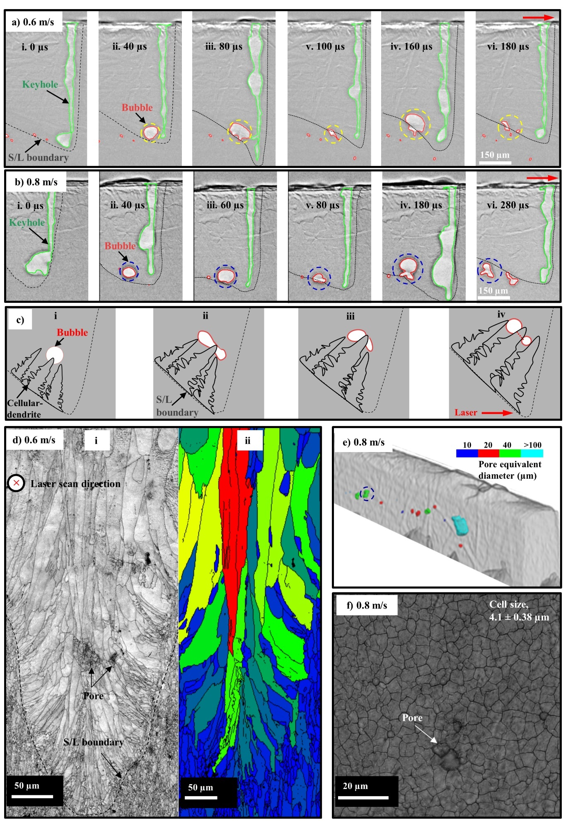
Fig S.14. Probe the bubble dynamics induced by the cellular-dendrite growth over the solid/liquid boundary. a), b) Bubble behaviours revealed from experimental configuration of the in situ synchrotron X-ray imaging under laser scan velocity 0.6 and 0.8 m/s. Laser power 500 W. c) Illustration of the observed bubble size change due to cellular-dendrite growth. d) EBSD band contrast (i) and grain size spread shown with rainbow colour (ii). e) Micro-computed tomography of track sample. f) Microstructure image shown by a laser microscope VHX-7000 (Keyence, Itasca, USA) with 2500X magnification.

Supplementary Tables
Table S. 1. Thermophysical properties for pure aluminium, Ti-6Al-4V, SS304 and Inconel 718 at the liquidus temperature¹⁸. Absorptivity values are averages over reported values for an unpolished, oxidized flat surface (commercial-grade) at room temperature, as well as elevated temperatures^{19–22} for laser beam with 1µm wavelength.
Material | Density (kg·m⁻³) | Liquidus temperature (K) | Heat capacity (J·kg⁻¹·K⁻¹) | Thermal diffusivity (10⁶ m^{2·}s⁻¹) | Absorptivity | Melting enthalpy  (10⁹ J·m⁻³)
Aluminium | 2385 | 933.5 | 1180 | 32 | 0.15 | 6.264
Ti-6Al-4V | 3920 | 1923 | 831 | 8.6 | 0.45 | 2.627
SS304 | 6900 | 1727 | 800 | 5.6 | 0.40 | 9.533
Inconel 718 | 7400 | 1609 | 720 | 5.6 | 0.40 | 8.573

Table S. 2. Physical property values for the studied materials, fed into the Fresnel/Drude model for absorptivity of a metal surface with varying angle of incidence, for further details see Mahrle and Beyer²³. The property values of aluminium, Ti-6Al-4V, SS304 and Inconel 718 were cited from references^{24–27}.
Material | Valence electrons per atom | Electric resistivity (10⁻⁸ Ω·m) | Atomic mass (10⁻³ kg·mol⁻¹)
Aluminium | 3 | 25 |  | 27
Ti-6Al-4V | 2 | 176 |  | 22
SS304 | 4 | 150 |  | 55
Inconel 718 | 2 | 169 |  | 28

Table S. 3. Characteristic parameters of the first identified bubble (radius, surface temperature) and process parameters (laser power, velocity and absorptivity (calculated based on the measured front keyhole wall angle, see Supp. Fig S.5)) and recoil pressure and pressure-driven bubble growth time calculated using Equations 2 – 4 (Methods) and ideal gas law²⁸. Laser power 500 W, laser beam diameter 100 um, ambient pressure $1.01×{10}^{5} Pa$.
Bubble initial radius, $r_{b0}$ (µm) | Laser velocity, $v_{l}$ (m/s) | Laser absorptivity, $β$ | Bubble surface temperature, $T_{bs}$ (K) | Recoil pressure, $p_{recoil}$ (${10}^{5} Pa$) | Pressure-driven bubble growth time, $t_{1}$(µs)
18.4 | 0.8 | 0.5 | 3463 | 23 | 5.4
21.8 | 1.2 | 0.45 | 1488 | 6 | 3.4

Supplementary Reference
1. Cunningham, R. et al. Keyhole threshold and morphology in laser melting revealed by ultrahigh-speed x-ray imaging. Science (80-. ). 363, 849–852 (2019).
2. Zhao, C. et al. Critical instability at moving keyhole tip generates porosity in laser melting. Science (80-. ). 370, 1080–1086 (2020).
3. Kouraytem, N. et al. Effect of Laser-Matter Interaction on Molten Pool Flow and Keyhole Dynamics. Phys. Rev. Appl. 11, 064054 (2019).
4. Parab, N. D. et al. Ultrafast X-ray imaging of laser–metal additive manufacturing processes. J. Synchrotron Radiat. 25, 1467–1477 (2018).
5. Hojjatzadeh, S. M. H. et al. Direct observation of pore formation mechanisms during LPBF additive manufacturing process and high energy density laser welding. Int. J. Mach. Tools Manuf. 153, (2020).
6. Ye, J. et al. Energy Coupling Mechanisms and Scaling Behavior Associated with Laser Powder Bed Fusion Additive Manufacturing. Adv. Eng. Mater. 21, 1900185 (2019).
7. Gan, Z. et al. Universal scaling laws of keyhole stability and porosity in 3D printing of metals. nature.com (2020).
8. Fabbro, R. Melt pool and keyhole behaviour analysis for deep penetration laser welding. J. Phys. D. Appl. Phys. 43, (2010).
9. Guo, Q. et al. In-situ full-field mapping of melt flow dynamics in laser metal additive manufacturing. Addit. Manuf. 31, 100939 (2020).
10. Tan, W. & Shin, Y. C. Analysis of multi-phase interaction and its effects on keyhole dynamics with a multi-physics numerical model. J. Phys. D. Appl. Phys. 47, (2014).
11. Kaplan, A. F. H. Fresnel absorption of 1 μm- and 10 μm-laser beams at the keyhole wall during laser beam welding: Comparison between smooth and wavy surfaces. Appl. Surf. Sci. 258, 3354–3363 (2012).
12. Kaplan, A. F. H. & Matti, R. S. Absorption peaks depending on topology of the keyhole front and wavelength. J. Laser Appl. 27, S29012 (2015).
13. Eriksson, I. New high-speed photography technique for observation of fluid flow in laser welding. Opt. Eng. 49, 100503 (2010).
14. Lee, P. D., Wang, J. & Atwood, R. C. Microporosity Formation during the Solidification of Aluminum-Copper Alloys. JOM 5 (2009).
15. Lee, P. D. & Hunt, J. D. Model of the interaction of porosity and the developing microstructure. in Modeling of Casting, Welding and Advanced Solidification Processes 585–592 (1995).
16. Thijs, L., Kempen, K., Kruth, J. P. & Van Humbeeck, J. Fine-structured aluminium products with controllable texture by selective laser melting of pre-alloyed AlSi10Mg powder. Acta Mater. 61, 1809–1819 (2013).
17. Pham, M. S., Dovgyy, B., Hooper, P. A., Gourlay, C. M. & Piglione, A. The role of side-branching in microstructure development in laser powder-bed fusion. Nat. Commun. 11, (2020).
18. Mills, K. C. Thermophysical Properties of Selected Commercial Alloys. (2011).
19. Rubenchik, A. M. et al. Temperature-dependent 780-nm laser absorption by engineering grade aluminum, titanium, and steel alloy surfaces. Opt. Eng. 53, 122506 (2014).
20. Boley, C. D., Mitchell, S. C., Rubenchik, A. M. & Wu, S. S. Q. Metal powder absorptivity: modeling and experiment. Appl. Opt. 55, 6496 (2016).
21. Rubenchik, A. et al. Direct measurements of temperature-dependent laser absorptivity of metal powders. Appl. Opt. 54, 7230 (2015).
22. Trapp, J., Rubenchik, A. M., Guss, G. & Matthews, M. J. In situ absorptivity measurements of metallic powders during laser powder-bed fusion additive manufacturing. Appl. Mater. Today 9, 341–349 (2017).
23. Mahrle, A. & Beyer, E. Theoretical aspects of fibre laser cutting. J. Phys. D Appl. 42, 9 (2009).
24. Pawel, R. E. & Williams, R. K. Survey of physical property data for several alloys. (1985).
25. Milck, J. T. Electrical resistivity data and bibliography on titanium and titanium alloys. (1970).
26. Ho, C. Y. & Chu, T. K. Electrical resistivity and thermal conductivity of nine selected AISI S. (1977).
27. Brandt, R. & Neuer, G. Electrical Resistivity and Thermal Conductivity of Pure Aluminum and Aluminum Alloys up to and above the Melting Temperature. Int. J. Thermophys. 28, 1429–1446 (2007).
28. Lee, P. D., Chirazi, A. & See, D. Modeling microporosity in aluminum-silicon alloys: A review. Journal of Light Metals vol. 1 15–30 (2001).

Movie 1
Dynamics of keyhole and keyhole bubbles during LPBF with 30 µm thick Al7A77 powder layer in the denoised synchrotron X-ray radiograph. The camera frequency rate is 50 kHz. The horizontal and vertical dimensions of the images are 1 mm and 1.33 mm, respectively. Laser power is 500 W, scanning velocity is 0.6 m/s.

Movie 2
Segmented keyhole (green colour) and keyhole bubble (red colour) during LPBF with 30 µm thick Al7A77 powder layer in the denoised synchrotron X-ray radiograph. Laser power is 500 W, scanning velocity is 0.6 m/s.

Movie 3
Dynamics of keyhole and keyhole bubbles during laser melting with bare aluminium plate in the denoised synchrotron X-ray radiograph. The camera frequency rate is 50 kHz. The horizontal and vertical dimensions of the images are 1 mm and 1.33 mm, respectively. Laser power is 500 W, scanning velocity is 0.6 m/s.

Movie 4
Segmented keyhole (green colour) and keyhole bubble (red colour) during laser melting with bare aluminium plate in the denoised synchrotron X-ray radiograph. Laser power is 500 W, scanning velocity is 0.6 m/s.

Movie 5
Dynamics of keyhole and keyhole bubbles during laser melting with bare aluminium plate in the denoised synchrotron X-ray radiograph. The camera frequency rate is 50 kHz. The horizontal and vertical dimensions of the images are 1 mm and 1.33 mm, respectively. Laser power is 500 W, scanning velocity is 0.8 m/s.

Movie 6
Segmented keyhole (green colour) and keyhole bubble (red colour) during laser melting with bare aluminium plate in the denoised synchrotron X-ray radiograph. Laser power is 500 W, scanning velocity is 0.8 m/s.

Movie 7
Dynamics of keyhole and keyhole bubbles during LPBF with 30 µm thick Al7A77 powder layer in the denoised synchrotron X-ray radiograph. The camera frequency rate is 50 kHz. The horizontal and vertical dimensions of the images are 1 mm and 1.33 mm, respectively. Laser power is 500 W, scanning velocity is 1 m/s.

Movie 8
Segmented keyhole (green colour) and keyhole bubble (red colour) during LPBF with 30 µm thick Al7A77 powder layer in the denoised synchrotron X-ray radiograph. Laser power is 500 W, scanning velocity is 1 m/s.

Movie 9
Dynamics of keyhole and keyhole bubbles during LPBF with 30 µm thick Al7A77 powder layer in the denoised synchrotron X-ray radiograph. The camera frequency rate is 50 kHz. The horizontal and vertical dimensions of the images are 1 mm and 1.33 mm, respectively. Laser power is 500 W, scanning velocity is 1.2 m/s.

Movie 10
Dynamics of keyhole and keyhole bubbles during laser melting with bare aluminium plate in the denoised synchrotron X-ray radiograph. The camera frequency rate is 50 kHz. The horizontal and vertical dimensions of the images are 1 mm and 1.33 mm, respectively. Laser power is 500 W, scanning velocity is 1.2 m/s.

Movie 11
Segmented keyhole (green colour) and keyhole bubble (red colour) during laser melting with bare aluminium plate in the denoised synchrotron X-ray radiograph. Laser power is 500 W, scanning velocity is 1.2 m/s.

Movie 12
Dynamics of keyhole and keyhole bubbles during LPBF with 30 µm thick Al7A77 powder layer in the denoised synchrotron X-ray radiograph. The camera frequency rate is 50 kHz. The horizontal and vertical dimensions of the images are 1 mm and 1.33 mm, respectively. Laser power is 500 W, scanning velocity is 1.6 m/s.

