Supplementary information:
Fabrication of a Low-Kink-Radius Bilayer Vascular Scaffold Incorporating a TPU Stent Fabricated via Melt Electrowriting and an Electrospun PCL/PU/Gelatin Layer
Mohamad Shahverdi ^{a,1}, Hossein Shaygani ^{b,c,1}, Mohamadreza Soltani ^{b,c}, Kayvan Dadkhah ª, Seyed Mohammad Hossein Rezaei Demneh ^{b,c}, Kaivan Mohammadi ^{a *}, Amir Shamloo ^{b,c **}
ª Advanced Manufacturing Laboratory, School of Mechanical Engineering, Sharif University of Technology, Azadi Ave., Tehran, Iran
^{b} Nano BioTechnology Laboratory, School of Mechanical Engineering, Sharif University of Technology, Tehran, Iran
^{c} Stem Cell and Regenerative Medicine Institute, Sharif University of Technology, Tehran 7 11155-9161, Iran.
¹ Equal contribution

*Corresponding Author: Dr. K. Mohammadi, School of Mechanical Engineering, Sharif University of Technology, Azadi Ave., Tehran, IRAN, Tel: 98-21-66165585, Email: kaivan.mohammadi@sharif.edu

**Corresponding Author: Dr. A. Shamloo, School of Mechanical Engineering, Sharif University of 13 Technology, Azadi Ave., Tehran, IRAN, Tel: 98-21-66165691, Fax: 98-21-66165599, email: 14 shamloo@sharif.edu

Supplementary note 1:
Please Double click (Notepad file)

Figure S1:
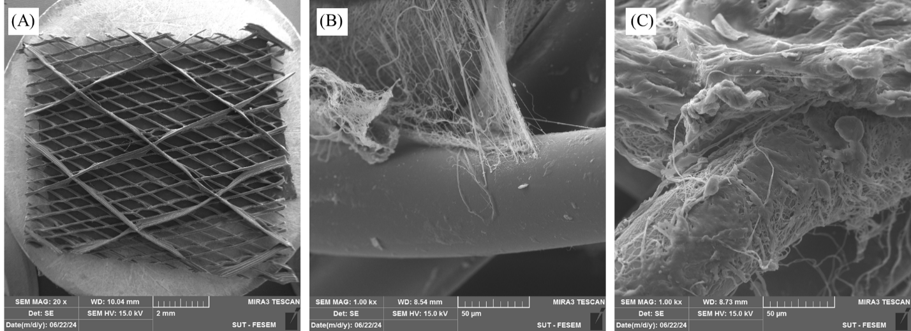
Fig. S1: FE-SEM images of the MEW Integrated layer (A), Adhesion of co-electrospun/MEW

