Supplemental material for Spontaneous EBV-positive B cell line from rectal tumor: characterization, interaction with autologous tumor-infiltrating T lymphocytes, comparison with B lymphoma cell lines
Tatiana V. Petrova¹*, Daria V. Kuznetzova¹, Alexandra V. Kanygina¹, Liubov O. Skorodumova¹, Viktor A. Ivanov¹, Tatiana A. Astrelina², Svetlana E. Varlamova², Elena I. Sharova¹*
*Correspondence: Tatiana V. Petrova, petrozik@gmail.com Elena I. Sharova sharova78@gmail.com
Table of contents
Supplementary Figures
Supplementary Tables
Supplementary Figures
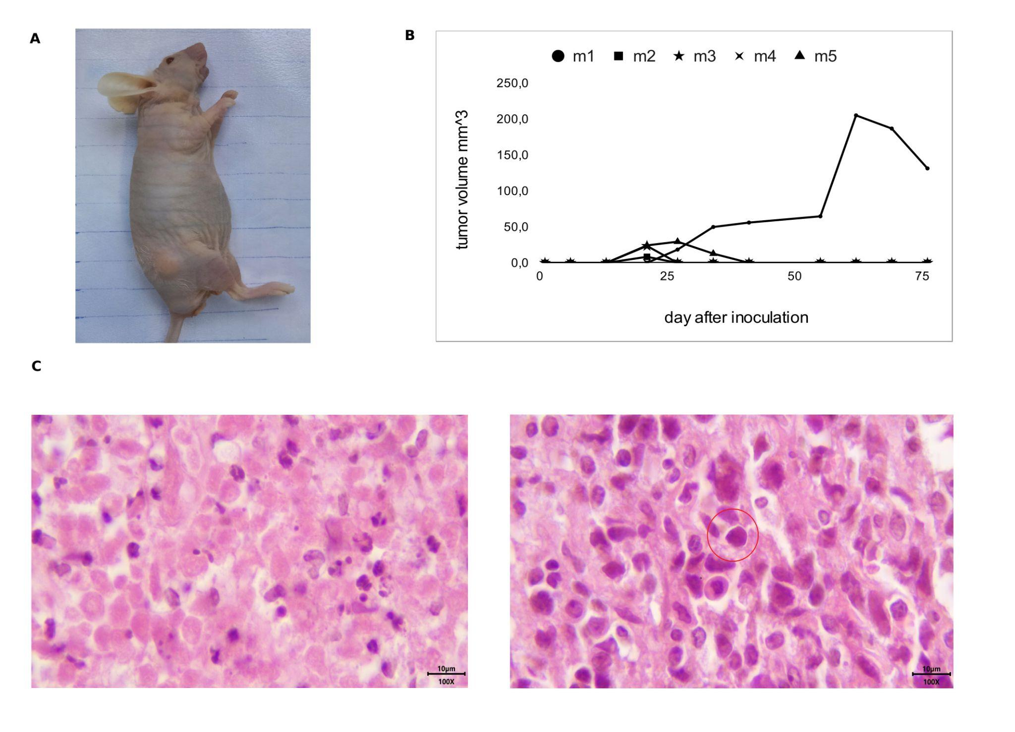
Supplementary Figure 1. Tumorigenicity of the lcl_burn0214 cell line in NU–A/A Tyrc/Tyrc Foxn1nu/Foxn1nu mice.
A Representative image of the tumor-bearing mouse.
B Tumor growth curve. One million cells of lcl_burn0214 cell line were subcutaneously inoculated into 5 NU–A/A Tyrc/Tyrc Foxn1nu/Foxn1nu male mice (m1-m5). Graft growth was monitored over the subsequent 75 days. Four (m2-m5) out of five lcl_burn0214 grafts regressed over time, with the exception of the tumor in mouse m1.
C Hematoxylin and eosin staining of tumor graft section from m1 mice (tissue sections are 3.5 mkm thick). The xenograft tumor exhibited large zones of necrosis with few alive blasts, the blast on the representative image is highlighted with a red circle (scale bar = 10 μm, 100x magnigication).

Supplementary Tables

Supplementary Table 1. Number of BCR clonotypes and proportion of the most frequent BCR clonotype in tum_burn0214 and lcl_burn0214 samples
BCR chain name | tum_burn0214  Number of clonotypes/proportion of the most frequent BCR clonotype | lcl_burn0214  Number of clonotypes/proportion of the most frequent BCR clonotype
IGH | 176/0.12 | 16/.92
IGK | 305/0.28 | 14/0.99
IGL | 180/0.1 | 8/0.98

Supplementary Table 2A. Cell deconvolution analysis of tum_burn0214 and lcl_burn0214 samples using bulk RNA-seq data and EPIC method
cell entity | lcl_burn0214 | tum_burn0214
B cell | 0,43 | 0,00
Cancer associated fibroblast | 0,00 | 0,01
T cell CD4+ | 0,00 | 0,01
T cell CD8+ | 0,00 | 0,01
Endothelial cell | 0,00 | 0,01
Macrophage | 0,00 | 0,00
NK cell | 0,00 | 0,00
uncharacterized cell | 0,57 | 0,95

Supplementary Table 2B. Cell deconvolution analysis of tum_burn0214 and lcl_burn0214 samples using bulk RNA-seq data and xCell method
cell entity | lcl_burn0214 | tum_burn0214
Myeloid dendritic cell activated | 0,00 | 0,00
B cell | 1,01 | 0,00
T cell CD4+ memory | 0,01 | 0,00
T cell CD4+ naive | 0,00 | 0,00
T cell CD4+ (non-regulatory) | 0,00 | 0,00
T cell CD4+ central memory | 0,00 | 0,00
T cell CD4+ effector memory | 0,00 | 0,00
T cell CD8+ naive | 0,00 | 0,00
T cell CD8+ | 0,00 | 0,00
T cell CD8+ central memory | 0,00 | 0,00

Supplementary Table 2C. Cell deconvolution analysis of tum_burn0214 and lcl_burn0214 samples using bulk RNA-seq data and MCP method
cell entity | lcl_burn0214 | tum_burn0214
T cell | 1,49 | 2,18
T cell CD8+ | 0,00 | 4,12
cytotoxicity score | 8,65 | 2,34
NK cell | 0,01 | 0,14
B cell | 1141,69 | 30,40
Monocyte | 10,82 | 3,49
Macrophage/Monocyte | 10,82 | 3,49
Myeloid dendritic cell | 1,01 | 1,14
Neutrophil | 6,96 | 3,92
Endothelial cell | 2,67 | 3,76

Supplementary Table 3. Short tandem repeat profiles of the PBMC_burn0214, TIL_burn0214 and lcl_burn0214 cell line at passages 15 and 53
Locus | PBMC_ burn0214 | TIL_burn0214 | lcl_burn0214_p53 | lcl_burn0214_p15
Amelogenin | X;Y | X;Y | X;Y | X;Y
D3S1358 | 17 | 17 | 17 | 17
D1S1656 | 15;16 | 15;16 | 15;16 | 15;16
D2S441 | 11 | 11 | 11 | 11
D10S1248 | 14;16 | 14;16 | 14;16 | 14;16
D13S317 | 9;11 | 9;11 | 9;11 | 9;11
Penta E | 10;12 | 10;12 | 10;12 | 10;12
D16S539 | 10;12 | 10;12 | 10;12 | 10;12
D18S51 | 14;16 | 14;16 | 14;16 | 14;16
D2S1338 | 23;26 | 23;26 | 23;26 | 23;26
CSF1PO | 11 | 11 | 11 | 11
Penta D | 12 | 12 | 12 | 12
TH01 | 6 | 6 | 6 | 6
vWA | 16;17 | 16;17 | 16;17 | 16;17
D21S11 | 32.2 | 32.2 | 32.2 | 32.2
D7S820 | 10 | 10 | 10 | 10
D5S818 | 12;13 | 12;13 | 12;13 | 12;13
TPOX | 8;11 | 8;11 | 8;11 | 8;11
D8S1179 | 11;12 | 11;12 | 11;12 | 11;12
D12S391 | 19;21 | 19;21 | 19;21 | 19;21
D19S433 | 12;15 | 12;15 | 12;15 | 12;15
SE33 | 18;30.2 | 18;30.2 | 18;30.2 | 18;30.2
D22S1045 | 15;16 | 15;16 | 15;16 | 15;16
DYS391 | 10 | 10 | 10 | 10
FGA | 20;21 | 20;21 | 20;21 | 20;21
DYS576 | 19 | 19 | 19 | 19
DYS570 | 18 | 18 | 18 | 18

Supplementary Table 4. Characteristics of selected B cell lines from Quentmeier H. dataset
Entity | Cell line name | Selected aberrations | Sex | Age | Ethnicity | EBV status | ERR #
B-NHL: PLL | MEC-1 | R3HCC1L-HTRA1 | M | 61 | european | positive | ERR3003563
B-NHL: PLL | PGA-1 |  | M | n.d. | caucasian | positive | ERR3003584
B-NHL: DLBCL | NU-DHL-1 | t(3;8)(p25;q24); t(14;18)(q32;q21) | M | 73 | european | negative | ERR3003577
B-NHL: DLBCL | DOHH-2 | t(8;14;18)(q24;q32;q21) | M | 60 | european | negative | ERR3003528
B-NHL: HCL | BONNA-12 |  | M | 46 | european | positive | ERR3003517
B-NHL: HCL | HC-1 |  | M | 56 | european | positive | ERR3003535
B-NHL: mantle cell lymphoma | REC-1 | t(11;14)(q13;q32) | M | 61 | european | negative | ERR3003587
B-NHL: PEL | BC-3 |  | M | 85 | european | negative | ERR3003514
B-NHL: PEL | CRO-AP2 |  | M | 49 | european | positive | ERR3003522
Hodgkin Lymphoma | HDLM-2 |  | M | 64 | european | negative | ERR3003536
B-cell non-Hodgkin lymphoma (B-NHL); hairy cell leukemia (HCL); primary effusion lymphoma (PEL); prolymphocytic leukemia (PLL); diffuse large B cell lymphoma (DLBCL)

