Supplementary Information for Water Resources Management

Evaluating the Performance of Automatic Detection for Urban Flood Levels Using Different Deep Learning Approaches
Zhonglin Zhao ¹, Baohong Lu ¹*, Shuo Zhang ^{2, 1, 3}, Daoli Wang ¹, Jiaquan Wan ¹, Ranyu Liu ¹, Huang Li ⁴, Zhensong Wang ⁵
¹ College of Hydrology and Water Resources, Hohai University, Nanjing, 210024, China.
² Institute of Water Resources and Tecnology, Hohai University, Nanjing, 210024, China.
³ Chinese Research Academy of Environmental Sciences, Beijing, 100012, China.
⁴ China Electric Power Construction Zhongnan Survey and Design Institute Co., Ltd, Changsha, 425099, China
⁵ Shenzhen Water Bureau, Shenzhen, 518000, China.

Supplementary Information
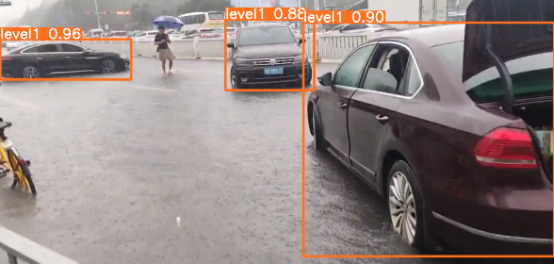 |  | 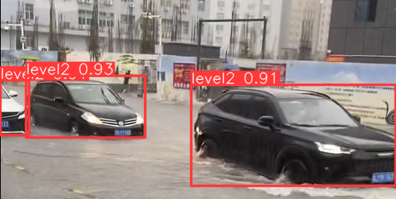
(a) F1 |  | (b) F2
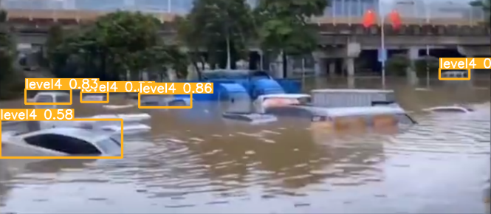 |  | 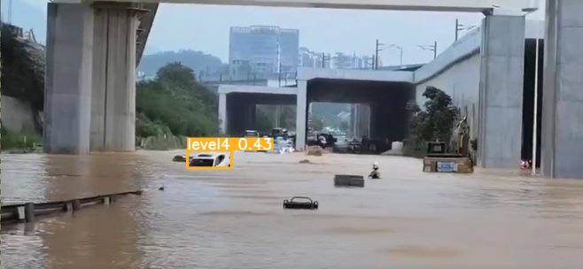
(c) F3 |  | (d) F4
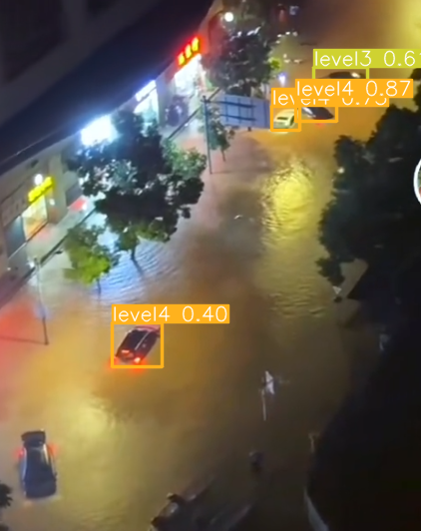 | 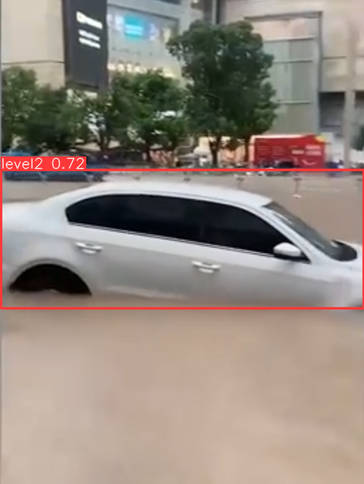 |  | 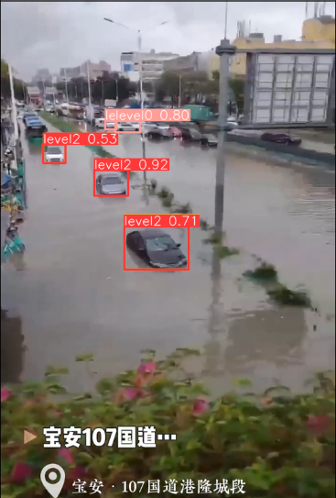
(e) F5 | (f) F6 |  | (g) F7
Fig. 7 Detection results with YOLOv10m.
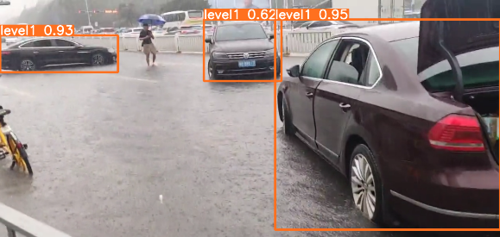 |  | 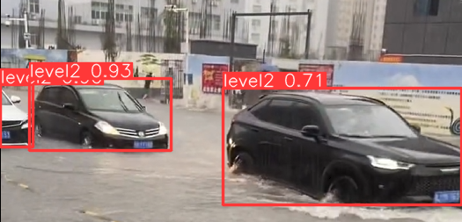
(a) F1 |  | (b) F2
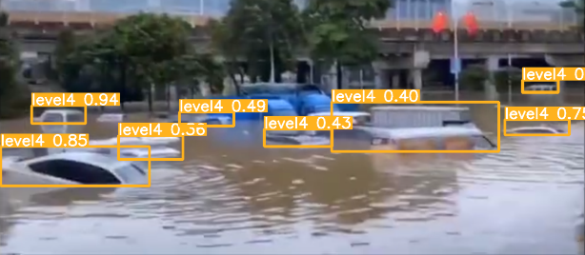 |  | 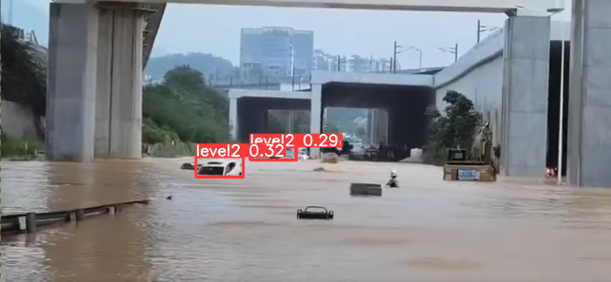
(c) F3 |  | (d) F4
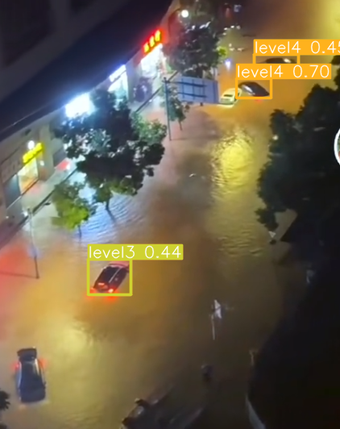 | 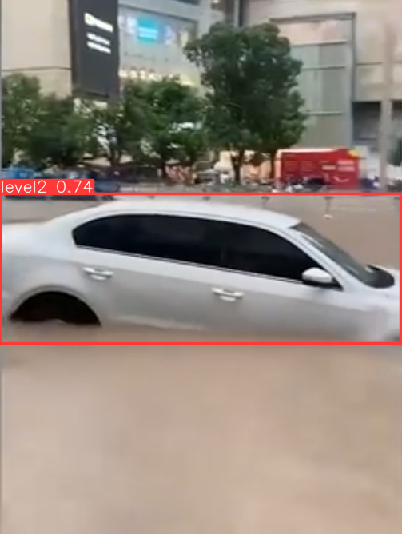 |  | 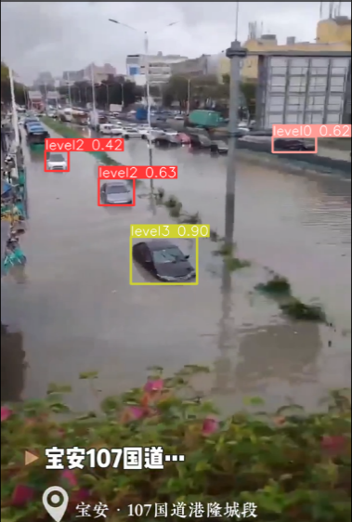
(e) F5 | (f) F6 |  | (g) F7
Fig. 8 Detection results with YOLOv10s.
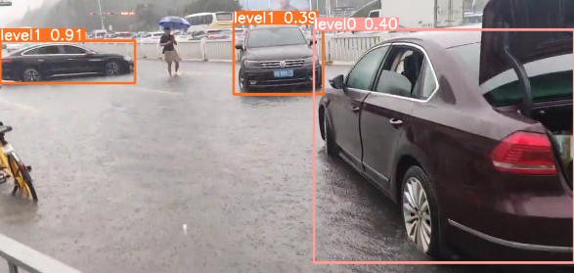 |  | 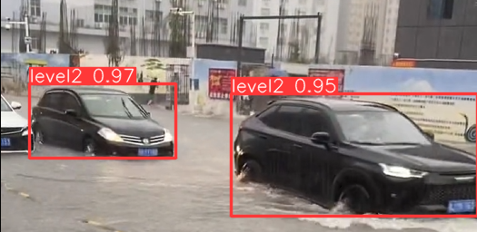
(a) F1 |  | (b) F2
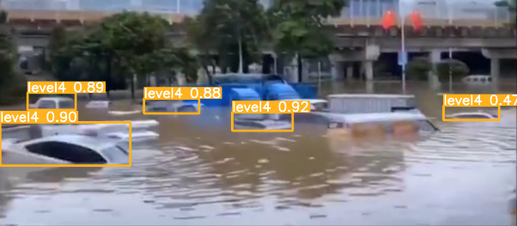 |  | 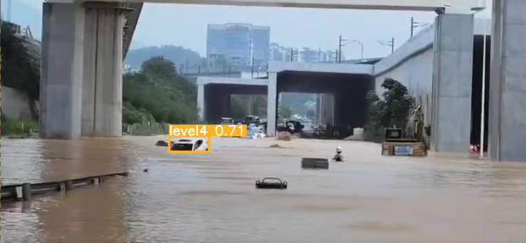
(c) F3 |  | (d) F4
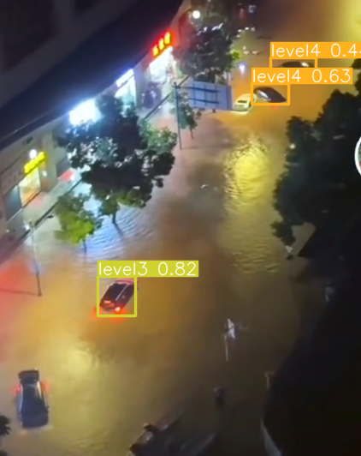 | 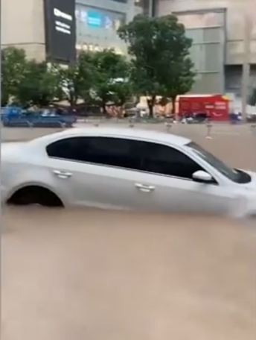 |  | 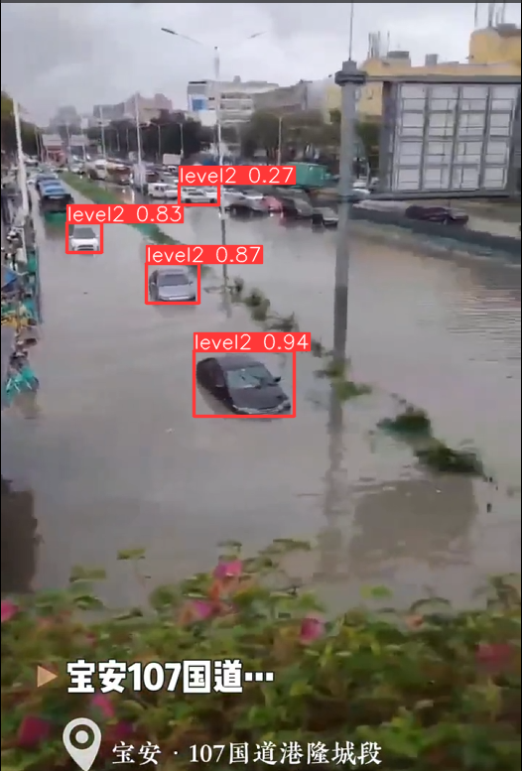
(e) F5 | (f) F6 |  | (g) F7
Fig. 9 Detection results with YOLOv10l.
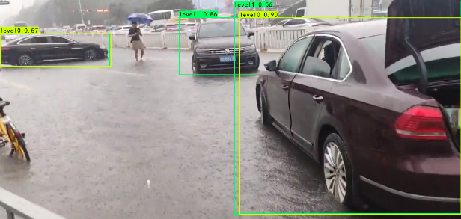 |  | 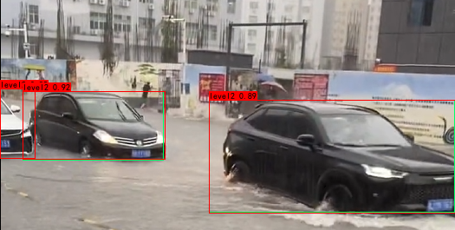
(a) F1 |  | (b) F2
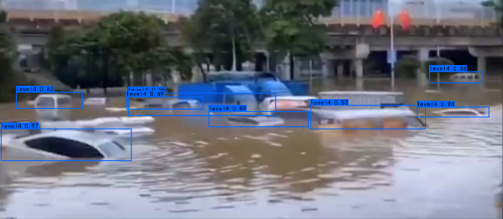 |  | 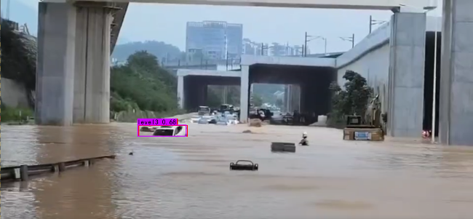
(c) F3 |  | (d) F4
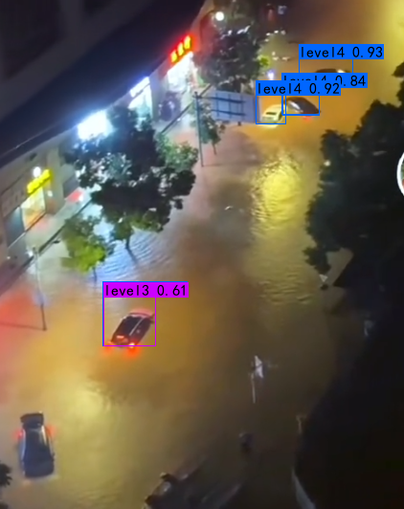 | 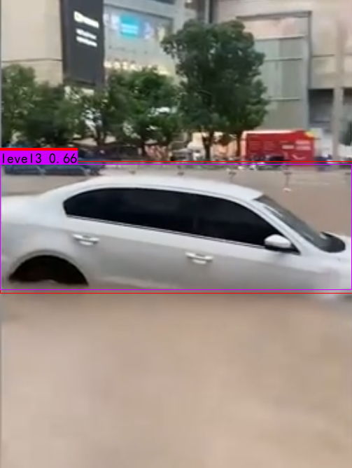 |  | 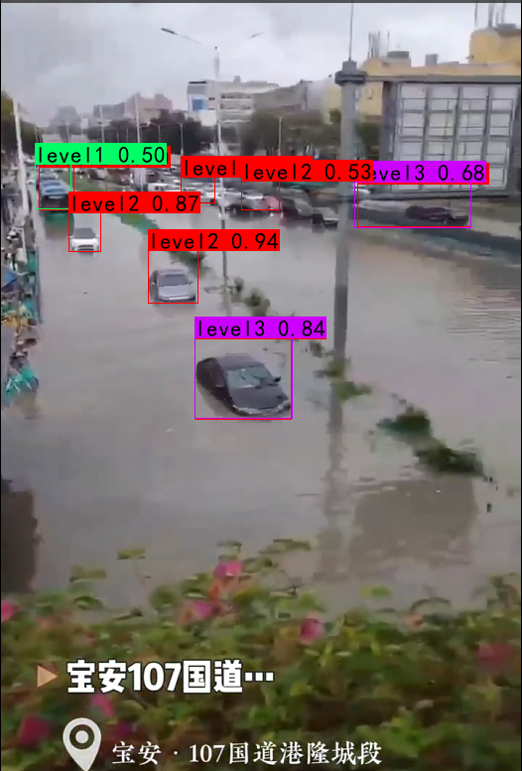
(e) F5 | (f) F6 |  | (g) F7
Fig. 10 Detection results with DETR.
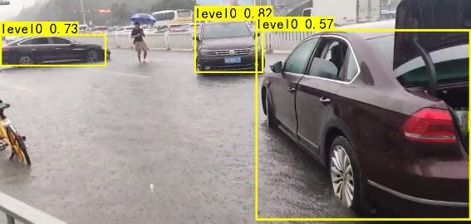 |  | 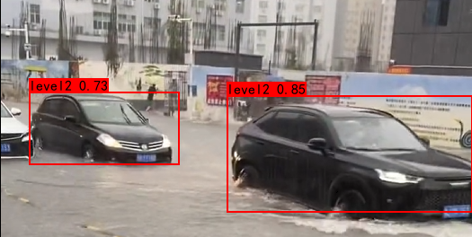
(a) F1 |  | (b) F2
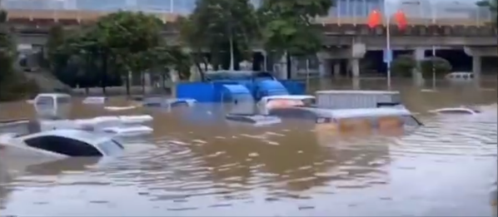 |  | 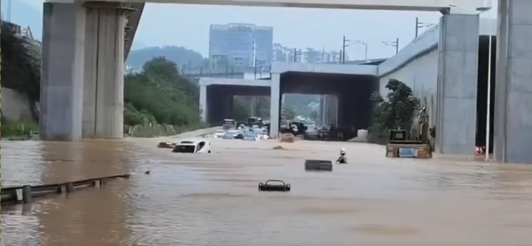
(c) F3 |  | (d) F4
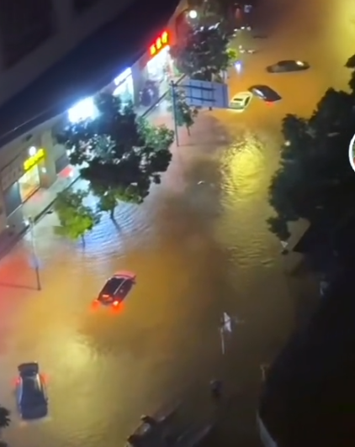 | 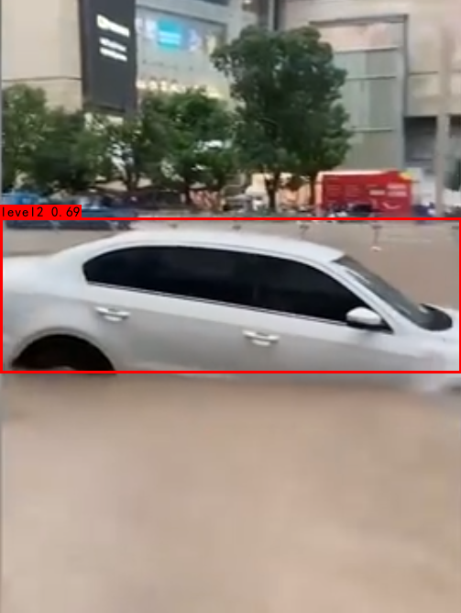 |  | 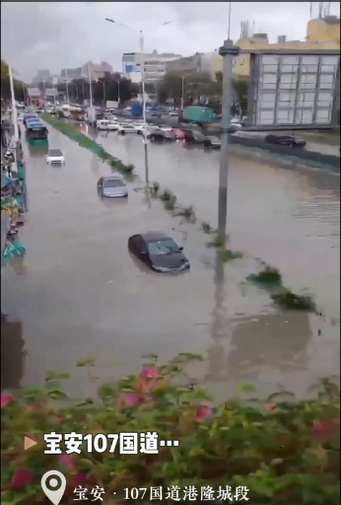
(e) F5 | (f) F6 |  | (g) F7
Fig. 11 Detection results with SSD.

* Corresponding author (Baohong Lu). E-mail address: Lubaohong@126.com

