Efficient and standardized interface energy calculations in hybrid heterostructures using fictitious atoms surface passivation
Sreejith PALLIKKARA CHANDRASEKHARAN, Sofia APERGI, Charles CORNET*,
Laurent PEDESSEAU*
Univ Rennes, INSA Rennes, CNRS, Institut FOTON – UMR 6082, F-35000 Rennes, France

*Corresponding Authors
Correspondence to Charles Cornet (charles.cornet@insa-rennes.fr) and Laurent Pedesseau (laurent.pedesseau@insa-rennes.fr)

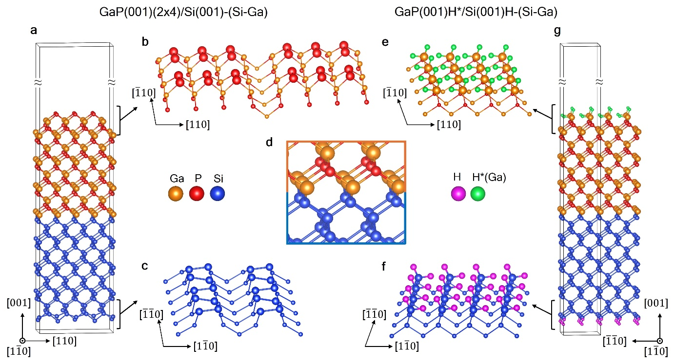
Supplementary Fig. S1. Schematic representation of the second slab model considered for determining absolute interface energies of GaP/Si with a Ga-abrupt interface and with a different surface reconstruction. a Total slab model of reconstructed surface method, with b reconstructed GaP(001)(2x4) on top and c Si(001) bottom surface for the d Ga-abrupt interface formation. H* passivation mechanism, e top and f bottom view of H* and H passivated surface terminations to compensate charges, and g the overall supercell model to determine absolute interface energy.

Table S1. The GaP/Si and GaAs/Si strained absolute interface energies calculated using reconstructed surfaces and H* passivated methodology computed by DFT, referencing our previous works^{1,2} and current study.
GaP surface | Energy (meV/Å²)
GaP surface | Ga-rich | P-rich
GaP(001) (2x4) | 40.80 | 72.00 ^{1,2}
GaP(001) md (2x4) | 38.50 | 69.70 ^{1,2}
GaP(001) H* | 43.55 | 74.68
GaAs surface | Ga-rich | As-rich
GaAs(001) β2(2x4) | 8.21 | 31.47
GaAs(001) H* | 3.48 | 26.74

Pseudomorphic layer growth of GaAs/Si
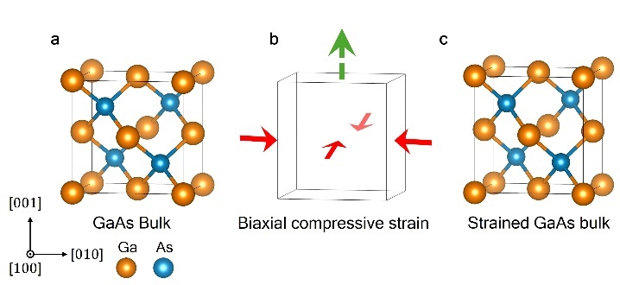
Supplementary Fig. S2. Biaxial strain process of GaAs. a GaAs bulk without strain, b influence of the biaxial compressive strain introducing an elongation towards growth direction (001), and c strained GaAs bulk.
During the initial phase of epitaxial growth of GaAs on silicon, strain arises due to the large lattice mismatch between the two materials, experimentally measured at 4%³. At this stage, coherent growth takes place, enabling elastic strain relaxation without the formation of defects. During this period, the III-V materials grow on the silicon substrate under biaxial compression, differing from their natural bulk state, this type of layer is known as pseudomorphic⁴. This biaxial compressive strain in the plane induces an elongation along the growth direction (001). As a result, a strained III-V bulk part forms during the growth process, as shown in Fig. S2a-c. In our interface energy calculations, we account for this strained bulk as part of the growth process to incorporate the induced strain into the absolute energy calculations. Moreover, biaxial strain must be included in surface slab calculations for both reconstructed and H* passivated surfaces, achieved by constructing biaxially deformed slabs, as shown in Fig. S3.
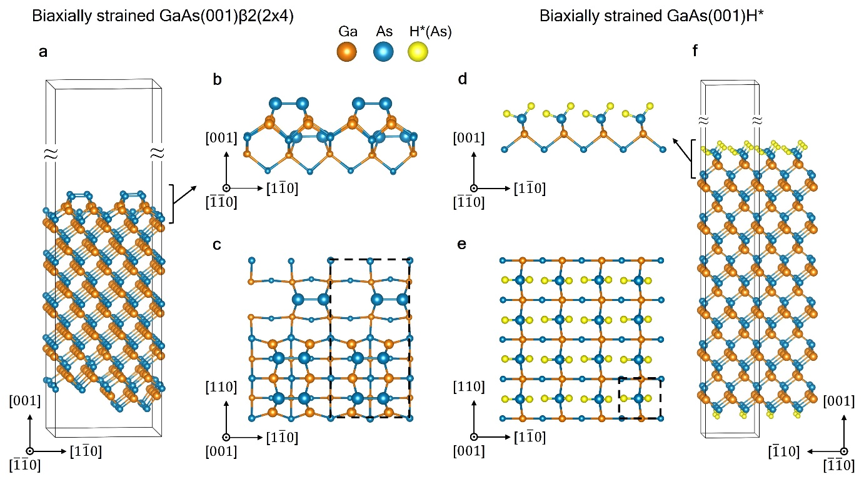
Supplementary Fig. S3. Strained GaAs surfaces. a Side profile, b top view, and c the slab model for biaxially strained GaAs(001)β2(2x4) surface. d Side profile, e top view, and f the slab model for biaxially strained GaAs(001)H* surface. Dashed lines in the top views indicate the unit cells of the reconstructions.

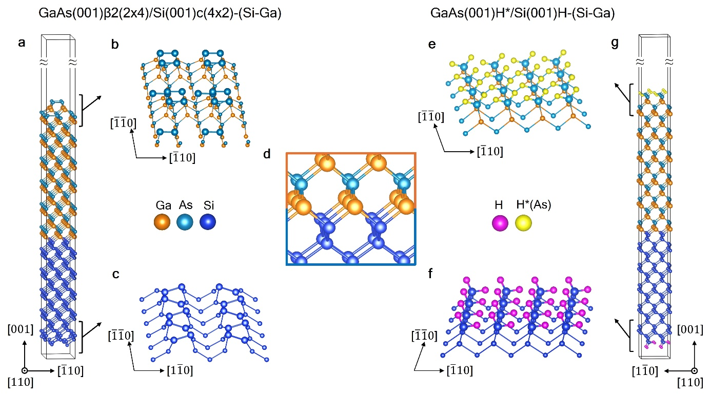
Supplementary Fig. S4. Schematic representation of slab model considered for determining absolute interface energies of GaAs/Si with the Ga-abrupt interface. a Total slab model of reconstructed surface method, with b reconstructed GaAs(001)β2(2x4) on top and c Si(001)c(4x2) bottom surface for the d Ga-abrupt interface formation. H* passivation mechanism, e top and f bottom view of H* and H passivated surface terminations to compensate charges, and g the overall supercell model to determine absolute interface energy.
Curve fitting details
The total electric dipole moment (E_{d,} in Debye) as a function of slab thickness (L) from Fig. 3b of the main text are fitted using the dipole–dipole interaction analytical expression⁵, $E(d)∝ L^{-3}$. The fit equations are: for the surface reconstruction method, E_{d}(L)= -0.1630-3120.8622/(L³); for the surface passivation H* method, E_{d}(L)= 1.0109-2192.5776/(L³).
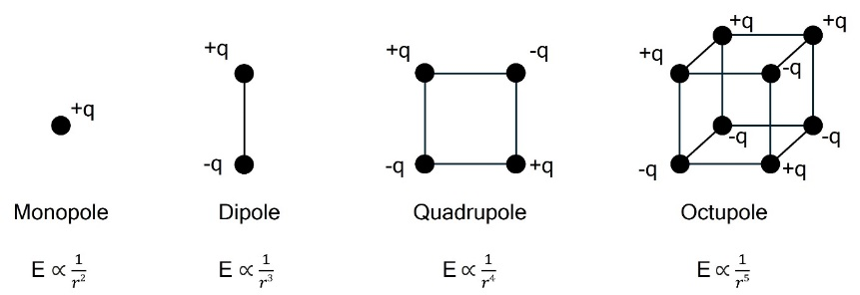
Supplementary Fig. S5. Schematic representation of multipole expansion of electric charge interactions (r is the distance). a Point charge exhibits monopole behavior, generating an electric field that decays proportionally to 1/r²​. In contrast, a dipole consists of two opposite charges, and its interactions produce an electric field that decays proportionally to 1/r³​. Moving to higher-order multipoles, a quadrupole involves the interaction of four point charges(1/r⁴), while an octupole consists of eight alternating point charges(1/r⁵), each representing progressively higher-order charge interactions with fields decaying more rapidly with distance.
References
1. Lucci, I. et al. Universal description of III-V/Si epitaxial growth processes. Phys. Rev. Materials 2, 060401 (2018).
2. Pallikkara Chandrasekharan, S., Lucci, I., Gupta, D., Cornet, C. & Pedesseau, L. Determination of III-V/Si absolute interface energies: Impact on wetting properties. Phys. Rev. B 108, 075305 (2023).
3. Kroemer, H. Heterostructure devices: A device physicist looks at interfaces. Surface Science 132, 543–576 (1983).
4. Pohl, U. W. Epitaxy of Semiconductors: Physics and Fabrication of Heterostructures. (Springer International Publishing, Cham, 2020). doi:10.1007/978-3-030-43869-2.
5. Kezerashvili, R. Ya. & Kezerashvili, V. Ya. Charge-dipole and dipole-dipole interactions in two-dimensional materials. Phys. Rev. B 105, 205416 (2022).

