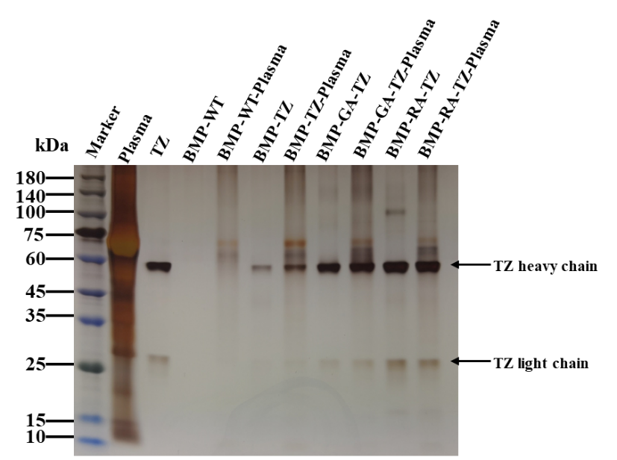
Figure S1. BMP-RA and BMP-GA were incubated with plasma or IgG plasma, and obtained proteins were separated by SDS-PAGE.

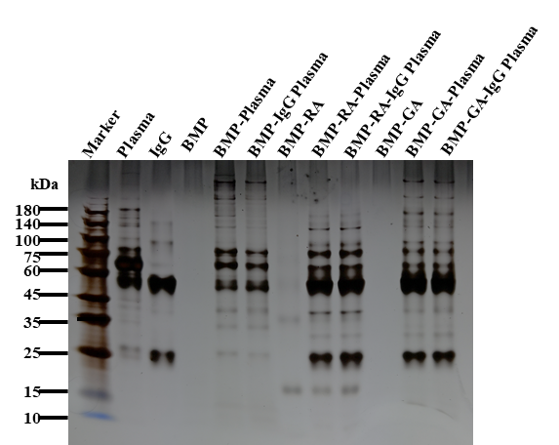
Figure S2. BMP-WT, BMP-GA-TZ, and BMP-RA-TZ were incubated with plasma, and obtained proteins were separated by SDS-PAGE.

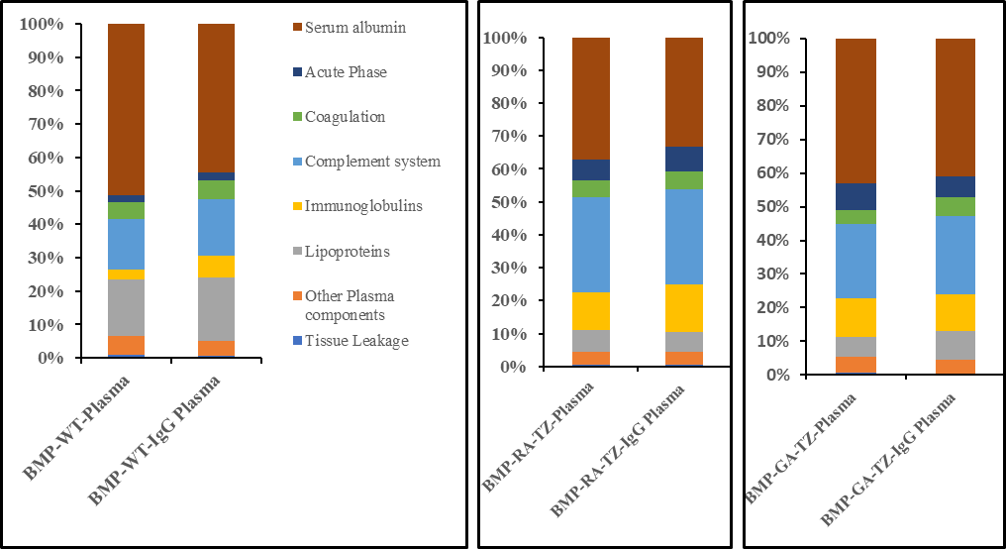
Figure S3. LC-MS analysis, and classification of corona proteins. For protein corona analysis, BMPs were incubated with 100% human plasma for 2 h. Values are expressed as percentages relative to total amount of all identified proteins.

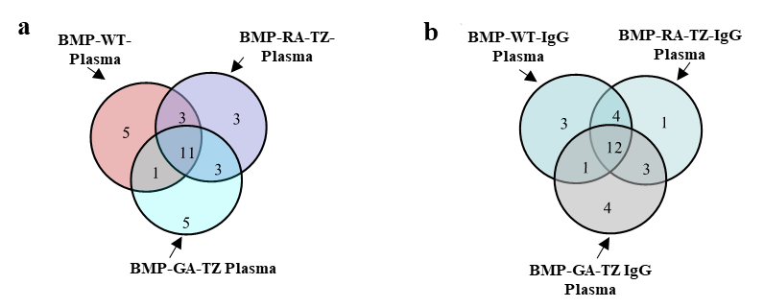
Figure S4. Overlap of protein identifications from BMPs incubated with plasma (a) or IgG plasma (b) by LC-MS/MS analysis.

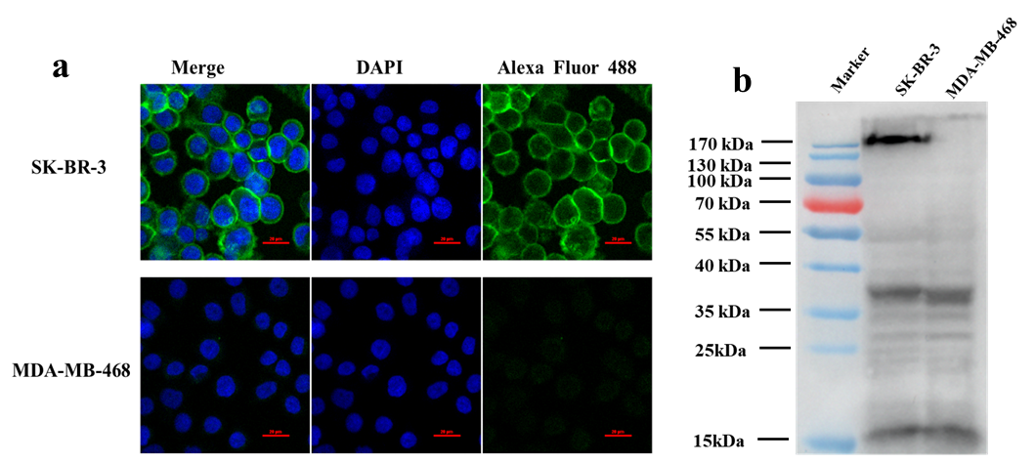
Figure S5. Immunofluorescence (a) and Western blotting (b) analysis of HER2 expression on SK-BR-3 and MDA-MB-468 cells.

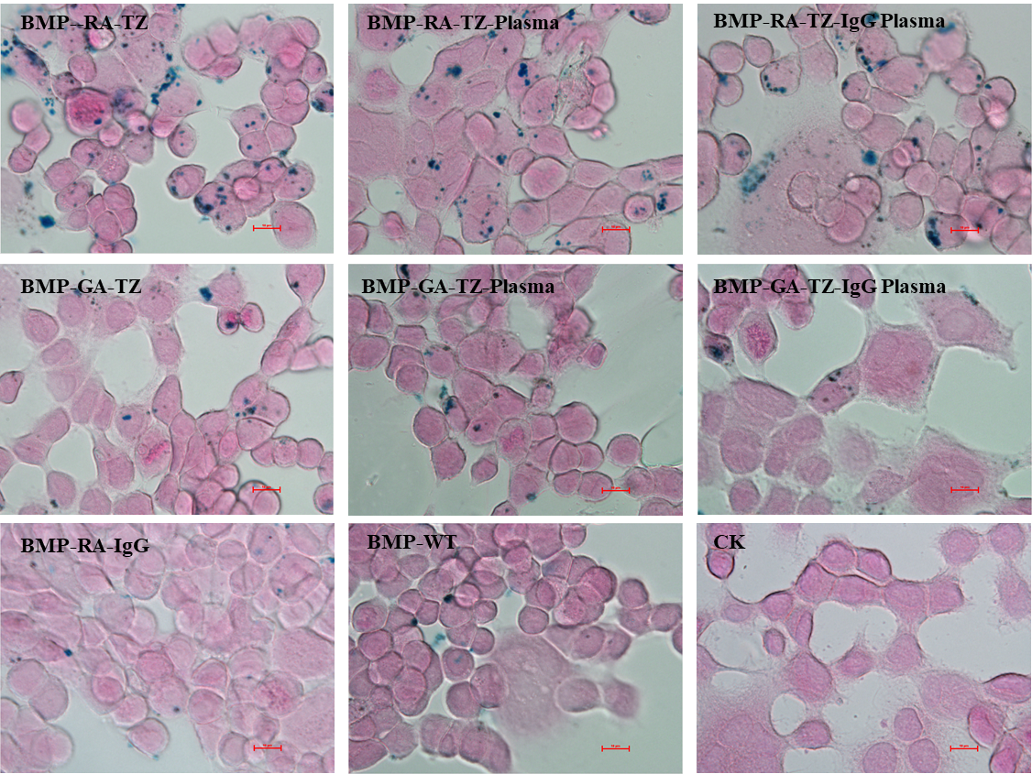

Figure S6. Prussian blue staining of iron in SK-BR-3 cells.

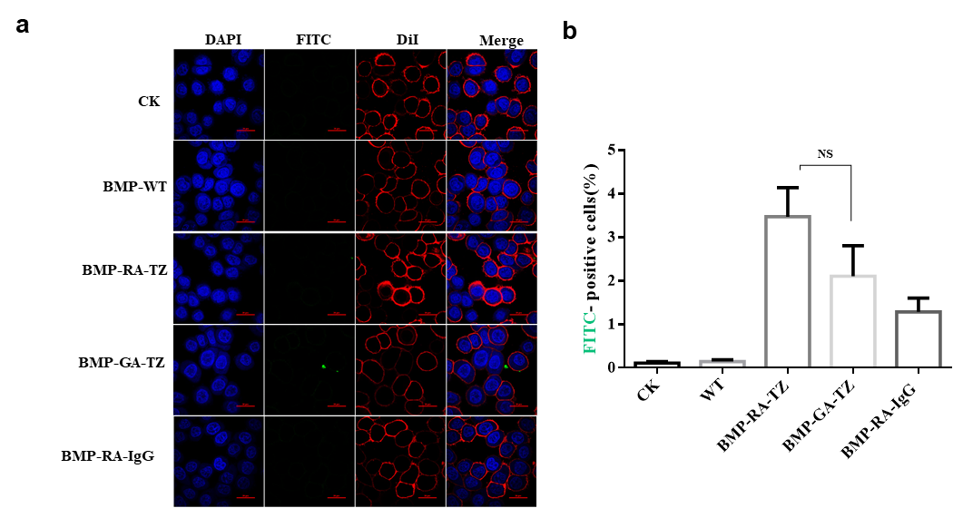
Figure S7. (a) CLSM imaging of MDA-MB-468 cells incubated with BMP-RA-TZ or BMP-GA-TZ. (b) Percentages (by flow cytometry) of FITC-positive cells for various conditions.

