Table 1. Reaction condition optimization.ª
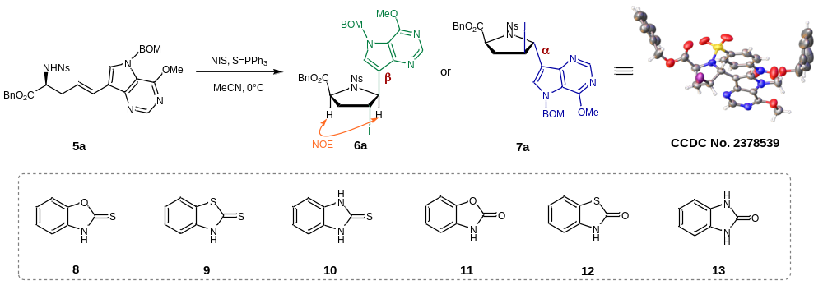
Entry | Variation from labeled conditions | Yield (%)^{b} | β:α (6a:7a)^{c}
1 | none | 92 | 5:1
2 | no S=PPh₃ | 95 | 1:1
3 | NaI instead of S=PPh₃ | 85 | 1:10
4 | 8 instead of S=PPh₃ | 93 | 11:1
5 | 9 instead of S=PPh₃ | 95 | 10:1
6 | 10 instead of S=PPh₃ | 95 | 25:1
7 | 11 instead of S=PPh₃ | 80 | 2:1
8 | 12 instead of S=PPh₃ | 82 | 5:1
9 | 13 instead of S=PPh₃ | 79 | 2:1
10 | NaI instead of S=PPh₃, THF instead of MeCN | 93 | 1:19
11 | no S=PPh₃, THF instead of MeCN | 90 | 1:3
ªReaction conditions: 5a (0.05 mmol), NIS (0.10 mmol), S=PPh₃ (0.05 mmol) in MeCN (2.5 mL), 0 °C for 1 h. ^{b}isolated yield. ^{c}β:α values were determined by HPLC.

