Supplementary Information

Hydrophilic PEG-grafted liquid-like surface: sliding or spreading
Junxu Chenª, Pengfei Zhangª, Wei Wang^{a, c}, Weilin Deng^{a, d}, Xinquan Yuª, Xiaofeng Han*^{,b}, Youfa Zhang*^{,a}
a. Jiangsu Key Laboratory of Advanced Metallic Materials, School of Materials Science and Engineering, Southeast University, No. 2, Southeast University Road, Nanjing, 211189, P. R. China
b. Institute for Brain and Intelligence, Southeast University, Nanjing, China.
c. NJIT-YSU Joint Research Institute, Nanjing Institute of Technology (NJIT), Nanjing, 211167, P. R. China
d. School of Materials Science and Engineering, Xinjiang University, Urumqi, 830046, P. R. China
*Corresponding author: xfhan@seu.edu.cn; yfzhang@seu.edu.cn

Table of contents
Materials and Methods
Supplementary Discussion
1. Calculation of surface energy
2. Theoretical model of critical stress triggering the wettability switching
3. Reasons for the exceptional underwater oil-repellency
Supplementary Figures 1-23
Supplementary Table 1

Materials and Methods
Materials
mPEG-silane of various molecular weight (350Da, 550Da, 750Da, 1000Da, 2000Da. 5000Da, 10000Da) were purchased from Chaorun(NanJing, China). Glass and silicon slides with dimensions of 25mm*75mm were bought from WanQing Chemical GlassWare and Instrument Co., Ltd (Nanjing, China). Deionized water, ethanol, concentrated hydrochloric acid, concentrated sulfuric acid, hydrogen peroxide, cyclohexane, hexadecane, toluene and TEOS were purchased from Aladdin(USA). Engine oil and soybean oil were purchased from local supermarket.

Preparation of PEG-grafted liquid-like surface
Pre-treatment of the substrate. First put the substrate (glass or silicon slides) in piranha solution for 24 hours (or treated in a 90 ℃ water bath for 2 hours), then removed and thoroughly cleaned, followed by oxygen plasma treatment for 20 minutes, and finally dried with nitrogen gas for later use.
Ethanol spin-coating method. Prepare mPEG-silane ethanol dispersions at different concentrations(0.05mM-20mM) and stir in a 40℃ water bath for 2 hours, then drop the solution onto the pretreated substrate. Do spin-coating at 1000rpm for 10 seconds, followed by 2000 rpm for 10 seconds, then dry in a 100℃ oven for 1 hour, obtaining the test surface.
PEG/TEOS spin-coating method. The solution was prepared according to the method described in Hozumi’s literature^{1,2}, the molar ratio of PEG to TEOS is 0.15. Other steps were consistent with the aforementioned procedures.
PEG-Monolayer grafted method. Disperse the mPEG-silane in toluene at the concentration used by Cha et al³. Immerse the pretreated substrate in the solution for at least 18 hours, then remove the substrate and rinse the surface with ethanol and deionized water, respectively, obtaining the test surface.

Preparation of PDMS-grafted liquid-like surface
Place the pretreated substrate and dichlorosilane-terminated PDMS(2000Da) in a sealed container, then transfer them together into a vacuum drying oven. Set the temperature to 60°C, allow the reaction to proceed for 6 hours under vacuum, and finally remove and rinse thoroughly with water.

Characterization techniques
Water contact angle (WCA) measurements. WCA was measured with an OCA 15 Pro video optical contact angle measuring instrument (DataPhysics, Germany). A small drop of deionized water was deposited on the surface and then its volume was increased to 5 μL, and the WCA was measured at three testing positions for each sample.
Contact angle hysteresis (CAH) measurements. A drop of 10 μL was first deposited on the surface, then insert the needle into the droplet and adjust its position to ensure it is centered within the droplet. Another 10 μL drop was infused and withdrawn at a rate of 0.1μL/s , after completing the withdrawal, let the droplet stand for 1min to allow its shape to stabilize and the whole process was recorded in a video. Capture images of the droplet on the surface after infusion and withdrawal, then fit its profile and determine the advancing and receding contact angles, subtract the two values to obtain the CAH.
Surface roughness measurements. Dimension ICON were used to obtain the roughness parameter of the PEG-grafted LLS. All images were taken in ScanAnalyst mode at a scale of 3μm*3μm at a slow line scan rate of 1.0 Hz. The images were analyzed using the Gwyddion software.
Sum Frequency Generation (SFG) spectroscopy measurements. The main experimental device is a picosecond SFG system produced by EKSPLA. The optical source is a 25 ps pulsed laser, with the output wavelength of 1064 nm, the repetition frequency of 20 Hz, and the energy of 30 mJ. Through nonlinear optical processes such as frequency doubling, frequency tripling, optical parametric generation/ampliﬁcation (OPG/OPA) and diﬀerence frequency generation(DFG), a visible light at 532.1 nm, and a wavelength-tunable mid-infrared radiation (MIR) required for SFG-VS data collection can be generated. Fused silica was used as the substrates in SFG experiments, and the grafting method for mPEG-silane was consistent with the aforementioned procedure. The input lasers, a visible light with ﬁxed wavelength (532.1 nm)and an IR beam with a tunable wavelength (2300−10000 nm), penetrate the fused silica and overlap spatially and temporally at the sample surface/interface to generate the SFG signals. The reﬂected SFG signal was collected by a monochromator along with a photomultiplier tube. The SFG spectra demonstrate the relationship between the SFG intensity and the IR wavenumber. All SFG spectra were collected using the ssp (s-polarized SFG output, s-polarized visible input, and p-polarized IR input) polarization combination.
Ellipsometry. Ellipsometry was conducted to measure the thickness of PEG layer. A spectral scan of the surface was collected between 200 and 2000 nm for an incident angle between 55° and 75° with an increment of 5° and the refractive index n is 1.45. At least five measurements were measured at different locations on each surface.

Friction test triggering the wettability switching.
Dry friction test. wear resistance tester() equipped with a non-woven fabric friction head was used to conduct the dry friction test, in order to protect the surface from been worn out, the load was set to 0 g initially with a friction distance of 10 cm per reciprocating cycle. After every 10 reciprocating friction cycles, the sample was removed, surface dust was blown off with nitrogen gas, and then its water contact angle (WCA) and contact angle hysteresis (CAH) were measured.
Wet friction test. The testing procedure was largely consistent with the dry friction test, with the key difference being that prior to friction, the sample surface was fully covered with liquid (5 mL was required for the substrate size used in this study). Friction testing was then conducted. After every 5 reciprocating cycles, the sample was removed, residual liquid was dried in an oven, surface dust was blown off with nitrogen gas, and the contact angle was measured. To verify the critical shear force, the friction head was set to perform only a single reciprocating motion while varying the applied load. The shear force was calculated using the classical friction model $F=μF_{N}$ ​. Although PEG-grafted surfaces typically exhibit ultralow friction (μ<0.05), the friction coefficient was conservatively estimated as μ=0.2 (wet) in this study to account for the significant surface roughness introduced by the nonwoven fabric probe. After each pass, the WCA change was measured following the aforementioned procedure.

Underwater oil-repellency test.
In conventional testing, different test oils with different volume were drop onto the sample surface, which was then slowly immersed into water using tweezers. The oil droplet detachment speed was recorded via video. To analyze the detachment speed of oil droplets on PEG-grafted surfaces prepared with varying chain lengths and concentrations, samples were clamped and immersed into water at a fixed speed with a constant-speed motor, while the oil removal process was recorded on video, and ​​20 µL of soybean oil​​ was used as the test contaminant.

Condensation test.
For the condensation test, the samples were tilted at an angle of ~30°, the temperature of the surfaces and air were ~2° and ~20° , respectively, and the relative humidity of the air was ~70%. A humidifier was positioned in front of the sample to increase ambient humidity without direct contact with the sample surface. Images of the condensation were captured at different time intervals with camera. The nucleation and growth of condensation droplets were recorded using an optical microscope, with images captured every 10 seconds. The droplet size distribution and quantity were analyzed using ImageJ software.

Supplementary Discussion
1.Calculation of surface energy
According to Fowkes’s theory⁴, the total free energy at a surface is the sum of contribution from the intermolecular forces at the surface. Thus the surface free energy could be written as:
 | $$γ_{s}=γ_{s}^{d}+γ_{s}^{p}$$ | (1)
where $γ_{s}^{d}$ and $γ_{s}^{p}$ refer to the dispersion force components and the polar force components. Then the OWRK’s method^{5,6} is utilized to solve for the value of $γ_{s}^{d}$ and $γ_{s}^{p}$. For different probe liquid, we have:
 | $$\frac{γ_{L}\left(1+\cos{θ}\right)}{2}=\sqrt{γ_{s}^{d}*γ_{L}^{d}}+\sqrt{γ_{s}^{p}*γ_{L}^{p}}$$ | (2)
Water and methylene iodide are two probing liquids and their surface free energy components are as follows:
$γ_{L_H_{2}O}=72.8\frac{mJ}{m^{2}}$ $γ_{L_H_{2}O}^{d}=21.8\frac{mJ}{m^{2}}$ $γ_{L_H_{2}O}^{p}=51\frac{mJ}{m^{2}}$
$γ_{L_CH_{2}I_{2}}=50.8\frac{mJ}{m^{2}}$ $γ_{L_CH_{2}I_{2}}^{d}=50.8\frac{mJ}{m^{2}}$ $γ_{L_CH_{2}I_{2}}^{p}=0\frac{mJ}{m^{2}}$ (3)
When the surface is at sliding state, $θ_{H_{2}O}=34.3°±0.2 ° θ_{CH_{2}I_{2}}=35.4°±0.1 °$
at spreading state, $θ_{H_{2}O}=4.1° ±0.1 ° θ_{CH_{2}I_{2}}=47.9°±0.3 °$ (4)
Combining (2), (3) and (4), we have:
Sliding state: $γ_{s}^{d}=41.7 \frac{mJ}{m^{2}}$ ; $γ_{s}^{p}=25.9 \frac{mJ}{m^{2}}$ ;
$$γ_{s_sliding}=γ_{s}^{d}+γ_{s}^{p}=67.6 \frac{mJ}{m^{2}}$$
Spreading state: $γ_{s}^{d}=35.4 \frac{mJ}{m^{2}}$ ; $γ_{s}^{p}=39.6 \frac{mJ}{m^{2}}$ ;
$$γ_{s_spreading}=γ_{s}^{d}+γ_{s}^{p}=75 \frac{mJ}{m^{2}}$$
The surface energy difference between the two states confirms that the spreading state is thermodynamically metastable.
2.Theoretical model of critical forces triggering the wettability switching
Based on Milner’s theoretical framework, we model the PEG chains as a system of flexible polymer chains composed of N kuhn segments(characteristic length b). These PEG chains are grafted onto a flat substrate with grafting density $σ$ (number of chains per unit area) and exposed to a solvent medium, and the equilibrium height $H$ is determined by the balance between two competing free energy contributions: the conformational entropy loss due to chain stretching, and the reduction in solvation free energy caused by interchain overlap⁷. Therefore, the free-energy of per PEG chain can be written as equation (5):
 | $$F=k_{b}T\left[\frac{3}{2}\frac{H^{2}}{Nb^{2}}+ν\frac{N^{2}σ}{H}\right]$$ | (5)
$k_{b}$: Boltzmann constant $k_{b}=1.380649*{10}^{-23} J/K$ ;
$T$: Absolute temperature $T=298 K$ ;
$N$: Degree of polymerization $N=17$ (750Da, and due to the presence of terminal groups, the degree of polymerization was equivalently extended based on atom count);
$H$: Equilibrium height;
$b$: Kuhn length $b=0.76nm$^{8,9} ;
$ν:$ Excluded volume parameter;
$σ:$ Grafting density.
Equation (5) consists of two energy terms: the elastic energy$F_{elastic}$⁷and the excluded volume energy $F_{exclude}$¹⁰:
 | $$F_{elastic}=\frac{3}{2}k_{b}T\frac{H^{2}}{Nb^{2}}$$ | (6)
 | $$F_{exclude}=\frac{1}{2}k_{b}Tν\frac{N^{2}σ}{H}$$ | (7)
and according to Flory-Huggins theory[]:
 | $$ν=\left(1-2χ\right)b^{3}$$ | (8)
$χ:$ Flory-Huggins parameter, for PEG, if the solvent is water(good solvent), $χ≈0.3$^{11,12}.
Under external forces, the conformation of the PEG brush undergoes changes, we can express the free energy change using an angular field representation:
 | $$F_{external}=τA\int_{0}^{L}{\sin{θ\left(s\right)}ds}$$ | (9)
$θ\left(s\right):$ the tilt angle of a small chain segment $s$ relative to the substrate normal (assuming that the chains initially are perpendicular to z-axis);
$L:$ Contour length, $L=Nb$;
$A:$ Contact area
Due to the chemical heterogeneity of PEG brush, the surface free energy also changes during the conformational transitions(cannot be expressed in an explicit analytical for with angular field representation):
 | $$F_{surface}=γ^{o}\left(θ\left(s\right)\right)$$ | (10)
The total free energy functional of the PEG brushes can be written as:
 | $$F=σA\left(F_{elastic}+F_{exclude}\right)+F_{external}+{AF}_{surface}$$ | (11)
To simplify the calculations, we assume uniform chain bending across the chain, as shown in Supplementary Discussion Fig. 1, that is:
 | $$θ\left(s\right)=θ$$ | (12)
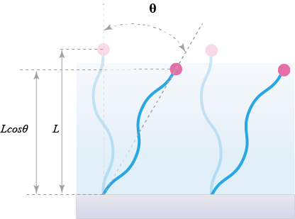
Supplementary Discussion Figure 1. Simplified schematic of the PEG brush angular field
Thus we have:
 | $$H=\int_{0}^{L}{\cos{θ\left(s\right)ds}}=L\cos{θ}$$ | (13)
 | $$F_{elastic}=\frac{3}{2}k_{b}T\frac{H^{2}}{Nb^{2}}=\frac{3}{2}k_{b}T\frac{L^{2}{\cos{θ}}^{2}}{Nb^{2}}$$ | (14)
 | $$F_{exclude}=\frac{1}{2}k_{b}Tν\frac{N^{2}σ}{L\cos{θ}}$$ | (15)
 | $$F_{external}=τA\int_{0}^{L}{\sin{θ\left(s\right)}ds}=τAL\sin{θ}$$ | (16)
Combing with equation (14) (15) (16), when the area is A and no external work is done, the total free energy of the system can be expressed as:
 | $$F=σA\left(\frac{3}{2}k_{b}T\frac{L^{2}{\cos{θ}}^{2}}{Nb^{2}}+\frac{1}{2}k_{b}Tν\frac{N^{2}σ}{L\cos{θ}}\right)+γ^{o}\left(θ\right)A$$ | (17)
At sliding state, $\cos{θ}=1$:
 | $$F_{sliding}=σA\left(\frac{3}{2}k_{b}T\frac{L^{2}}{Nb^{2}}+\frac{1}{2}k_{b}Tν\frac{N^{2}σ}{L}\right)+γ^{o}\left(0\right)A$$ | (18)
At spreading state, $\cos{θ}=\cos{θ_{c}}$:
 | $$F_{spreading}=σA\left(\frac{3}{2}k_{b}T\frac{L^{2}{\cos{θ_{c}}}^{2}}{Nb^{2}}+\frac{1}{2}k_{b}Tν\frac{N^{2}σ}{L\cos{θ_{c}}}\right)+γ^{o}\left(θ_{c}\right)A$$ | (19)
The free energy barrier $∆F$ is equation (19) - (18) :
 | $$∆F=F_{spreading}-F_{sliding} \\ =\frac{3k_{b}TσAL^{2}}{2Nb^{2}}\left({\cos{θ_{c}}}^{2}-1\right)+\frac{k_{b}TνN^{2}σ^{2}A}{2L}\left(\frac{1}{\cos{θ_{c}}}-1\right)+∆γA$$ | (20)
Therefore, the work done by the external force must be at least equal to $∆F$：
 | $$F_{external}≥∆F$$ | (21)
that is:
$$τ_{c}AL\sin{θ ≥}\frac{3k_{b}TNσA}{2}\left({\cos{θ_{c}}}^{2}-1\right)+\frac{k_{b}TνNσ^{2}A}{2b}\left(\frac{1}{\cos{θ_{c}}}-1\right)+∆γA$$
simplified, we obtain:
 | $$τ_{c}≥\frac{3k_{b}Tσ}{2b\sin{θ_{c} }}\left({\cos{θ_{c}}}^{2}-1\right)+\frac{k_{b}Tνσ^{2}}{2b^{2}}\left(\frac{1}{\cos{θ_{c}}\sin{θ_{c} }}-\frac{1}{\sin{θ_{c} }}\right)+\frac{∆γ}{Nb\sin{θ_{c} }}$$ | (22)
When $τ=τ_{c}$, the surface transitions from sliding to spreading state, and the change in surface energy is $∆γ=7.4 mJ/m^{2}$ (Supplementary Discussion 1), and $σ≃{\left(\frac{L}{Na}\right)}^{3}=0.7 chains/{nm}^{2}$ (the equation is given by de Gennes¹³, and due to the presence of terminal groups such as silane, the degree of polymerization was equivalently extended to $N=17$ based on atom count. Besides, the precise determination of $σ$ remains unattainable due to the presence of silane cross-linking).
Combing equation (22) with (8), we have the expression:
 | $$τ_{c}≥C_{1}\sin{θ_{c} }+C_{2}\left(\frac{1}{\cos{θ_{c}}\sin{θ_{c} }}-\frac{1}{\sin{θ_{c} }}\right)+C_{3}\frac{1}{\sin{θ_{c} }}$$ | (23)
where:
$$C_{1}=-\frac{3k_{b}Tσ}{2b}=-2.84*{10}^{6} N/m^{2}$$
$$C_{2}=\frac{k_{b}T\left(1-2χ\right)bσ^{2}}{2}=7.59*{10}^{4} N/m^{2}$$
$$C_{3}=\frac{∆γ}{Nb}=5.7*{10}^{5} N/m^{2}$$
This model indicates that different critical angles $θ_{c}$ correspond to distinct critical shear stresses $τ_{c}$. However, when $θ_{c}$ is either too small or too large, the predictive capability of $τ_{c}$ breaks down: excessively small $θ_{c}$ lead to unrealistically high orders of magnitude for $τ_{c}$ given the insufficient exposure of ether groups and large $θ_{c}$ result in non-physical negative values due to dominant excluded volume effects as shown in Supplementary Discussion Fig. 2a. We found that only when the critical bending angle is around 23°to 51.2° does the resulting $τ_{c}$ fall within the experimentally measured range. Based on experimental measurements (Supplementary Fig.16), our model demonstrates satisfactory predictive capability, exhibiting agreement with empirical data within a range of approximately 51°. However, due to limitations in both theoretical models and experimental setups, we are unable to determine the precise critical shear force values that switching the wettability of PEG-grafted LLS, and the above derivation only provides a mathematical explanation for this unexpectedly phenomena.
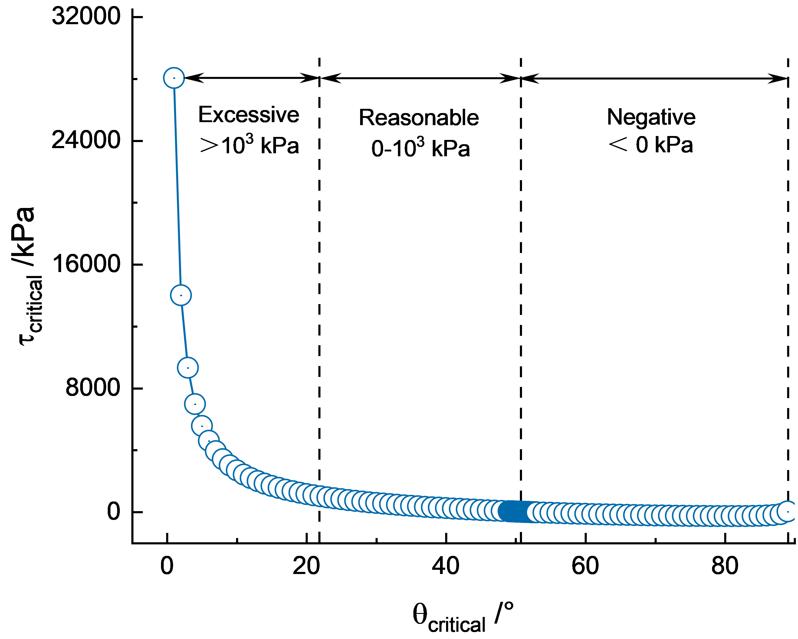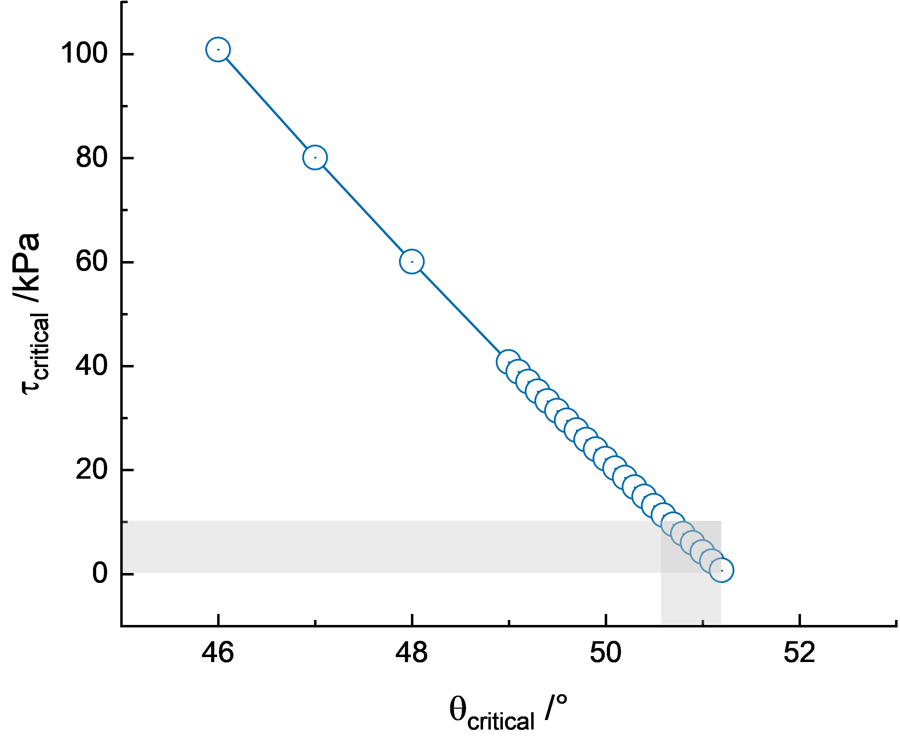
(b)
(a)
Supplementary Discussion Figure 2. (a) Critical shear force corresponding to different critical bending angles based on equation (23), (b) Overlapping regions of experimentally measured critical shear force ranges for water as wet friction media with theoretical predictions from equation(23). (The horizontal gray shaded area represents the experimentally measured range of possible critical shear stress values and the vertical one represents the corresponding theoretically predicted range of critical angles)
3. Reasons for the exceptional underwater oil-repellency
Based on Fig. 4d, when an oil droplet undergoes detaching underwater, the force driving the three-phase contact line motion in horizontal direction can be expressed as:
 | $$F_{shrink}=F_{hydration}+F_{surface}-F_{friction}$$ | (24)
Like other underwater hydrophilic surfaces, the main driving force for the oil detachment is surface’s hydration force¹⁴:
 | $$F_{hydration}=F_{0}*e^{-\frac{D}{λ_{0}}}$$ | (25)
where $F_{0}$ depends on the hydration of the surfaces but is usually below 3-30 mJ/m²,$D$ represents the distance between the water molecular and the surface and $λ_{0}$ is the decay length ranging from 0.1-1nm typically, depending on the hydrophilicity of surface. Thus, a lower water contact angle indicates stronger hydrophilicity, corresponding to a larger $F_{0}$ and $λ_{0}$, and consequently, a greater hydration force.
As for the dynamic friction force(lateral force resisting contact line motion), we here use the theoretical formulation of the liquid-solid Amonton’s law proposed by Glen et al^{15,16}:
 | $$F_{friction}=μ_{dynamic}F_{N}$$ | (26)
where $μ_{dynamic}$ is the coefficient of droplet friction and considering the oil droplet is in motion at a speed $v$ and combing with Cox-Voinov theory^{17,18}:
 | $$μ_{dynamic}=\frac{k∆θ\left(v\right)}{π}=\frac{k}{π}\left(∆θ+\frac{6Ca}{θ_{e}^{2}}\log\left(\frac{L}{l_{m}}\right)\right)$$ | (27)
$k$: a dimensionless shape factor for the three-phase contact line;
$Ca=ηv/γ_{L}$ is the capillary number, and $η$ is the viscosity of the droplet;
$θ_{e}$: is the theoretical equilibrium Young’s contact angle;
the logarithmic term uses a microscopic length $l_{m}$ and a typical macroscopic length scale$L$ at which the dynamic contact angle is measured.
The capillary number $Ca$ reflects the competition between surface tension and viscous forces during the detaching process. In our cases, the mean deatching velocity $v$ can be calculated by
 | $$v=\frac{r}{t}$$ | (28)
where $r$ is the radius of spreading oil and $t$ is the detaching time and $v≈0.75cm/s$(the radius of the spreading oil is 0.6cm and the detaching time is 0.8s in 25℃). Therefore the capillary number $Ca≈\left(0.035*0.0075\right)/0.03=0.00875≪1$, (the viscosity of soybean oil is 35 mPa*s, and the interfacial energy $γ_{L}$ is 30 mJ/m²) combing with that the oil is macroscopic, it can be assumed that the detaching process is dominated by surface tension rather than the viscosity and the viscous force is neglected in our analysis.
Although the retraction of oil droplet on the surface underwater differs from their sliding motion, equation (27) reveals that surfaces with liquid-like properties (lower $∆θ$)exhibit a significantly lower dynamic friction coefficient($Ca$’s contribution to the dynamic friction coefficient is small compared to $∆θ$) compared to conventional oil-repellent surfaces, resulting in reduced resistance to the contact line motion.
The surface tension component can also be expressed in terms of dynamic contact angles $θ_{dynamic}$ as follows:
 | $$F_{surface}={γ_{S/O}-γ}_{S/W}-γ_{O/W}\cos{θ_{dynamic}}= γ_{O/W}\left(\cos{θ_{e}}-\cos{θ_{dynamic}}\right)$$ | (29)
In the Cox-Voinov theory, the dynamic contact angle $θ_{dynamic}$ is written as^{15,19}:
 | $$θ_{dynamic}=θ_{microscopic}^{3}+9Ca\log_{3}\left(\frac{L}{l_{m}}\right)$$ | (30)
$θ_{microscopic}$ can be assumed as the advancing/receding angle when considering different edges¹⁵. Given that the capillary number $Ca$ is quite small, the influence of surface tension is primarily governed by underwater oleophobicity($θ_{e}$,$θ_{microscopic}$). However, the vast majority oil-repellent hydrophilic surfaces inherently exhibit underwater superoleophobicity(underwater oil contact angle ＞150°)²⁰, demonstrating this force is not the dominant factor responsible for the exceptional oil-repellency of PEG-grafted surface.
From the above analysis, it can be assumed that the good oil-repellency of PEG-grafted LLS at spreading state primarily stems from strong hydration force and small friction force.
A lower contact angle indicates stronger hydration capability of the surface compared with the reported highly flat, hydrophilic surface (sulfonic acid groups max-packed in 2-dimension). The hydration capability of a single sulfonate group is significantly stronger than that of an ether group because the former has more hydrogen bond acceptors, thus we attribute PEG’s stronger hydrophilicity to the fact that its three-dimensional extended chains provides a greater number of hydrogen-bond-accepting oxygen atoms compared to the total acceptor capacity of two-dimensional closely packed sulfonate groups.
According to Wang’s article²¹, the two-dimensional maximum packed sulfonated surface possesses around 17 sulfonate groups per 1 nm² and each 3 closely-packed sulfonate groups can absorb about 1 water molecule, thus ideally the number of water molecules adsorbed pre 1 nm² is about 5.7. However, the water molecular uptake per EG unit is 1.5 based on Fick’s et al report^{22,23}. For the mPEG-silane(1000Da, 22 EG units, demonstrating fastest oil detachment) used in our experiment, taking the grafting density $σ=0.7 chains {nm}^{2}$ into consideration, the number of water molecules adsorbed per 1 nm² is about 23.1(0.7*1.5*22). Therefore, it exhibits greater hydration force magnitude $F_{0}$ and decay length $λ_{0}$(higher detaching driving force $F_{hydration}$).
In terms of dynamic friction force $F_{friction}$ hindering the oil detachment, the solution to diminish it is to make the hydrophilic surface as smooth as possible^{24,25}(smaller $μ_{dynamic}$), since rough structures compromise their long-term performance. The prepared PEG-grafted LLS exhibits a roughness of only 435 pm. Compared to other molecular-level smooth surfaces, the advantage of PEG-grafted LLS lies in the fact that the liquid-like PEG brushes provides low contact angle hysteresis($∆θ$) further reducing the detaching resistance²⁶. Moreover, for the design of proactive underwater oil-repellent surfaces, the following strategies can be considered based on the above discussion: 1) enhancing hydration force(increasing the density of adsorbed water molecules per unit area), and 2) reducing friction coefficient(minimizing interfacial resistance).

Supplementary Figures
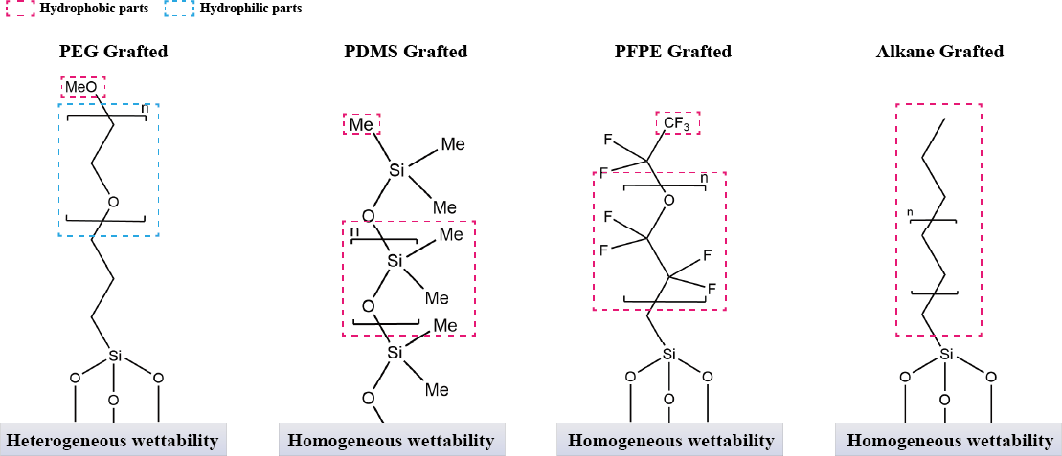
Supplementary Scheme 1. Diagram of typical polymer brush architectures for fabricating liquid-like surfaces

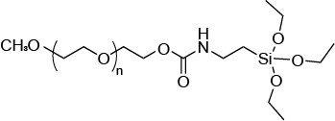

Supplementary Figure 1. Molecular structure of mPEG-silane employed in this study.
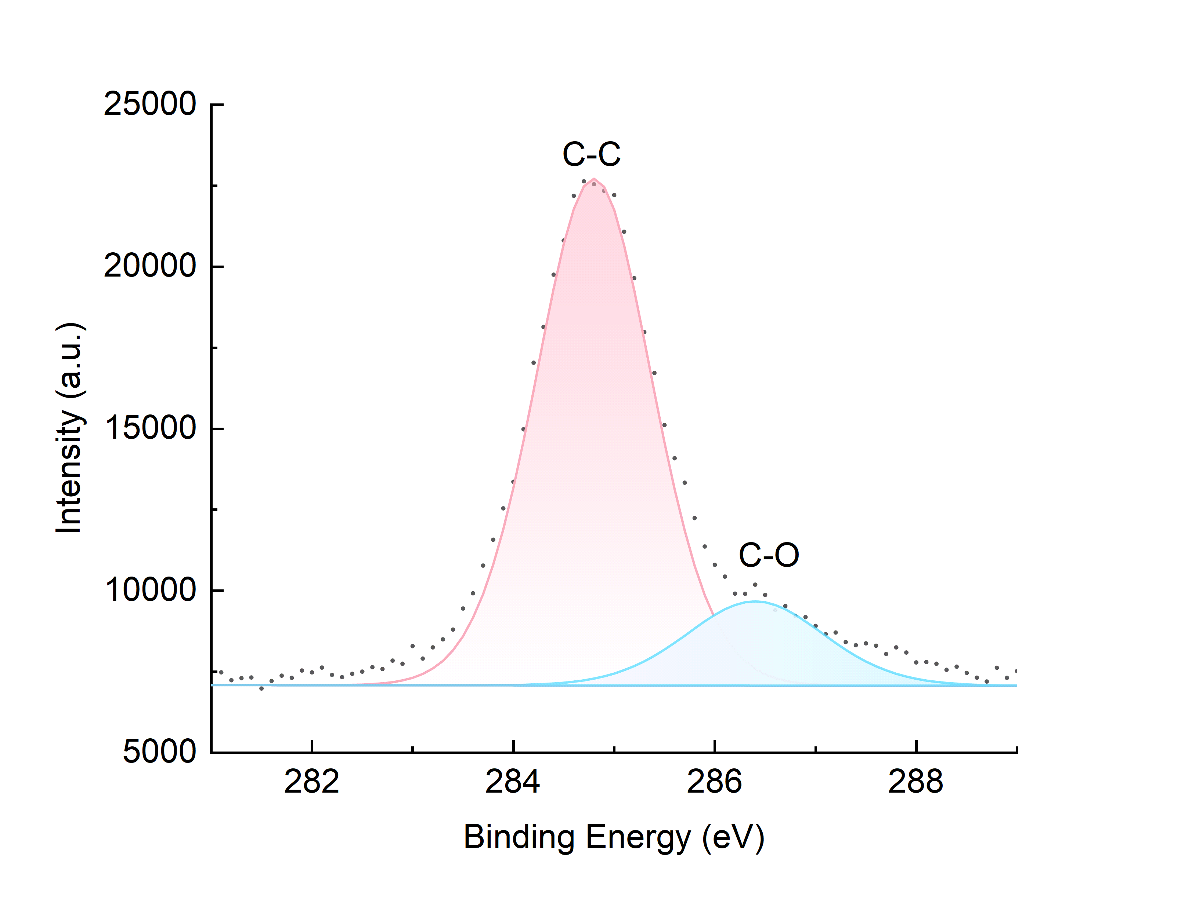
Supplementary Figure 2. XPS C1s spectra of PEG-grafted silicon surface exhibiting C-O bonding signals.

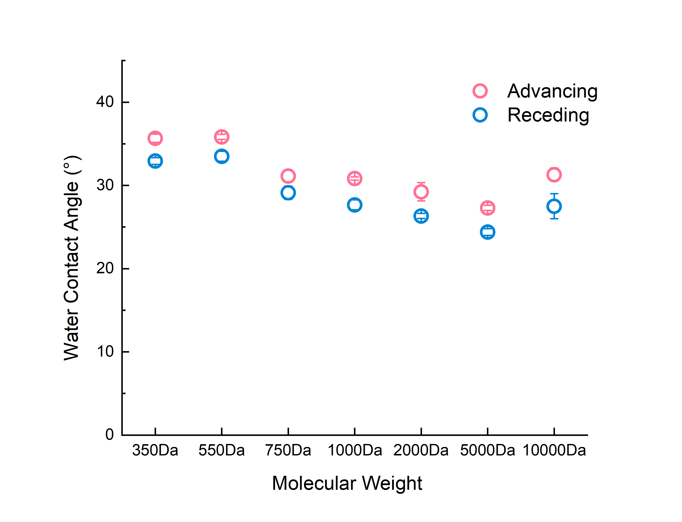
(a)
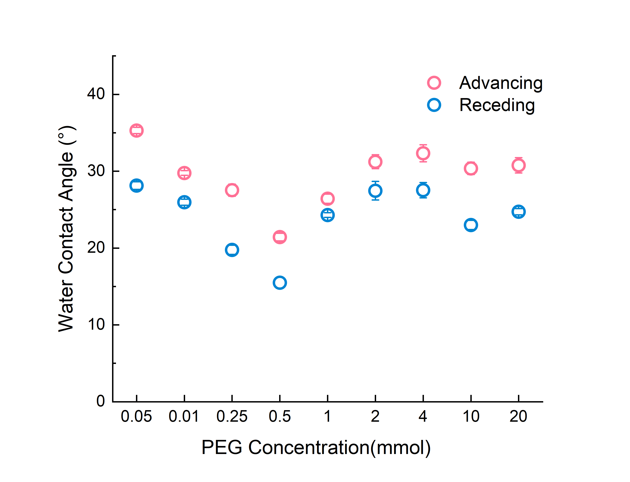
(b)
Supplementary Figure 3. Dependence of water contact angle hysteresis on LLS fabricated with
(a) varying PEG chain length (molecular weight) and (b) spin-coating concentration

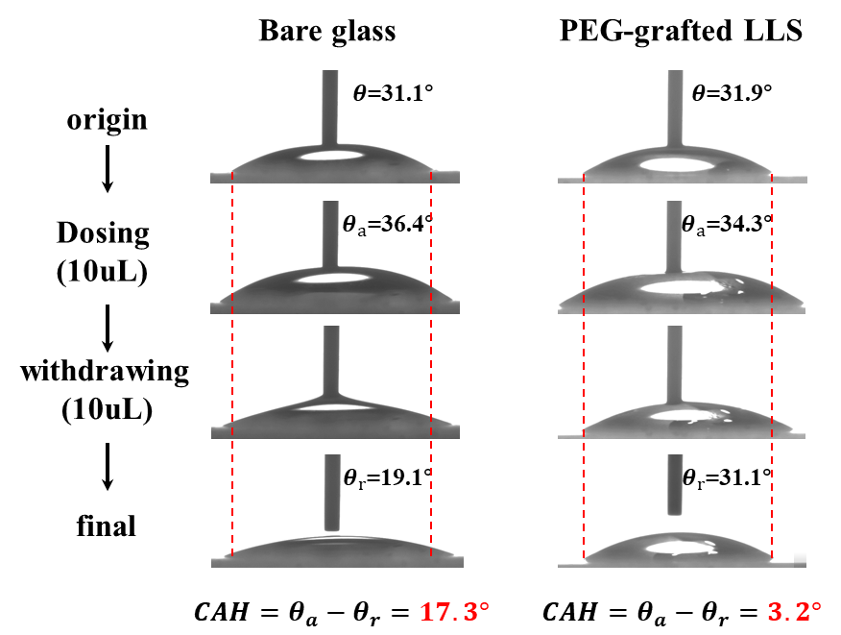
(b)
(a)
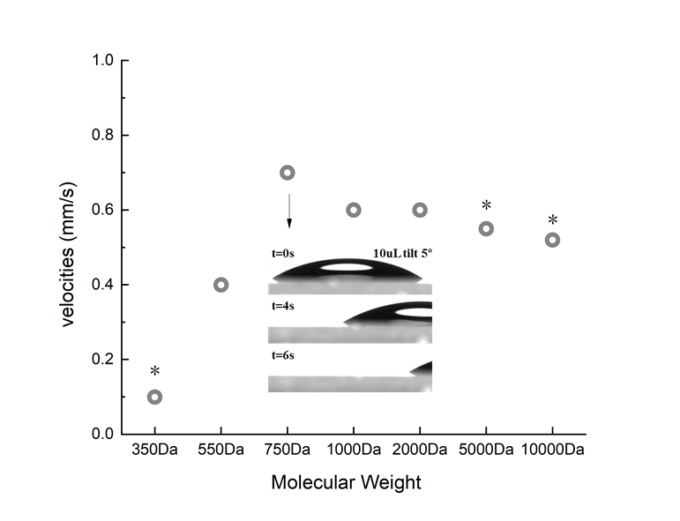
Supplementary Figure 4. (a) CAH contrast: PEG-grafted surface (Mw=750Da, 1mM) versus unmodified glass. (b) 10 μL water droplet sliding velocities on PEG surface of varied chain lengths (* denotes the appearance of a tailing).

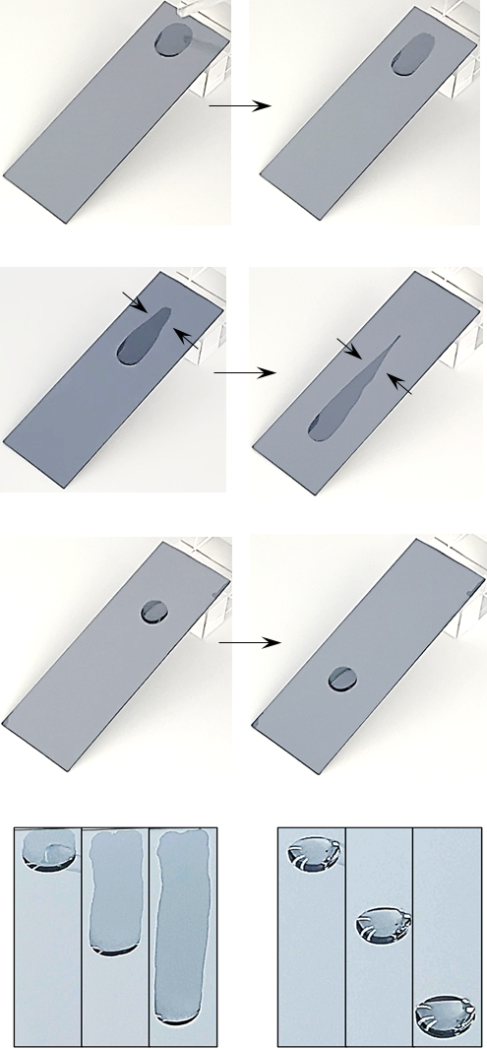
(d)
(c)
(b)
(a)
Supplementary Figure 5. Dynamic wetting transition on the spin-coating fabricated PEG-grafted surface: from (a) initial spreading state(superhydrophilic) to (b) wedge-shaped tail retraction by droplet motion and (c) sliding state formation. (d) Images in normal direction showing distinct droplet movement characteristics on same surface in different states (left: spreading; right: sliding).

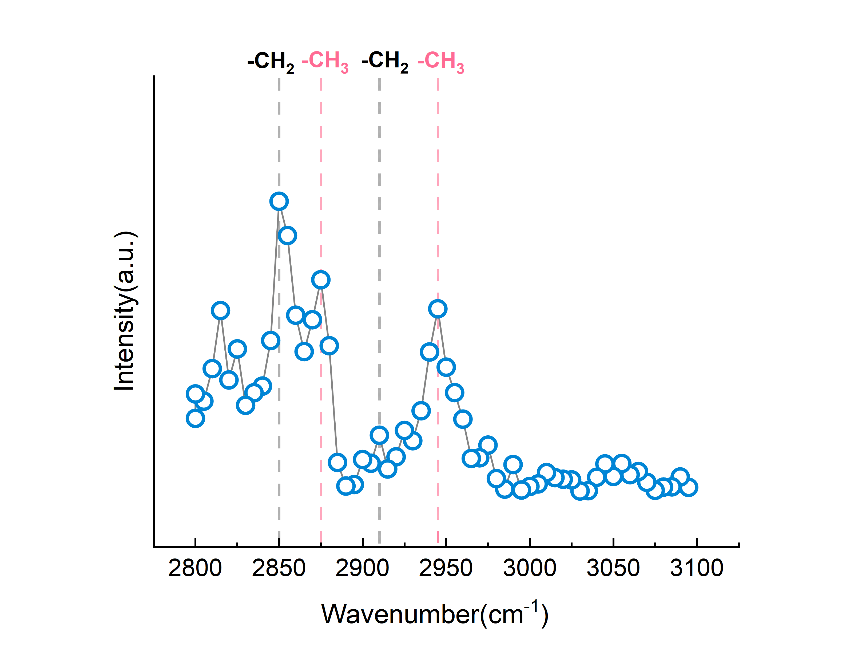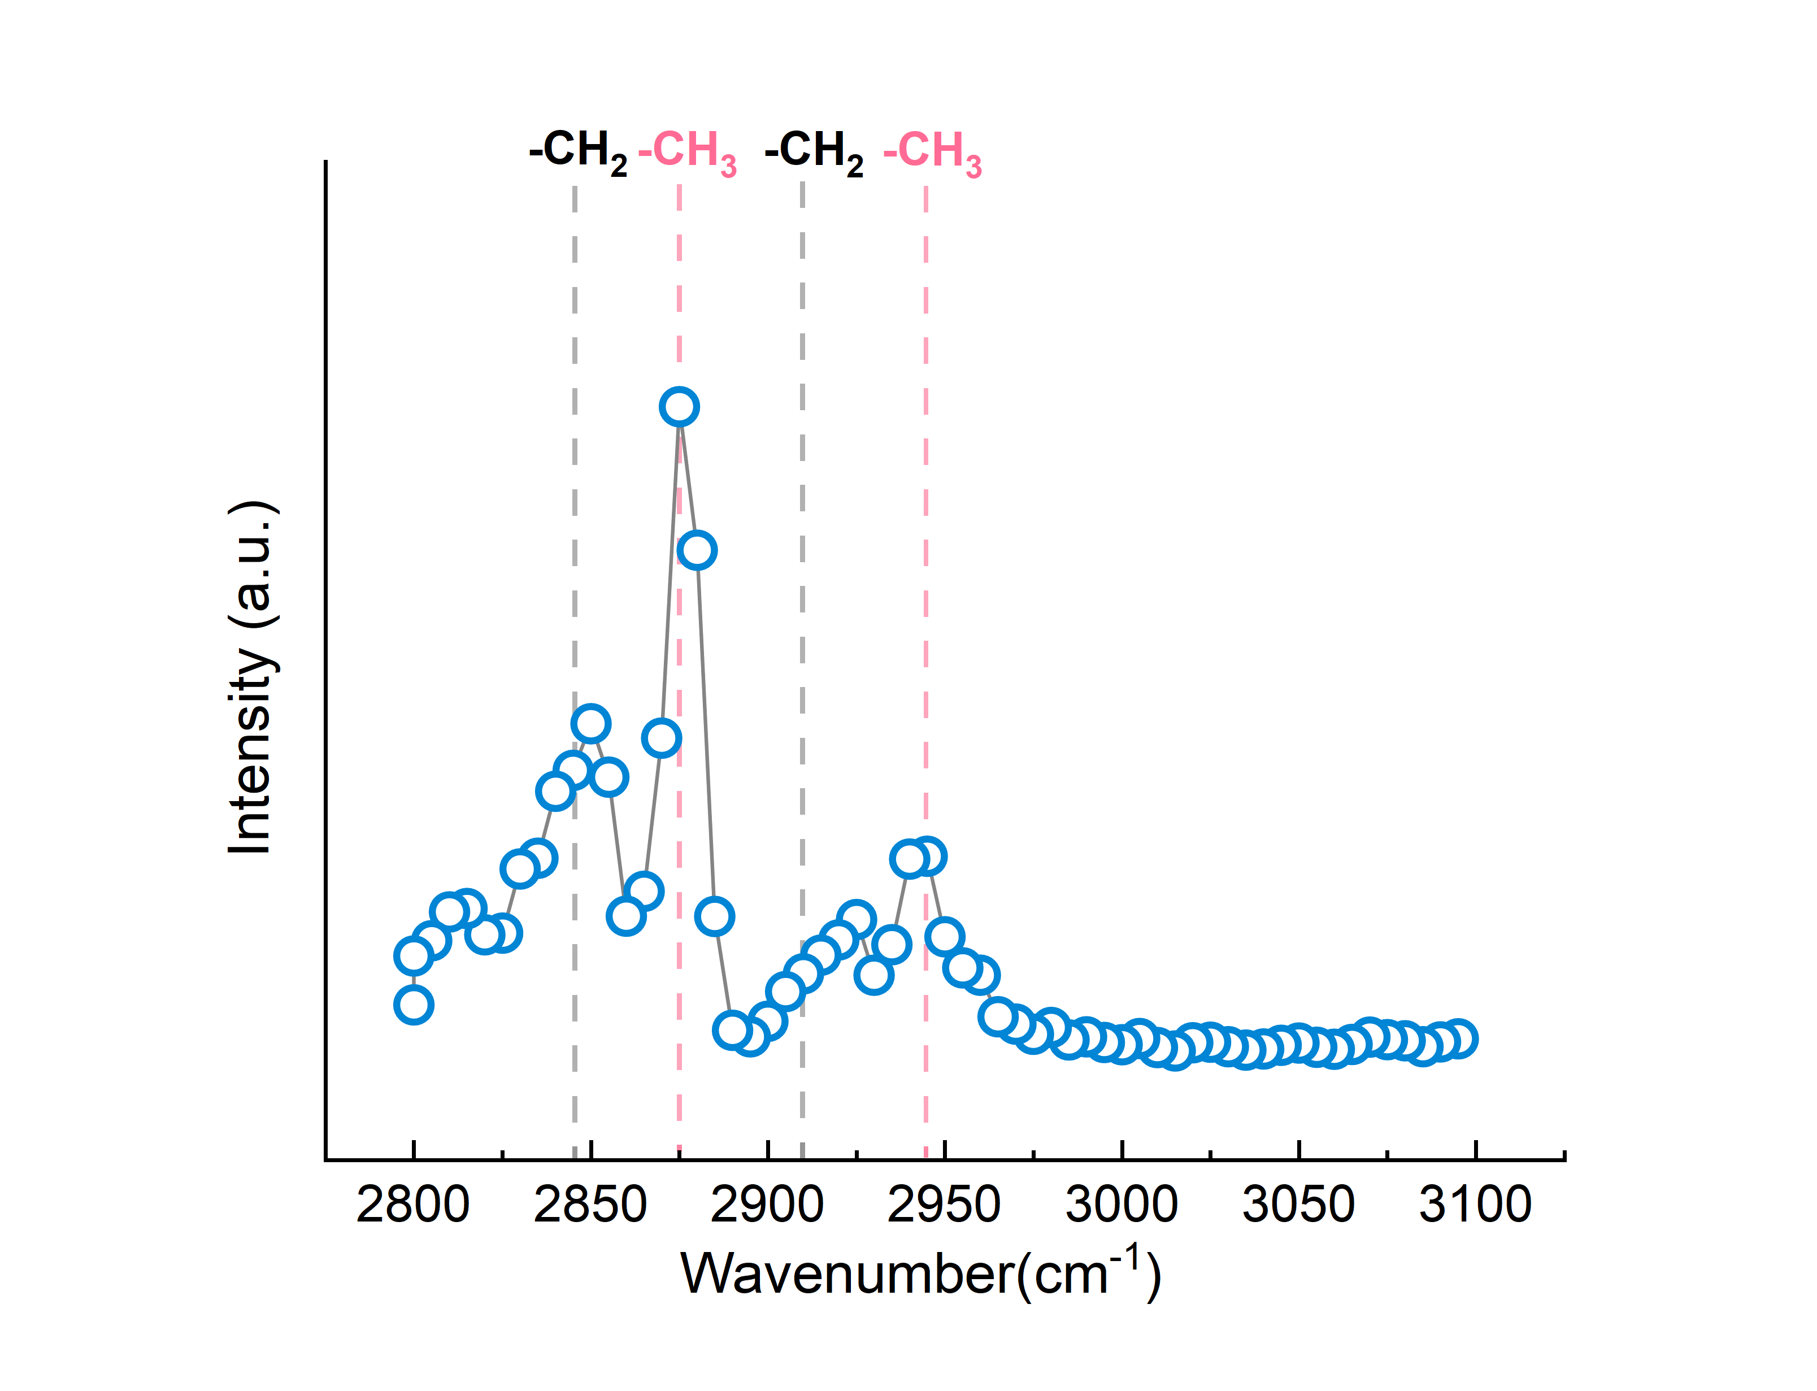
(b)
(a)
Supplementary Figure 6. SFG spectra shows (a) siginicant methylene signals on freshly prepared surface versus (b) dominant methyl signals on surface in sliding state.

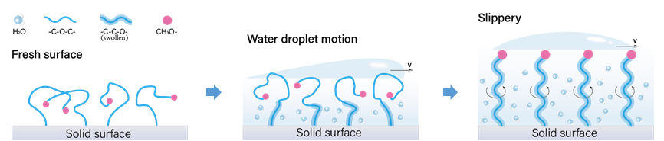
Supplementary Figure 7. Schematic illustration of PEG-grafted LLS transition from initial spreading state to stable sliding state under swelling and shear force during droplet motion.
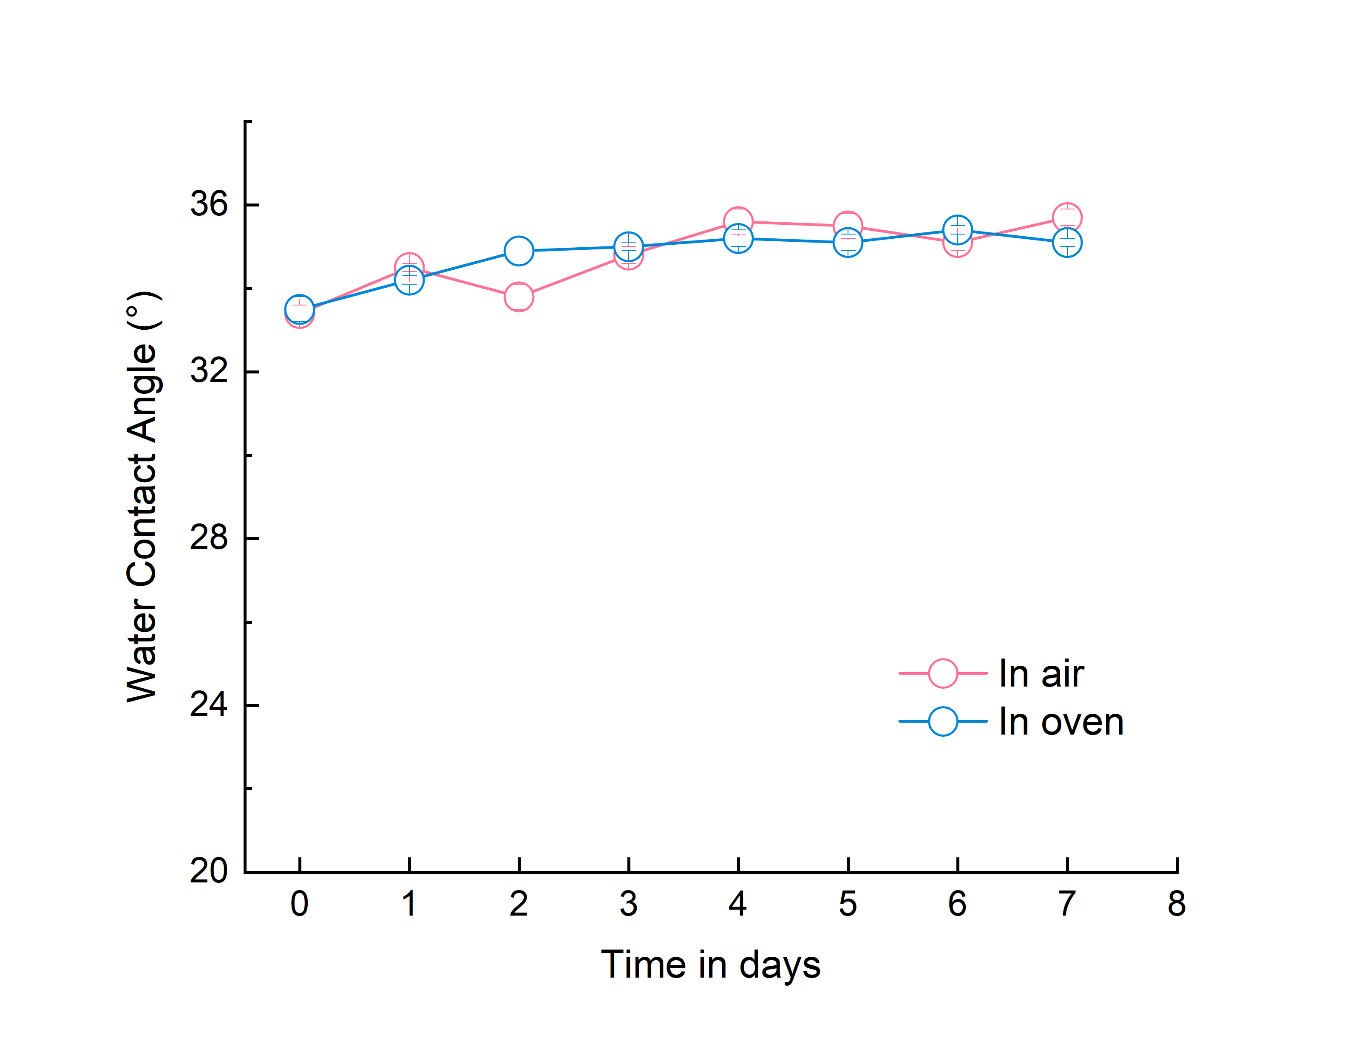
(a)
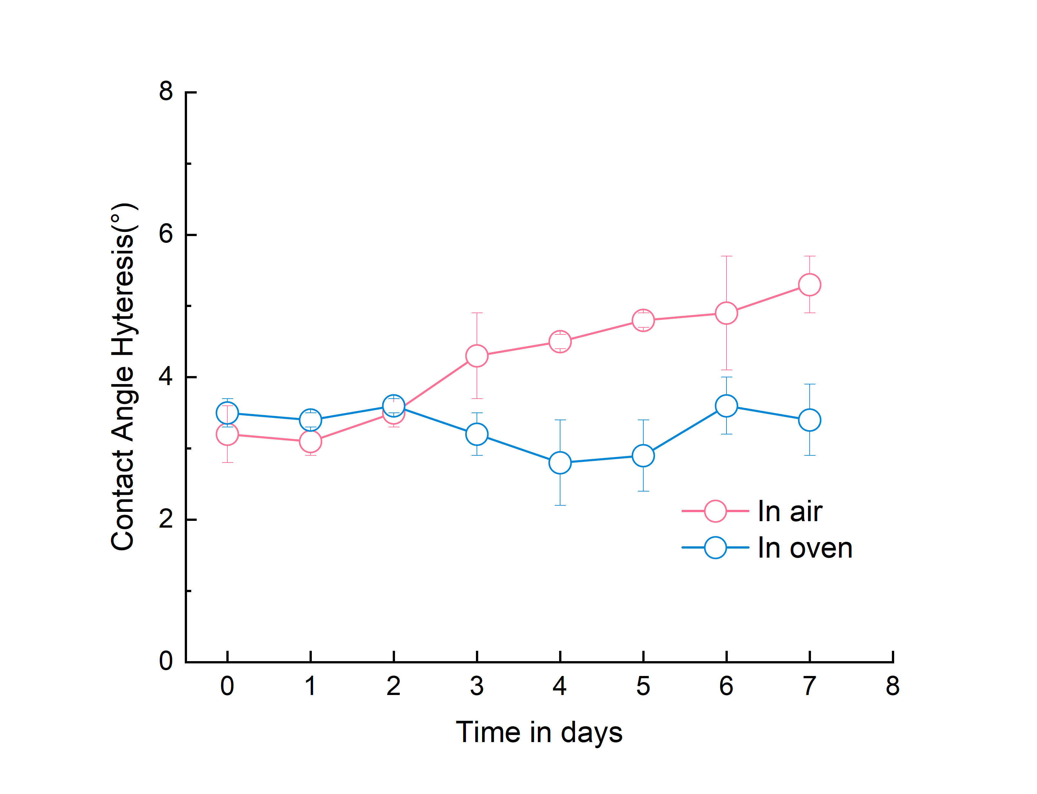
(b)
Supplementary Figure 8. PEG-grafted LLS in sliding state maintains stable wettability (WCA and CAH) following 7-day exposure to ambient and thermal aging.

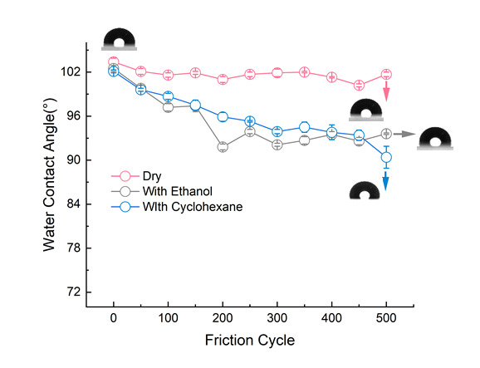
Supplementary Figure 9. PDMS-grafted LLS displays little change in WCA after 500-cycle friction test (none solvent, with ethanol, and with cyclohexane).
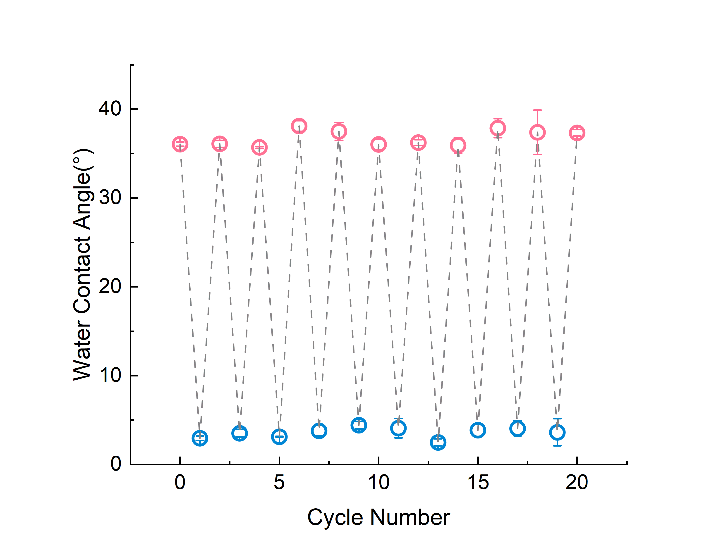
Supplementary Figure 10. PEG-grafted LLS enables reversible wettability switching for at least 10 times without degradation
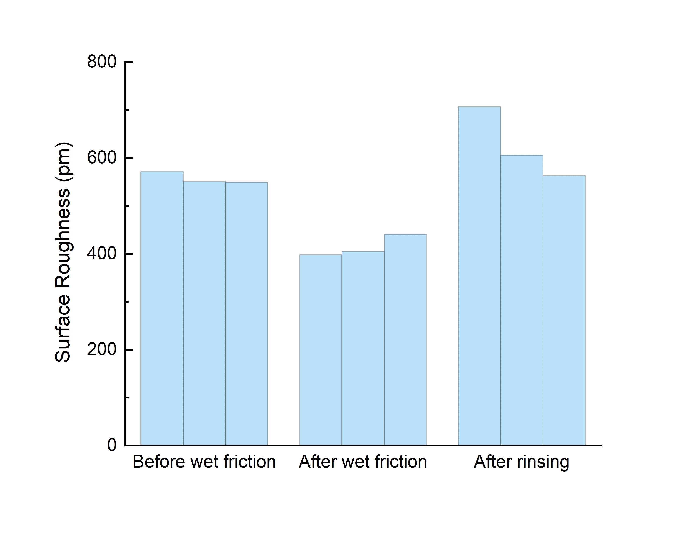
Supplementary Figure 11. Surface roughness changes during wettability switching, at least three locations are measured at each of three stages: before wet friction (sliding state), after wet friction (spreading state) and after water rinsing (sliding state).
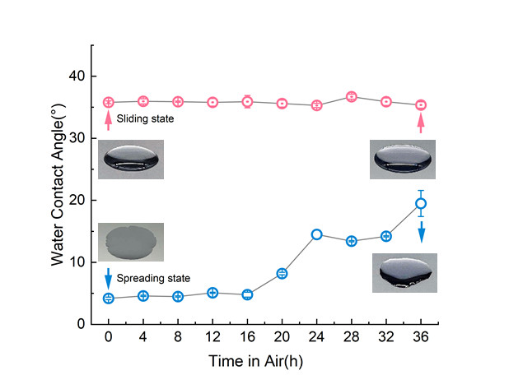
Supplementary Figure 12. Stability duration of the sliding state and spreading state in air.

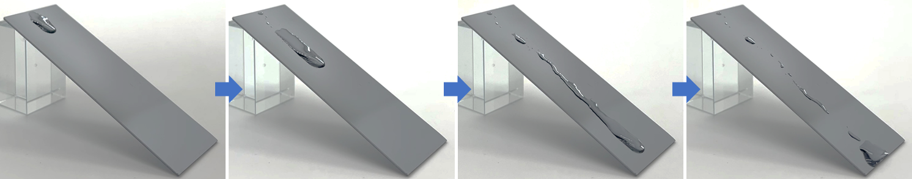Supplementary Figure 13. Despite the WCA (32°) recovers from the spreading state (4°) after prolonged air exposure, an irreversible loss of liquid-like properties was observed, denoting the necessity of water rinsing.
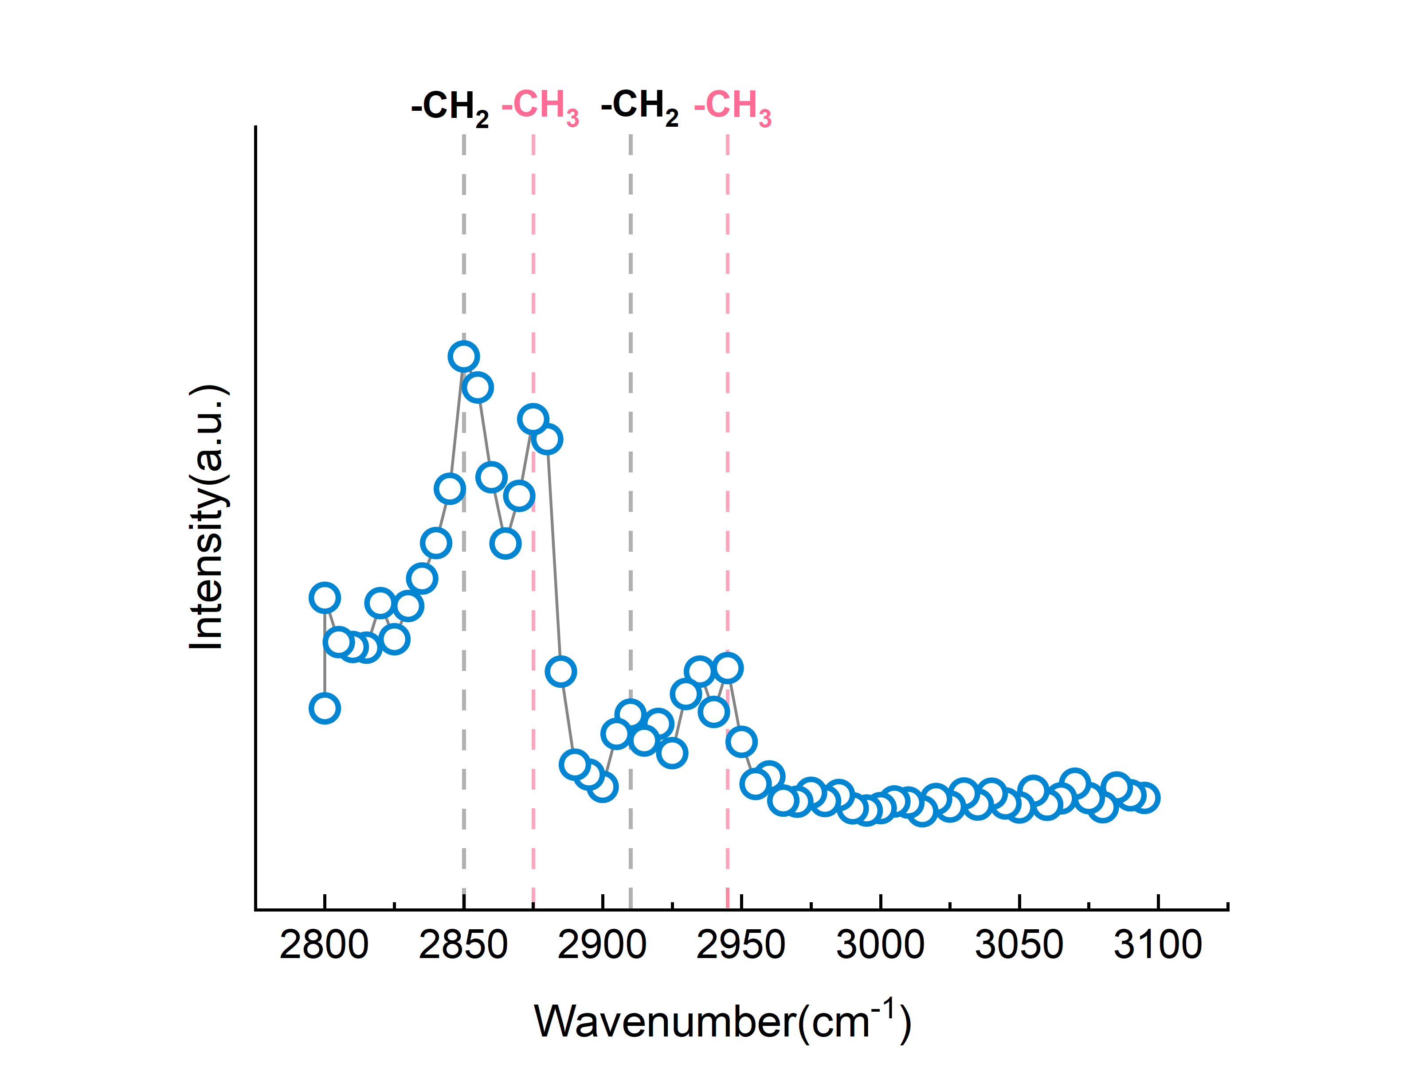
(b)
(a)
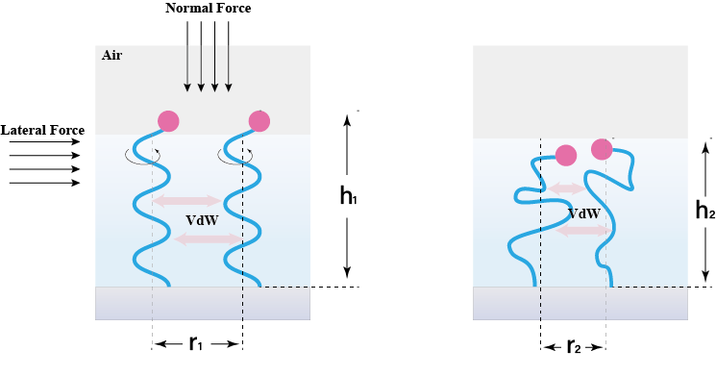
Supplementary Figure 14. (a) ​SFG spectra reveals loss of slipperiness stems from molecular brush disorder after dry friction, with (b) illustrating disrupted brush conformations enhance van der Waals interactions ($r_{2}<r_{1} , ω_{VdW}\left(r\right)=-\left[C_{ind}+C_{orient}+C_{disp}\right]/r^{6}$) thus impeding excessive ether groups exposure and preventing spreading-state switching.
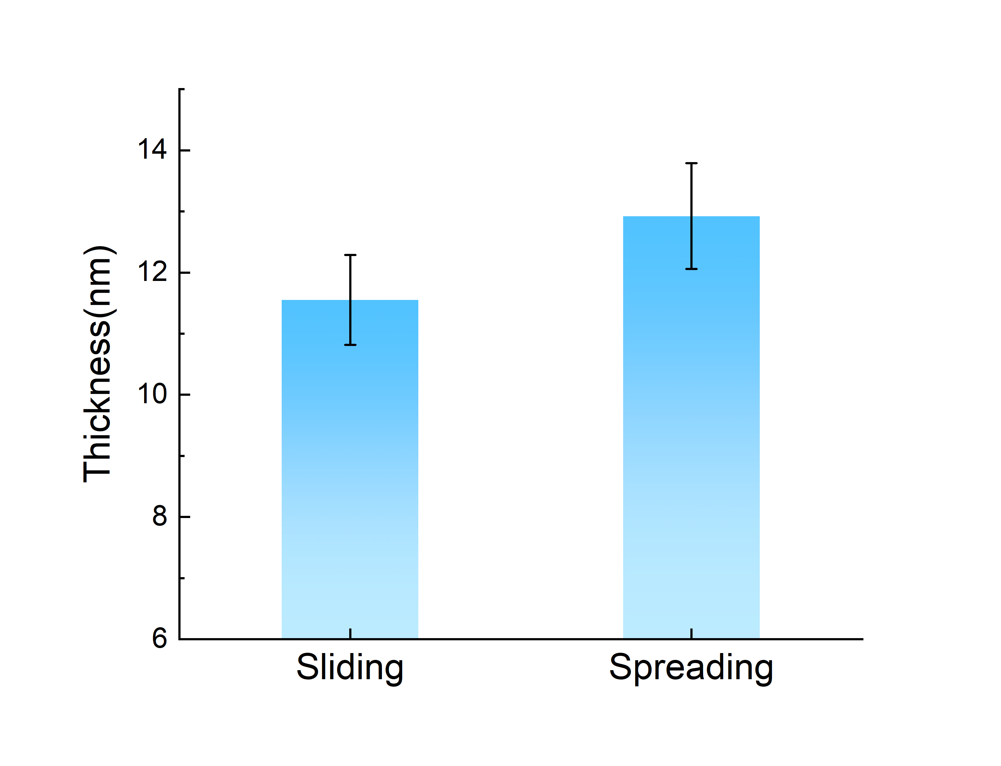
Supplementary Figure 15. Comparison of brush thickness between sliding and spreading states, with data measured at 5 points for each sample.

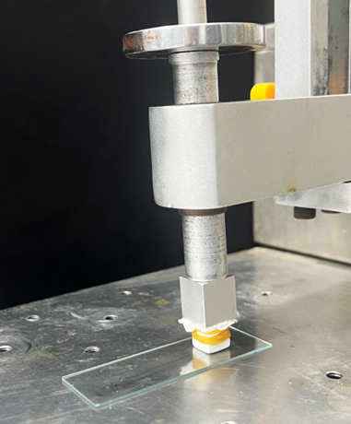
Non-woven
load
Samples
(a)
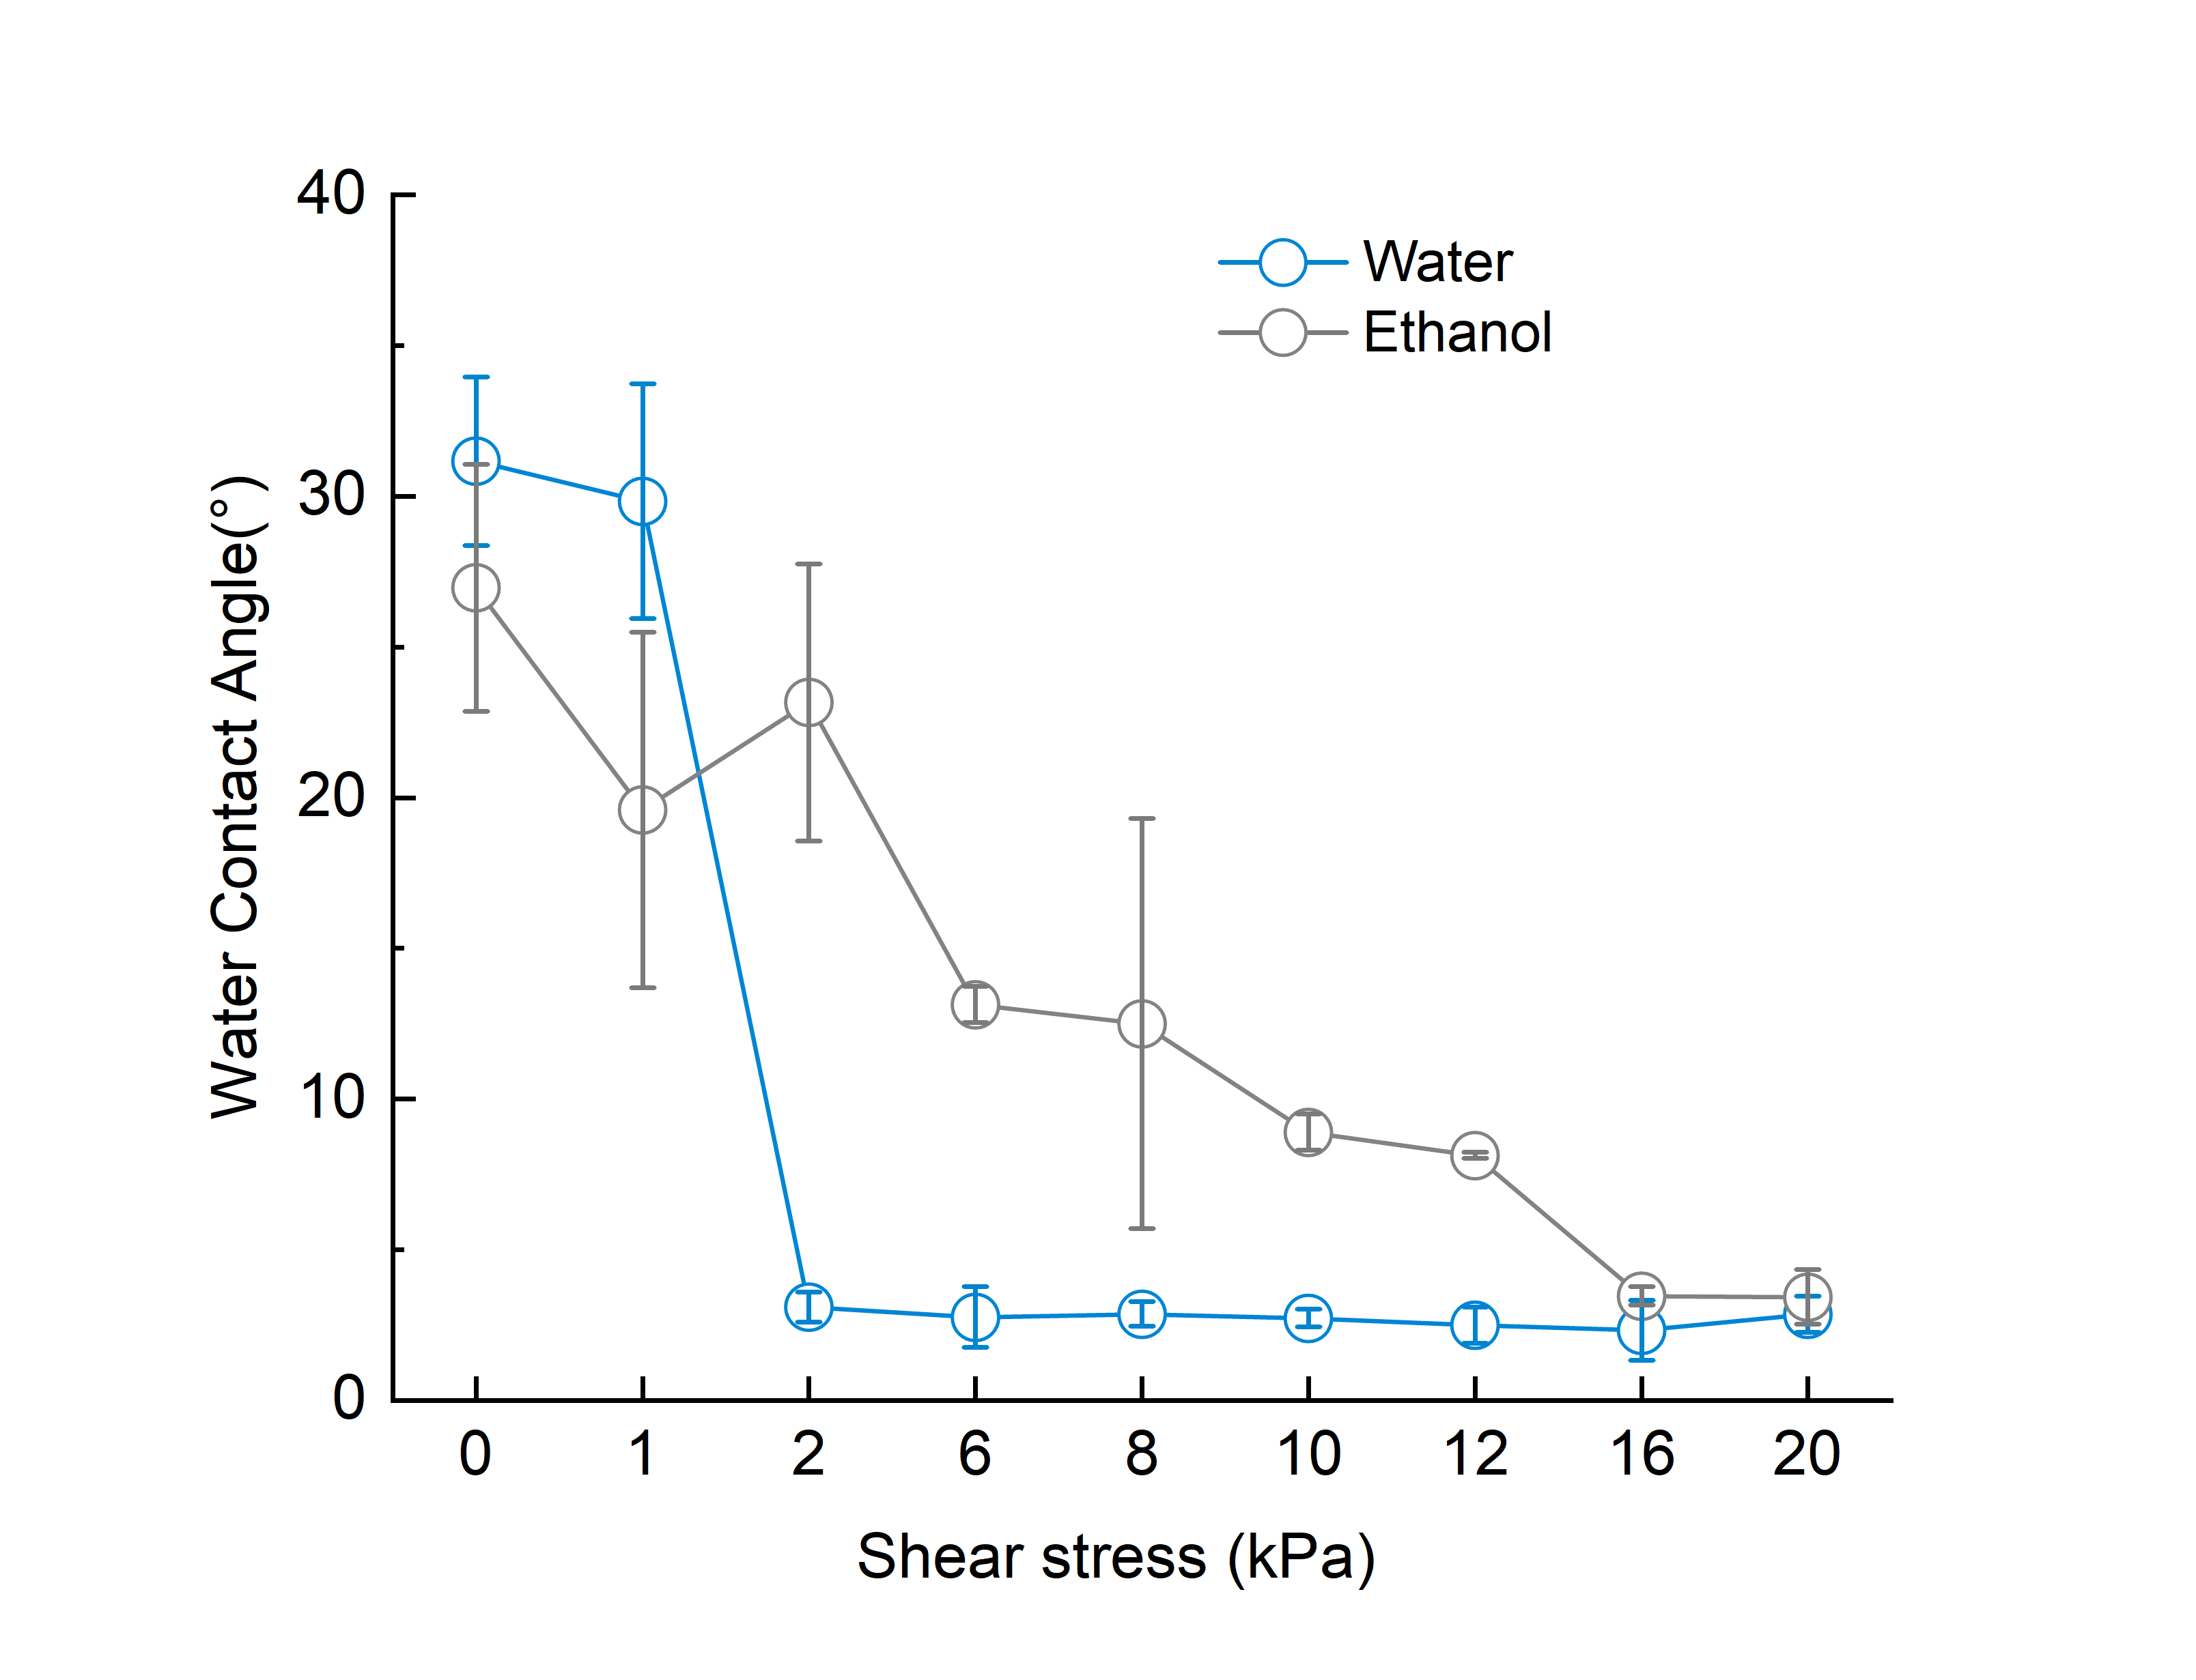Supplementary Figure 16. (a) Schematic illustration of the experimental setup for determining the critical shear force range (the wet friction coefficient μ = 0.2 given the nonwoven fabric exhibits μ = 0.5 which will decrease under wet condition). (b) Variations in water contact angle (WCA) following reciprocating wet friction tests under different shear stresses and liquid media conditions.
(b)
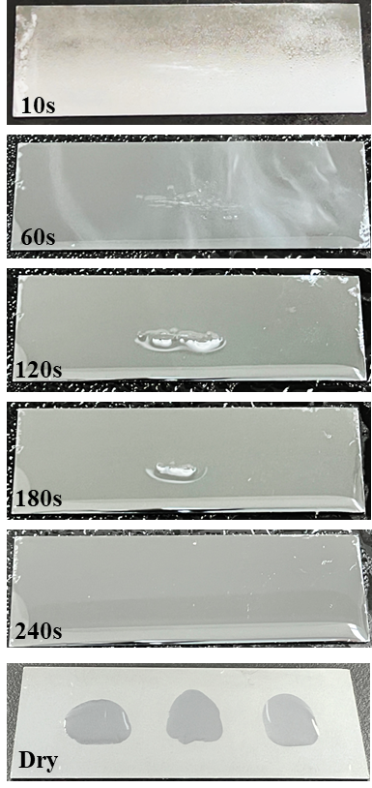
Supplementary Figure 17. Persistent spreading state post-condensation: 240s water film exposure with subsequent drying maintains non-recovered WCA, indicating mere solvation fail to trigger the wettability switching.

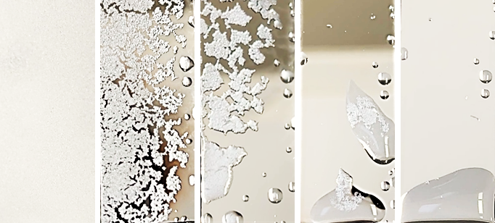
Supplementary Figure 18. Defrosting performance of PEG-grafted LLS in sliding state.

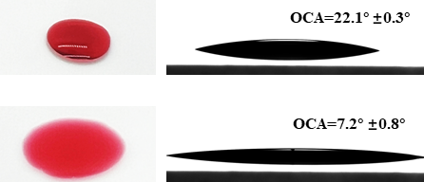
(b)
(a)
Supplementary Figure 19. Wettability demonstration of soybean oil on surface in (a) spreading state and (b) sliding state.

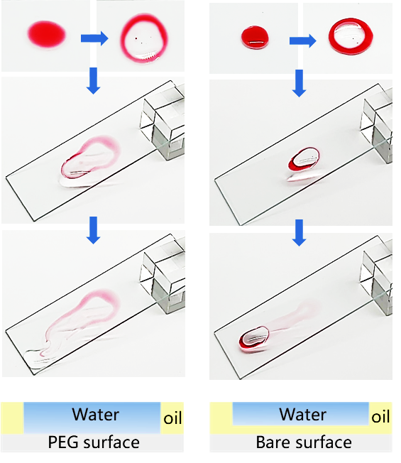
(a)
(b)
Supplementary Figure 20. ​​Contrasting anti-oilfouling performance: (a) Water penetrates oil film on PEG-grafted surface in sliding state (leaving clear aqueous trails) versus (b) oil-dominated sliding on pristine glass.​

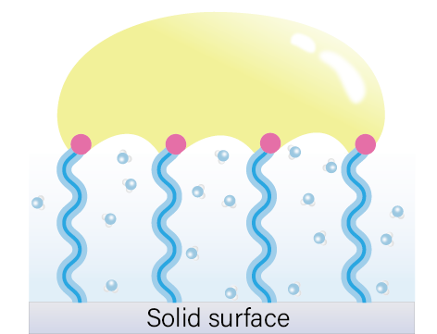
Pinning
(a)

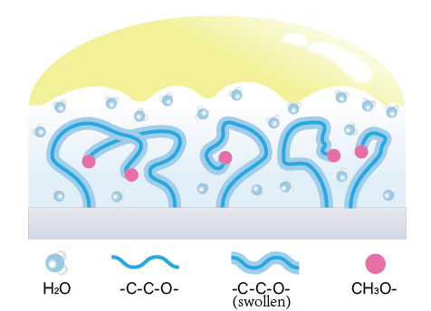
Detaching
(b)
Supplementary Figure 21. ​​The molecular origins of different oil detaching behaviors under sliding and spreading states: (a) The oleophilic methoxy groups anchor the oil phase through pinning. (b) The strong hydration capability of ether groups enables rapid detaching.​

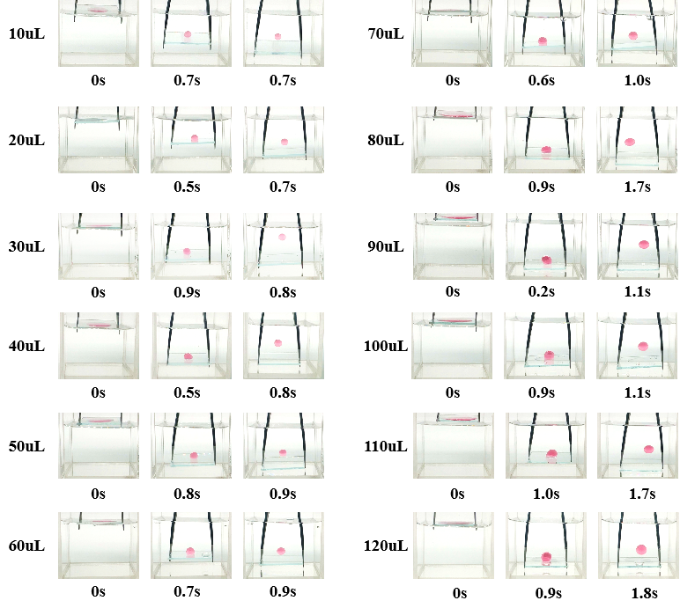
Supplementary Figure 22. Detaching time comparison of 10-120 μL soybean oil from PEG-grafted LLS(spreading state).
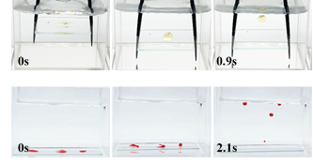
(a)
(b)
Supplementary Figure 23. Rapid detachment of (a) viscous engine oil and (b) solid hexadecane from spreading-state PEG-grafted LLS.

Supplementary Table
Supplementary Table 1. Summary of oil-repellent performance of existing hydrophilic coatings
Author | Materials | Probe oil | Oil volume | Detaching velocity
DY Wang et al.¹⁴ | CNC | Rapeseed oil | 30 μL | 4.0s
DY Wang et al.²¹ | PVS | Soybean oil | 20 μL | 2.0s
DY Wang et al. ²⁷ | PMPC | Rapeseed oil | 30 μL | 1.12s
DY Wang et al. ²⁸ | PDAMAC-SO₄ | Rapeseed oil | 20 μL | 2.0s
J Jin et al. ²⁹ | HEMA-pSB | Crude oil | -- | 15s
ZZ Zeng et al.²⁵ | PSA | Rapeseed oil | 20 μL | 2.2s
P Yang et al. ²⁶ | CNC | Rapeseed oil | 20 μL | 16s
ZZ Zeng et al. ²⁴ | BaSO4 | Soybean oil | 20 μL | 10.0s
XD Chen et al. ³⁰ | PMPC-PDMS | Canola oil | 20 μL | 1.0s
WL Deng et al. ³¹ | Halloysite | Engine oil | 20 μL | 3.0s
JX Chen et al. ³² | Lithium Polysilicate | Soybean oil | 100 μL | 7s
This work | mPEG-silane | Soybean oil | 20-60μL | ＜1s

Supplementary References
1. Kaneko, S., Urata, C., Sato, T., Hönes, R. & Hozumi, A. Smooth and Transparent Films Showing Paradoxical Surface Properties: The Lower the Static Contact Angle, the Better the Water Sliding Performance. Langmuir 35, 6822–6829 (2019).
2. Nakamura, S., Kakiuchida, H., Okada, M. & Hozumi, A. Statically Very Hydrophilic but Dynamically Hydrophobic Surfaces Showing Surprising Water Sliding Performance. Adv. Funct. Mater. 34, 2310265 (2024).
3. Cha, H. et al. Dropwise condensation on solid hydrophilic surfaces. Sci. Adv. 6, eaax0746 (2020).
4. Fowkes, F. M. ATTRACTIVE FORCES AT INTERFACES. Ind. Eng. Chem. 56, 40–52 (1964).
5. Owens, D. K. & Wendt, R. C. Estimation of the surface free energy of polymers. J. Appl. Polym. Sci. 13, 1741–1747 (1969).
6. Kaelble, D. Dispersion-Polar Surface Tension Properties of Organic Solids. J. Adhes. 2, 66- (1970).
7. Milner, S. T. Polymer Brushes. Science 251, 905–914 (1991).
8. Gao, R. et al. A highly homogeneous polymer composed of tetrahedron-like monomers for high-isotropy expansion microscopy. Nat. Nanotechnol. 16, 698-+ (2021).
9. Kienberger, F. et al. Static and Dynamical Properties of Single Poly(Ethylene Glycol) Molecules Investigated by Force Spectroscopy. Single Mol. 1, 123–128 (2000).
10. Alexander, S. Adsorption of chain molecules with a polar head a scaling description. J. Phys. 38, 983–987 (1977).
11. Eliassi, A. & Modarress, H. Water activities in binary and ternary aqueous systems of poly(ethylene glycol), poly(propylene glycol) and dextran. Eur. Polym. J. 37, 1487–1492 (2001).
12. Haynes, C. A., Beynon, R. A., King, R. S., Blanch, H. W. & Prausnitz, J. M. Thermodynamic properties of aqueous polymer solutions: poly(ethylene glycol)/dextran. J. Phys. Chem. 93, 5612–5617 (1989).
13. de Gennes, P. G. Conformations of Polymers Attached to an Interface. Macromolecules 13, 1069–1075 (1980).
14. Huang, S. & Wang, D. A Simple Nanocellulose Coating for Self-Cleaning upon Water Action: Molecular Design of Stable Surface Hydrophilicity. Angew. Chem. Int. Ed. 56, 9053–9057 (2017).
15. McHale, G., Gao, N., Wells, G. G., Barrio-Zhang, H. & Ledesma-Aguilar, R. Friction Coefficients for Droplets on Solids: The Liquid–Solid Amontons’ Laws. Langmuir 38, 4425–4433 (2022).
16. Furmidge, C. G. L. Studies at phase interfaces. I. The sliding of liquid drops on solid surfaces and a theory for spray retention. J. Colloid Sci. 17, 309–324 (1962).
17. Hydrodynamics of wetting.
18. Cox, R. The Dynamics of the Spreading of Liquids on a Solid-Surface .1. Viscous-Flow. J. FLUID Mech. 168, 169–194 (1986).
19. Podgorski, T., Flesselles, J.-M. & Limat, L. Corners, Cusps, and Pearls in Running Drops. Phys. Rev. Lett. 87, 036102 (2001).
20. Chen, F. et al. Robust and durable liquid-repellent surfaces. Chem. Soc. Rev. 51, 8476–8583 (2022).
21. Wang, R., Cheng, C., Wang, H., Tao, Q. & Wang, D. A Simple Poly(Vinyl Sulfonate) Coating for All-Purpose, Self-Cleaning Applications: Molecular Packing Density–Defined Surface Superhydrophilicity. Adv. Funct. Mater. 33, 2301085 (2023).
22. Fick, J. et al. Swelling Behavior of Self-Assembled Monolayers of Alkanethiol-Terminated Poly(ethylene glycol): A Neutron Reflectometry Study. Langmuir 20, 3848–3853 (2004).
23. Richartz, Th., Galle, J. & Klose, G. Water interaction with oligo-(ethoxy) ethylene glycols. Chem. Phys. Lett. 271, 79–83 (1997).
24. Deng, W. et al. Viscous Oil De-Wetting Surfaces Based on Robust Superhydrophilic Barium Sulfate Nanocoating (vol 13, pg 27674, 2021). ACS Appl. Mater. INTERFACES 14, 14836–14836 (2022).
25. Tang, L. et al. Study of Oil Dewetting Ability of Superhydrophilic and Underwater Superoleophobic Surfaces from Air to Water for High-Effective Self-Cleaning Surface Designing. ACS Appl. Mater. INTERFACES 11, 18865–18875 (2019).
26. Feng, N. et al. Detaching adhesive oil staining from a surface by water. Aggregate 5, e465 (2024).
27. He, K. et al. Cleaning of Oil Fouling with Water Enabled by Zwitterionic Polyelectrolyte Coatings: Overcoming the Imperative Challenge of Oil–Water Separation Membranes. ACS Nano 9, 9188–9198 (2015).
28. Tao, Q. et al. Counterion-Dictated Self-Cleaning Behavior of Polycation Coating upon Water Action: Macroscopic Dissection of Hydration of Anions. Angew. Chem. Int. Ed. 59, 14466–14472 (2020).
29. Dong, D. et al. Double-Defense Design of Super-Anti-Fouling Membranes for Oil/Water Emulsion Separation. Adv. Funct. Mater. 32, 2113247 (2022).
30. He, K. et al. An On-Skin Electrode with Anti-Epidermal-Surface-Lipid Function Based on a Zwitterionic Polymer Brush. Adv. Mater. 32, 2001130 (2020).
31. Deng, W. et al. Negative expansion induced anti-abrasive self-cleaning coatings for enhancing output of solar panels. Chem. Eng. J. 499, 156153 (2024).
32. Chen, J. et al. Oil-Resistant Underoil Superhydrophilic Metallic Foams for Lampblack Prefiltration. ACS Appl. Mater. Interfaces (2024) doi:10.1021/acsami.4c13153.

