Supplementary Information

Freeform 3D Plasmonic Superstructures
Won-Geun Kim^{1,†}, Jong-Min Lee^{2,†}, Vasanthan Devaraj², Minjun Kim³, Hyuk Jeong⁴, Eun-Jung Choi², Jihyuk Yang⁵, Donghan Lee³, Ji Tae Kim^{5,*} and Jin-Woo Oh^{1,2,4,*}
¹Department of Nano Fusion Technology, Pusan National University, Busan, 46241, Korea
²BIT Fusion Technology Center, Pusan National University, Busan 46241, Korea
³Department of Physics, Chungnam National University, Daejeon, 34134, Korea
⁴Department of Nanoenergy Engineering, Pusan National University, Busan, 46241, Korea
⁵Department of Mechanical Engineering, The University of Hong Kong, Pokfulam Road, Hong Kong, China

†These authors contributed equally to this work.
*Corresponding author E-mail: ojw@pusan.ac.kr (J.-W. Oh) & jtkim@hku.hk (J.T. Kim)

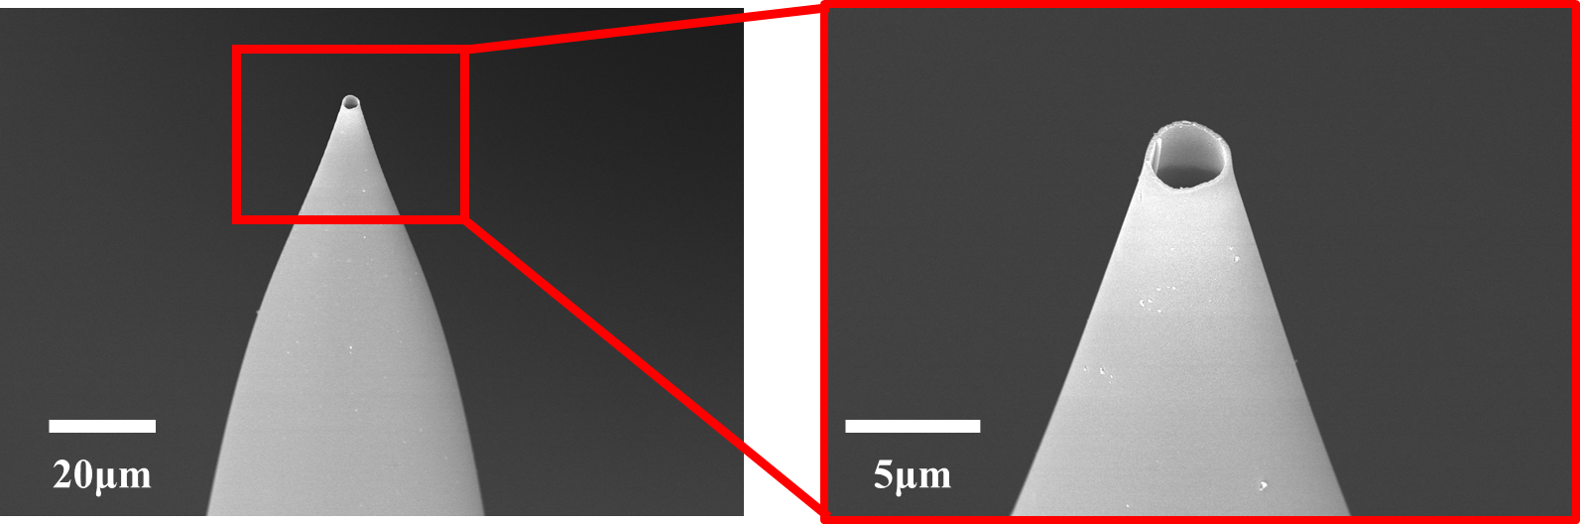
Supplementary Figure S1. FE-SEM images of a micropipette for 3D printing of hierarchical plasmonic clusters.

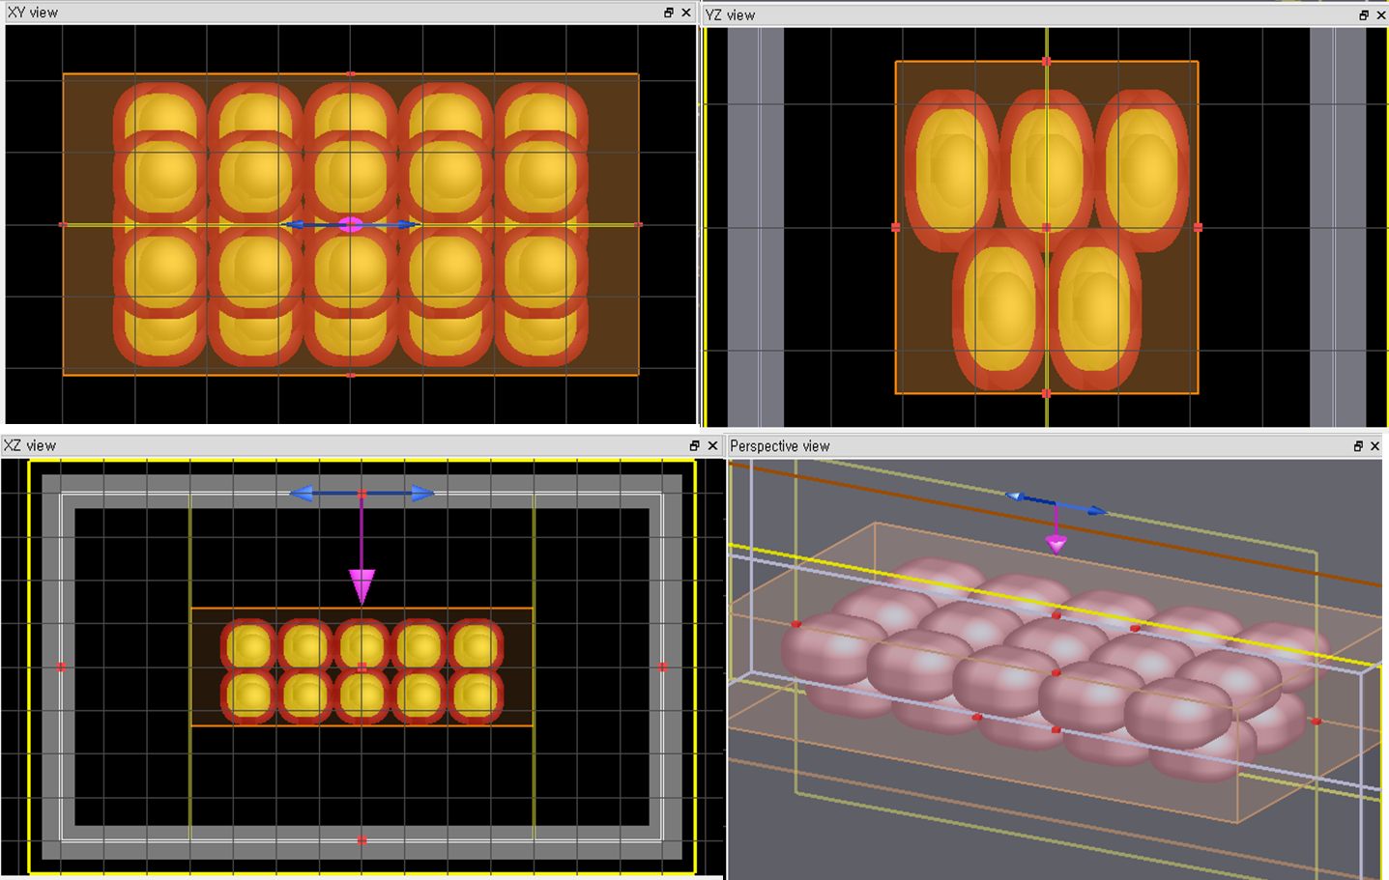
Supplementary Figure S2. FDTD simulation model in different viewpoints.

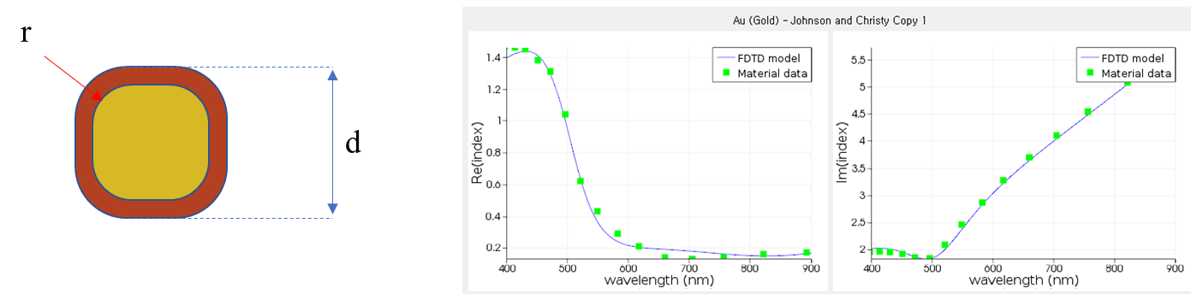
Supplementary Figure S3. (left) rounded rectangle. (right) Fitting results of optical properties of gold. TEM images of the gold nanoparticles provided by the manufacturer show that the nanoparticles contain truncated surfaces. Previous studies have shown that the properties of faceted nanoparticles are completely different from those of spherical nanoparticles. Here, the shape of the gold nanoparticles is represented by a rounded rectangle to modeling randomly faceted nanoparticles. The diameter of the core gold nanoparticles (d) was 100 nm and the radius of the round face (r) was set to 40 nm. The outer dielectric coating had a refractive index of 1.4 and a thickness of 16 nm. This is implemented by overlapping two rounded rectangles. The diameter of the outer rounded rectangle is 132 nm and the radius of the round face is 50 nm. Five nanoparticles were arranged in the X-axis direction while being arranged in the form of the Olympic ring on the YZ plane. TFSF sources sized of x-axis 1400 nm, 6-axis 800 nm, z-axis 800 nm was placed in the center.

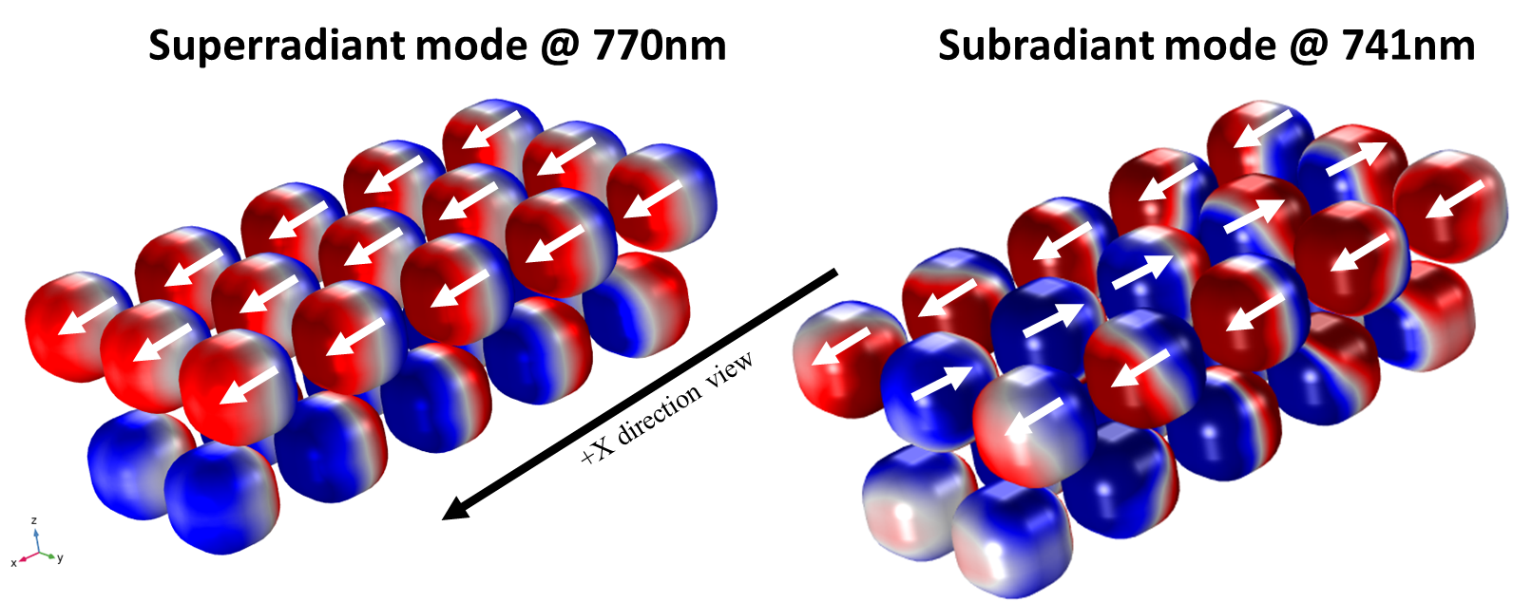
Supplementary Figure S4. Surface charge maps of (left) superradiant mode and (right) subradiant mode.

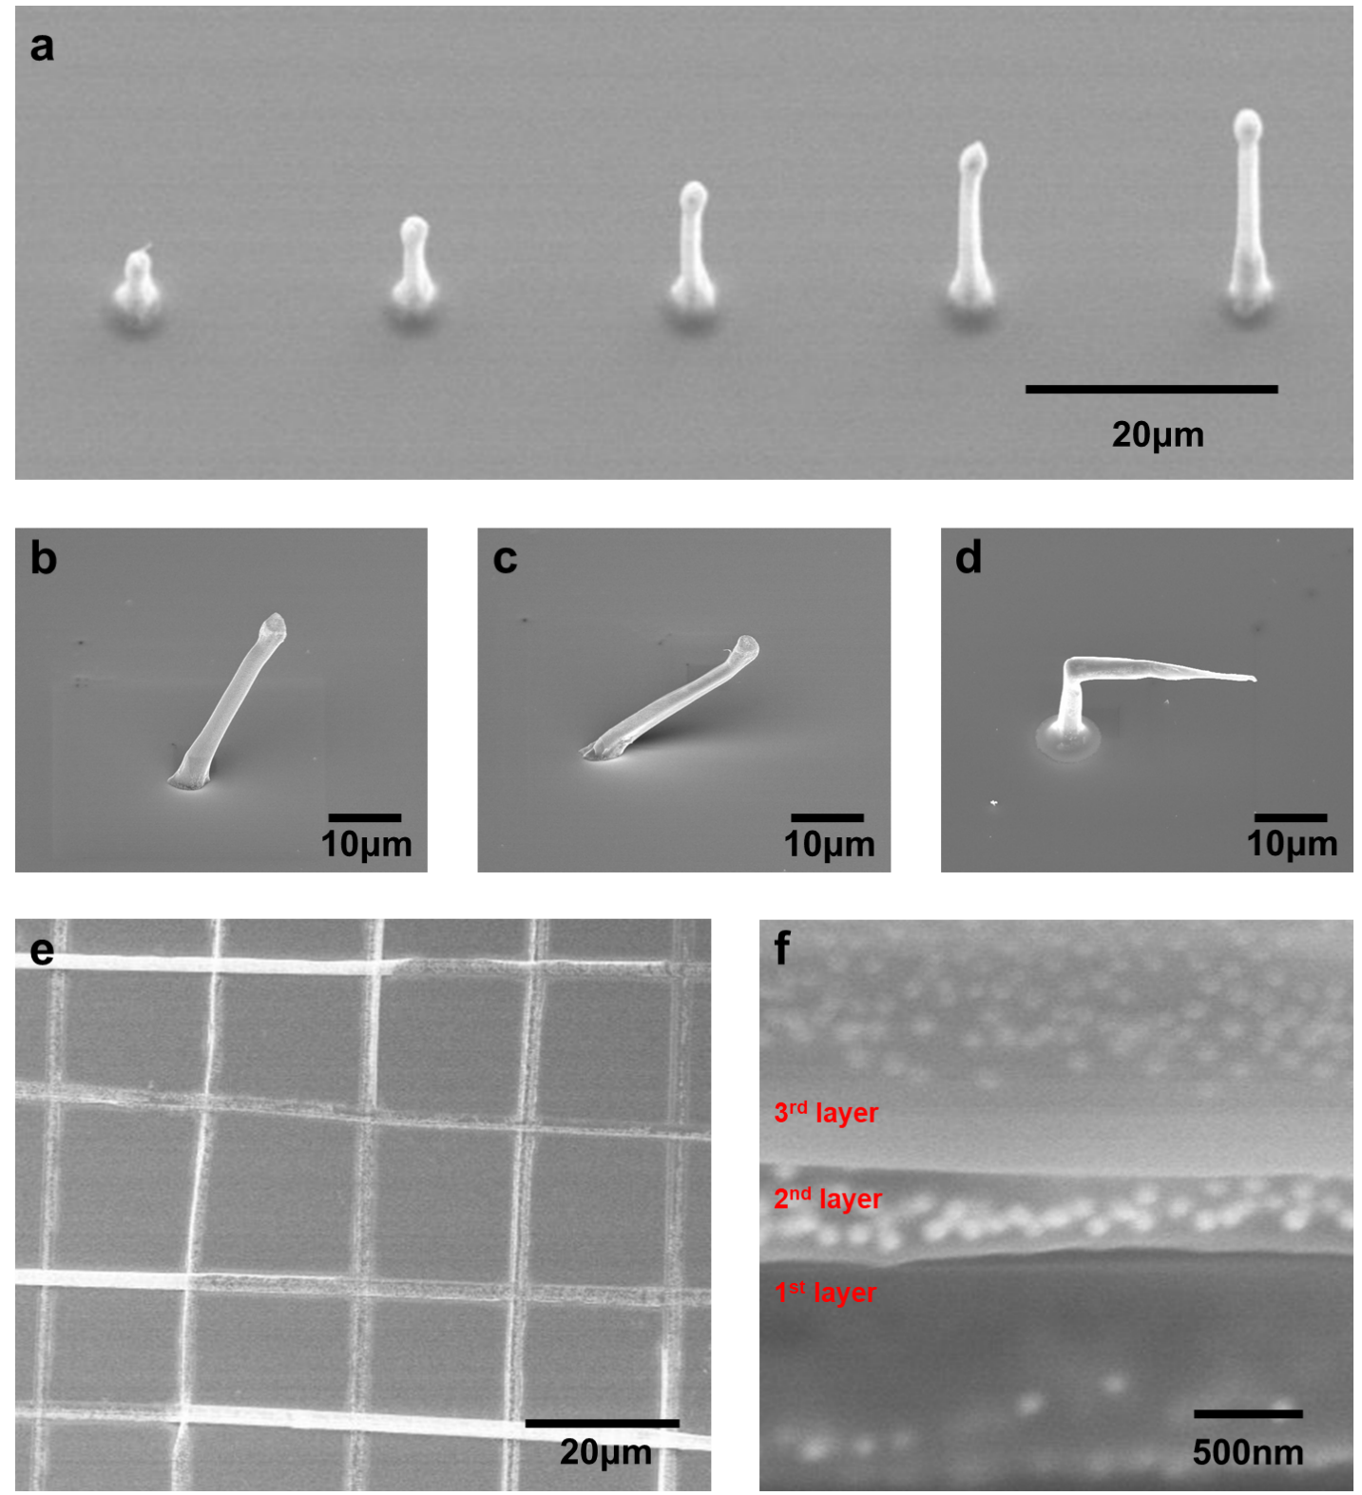
Supplementary Figure S5. FE-SEM images of (a) HPC with various height, (b) 60° tilted pillar, (c) 30° tilted pillar, (d) 2-folded pillar with folding angle of 90°, (e) grid structure and (f) layer-by-layer structure.

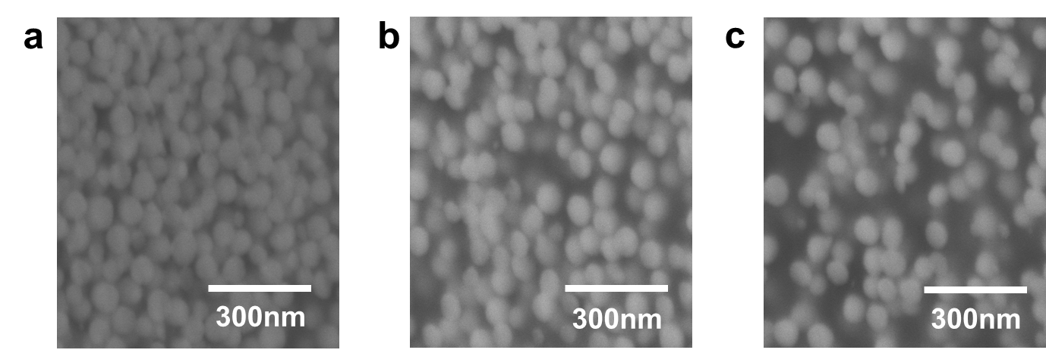
Supplementary Figure S6. FE-SEM images displaying the change in interparticle spacing at different particle number ratio (N_{SiO2} / N_{Au}).

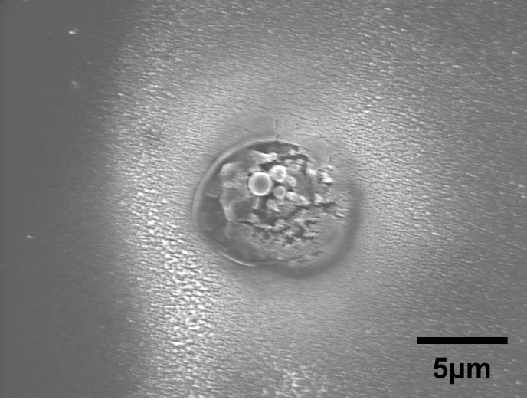
Supplementary Figure S7. SEM image of the collapsed QD-embedded AuNP cluster.

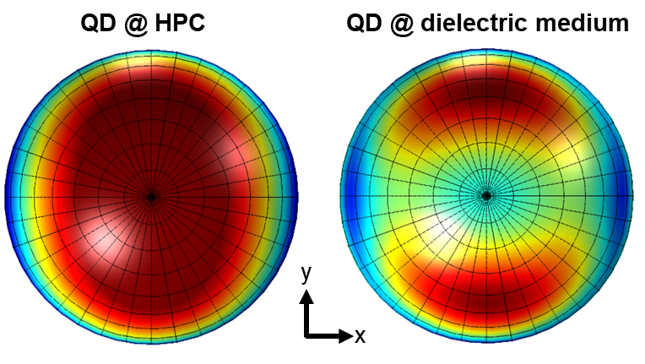
Supplementary Figure S8. Simulation results on far-field characteristics of QD-embedded HPC and dielectric medium.

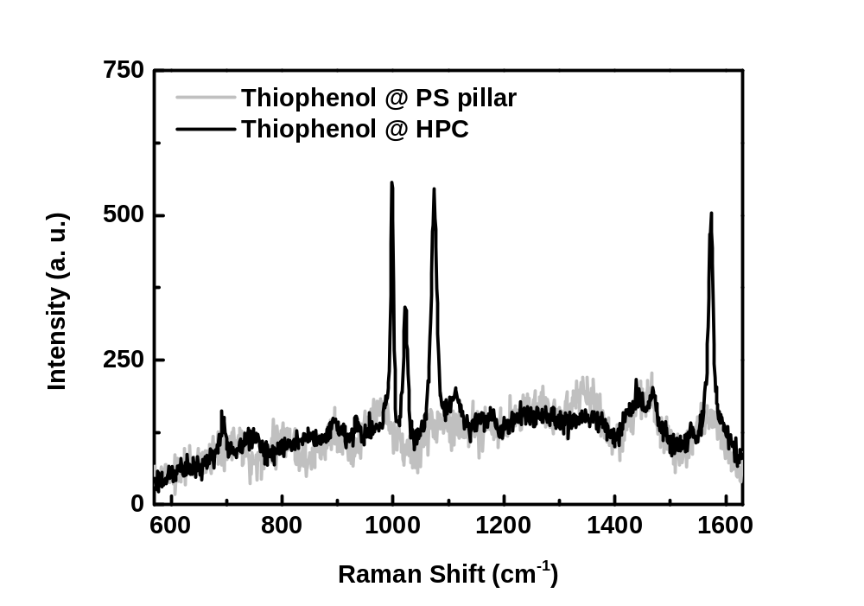
Supplementary Figure S9. SERS spectra of thiophenol embedded in HPS and PS pillar.

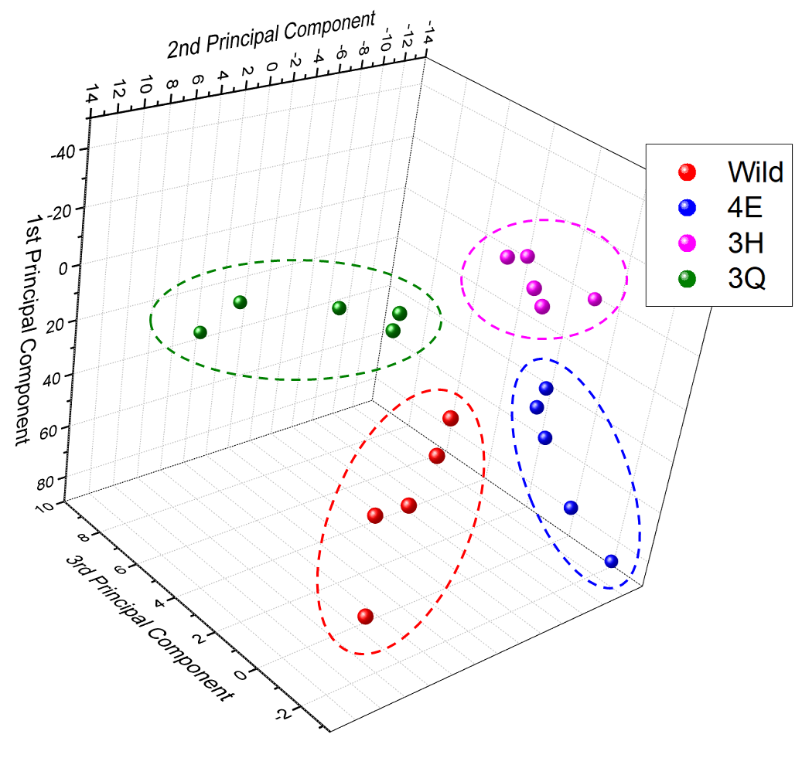
Supplementary Figure S10. Principal component analysis performed on Raman spectra of various mutant M13 bacteriophage.

