uncropped blots of Figure3C： Western blot analysis of EV markers in SKOV3-EVs (left) and HO8910-EVs (right)

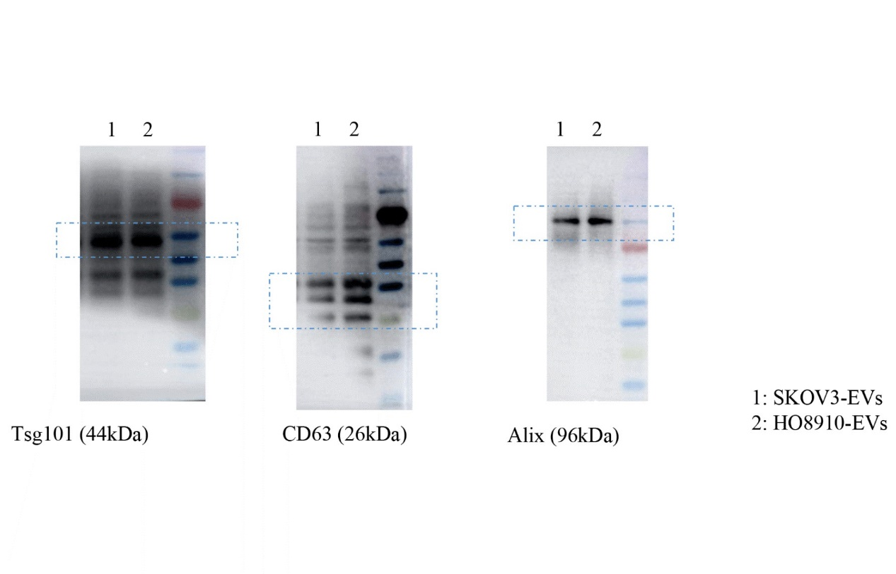

uncropped blots of figure5E：Western blot of VEGFR expression in HUVECs co-cultured with differently pre-treated macrophages.

