Supporting Information for
Immobilization of levansucrase Ba-SacB from Bacillus amyloliquefaciens on nano zinc oxide
Song Gao ^{a§}, Mingxiong Tan ^{b§}, Ran Lu ^{a,c§}, Guoshi Kan ^{a,c}, Jayaweera Arachchige Asela Sampath Jayaweera ^{d}, Yingfeng An ^{a, c*}

ª College of Biosciences and Biotechnology, Shenyang Agricultural University, Shenyang, China
^{b} Guangxi Key Laboratory of Agricultural Resources Chemistry and Biotechnology, Yulin 537000, China.
^{c} Shenyang Key Laboratory of Microbial Resource Mining and Molecular Breeding
^{d} Department of Microbiology, Rajarata University of Sri Lanka, Saliyapura, Sri Lanka

§These authors contributed equally to this work
* Corresponding author: Yingfeng An Email: anyingfeng666@163.com
Address: College of Bioscience and Biotechnology, Shenyang Agricultural University. No.120 Dongling Road, Shenyang 110161, P. R. China.
Tel: +86-24-88487163. Fax: +86-24-88487163

Fig. S1. The effect of protein concentration on enzyme loading of Ba-SacB during immobilization.
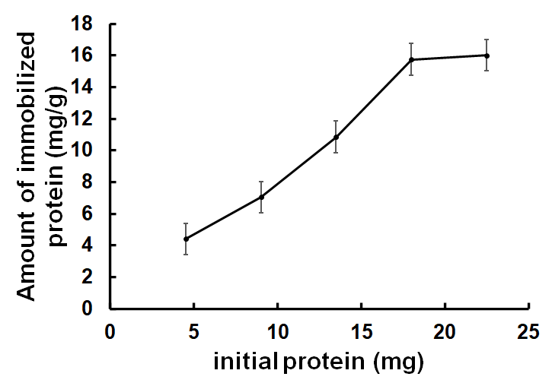

Fig. S2. The effect of immobilization time on enzyme loading of Ba-SacB during immobilization.
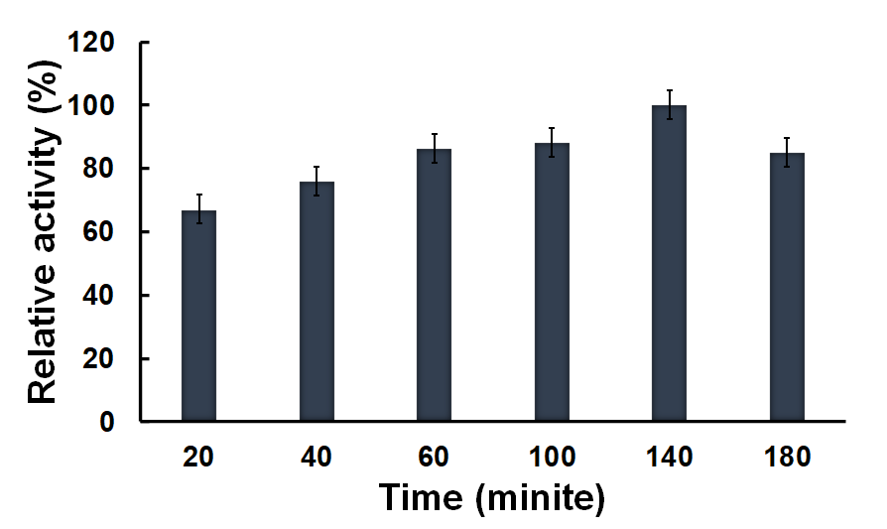

Fig. S3. Analysis of the products catalyzed by Ba-SacB-ZnO and Ba-SacB using HPLC. (a) and (b) show the products catalyzed by Ba-SacB-ZnO and Ba-SacB, respectively. The fructose, glucose, sucrose, 1-kestose and nystose are shown as F, G, GF, GF2, GF3, respectively.

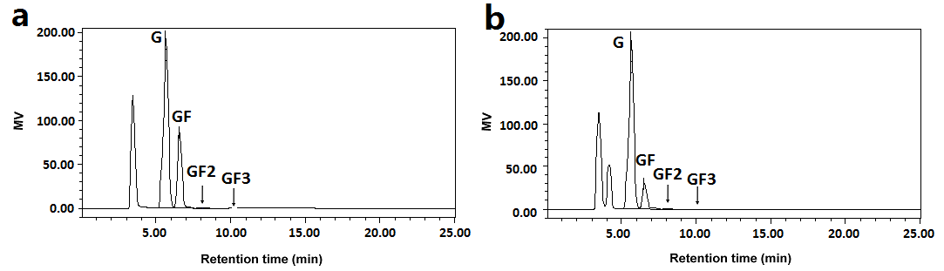
Fig. S4. Analysis of components of polysaccharides synthesized using Ba-SacB-ZnO and Ba-SacB by ¹³C NMR spectra. (a) and (b) show ¹³C NMR spectra of polysaccharides synthesized using Ba-SacB-ZnO and Ba-SacB, respectively.

