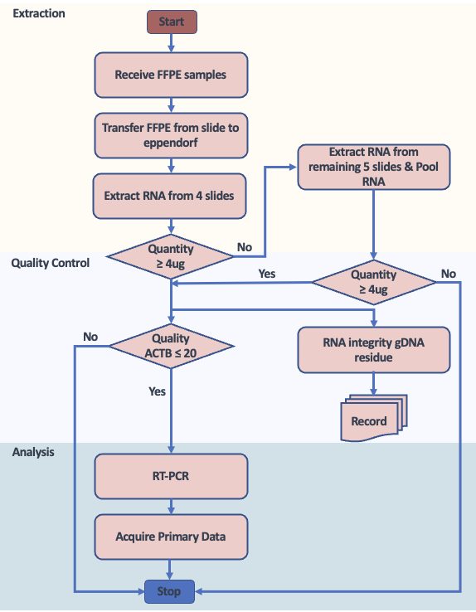
Figure S1. 28-Gene testing laboratory related operations and quality control requirements.

