Table S1. Material parameters of heterogeneous vs. homogeneous meniscus models
Meniscus Type | Zone ID | Elastic Modulus (MPa) | Poisson's Ratio
Heterogeneous | 1 | 35.85 | 0.49
Heterogeneous | 2 | 77.57 | 0.49
Heterogeneous | 3 | 42.59 | 0.49
Heterogeneous | 4 | 118.55 | 0.49
Heterogeneous | 5 | 15.22 | 0.49
Heterogeneous | 6 | 28.07 | 0.49
Heterogeneous | 7 | 83.95 | 0.49
Heterogeneous | 8 | 42.68 | 0.49
Heterogeneous | 9 | 1.83 | 0.49
Heterogeneous | 10 | 14.56 | 0.49
Heterogeneous | 11 | 38.55 | 0.49
Heterogeneous | 12 | 37.13 | 0.49
Homogeneous | - | 43.91 | -

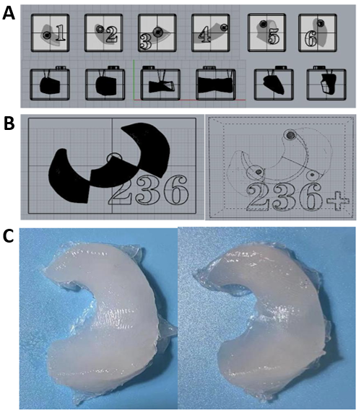
Figure S1. Fabrication of PVA-H heterogeneous meniscus by two kinds of molds.
(A) The first mold to fabricate PVA-H heterogeneous meniscus, in which the meniscus was divided into 6 zones. (B) The second mold to fabricate PVA-H heterogeneous meniscus, in which the meniscus was divided into 3 zones. (C) Comparison diagram of PVA-H heterogeneous meniscus made by two kinds of molds.

