Appendices:

Appendix A: Data Extraction Form
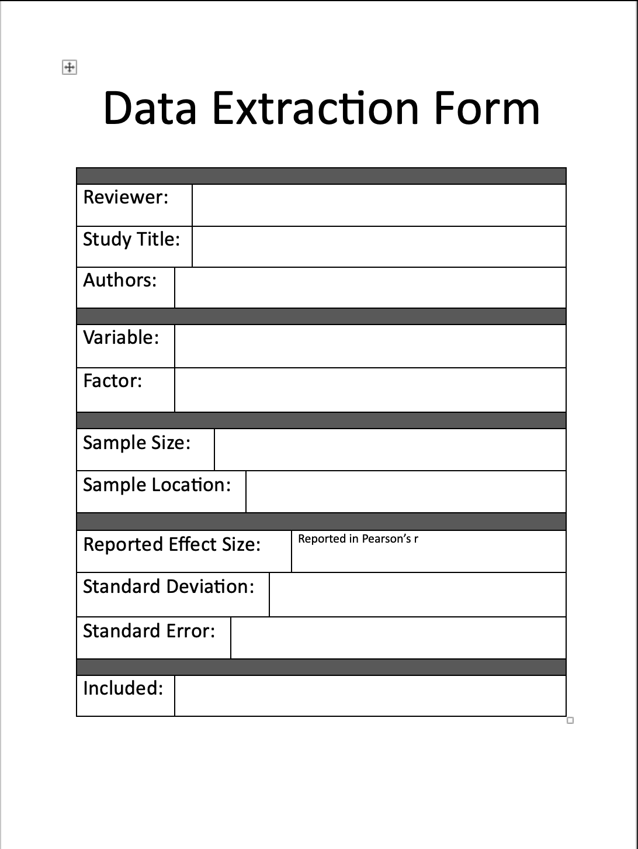

Appendix B: Citations for Included Studies
